OBJECT ORIENTED DESIGN
QUIZ 1 – SKPL DOCUMENT



KHEN MUHAMMAD CAHYO
244107023002
TI-2I
STATE POLYTECHNIC OF MALANG
INFORMATION TECHNOLOGY DEPARTMENT

SOFTWARE SYSTEM
REQUIREMENTS

STUDENT UKM SELECTION
DETERMINATION SYSTEM
Version 1.0.0

Prepared by - Khen Muhammad Cahyo

March, 13 2025

Functional Requirement

Use Case Diagram
- Cases
  - System Admin can manage master data such as criteria, UKM, classes, and departments as the main data used in the selection system.
  - Students can request UKM recommendations by inputting name, email, nim, class, and department data and selecting the desired criteria.
  - Students also can search their previous recommendations data by search the data from input in recommendations data collections.
  - UKM Organization can approve join request from students on their UKM.
  - UKM Organization can manage members data on their UKM.
- Actors & Goals
  - Actors
Based on previous explained use cases, there is 3 actors that will be used on this systems.
- Admin
- Student
- UKM Organization
  - Goals
The purpose of this system is to provide recommendations to students when students are confused about choosing which UKM is in accordance with their abilities and other factors.

- Diagram
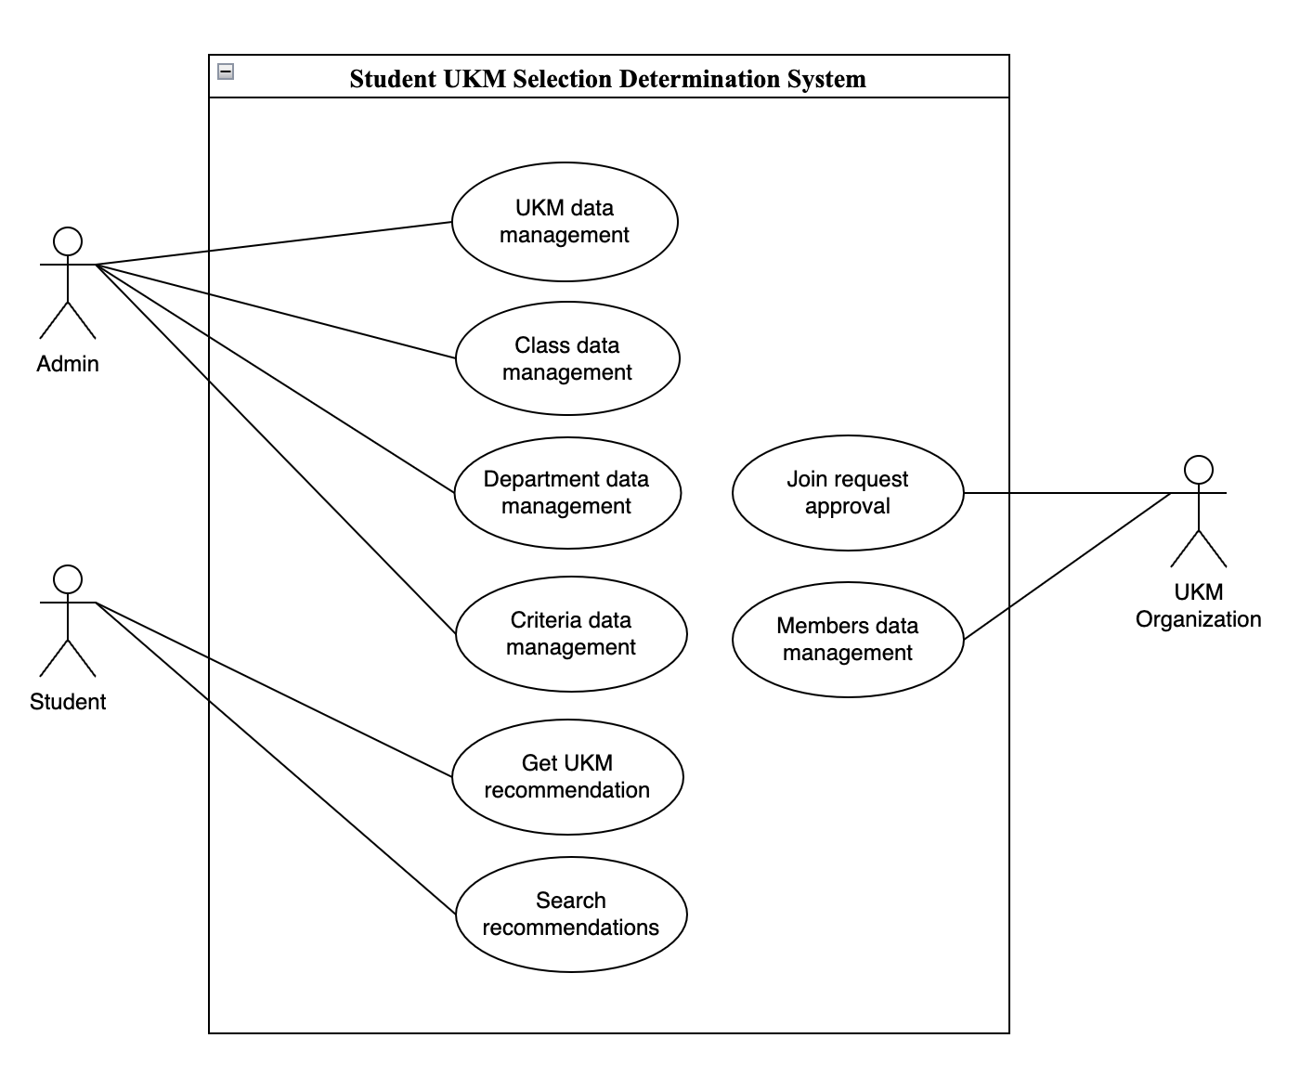

Use Case Description
- Get UKM Recommendation
Use Case Name: Get UKM Recommendation | ID: UCD-001 | Importance Level: High
Primary Actor: Student | Use Case Type: Detail, Overview
Stakeholder and Interest:
Student – Want to get UKM recommendation for their personals.
Brief Description:
This use case described how students can get UKM recommendation on this app.
Trigger: Student click Get Recommendation button on get recommendation page after filled form inputs.
Type: Temporal Trigger
Relationship:
Normal Flow Event:
- Student open the app on browser.
- Student fill form inputs (name, email, nim, class, department, and their criterias) and submit the data.
- System will calculates the criterias from student.
- After that, system will give student an recommendations based on the calculating results.
- Student can select one or more UKM from recommendations results and register on UKM that they selected.
Sub Flows:
- System admin created master data for get UKM recommendations needs (classes, departments, ukm, and criterias).
- System admin ensure that this data can accessed by students in get UKM recommendations feature.
Alternate/Exceptional Flow:
If student don’t get an recommendations from system, they can submit request again with different criterias.

- Search Recommendations
Use Case Name: Search Recommendation | ID: UCD-002 | Importance Level: High
Primary Actor: Student | Use Case Type: Detail, Essential
Stakeholder and Interest:
Student – Search recommendations and join requests status for their personals.
Brief Description:
This use case described how student can check their recommendations and UKM join requests approval status.
Trigger: Search input on recommendations table.
Type: Temporal Trigger
Relationship:
Normal Flow Event:
- Student open the app on browser.
- On landing page, students will see table recommendations results from all students that has request on this app.
- In search input, students can search their recommendations data based on their name.
- After that, student can see their recommendations and their UKM join requests approval status.
Sub Flows:
Alternate/Exceptional Flow:

- Join Request Approval
Use Case Name: Join Request Approval | ID: UCD-003 | Importance Level: High
Primary Actor: UKM Organization | Use Case Type: Detail, Real
Stakeholder and Interest:
UKM Organization – Approve UKM join requests from students.
Brief Description:
This use case described how student can check their recommendations and UKM join requests approval status.
Trigger: Approve or Reject button.
Type: Temporal Trigger
Relationship:
Normal Flow Event:
- UKM Organization open members candidate page that showing all of members candidate data in table.
- UKM Organization choose one of the members candidate.
- UKM Organization click on Actions button and it will show 2 options (Approve and Reject).
- UKM Organization give an approval answer for candidates based on 2 options before.
Sub Flows:
- System admin registered one account for one organization
- System admin give the registered account to UKM Organization leader
- UKM Organization login on the app for give approval to members candidate with input username and password.
- After UKM Organization give approval results, Students who are given approval status will receive notification on their email.
Alternate/Exceptional Flow:
- If UKM Organization leader forget they password, they can request reset password by email.

Class Diagram
- Identify Entities
Here are each entities that will used on this case.
  - Department
  - Class
  - Student
  - UKM
  - StudentUKM
  - Criteria
  - Assessment
  - Recommendation
  - UKMCriteria

- Entity Attributes & Methods
Here are the attributes and methods that is owned by each entities:
- Department
  - #id: string
  - #name: string
  - #email: string
  - #nim: string
  - #class: Class
  - +createStudent(name, nim, class)
  - +getStudentById(id)
  - +getUkmRecommendation()
- Class
  - #id: string
  - #name: string
  - #department: Department
  - +createClass(name, department)
  - +getAllClass()
  - +getClassById(id)
- Student
  - #id: string
  - #name: string
  - #email: string
  - #nim: string
  - #class: Class
  - +createStudent(name, nim, class)
  - +getStudentById(id)
  - +getUkmRecommendation()

- UKM
  - #id: string
  - #name: string
  - #description: string
  - #leader: Student
  - +createUkm(name, description, leader)
  - +getAllUkm()
  - +getUkmById(id)
- StudentUKM
  - #id: string
  - #student: Student
  - #ukm: UKM
  - +getStudentUkm(student)
- Criteria
  - #id: string
  - #name: string
  - #weight: float
  - +createCriteria(name, weight)
  - +getAllCriteria()
  - +getCriteriaById(id)
- Assessment
  - #id: string
  - #name: string
  - #score: float
  - +getStudentAssessments(student)
  - +getStudentRecommendation(student)
- Recommendation
  - #id: string
  - #ukm: UKM

- UKMCriteria
  - #ukm: UKM
  - #criteria: Criteria
- Relationship Between Entities
Here are explanation about relationship between entities that will used on this case.
- Department – Class
  - Relations: Composition (1-to-Many)
  - Explanations: 1 Department has many Class, but Class can’t exist without Department.
- Class – Student
  - Relations: Association (1-to-Many)
  - Explanations: 1 Class can accommodate many Student, and Student must registered on 1 Class.
- Student – StudentUKM
  - Relations: Aggregation (1-to-Many)
  - Explanations: 1 Student can follows many UKM, and StudentUKM only connector table.
- Student – Assessment
  - Relations: Composition (1-to-Many)
  - Explanations: 1 Student has many Assessment, but Assessment can’t exist without Student.
- StudentUKM – UKM
  - Relations: Association (Many-to-Many)
  - Explanations: Many Student can joins with many UKM.
- Assessment – Criteria
  - Relations: Association (1-to-1)
  - Explanations: Each Assessment assesses 1 specific criteria, allows to tracking per-criteria value.

- UKM – UKMCriteria
  - Relations: Composition (1-to-Many)
  - Explanations: 1 UKM has many Criteria with different weight, determine priority for UKM assessments.
- UKMCriteria – Criteria
  - Relations: Association (Many-to-Many)
  - Explanations: Store criteria-specific weights for each UKM, allows for weight variation between UKMs.
- Recommendation – Assessment
  - Relations: Dependency (1-to-1)
  - Explanations: Recomendation generated based on Assessment calculation, and 1
- Recommendation – UKM
  - Relations: Dependency (1-to-1)
  - Explanations: Every Recommendation leading to specific UKM, demonstrate Student’s fit with UKMs.
- UKM – Student (Leader)
  - Relations: Association (1-to-1)
  - Explanations: Every UKM led by 1 Student, and Leader is a registered UKM members.

- Diagram
