ADVANCED WEB PROGRAMMING
APPLICATION PROGRAMMING INTERFACE (PART 2)



KHEN MUHAMMAD CAHYO
244107023002
TI-2I
STATE POLYTECHNIC OF MALANG
INFORMATION TECHNOLOGY DEPARTMENT

PRACTICUM API UPLOAD PROFILE
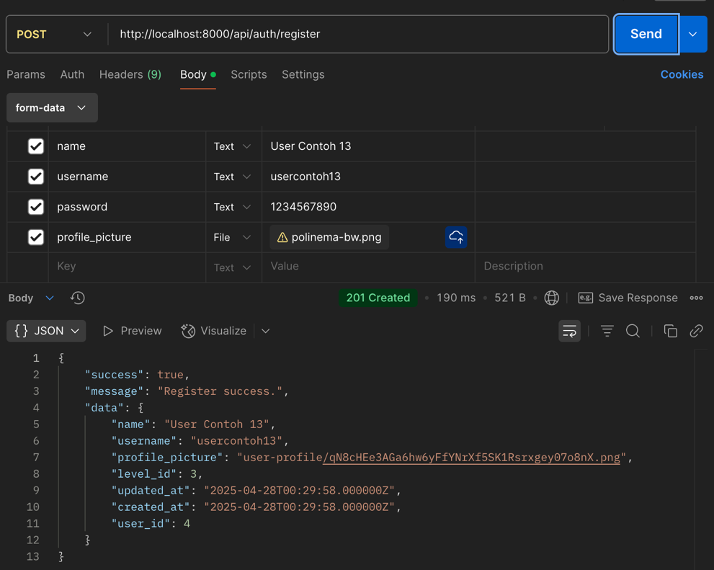

JOBSHEET UPLOAD ITEM WITH IMAGE
