ADVANCED WEB PROGRAMMING
DATABASE MIGRATION



KHEN MUHAMMAD CAHYO
244107023002
TI-2I
STATE POLYTECHNIC OF MALANG
INFORMATION TECHNOLOGY DEPARTMENT

PRACTICUM 1 (DATABASE SETTINGS)
- Creating Database

- Change .env
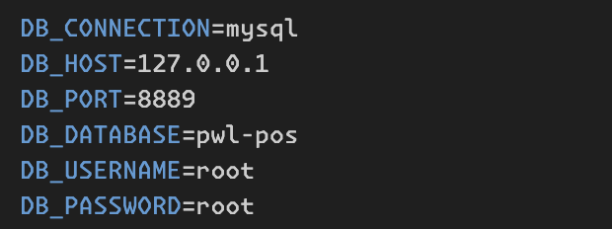

PRACTICUM 2 (MIGRATION)
- Creating Migration (Don’t Have Relations and Have Relation)
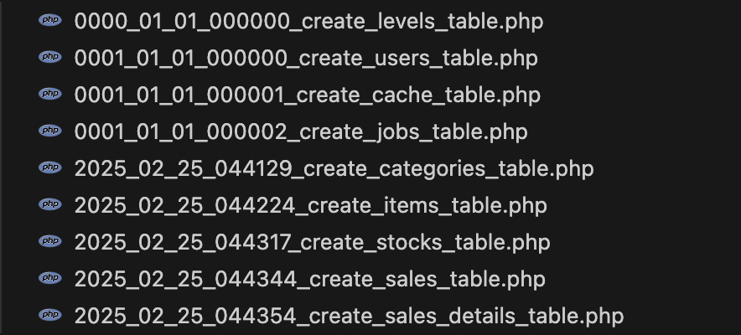
- Run Migration
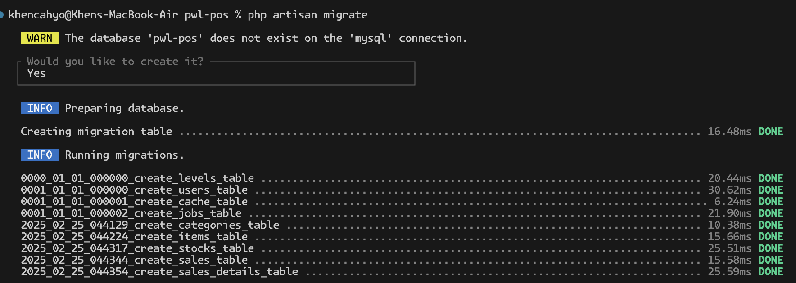
- PhpMyAdmin Table Designer
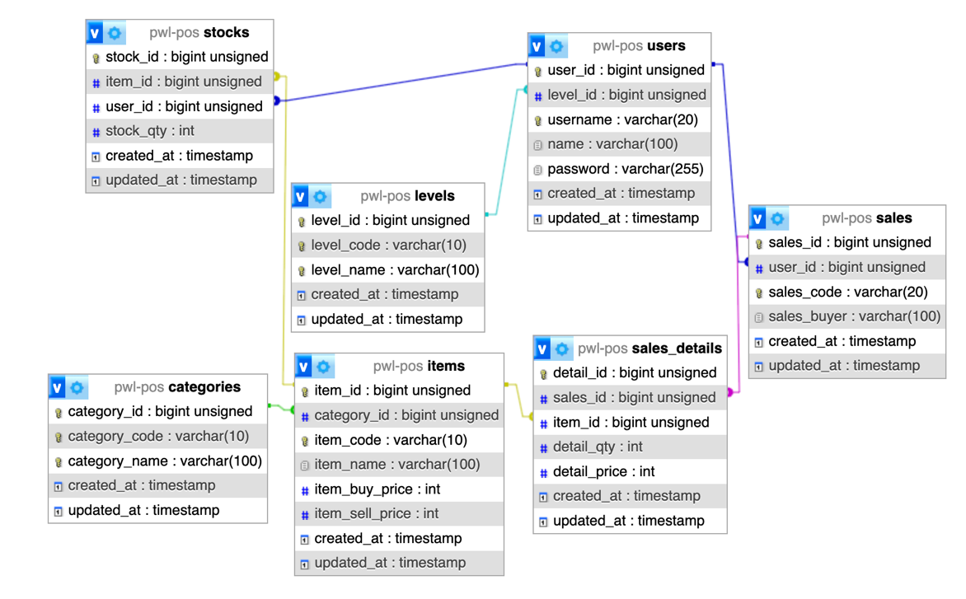

PRACTICUM 3 (SEEDER)
- Creating Level & User Seeder
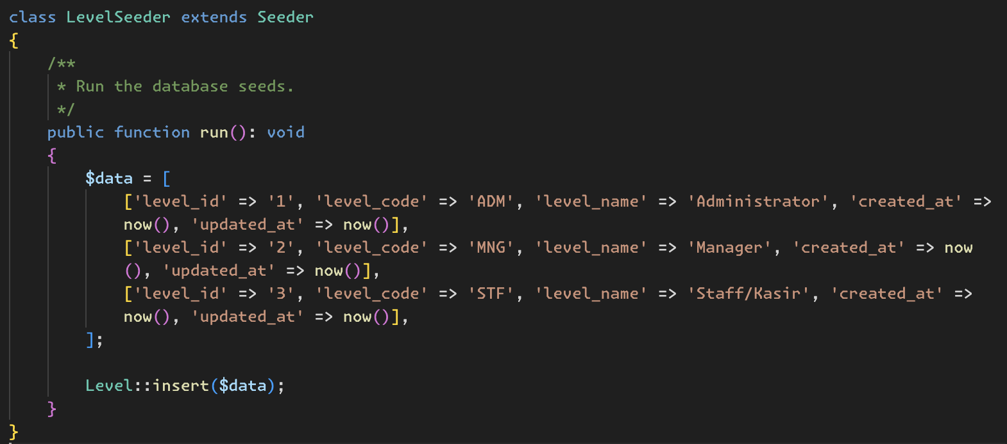
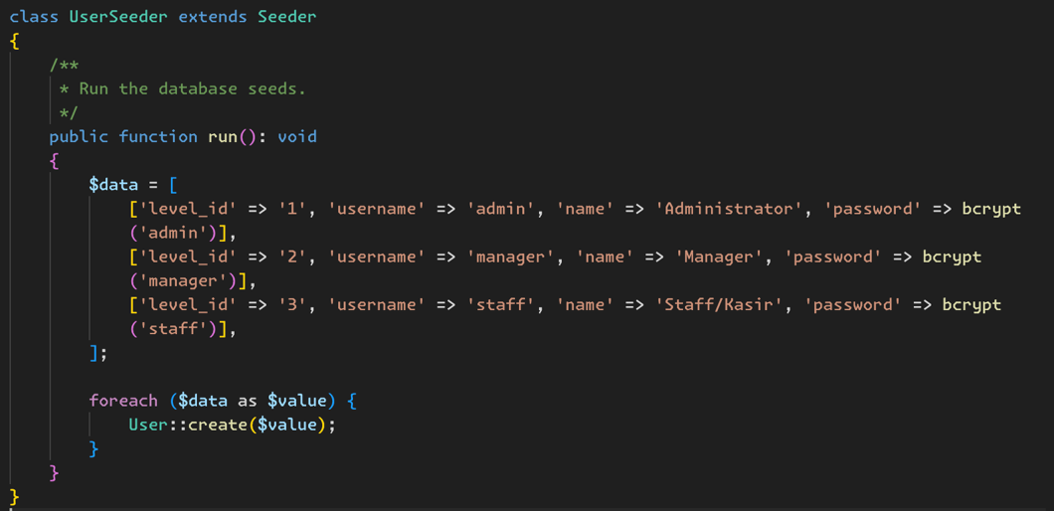
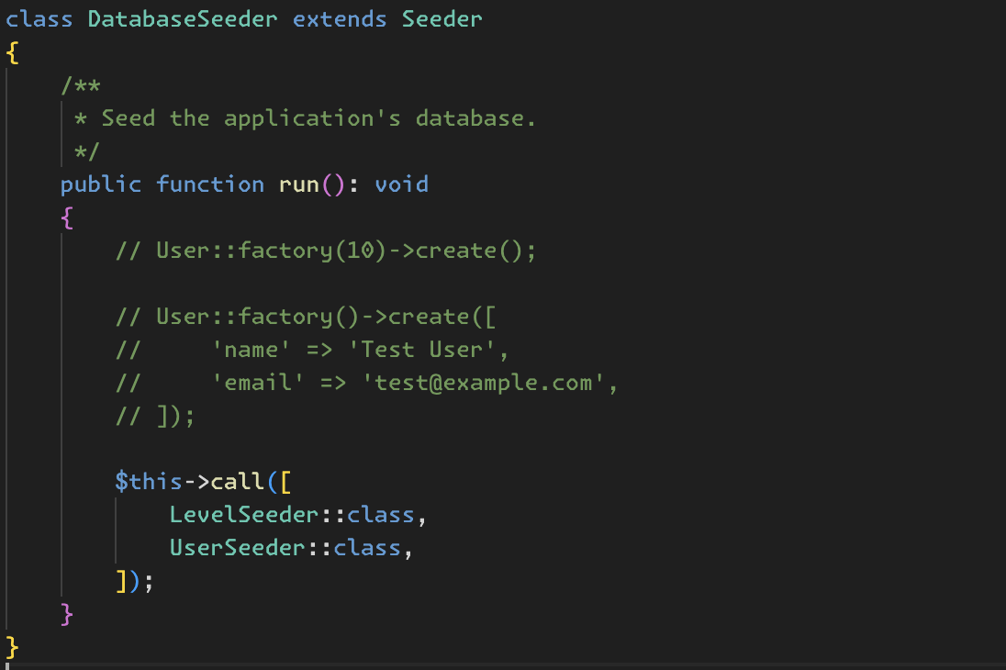

- Run Migration
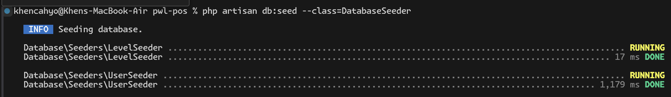
- Creating Additional Migrations (Category, Items, Stock, Sales, Sales Details)
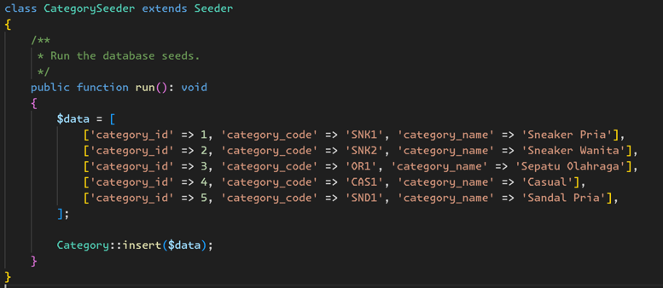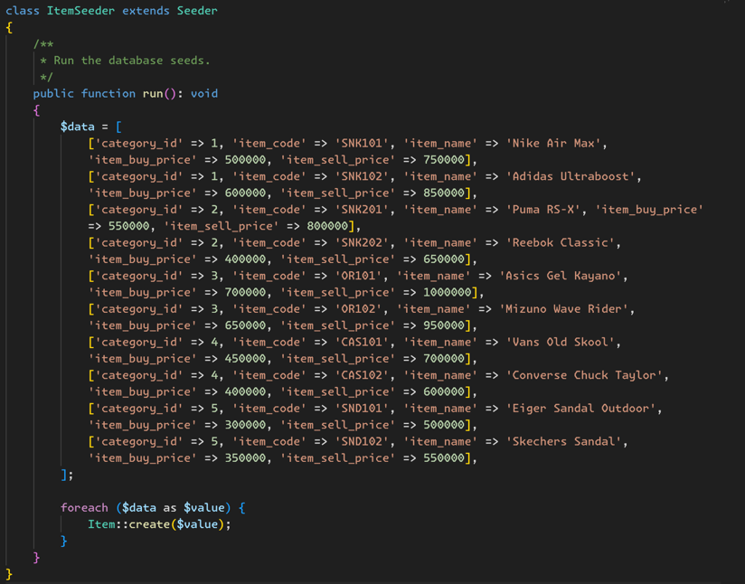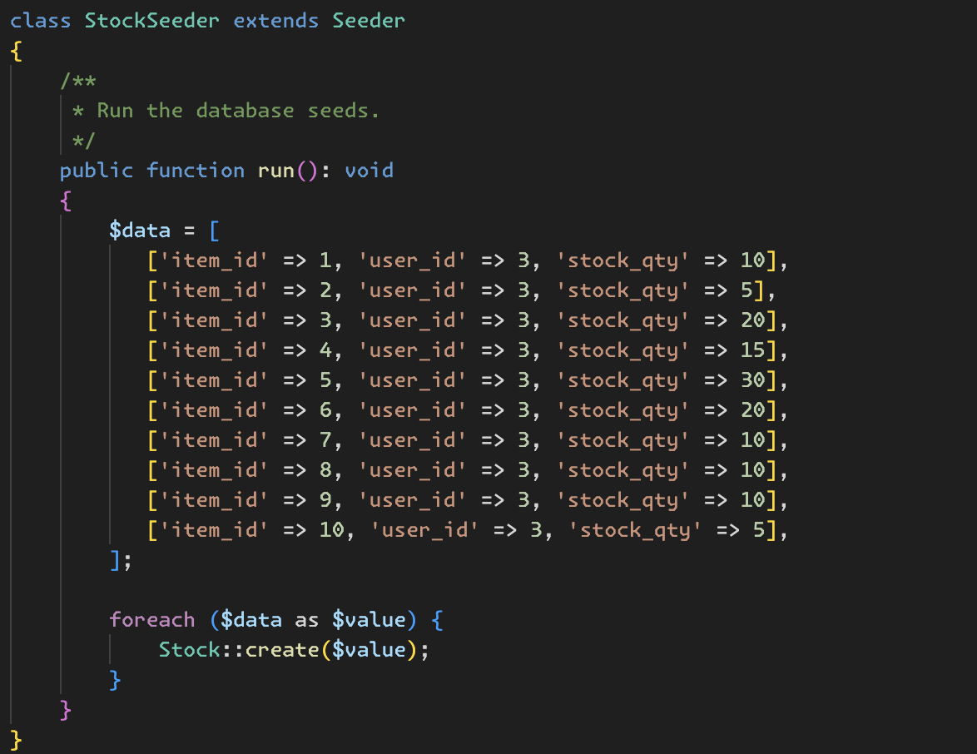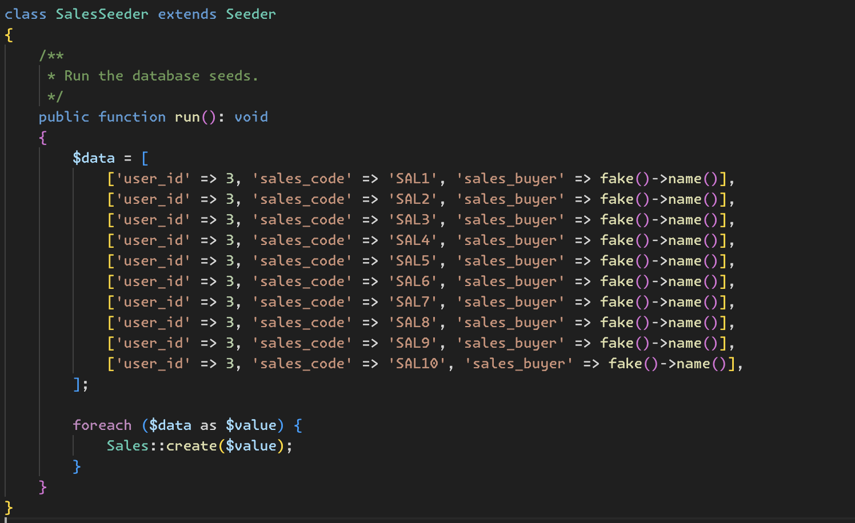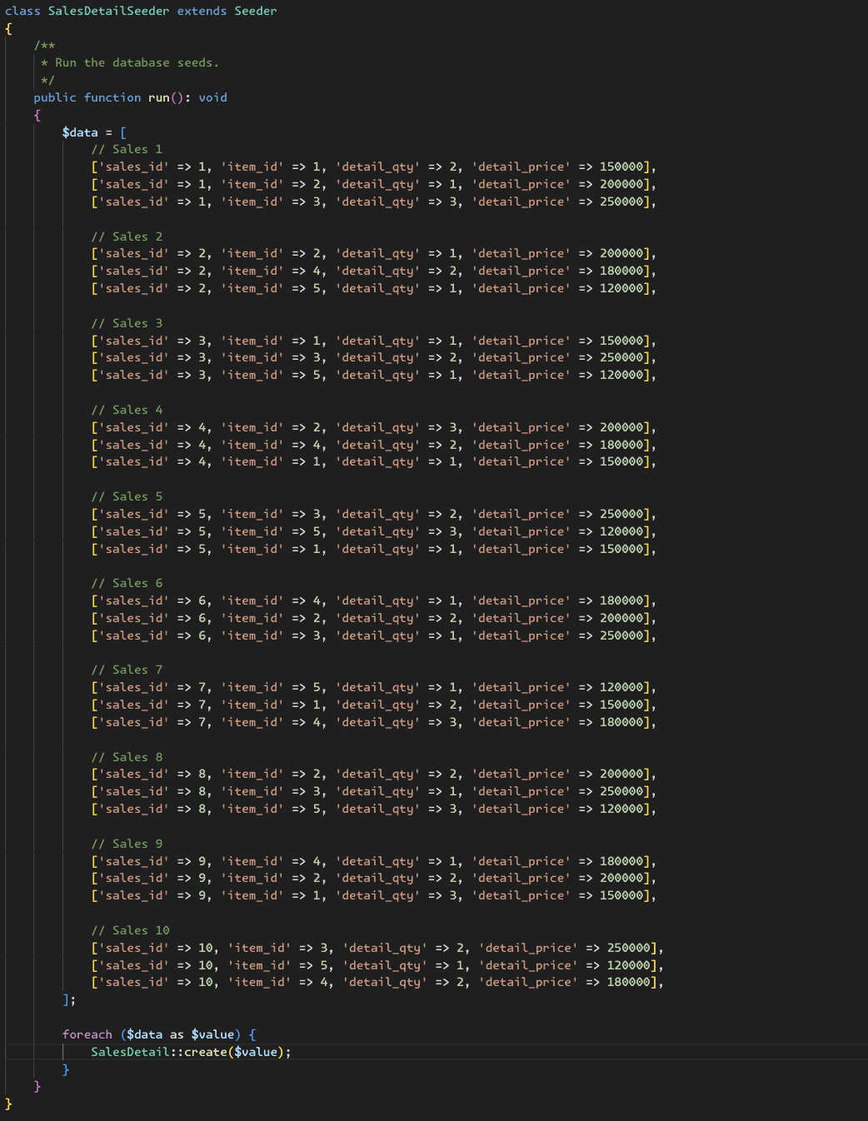
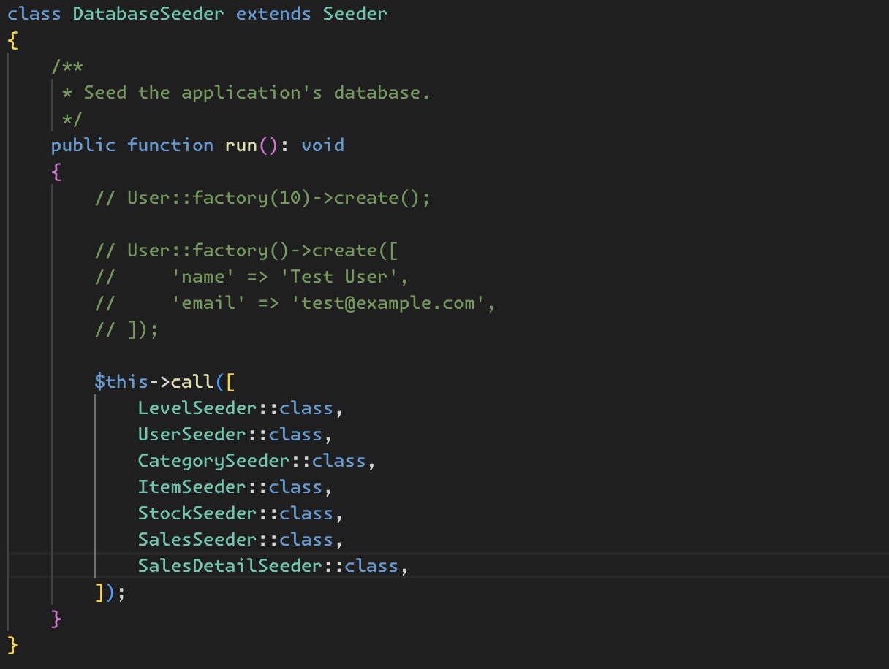
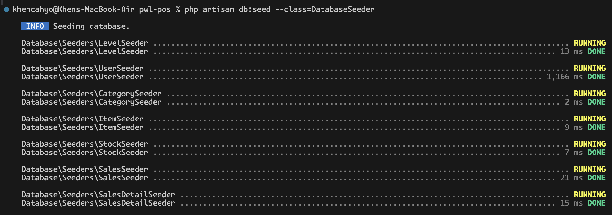

PRACTICUM 4 (DB FACADE)
- Creating Routes
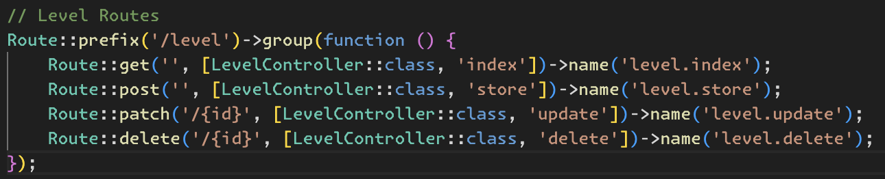
- Creating Controller
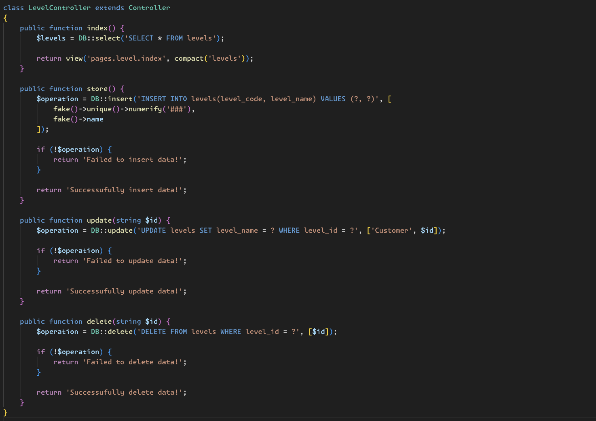

- Creating View
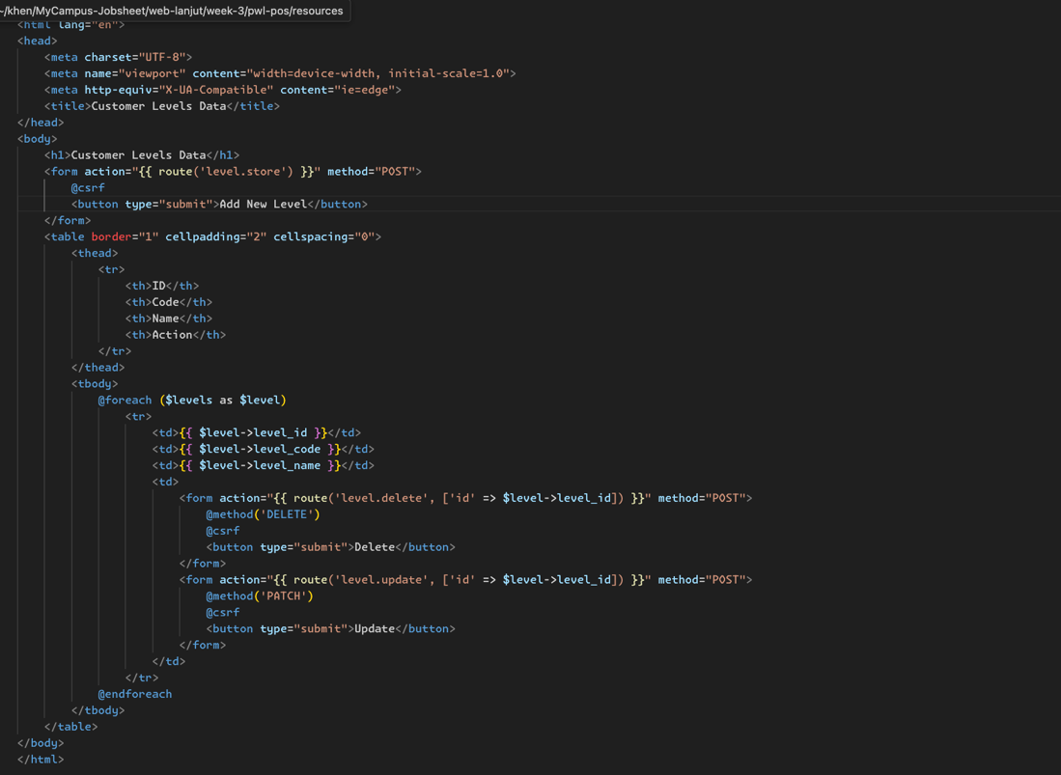
- Results
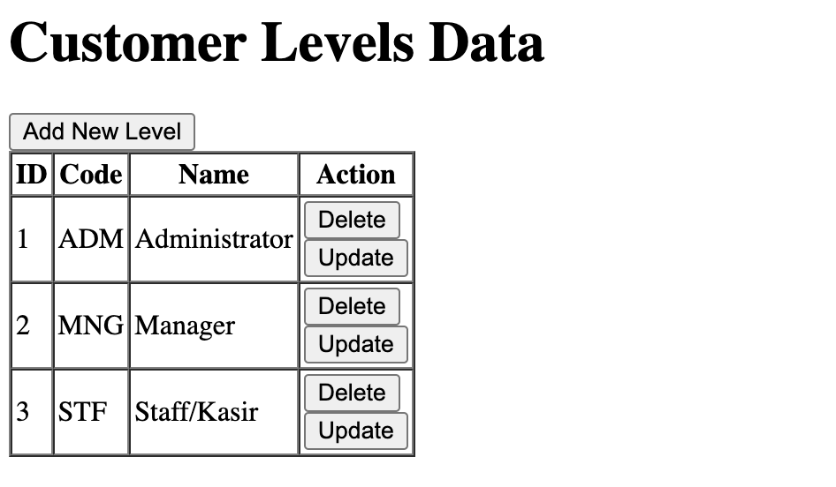

PRACTICUM 5 (QUERY BUILDER)
- Creating Routes
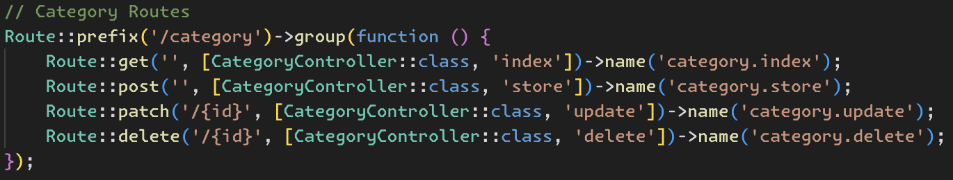
- Creating Controller
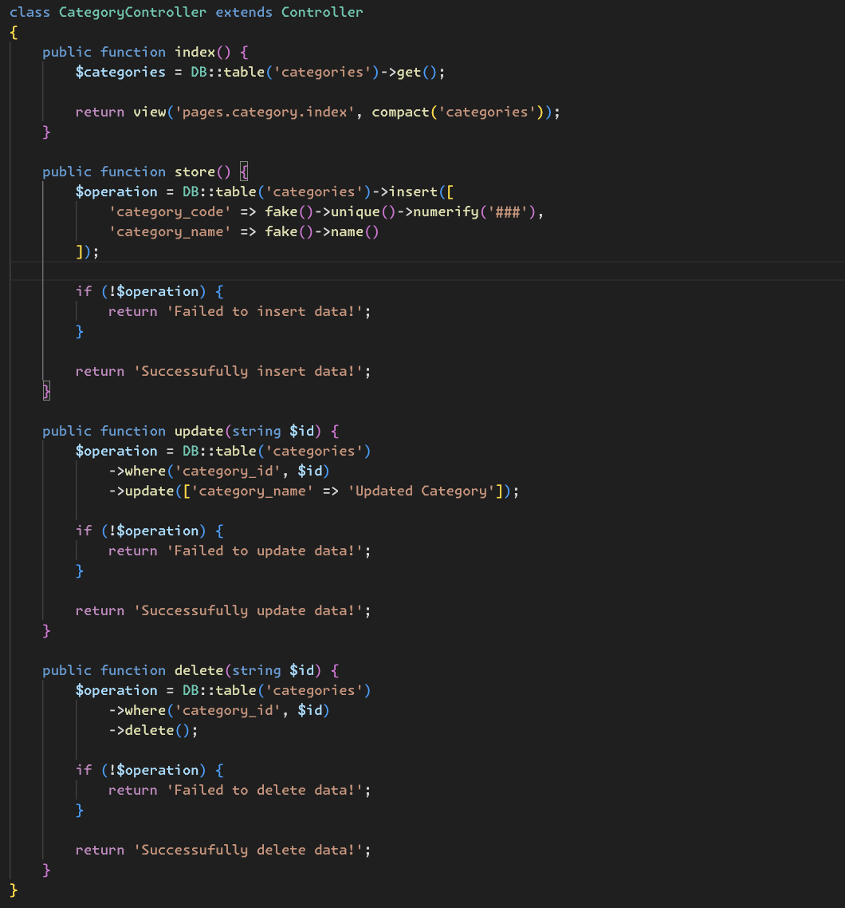
- Creating View
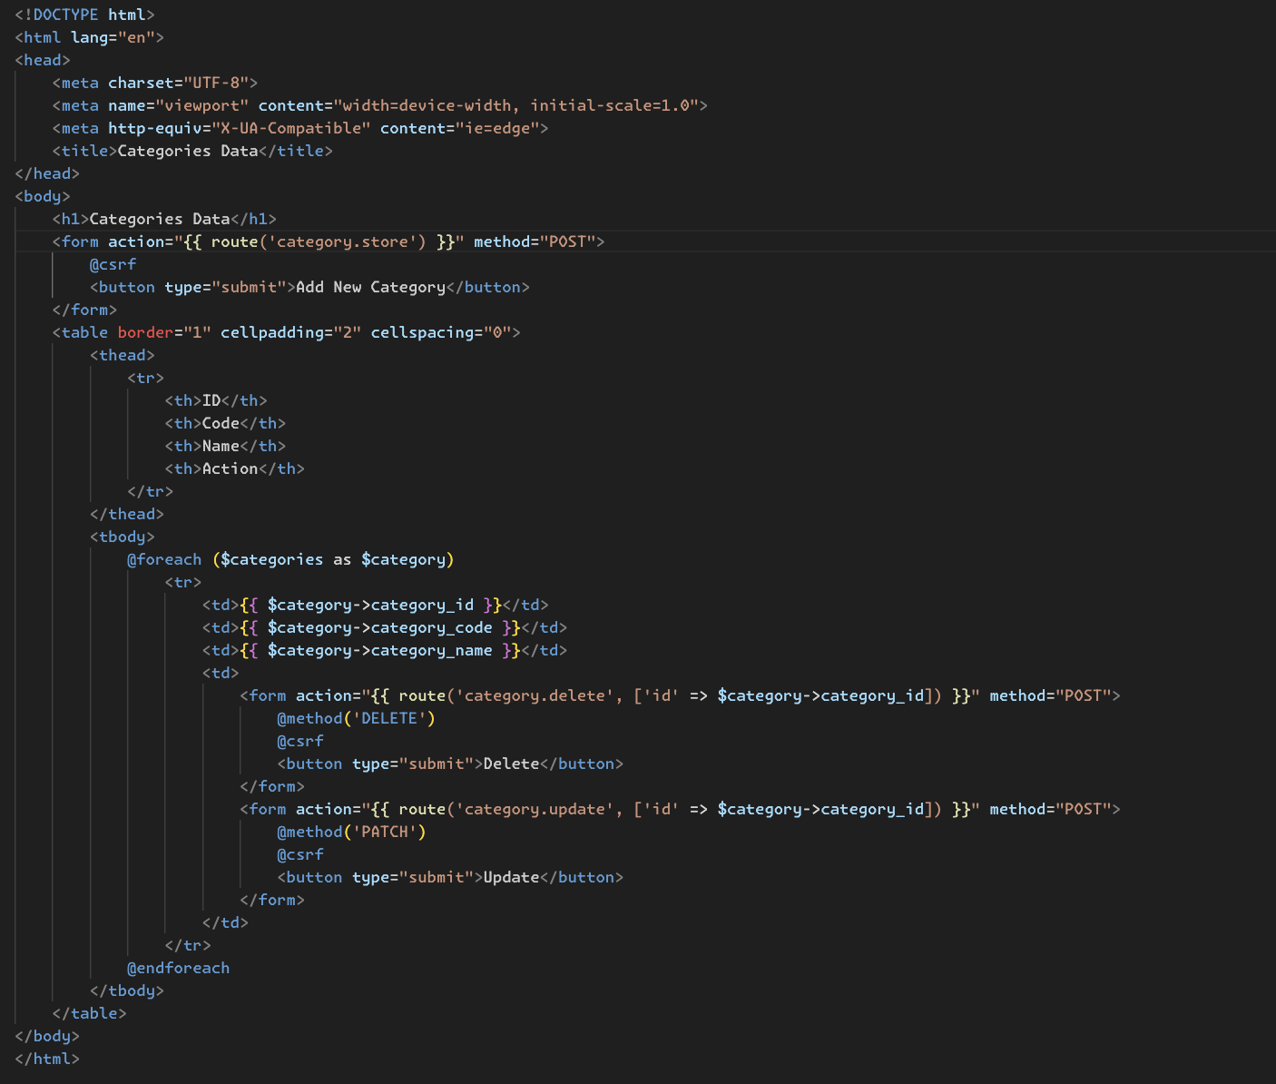
- Results
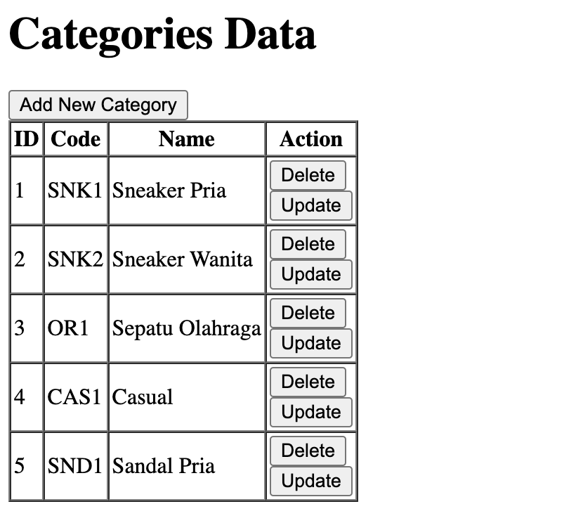

PRACTICUM 6 (ELOQUENT ORM)
- Creating Routes
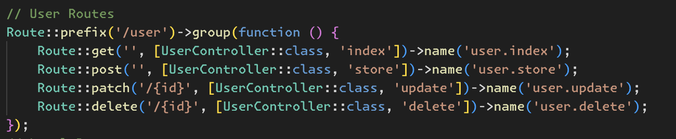
- Creating Controller
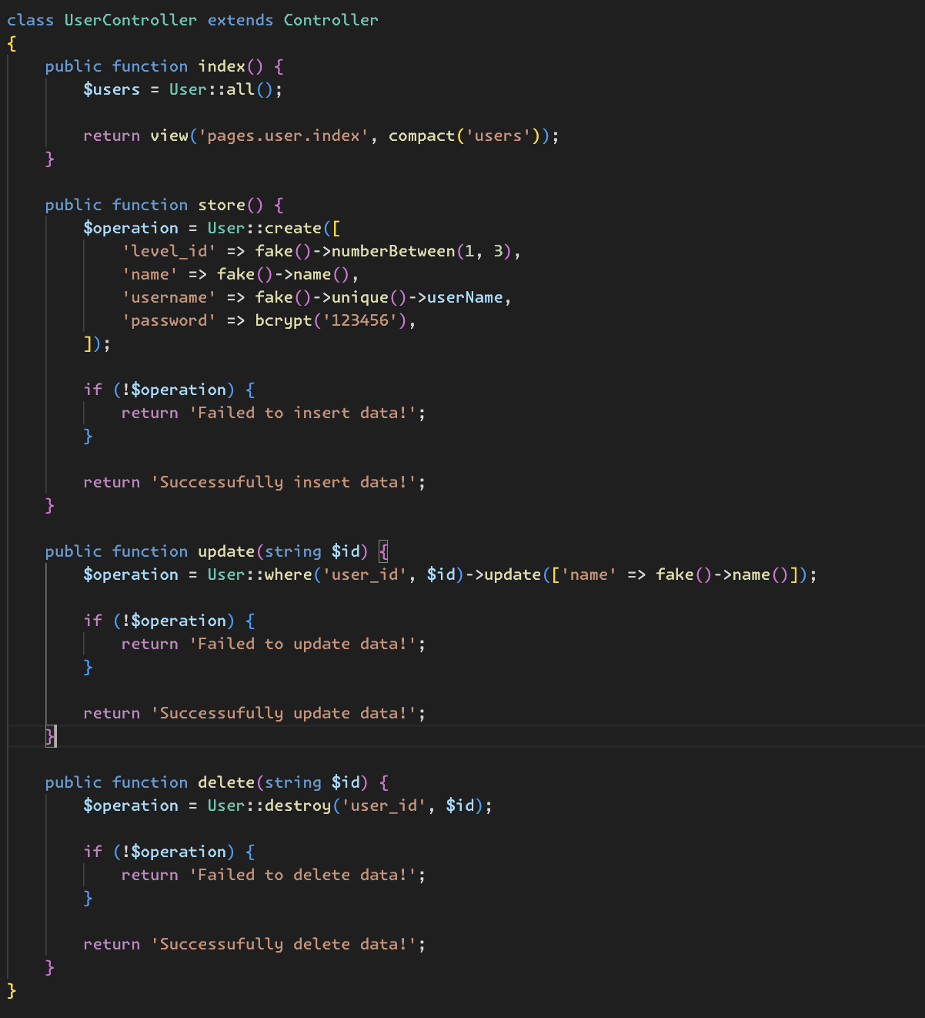
- Creating View
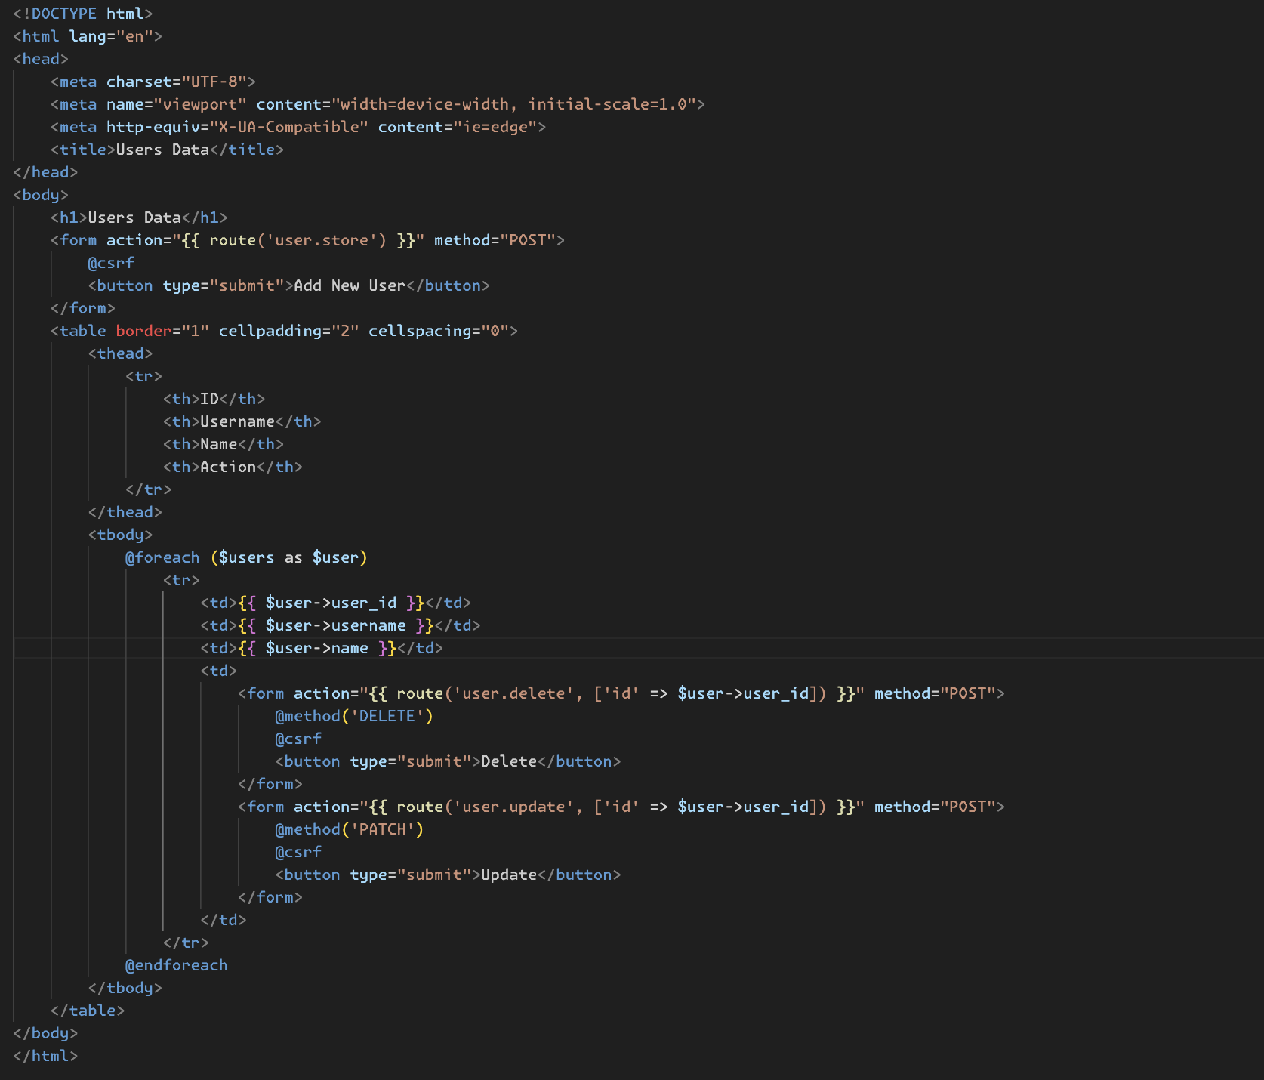
- Results
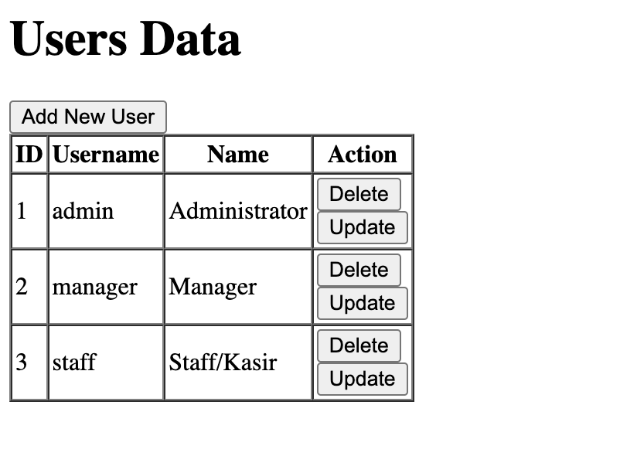

QUESTION ANSWERS
- Usually this key used as auth key in Laravel for encrypting and decrypting data, hashing password, etc that has a relationship with sensitive data.
- Usually, app key generated automatically by Laravel when we install the project, but if we work with a team and we sharing the project, we must generate this key manually, and we can generate this key using artisan command php artisan key:generate.
- By default, Laravel give us 3 migration file which is core migration for our Laravel project. Here is explanation for each migration file:
- users: In this migration file, there are 3 table schemas. First one for table users that use for accommodate user account data and has a column for validate the account. Second one is password_reset_tokens for accommodate a reset token password that requested by user, and the last is sessions that used for accommodate user session in our web which created with Laravel.
- cache: In this migration file, there are 2 table schemas. First one is cache, usually this table used for accommodate cached data in our Laravel app and this table only used if we set the cache driver in our Laravel app to DB or Database. Second one is cache_locks, same like cache but in this table the cached data has an owner. Usually we use this table if we want to caching data personally to user.
- jobs: In this migration file, the are 3 table schemas. First one is jobs, this table used for accommodate queue data in our Laravel app, if we used Queue or Job feature in Laravel. Second one is job_batches to accommodate jobs ordering in our Laravel app. Last is failed_jobs that accommodates which jobs are failed in our Laravel app.
- This builder will be make a timestamps column in our table as created_at and updated_at. Usually, this column used for tracking wheter user updating and creating the data.
- Unsigned Big Integer and automatically the column that used this builder will be a primary key column in our table. Laravel provide us convenience for declare the primary key column in our table using it.
- The different only in column name, if we only used id() by default Laravel will give default name in the column as id, but we can create custom column name for it using id(‘level_id’) and then Laravel will give name in our primary column as level_id.
- For ensure that the column has unique value. For example, when we create an account in other app, definitely we must insert a username right? For ensure that every username in users table are unique, we can use this builder unique().
- Because in users table, this table has reference to level table, and if we want to referencing the table as column, we must create a column with same data type in the referenced table, and in this case when we use id() builder as primary key column in our table, the data type for this column is Unsigned Big Integer. So, if we want to have references to the table that have primary key with id() builder, we must use UnsignedBigInteger in our referenced column.
- Hash is a factory class that provided by Laravel that we can use for hashing our sensitive data, and in this case Hash is used for hashing user password data, and Hash::make(‘1234’) syntax showed that we hash a 1234 password for user.
- I think, the syntax like in PDO, when we used raw query, we must prepare the value that used for insert, update, or delete data in our table using ?, and usually we used this syntax for avoiding SQL Injection in our app.
- protected $table is used for define which tables can use by Model, and protected $primaryKey is used for define which primary key column in table that used by Model, by default the value of this property is ‘id’, so if we don’t change the default primary key column name by Laravel, we don’t need it.
- For me, I like used ORM, because they provide me a convenience. Maybe in the case when we want to join other tables, we can just define the relationship in each table and the we only used with() to get the data for relations tables. But, in other case, I think I can used Query Builder also, maybe in case nested filtering data, I used this feature.

