COMPUTER NETWORKING
TRANSPORT LAYER PROTOCOL



KHEN MUHAMMAD CAHYO
244107023002
TI-2I
STATE POLYTECHNIC OF MALANG
INFORMATION TECHNOLOGY DEPARTMENT

- Netstat on Linux OS
- Install net-tools
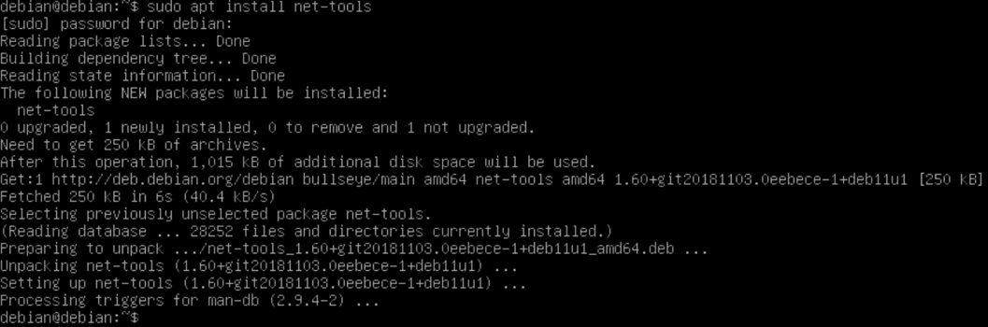
- Display Open and Listening Port
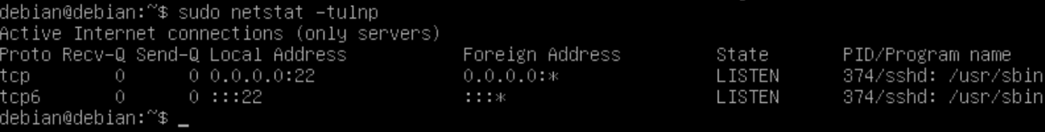
- Display All Active Connections & Ports
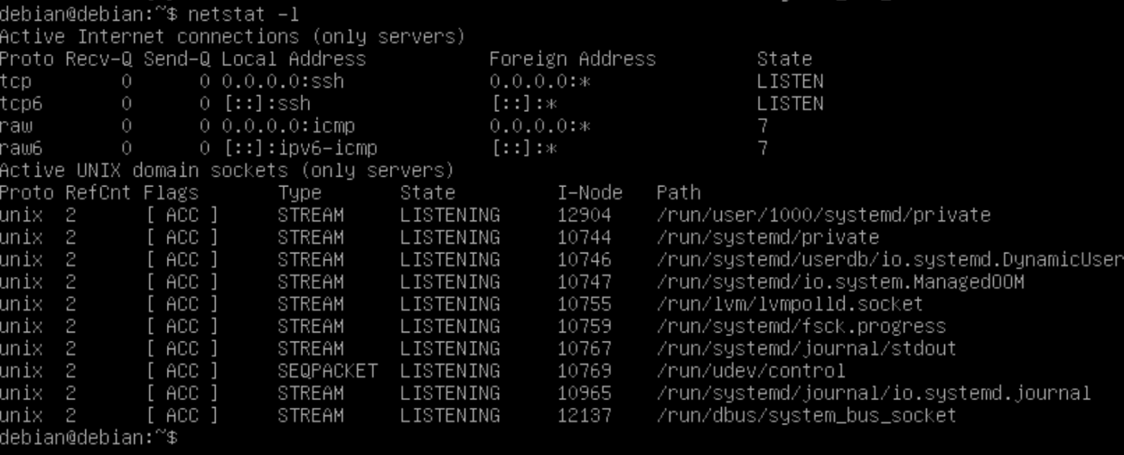

- Display Active Ports
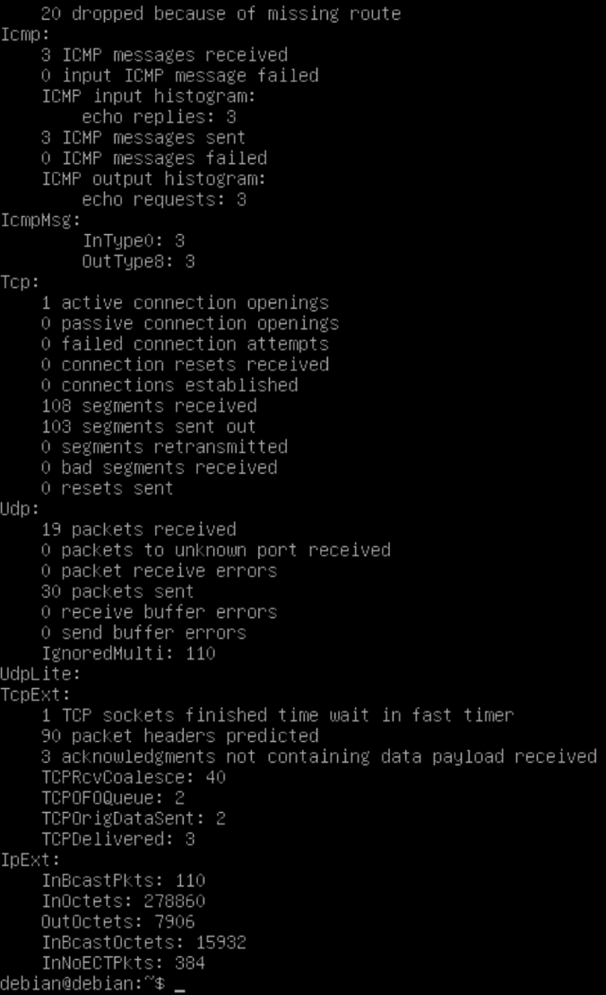
- Display IP Address and Port Number
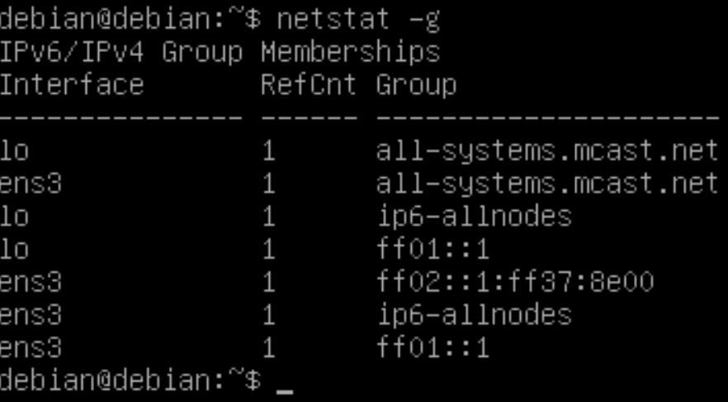

- Netstat on Windows OS
- Check Netstat
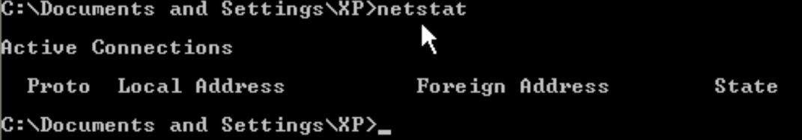
- Show All Active Connections and Ports
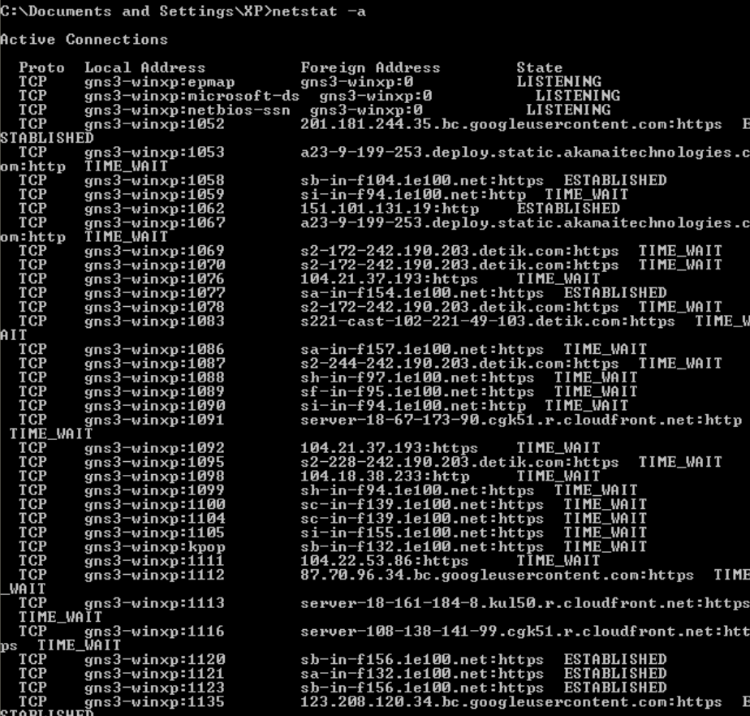
- Display Network Interface Statistic
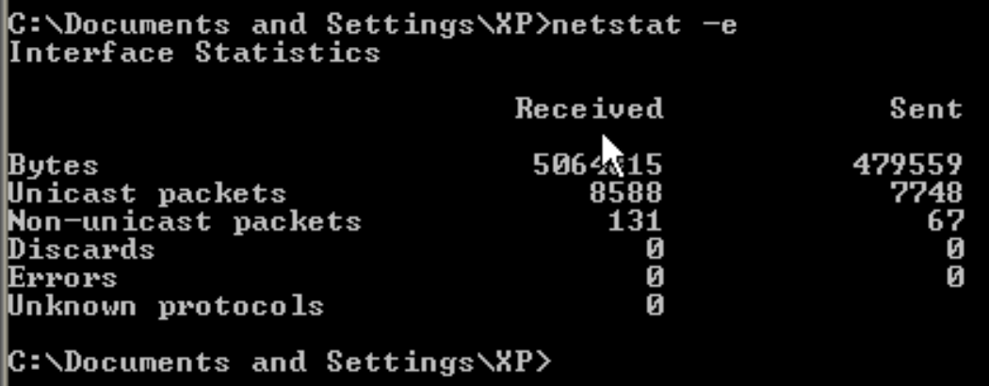

- Show Network Details Statistic
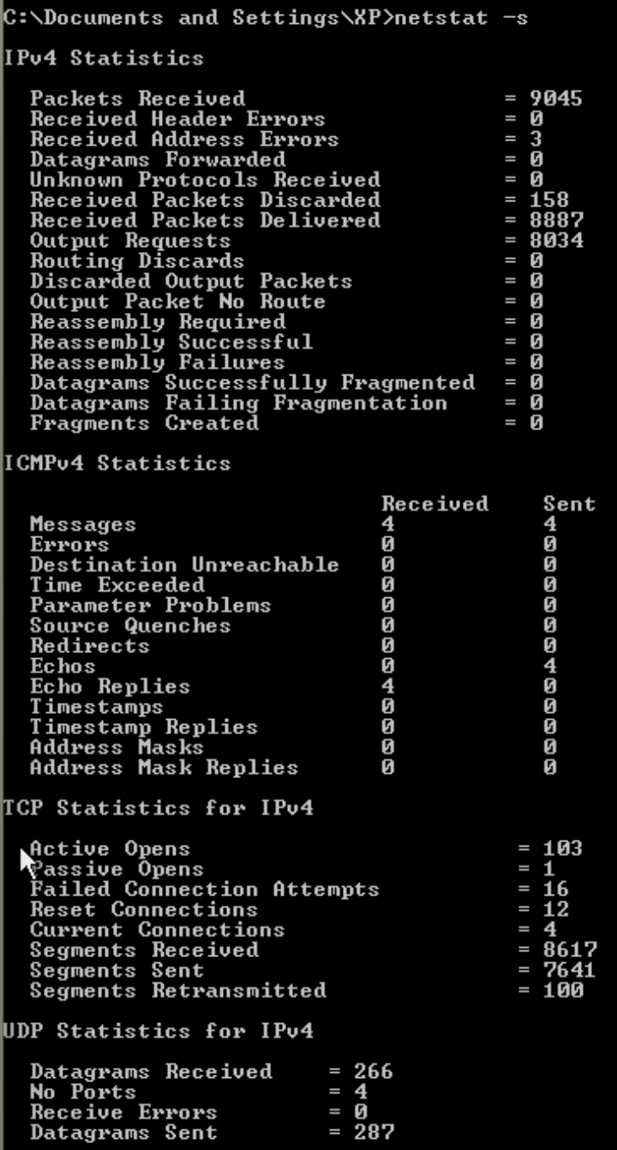

- NMAP
- Install NMAP
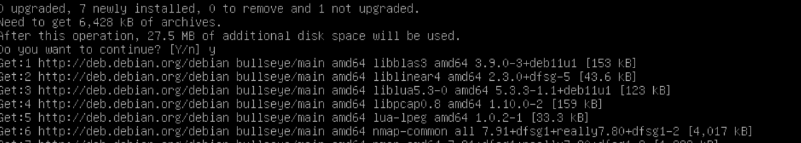
- Run NMAP
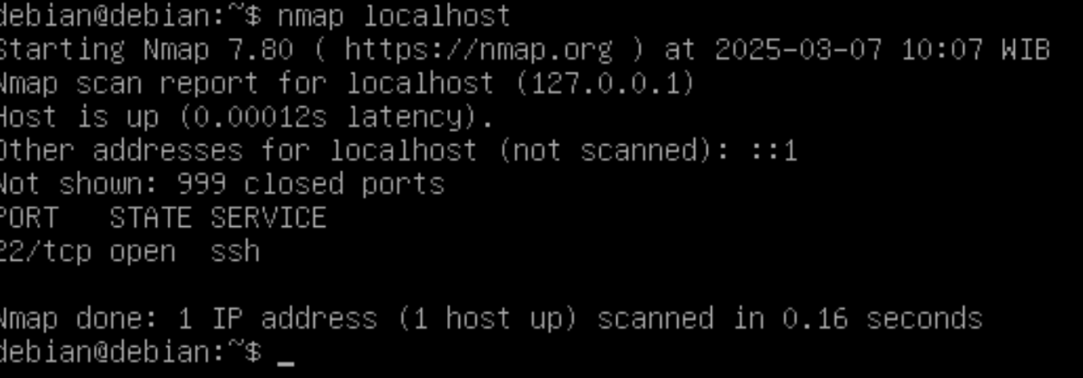
- Check Open Ports in repolinux.jti
