Software Requirements Specification

for

STUDENT UKM SELECTION DETERMINATION SYSTEM
Version 1.1
Prepared by
KHEN MUHAMMAD CAHYO

March, 14 2025

Table of Contents
1. Pendahuluan 1
1.1 Tujuan Penulisan Dokumen 1
1.2 Audien yang Dituju dan Pembaca yang Disarankan 1
1.3 Batasan Produk 1
1.4 Definisi dan Istilah 1
1.5 Refrensi 1
2. Deskripsi Keseluruhan 2
2.1 Deskripsi Produk 2
2.2 Fungsi Produk 2
2.3 Penggolongan Karakterik Pengguna 2
2.4 Lingkungan Operasi 2
2.5 Batasan Desain dan Implementasi 2
2.6 Dokumentasi Pengguna 3
3. Kebutuhan Antarmuka Eksternal 4
3.1 User Interfaces 4
3.2 Hardware Interface 4
3.3 Software Interface 4
3.4 Communication Interface 4
4. Functional Requirement 5
4.1 Use Case Diagram 6
4.2 Nama Use Case 1 Error! Bookmark not defined.
4.3 Nama Use Case 2 Error! Bookmark not defined.
4.4 Class Diagram 9
5. Non Functional Requirements 2

Revision History
Name | Date | Reason For Changes | Version
Khen Muhammad Cahyo | March, 20 2025 | - Add master data management Use Case Description  - | 1.1

Pendahuluan

Tujuan Penulisan Dokumen
<Tulis tujuan penulisan dokumen disini.>

Audien yang Dituju dan Pembaca yang Disarankan
<Jelaskan berbagai jenis pembaca bahwa dokumen ini ditujukan untuk, seperti pengembang, manajer proyek, staf pemasaran, pengguna, penguji, dan lainnya>

Batasan Produk
<Berikan penjelasan singkat dari perangkat lunak yang ditentukan dan tujuannya, termasuk manfaat yang relevan, tujuan, dan sasaran. Hubungkan perangkat lunak untuk tujuan perusahaan atau strategi bisnis>

Definisi dan Istilah
<tulis istilah dan definisikan jika ada>

- SRS : Software Requirements Specification, atau
Spesifikasi Kebutuhan Perangkat Lunak (SKPL)

- IEEE : Institute of Electrical and Electronics Engineering
Standar internasional untuk pengembangan dan perancangan produk.

Refrensi
<Tulis daftar dokumen lain atau alamat web yang menjadi acuan SRS ini.>

Deskripsi Keseluruhan

Deskripsi Produk
<Deskripsikan produk/sistem yang akan dibuat disini.>

Fungsi Produk
<Berisi hanya rangkuman fungsi utama produk, produk harus melakukan apa atau memungkinkan pengguna melakukan apa. Hanya ringkasan tingkat tinggi (seperti bullet list) yang dibutuhkan di sini.>

Penggolongan Karakterik Pengguna
<Identifikasi berbagai golongan pengguna yang terkait dengan produk yang dikembangkan>

Tabel 1 Karakteristik Pengguna
Kategori Pengguna | Tugas | Hak Akses ke aplikasi | Kemampuan yang harus dimiliki
Kasir (example) | Mencatat transaksi penjualan harian | Insert Data | Entry Data Transaksi Penjualan
Supervisior (Example) | Memanipulasi Data jika ada kesalahan entry dari kasir | Insert, Update, Delete Data | Manupulasi Data Transaksi Penjualan

Lingkungan Operasi
<Jelaskan lingkungan di mana perangkat lunak akan beroperasi, termasuk platform, perangkat keras, sistem operasi dan versi, dan komponen perangkat lunak lain atau aplikasi yang berdampingan>

Batasan Desain dan Implementasi
<Jelaskan setiap item atau masalah yang akan membatasi pilihan yang tersedia untuk para pengembang / developer. Ini mungkin termasuk: kebijakan perusahaan atau peraturan; keterbatasan hardware (persyaratan memori); teknologi tertentu, alat, dan database yang akan digunakan; persyaratan bahasa; protokol komunikasi; pertimbangan keamanan; atau standar pemrograman>

Dokumentasi Pengguna
<Daftar komponen dokumentasi pengguna (seperti user manual, on-line help, dan tutorial) yang akan disampaikan bersama dengan perangkat lunak yang akan dikirim>

Kebutuhan Antarmuka Eksternal

User Interfaces
<Describe the logical characteristics of each interface between the software product and the users. This may include sample screen images, any GUI standards or product family style guides that are to be followed, screen layout constraints, standard buttons and functions (e.g., help) that will appear on every screen, keyboard shortcuts, error message display standards, and so on. Define the software components for which a user interface is needed. Details of the user interface design should be documented in a separate user interface specification.>

Hardware Interface
<Describe the logical and physical characteristics of each interface between the software product and the hardware components of the system. This may include the supported device types, the nature of the data and control interactions between the software and the hardware, and communication protocols to be used.>

Software Interface
<Describe the connections between this product and other specific software components (name and version), including databases, operating systems, tools, libraries, and integrated commercial components. Identify the data items or messages coming into the system and going out and describe the purpose of each. Describe the services needed and the nature of communications. Refer to documents that describe detailed application programming interface protocols. Identify data that will be shared across software components. If the data sharing mechanism must be implemented in a specific way (for example, use of a global data area in a multitasking operating system), specify this as an implementation constraint.>

Communication Interface
<Describe the requirements associated with any communications functions required by this product, including e-mail, web browser, network server communications protocols, electronic forms, and so on. Define any pertinent message formatting. Identify any communication standards that will be used, such as FTP or HTTP. Specify any communication security or encryption issues, data transfer rates, and synchronization mechanisms.>

Functional Requirement
<Area ini menggambarkan pengorganisasian persyaratan fungsional untuk produk dengan fitur sistem, layanan utama yang disediakan oleh produk>

<Tulis Kebutuhan Fungsional / Functional Requirement disini>
Diawali dengan membuat daftar kebutuhan fungsional P/L, lengkap dengan ID dan penjelasan jika perlu. Bisa dibuat dalam bentuk tabel.

ID | Kebutuhan Fungsional | Penjelasan

Use Case Diagram

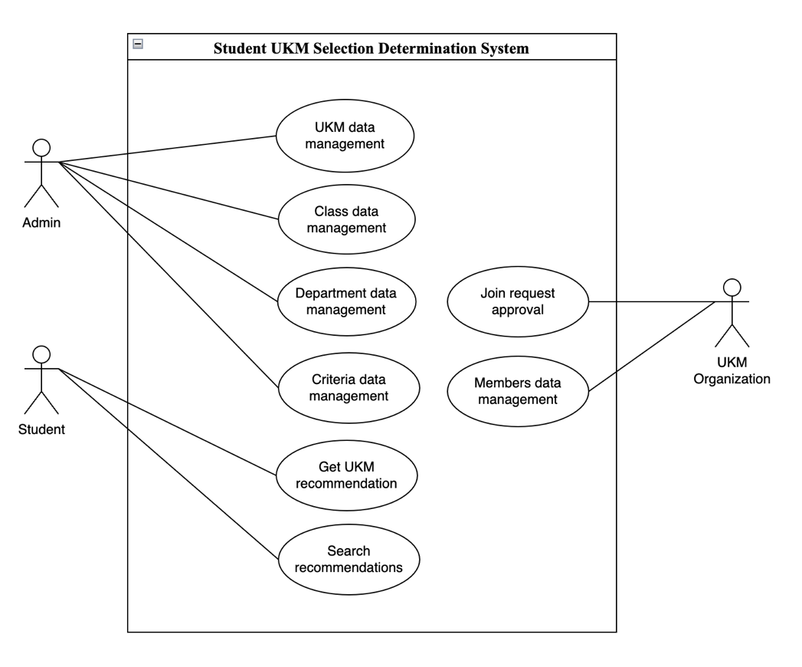

Get UKM Recommendation
4.1.1 Deskripsi Use Case
Use Case Name: Get UKM Recommendation | ID: UCD-001 | Importance Level: High
Primary Actor: Student | Use Case Type: Detail, Overview
Stakeholder and Interest:
Student – Want to get UKM recommendation for their personals.
Brief Description:
This use case described how students can get UKM recommendation on this app.
Trigger: Student click Get Recommendation button on get recommendation page after filled form inputs.
Type: Temporal Trigger
Relationship:
Normal Flow Event:
- Student open the app on browser.
- Student fill form inputs (name, email, nim, class, department, and their criterias) and submit the data.
- System will calculates the criterias from student.
- After that, system will give student an recommendations based on the calculating results.
- Student can select one or more UKM from recommendations results and register on UKM that they selected.
Sub Flows:
- System admin created master data for get UKM recommendations needs (classes, departments, ukm, and criterias).
- System admin ensure that this data can accessed by students in get UKM recommendations feature.
Alternate/Exceptional Flow:
If student don’t get an recommendations from system, they can submit request again with different criterias.

4.1.2 Stimulus and Respon
4.1.4 Activity Diagram

Search Recommendations
4.1.1 Deskripsi Use Case
Use Case Name: Search Recommendation | ID: UCD-002 | Importance Level: High
Primary Actor: Student | Use Case Type: Detail, Essential
Stakeholder and Interest:
Student – Search recommendations and join requests status for their personals.
Brief Description:
This use case described how student can check their recommendations and UKM join requests approval status.
Trigger: Search input on recommendations table.
Type: Temporal Trigger
Relationship:
Normal Flow Event:
- Student open the app on browser.
- On landing page, students will see table recommendations results from all students that has request on this app.
- In search input, students can search their recommendations data based on their name.
- After that, student can see their recommendations and their UKM join requests approval status.
Sub Flows:
Alternate/Exceptional Flow:

Join Request Approval
4.1.1 Deskripsi Use Case
Use Case Name: Join Request Approval | ID: UCD-003 | Importance Level: High
Primary Actor: UKM Organization | Use Case Type: Detail, Real
Stakeholder and Interest:
UKM Organization – Approve UKM join requests from students.
Brief Description:
This use case described how student can check their recommendations and UKM join requests approval status.
Trigger: Approve or Reject button.
Type: Temporal Trigger
Relationship:
Normal Flow Event:
- UKM Organization open members candidate page that showing all of members candidate data in table.
- UKM Organization choose one of the members candidate.
- UKM Organization click on Actions button and it will show 2 options (Approve and Reject).
- UKM Organization give an approval answer for candidates based on 2 options before.
Sub Flows:
- System admin registered one account for one organization
- System admin give the registered account to UKM Organization leader
- UKM Organization login on the app for give approval to members candidate with input username and password.
- After UKM Organization give approval results, Students who are given approval status will receive notification on their email.
Alternate/Exceptional Flow:
- If UKM Organization leader forget they password, they can request reset password by email.

UKM Data Management
    - Deskripsi Use Case
Use Case Name: UKM Data Management | ID: UCD-004 | Importance Level: High
Primary Actor: Admin | Use Case Type: Detail
Stakeholder and Interest:
Admin – Manage UKM data for base data in get UKM recommendation feature
Brief Description:
This use case described how admin can manage UKM master data for base data in get UKM recommendation feature
Trigger: Navigation Link or Action Button
Type: Temporal Trigger
Relationship:
- UKM – Student (Leader): Association (1-to-1)
Normal Flow Event:
- Admin must login first to manage this data.
- Visit UKM menu
Sub Flows:
- Delete Data
- Choose one of data that want to delete
- Click Delete button on the data
- Confirm Admin want to delete the data
- Update Data
- Choose one of data that want to update
- Fill the form to update data
- Click Save button to save updated data
- Confirm Admin want update the data
- Create Data
- Click Create UKM
- Fill the form to create data
- Click Save button to save created data
Alternate/Exceptional Flow:

Class Data Management
4.1.1 Deskripsi Use Case
Use Case Name: Class Data Management | ID: UCD-005 | Importance Level: High
Primary Actor: Admin | Use Case Type: Detail
Stakeholder and Interest:
Admin – Manage Class data for base data in get UKM recommendation feature
Brief Description:
This use case described how admin can manage Class master data for base data in get UKM recommendation feature
Trigger: Navigation Link or Action Button
Type: Temporal Trigger
Relationship:
Normal Flow Event:
- Admin must login first to manage this data.
- Visit Class menu
Sub Flows:
- Delete Data
- Choose one of data that want to delete
- Click Delete button on the data
- Confirm Admin want to delete the data
- Update Data
- Choose one of data that want to update
- Fill the form to update data
- Click Save button to save updated data
- Confirm Admin want update the data
- Create Data
- Click Create Class
- Fill the form to create data
- Click Save button to save created data
Alternate/Exceptional Flow:

Department Data Management
4.1.1 Deskripsi Use Case
Use Case Name: Department Data Management | ID: UCD-006 | Importance Level: High
Primary Actor: Admin | Use Case Type: Detail
Stakeholder and Interest:
Admin – Manage Department data for base data in get UKM recommendation feature
Brief Description:
This use case described how admin can manage Department master data for base data in get UKM recommendation feature
Trigger: Navigation Link or Action Button
Type: Temporal Trigger
Relationship:
- Department – Class: Composition (1-to-Many)
Normal Flow Event:
- Admin must login first to manage this data.
- Visit Department menu
Sub Flows:
- Delete Data
- Choose one of data that want to delete
- Click Delete button on the data
- Confirm Admin want to delete the data
- Update Data
- Choose one of data that want to update
- Fill the form to update data
- Click Save button to save updated data
- Confirm Admin want update the data
- Create Data
- Click Create Department
- Fill the form to create data
- Click Save button to save created data
Alternate/Exceptional Flow:

Criteria Data Management
4.1.1 Deskripsi Use Case
Use Case Name: Criteria Data Management | ID: UCD-007 | Importance Level: High
Primary Actor: Admin | Use Case Type: Detail
Stakeholder and Interest:
Admin – Manage Criteria data for base data in get UKM recommendation feature
Brief Description:
This use case described how admin can manage Criteria master data for base data in get UKM recommendation feature
Trigger: Navigation Link or Action Button
Type: Temporal Trigger
Relationship:
Normal Flow Event:
- Admin must login first to manage this data.
- Visit Criteria menu
Sub Flows:
- Delete Data
- Choose one of data that want to delete
- Click Delete button on the data
- Confirm Admin want to delete the data
- Update Data
- Choose one of data that want to update
- Fill the form to update data
- Click Save button to save updated data
- Confirm Admin want update the data
- Create Data
- Click Create Criteria
- Fill the form to create data
- Click Save button to save created data
Alternate/Exceptional Flow:

Members Data Management
4.1.1 Deskripsi Use Case
Use Case Name: Members Data Data Management | ID: UCD-008 | Importance Level: High
Primary Actor: UKM Organization | Use Case Type: Detail
Stakeholder and Interest:
UKM Organization – Manage members data on their UKM
Brief Description:
This use case described how UKM Organization can manage their UKM members.
Trigger: Navigation Link or Action Button
Type: Temporal Trigger
Relationship:
Normal Flow Event:
- UKM Organization must login first to manage this data.
- Visit Members menu
Sub Flows:
- Delete Data
- Choose one of data that want to delete
- Click Delete button on the data
- Confirm Admin want to delete the data
- Update Data
- Choose one of data that want to update
- Fill the form to update data
- Click Save button to save updated data
- Confirm Admin want update the data
- Create Data
- Click Create Member
- Fill the form to create data
- Click Save button to save created data
Alternate/Exceptional Flow:

Class Diagram

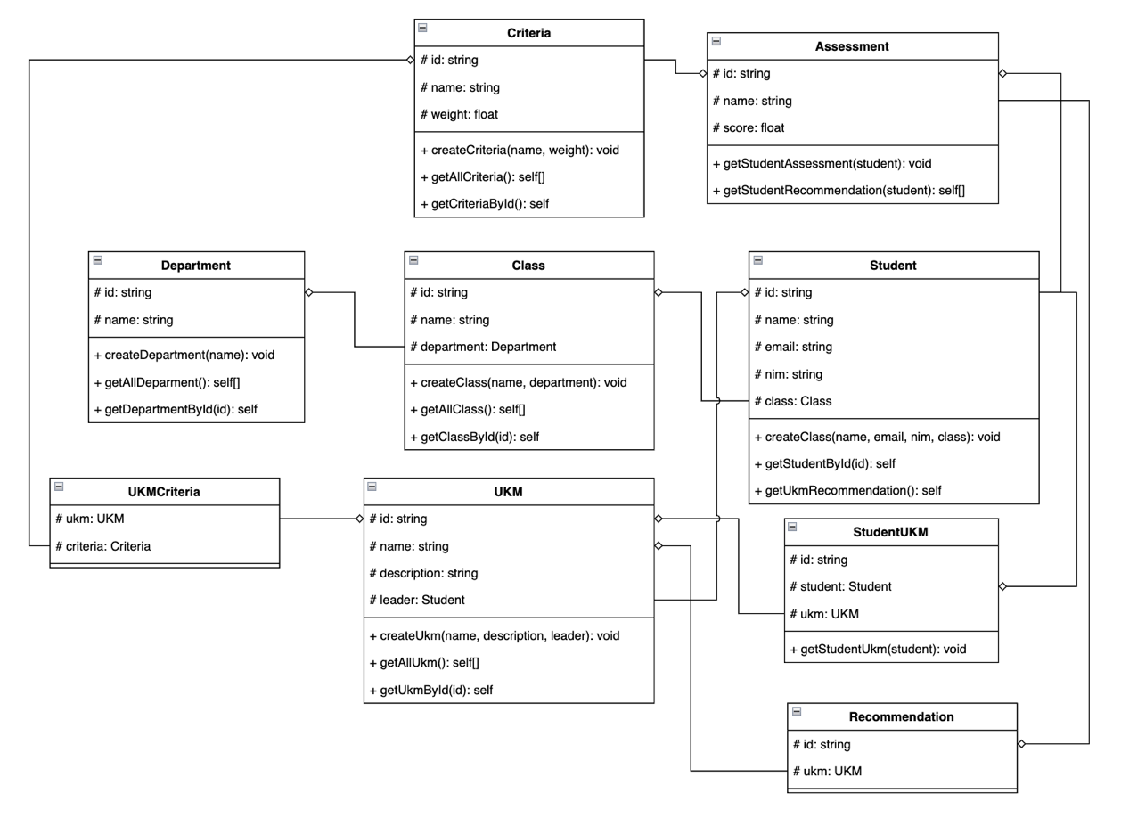
- Identify Entities
Here are each entities that will used on this case.
  - Department
  - Class
  - Student
  - UKM
  - StudentUKM
  - Criteria
  - Assessment
  - Recommendation
  - UKMCriteria

- Entity Attributes & Methods
Here are the attributes and methods that is owned by each entities:
- Department
  - #id: string
  - #name: string
  - #email: string
  - #nim: string
  - #class: Class
  - +createStudent(name, nim, class)
  - +getStudentById(id)
  - +getUkmRecommendation()
- Class
  - #id: string
  - #name: string
  - #department: Department
  - +createClass(name, department)
  - +getAllClass()
  - +getClassById(id)
- Student
  - #id: string
  - #name: string
  - #email: string
  - #nim: string
  - #class: Class
  - +createStudent(name, nim, class)
  - +getStudentById(id)
  - +getUkmRecommendation()

- UKM
  - #id: string
  - #name: string
  - #description: string
  - #leader: Student
  - +createUkm(name, description, leader)
  - +getAllUkm()
  - +getUkmById(id)
- StudentUKM
  - #id: string
  - #student: Student
  - #ukm: UKM
  - +getStudentUkm(student)
- Criteria
  - #id: string
  - #name: string
  - #weight: float
  - +createCriteria(name, weight)
  - +getAllCriteria()
  - +getCriteriaById(id)
- Assessment
  - #id: string
  - #name: string
  - #score: float
  - +getStudentAssessments(student)
  - +getStudentRecommendation(student)
- Recommendation
  - #id: string
  - #ukm: UKM

- UKMCriteria
  - #ukm: UKM
  - #criteria: Criteria
- Relationship Between Entities
Here are explanation about relationship between entities that will used on this case.
- Department – Class
  - Relations: Composition (1-to-Many)
  - Explanations: 1 Department has many Class, but Class can’t exist without Department.
- Class – Student
  - Relations: Association (1-to-Many)
  - Explanations: 1 Class can accommodate many Student, and Student must registered on 1 Class.
- Student – StudentUKM
  - Relations: Aggregation (1-to-Many)
  - Explanations: 1 Student can follows many UKM, and StudentUKM only connector table.
- Student – Assessment
  - Relations: Composition (1-to-Many)
  - Explanations: 1 Student has many Assessment, but Assessment can’t exist without Student.
- StudentUKM – UKM
  - Relations: Association (Many-to-Many)
  - Explanations: Many Student can joins with many UKM.
- Assessment – Criteria
  - Relations: Association (1-to-1)
  - Explanations: Each Assessment assesses 1 specific criteria, allows to tracking per-criteria value.

- UKM – UKMCriteria
  - Relations: Composition (1-to-Many)
  - Explanations: 1 UKM has many Criteria with different weight, determine priority for UKM assessments.
- UKMCriteria – Criteria
  - Relations: Association (Many-to-Many)
  - Explanations: Store criteria-specific weights for each UKM, allows for weight variation between UKMs.
- Recommendation – Assessment
  - Relations: Dependency (1-to-1)
  - Explanations: Recomendation generated based on Assessment calculation, and 1
- Recommendation – UKM
  - Relations: Dependency (1-to-1)
  - Explanations: Every Recommendation leading to specific UKM, demonstrate Student’s fit with UKMs.
- UKM – Student (Leader)
  - Relations: Association (1-to-1)
- Explanations: Every UKM led by 1 Student, and Leader is a registered UKM members.

Non Functional Requirements
<Uraikan dengan ringkas kebutuhan non fungsional dalam tabel sebagai berikut. Isilah Kolom Kebutuhan dengan kalimat yang jelas dan kelak dapat ditest untuk dipenuhi. ID adalah nomor kebutuhan yang harus ditelusuri pada saat test. Tuliskan N/A bila Not Applicable>

ID | Parameter | Kebutuhan
 | Availability
 | Reliability
 | Ergonomy
 | Portability
 | Memory
 | Response time
 | Safety | N/A
 | Security
 | Others 1: Bahasa komunikasi | Misalnya : semua tanya jawab harus dalam bahasa Indonesia
 |  | Setiap layar harus mengandung logo PT Pos Indonesia

Catatan :
Availability : ketersediaan aplikasi, misalnya harus terus menerus beroperasi 7 hari perminggu, 24 jam per haritanpa gagal
Reliability : keandalan, misalnya tidak pernah boleh gagal(atau kegagalan yang ditolerir adalah …%) sehingga harus dipikirkan fault tolerant architecture. Biasanya hanya perlu untuk Critical Application yang jika gagal akan berakibat fatal.
Ergonomy : kenyamanan pakai bagi pengguna
Portability : kemudahan untuk dibawa dan dioperasikan ke mesin/sistem operasi/platform yang lain
Memory : jika perhitungan kapasitas memori internal kritis (misalnya untuk SW yang harus dijadikan CHIPS dan ukurannya harus kecil
Response time : Batasan waktu yang harus dipenuhi. Sangat penting untuk aplikasi Real Time. Contoh: “Aaplikasi harus mampu menampilkan hasil dalam 4 detik”, atau “ATM harus menarik kembali kartu yang tidak diambil dalam waktu 3 menit”
Safety: yang menyangkut keselamatan manusia, misalnya untuk SW yang dipakai pada sistem kontrol di pabrik
Security : aspek keamanan yang harus dipenuhi

