ADVANCED WEB PROGRAMMING
BLADE VIEW, WEB TEMPLATING, AND DATATABLES



KHEN MUHAMMAD CAHYO
244107023002
TI-2I
STATE POLYTECHNIC OF MALANG
INFORMATION TECHNOLOGY DEPARTMENT

PRACTICUM 1 – ADMINLTE TEMPLATE LAYOUTING
- Layouts
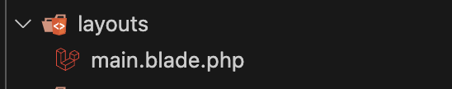
- Components
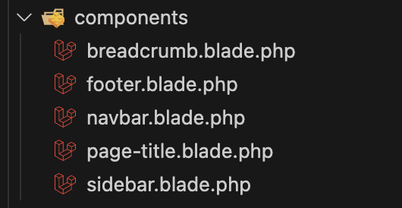
PRACTICUM 2 – LAYOUT USAGE
- Dashboard
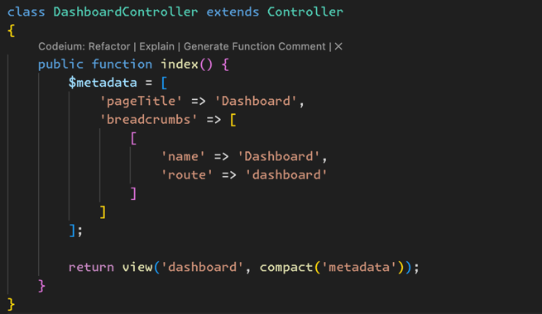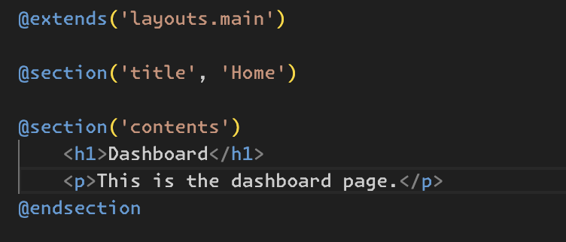
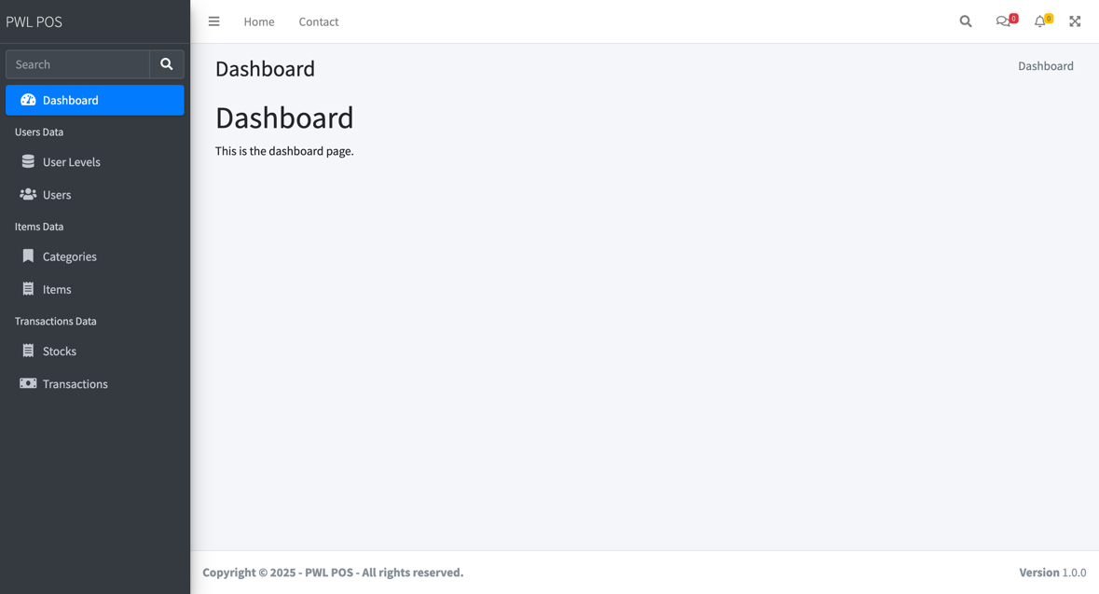
PRACTICUM 3 – JQUERY DATATABLE IMPLEMENTATION
- List Data
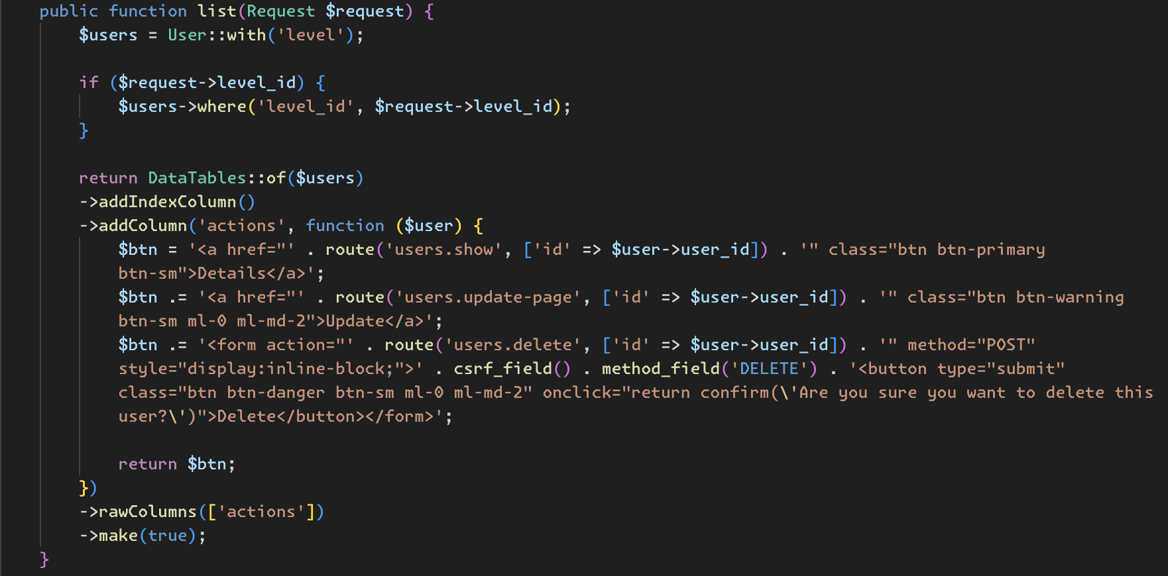
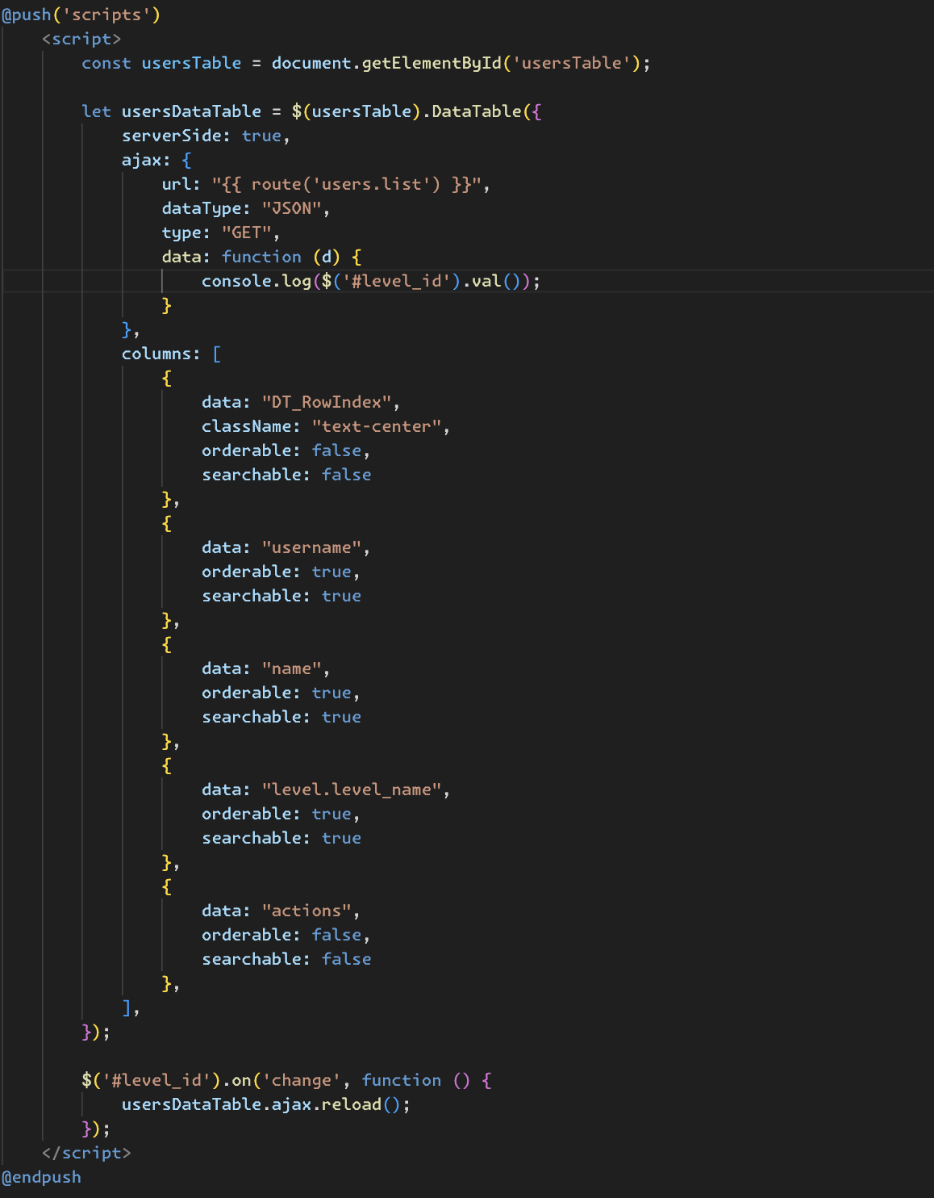
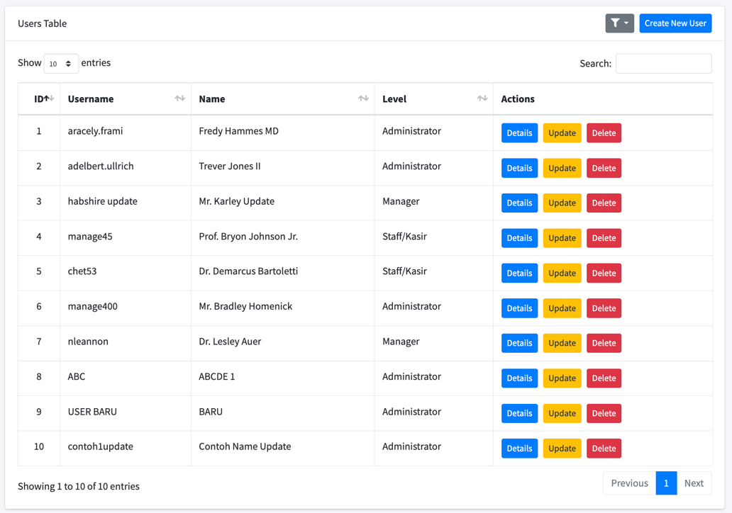

- Details Data
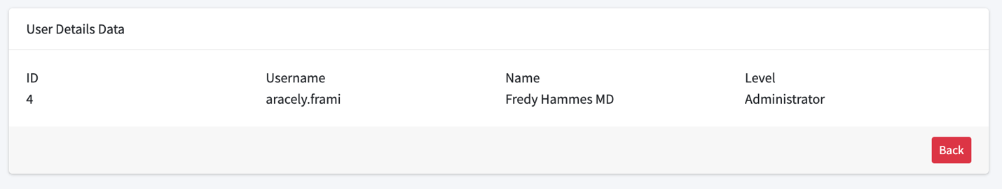
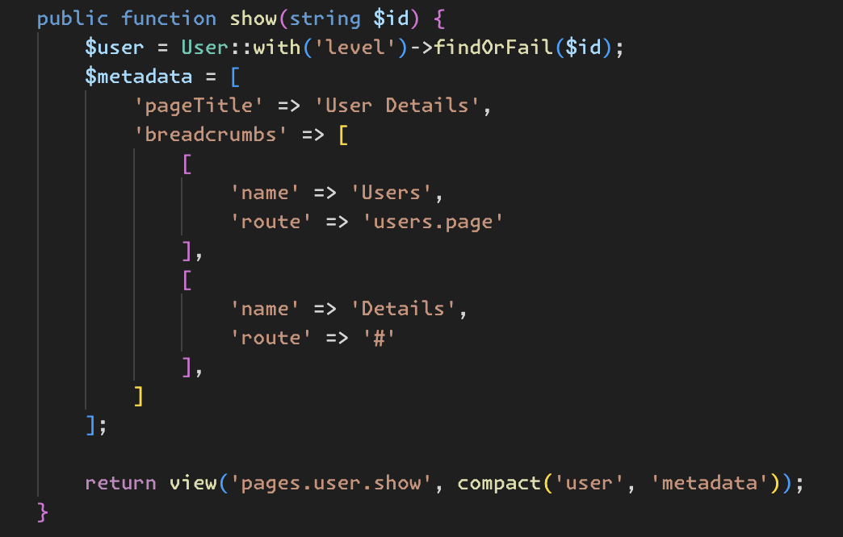

- Create Data
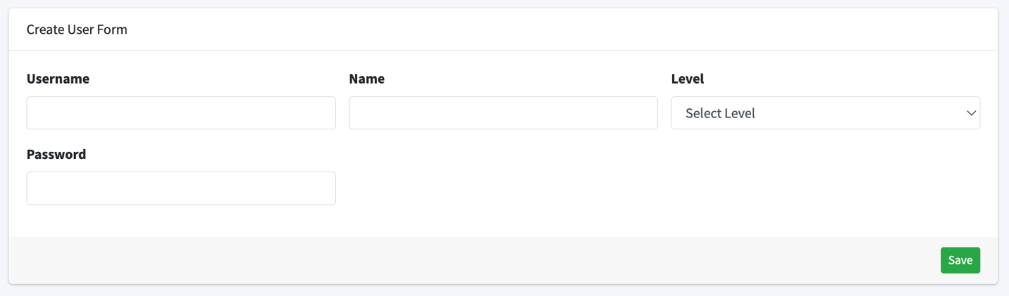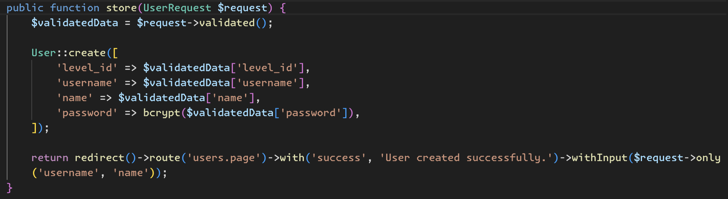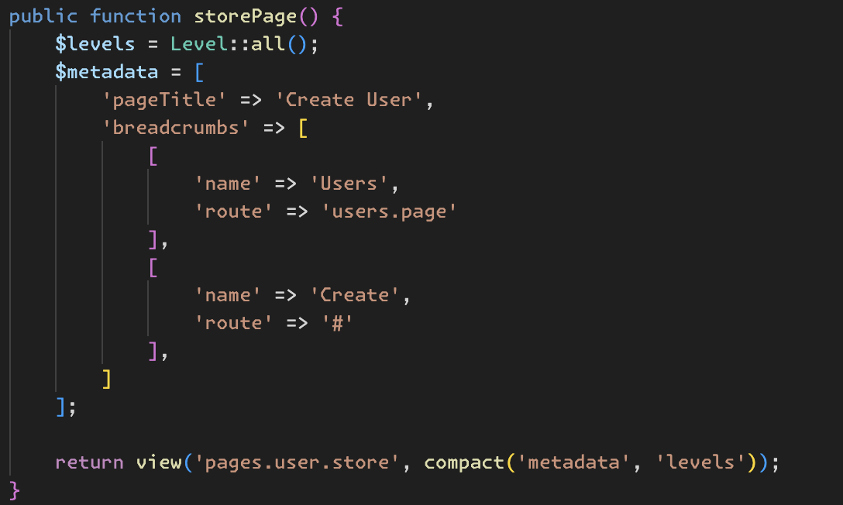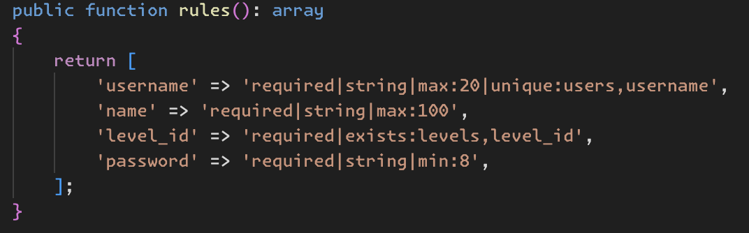

- Update Data
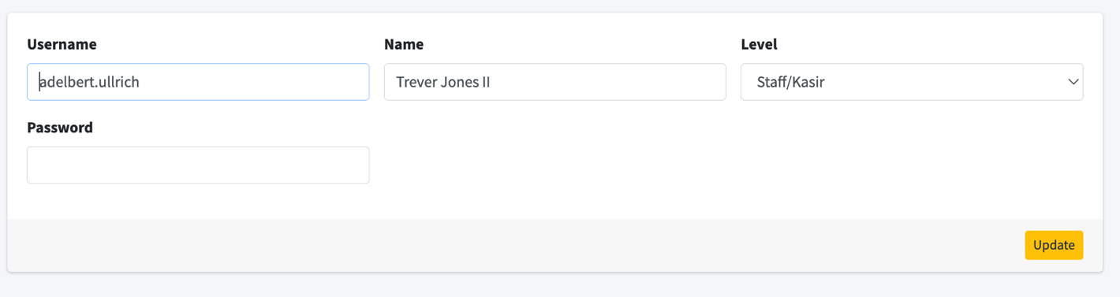
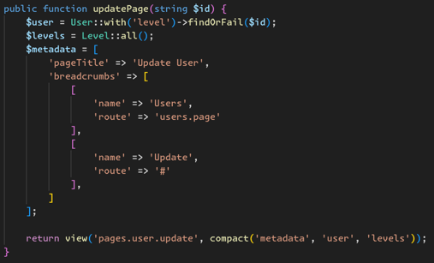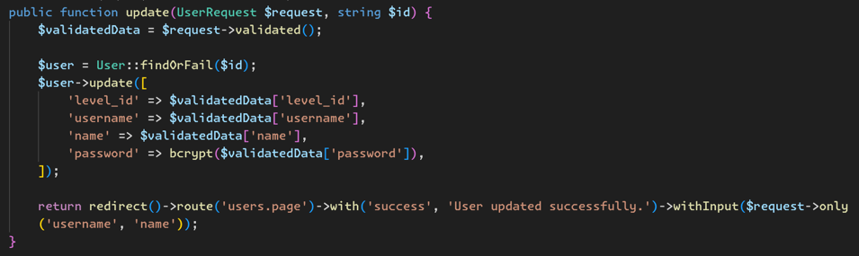

- Delete Data
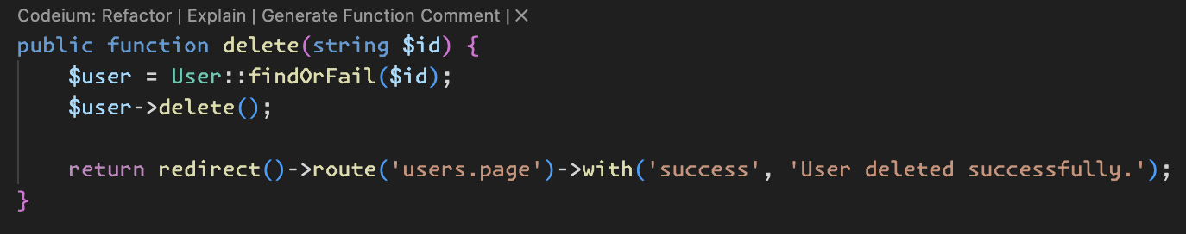

PRACTICUM 4 – JQUERY DATA FILTER
- Filtering
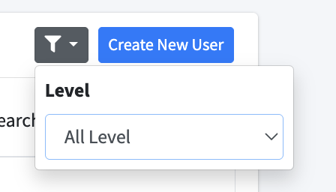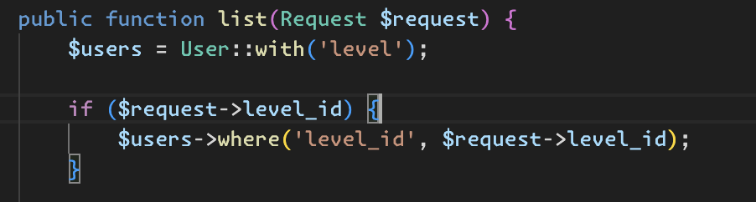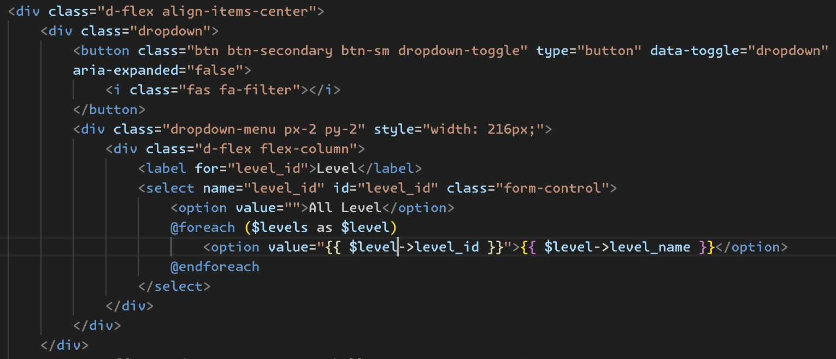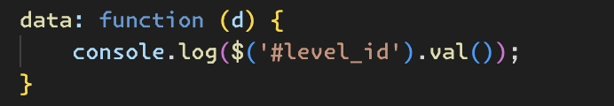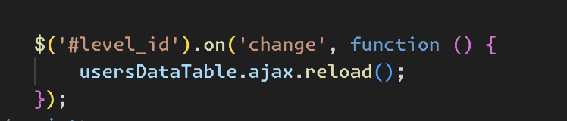

JOBSHEET ANSWER
- Levels Table
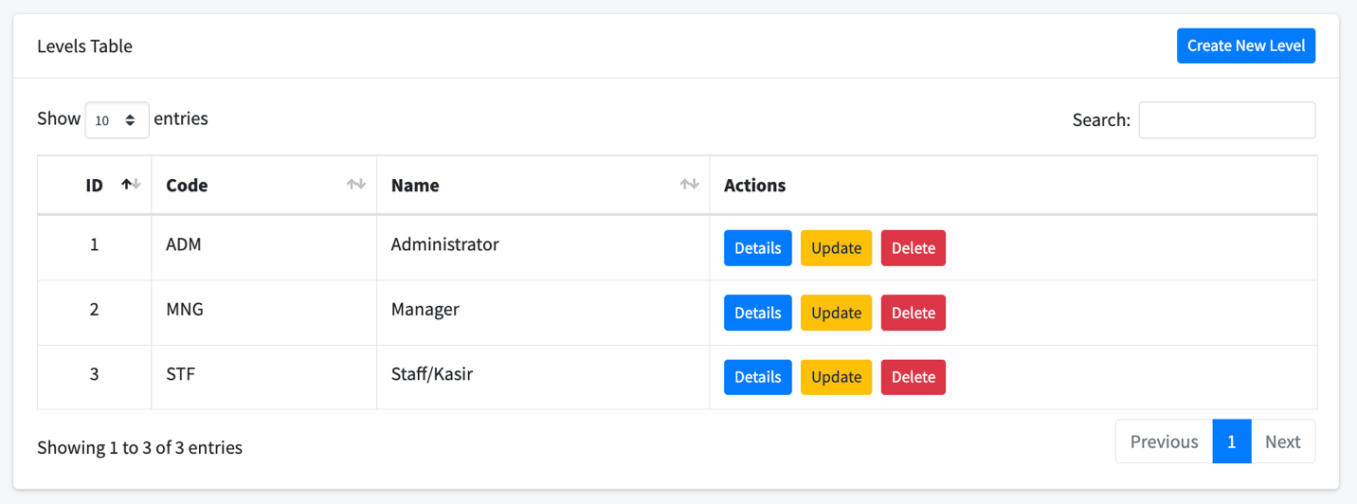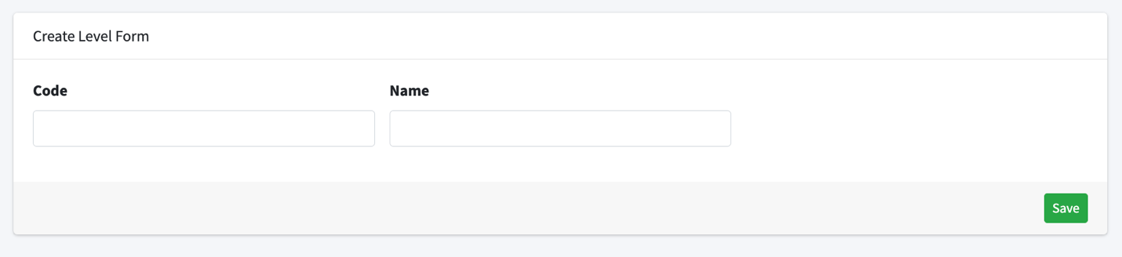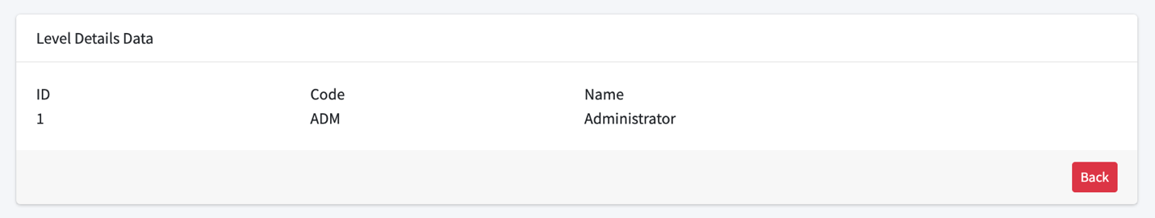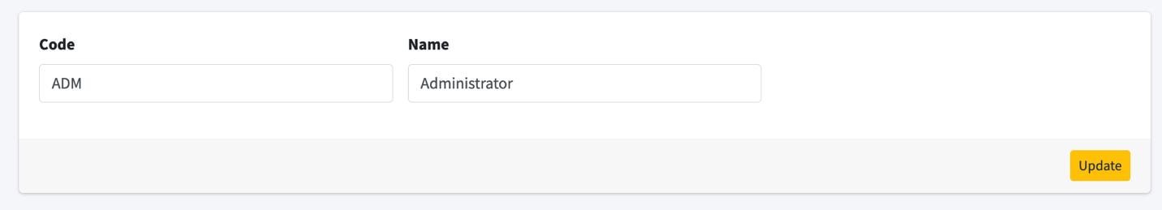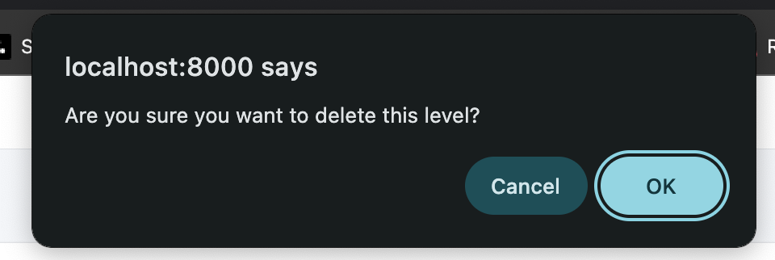

- Categories Table
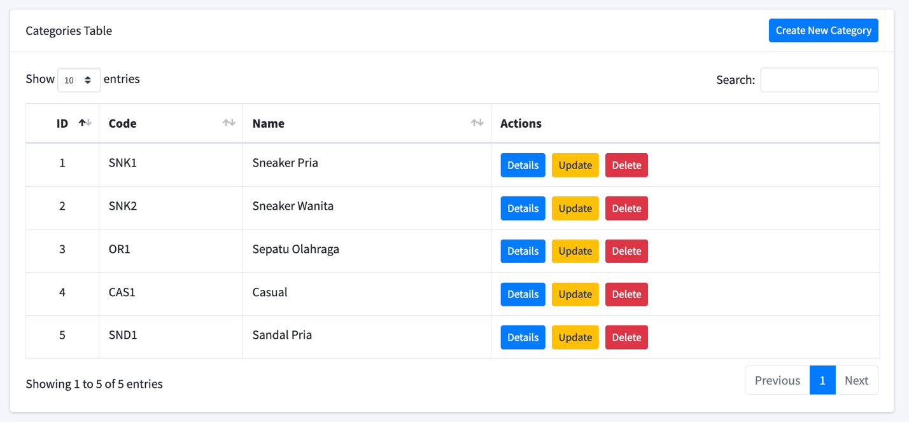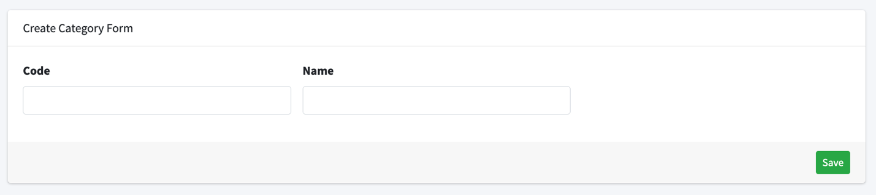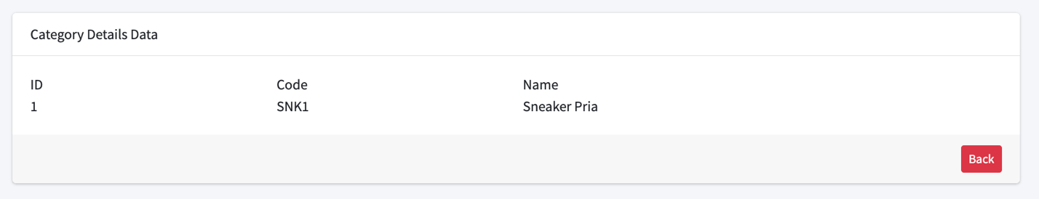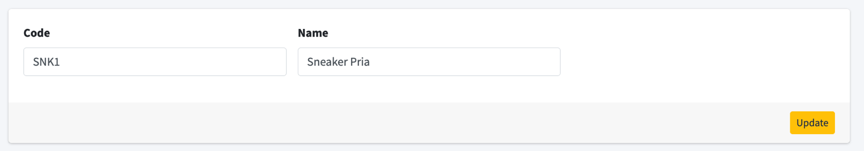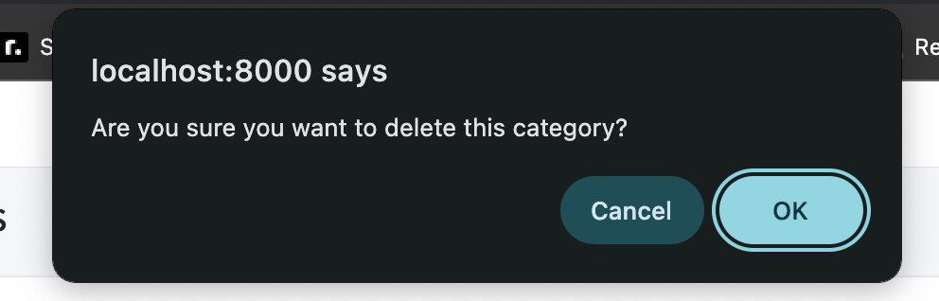

- Stocks Table
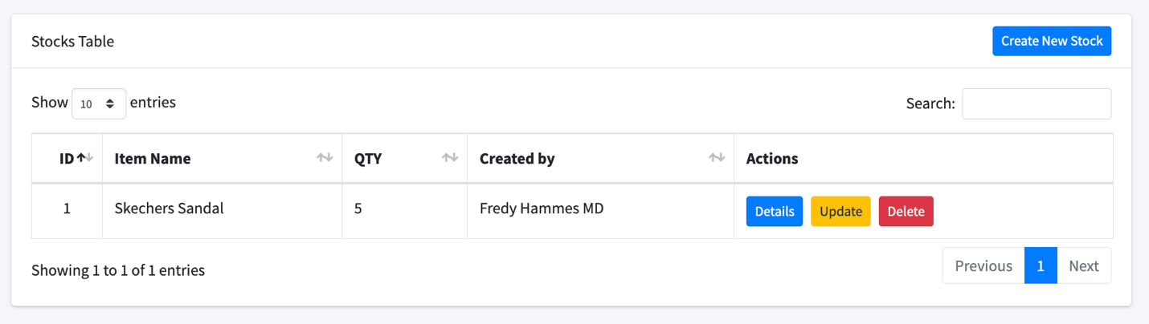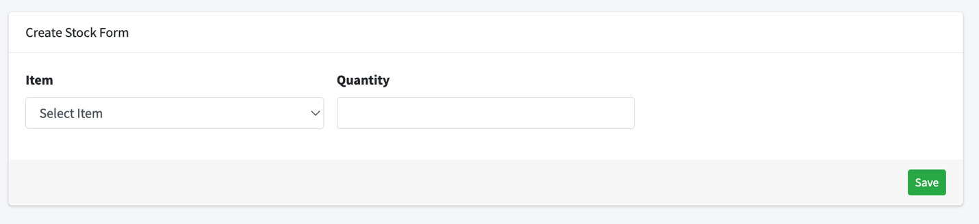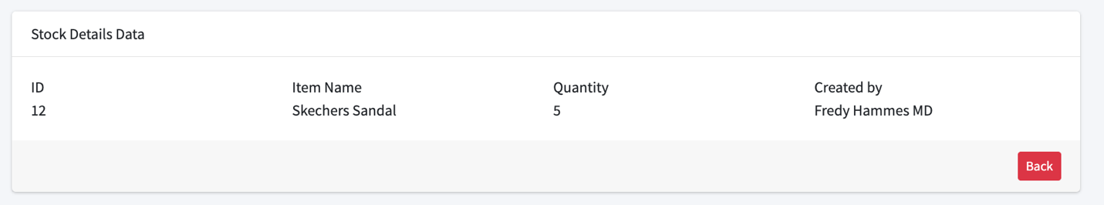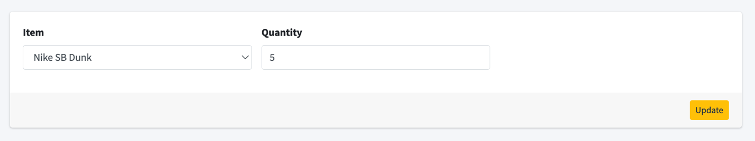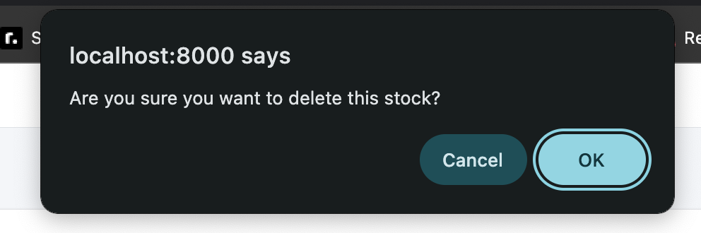

- Items Table
