COMPUTATIONAL STATISTIC
WEEK 8 – MID TERM



KHEN MUHAMMAD CAHYO
244107023002
TI-2I
STATE POLYTECHNIC OF MALANG
INFORMATION TECHNOLOGY DEPARTMENT

ANSWER QUESTION 1 (SECTION 1)
Import dataset using preferred tools:
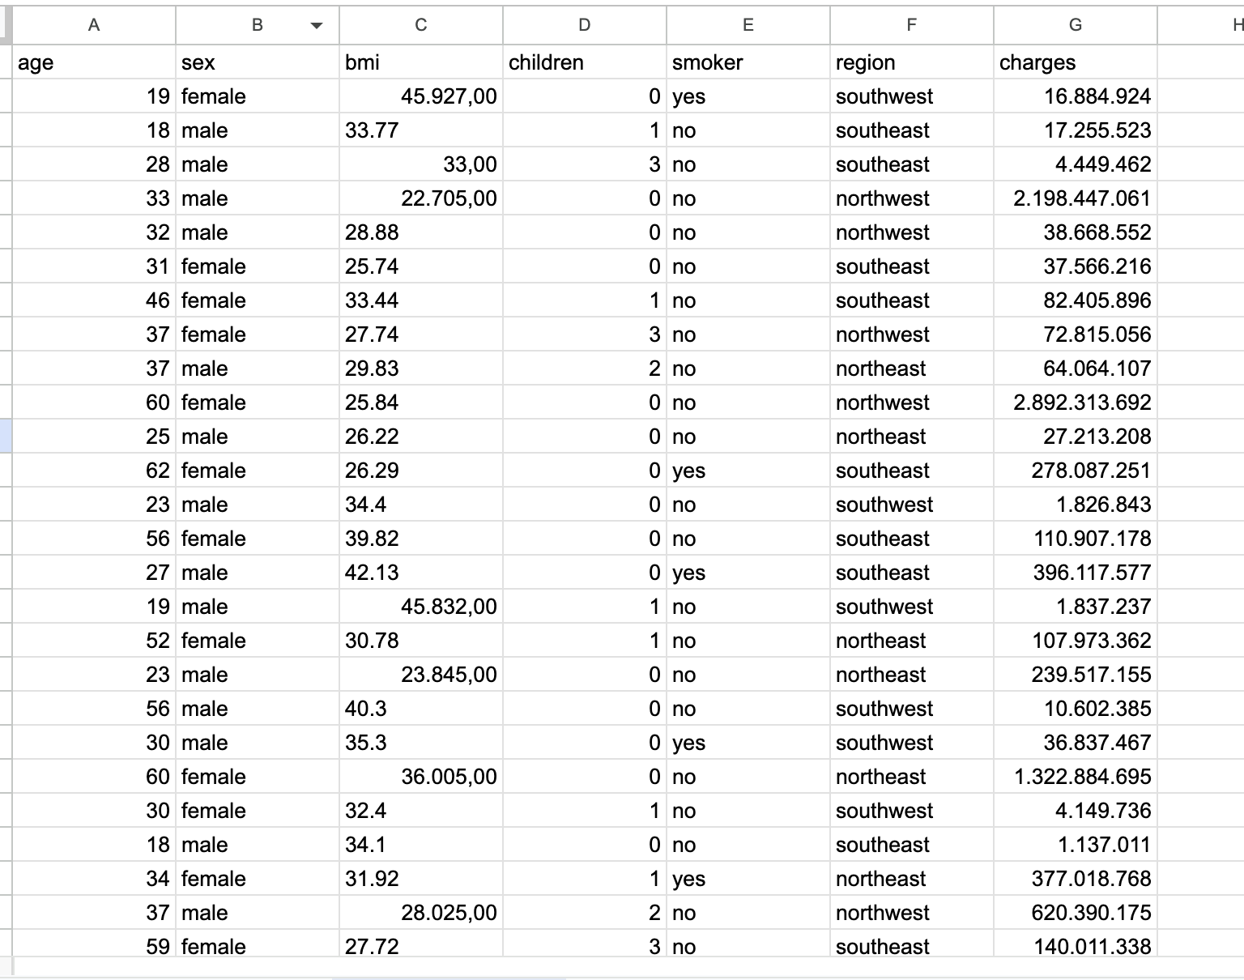

ANSWER QUESTION 2 (SECTION 1)
Explore basic values
- Answer A Question
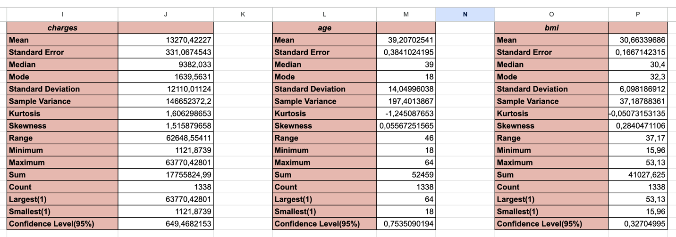
- Answer B Question
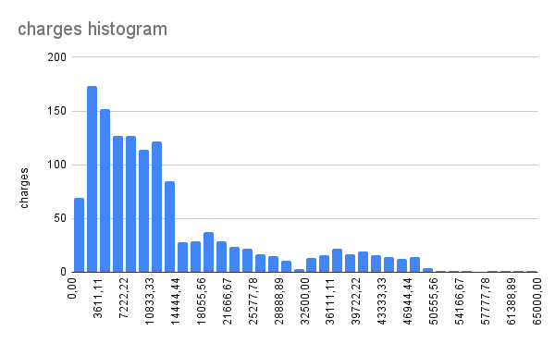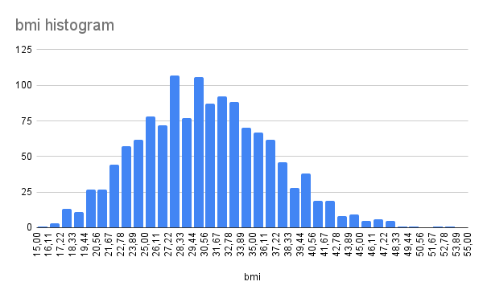

ANSWER QUESTION 3 (SECTION 1)
- Answer B Question
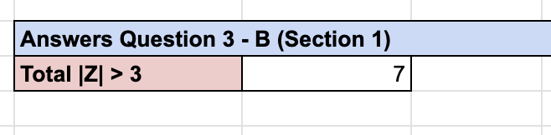

ANSWER QUESTION 1 (SECTION 2)
- Answer A Question
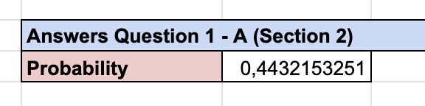
- Answer B Question
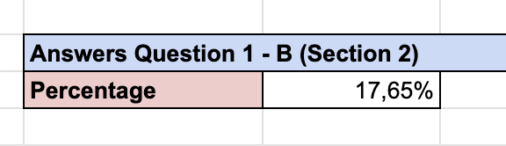

ANSWER QUESTION 2 (SECTION 2)
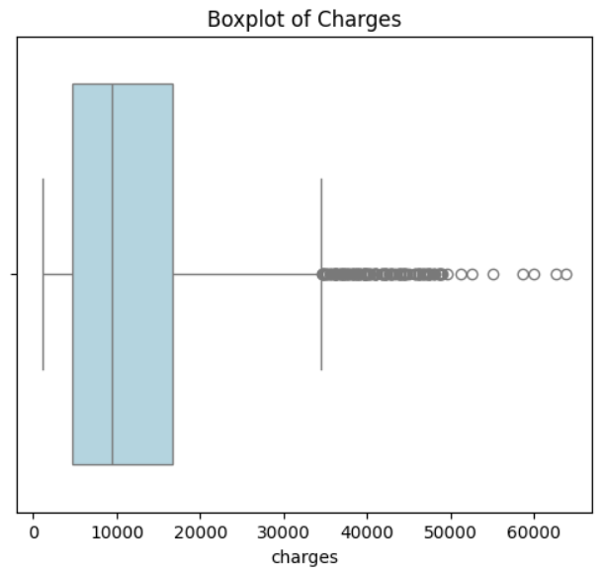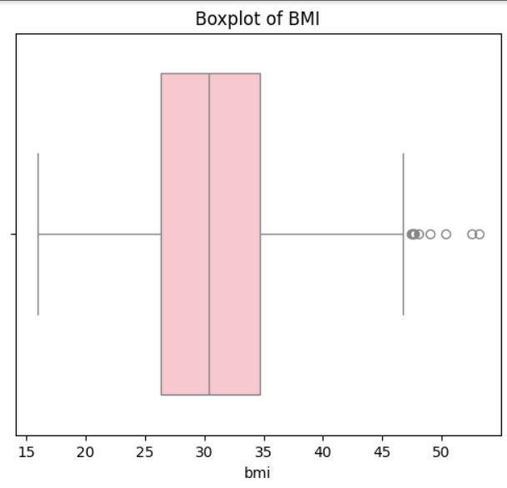

ANSWER QUESTION 1 (SECTION 3)
- Answer A Question
In this answer, I’am only displayed the answer for C2 row.
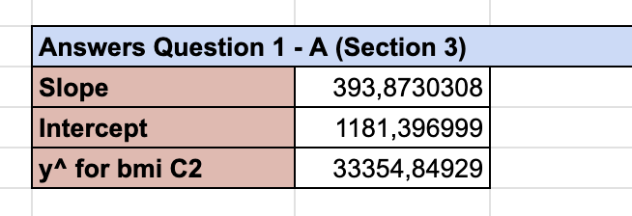
- Answer B Question
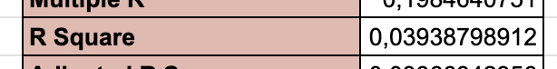
Based on the calculation results, the coefficient of determination (R²) is 0.039, which means that only about 3.9% of the variation in charges can be explained by the bmi variable. This shows that the relationship between bmi and charges is very weak, so bmi is not a strong predictor to accurately model charges in this context.
ANSWER QUESTION 2 (SECTION 3)
- Answer A Question

- Answer B Question

