ADVANCED WEB PROGRAMMING
API (APPLICATION PROGRAMMING INTERFACE)



KHEN MUHAMMAD CAHYO
244107023002
TI-2I
STATE POLYTECHNIC OF MALANG
INFORMATION TECHNOLOGY DEPARTMENT

RESOURCES
- Postman
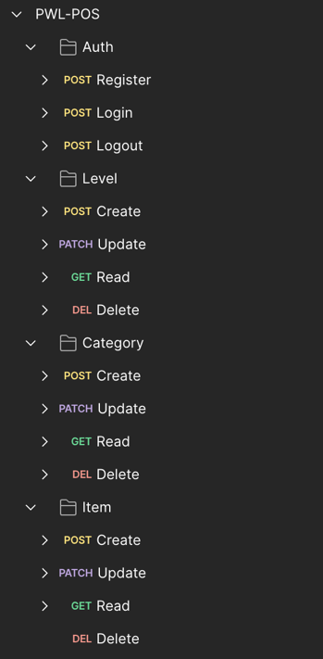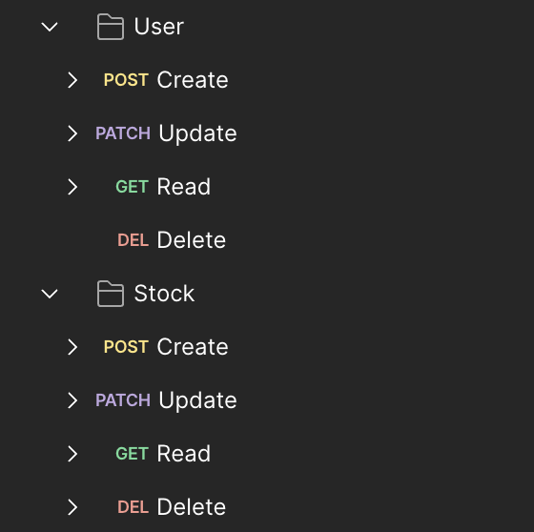
- Routes
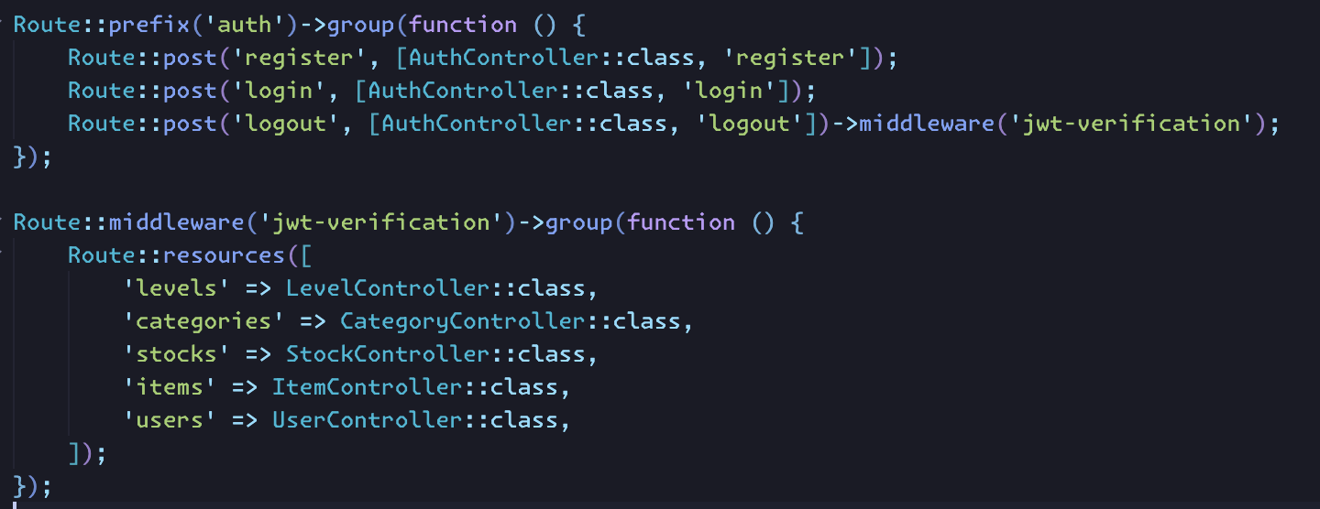
PUSH GITHUB

TOKEN VERIFICATION
Here is the token verification response when users send a request into API.
- Token not Provided
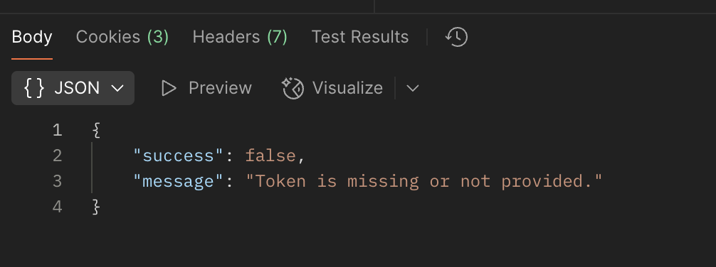
- Invalid Token
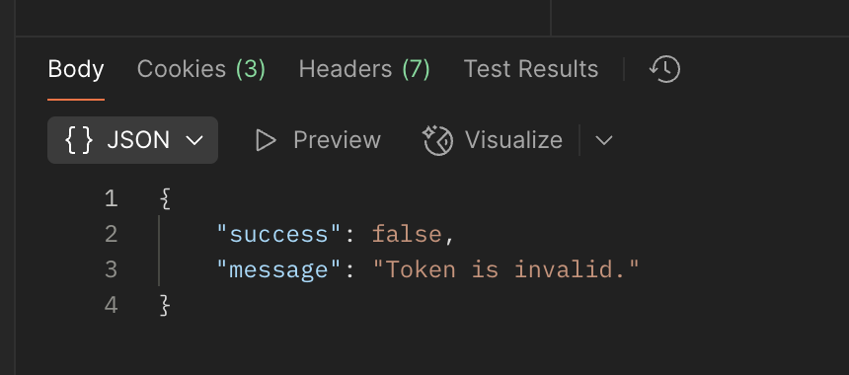
- Token Expired
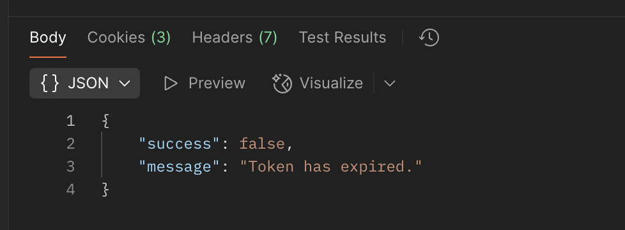

PRACTICUM 1 – REGISTER API
- Request Validation
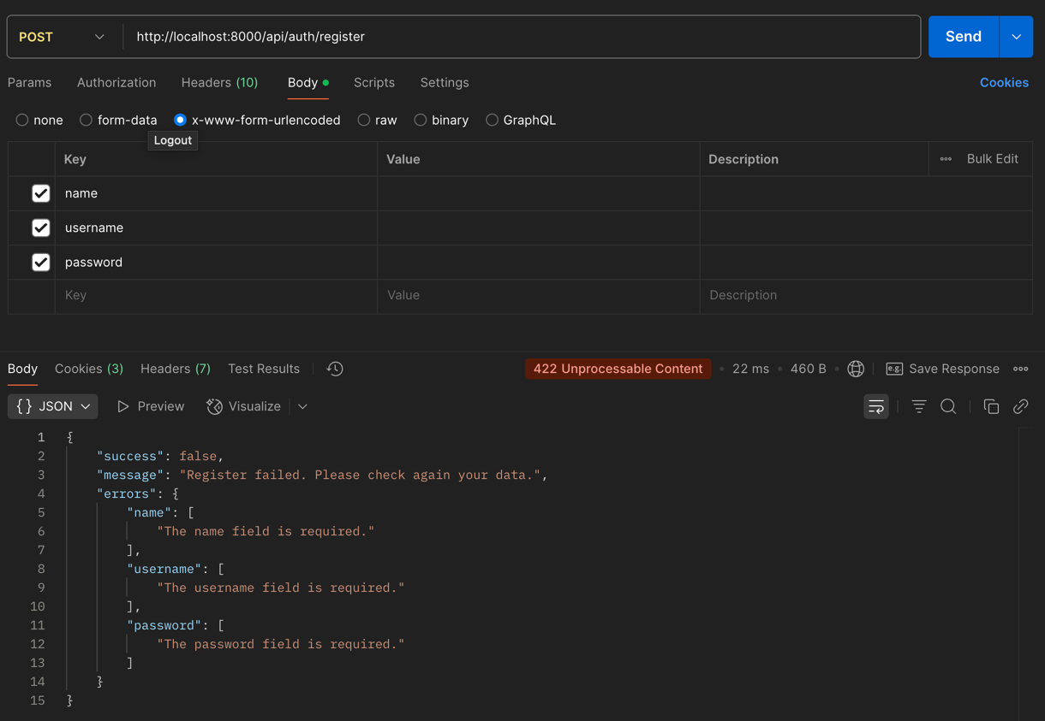
- Successfully Register
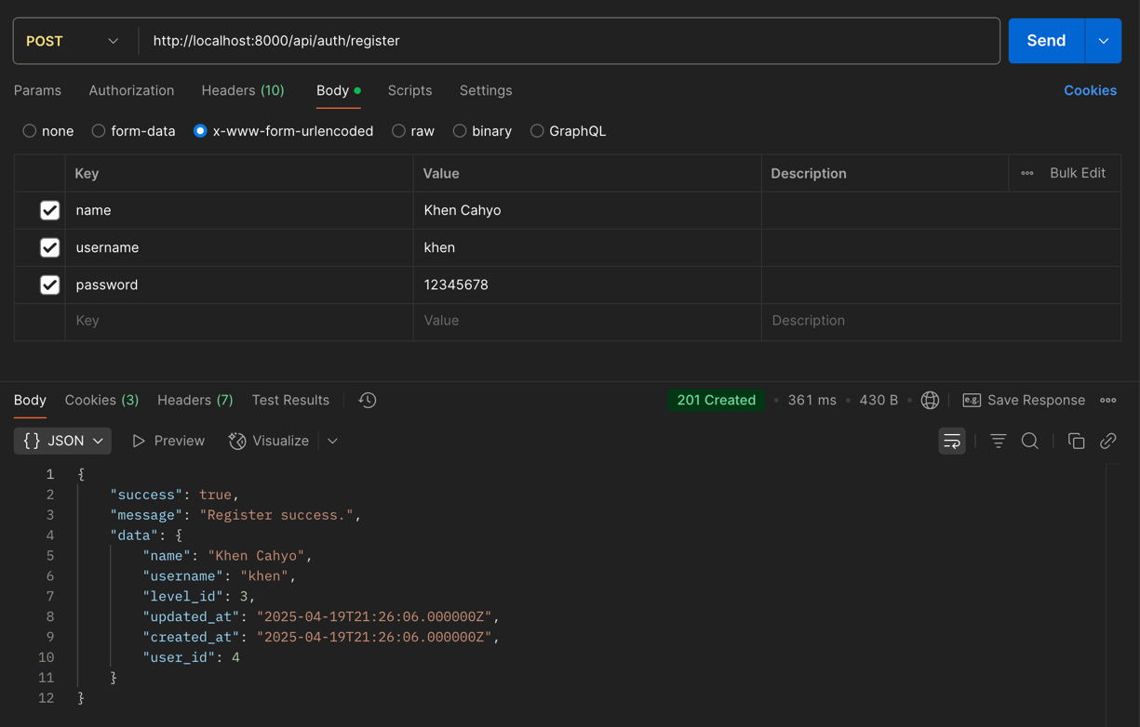

PRACTICUM 2 – LOGIN API
- Request Validation
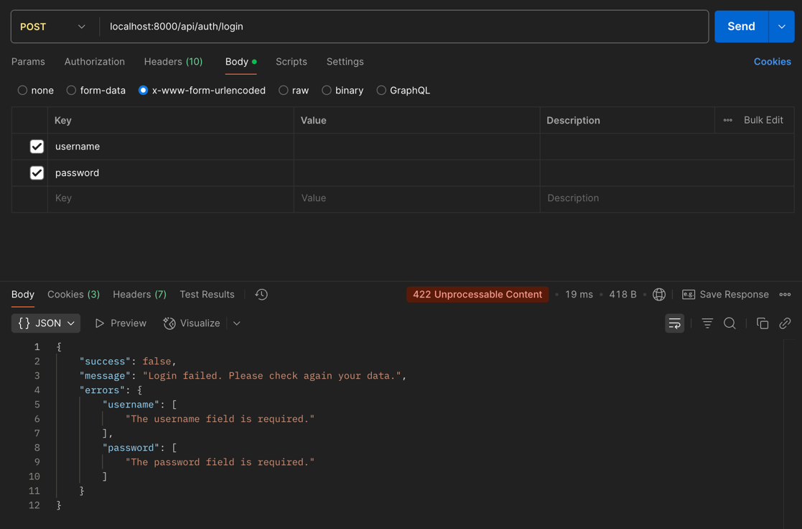
- Successfully Login
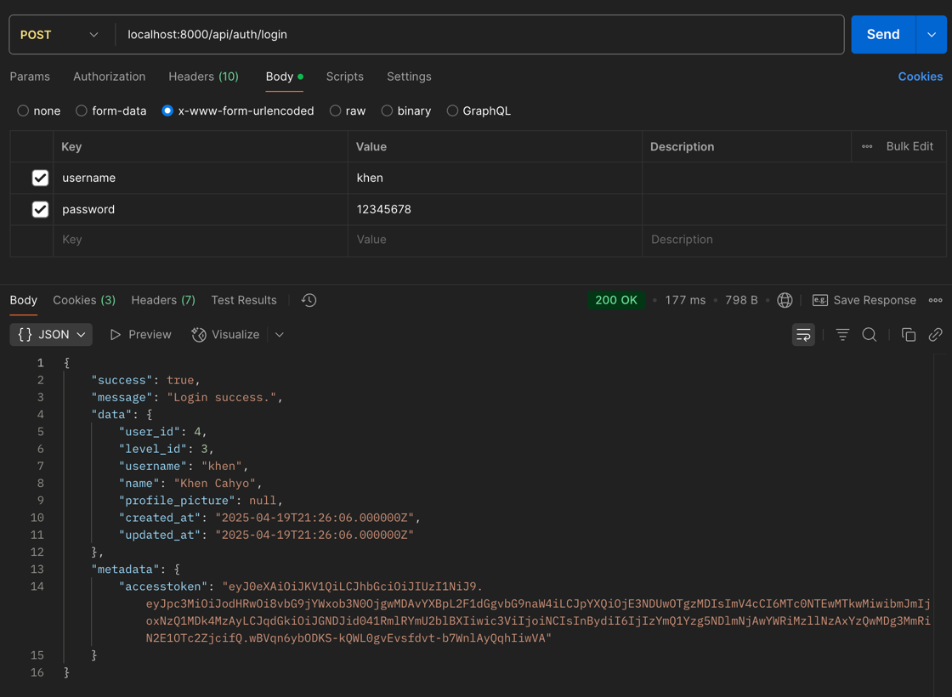

PRACTICUM 3 – LOGOUT API
- Successfully Logout
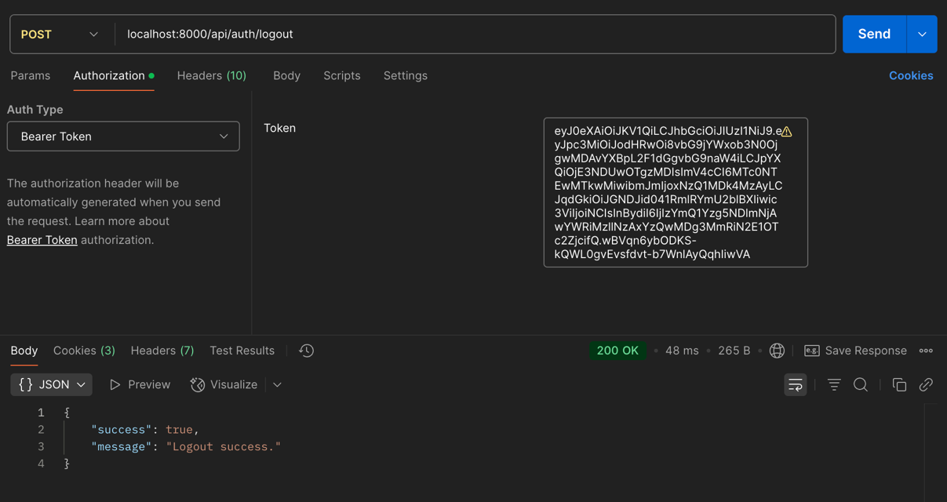

PRACTICUM 4 – CRUD USER LEVEL API
- Request Validation
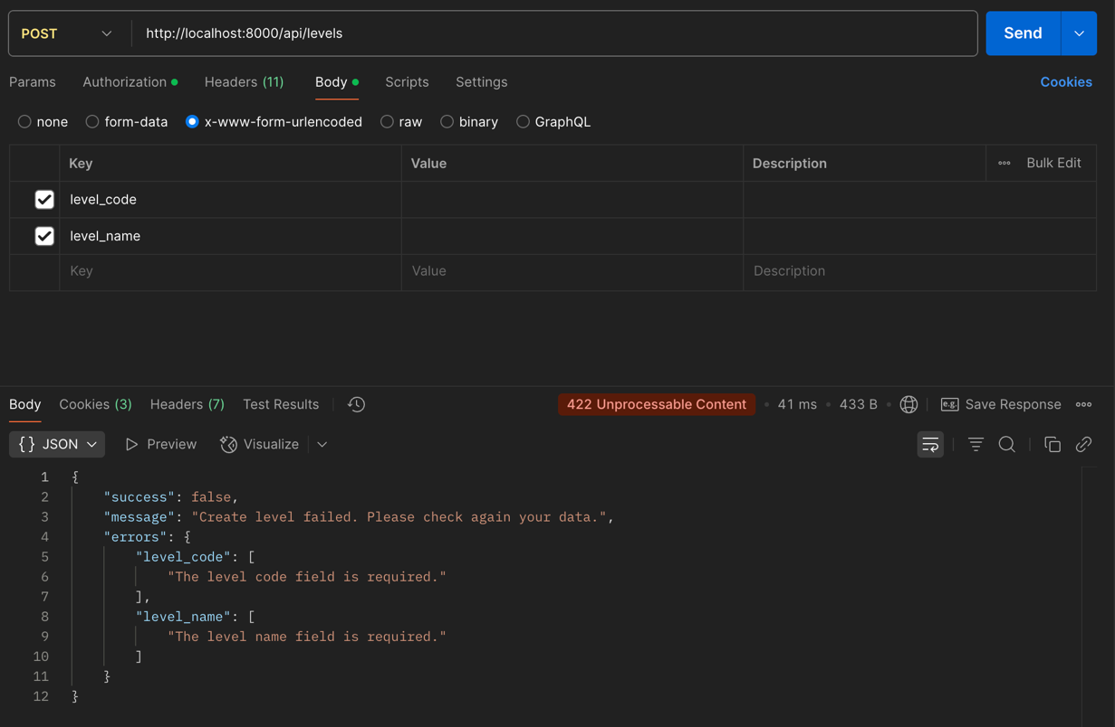
- Successfully Create
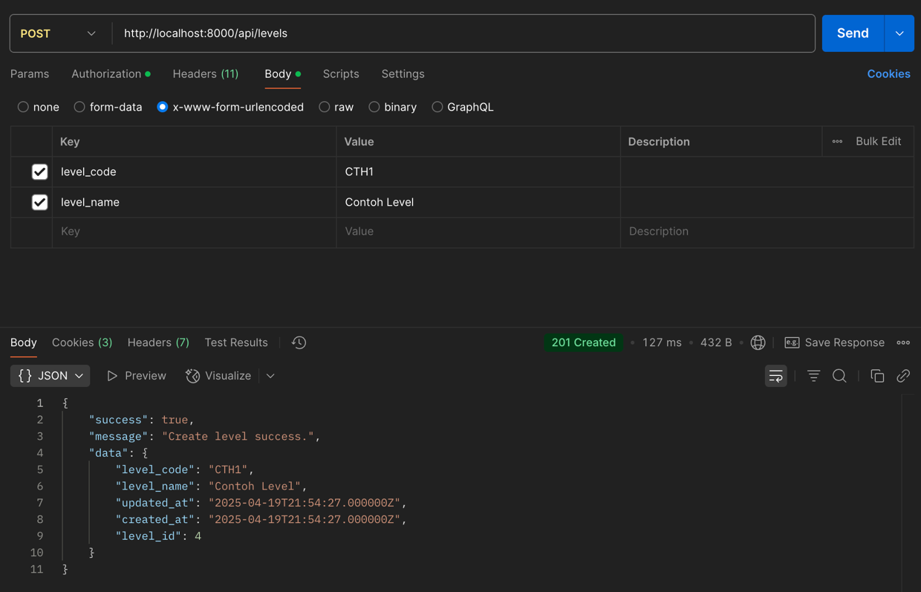

- Successfully Read
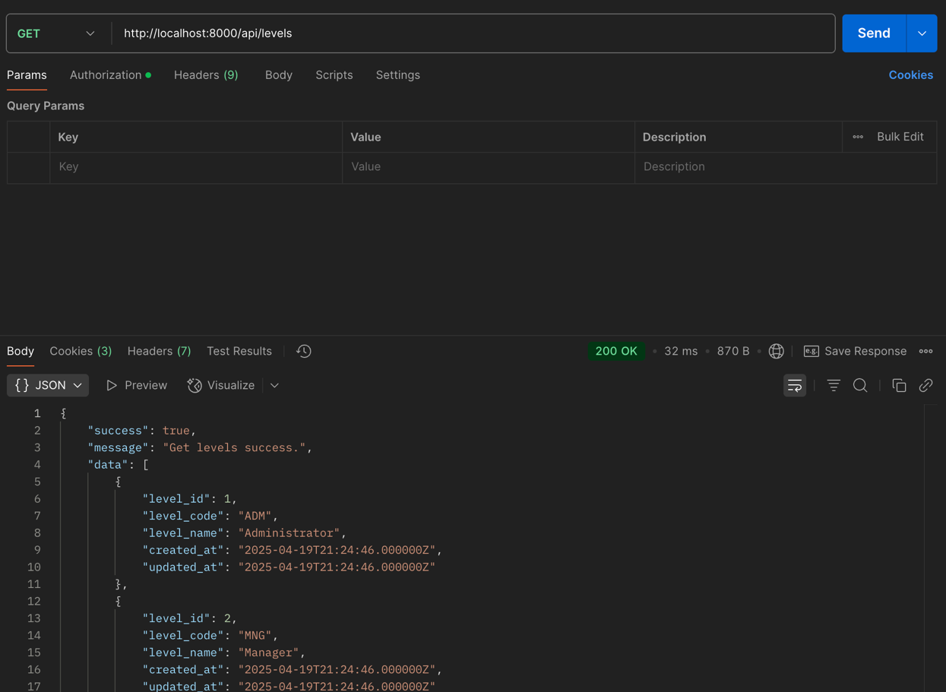
- Successfully Update
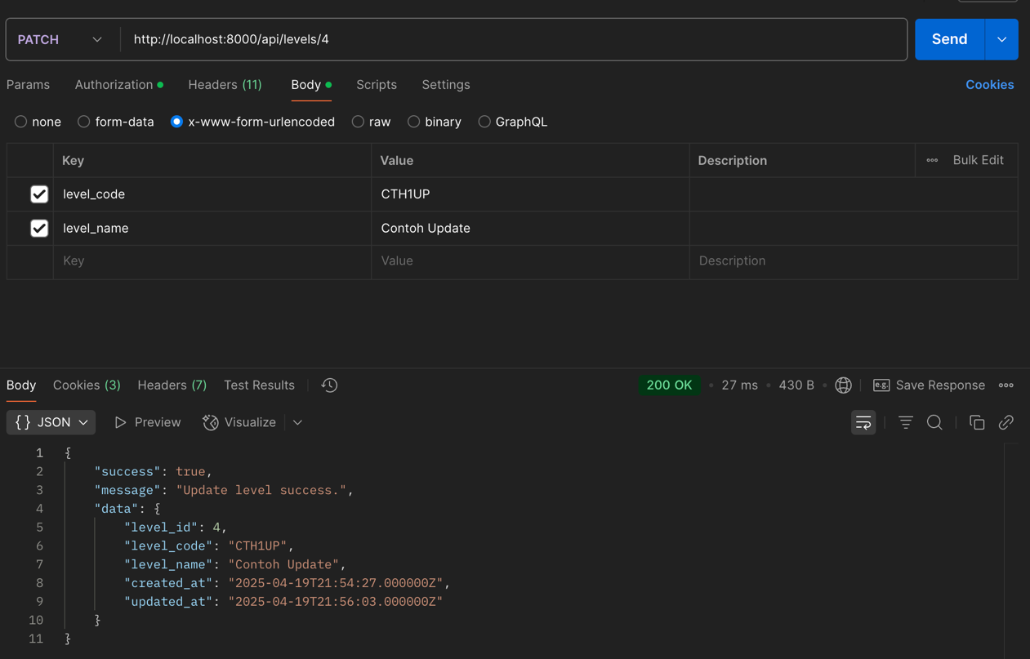

- Successfully Delete
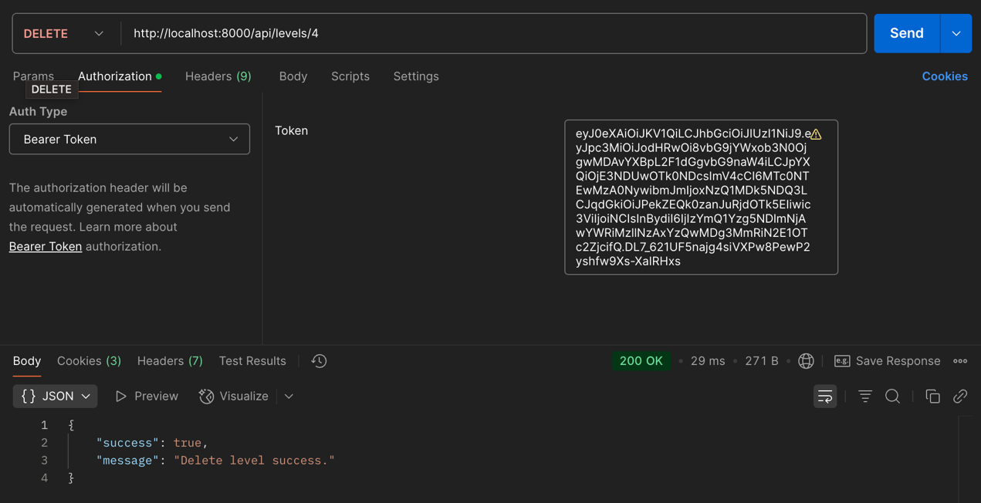

TASK 1 – CRUD CATEGORY API
- Request Validation
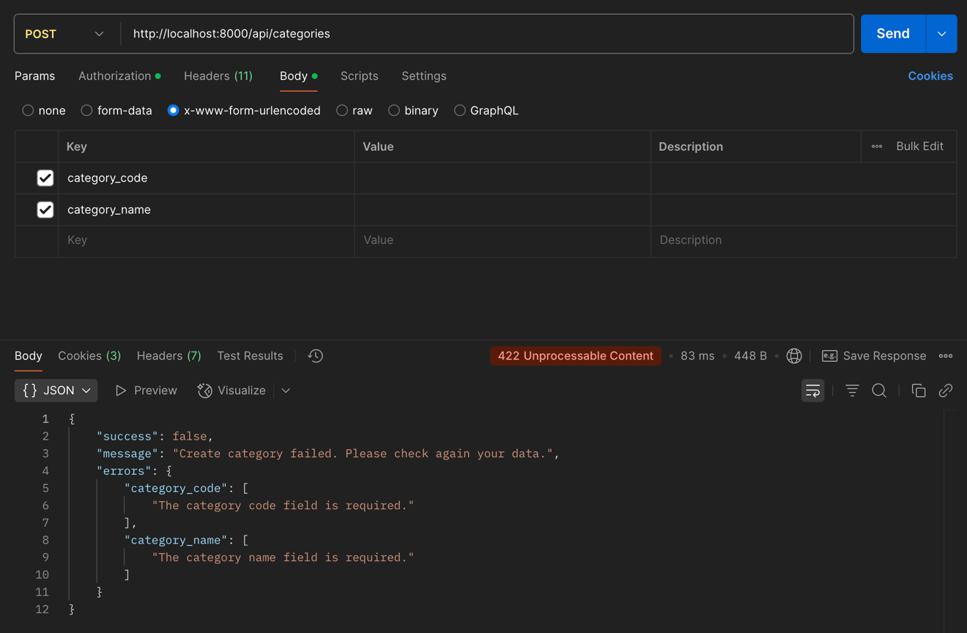
- Successfully Create
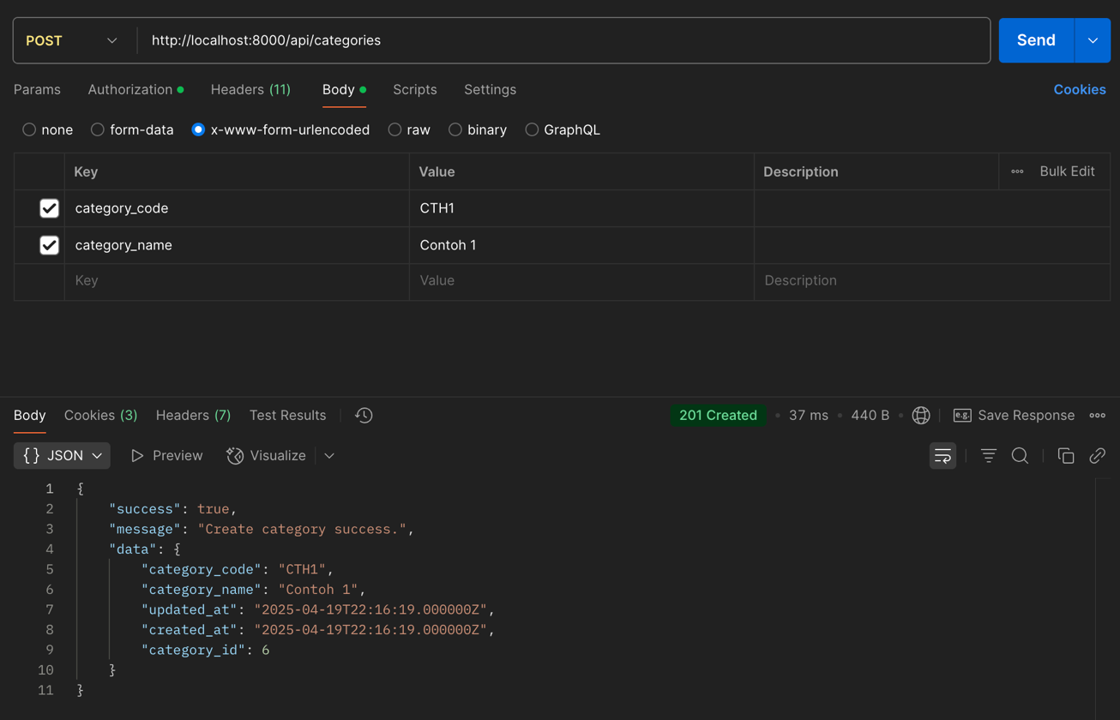

- Successfully Read
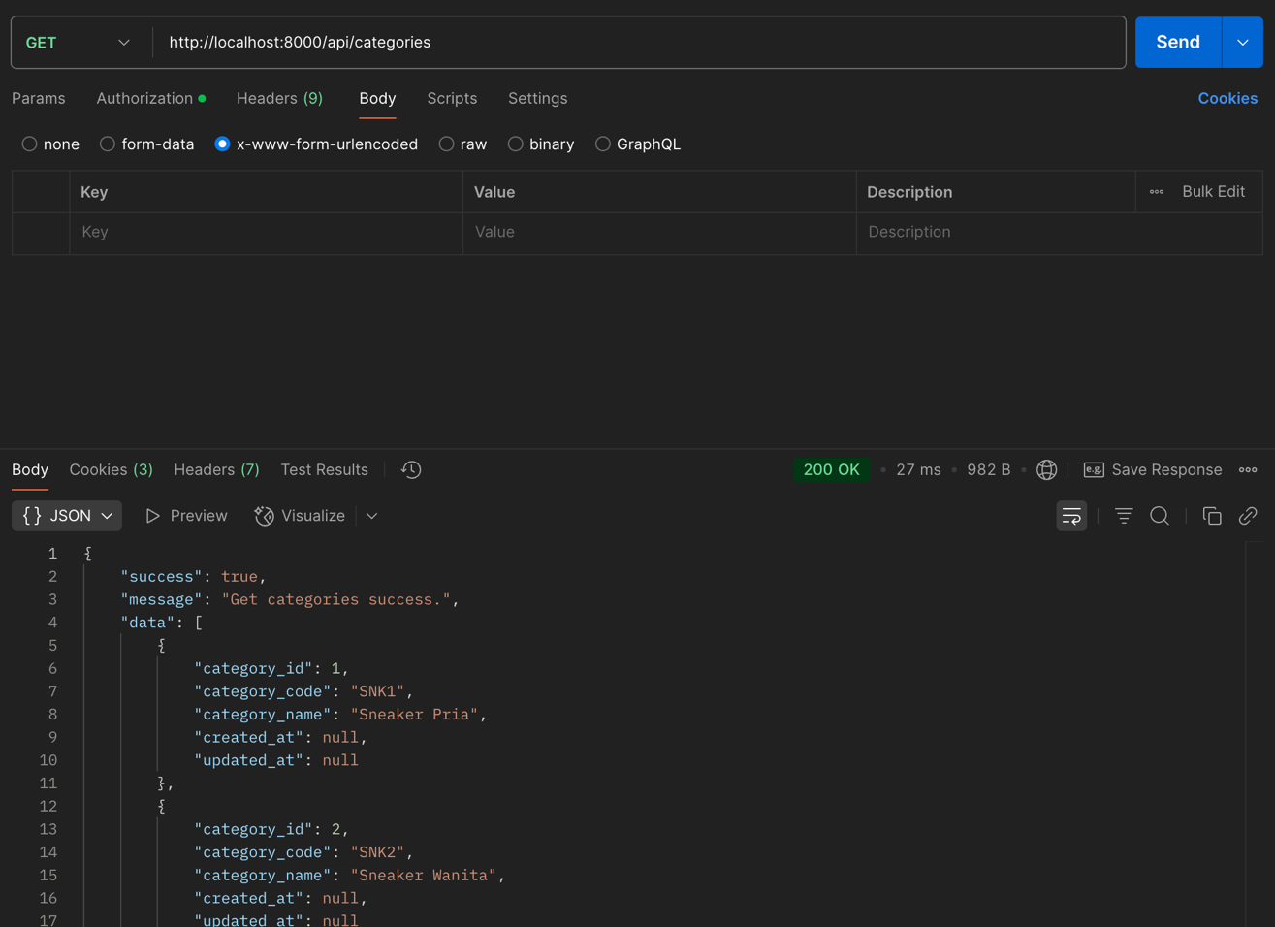
- Successfully Update
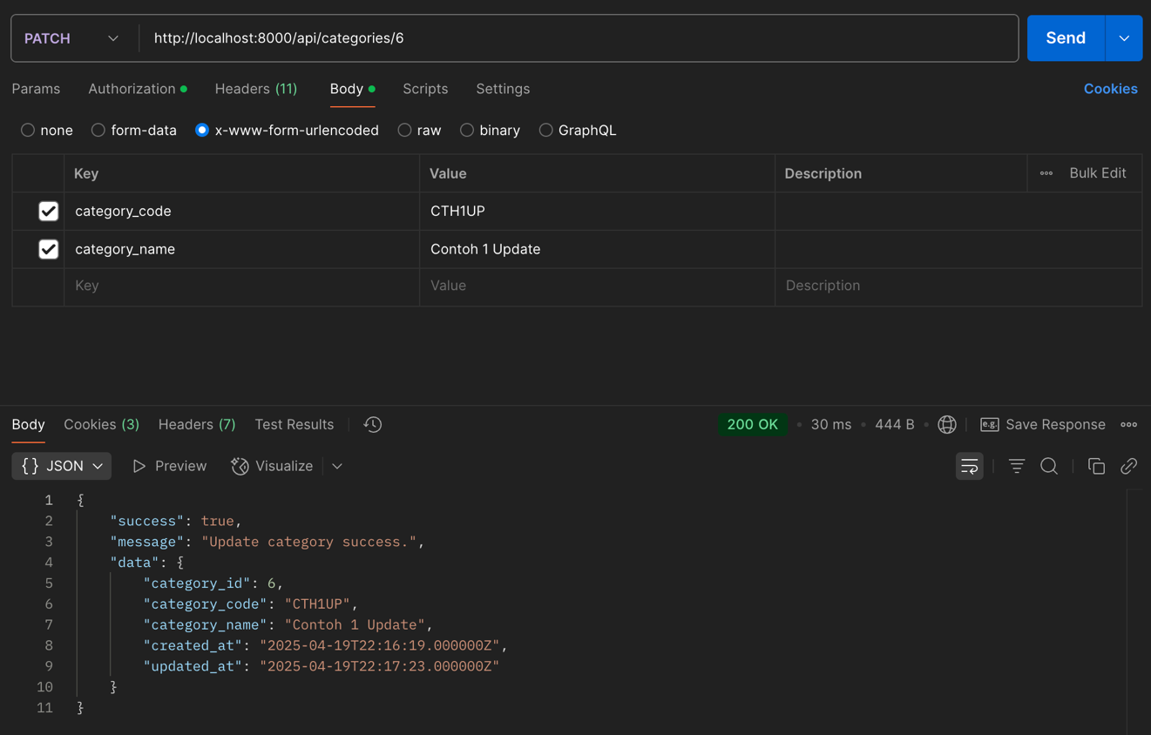
- Successfully Delete
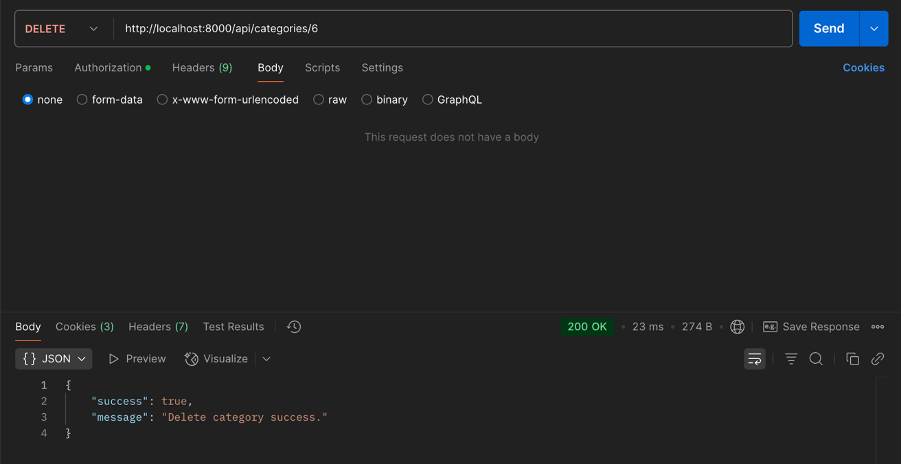

TASK 2 – CRUD ITEM API
- Request Validation
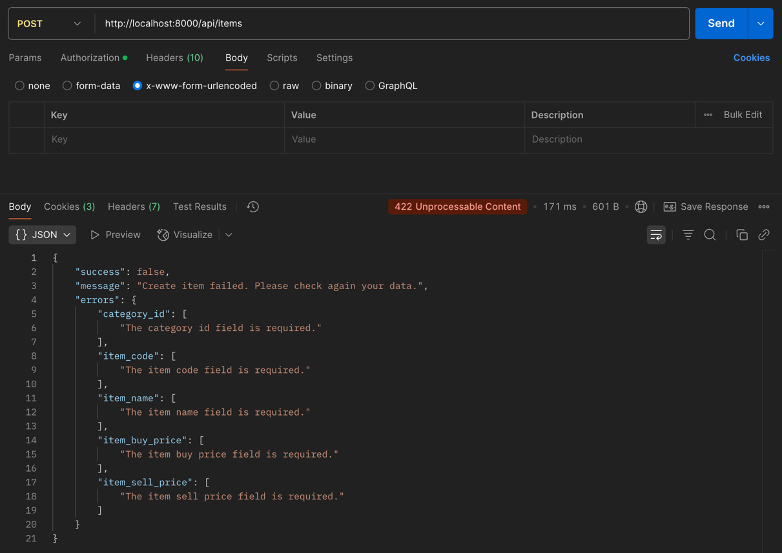
- Successfully Create
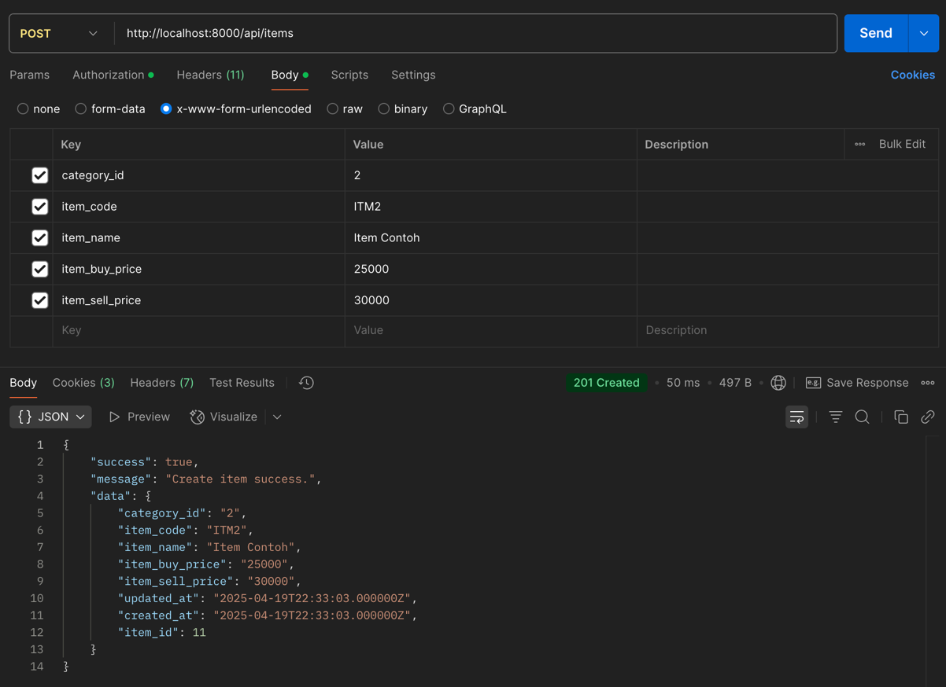
- Successfully Read
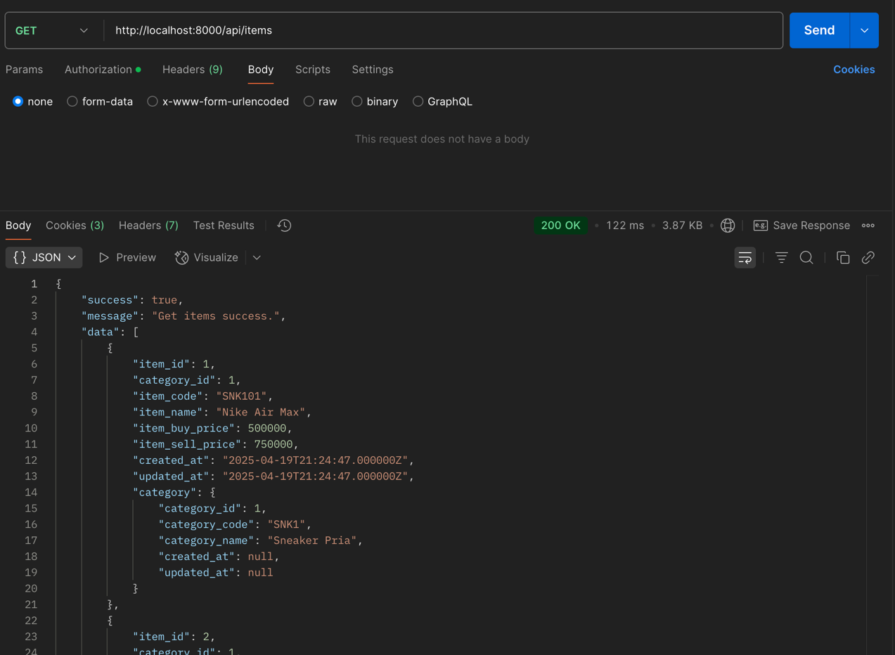
- Successfully Update
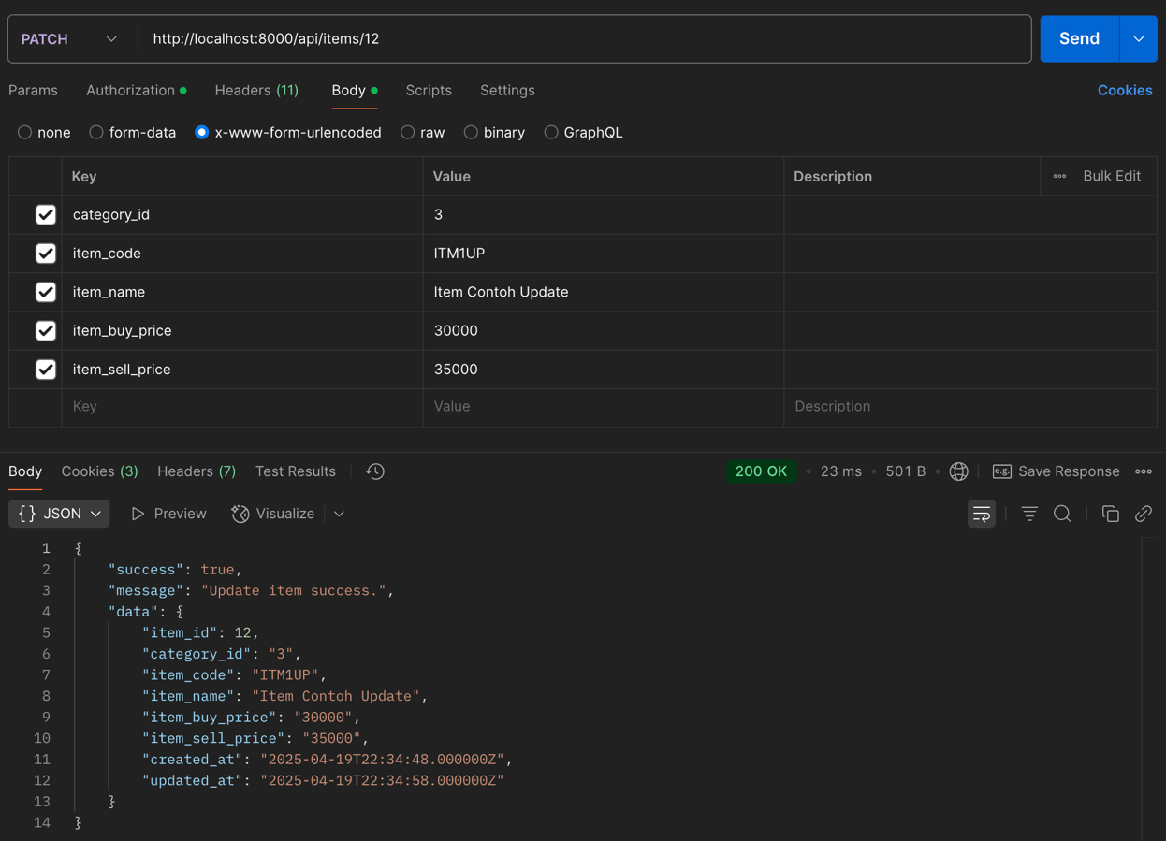
- Successfully Delete
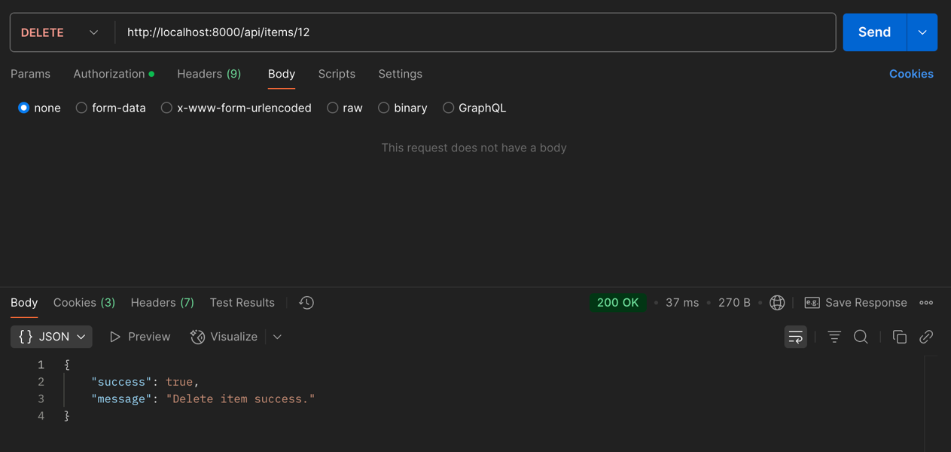

TASK 3 – CRUD USER API
- Request Validation
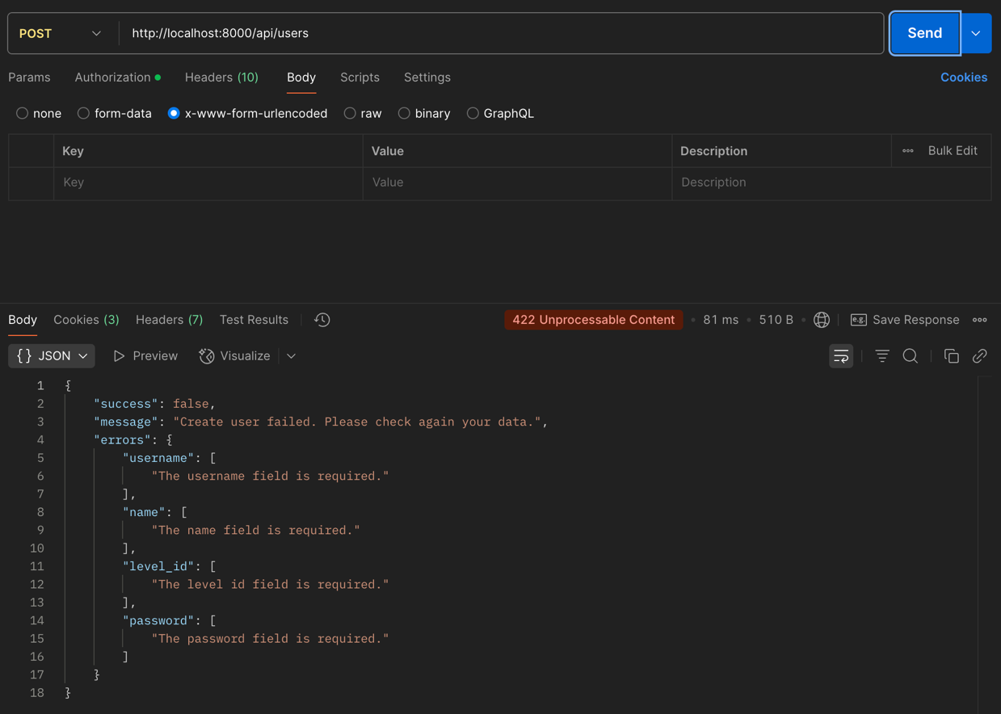
- Successfully Create
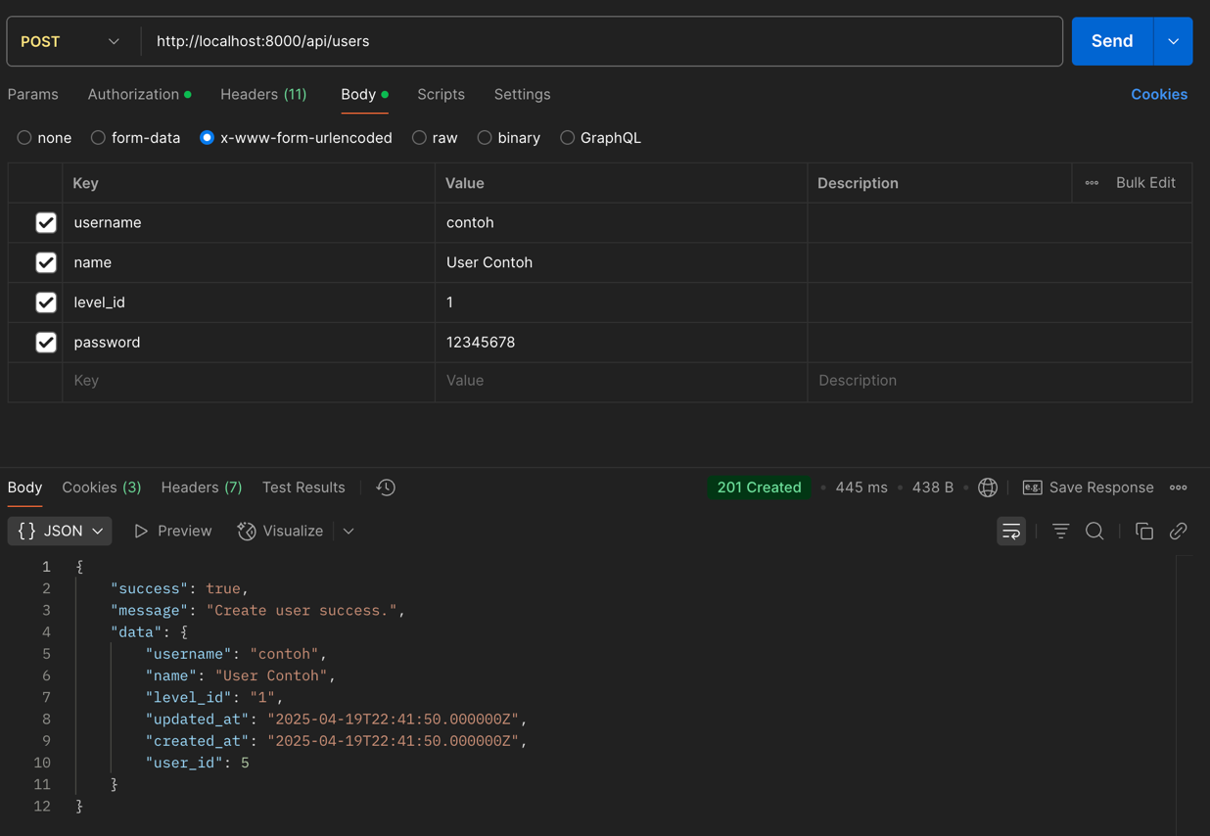
- Successfully Read
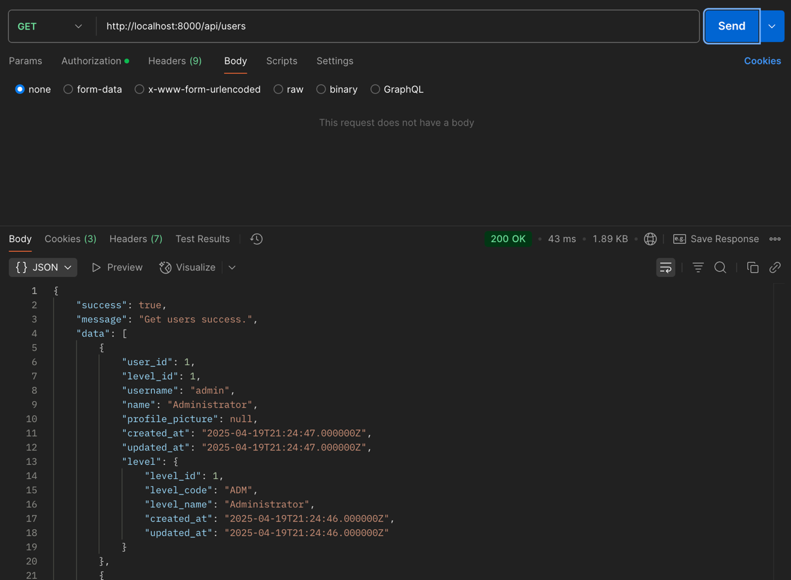
- Successfully Update
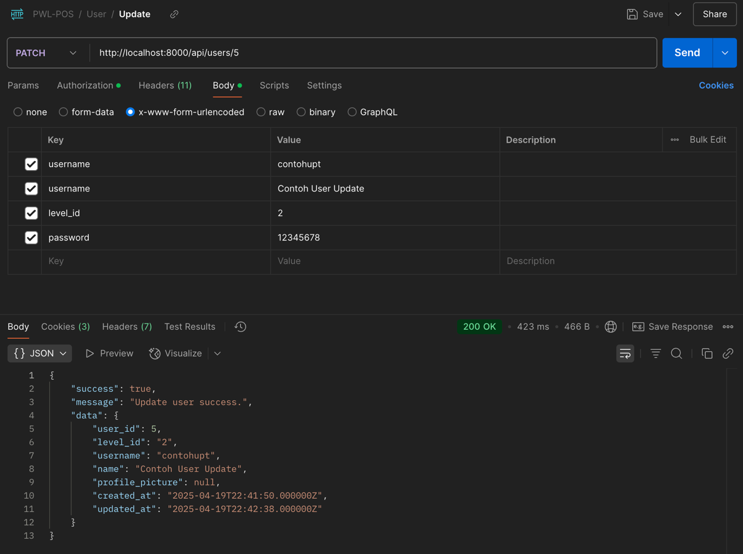
- Successfully Delete
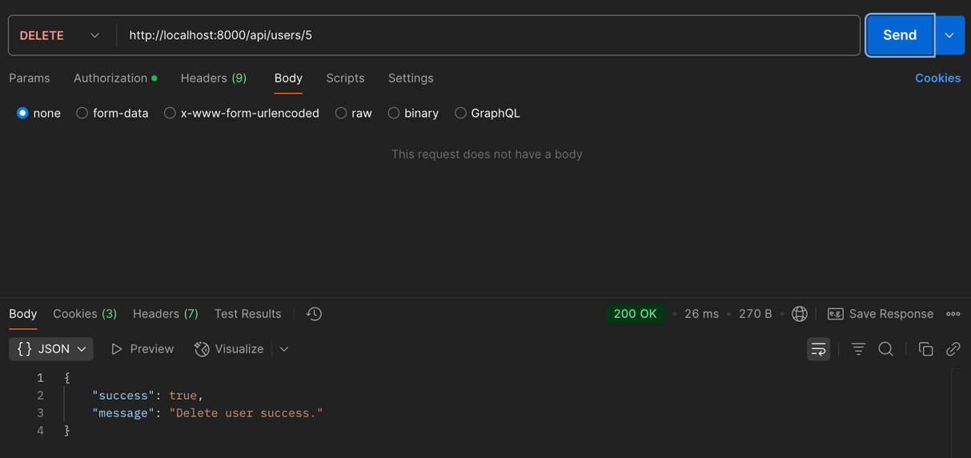

TASK 4 – CRUD STOCK API
- Request Validation
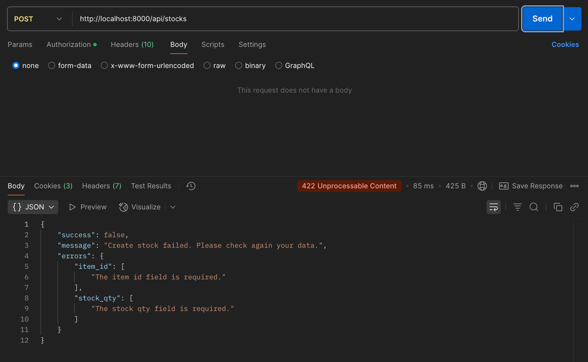
- Successfully Create
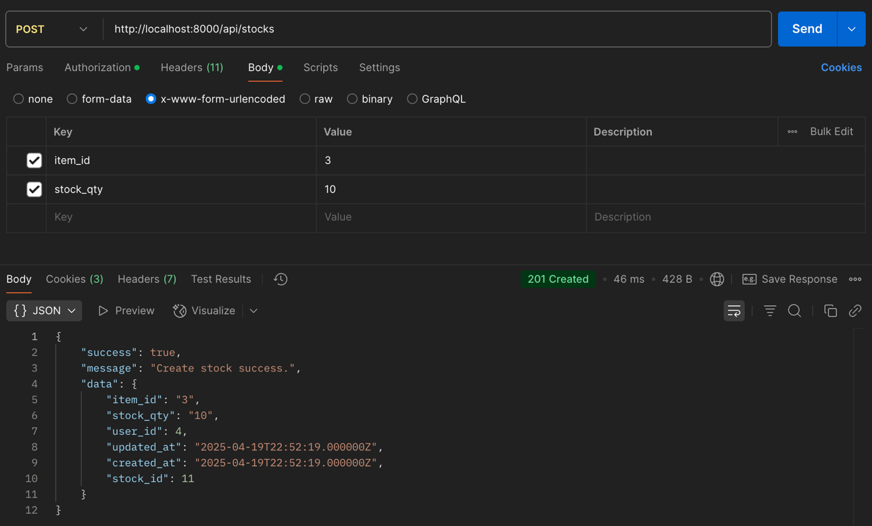

- Successfully Read
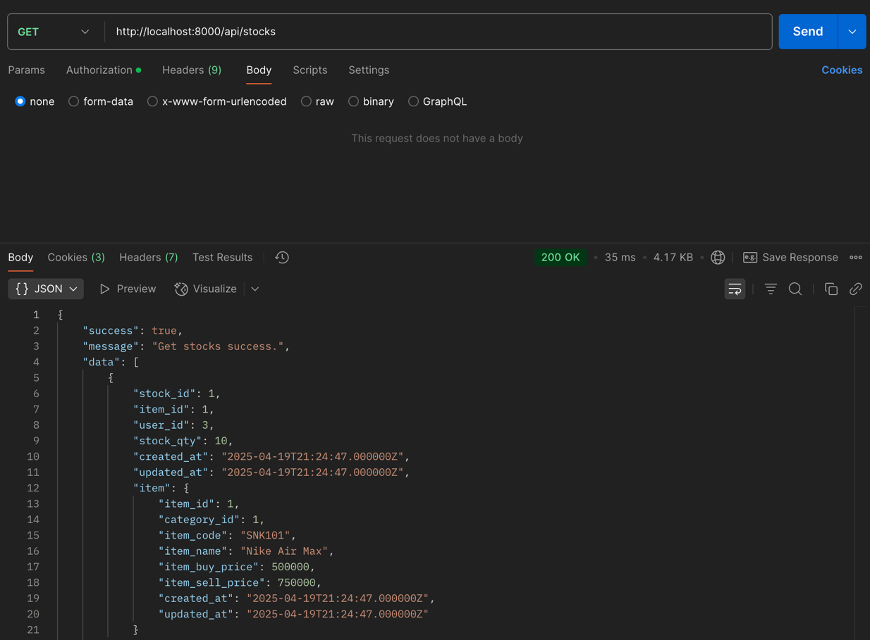
- Successfully Update
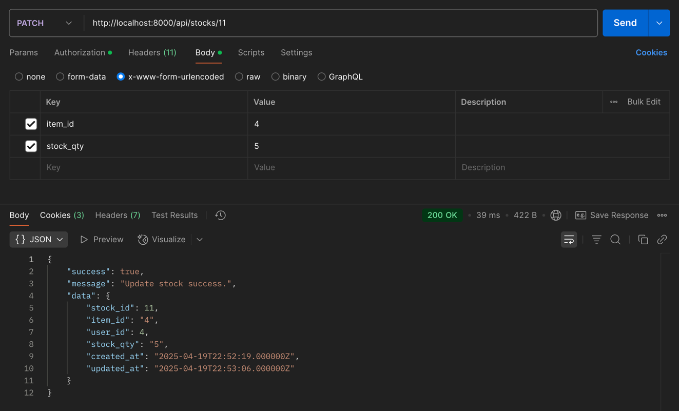

- Successfully Delete
