**PRACTICUM COMPUTER NETWORKING**

**IDENTIFY HARDWARE NETWORK AND DYNAMIC-STATIC IP CONFIGURATION**



**KHEN MUHAMMAD CAHYO**

[**244107023002**](mailto:%32%34%34%310%37%302%33%3002@%70%6f%6cine%6d%61%2e%61%63%2e%69%64)

**TI-2I**

**STATE POLYTECHNIC OF MALANG**

**INFORMATION TECHNOLOGY DEPARTMENT**

1. **IDENTIFY HARDWARE NETWORKING**
2. **Identify in Linux OS**

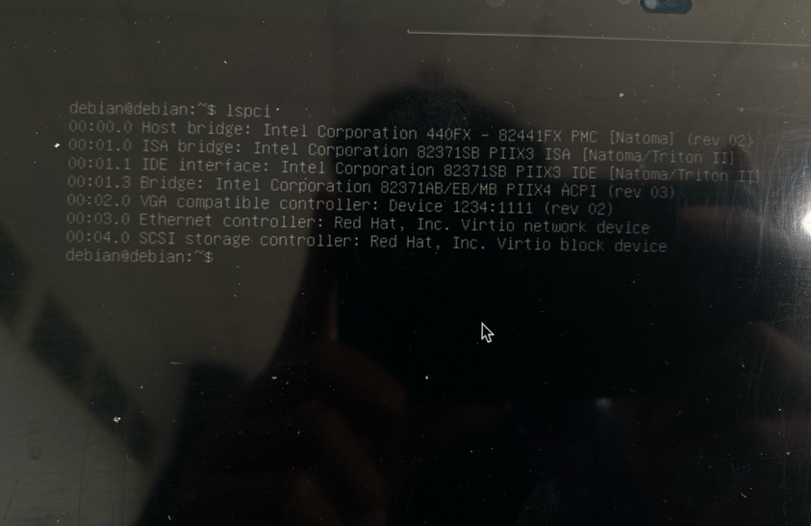

1. **Identify in Windows OS**

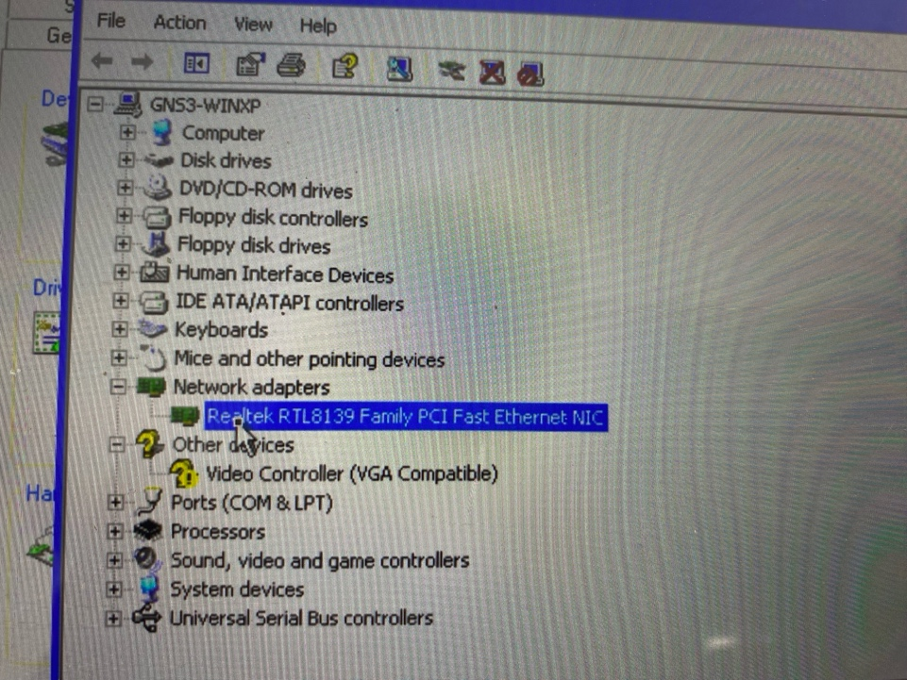

1. **DYNAMIC IP CONFIGURATION**
2. **Configuration in Linux OS**

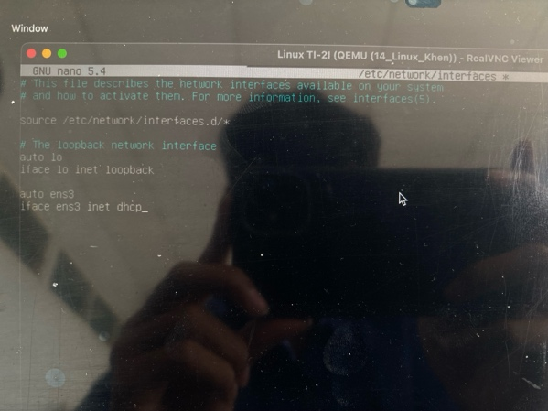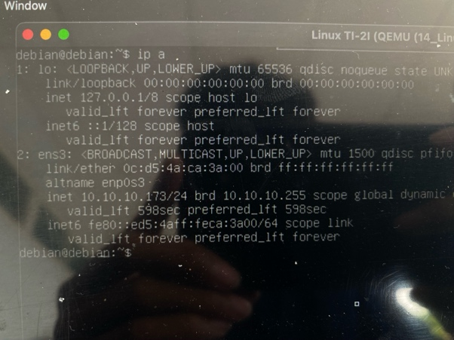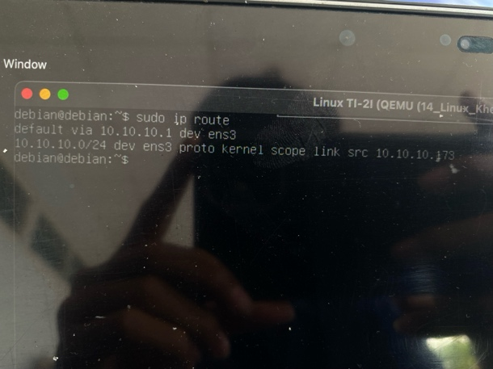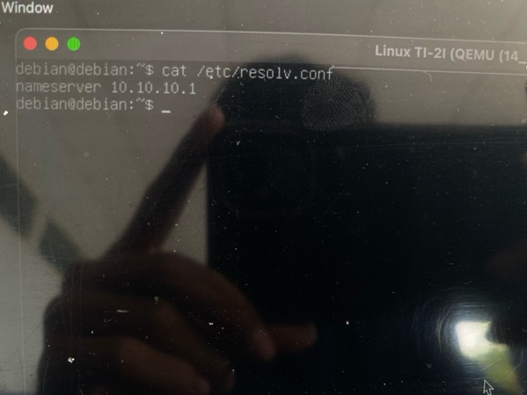

1. **Configuration in Windows OS**

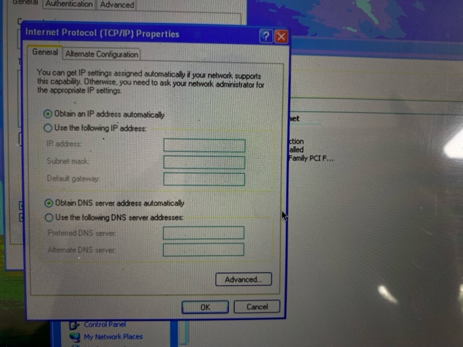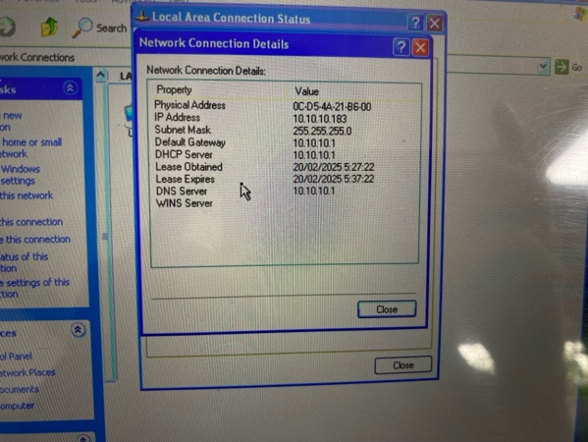

1. **STATIC IP CONFIGURATION**
2. **Configuration in Linux OS**

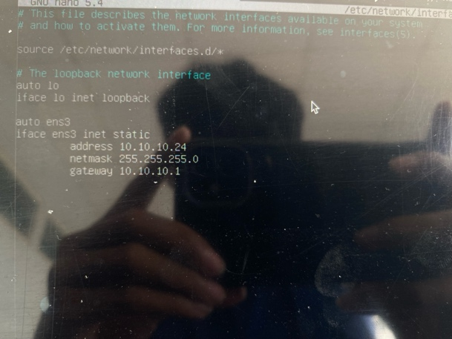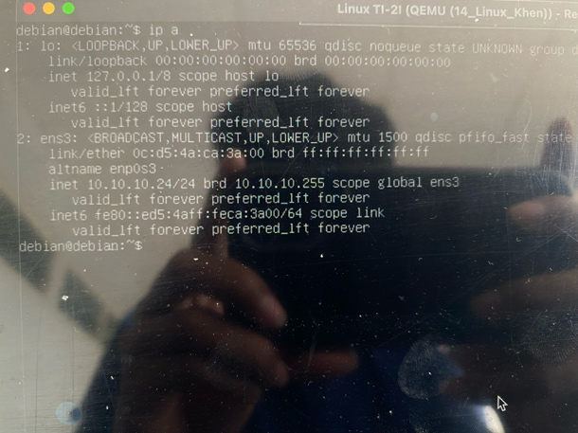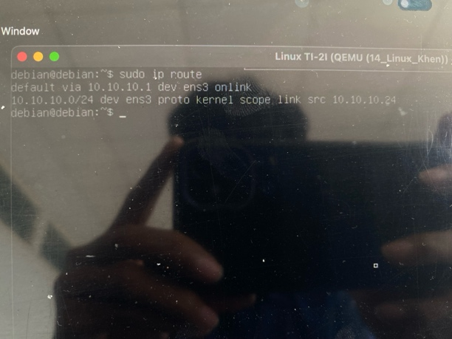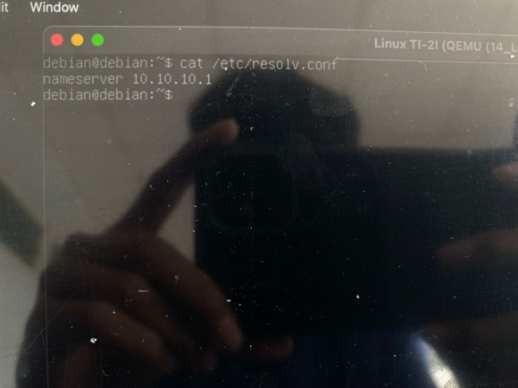

1. **Configuration in Windows OS**

