**PRACTICUM COMPUTER NETWORKING**

**SETUP VIRTUAL LAB**



**KHEN MUHAMMAD CAHYO**

[**244107023002**](mailto:%32%34%34%310%37%302%33%3002@%70%6f%6cine%6d%61%2e%61%63%2e%69%64)

**TI-2I**

**STATE POLYTECHNIC OF MALANG**

**INFORMATION TECHNOLOGY DEPARTMENT**

1. **Setup GNS3**

Here the results of my GNS3 setup:

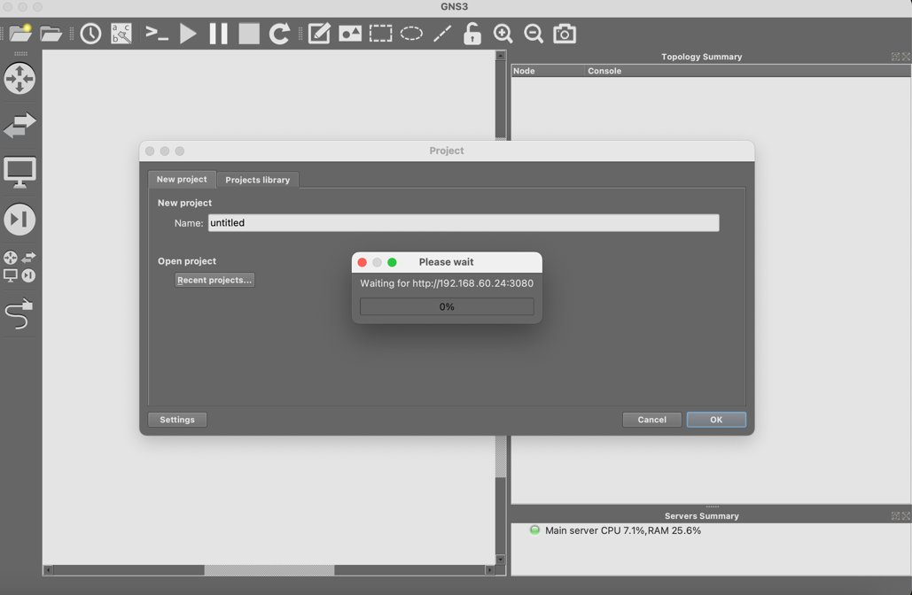

1. **Setup OpenVPN**

Here the results of my OpenVPN setup. This vpn can’t connect to Polinema server because the server disabled by Polinema.

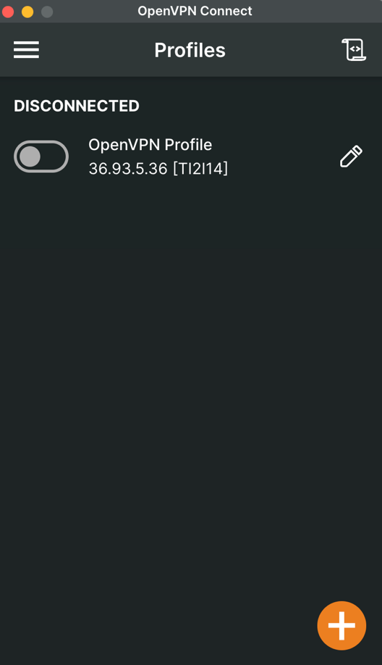

1. **Final Setup**

Here are the results of my final setup which my laptop can connect into GNS3 Polinema server for TI 2I class.

