**ADVANCED WEB PROGRAMMING**

**WEB FRAMEWORK (WEEK-1)**



**KHEN MUHAMMAD CAHYO**

[**244107023002**](mailto:%32%34%34%310%37%302%33%3002@%70%6f%6cine%6d%61%2e%61%63%2e%69%64)

**TI-2I**

**STATE POLYTECHNIC OF MALANG**

**INFORMATION TECHNOLOGY DEPARTMENT**

1. **Laragon Installation**

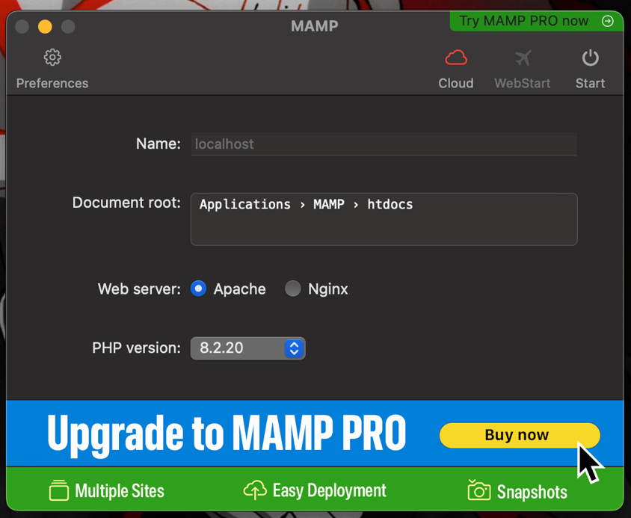

For this course, I used MAMP mam, because in Laragon does’nt supported with MacOS. MAMP also like Laragon which they have local server development and PhpMyAdmin for MySQL interface.

1. **PhpMyAdmin Installation**

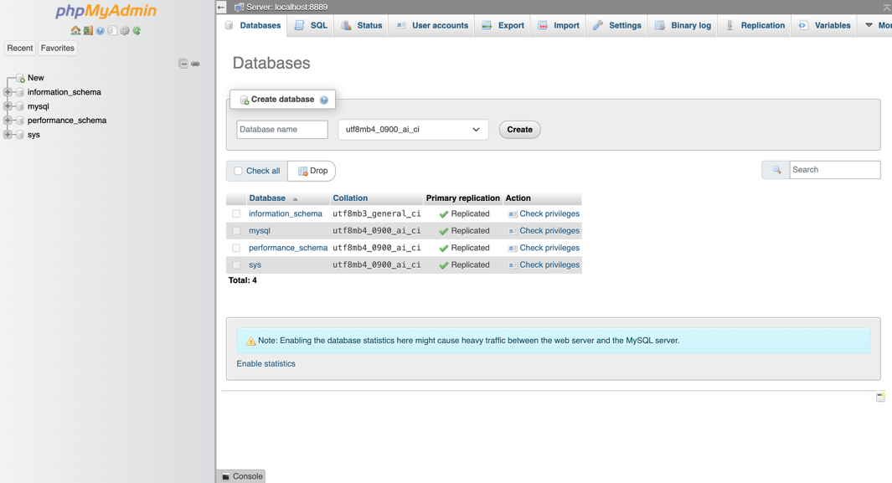

There is my PhpMyAdmin interface for MySQL Database which run by MAMP.

1. **VSCode Installation**

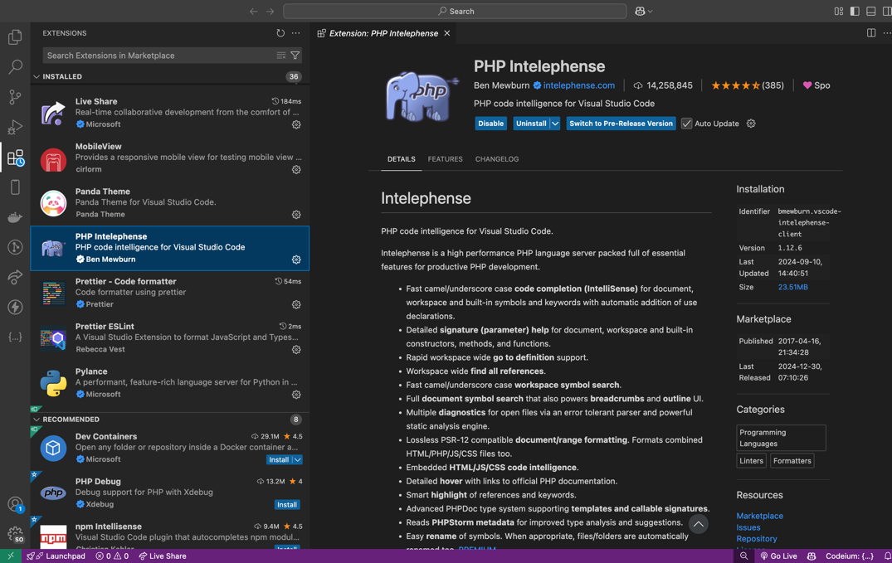

There is my VSCode with PHP Intelephense extension.

1. **Composer Installation**

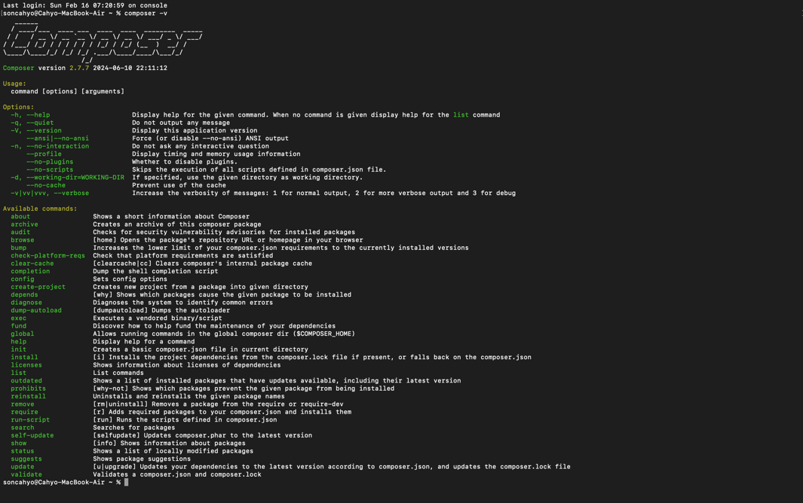

There is my Composer library for dependency manager in PHP.

1. **Git Installation**

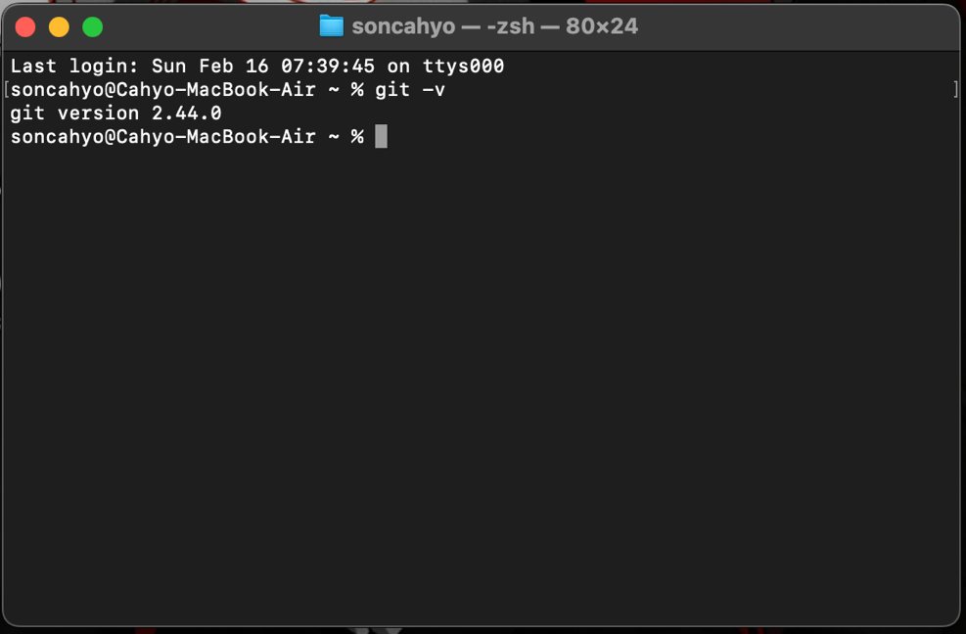

This is a result of Git installation

1. **Laravel Installation**

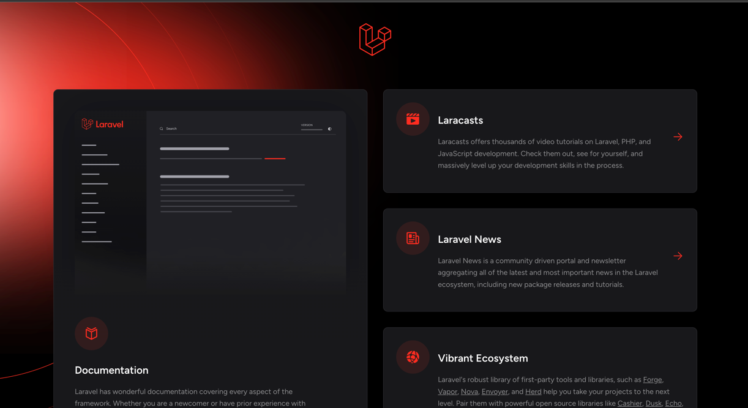

There is a result of Laravel installation.

1. **Publish Laravel Project to Github**

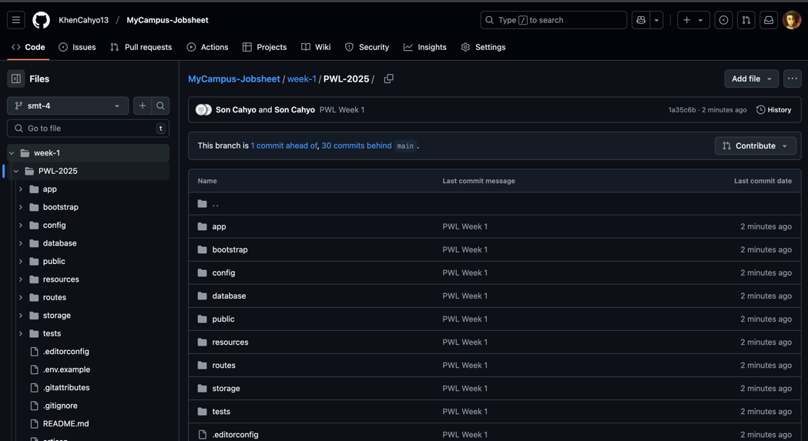

There is a result of publishing Laravel project to my Github account.

1. **Update Program Code and Sync to Github Repo**

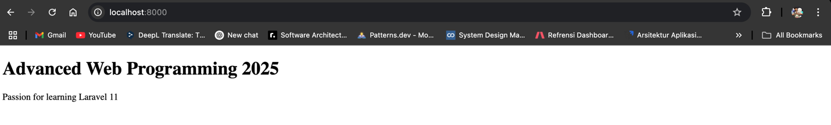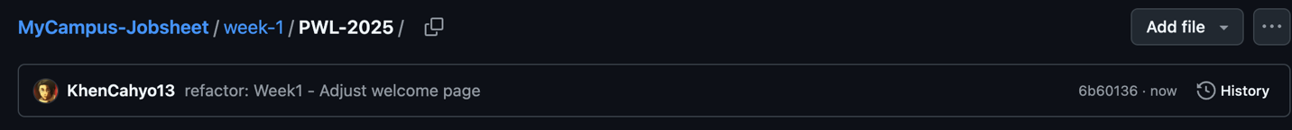

This is a result of updating program code and push it to Github again.