LAB211 Project Report
Car Showroom Management Program

1. Introduction
This report presents the development of the Car Showroom Management system. The application is implemented in Java as a console application using Object-Oriented Programming (OOP) principles and Computational Thinking (CT). The system facilitates the management of brand and car data, supporting essential CRUD (Create, Read, Update, Delete) operations, complex sorting, searching, strict input validation, and reliable persistence of data to text files (brands.txt and cars.txt).

2. Requirement Analysis
The project is based on assignment J1.L.P0032, and adheres closely to it. The primary goal of the project is to create a console-based application capable of managing the core data for a BMW showroom, fulfilling the requirements as described below:
- Manage brand information and store it in brands.txt.
- Manage car information and store it in cars.txt.
- Implement a total of 14 main functions (which can be changed as new implementations arise in the future):
  - List all brands (sorted ascending by name).
  - Add a new brand.
  - Search a brand by ID.
  - Remove a brand by ID.
  - Update a brand by ID.
  - List all brands with prices less than or equal to an input value.
  - List all cars (sorted by brand name ascending, then price descending).
  - Search cars by partial brand name match.
  - Add a new car.
  - Remove a car by ID.
  - Update a car by ID.
  - List all cars by a specific color.
  - Save data to files (brands.txt and cars.txt).
  - Quit program (with mandatory save/discard confirmation and an Autosave/Crash recovery mechanic).

3. Program Development Path
3.1. Project goals
Adhering to the original requirement, the main goal is to fully build a complete, robust, console-based application capable of handling the task of managing the core data for a BMW showroom. This involved establishing a clear data model, implementing full CRUD (Create, Read, Update, Delete) functionality, and ensuring reliable data persistence. To achieve this, the main goal is divided into multiple sub-goals as described below:
- Plan out the implementation of a layout largely based on the Model-View-Controller (MVC) pattern, then use this solid foundation to develop the program forward.
- Define two core entities, Brand and Car, and manage them within dedicated collections (BrandList and CarList).
- Enforce all specified constraints, including the uniqueness of IDs (carID, frameID, engineID) and the strict format for technical identifiers (F00000 and E00000) using a single class dedicated to validation, which also serves as where the scanner is placed for input.
- Implement functions to store and retrieve all data from the pre-provided .txt files (brands.txt and cars.txt) using a defined, delimited format, and implement a read mechanism in these functions to prevent weird situations or corrupted data (see more detail in challenges below). In the meantime, another goal is to plan out a way to set up a complete autosave mechanism, ensuring complete data integrity.
- Provide essential functionality to list data, sort and filter based on required criteria and present all lists according to programmed sorting rules, using a clear tabular format to ensure visibility and ease to understand for viewers.
- Build a complex business implementation to connect everything together and handle business logic, stepping closer to full completion.
- As the program completes for the first time, use multiple means to check for inherent weaknesses in the initial design, and slowly improve the implementation further as new problems inevitably arise.
3.2. Challenges
Developing a management system that ensures high data quality and stability while using a flat-file backend presented several critical challenges.
- The greatest technical challenge was ensuring zero data loss in the event of an unexpected program termination (a crash, power outage, or force-quit). This required moving beyond simple saving and implementing a system that could differentiate between a genuine crash and an intentional user action to discard changes, which goes beyond something most amateur Java programmers can normally do with their knowledge.
- Since the data is stored in easily editable text files, corruption is a high risk. The standard approach of parsing a whole file at once would result in the program crashing upon encountering a single faulty or malformed line. The system needed a mechanism to read data robustly while skipping corrupted lines.
- The initial implementation of sorting using verbose manual comparisons in the compareTo functions of Brand and Car was prone to error and reduced code readability, especially for the complex two-stage car sort.
3.3. Implemented solutions
After a period of developing and updating, the program has implemented several sophisticated solutions to overcome these challenges.
3.3.1. Autosave mechanism
After some time searching and gathering information, an ideal solution has been found for the crash recovery problem, which is the implementation of autosave functions for each time data of the application is modified.
- After each change, data is saved to temporary files (_temp.txt).
- The Auxiliary class is created, which contains a set-up for the intentional_quit.flag file and logic related to this mechanic. If the user explicitly declines to save changes upon quitting, this flag is created, instructing the Shutdown Hook to ignore the unsaved data, honoring the user's decision. Meanwhile, the class itself is open to more developments for other side tasks, not just the management of that flag.
- On program startup, the system checks for temporary files and prompts the user to restore the unsaved data from the last session if there are any.
3.3.2. Faulty data skipping mechanism
To ensure robustness against data corruption, the loading methods in BrandList and CarList were refactored to wrap the entire parsing logic within a line-by-line try-catch block. This allows the program to skip any line that fails validation or parsing, log a clean “Skipping faulty line...” warning, and continue processing the rest of the file without crashing.
3.3.3. Refactoring of sorting functions
To improve code quality and maintenance, the compareTo functions in Brand and Car were refactored to use more complex pre-developed static methods in java.util.Comparator.
- Brand: Uses Comparator.comparing(Brand::getBrandName) for simple ascending sort.
- Car: Uses a chained comparison, Comparator.comparing(...).thenComparing(...), to clearly define the two-stage sort by Brand Name (ascending) and Price (descending).
3.4. Eventual results
The eventual work of this project successfully delivered a robust console application that meets all core requirements and more:
- All core functionalities of the program have been fully implemented and experimented throughout to reduce side effects to the bare minimum, with all outdated, error-prone or generally problematic implementations eventually refactored to ensure the management process could smoothly run and fit all the needs of the user.
- A brand new cascading delete function for Brand is included so that users can remove unwanted or end-of-service BMW brands from the showroom lists.
- All essential validation checks, including the uniqueness of primary keys and complex technical IDs are implemented and enforced at the point of input. This guarantees the quality of data persisted to files.
- The use of an inner try-catch block within the file loading loops allows the system to validate and skip corrupted lines in the text files, ensuring the program does not contain problems due to external file manipulation.
- The implementation of recovery saving functions and intentional_quit.flag mechanism form a vital part of this program’s data storage. This crash recovery system effectively eliminates the risk of losing modified data, which is a critical factor that any data management application must contain.

4. Program Design
4.1. Applying Computational Thinking
4.1.1. Decomposition
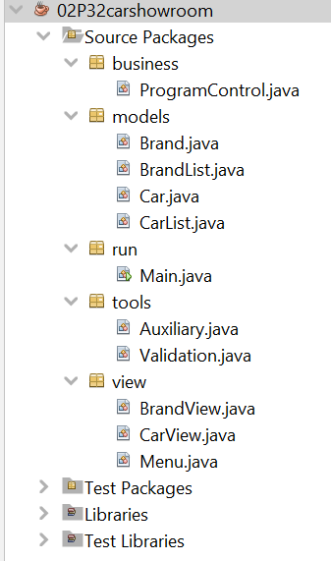
The system is architecturally decomposed into different modules, ensuring modularity and separation of concerns:
- Models module (Brand, Car, BrandList, CarList): Manages data structures (lists), core business logic (sorting, searching, data integrity), and file I/O (loading/saving data).
- View module (BrandView, CarView, Menu): Handles all console input/output, user interface display, and data presentation in correct formats.
- Business module (ProgramControl): Manages the application flow, links the View and Model layers, and controls the state of the program.
- Tools module (Auxiliary and Validation): Encapsulates all input validation and re-prompting logic, ensuring strict adherence to constraints, as well as auxiliary functions for essential operations.
- Run module: Contains the Main class to serve as the program’s entry point.
Figure 1.1. Decomposition of the program
4.1.2. Pattern Recognition
Common patterns implemented in the design would allow the creation of reusable components, which increased consistency and reduced redundant code:
- All major data manipulation operations are fundamentally the same for both Brand and Car. This led to the creation of similar, parallel methods across the BrandList and CarList classes, making editing the code easier.
- All user input that needs validation would require throughout checking (non-empty strings, range bounds, format, uniqueness). This single, recurring requirement was abstracted into the static Validation.java class, centralizing all input checking logic and ensuring consistency across the entire application.
- The process of loading, parsing, and saving data is repeated for both brands.txt and cars.txt. This led to the creation of reusable private load() and save() methods within both BrandList and CarList, handling file paths and I/O exceptions uniformly.
4.1.3. Abstraction
Essential attributes are identified and isolated:
- Brand: brandID, brandName, soundBrand, price.
- Car: carID, brand (reference object), color, frameID, engineID.
- Both Brand.java and Car.java implement the Comparable interface. This enforces the contract that both classes must define a compareTo() method. This allows any external Java utility (like Collections.sort()) to sort lists of these objects without knowing the internal details of how the comparison is performed
Unnecessary implementation details are abstracted into helper methods to focus on core object behaviors.
The file loading methods in BrandList and CarList abstract the raw process of reading text lines, splitting strings by delimiters, and handling NumberFormatException errors. Therefore, ProgramControl only needs to call a simple dedicated load function, not having to worry about line-by-line file access.
4.1.4. Inheritance
While classical inheritance (class-to-class) was not heavily utilized in the primary data models, the project relies more on Composition and Interface Implementation:
- Composition: CarList and BrandList have-a classical ArrayList structure and the Car object has-a Brand object. This is preferred for its flexibility over deep inheritance hierarchies.
- Interface Implementation: As noted above, the use of Comparable and Serializable acts as a structural substitute for inheritance, enforcing necessary methods and contracts.

4.1.5. Algorithm Design
To better understand the program, the below program flows are provided, which details the inner workings of the main menu, as well as each individual primary function that forms the overall program.
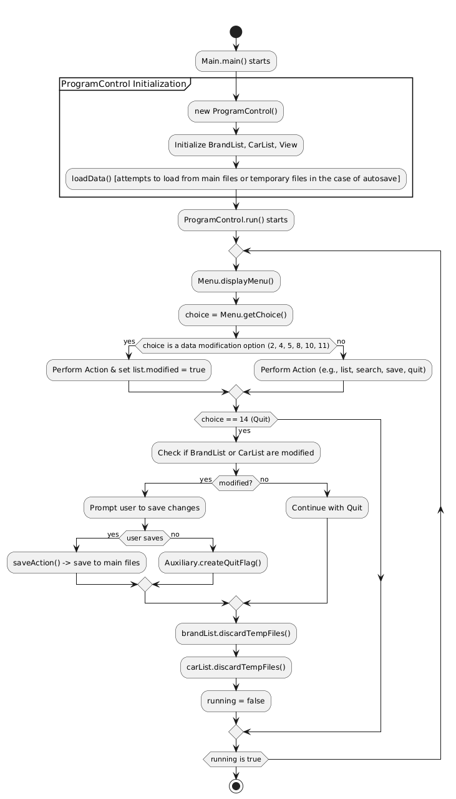
Overall code flow for initialization and main loop
- The program initializes the ProgramControl object, which immediately loads data (and check for recovery files). The flow then enters the main do-while loop:
- The user views the Menu and inputs a Choice.
- ProgramControl routes the choice to the corresponding function.
- If the action modifies data, the modified flag of that action is set to true.
- Upon selecting Quit (14), the program checks for modified flags. If changes exist, the user is prompted to save.
- If the user saves, the data is persisted (see Figure 2.1.13 and its description for more information), and the recovery flags are cleared.
- If the user declines saving, an auxiliary flag is created, confirming that the user will discard changes and cause the program to discard all temporary recovery files in the next session.
Figure 2.1. Program Flow of the overall main loop
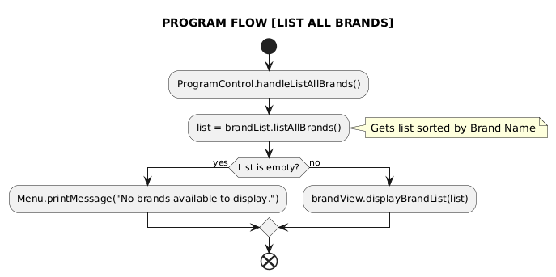
Figure 2.1.1. Program Flow of “1. List all brands (ascending by name)"
List All Brands (1)
- The ProgramControl.handleListAllBrands() function is invoked, which instantly calls brandList.listAllBrands().
- The BrandList internally uses the natural ordering defined in Brand.compareTo(), which sorts the data ascending by brand name.
- The sorted list is returned to the controller, which passes it to brandView.displayBrandList().
- The BrandView prints the data in a formatted, tabular layout, or prints an appropriate message if the list is empty.

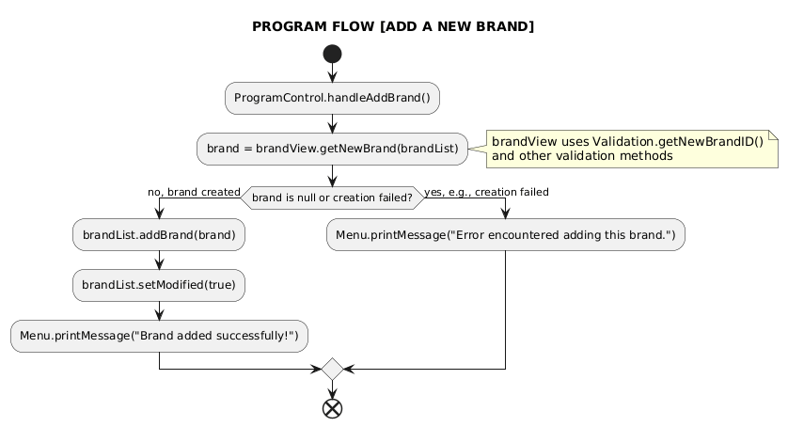
Figure 2.1.2. Program Flow of “2. Add a new brand"
Add a New Brand (2)
- The ProgramControl.handleAddBrand() function delegates to the view: brandView.getNewBrand(brandList), prompting the user for all four required fields: ID, Name, Sound Brand, and Price. Each field is validated by Validation methods, and if any validation fails, the user is prompted to re-enter the data.
- If a valid Brand object is successfully created, the controller calls brandList.addBrand(brand). If it somehow fails, a message is outputted signifying a failure occurred.
- The BrandList.setModified(true) flag is set, signaling unsaved data.
- A message is displayed signaling success (if it does succeed).

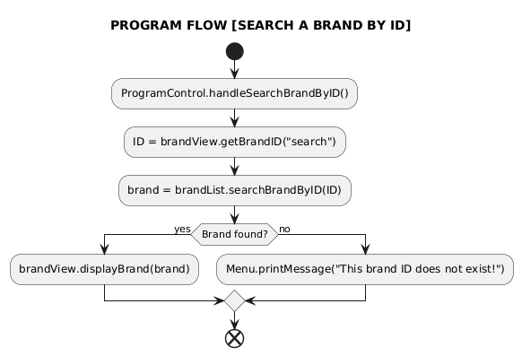
Figure 2.1.3. Program Flow of “3. Search a brand by ID"
Search a Brand by ID (3)
- The BrandView.getBrandID("search") function obtains the desired ID from user input.
- The controller calls brandList.searchBrandByID(ID) to locate the object. If:
- Found: If the object is returned, the controller passes it to brandView.displayBrand() for detailed output.
- Not Found: If the result is null, the controller outputs a message signaling the object’s nonexistence.

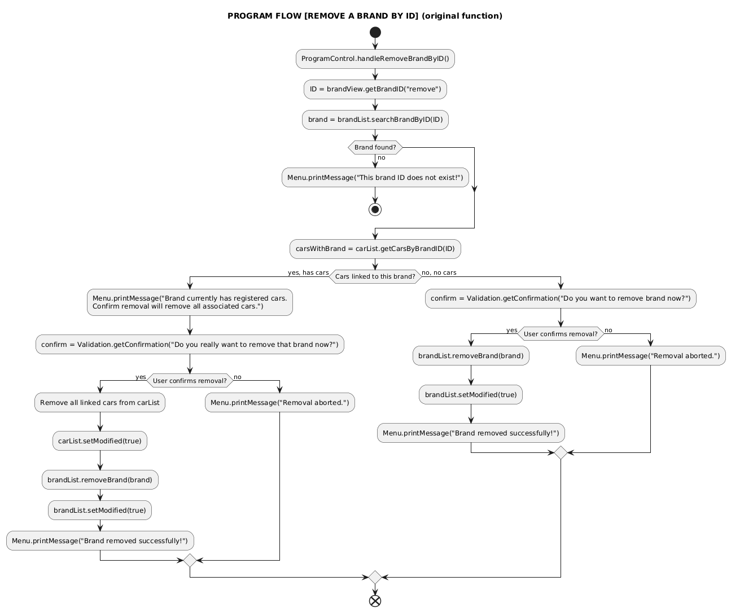
Figure 2.1.4. Program Flow of “4. Remove a brand by ID"
Remove a Brand by ID (4) [original function not from requirements]
- The controller retrieves the ID and searches for the target Brand. If not found, the operation terminates immediately with an error message.
- The controller calls carList.getCarsByBrandID(ID) to see if any Car objects are currently linked to this brand.
  - If cars are linked: The program shows information on linked cars and prompts confirmation via Validation.getConfirmation() to proceed with the removal of both the brand and all linked cars (a cascading delete).
  - If confirmed: The controller first instructs carList to remove all linked cars, then instructs brandList to remove the Brand. Both lists' modified flags are set to true.
  - If not, a simple message will be displayed, signaling abortion
  - If cars are not linked: Similarly to when cars a linked, but the controller only removes the brand instead if confirmed, and the message from Validation.getConfirmation() is different.
- If user proceeds with deletion, a message is displayed based on whether a single brand was removed or a brand and multiple cars were removed.

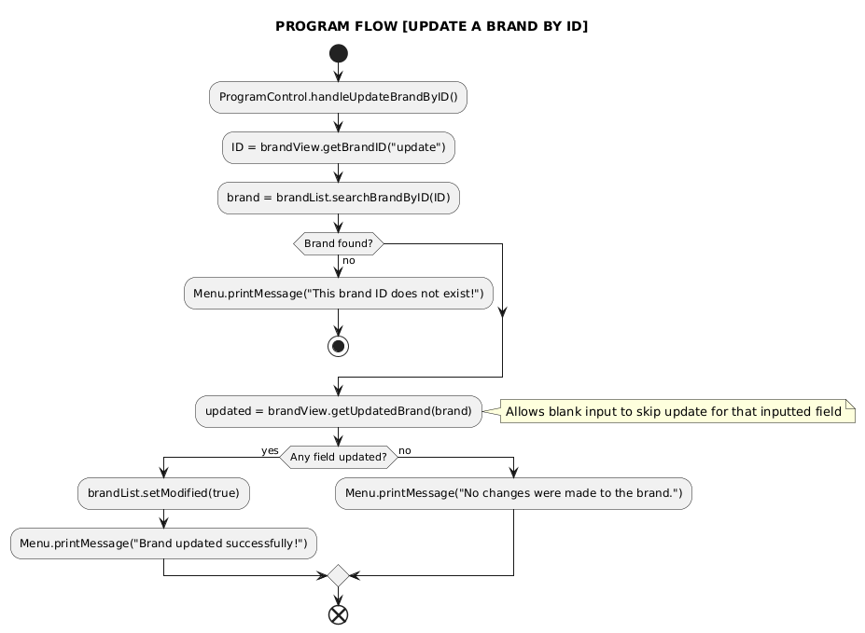
Figure 2.1.5. Program Flow of “5. Update a brand by ID”
Update a Brand by ID (5)
- The controller searches for the target Brand by ID. If not found, the operation stops, and a single message indicating object not found is presented.
- The found Brand object is passed to brandView.getUpdatedBrand(brand).
- The BrandView prompts the user for new Name, Sound Brand, and Price.
- Leaving an input blank skips the update for that field, allowing for partial modification. Any field that needs validation is validated on input.
- If the BrandView logic detects that any field was successfully changed, it returns true. The controller then sets brandList.setModified(true).
- Depending on if any field is updated, a message is shown that the Brand was updated, or a message confirming that no changes were made.

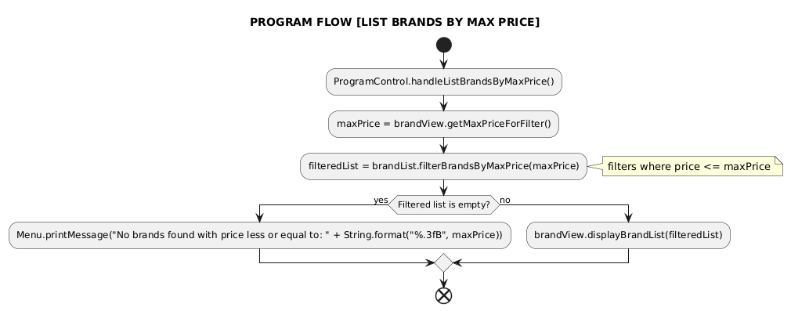
Figure 2.1.6. Program Flow of “6. List all brands with prices <= input value"
List Brands by Max Price (6)
- The controller calls brandView.getMaxPriceForFilter() to get the maximum price threshold from the user.
- The controller passes this value to brandList.filterBrandsByMaxPrice(maxPrice).
- The BrandList iterates through its collection, filtering for all Brand objects where price <= maxPrice.
- The filtered list (which is also sorted by the default Brand comparison) is displayed by brandView.displayBrandList().
- The list of matching brands is shown, or a message indicating no brands were found in the specified range.
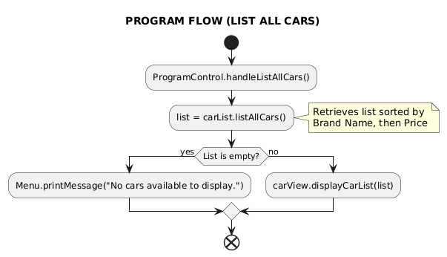
Figure 2.1.7. Program Flow of “7. List all cars (ascending by brand name)"
List All Cars (7)
- The ProgramControl.handleListAllCars() function is invoked, which then instantly calls carList.listAllCars().
- The CarList returns the collection, which is sorted using the logic defined in Car.compareTo(): Ascending order of brand names, then descending order of price (for cars under the same brand).
- The sorted list is passed to carView.displayCarList().
- The CarView prints the data in a formatted, tabular layout, or prints an appropriate message if the list is empty.

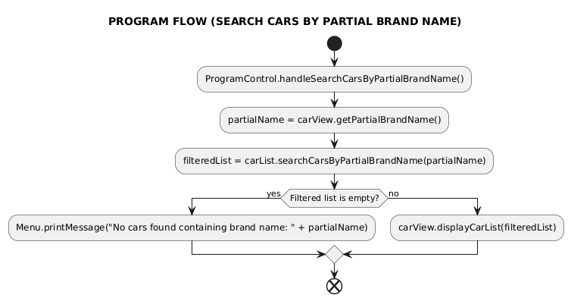
Figure 2.1.8. Program Flow of “8. Search cars by partial brand name"
Search Cars by Partial Brand Name (8)
- The controller requests the search term via carView.getPartialBrandName().
- The controller calls carList.searchCarsByPartialBrandName(partialName).
- The CarList iterates through its stored cars, checking if the brand name of each car contains the input provided by user (case-insensitive search).
- The filtered list is passed to carView.displayCarList().
- The list of matching cars is displayed, or a message is shown indicating no cars match.

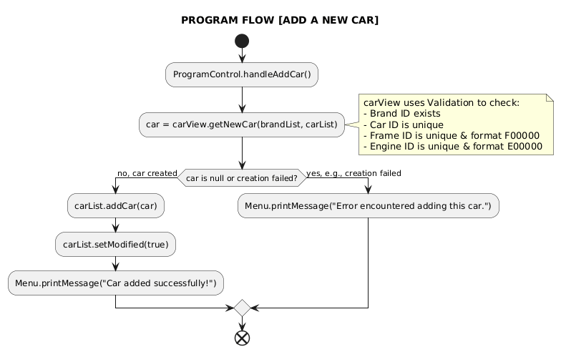
Figure 2.1.9. Program Flow of “9. Add a new car"
Add a New Car (9)
- The controller calls carView.getNewCar(brandList, carList).
- The CarView collects and attempts to validate all required fields:
  - Brand ID: Must exist in the BrandList
  - Car ID: Must be unique within the CarList.
  - Color: Must be a non-empty string.
  - Frame ID (F00000): Must be in the required format and unique within the CarList.
  - Engine ID (E00000): Must be in the required format and unique within the CarList.
- If a valid Car object is successfully created, the controller calls carList.addCar(car). If it somehow fails, a message is outputted signifying a failure occurred.
- The CarList.setModified(true) flag is set, signaling unsaved data.
- A message is displayed signaling success (if it does succeed).
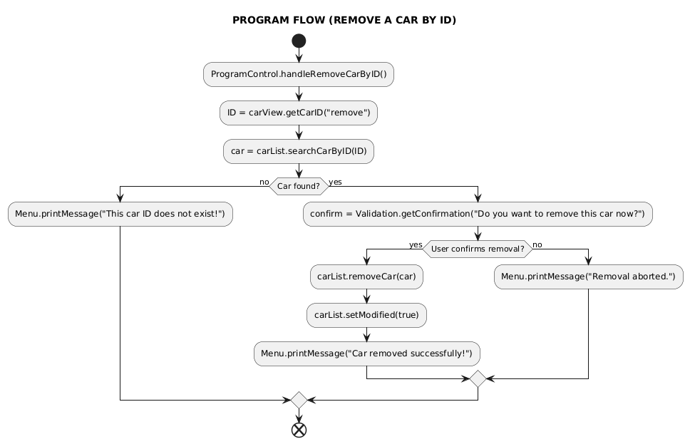
Figure 2.1.10. Program Flow of “10. Remove a car by ID"
Remove a Car by ID (10)
- The controller obtains the ID via carView.getCarID("remove") and searches for the car using carList.searchCarByID(ID). If not found, the operation terminates immediately with an error message.
- The controller uses Validation.getConfirmation() to confirm if user wants to remove the object now. If the user confirms:
- The controller calls carList.removeCar(car).
- The CarList.setModified(true) flag is set.
- A message indicates the car was removed, or confirms the removal was aborted.
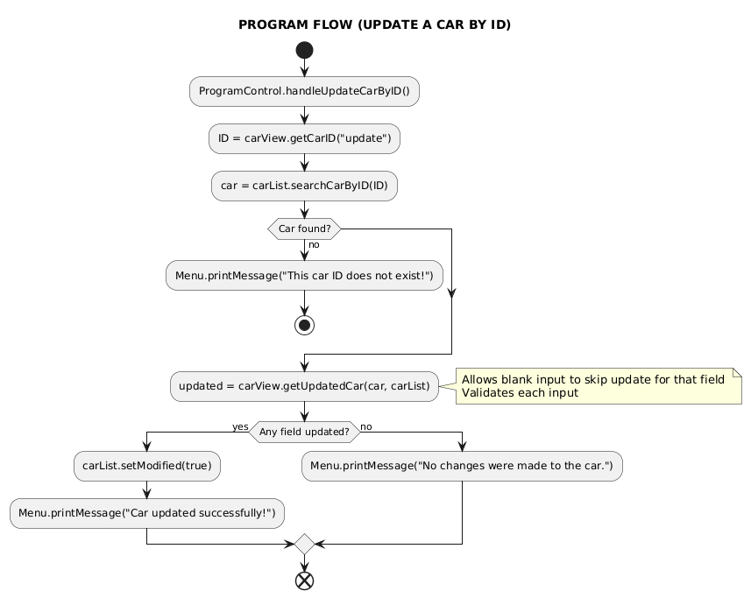
Figure 2.1.11. Program Flow of “11. Update a car by ID"
Update a Car by ID (11)
- The controller searches for the target Car by ID. If not found, the operation with a message.
- The found Car object is passed to carView.getUpdatedCar(car, carList).
- The CarView prompts for new Color, Frame ID, and Engine ID.
- Leaving an input blank skips the update for that field, allowing for partial modification. Any field that needs validation is validated on input.
- If the view returns true (signaling any field was successfully changed), the controller sets carList.setModified(true).
- Depending on if any field is updated, a message is outputted showing that the Car was updated, or no changes were made.
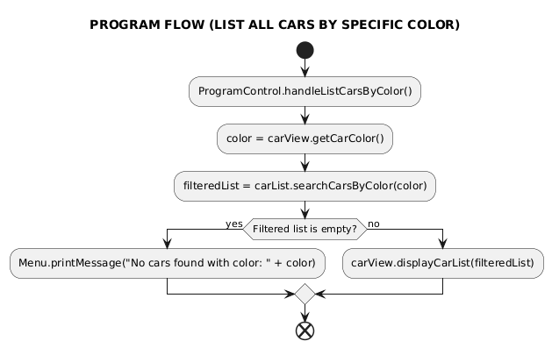
Figure 2.1.12. Program Flow of “12. List all cars by a specific color"
List all Cars by specific Color (12)
- The controller calls carView.getCarColor() to get the color string.
- The controller calls carList.searchCarsByColor(color).
- The CarList returns a list containing all cars whose color matches the input string (typically case-insensitive).
- The filtered list is passed to carView.displayCarList().
- The list of matching cars is displayed, or a message is shown indicating no cars match.
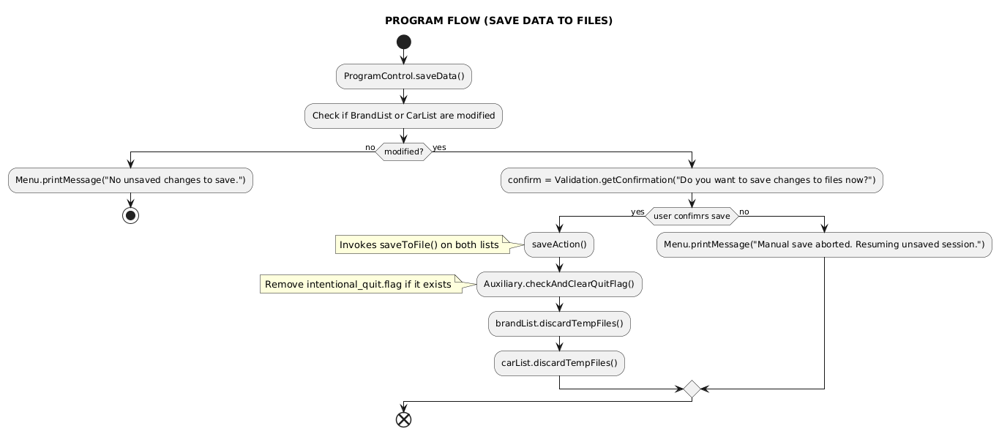
Figure 2.1.13. Program Flow of “13. Save data to files"
Save Data to Files (13)
- The ProgramControl.handleSaveData() function is invoked.
- The function first checks the modification flags. If there is no change, it simply displays a message before backing out to the menu. If there are unsaved changes, it then prompts the user for confirmation with Validation.getConfirmation().
- If confirmed, the controller calls brandList.saveToFile() and carList.saveToFile(). These functions write the current data to the permanent brands.txt and cars.txt files and set their internal modified flags to false.
- If saving is successful, the controller then calls Auxiliary.checkAndClearQuitFlag() to delete the crash recovery flag and instructs both lists to discardTempFiles(), ensuring a clean state.
- A message is displayed indicating the data has been successfully saved to the files, or saving is aborted if initially not confirmed.

4.2. System Design (UML)
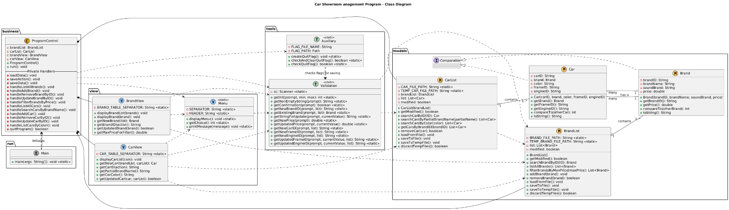
Figure 2.2. UML class diagram of the application
The UML Class Diagram illustrates the four key modules of the application: models, view, business, and tools.
Models module (data core)
Brand and Car: Fundamental entities. They are serializable and implement the Comparable interface to define specific sorting rules as requested by the original project requirements.
BrandList and CarList: Manage collections of their respective entities. They encapsulate all file operations (load, save, temp file handling) and implement search/filter algorithms. Car has a "has-a" relationship with Brand. The CarList class depends on the BrandList to ensure referential integrity (every car's brandID must correspond to an existing Brand object).
Tools module (utilities)
Validation: Provides static utility methods for ensuring data integrity by validating every input using provided constraints (non-empty strings, price format, unique IDs, F00000/E00000 format).
Auxiliary: Manages side features of the program, currently only having the intentional_quit.flag file, used to distinguish between an intentional save-skip exit and an unexpected program crash.
View module (user interface)
Menu: A static utility for displaying the main menu and obtaining the user's initial choice.
BrandView and CarView: Handle all user interactions specific to their entities:
- Prompting the user for new data or updated fields, heavily relying on the Validation class.
- Displaying lists and single objects in a clear, formatted, tabular manner.
Business module (the controller)
ProgramControl: Embodies the core business logic, including:
- Composition of BrandList, CarList, BrandView, and CarView. It acts as the intermediary, receiving user choices from the Menu and delegating execution to the appropriate List (Model) or View components.
- Management of the entire lifecycle, including data loading, registering the advanced Shutdown Hook for crash recovery, and orchestrating the final quit sequence.
Run module (Main runner)
Main: The entry point of the program, initiating the program from here.
Quick summary of key components and relationships:
- Main initiates ProgramControl.
- ProgramControl holds instances of BrandList, CarList, BrandView, and CarView. It directs all data flow and program execution.
- BrandList and CarList manage their respective collections, data loading/saving, and core business logic. CarList is dependent on BrandList.
- Brand and Car are the core data entities. Car has a compositional relationship with Brand.
- BrandView and CarView handle user interaction and presentation.
- Validation provides means to instantly validate every input with provided constraints.

5. Implementation & Testing
The application is implemented using the Java standard library, focusing on console I/O, file handling, and collections.
Specialized Features:
- Implements Comparable for both Brand sorting and Car sorting.
- Brand new Remove a Brand by ID function.
- All IDs are stored in uppercase, and car colors are stored in lowercase, ensuring search and storage integrity regardless of user input case.
- An autosaving mechanism is registered in ProgramControl to automatically save unsaved data to temporary files (_temp.txt) upon unexpected termination, which are loaded on the next startup if detected.
Main Test Cases:
Primary examples of important test cases:
- Test adding with duplicate ID, invalid format, non-existent foreign key (Brand ID).
- Test updating with blank input (skip), entering the same data (should not count as modified), and entering a duplicate ID (for Frame/Engine).
- Test car listing to verify correct sorting criteria.
- Test saving and quitting to confirm the modified flag is correctly managed and data persists.
For more details on test cases, see 6. Experimental Results below.

6. Experimental Results
A brief introduction before we continue:
- In this portion of the report, we will discover the testing results of the completed application. This will include screenshots of the program output on the currently used environment (in this case, NetBeans 13), alongside tables detailing the input/output process and result.
- For the details on what and how the program and each individual menu option actually work, revisit 4. Program Design, especially 4.1.5. Algorithm Design and the series of figures from Figure 2.1 and it’s derived figures.
- These testing will not contain everything at once, only enough testing to ensure all functionalities return no errors or unexpected outcomes, only invalid inputs properly failing and returning appropriate messages, and valid inputs working successfully.
- Most of the functions here accept inputs and verify them without caring about case (CASE INSENSITIVE), so most inputs of case insensitive functions shown here will be in lowercase to save time.
- This version of the program is the “completed” version, with everything detailed in this report implemented. But if any new functionality is included in the future, some of these tests might get outdated, so treat this as how this current version works.

Initial loadup test with erroneous lines in both txt files
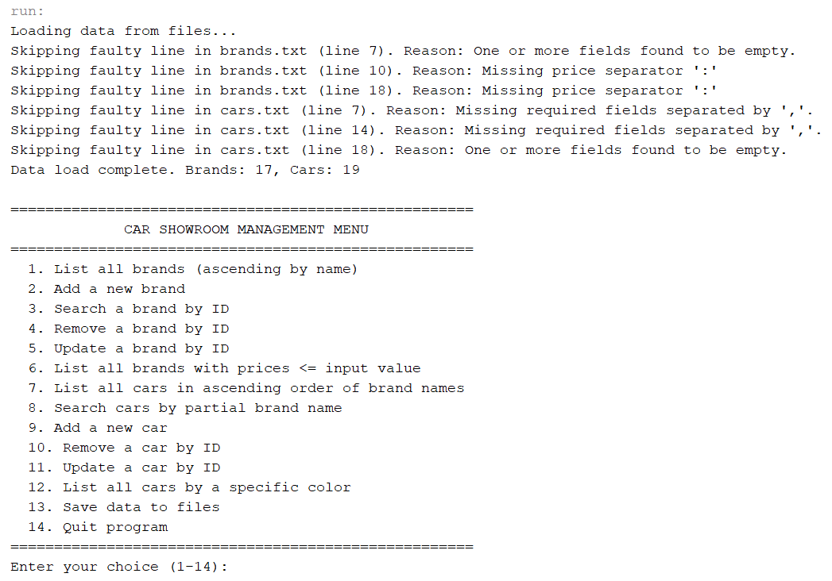
Figure 3.1.1a. Load-up test with erroneous lines in .txt files
Details:  brand.txt error lines:  - , , error: 17  - something error line here  - , , more errors  car.txt error lines:  - something error line here  - CXX, BMW, nothing  - , , , , G11111 | Testing result:  Loading data from files…  *messages indicating the existence of faulty lines in .txt files and the current program session skipping them*  Data load complete. Brands: [no. of brands], Cars: [no. of cars]
Table 3.1.1. Load-up test details
Notes:
- For the sake of testing, either these faulty lines are manually included into the .txt files, or brand new .txt files with the exact name, but different values and containing faulty lines are included in the same directory instead. These are the only methods to include these lines for load-up testing due to the completed application now validating and parsing these objects very strictly, with no room for error. The program would then skip these lines (Figure 3.1.1a) using the line-by-line try-catch block in the collection classes in Models module as described in 3.3.2. Faulty data skipping mechanism.
- After we have manually included faulty lines in the .txt files, if a .txt file is saved, the data in the file will be overwritten by the data that the program currently holds. This would also eliminate all faulty lines in that .txt file, and the next session will no longer output the skipping faulty lines belonging to that file due to these no longer existing. For example:
- If brands.txt is saved and not cars.txt, faulty lines in brands.txt are overwritten entirely, so for the next time the program loads, it will only display message signaling the existence of faulty lines in cars.txt only (Figure 3.1.1b), and vice versa if we save cars.txt and not brands.txt.
- If both files are saved, all faulty lines are eliminated, and the next session of the program would no longer be displaying these messages at startup, indicating all faulty lines are erased and data in both .txt files are now correct.
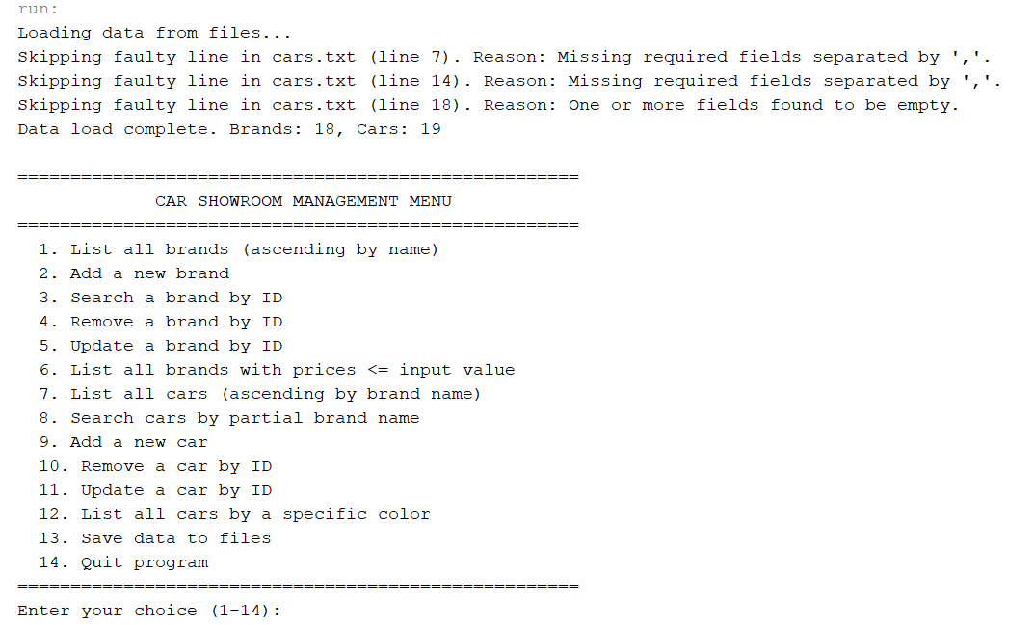
Figure 3.1.1b. The same load-up as Figure 3.1.1a, but after saving only brands.txt

Testing invalid choices input for menu
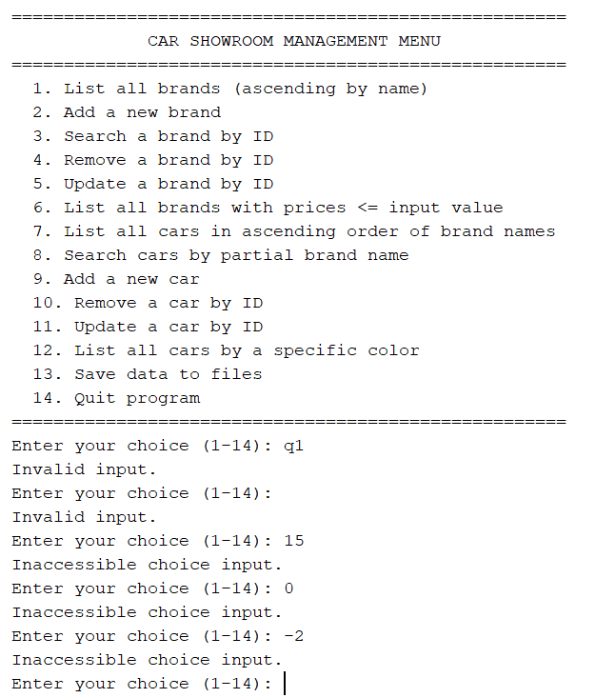
Figure 3.1.2. Testing with invalid menu choice inputs
Details
Menu Input | Output | Testing Result
q1 | Invalid input | FAILURE
 | Invalid input | FAILURE
15 | Inaccessible choice input | FAILURE
0 | Inaccessible choice input | FAILURE
-2 | Inaccessible choice input | FAILURE
Table 3.1.2. Invalid menu input details

Testing “1. List all brands (ascending by name)”
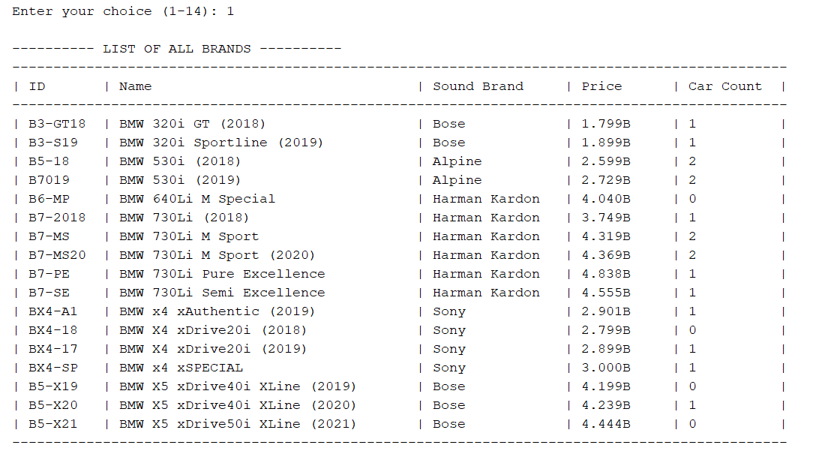
Figure 3.2.1. Testing “1. List all brands (ascending by name)"
Details
Menu Input | Output | Testing Result
1 | ---- LIST OF ALL BRANDS ----  *detailed table sorted by ascending brand name* | SUCCESS
Table 3.2.1. Details of testing menu option 1

Testing “2. Add a new brand”
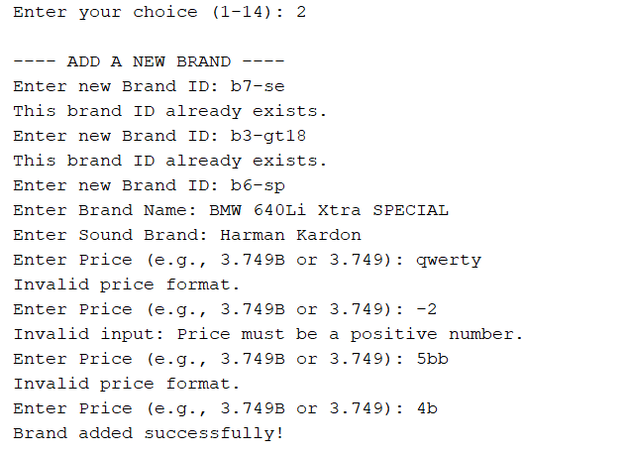
Figure 3.2.2. Testing “2. Add a new brand"
Details
Menu Input | Output | Testing Result
2 | ---- ADD A NEW BRAND ----  Enter new Brand ID: | SUCCESS
Table 3.2.2a. Details of testing menu option 2
Details
Prompt | Input | Output | Testing Result
Enter new Brand ID: | b7-se | This brand ID already exists. | FAILURE
Enter new Brand ID: | b3-gt18 | This brand ID already exists. | FAILURE
Enter new Brand ID: | b6-sp | *nothing, indicating success* | SUCCESS
Enter Brand Name: | BMW 640Li Xtra SPECIAL | *nothing, indicating success* | SUCCESS
Enter Sound Brand: | Harman Kardon | *nothing, indicating success* | SUCCESS
Enter Price (e.g., 3.749B or 3.749): | Qwerty | Invalid price format. | FAILURE
Enter Price (e.g., 3.749B or 3.749): | -2 | Invalid input: Price must be a positive number. | FAILURE
Enter Price (e.g., 3.749B or 3.749): | 5bb | Invalid price format. | FAILURE
Enter Price (e.g., 3.749B or 3.749): | 4b | *nothing, indicating success* | SUCCESS
Brand added successfully! |  |  | SUCCESS
Table 3.2.2b. Details of testing adding a new brand
Notes:
- These tests all refer to Figure 3.2.1. test result for unique ID testing.
- For Brand Name and Sound Brand, there is no validation and nothing going on, so the input is normal and standard like other values for the sake of consistency.

Testing "3. Search a brand by ID"
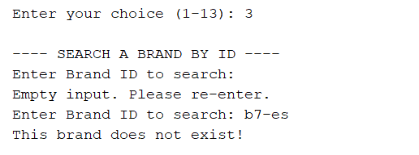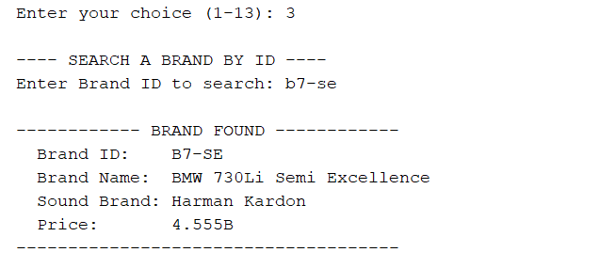
Figure 3.2.3. Testing “3. Search a brand by ID"
Details
Menu Input | Output | Testing Result
3 | ---- SEARCH A BRAND BY ID ----  Enter Brand ID to search: | SUCCESS
Table 3.2.3a. Details of testing menu option 3
Details
Prompt | Input | Brand with inputted ID found? | Output | Testing Result
Enter Brand ID to search: | b7-es | no | This brand does not exist! | SUCCESS
Enter Brand ID to search: | b7-se | yes | ---- BRAND FOUND ----  *details of Brand with inputted ID* | SUCCESS
Table 3.2.3b. Details of testing search brand by ID

Testing “4. Remove a brand by ID”
Details
Menu Input | Output | Testing Result
4 | ---- REMOVE A BRAND BY ID ----  Enter Brand ID to remove: | SUCCESS
Table 3.2.4a. Details of testing menu option 4

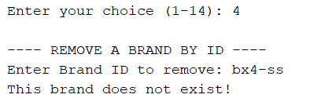
Figure 3.2.4a. Testing “4. Remove a brand by ID" case brand not found
Details
Prompt | Input | Targeted Brand Status | Output | Testing Result
Enter Brand ID to remove: | bx4-ss | Not found | This brand does not exist! | SUCCESS
Table 3.2.4b. Details of not finding a brand to remove

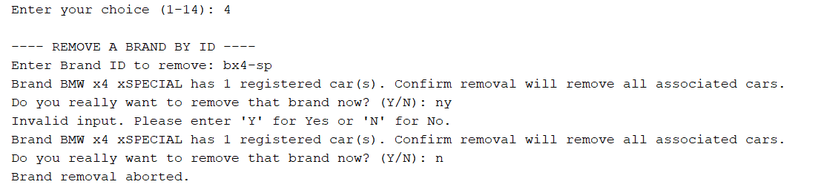
Figure 3.2.4b. Testing “4. Remove a brand by ID" case invalid confirmation input and aborting removal
Details
Prompt | Input | Targeted Brand Status | Output | Testing Result
Enter Brand ID to remove: | bx4-sp | Found, has 1 car | Brand BMW x4 xSPECIAL has 1 registered car(s). Confirm removal will remove all associated cars.  Do you really want to remove that brand now? (Y/N): | SUCCESS
Do you really want to remove that brand now? (Y/N): | ny | Unchanged due to invalid input | Invalid input. Please enter 'Y' for Yes or 'N' for No. | FAILURE
Do you really want to remove that brand now? (Y/N): | n | Not removed, still exist in list | Brand removal aborted. | SUCCESS
Table 3.2.4c. Details of aborting removal of a brand

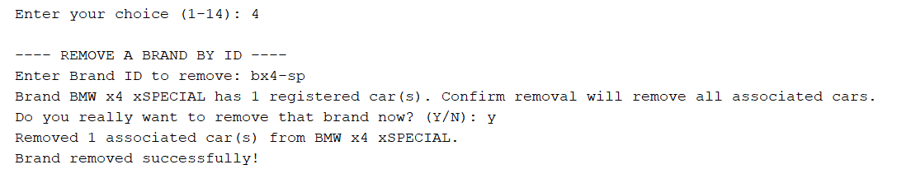
Figure 3.2.4c. Testing “4. Remove a brand by ID" case remove brand with car
Details
Prompt | Input | Targeted Brand Status | Output | Testing Result
Enter Brand ID to remove: | bx4-sp | Found, has 1 car | Brand BMW x4 xSPECIAL has 1 registered car(s). Confirm removal will remove all associated cars.  Do you really want to remove that brand now? (Y/N): | SUCCESS
Do you really want to remove that brand now? (Y/N): | y | Removed, along with its linked car(s) | Removed 1 associated car(s) from BMW x4 xSPECIAL.  Brand removed successfully! | SUCCESS
Table 3.2.4d. Details of removing a brand with car

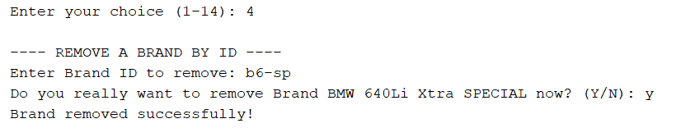
Figure 3.2.4d. Testing “4. Remove a brand by ID" case remove brand without car
Details
Prompt | Input | Targeted Brand Status | Output | Testing Result
Enter Brand ID to remove: | b6-sp | Found, has no car | Do you really want to remove Brand BMW 640Li Xtra SPECIAL now? (Y/N): | SUCCESS
Do you really want to remove Brand BMW 640Li Xtra SPECIAL now? (Y/N): | y | Removed | Brand removed successfully! | SUCCESS
Table 3.2.4e. Details of removing a brand without car
Notes:
- These tests all refer to Figure 3.2.1. test result for checking status of targeted brand.
- The message and action for aborting removal are the same regardless of the targeted brand has a car or not, so its test only appears once.

Testing “5. Update a brand by ID”
Details
Menu Input | Output | Testing Result
5 | ---- UPDATE A BRAND BY ID ----  Enter Brand ID to update: | SUCCESS
Table 3.2.5a. Details of testing menu option 5

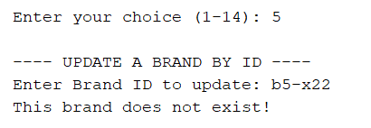
Figure 3.2.5a. Testing “5. Update a brand by ID" case brand not found
Details
Prompt | Input | Targeted Brand Status | Output | Testing Result
Enter Brand ID to update: | b5-x22 | Not found | This brand does not exist! | SUCCESS
Table 3.2.5b. Details of not finding a brand to update
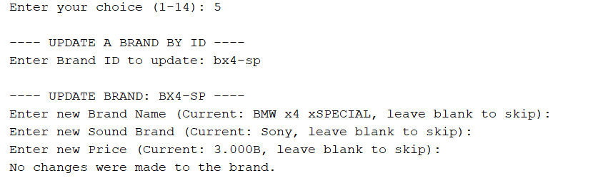
Figure 3.2.5b. Testing “5. Update a brand by ID" case skip all updates
Details
Prompt | Input | Targeted Brand Status | Output | Testing Result
Enter Brand ID to update: | bx4-sp | Found | ---- UPDATE BRAND: BX4-SP ----  Enter new Brand Name (Current: BMW x4 xSPECIAL, leave blank to skip): | SUCCESS
Enter new Brand Name (Current: BMW x4 xSPECIAL, leave blank to skip): |  | Kept old value |  | SUCCESS
Enter new Sound Brand (Current: Sony, leave blank to skip): |  | Kept old value |  | SUCCESS
Enter new Price (Current: 3.000B, leave blank to skip): |  | Kept old value |  | SUCCESS
No changes were made to the brand. |  |  |  | SUCCESS
Table 3.2.5b. Details of skipping all updates to a brand

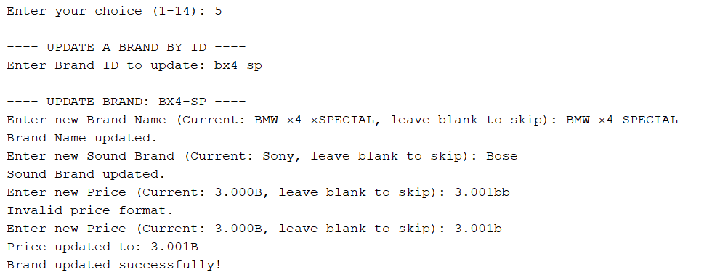
Figure 3.2.5c. Testing “5. Update a brand by ID" case with updates
Details
Prompt | Input | Targeted Brand Status | Output | Testing Result
Enter Brand ID to update: | bx4-sp | Found | ---- UPDATE BRAND: BX4-SP ----  Enter new Brand Name (Current: BMW x4 xSPECIAL, leave blank to skip): | SUCCESS
Enter new Brand Name (Current: BMW x4 xSPECIAL, leave blank to skip): | BMW x4 SPECIAL | Updated | Brand Name updated. | SUCCESS
Enter new Sound Brand (Current: Sony, leave blank to skip): | Bose | Updated | Sound Brand updated. | SUCCESS
Enter new Price (Current: 3.000B, leave blank to skip): | 3.001bb | *invalid input, prompt again* | Invalid price format. | FAILURE
Enter new Price (Current: 3.000B, leave blank to skip): | 3.001b | Updated | Price updated to: 3.001B | SUCCESS
Brand updated successfully! |  |  |  | SUCCESS
Table 3.2.5c. Details of updating a brand successfully

Testing “6. List all brands with prices <= input value”
Details
Menu Input | Output | Testing Result
6 | ---- FILTER BRANDS BY MAX PRICE ----  Enter maximum price (in billions, for example 2.7 or 2.7B): | SUCCESS
Table 3.2.6a. Details of testing menu option 6
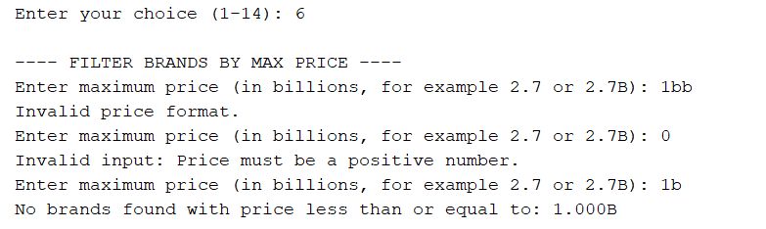
Figure 3.2.6a. Testing “6. List all brands with price <= input value" case invalid inputs and input = 1b

Details
Prompt | Input | List has brands with prices less than input value? | Output | Testing Result
Enter maximum price (in billions, for example 2.7 or 2.7b): | 1bb | *invalid input* | Invalid price format. | FAILURE
Enter maximum price (in billions, for example 2.7 or 2.7b): | 0 | *invalid input* | Invalid input: Price must be a positive number. | FAILURE
Enter maximum price (in billions, for example 2.7 or 2.7b): | 1b | no | No brands found with price less than or equal to: 1.000B | SUCCESS
Table 3.2.6b. Details of testing list brands with price <= 1b

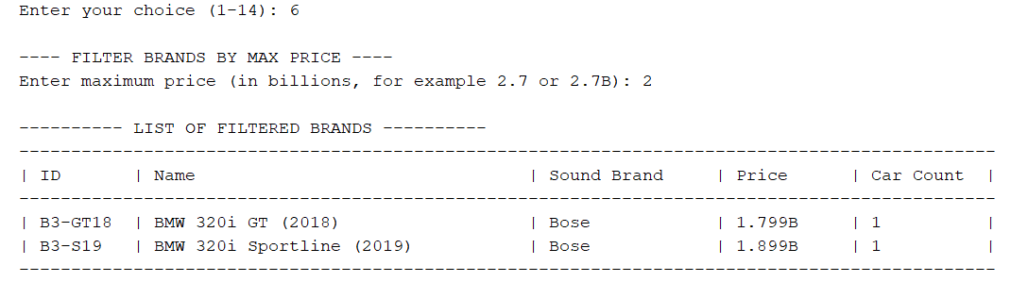
Figure 3.2.6b. Testing “6. List all brands with price <= input value" case input = 2
Details
Prompt | Input | List has brands with prices less than input value? | Output | Testing Result
Enter maximum price (in billions, for example 2.7 or 2.7b): | 2 | yes | ---- LIST OF FILTERED BRANDS ----  *detailed table of cars with price <= 2b* | SUCCESS
Table 3.2.6c. Details of testing list brands with price <= 2b

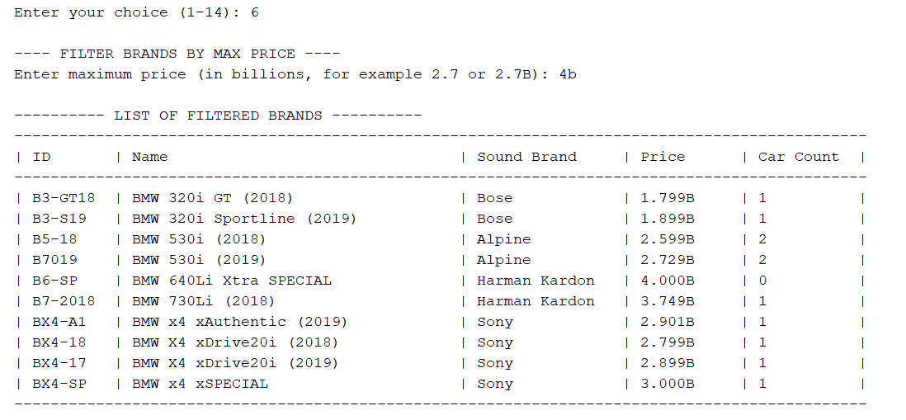
Figure 3.2.6c. Testing “6. List all brands with price <= input value" case input = 4b
Details
Prompt | Input | List has brands with prices less than input value? | Output | Testing Result
Enter maximum price (in billions, for example 2.7 or 2.7b): | 4b | yes | ---- LIST OF FILTERED BRANDS ----  *detailed table of cars with price <= 4b* | SUCCESS
Table 3.2.6d. Details of testing list brands with price <= 4b

Testing “7. List all cars in ascending order of brand names”
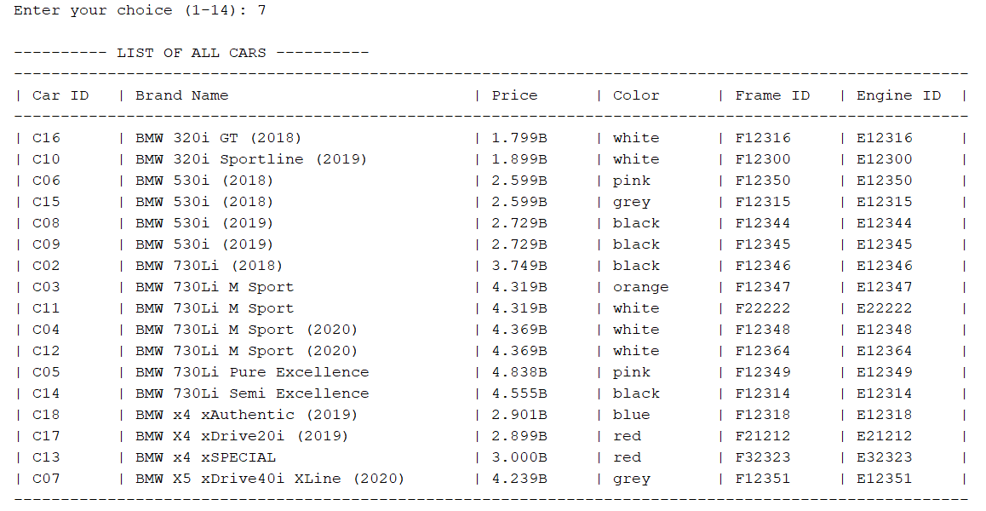
Figure 3.2.7. Testing “7. List all cars in ascending order of brand names”
Details
Menu Input | Output | Testing Result
7 | ---- LIST OF ALL CARS ----  *detailed table sorted by ascending brand names* | SUCCESS
Table 3.2.7. Details of testing menu option 7

Testing “8. Search cars by partial brand name"
Details
Menu Input | Output | Testing Result
8 | ---- SEARCH CARS BY PARTIAL BRAND NAME ----  Enter partial Brand Name to search: | SUCCESS
Table 3.2.8a. Details of testing menu option 8

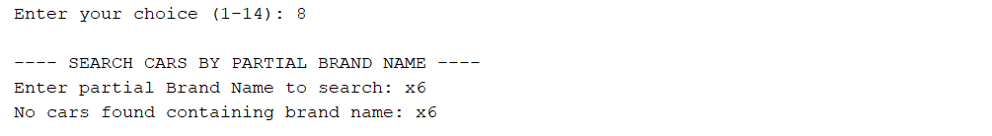
Figure 3.2.8a. Testing “8. Search cars by partial brand name” case car not found
Details
Prompt | Input | List has cars belonging to Brand Name containing input? | Output | Testing Result
Enter partial Brand Name to search: | x6 | no | No cars found containing brand name: x6 | SUCCESS
Enter partial Brand Name to search: | 730 | yes | ---- LIST OF CARS FOUND ----  *detailed table of cars of 730 line* | SUCCESS
Table 3.2.8b. Details of testing search cars by partial Brand Name

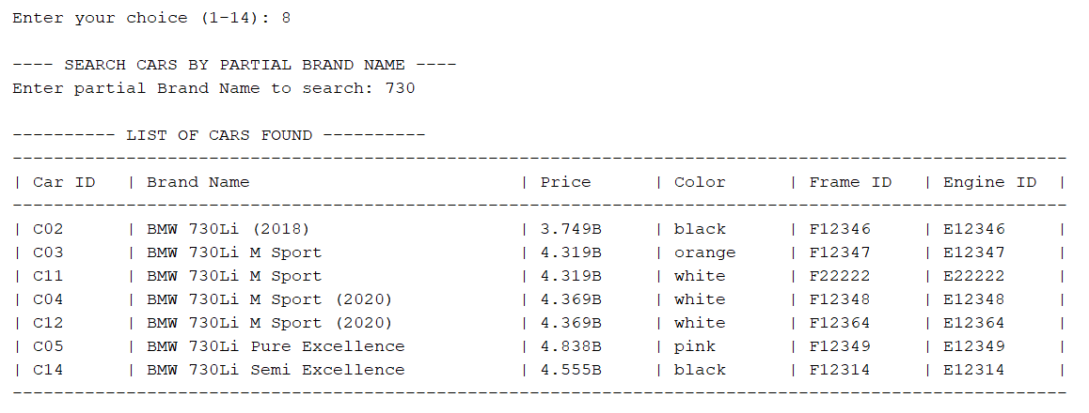
Figure 3.2.8b. Testing “8. Search cars by partial brand name” case cars found
Notes:
- Testing this heavily depends on the displayed result of the whole list shown in Figure 3.2.7 so that the function could return the exact number of cars in the list with the inputted partial brand name.

Testing “9. Add a new car”
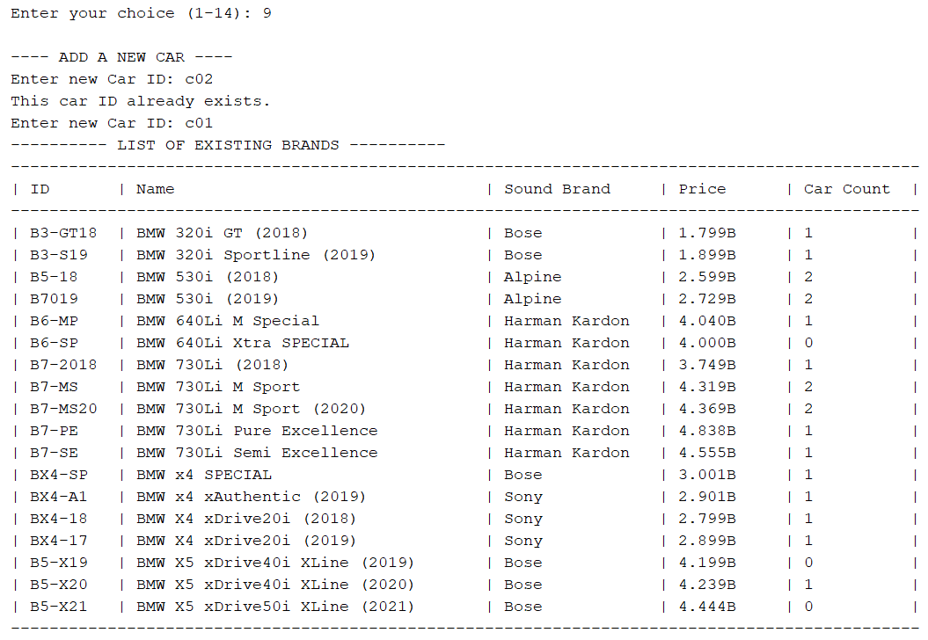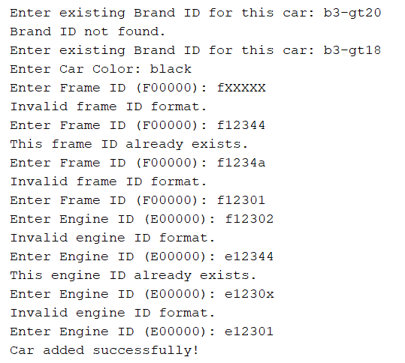
Figure 3.2.9. Testing “9. Add a new car"
Details
Menu Input | Output | Testing Result
9 | ---- ADD A NEW CAR ----  Enter new Car ID: | SUCCESS
Table 3.2.9a. Details of testing menu option 9
Details
Prompt | Input | Output | Testing Result
Enter new Car ID: | c02 | This car ID already exists. | FAILURE
Enter new Car ID: | c01 | *nothing, indicating success* | SUCCESS
---------- LIST OF EXISTING BRANDS ----------
*display detailed list of existing brands*
Enter existing Brand ID for this car: | b3-gt20 | Brand ID not found. | FAILURE
Enter existing Brand ID for this car: | b3-gt18 | *nothing, indicating success* | SUCCESS
Enter Car Color: | black | *nothing, indicating success* | SUCCESS
Enter Frame ID (F00000): | fXXXXX | Invalid frame ID format. | FAILURE
Enter Frame ID (F00000): | f12344 | This frame ID already exists. | FAILURE
Enter Frame ID (F00000): | f1234a | Invalid frame ID format. | FAILURE
Enter Frame ID (F00000): | f12301 | *nothing, indicating success* | SUCCESS
Enter Engine ID (E00000): | f12302 | Invalid engine ID format. | FAILURE
Enter Engine ID (E00000): | e12344 | This engine ID already exists. | FAILURE
Enter Engine ID (E00000): | e1230x | Invalid engine ID format. | FAILURE
Enter Engine ID (E00000): | e12301 | *nothing, indicating success* | SUCCESS
Car added successfully! |  |  | SUCCESS
Table 3.2.9b. Details of testing adding a new car
Notes:
- These tests all refer to Figure 3.2.7. test result for unique ID testing.
- For Car Color, there is no validation and nothing going on, so the input is normal and standard like other values for the sake of consistency.

Testing “10. Remove a car by ID"
Details
Menu Input | Output | Testing Result
10 | ---- REMOVE A CAR BY ID ----  Enter Car ID to remove: | SUCCESS
Table 3.2.10a. Details of testing menu option 10
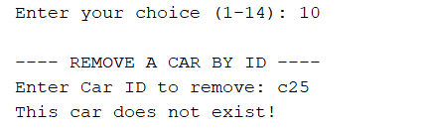
Figure 3.2.10a. Testing “10. Remove a car by ID" case car not found
Details
Prompt | Input | Targeted Car Status | Output | Testing Result
Enter Car ID to remove: | c25 | Not found | This car does not exist! | SUCCESS
Table 3.2.10b. Details of not finding a car to remove
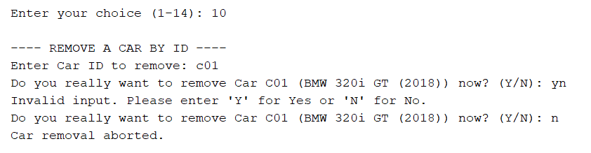
Figure 3.2.10b. Testing “10. Remove a car by ID" case invalid confirmation input and aborting removal
Details
Prompt | Input | Targeted Car Status | Output | Testing Result
Enter Car ID to remove: | c01 | Found | Do you really want to remove Car C01 (BMW 320i GT (2018)) now? (Y/N): | SUCCESS
Do you really want to remove Car C01 (BMW 320i GT (2018)) now? (Y/N): | yn | Unchanged due to invalid input | Invalid input. Please enter 'Y' for Yes or 'N' for No. | FAILURE
Do you really want to remove Car C01 (BMW 320i GT (2018)) now? (Y/N): | n | Not removed, still exist in list | Car removal aborted. | SUCCESS
Table 3.2.10c. Details of aborting removal of a car
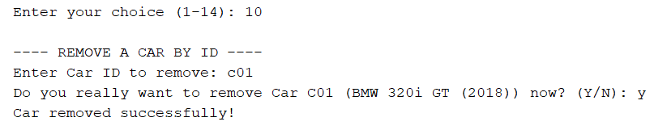
Figure 3.2.10c. Testing “10. Remove a car by ID" case successful removal
Details
Prompt | Input | Targeted Car Status | Output | Testing Result
Enter Car ID to remove: | c01 | Found | Do you really want to remove Car C01 (BMW 320i GT (2018)) now? (Y/N): | SUCCESS
Do you really want to remove Car C01 (BMW 320i GT (2018)) now? (Y/N): | y | Removed | Car removed successfully! | SUCCESS
Table 3.2.10d. Details of removing a car successfully

Testing “11. Update a car by ID”
Details
Menu Input | Output | Testing Result
11 | ---- UPDATE A CAR BY ID ----  Enter Car ID to update: | SUCCESS
Table 3.2.11a. Details of testing menu option 11

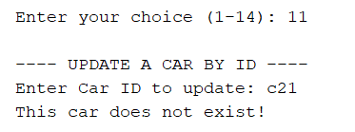
Figure 3.2.11a. Testing “11. Update a car by ID" case car not found
Details
Prompt | Input | Targeted Car Status | Output | Testing Result
Enter Car ID to update: | c21 | Not found | This car does not exist! | SUCCESS
Table 3.2.11b. Details of not finding a car to update
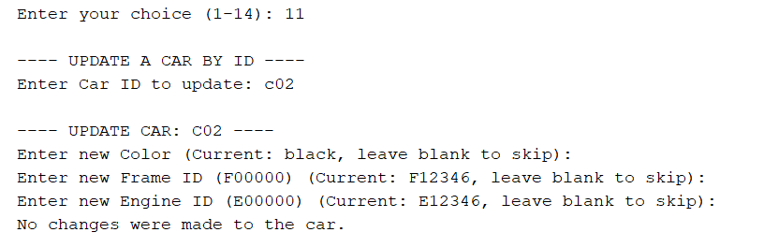
Figure 3.2.11b. Testing “11. Update a car by ID" case skipping all updates
Details
Prompt | Input | Targeted Car Status | Output | Testing Result
Enter Car ID to update: | c02 | Found | ---- UPDATE CAR: C02 ----  Enter new Color (Current: black, leave blank to skip): | SUCCESS
Enter new Color (Current: black, leave blank to skip): |  | Kept old value |  | SUCCESS
Enter new Frame ID (F00000) (Current: F12346, leave blank to skip): |  | Kept old value |  | SUCCESS
Enter new Engine ID (E00000) (Current: E12346, leave blank to skip): |  | Kept old value |  | SUCCESS
No changes were made to the car. |  |  |  | SUCCESS
Table 3.2.11b. Details of skipping all updates to a car

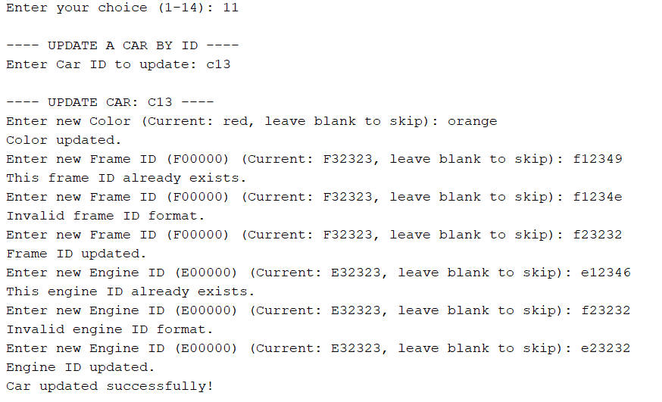
Figure 3.2.11c. Testing “11. Update a car by ID" case with updates
Details
Prompt | Input | Targeted Car Status | Output | Testing Result
Enter Car ID to update: | c13 | Found | ---- UPDATE CAR: C13 ----  Enter new Color (Current: red, leave blank to skip): | SUCCESS
Enter new Color (Current: red, leave blank to skip): | orange | Updated | Color updated. | SUCCESS
Enter new Frame ID (F00000) (Current: F32323, leave blank to skip): | f12349 | *new ID not unique, prompt again* | This frame ID already exists. | FAILURE
Enter new Frame ID (F00000) (Current: F32323, leave blank to skip): | f1234e | *invalid input, prompt again* | Invalid frame ID format. | FAILURE
Enter new Frame ID (F00000) (Current: F32323, leave blank to skip): | f23232 | Updated | Frame ID updated. | SUCCESS
Enter new Engine ID (E00000) (Current: E32323, leave blank to skip): | e12346 | *new ID not unique, prompt again* | This engine ID already exists. | FAILURE
Enter new Engine ID (E00000) (Current: E32323, leave blank to skip): | f23232 | *invalid input, prompt again* | Invalid engine ID format. | FAILURE
Enter new Engine ID (E00000) (Current: E32323, leave blank to skip): | e23232 | Updated | Engine ID updated. | SUCCESS
Car updated successfully! |  |  |  | SUCCESS
Table 3.2.11c. Details of updating a car successfully

Testing "12. List all cars by a specific color”
Details
Menu Input | Output | Testing Result
12 | ---- SEARCH CARS BY COLOR ----  Enter color to list cars: | SUCCESS
Table 3.2.12a. Details of testing menu option 12

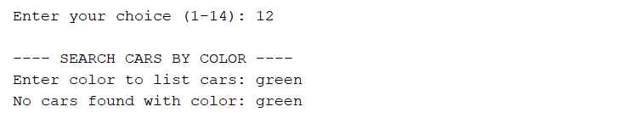
Figure 3.2.12a. Testing “12. List all cars by a specific color" case car not found
Details
Prompt | Input | List has cars of this color? | Output | Testing Result
Enter color to list cars: | green | no | No cars found with color: green | SUCCESS
Enter color to list cars: | white | yes | ---- LIST OF FILTERED CARS ----  *detailed table of all white cars* | SUCCESS
Table 3.2.12b. Details of testing list cars by color

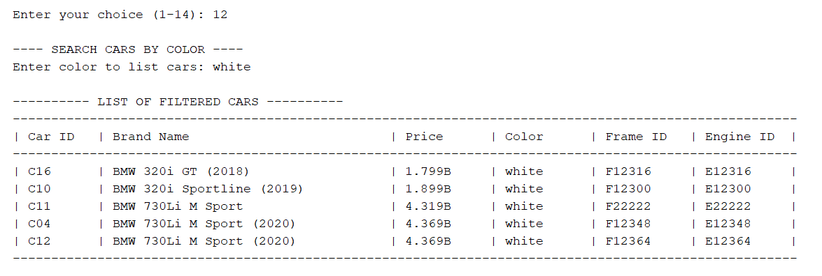
Figure 3.2.12b. Testing “12. List all cars by a specific color" case cars found
Notes:
- Testing this heavily depends on the displayed result of the whole list shown in Figure 3.2.7 so that the function could return the exact number of cars in the list with the inputted color.

Testing “13. Save data to files"
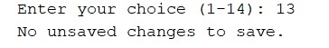
Figure 3.2.13a. Testing “13. Save data to files" case no changes
Details
Menu Input | Has unsaved changes? | Output | Testing Result
13 | No | No unsaved changes to save. | SUCCESS
13 | Yes | Do you want to save changes to files now? (Y/N): | SUCCESS
Table 3.2.13a. Details of testing menu option 13

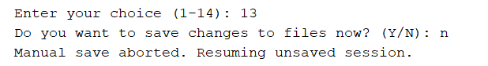
Figure 3.2.13b. Testing “13. Save data to files" case aborting the manual save
Details
Prompt | Input | Output | Testing Result
Do you want to save changes to files now? (Y/N): | n | Manual save aborted, resuming unsaved session. | SUCCESS
Table 3.2.13b. Details of aborting the manual save

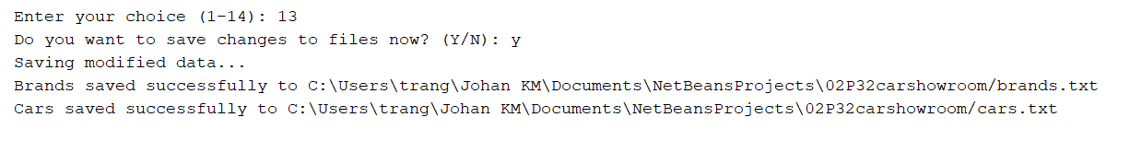
Figure 3.2.13c. Testing “13. Save data to files" case confirming the manual save
Details
Prompt | Input | Output | Testing Result
Do you want to save changes to files now? (Y/N): | y | Saving modified data…  Brand saved successfully to [FILE DIRECTORY]  Car saved successfully to [FILE DIRECTORY] | SUCCESS
Table 3.2.13c. Details of confirming the manual save
Notes:
- For the manual saving, if only one file has unsaved changes, the “saved successfully” message will only display for that file (Brand or Car). In the case of Figure 3.2.13c and Table 3.2.13c, both files have unsaved changes, thus 2 messages displayed.

Testing “14. Quit program"
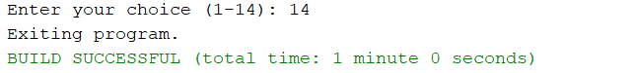
Figure 3.2.14a. Testing “14. Quit program" case no changes
Details
Menu Input | Has unsaved changes? | Output | Testing Result
14 | No | Exiting program.  BUILD SUCCESSFUL (total time:…) | SUCCESS
14 | Yes | Unsaved changes detected. Do you want to save changes before quitting? (Y/N): | SUCCESS
Table 3.2.14a. Details of testing menu option 14
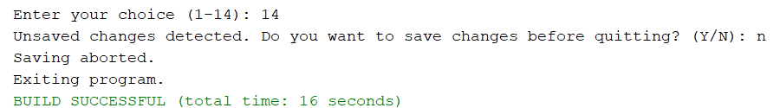
Figure 3.2.14b. Testing “14. Quit program" case quitting without saving
Details
Prompt | Input | Output | Testing Result
Unsaved changes detected. Do you want to save changes before quitting? (Y/N): | n | Saving aborted. Exiting program.  BUILD SUCCESSFUL (total time:…) | SUCCESS
Table 3.2.14b. Details of quitting without saving
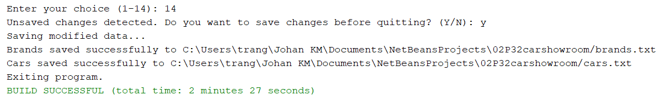
Figure 3.2.14c. Testing “14. Quit program" case saving then quitting
Details
Prompt | Input | Output | Testing Result
Unsaved changes detected. Do you want to save changes before quitting? (Y/N): | y | Saving modified data…  Brand saved successfully to [FILE DIRECTORY]  Car saved successfully to [FILE DIRECTORY]  BUILD SUCCESSFUL (total time:…) | SUCCESS
Table 3.2.14c. Details of saving then quitting
Notes:
- Similarly to the above testing of option 13, if only one file has unsaved changes, the “saved successfully” message will only display for that file (Brand or Car). In the case of Figure 3.2.14c and Table 3.2.14c, both files have unsaved changes, thus 2 messages displayed.
Testing crash recovery mechanism
Details:
- Condition: Modify something, then cancel running task or quit NetBeans entirely
- Output when initiating a new session:
=== TEMPORARY AUTOSAVED DATA DETECTED ===
It appears the program terminated unexpectedly during the last session.
Do you want to load the unsaved recovery data and integrate into current session? (Y/N):
- Result: SUCCESS

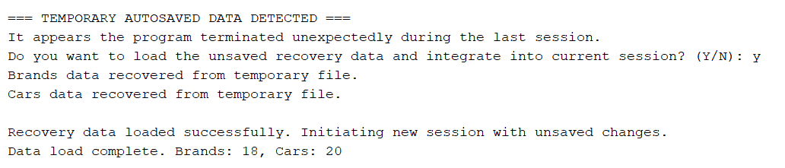
Figure 3.3.1. Testing autosave case loading recovery data from a previous crash
Details
Prompt | Input | Output | Testing Result
Do you want to load the unsaved recovery data and integrate into current session? (Y/N): | y | Brands data recovered from temporary file.  Cars data recovered from temporary file.  Recovery data loaded successfully. Initiating new session with unsaved changes.  Data load complete. Brands: [no. of brands], Cars: [no. of cars] | SUCCESS
Table 3.3.1. Details of testing loading recovery data from a previous crash

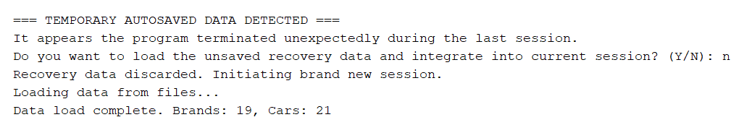
Figure 3.3.2. Testing autosave case discarding recovery data from a previous crash
Details
Prompt | Input | Output | Testing Result
Do you want to load the unsaved recovery data and integrate into current session? (Y/N): | n | Recovery data discarded. Initiating brand new session.  Loading data from files...  Data load complete. Brands: [no. of brands], Cars: [no. of cars] | SUCCESS
Table 3.3.2. Details of testing discarding recovery data from a previous crash

Figure 3.3.3. Testing autosave case unchanged data
Details:
- Condition: Keeping the application with no unsaved changes, then cancel running task or quit NetBeans entirely
- Output when initiating a new session:
Loading data from files...
Data load complete. Brands: [no. of brands], Cars: [no. of cars]
- Note: This will test if the application loads up its new session entirely normally if we crash it without leaving anything unsaved (normal load-up)
- Result: SUCCESS

7. Conclusion
7.1. Strengths of the program
The system exhibits some notable key strengths that contribute to its stability and maintainability:
- The program implements a form of the Model-View-Controller (MVC) pattern. The models package handles data structure and persistence, the view package handles all presentation and basic input, and ProgramControl acts as the central controller, orchestrating the flow. This separation makes updates straightforward and simpler.
- A significant strength is the implementation of autosaving on each modification and the intentional_quit.flag mechanism. This logic effectively distinguishes between an unexpected crash (where unsaved data is preserved in temp files) and an intentional exit (where unsaved data is already saved to main files or discarded). This makes the system adaptable against data loss.
- Another strong trait of the program is how throughout BrandList and CarList load data from the .txt files with clear logic to distinguish and filter faulty/corrupted data, ensuring consistently clean data and smooth management operations.
- The application adheres to strong data integrity principles:
- The removeBrandByID function checks the CarList for dependencies and enforces a cascading delete with user confirmation, preventing weird data situations.
- Strict format validation is enforced for necessary entities, and uniqueness checks are consistently applied across new and updated records.

7.2. Weaknesses of the program
Despite its strengths, the current implementation has several architectural and structural weaknesses that could impede future scalability and testing efforts.
- The primary architectural weakness lies in the heavy reliance on static methods within the Validation and Auxiliary classes. These classes are accessed directly from nearly every part of the view and business layers. This tight coupling makes unit testing difficult, as the business logic cannot be tested in isolation without also relying on console-based I/O methods within the static Validation class.
- The autosaving on each change mechanism, while safest for this project and bypassing NetBeans shutting down, cause disk I/O to slow down exponentially, potentially creating problems in the long run (when data expands a lot more).
- The program uses simple text files (.txt) for persistence. While this method is requested by the original project requirements, it has a fair share of downsides:
- Lacks scalability: Reading and writing large datasets becomes slow and memory-intensive as the entire collection must be processed line-by-line.
- Risk data integrity: The persistence format relies entirely on specific delimiters (commas and colons), making it vulnerable to manual file corruption.
- The entire user interface is console-based, which is inherently inflexible. Custom formatting relies on hardcoded printf strings with fixed column widths, which is brittle and difficult to change. Adding new fields or shifting to a different output format requires rewriting numerous lines of code across the BrandView and CarView classes.
- The core data structure in BrandList and CarList is a standard ArrayList. While adequate for small datasets, its search operations require a linear scan of the entire list (O(n) complexity). For a much larger showroom data, this will lead to noticeable performance degradation.

7.3. Future developments and modifications
To mitigate the current weaknesses and expand the system's capabilities, the following areas should be prioritized:
1. Architectural Refactoring
- Refactor the static Validation class into a non-static service interface (e.g., IValidationService). This service should be instantiated and injected into the ProgramControl and View classes, allowing easier testing and replacing the console-based validation with mock implementations when needed.
2. Persistence Layer Upgrade
- Migrate the persistence layer from flat files to a relational database using JDBC (Java Database Connectivity). This would solve scalability issues, enforce data types, allow complex querying, and handle concurrent access if the application were ever to be multi-threaded.
- If able, switch the file format to JSON or CSV to simplify the reading/writing logic and increase compatibility with other systems.
3. User Interface Enhancement
- Develop a Graphical User Interface using a framework like JavaFX or Swing. This would eliminate the rigid nature of console I/O, provide a better user experience, and separate the output formatting entirely from the view logic.
4. Advanced Features
- Implement a third data model (TransactionList) to record modifications with timestamps, enhancing accountability and audit trails.
- Implement dynamic pricing logic and introduce more complex querying functions (e.g., search by price range across all cars, grouping by color).

7.4. Derived meanings and lessons learned
The development process yielded several important meanings and lessons:
- The strict adherence to the Model-View-Controller (MVC) pattern was a significant success factor. By keeping file I/O and data manipulation logic within the models and isolating user display logic in the view, any change request (modifying a data constraint or changing a display format) could be addressed in a single, isolated package, drastically reducing the risk of introducing bugs into unrelated components.
- The challenge of crash recovery highlighted that persistence should not only involve saving data but also planning for when and how data should be recovered in the case of unexpected events. The solution of using a Shutdown Hook and the .flag file to track the state of the program sessions demonstrated that learning and knowing how and when to implement custom solutions are required for lots of essential requirements in modern programming, especially the crash recovery implementation like this.
- The use of static utility classes (like Validation and Auxiliary) provided immediate convenience and simplicity during development, which fits the nature of this project. However, this introduced tight coupling across the entire application, making components dependent on one another. The lesson learned is that for any logic that is prone to massive changes for later, it is structurally superior to use a regular class and/or functions that can be easily tested or replaced, despite the immediate simplicity of static classes and functions.
- It is vital to have a carefully planned development process, and a solid schedule for development that can save as much time as possible. Due to the nature of this program, a program that will contain errors and need much testing to yield the best result, as well as the inclusion of a report and a means of presentation, having a clear time-saving schedule allow for a lot of wiggle room, allowing full completion while still saving time for other concurrent projects.

8. Appendix
Source Files:
- Run/Main.java
- business/ProgramControl.java
- models/Brand.java
- models/BrandList.java
- models/Car.java
- models/CarList.java
- view/Menu.java
- view/BrandView.java
- view/CarView.java
- tools/Validation.java
- tools/Auxiliary.java
Sample Data Files:
- brands.txt
- cars.txt
- brands_temp.txt (used for crash recovery, usually nonexistent)
- cars_temp.txt (used for crash recovery, usually nonexistent)

