**CST8390 - Lab 4 Part 1**

**Clustering by kMeans**

**Student Name: Hasib**

**Student Number: 041012318**

**7. Clustering Model:**

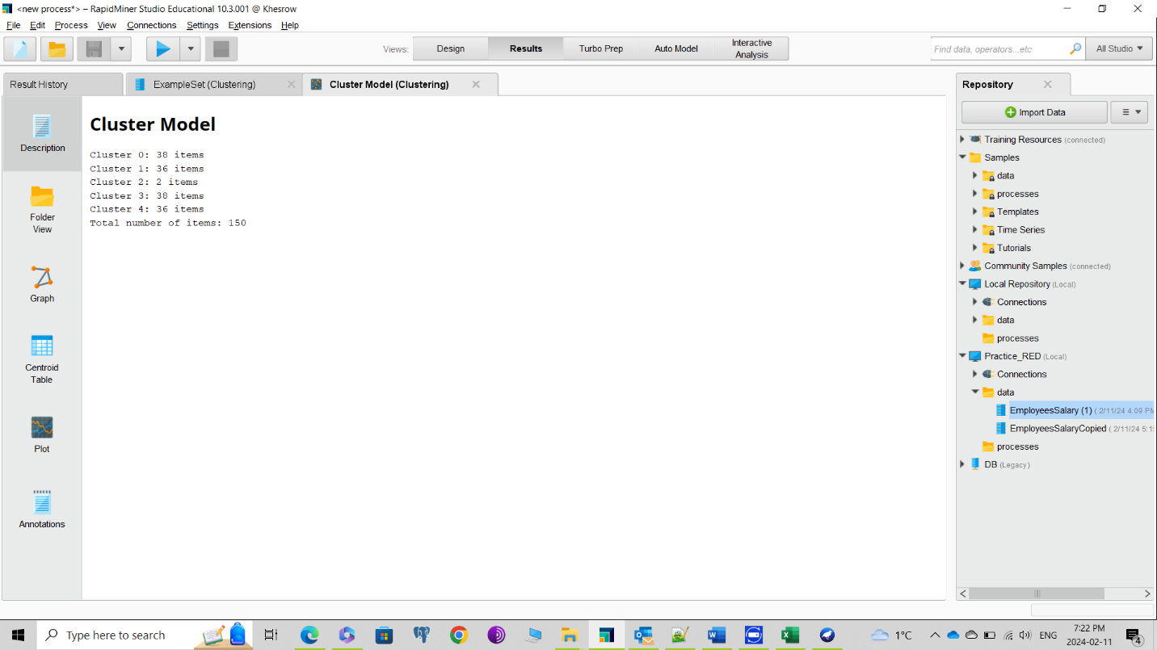

**8. Clustering Model:**

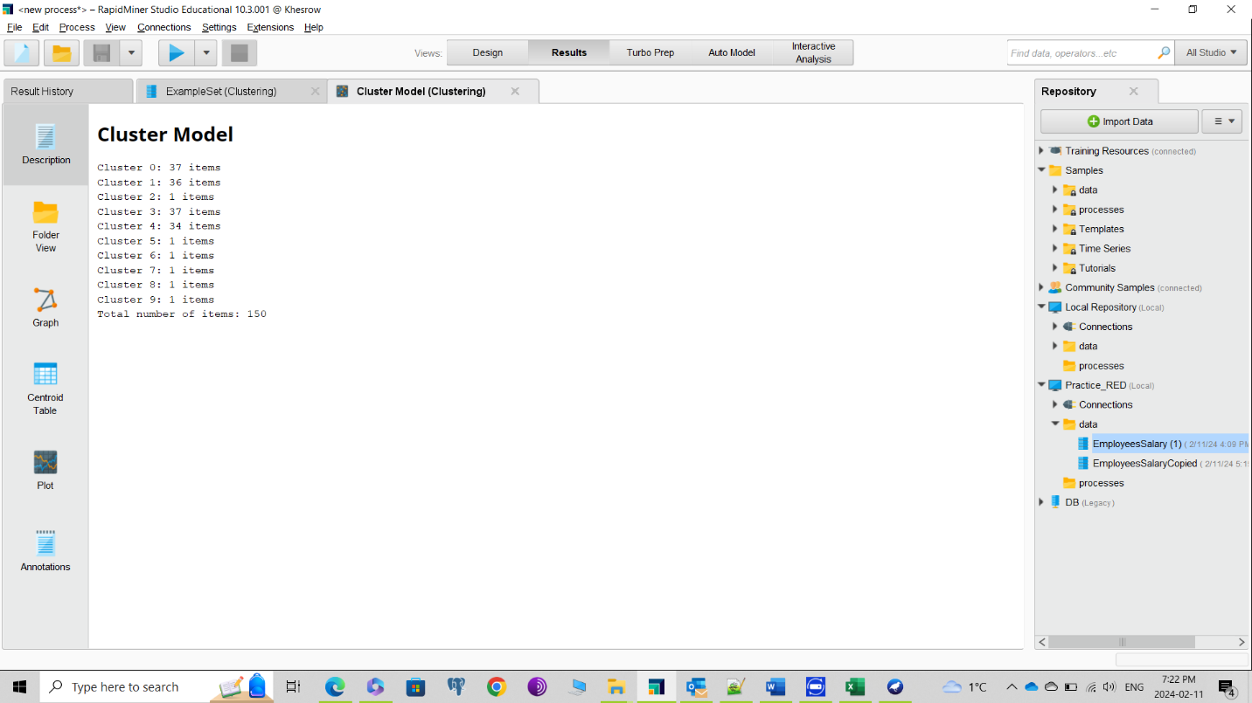

**9. Filtered instances:**

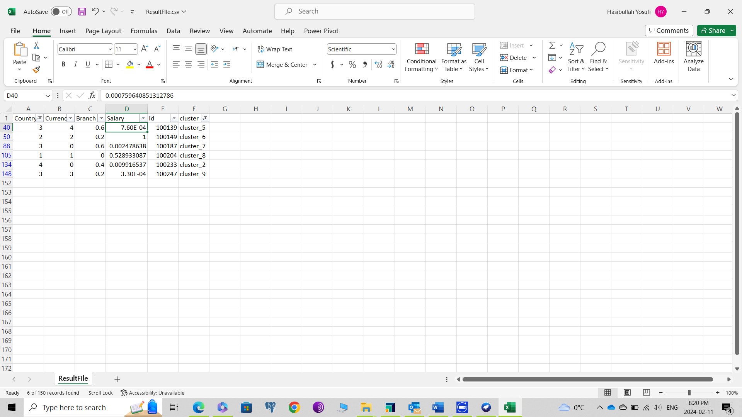

**10. Screenshot of the process**

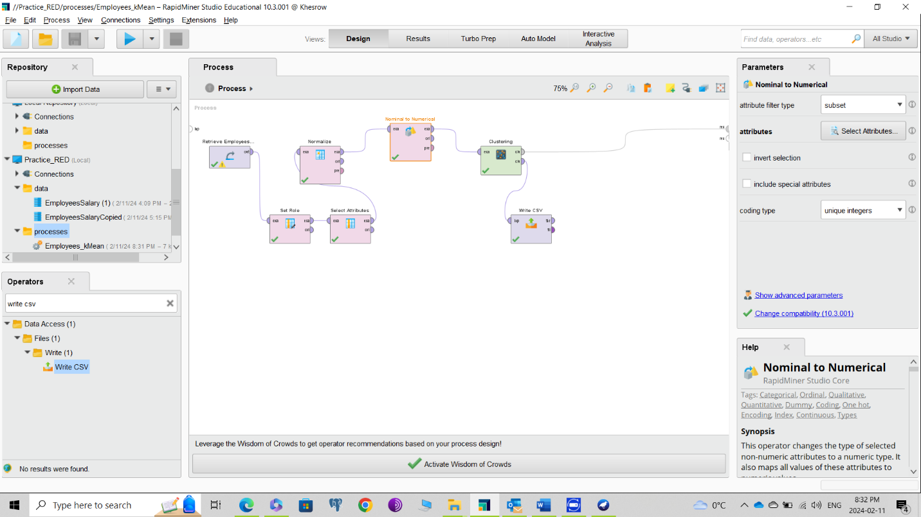

Lab 4 part b:

LOF Flag:

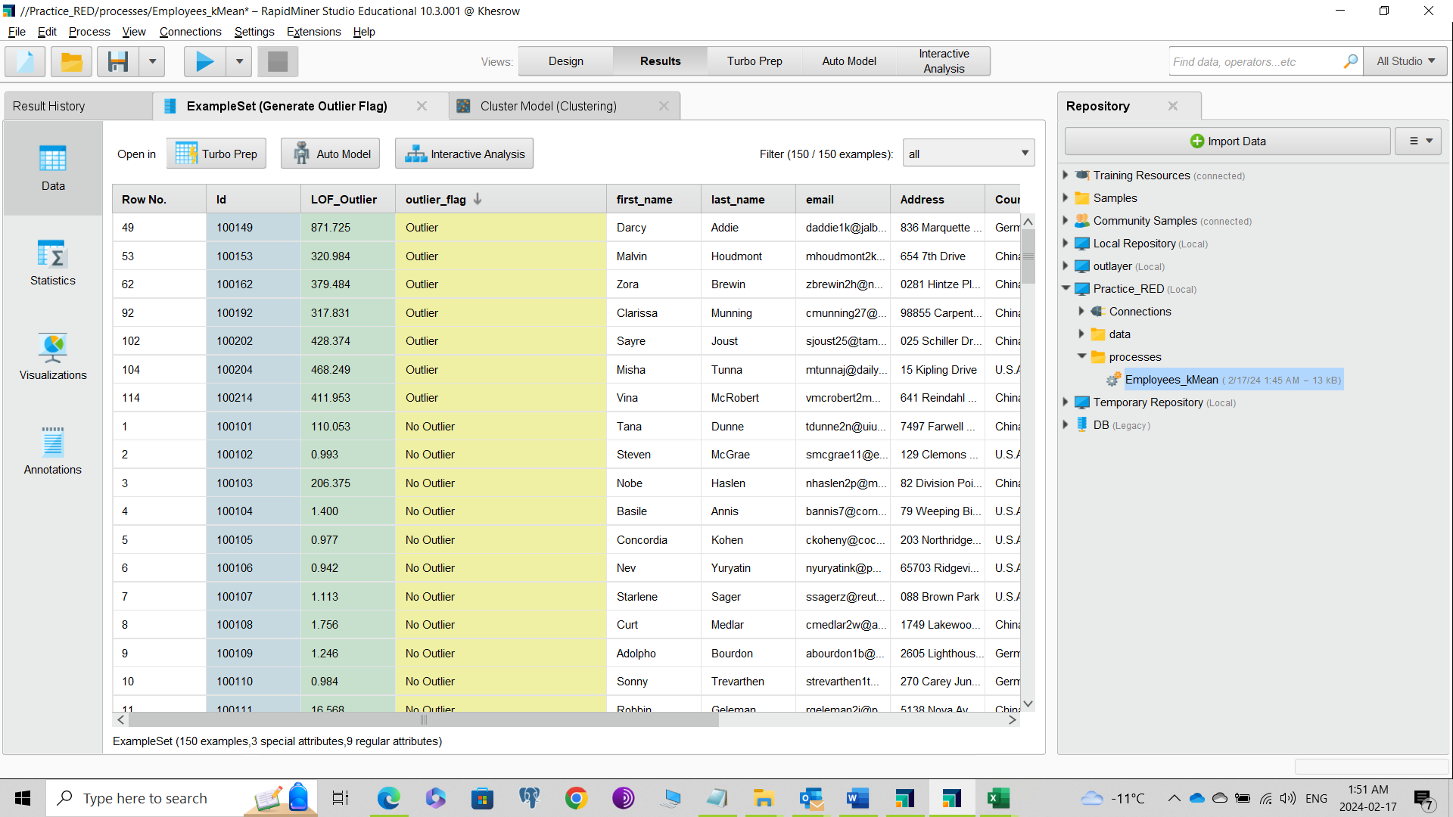

Distance Outlier:

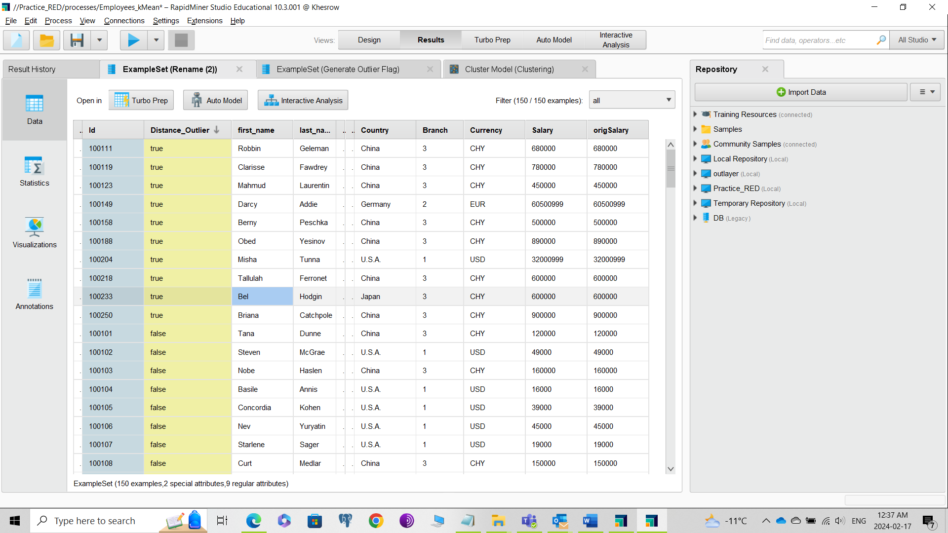

CSV Filter:

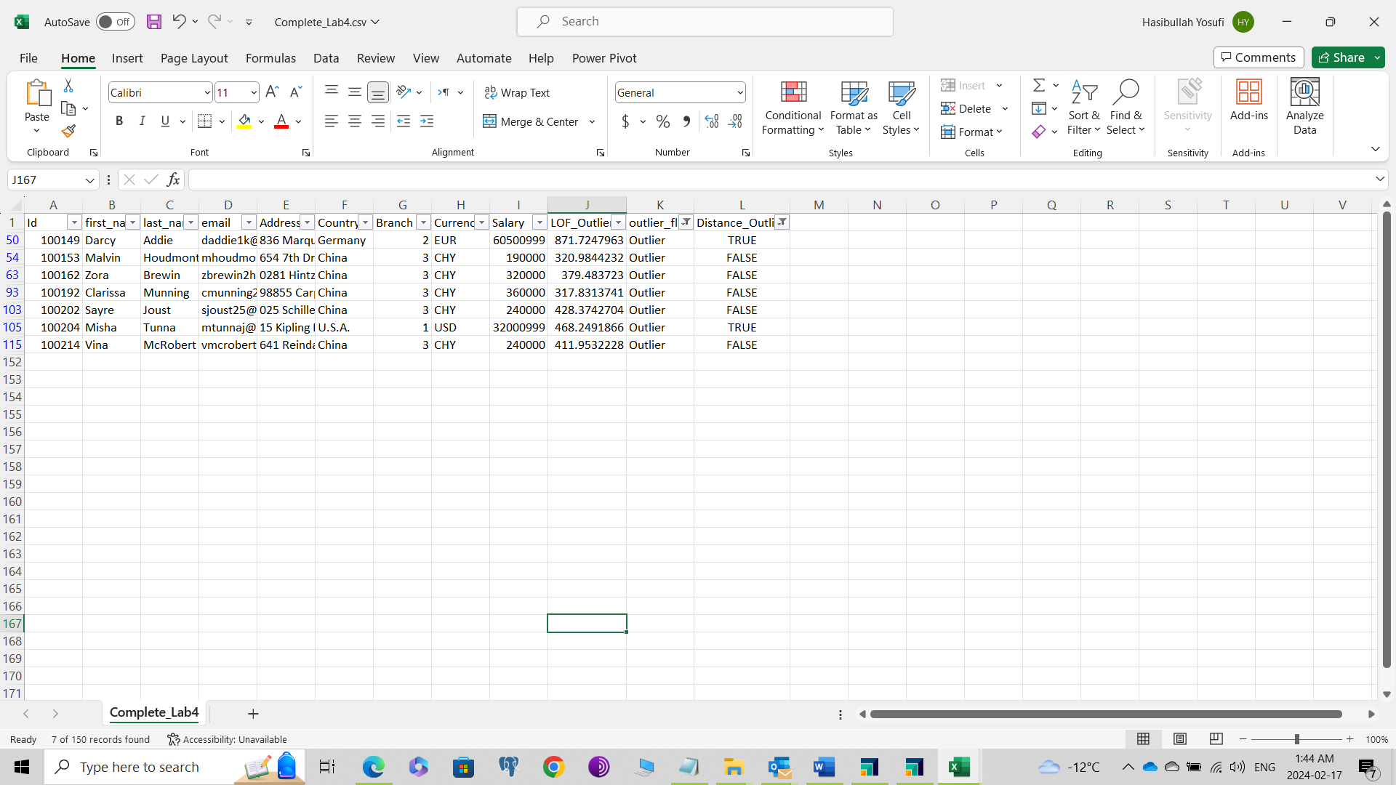

Processes Screenshot:

