**PHONE BOOK APPLICATION**

PhoneBookApplication is a project where adding the records,deleting the records,displaying the list of records and updating the records can be done.

While adding the new record it will ask the personal information like the FirstName, LastName,

Gender, Email, PhoneNumber, DateOfBirth, City, State and Address.

**UseCase Diagram For Phone Book Application**

**Contact**

**ContactCategory**

Create

Create

Update

View

Delete

View

Delete

Update

Admin User

**Specification of UseCases:-**

Use Case AddContact

|  |  |
| --- | --- |
| Add Contact Details | |
| Actor | Admin |
| Trigger | New Contact details needs to be added |
| Pre Conditions | Contact details was not present in database |
| Post Conditions | New Contact will get added into the database contact id will be auto-generated. |
| Normal Course | 1. Admin click the Add New Contact after login. 2. Empty AddContact form will be displayed. 3. Admin will fill all the details of the new contact. 4. Validation of the fields are to be done. 5. Details has to be submitted to server. 6. Message will be displayed after the successful creation of contact. |
|  |  |

Use Case UpdateContact

|  |  |
| --- | --- |
| Update Contact Details | |
| Actor | Admin |
| Trigger | Admin wants to modify the contact details. |
| Pre Conditions | Contact details was already present in database. |
| Post Conditions | Existing Contact will get updated into the database. |
| Normal Course | 1. Admin click the update Contact after login. 2. Existing Contact form will be displayed. 3. Admin will update all the details of the contact. 4. Validation of the fields are to be done. 5. Details has to be submitted to server. 6. Message will be displayed after the successful updation of contact. |
|  |  |

Use Case Delete Contact

|  |  |
| --- | --- |
| Delete Contact Details | |
| Actor | Admin |
| Trigger | Existing Contact details needs to be deleted. |
| Pre Conditions | Contact details was present in database. |
| Post Conditions | Existing Contact will get deleted from the database based on id. |
| Normal Course | 1. Admin click the delete Contact after login. 2. Existing Contact will be deleted. 3. Admin will delete the existing contact. 4. Validation of the fields are to be done. 5. Details has to be submitted to server. 6. Message will be displayed after the successful deletion of contact. |
|  |  |

Use Case View Contact

|  |  |
| --- | --- |
| View Contact Details | |
| Actor | Admin,User |
| Trigger | Existing Contact details needs to be Viewed. |
| Pre Conditions | Contact details was not present in database |
| Post Conditions | New Contact will get added into the database contact id will be auto-generated. |
| Normal Course | 1. Admin click the Add New Contact after login. 2. Empty AddContact form will be displayed. 3. Admin will fill all the details of the new contact. 4. Validation of the fields are to be done. 5. Details has to be submitted to server. 6. Message will be displayed after the successful creation of contact. |
|  |  |

Phone Book Application entities and their attributes:

* **ContactCategory Entity**:

Attributes of ContactCategory are CategoryId and Contact Name.

* **Contact Entity:**

Attributes of Contact are contactId, CategoryId, the FirstName, LastName,

Gender, Email, PhoneNumber, DateOfBirth, City, State and Address.

**Entity Relationship Diagram:**

The ER (Entity Relationship)diagram represents the model of the phone book application. The entity relationship shows all the visual instrument of database tables and the relations between ContactCategory and Contact.

Has

ContactCategory

Contact

**Database Table Design:**

ContactCategory Table

|  |  |  |
| --- | --- | --- |
| Field Name | Type | Remarks |
| CategoryId | int | PK |
| CategoryName | Varchar(50) |  |

Contact Table

|  |  |  |
| --- | --- | --- |
| Field Name | Type | Remarks |
| ContactId | int | PK |
| CategoryId | int | FK |
| FirstName | Varchar(50) |  |
| LastName | Varchar(50) |  |
| Gender | Varchar(50) |  |
| DateOfBirth | Date |  |
| Email | Varchar(50) |  |
| PhoneNumber | bigint |  |
| City | Varchar(20) |  |
| State | Varchar(20) |  |
| Country | Varchar(20) |  |

**APPENDICES**

**ContactCategories Page:**

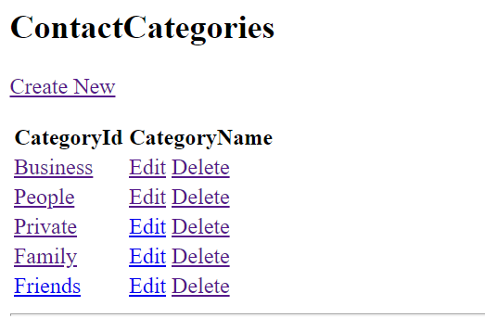

**Contact Details Page:**

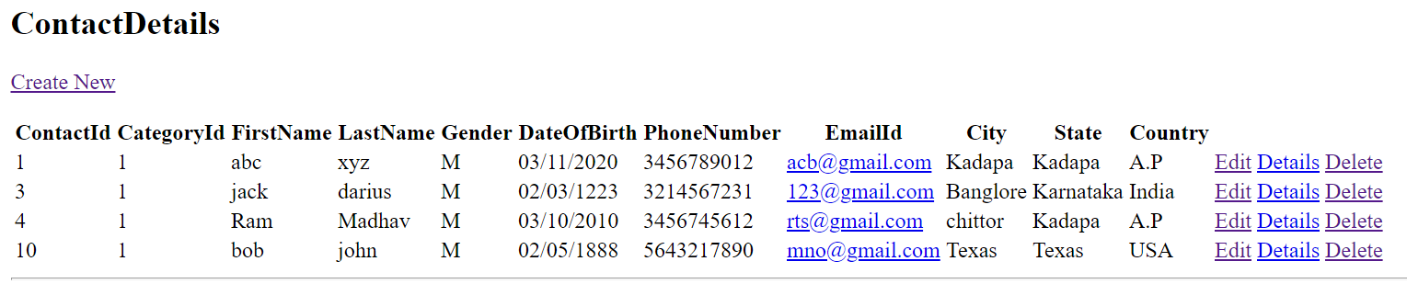

**Create Page of ContactCategory:**

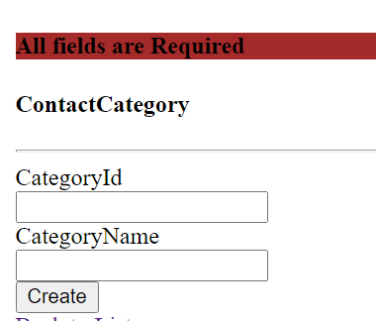

**Create page of Contact:**

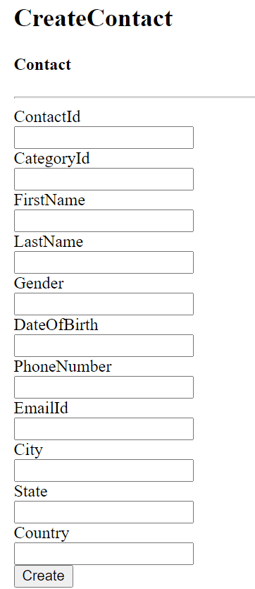

**Edit Page of ContactCategory:**

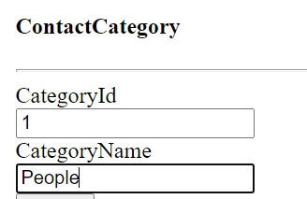

**Edit Page of Contact:**

