<html>

<head>

<title>Deepak Joshi Roll No: 14</title>

</head>

<body>

<script>

for(var i=2;i<=250;i++)

{

var isprime=1;

for(var j=2;j<=Math.sqrt(i);j++)

if(i%j==0)

{

isprime=0;

break;

}

if(isprime==1)

document.write(i+"<br>");

}

</script>

</body>

</html>

**OUTPUT-**

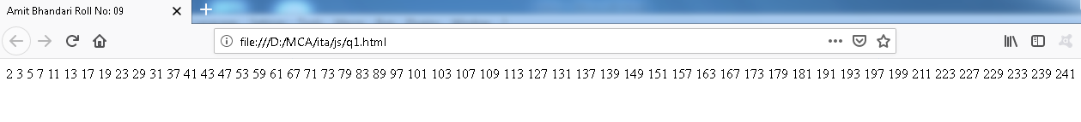

<html>

<head>

<title>Deepak Joshi Roll No: 14</title>

</head>

<body>

<script>

var x=prompt("Enter string");

var vowel="aeiou";

var vow=0,cons=0;

var arr=x.split(" ");

document.write("The String is: "+x+"<br>");

document.write("Total no of words: "+arr.length+"<br>");

document.write("Total characters: "+x.length+"<br>");

for(var i=0;i<x.length;i++)

{

var ch=x.toLowerCase().charAt(i);

if(vowel.includes(ch+""))

vow++;

else if(ch>='a'&&ch<='z')

cons++;

}

document.write("Total vowels: "+vow+"<br>");

document.write("Total consonants: "+cons);

</script>

</body>

</html>

OUTPUT:-

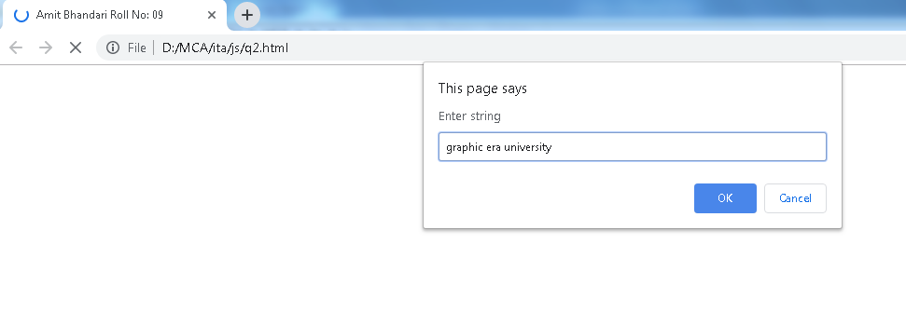

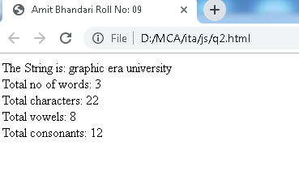

<html>

<head>

<title>Deepak Joshi Roll No: 14</title>

<script>

function test()

{

var x=prompt("Enter your name");

var ele=document.getElementById("p1");

ele.style.color="red";

ele.style.fontSize="24px";

ele.style.background="yellow";

ele.innerHTML+=" "+x;

}

</script>

</head>

<body>

<p id="p1">Welcome</p>

<input type="button" value="Click" onclick="test()">

</body>

</html>

**OUTPUT:-**

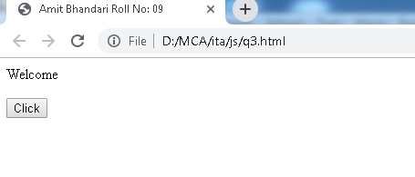

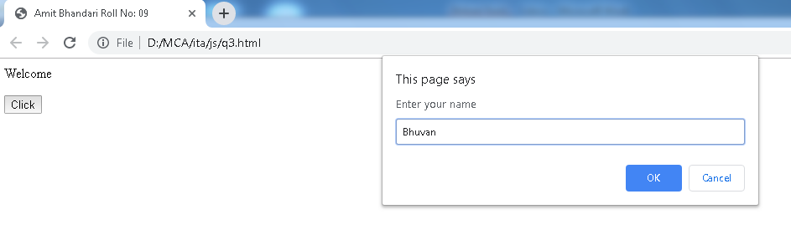

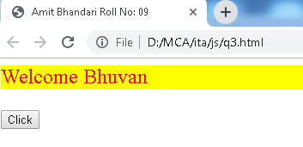

<html>

<head>

<title>Deepak Joshi Roll No: 14</title>

<script>

function load()

{

var wind=window.open("","","height=300, width=600");

wind.document.title="New Window";

wind.document.body.innerHTML="<h1>Hello</h1>";

var x=wind.confirm("Do you want to close");

if(x)

{

wind.close();

document.write("<h1>Window closed</h1>");

}

}

</script>

</head>

<body onload="load()">

</body>

</html>

OUTPUT:-

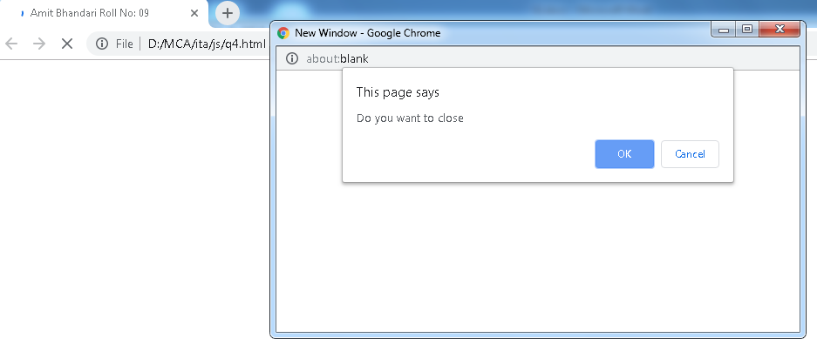

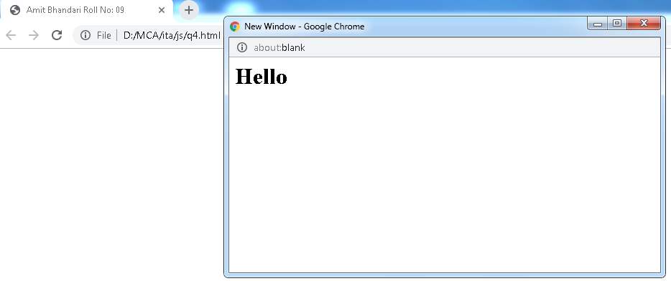

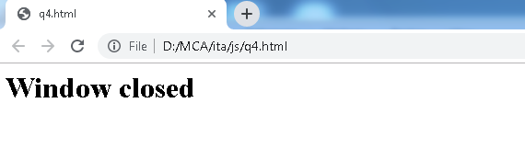

<html>

<head>

<title>Deepak Joshi Roll No: 14</title>

<script>

function load()

{

var wind=window.open("","","height=300, width=600");

wind.document.title="New Window";

wind.document.body.innerHTML="<h1>Hello</h1>";

var x=wind.confirm("Do you want to close");

if(x){

wind.close();

document.write("<h1>Window closed</h1>");

}

}

</script>

</head>

<body onload="load()"></body>

</html>

**OUTPUT:-**

