<html>

<head>

<title>Amit Bhandari Roll No: 09</title>

<script>

function load()

{

var wind=window.open("","","height=300, width=600");

wind.document.title="New Window";

wind.document.body.innerHTML="<h1>Hello</h1>";

var x=wind.confirm("Do you want to close");

if(x)

{

wind.close();

document.write("<h1>Window closed</h1>");

}

}

</script>

</head>

<body onload="load()">

</body>

</html>

OUTPUT:-

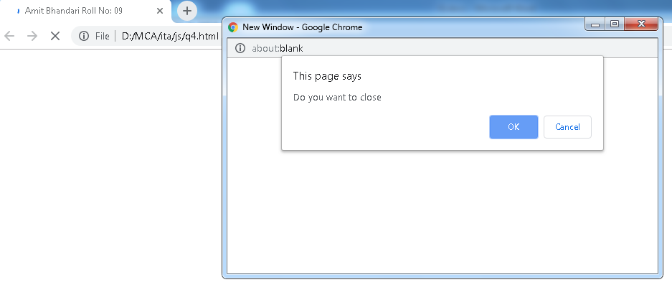

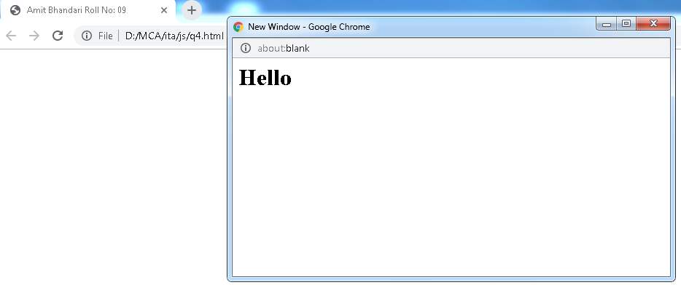

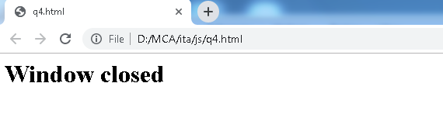

<html>

<head>

<title>Amit Bhandari Roll No: 09</title>

<script>

function load()

{

var wind=window.open("","","height=300, width=600");

wind.document.title="New Window";

wind.document.body.innerHTML="<h1>Hello</h1>";

var x=wind.confirm("Do you want to close");

if(x){

wind.close();

document.write("<h1>Window closed</h1>");

}

}

</script>

</head>

<body onload="load()"></body>

</html>

**OUTPUT:-**

