TRAILD SOFTWARE REPLACEMENT
Below is a complete build brief you can paste into Replit to recreate Traild-style AP invoice ingestion → review/coding → approvals → MYOB export, matching the screens you attached (invoice list, supplier-filtered list, invoice detail + PDF viewer + field mapping, coding screen with date picker and “field mappings” panel).

1) Product goal
Build an Accounts Payable Invoice Processing Portal that:
- Pulls invoices from a dedicated email inbox (e.g. ap@yourdomain.com)
- Extracts header + line data from PDFs (and images) with bounding boxes + confidence
- Presents a Traild-like review UI:
  - Invoice list with status tabs and risk bar
  - Supplier-level list view
  - Invoice detail view with PDF viewer on left, extracted data and coding on right
  - Field mapping mode: when a user clicks a field (Invoice Date, Invoice Number, Supplier, etc.) the PDF highlights the exact region it was read from (your red-box behaviour)
- Runs an approval workflow (rules + manual routing)
- On approval, exports to MYOB (creates the bill, allocates splits, attaches the invoice PDF, records MYOB IDs)
- Provides clear status lifecycle: Draft → Pending Review → Approved → Exported (and Failed Export / Rejected)

2) Core screens to match the attached UI
A) Invoices List Screen (matches your first screenshot)
Route: /invoices
Top bar
- Page title: “Invoices”
- Search input: “Search for invoices…”
- Status tabs (pill buttons) exactly like your UI:
  - Waiting On Me (badge count)
  - Drafts
  - Pending Review
  - Approved
  - Exported
  - Failed Export
  - Rejected
  - All
- Utility icons on right: Delete (trash), bookmark/flag (optional)
Filters row
- Dropdown: Flags
- Dropdown: Uploaded by
- Dropdown: Company
Table columns (match screenshot)
- Checkbox (bulk select)
- Invoice Number (clickable)
- Supplier (clickable)
- Company
- Upload Date
- Invoice Date
- Due Date
- Invoice Total
- Assignee
- Risk Warning (progress bar)
- Status
Row actions
- Clicking invoice number opens /invoices/:id
- “View Approval Path” link in Assignee column (opens modal / side panel)

B) Supplier Invoices Screen (matches your second screenshot)
Route: /suppliers/:supplierId/invoices
Header shows:
- Supplier: SUP0672 - HY-TEC INDUSTRIES (VIC) PTY LTD
Right side header buttons:
- “Download invoices” (bulk download selected or all filtered)
- “Document management” (opens doc vault for this supplier)
Same status tabs + search, same table but slightly different columns per screenshot:
- Invoice Number
- Upload Date
- Invoice Date
- Due Date
- Invoice Total
- Assignee
- Approver
- Risk Warning
- Status
- Row kebab menu “…” (actions: view, reassign, add note, reject, etc.)

C) Invoice Review / Approval Screen (matches your third screenshot)
Route: /invoices/:id
Layout: split screen
- Left (50–60%): PDF viewer with:
  - page thumbnails (optional)
  - zoom controls
  - page nav
  - “Download invoice”
  - “Document management”
- Right (40–50%): stacked cards:
  - Risk card (e.g. “Low Risk”) with:
    - invoice total
    - supplier average
    - supplier monthly approved total mini chart (simple sparkline ok)
  - Invoice summary card:
    - Invoice number
    - Company
    - Supplier
    - Job (dropdown; “selected at line level” shown if splits)
    - Invoice date
    - Due date
    - Post period rule display
    - Description
  - Splits table (critical)
    - Item Id
    - Description
    - % Split
    - Extended Cost
    - Total
    - GL Code
    - Job
    - A “100%” completion indicator and variance check (Variance: 0.00)
  - Activities feed
    - System events like “submitted for review…”, “approval rule triggered…”
  - General Information
    - GL Code summary
    - View Approval Path link
    - Buttons: On Hold, Urgent
  - Comments
    - Threaded comments + @mentions
Primary actions
- “Send for approval” (if Draft / Pending Review)
- “Approve” / “Reject” (depending on role + stage)
- “Export to MYOB” (only if approved, or auto-export on approval based on settings)
- If export fails: show banner + “Retry export”

D) Field Mapping / Coding Screen (matches your red-box screenshot)
This can be the same /invoices/:id screen with a toggle, or a separate route:
- /invoices/:id/edit or “Field mappings” button.
Right panel fields (as per screenshot)
- Invoice Number*
- Company*
- Supplier*
- Job (optional header-level)
- Invoice Date* (date picker)
- Due Date (date picker)
- Post Period (computed or selectable)
- Description
- Goods/Lines table (optional to keep MVP simpler)
Field mapping behaviour (must-have)
- Each field has:
  - extracted value
  - confidence indicator (e.g. dot or %)
  - “source” reference to the PDF region (bounding box)
- When user clicks into a field, highlight the corresponding PDF region with a red rectangle overlay (like your screenshot).
- User can:
  - Accept extracted value
  - Override value
  - Re-run extraction (optional)
  - Select a different region:
    - “Pick from document” mode: user draws a rectangle or clicks a detected text block; system re-parses and sets the value

3) Status model (must match tabs)
InvoiceStatus enum:
- DRAFT (created but not submitted)
- PENDING_REVIEW (in review queue)
- PENDING_APPROVAL (actively in approval workflow; can still show as Pending Review in UI if you want Traild-style simplification)
- APPROVED
- REJECTED
- EXPORTED
- FAILED_EXPORT
- DELETED (soft delete only)
Also track:
- waitingOnMe: derived flag (current approver/assignee == logged in user AND status requires action)

4) Workflow end-to-end
Step 1 — Ingest from Email Inbox
Goal: automatically create invoice records from incoming emails.
Implementation requirements
- Support at least one provider at MVP:
  - Microsoft 365 (Graph API) OR Gmail (Gmail API) OR generic IMAP
- Configure:
  - mailbox connection (OAuth2 preferred)
  - allowed senders (optional)
  - attachment rules: accept PDF, JPG, PNG, TIFF
- Process:
  - Poll or webhook for new messages
  - For each attachment, create an InvoiceDocument
  - Create an Invoice record with status DRAFT or PENDING_REVIEW based on settings
  - Store raw email metadata: from, subject, receivedAt, messageId
  - Store files server-side (S3-like object storage or local bucket), and generate secure view URLs
Queueing
- Put extraction into a background job queue (BullMQ / Rabbit / pg-boss).
- Invoice shows “Processing” until extraction completes.

Step 2 — Extract Fields from PDF (OCR + structure)
Goal: capture:
- Supplier name + ABN (optional)
- Invoice number
- Invoice date
- Due date (if present)
- Total (and GST breakdown if possible)
- PO number (optional)
- Line items (optional MVP; header extraction + manual splits is acceptable)
- Bounding boxes for each extracted field
Approach
- Use a document extraction engine that can return text blocks + bounding boxes:
  - AWS Textract / Google Document AI / Azure Form Recognizer
  - Or OpenAI Vision + a PDF text/coords layer (harder to do bounding boxes reliably)
- Store results as:
  - ExtractedField { key, value, confidence, page, bbox }
  - bbox in normalized coordinates (0–1) so it scales with zoom
Confidence + validation
- Auto-flag “Risk Warning” when:
  - Total deviates from supplier avg by threshold
  - Duplicate invoice number for same supplier
  - Missing mandatory fields
  - Low OCR confidence for key fields

Step 3 — Review & Coding
Goal: user confirms fields and codes invoice to accounts/jobs.
Rules:
- Mandatory header fields before approval submission:
  - Supplier, Company, InvoiceNumber, InvoiceDate, Total
- Allow coding patterns:
  - Header-coded (single GL + job)
  - Split-coded (multiple lines with % or amount)
- Split validation:
  - Sum(amounts) == invoice total (tolerance configurable)
  - Sum(%) == 100

Step 4 — Approval Routing (Traild-like)
Goal: assign approvers automatically based on rules + allow manual override.
Approval Rules engine
- Rule inputs:
  - company
  - supplier
  - GL code
  - job
  - amount thresholds
  - flags (urgent/on-hold)
- Rule outputs:
  - assignee (reviewer)
  - approver chain (one or multiple)
  - auto-approve conditions (optional)
Approval Path UI
- “View Approval Path” shows:
  - Who reviewed
  - Who approved
  - timestamps, comments, decisions
  - pending step highlighted
Waiting On Me
- An invoice appears in Waiting On Me if the user is:
  - current reviewer OR
  - current approver at the active step

Step 5 — Export to MYOB (on approval)
Goal: create a MYOB bill with correct supplier, dates, allocations, and attachment.
MYOB integration requirements
- Use MYOB AccountRight API (OAuth2):
  - Store tokens encrypted
  - Allow multiple MYOB “files” per company (mapping table)
- Sync masters nightly/on-demand:
  - Suppliers (Card / Supplier)
  - Accounts (GL codes)
  - Jobs / Categories (if used)
  - Tax codes
- Export mapping:
  - Supplier: match by MYOB UID or create if allowed
  - Bill header: invoice number, dates, total, description
  - Lines: from splits (each split becomes a line with account + job + tax code)
  - Attach PDF to the bill record (or store link if MYOB attachment unsupported in your plan)
- After export:
  - store myobBillId, myobSupplierId, exportedAt
  - status → EXPORTED
- If export fails:
  - status → FAILED_EXPORT
  - store error blob + show it in UI + allow “Retry export”

5) Data model (database tables)
Users & permissions
- users
- roles (Admin, AP Clerk, Reviewer, Approver, ReadOnly)
- user_company_access (which companies a user can see/approve)
Core masters
- companies (maps to MYOB file)
- suppliers (internal supplier + MYOB IDs)
- gl_accounts (GL code list per company)
- jobs (job list per company)
- tax_codes (MYOB tax codes)
Invoices
- invoices
  - id
  - companyId
  - supplierId
  - invoiceNumber
  - invoiceDate
  - dueDate
  - totalEx
  - totalTax
  - totalInc
  - currency
  - status
  - assigneeUserId
  - createdByUserId
  - uploadedAt
  - riskScore (0–100)
  - riskReasons (json)
  - myobBillId (nullable)
  - exportError (json nullable)
- invoice_documents
  - id, invoiceId, storageKey, fileName, mimeType, pages, checksum
- invoice_extraction_results
  - id, invoiceId, engine, rawJson, createdAt
- invoice_extracted_fields
  - id, invoiceId, key, value, confidence, page, bboxJson
- invoice_splits
  - id, invoiceId
  - description
  - percent (nullable)
  - amount
  - glAccountId
  - jobId (nullable)
  - taxCodeId
- invoice_activity
  - id, invoiceId, type, message, actorUserId, createdAt, metaJson
- invoice_comments
  - id, invoiceId, userId, body, createdAt
- invoice_approvals
  - id, invoiceId, stepIndex, approverUserId, status (PENDING/APPROVED/REJECTED), decisionAt, note
Email ingest
- mailboxes
  - provider, authTokensEncrypted, pollingCursor, enabled
- email_messages
  - mailboxId, messageId, from, subject, receivedAt, rawMetaJson
- email_attachments
  - emailMessageId, storageKey, fileName, checksum, linkedInvoiceId

6) API endpoints (Replit should implement)
Invoices
- GET /api/invoices?status=&q=&companyId=&supplierId=&assignee=&flags=
- GET /api/invoices/:id
- POST /api/invoices/:id/submit (Draft → Pending Review)
- POST /api/invoices/:id/assign (set assignee)
- POST /api/invoices/:id/approve
- POST /api/invoices/:id/reject
- POST /api/invoices/:id/on-hold
- POST /api/invoices/:id/urgent
- POST /api/invoices/:id/splits (replace splits)
- POST /api/invoices/:id/export/myob
- POST /api/invoices/:id/retry-extraction
Extraction overlays
- GET /api/invoices/:id/extracted-fields (returns key/value + bbox per field)
- POST /api/invoices/:id/field-map (update a field value + bbox source)
Suppliers / codes
- GET /api/suppliers
- GET /api/gl-accounts?companyId=
- GET /api/jobs?companyId=
- GET /api/tax-codes?companyId=
Email ingest
- POST /api/mailboxes/connect (OAuth flow start)
- POST /api/mailboxes/sync (manual trigger)
- Background worker: processIncomingMail, runExtraction

7) UI behaviour details (copy these exactly)
Risk Warning bar
- Display a horizontal bar:
  - Green = low risk
  - Orange = medium
  - Red = high
- Tooltip shows reasons (e.g. “Low confidence invoice date”, “Total above supplier avg by 2.1x”, “Possible duplicate invoice number”)
Status tabs
- Tabs are not just filters—each tab shows a count badge.
- “Waiting On Me” uses derived count based on current user.
“View Approval Path”
- Opens a right-side drawer:
  - Rule that routed it (if applicable)
  - Step list with approvers and status
  - timestamps and notes
Field mapping mode
- When focusing a field:
  - highlight box on PDF (red stroke, light fill)
  - scroll PDF to that area (page + y offset)
- If the field has no bbox (manual entry), no highlight.
Date picker
- When user edits Invoice Date or Due Date:
  - show calendar
  - store in ISO date
  - optionally suggest due date based on supplier terms

8) MYOB specifics (what Replit must build)
Connection & security
- OAuth2 connection per company:
  - admin connects once
  - tokens stored encrypted
- Map companyId → myobFileId
Sync job
- nightly + “Sync now” button:
  - suppliers
  - accounts
  - jobs/categories
  - tax codes
Export rules
- Only export if:
  - status == APPROVED
  - mandatory fields present
  - splits valid (0 variance)
- After export:
  - lock invoice coding (editable only by Admin with “Unlock” action)
- Attachments:
  - attach the invoice PDF to MYOB bill if supported
  - otherwise store document link + keep invoice file in your system

9) Roles & permissions (must-have)
- AP Clerk: can view all, edit coding, submit for approval
- Reviewer: can edit coding, send to approver
- Approver: can approve/reject, add comments
- Admin: manage mailboxes, MYOB connections, rules, master data, unlock invoices
- ReadOnly: view only
All actions logged in invoice_activity.

10) What to build first (MVP sequence)
- Invoice list + status tabs + search + table
- Invoice detail split screen with PDF viewer
- Extraction pipeline returning fields + bbox
- Field mapping highlight behaviour
- Splits table + variance validation
- Approval routing + “Waiting On Me” logic
- MYOB export + failure handling
- Supplier invoices view + document management

11) Non-negotiables to match Traild “feel”
- The list → detail → coding navigation must be fast (no full page reloads).
- Every invoice change must be autosaved (like Traild): edits commit immediately with optimistic UI.
- The PDF highlight must be exactly tied to extracted field bounding boxes.
- Status counts must reflect real workflow state

SCREENS

CONFIRM PDF DATA AND CODING
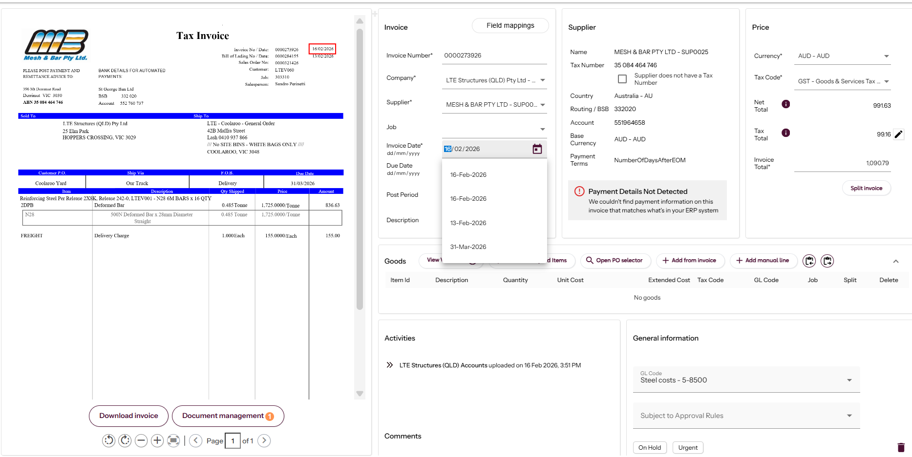
INVOICES THAT HAVE BEEN CODED AND WAITING FOR APPROVAL
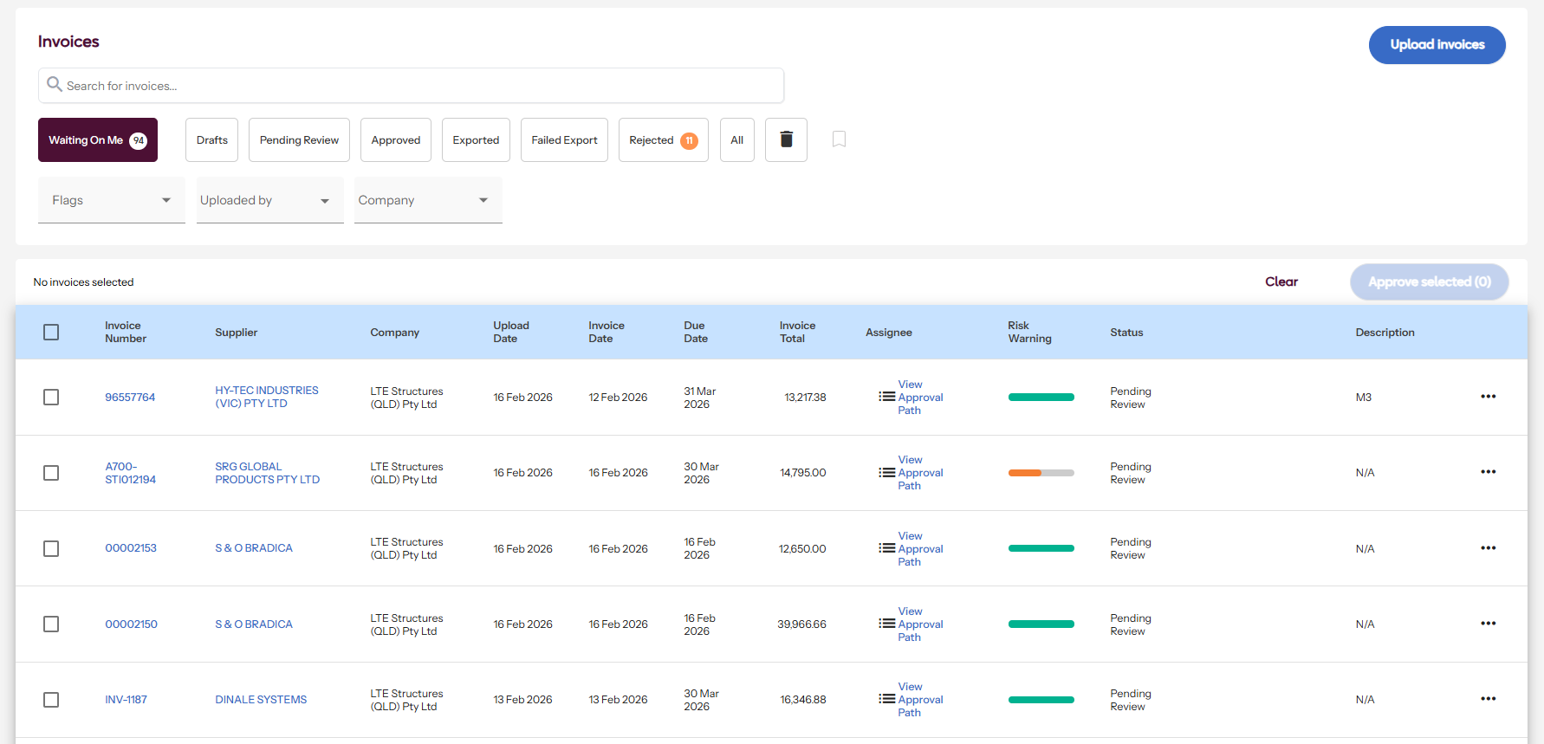

SUPPLIER VIEW FOR INVOICES
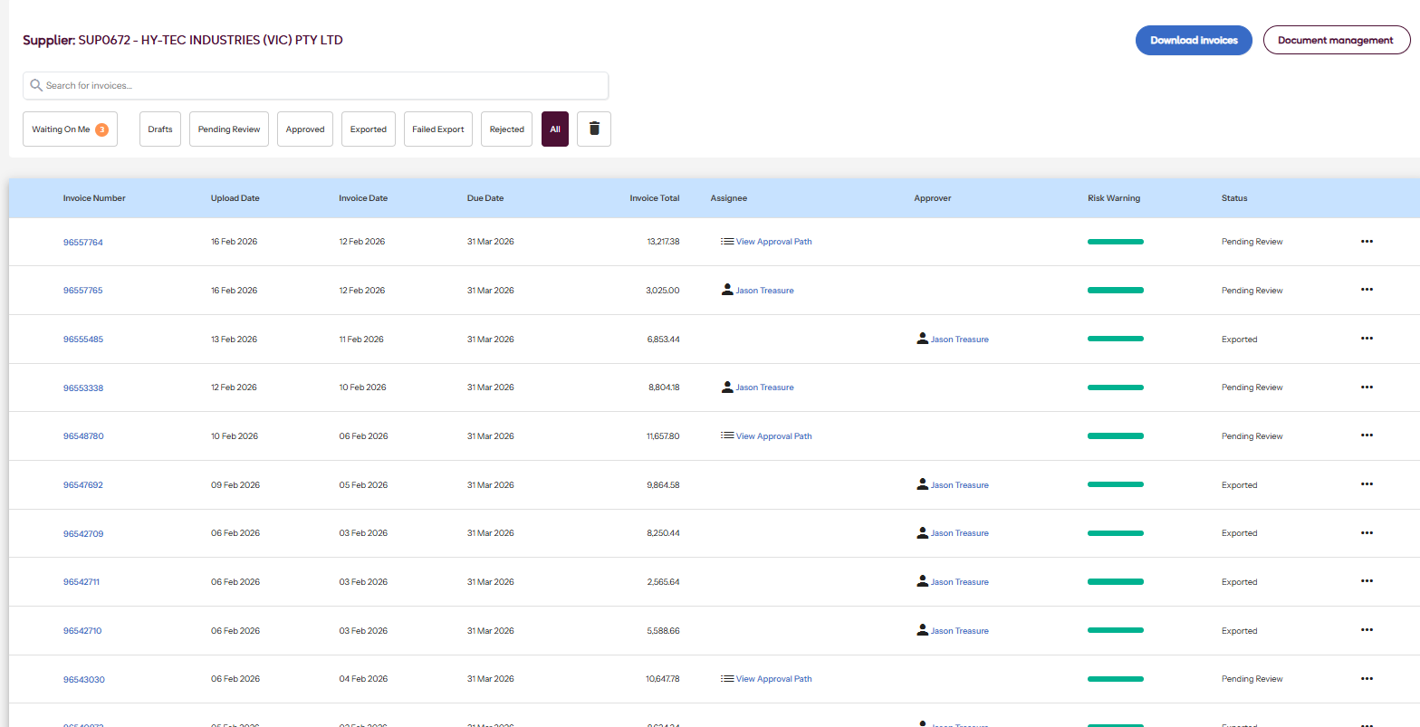
APPROVAL RULES
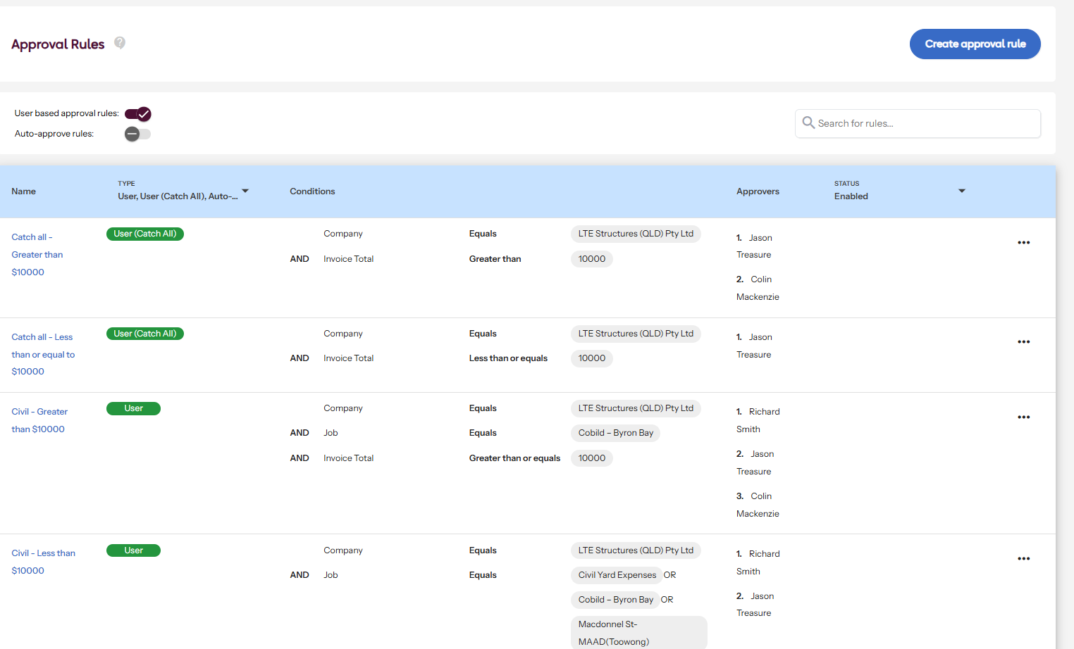

APPROVAL SCREEN WITH RISK RATING, CODING, ABILITY TO ADD NOTES AND REQUEST FURTHER INFORMATION – NOTE MULTIPAGE PDF VIEWER
