A project manager makes a weekly call to a builder when they call we bring up the pour sequence and we collect information about their project. Our questions relate to whether or not they next 60 days is on time (we should filter the production sequence shown to 60 days). Our interview questions relate to the dates below on the project that shows the pour dates. For each level we can mark late or on time. If it is late on click we want to ask how many days – it will then affect the start date of that activity and the resulting dates of all connected activities.
PM CALL LOGS
Field appears when changes made – allowing people to be notified
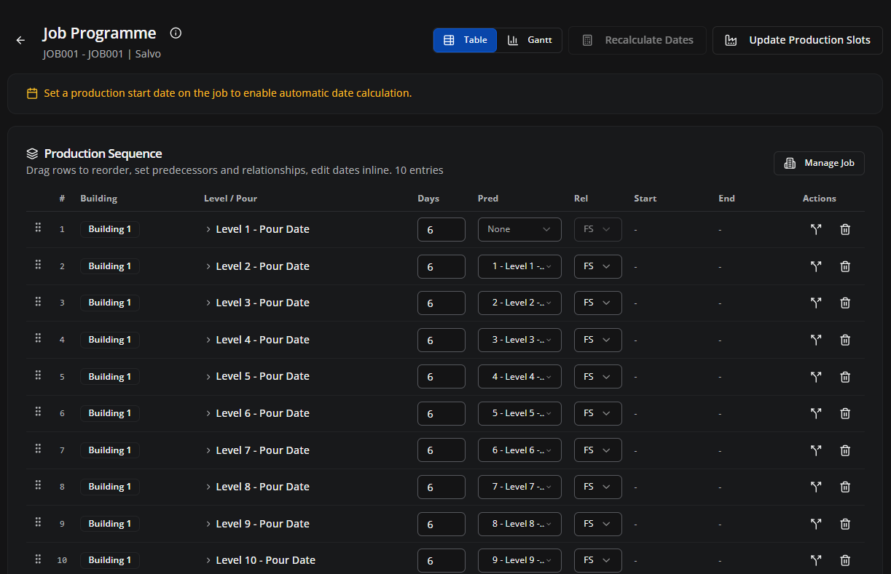
Update Logistics
Time of Delivery:
Date of Next Delivery:
Timing
Triggers update
Update: Production Schedule | Drafting Schedule
Notify: Manager | Email Client | Production

Drafting Concerns
Client design changes

Issues Reported by Client:
Notes
Contact:
Call Date/Time:
Project Manager Call Log
Late
On time
Late
On time
On time
Late
Late
On time
On time
Late
On time
Late
On time
Late
Late
On time
Late
On time
Late
On time
Installation Problems

The system need to use these call logs to manage the production and drafting schedules. These help us know if a project is on time and whether there are problems onsite that we need to address. On click of the Production Schedule and drafting schedule update it will take the new dates and recalculate our deliverable dates based on our formulas and settings (i.e. work days, days in advance etc). This should be an interview style approach where a production PM can call a site PM and get the information they need from the PM – if the next delivery is confirmed then the time of delivery is added and the user can update logistics to book in the loading list for a specific time. This is important that we store the dates and times for panels so we can deliver at the right time and avoid wait time.

