Create a purchase order manual where people can make purchases and submit for approval.
Make it exactly like this image
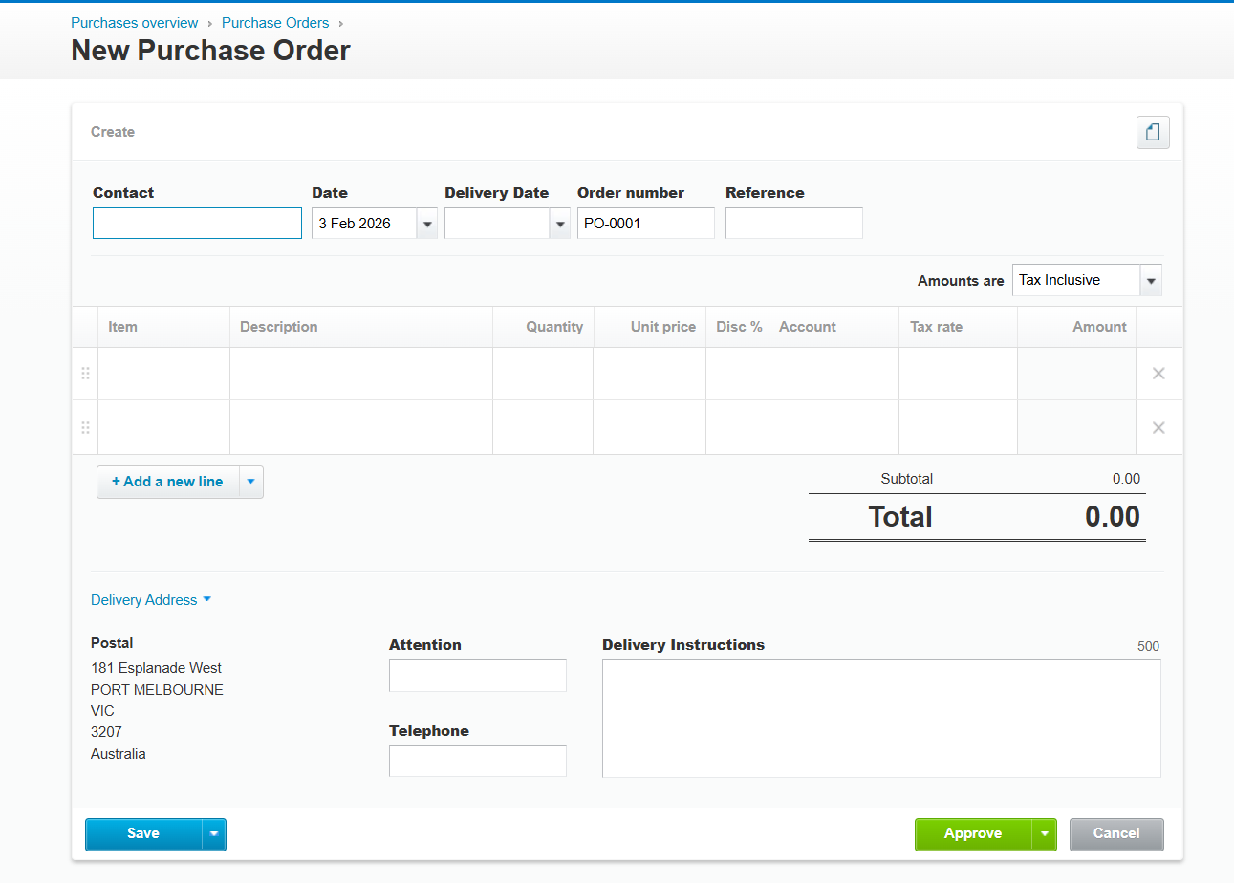
- Replace Contact with Supplier – create a supplier table storing supplier name, key contact, ABN, ACN etc
- Create an item category table
- Create an item table we can select that shows the item details including price, minimum order quantity etc.
- Make sure you have grid style adding like this where it automatically updates the total. Attached is also the basic information relating to products we purchase. Add all the fields required to import this into the database.
- Add a management approval function before this can be printed and emailed. Make sure once approved by a manager this can be PDF’d and sent – it needs to look professional when printed with a logo. Add approval as part of user setup for the premissions. Put checkbox “PO Approval” – with this checked then have a text box with approval limit. The user will only be able to approve PO’s under or equal to the value on this limit.
- Test end to end to make sure we can add purchase order using existing items ADD add our own items. We need to be able to enter things without selecting an item itself so make sure it is flexible.
- IT IS EXTREMELY IMPORTANT THAT THE GRID FUNCTIONALITY IS QUICK AND ON CHANGE IT UPDATES THE TOTALS.

