Panels
- The drafting team is responsible for managing the status of each panel
- When the panel is ready for production we need to do a final review confirming critical panel information.
- When a drafting user enters an entry and marks a panel complete and approved for production we require them to enter certain specific information as follows:
  - Load Width
  - Load Height
  - Panel thickness
  - Panel volume
  - Panel mass (note default from panel type is replaced by this)
  - Panel area (sqm)
  - 28 Day F’c
  - Lift Fcm
- Add each of these field values in the panel table where we record the panel name.
- I suggest that there is a QA hold point where they have to click on the list of panels drawn and a button called “Build” where:
  - On click it opens the panel and allows the user to enter and update the above field values and to drag and drop the production drawing (PDF) file onto the screen
  - I want a process where It automatically gets the above information from the PDF using open AI to review the PDF and find these details. Here is an example of a screen shot showing a panel drawing – note right hand corner shows most of the information
- 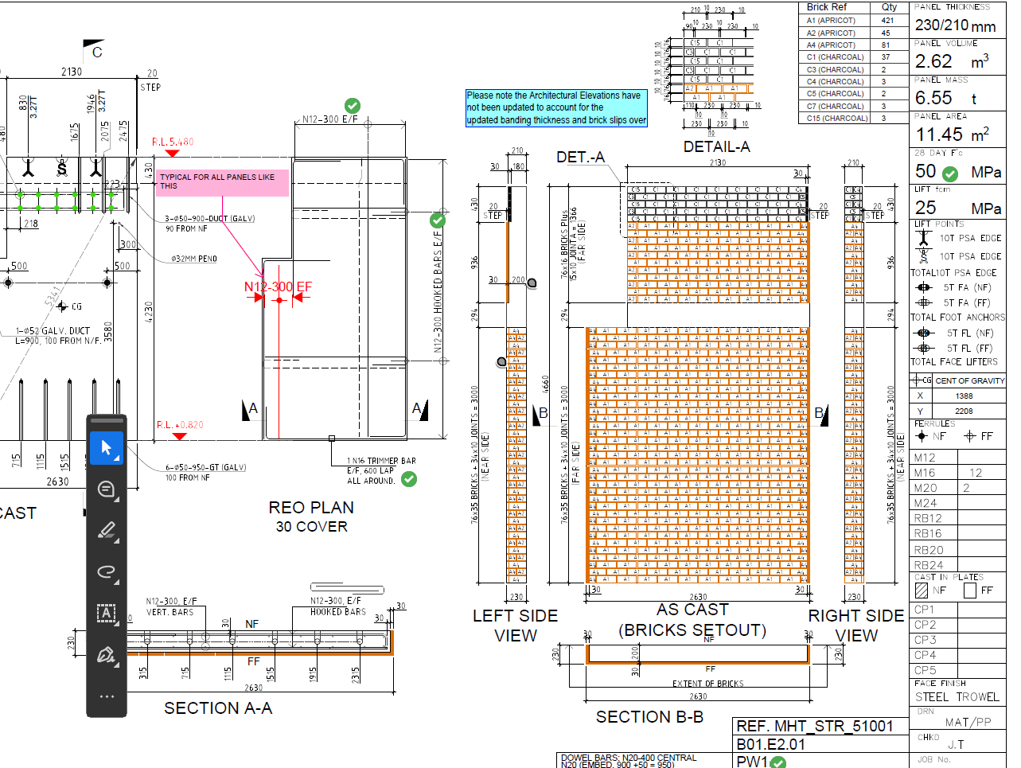
  - User is required to verify it got the right information then approves it for production.
  - Update so only panels approved for production can be entered into production report.

