Logistics

- Create a manual entry form for a load list where we pick the panel from the panel list to be loaded and it automatically populates this list.
- Information relating to the panel comes when the drafting person closes the panel as complete for production – this includes the thickness, width, weight etc.
- I see we missed rotational lifters and primary lifters from when we added the panel information from the pdf scan. Add these two fields on the screen where we add the rest of the information. Grab that data when we prepare the load list.
- Your load list will look like below – the job we select – the date will default to today but can be changed – the time will default to now but can be changed.
- Allow a text box for UHF.
- Address will come from the job, the site contact should be added into the information for the job and added when the job is setup.
- Trailer should come from a drop down with options Layover, A-Frame (we will need to add new values so create a table and store the index value.
- The panels will be selected with their information coming from the database. The weight will be based on the panel type and calculated based on the panel information added.
- Use the structure of the Load list below
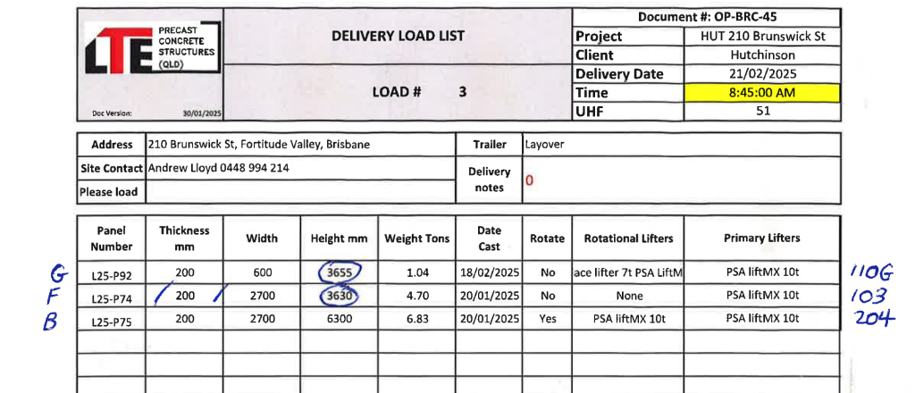

Once there is a load list a driver will load their truck and we need to store all the information:
Combine the fields from this sheet and the load document - effectively a person manually fills out the load document then it is entered into the computer system.
So the process is the logistics manager for each job works out what panels are going that day.
They create the load list.
Then when the truck arrives the truck information is entered including the delivery times (manual form first)
So for each load list there should be corresponding data relating to the date and time it was delivered and by who. The manual form is below:
You need fields for:
Docket Number
- Load Document #
- Truck Rego
- Trailer Rego
- Date
- Preload
- Load Number
- Number panels
- Comment
- Start
  - Leave Depot(time)
  - Arrive LTE (time)
- Pickup Location
  - Arrive (time)
  - Leave (time)
- Delivery Location
  - Arrive Holding (time)
  - Leave Holding (time)
- Unloading
  - Site first lift (time)
  - Site last lift/leave (time)
- Return Depot/ Reload
  - Arrive (time)
We then calculate total hours. See below the fields -

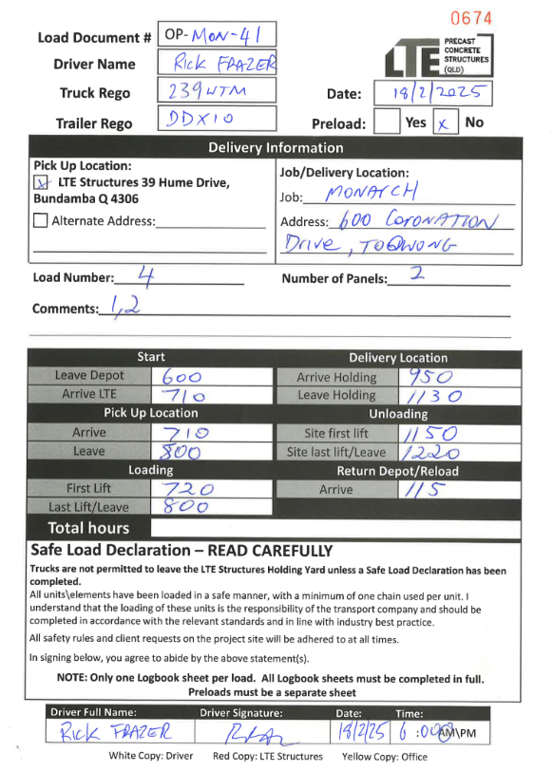

MENU ITEMS and idea
Add a logistics menu item - on this it shows each load list that has been created (refer below)
It has an add new button to create a new load list - also users can select a load list and add all the delivery information including driver times etc. (thats the second image I have there so make sure you create all the necessary fields) at that point the status of the load list will be changed from pending to complete. so make sure we have two integer values for each of the load lists for the pending or complete status. we will be using these logistics sheets to report - so make sure - list out for me all the fields you are adding - note we should be adding for the jobs the site managers name and contact details.

