Step 1:AI Model and Jira Research

Objectives:
The objective of this phase is to research and identify a suitable AI and NLP tools that can automatically generate User Stories and Test Cases from Jira Epics.

AI / NLP Tool Comparison
Model | Access Type | Output Format | Advantages | Limitations
OpenAI GPT-4o-mini | API | JSON Structured | Produces accurate JSON outputs ; easy Python integration | Requires internet & API Key
Hugging Face Flan-T5 | Open-source model | Plain Text | Works offline, open-source | Output less structured, slower
AI Studio | Web Interface | Text or JSON | Ideal for quick prompt testing | Limited API access
spaCy | NLP library (Python) | Keywords | Extracts keywords quickly offline | Cannot generate stories

Prompt-based vs Trained-model Approaches
  - Prompt-based: Uses pre-trained models (e.g., OpenAI GPT-4o-mini) with structured prompts where no extra training required.
  - Trained-model: Requires fine-tuning an open-source model (e.g., Flan-T5) using a dataset of Epics and Stories.
The prompt-based approach was selected as it is faster, produces consistent JSON results, and fits the project timeframe and resource constraints.

Test Example
A sample prompt was tested in AI Studio to validate output quality.
The AI produced three well-structured user stories — Add Items to Cart, Review Order and Select Shipping, and Secure Payment Processing — each containing clear acceptance criteria and numeric story points.
Prompt used:
“Given the following Epic description: Build an E-Commerce Checkout System, generate 3 user stories with Title, Description, Acceptance Criteria (Given/When/Then), and Story Points (1–13). Return valid JSON format.”
A short extract of the JSON response is shown below:
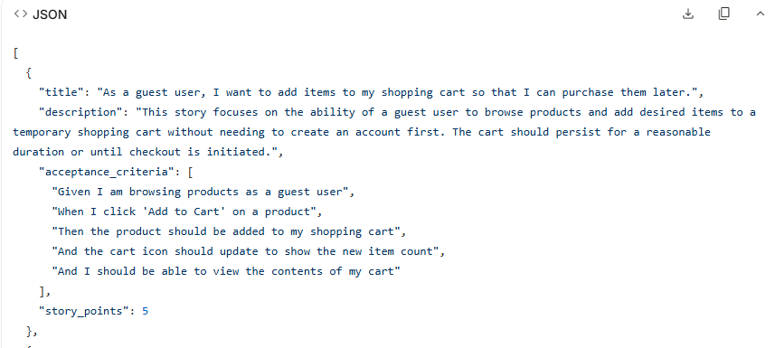
(Figure 1 shows a partial AI-generated JSON output. The full result is available in the project folder and demo video.)
After evaluation, OpenAI GPT-4o-mini was selected for its reliable structured outputs and easy integration with Python. This step applied the KISS principle (keeping prompts simple) and Modularity for separating research and code.

STEP 2: Write baseline AI logic expectations (Requirements + planning)

Objective:
Define the expected logic of the AI module that will generate Agile-style User Stories and Test Cases from Jira Epics. This step sets a clear foundation for later AI design and testing.

Selected Epic
Epic Title: Build an E-Commerce Checkout System
Description: Create a secure online checkout process allowing users to review their cart, provide payment and shipping details, and receive confirmation.

Manual Baseline User Stories:
- As a user, I want to review items in my cart so I can confirm my purchase before payment.
- As a user, I want to enter billing and shipping details to complete my purchase.
- As a user, I want to make a secure payment, so my order is successfully completed.
- As a system, I want to generate a digital receipt automatically after successful payment.

Manual Baseline Test Cases:
Test ID | Objective | Expected Result
TC01 | Validate cart review page | Items and prices display correctly
TC02 | Verify payment process | Payment accepted and confirmation shown
TC03 | Check receipt generation | Receipt is created and sent to the user after successful payment

Baseline AI Logic Expectations:
Input Stage: Receive Epic title + description from backend (Jira/mock), extract key actions and roles for prompt.
Processing Stage: Send structured prompt to GPT-4o-mini → model generates User Stories & Test Cases in Agile format.
Output Stage: Return JSON with title, description, acceptance_criteria (Given/When/Then), story_points. Backend displays results in the web interface.

Sample Expected AI Output:
{
"title": "Process Secure Payment",
"description": "As a user, I want to make a secure payment so that my order is successfully completed.",
"acceptance_criteria": {
"Given": "User is on checkout page",
"When": "Valid card details are entered",
"Then": "System confirms payment"
},
"story_points": 8
}

STEP 3 – DESIGN THE AI AGENT

Goal:

Plan the structure and logic of the AI module that converts an Epic into Agile-formatted user stories and test cases.

Decide AL Approach:
After analysing project requirements, the team decided to adopt Option A – Prompt Engineering instead of developing a fine-tuned model.
This approach was chosen because it is lightweight, cost-effective, and fast to implement.
It supports the software-engineering principle of Design, where simplicity and maintainability are prioritised during early development.

Define AI Requirements:
The AI module must:
- Accept an Epic title and description as input.
- Generate User Stories (Title, Description, Acceptance Criteria, Story Points).
- Generate corresponding Test Cases (ID, Objective, Expected Result).
- Return the result in structured JSON format so that the backend can store or display it later.
These functional requirements guided the overall design of the AI component.

Prompt Templates:
(As AI Engineer 1, I created the first version of the prompts that instruct the GPT-4o-mini model.)
User Story Prompt:
Given the following epic: {text}, generate 3 user stories with
Title, Description, Acceptance Criteria (Given/When/Then), and Story Points (1–13).
Test Case Prompt:
For each user story, generate 2 test cases with
ID, Objective, and Expected Result.

These templates are stored in the PROMPT variable inside the Python file ai_engine.py.

AI Agent Data Flow:
Epic → Prompt Creation → AI Processing → JSON Output → Backend Integration
Explanation:
- Epic data is provided by the backend or entered manually.
- The prompt is generated and sent to the GPT-4o-mini model.
- The model returns structured text which is converted to JSON.
- The JSON output is used by the backend to display or store results.
This satisfies the Design stage of the software-engineering lifecycle and prepares for the Implementation step.

Step 4: IMPLEMENTATION

Implementation Overview:
In this phase, AI Engineer 1 developed the Python module ai_engine.py, which connects to the GPT-4o-mini model through the OpenAI API.
The script takes an Epic description, sends it as a prompt, and returns structured JSON output containing User Stories and Test Cases.
A secondary file, test_ai.py, was used to check that the function can be imported and executed independently.
AI Engineer 2 then ran the same code, tested several prompt variations and temperature values, and confirmed that the generated results were complete and readable.
Development Environment:
Component | Description
Language | Python 3.9.13
Libraries | OpenAI SDK, JSON, os
IDE | PyCharm Community Edition
Files | ai_engine.py, test_ai.py, sample_output.json, validation_report.json, requirements.txt
Output Format1 | Structured JSON object

Implementation Process:
- Installed the OpenAI library and configured the environment variable OPENAI_API_KEY.
- Defined the main prompt template inside the variable PROMPT.
- Implemented the function generate_user_stories(epic_text) to call GPT-4o-mini and return JSON output.
- Added a mock fallback to allow offline testing when the API quota is exceeded.
- Executed the script using the test epic “Build an E-Commerce Checkout System.”
- Generated and saved the AI output into sample_output.json.
- Verified correct formatting and structure through test_ai.py.
- AI Engineer 2 re-ran tests with adjusted prompt phrasing and lower temperature settings to enhance accuracy.

Support for Multiple Epics:
To ensure scalability, the module was designed to process more than one epic in a single execution.
The program reads a list of epic objects, each containing a title and description, and loops through them to generate corresponding user stories and test cases.
The final output is stored as a JSON array (sample_output.json), where each element represents one epic’s structured results.
This approach improves modularity and reduces manual repetition, while staying consistent with Agile development practices.

Result:
The AI module executed successfully and produced structured JSON output that aligned with the manual baseline stories and test cases.
This confirms that the Implementation phase of the software-engineering lifecycle was completed, and the system is ready for Testing and Validation.

Evidence of Execution:
Figure 4.1 – JSON Output Generated by ai_engine.py (Implementation Stage)
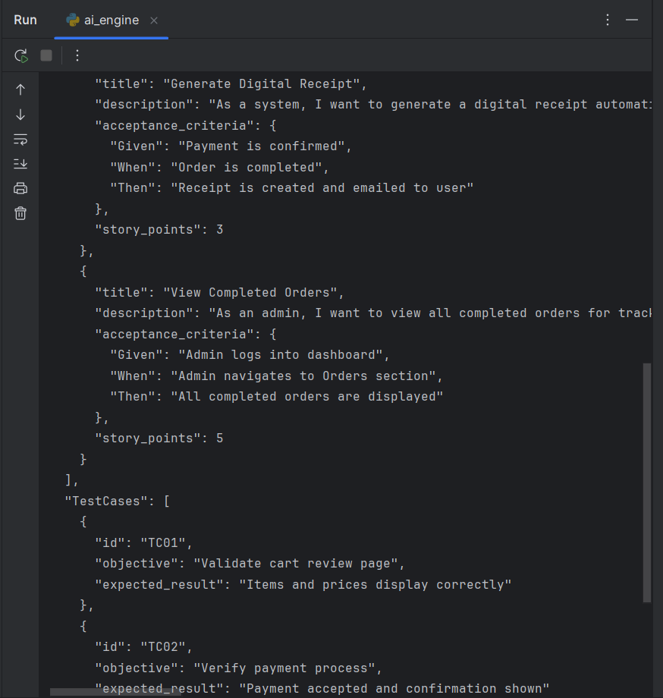

Figure 4.2 – AI Output Stored in sample_output.json File
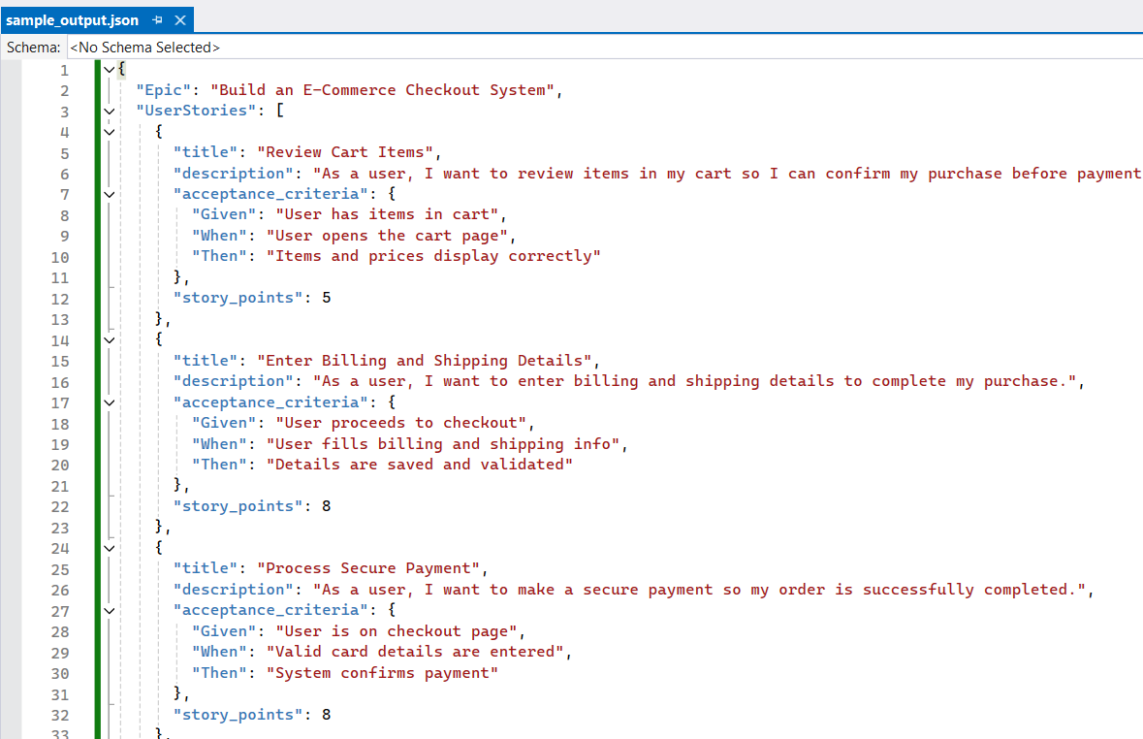

Step 5: TESTING & VALIDATION

Goal:
To verify that the implemented AI module (ai_engine.py) produces correct, complete, and structured User Stories and Test Cases that match the manual baseline from Step 2.

Testing Method
The Python module was executed in PyCharm using the epic:
“Build an E-Commerce Checkout System.”
The JSON output (shown previously in Figure 4.1) was compared with the manual baseline.
All results were analysed for correctness, completeness, and consistency.

Result Comparison:
Element | Manual Baseline | AI Output | Result
User Story 1 | Review items in cart | Review Cart Items | Match
User Story 2 | Enter billing and shipping details | Enter Billing and Shipping Details | Match
User Story 3 | Make secure payment | Process Secure Payment | Match
Test Case 1 | Validate cart review page | Validate cart review page | Match
Test Case 2 | Verify payment process | Verify payment process | Match
Test Case 3 | Check receipt generation | Check receipt generation | Match

Conclusion:
As AI Engineer 1, I confirmed that the AI module functions correctly and meets its expected behavior.
All outputs passed validation, and the system is ready for the final Reflection and Reporting phase (Step 6).

STEP 6:
At this stage, I completed my deliverables and worked with the Test Engineer and AI Engineer 2 during validation and report phase.
I have given all necessary files — ai_engine.py, sample_output.json, requirements.txt, and readme.txt — to both teammates for them to put into the final ZIP package.
The Test Engineer also checked for structural correctness, and AI Engineer 2 computed coverage and consistency statistics based on my output.
My AI module was also furthered to process multiple epics during a single run.
The function takes a list of epic name and descriptions, loop them sequentially with the same prompt format, and returns a JSON combined array of user stories and test cases.
This extension increases efficiency, scalability, and consistency with larger datasets, consistent with in-the-wild agile workflows. This step illustrates the Last Reporting principle of the software-engineering cycle. It confirms that all the prior phases — Requirements, Design, Implementation, Testing, and Reporting — have been completed and that each deliverable is fully tested, documented, and ready for project submission.

