Virtual Merchant Payment Module

You may use standard module installation procedures to install the module. Once the module is installed on your Prestashop store, you must configure the module by clicking the Configure link.
The following screen shot depicts the settings you should update before trying to use the module.
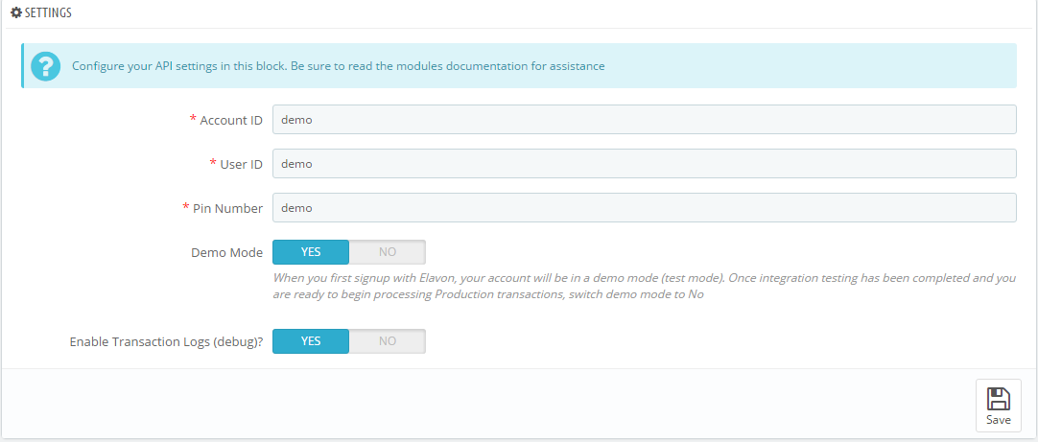

Account Id: Elavon will provide this information to you.
User Id: Elavon will provide this information to you.
Pin Number: Elavon will provide this information to you.
Demo Mode: When you first signup with Elavon, your account will be in a demo mode (test mode). Once integration testing has been completed and you are ready to begin processing Production transactions, switch demo mode to No
Enable Transaction Logs: If this option is enabled, all transactions to and from the VM gateway will be recorded in the “/modules/virtualmerchant/logs” directory. This is useful for testing in the sandbox and for troubleshooting issues. It is recommended to disable this option when you move to “Production” mode, and only enable if you are encountering issues or have been requested to enable by our support team. Sensitive customer and payment information will be recorded in this logs, so be sure to delete these logs when you are finished with them.

