

University of Science and Technology of Hanoi
Information of Communication Technology Department

Bachelor Thesis

Academic year 2021 - 2024

Webapp Book Recommendation using Vector Search and OpenAI embeddings

Presented by
NGUYEN Tuan Khiem
registered at University of Science and Technology Hanoi
Supervised by Mr. NGUYEN Van Nam
Internal supervised by Dr. NGUYEN Minh Huong

Hanoi, July - 2025
To whom it may concern,
I, Nguyen Van Nam (supervisor’s name), certify that the thesis/ internship report of Mr. Nguyen Tuan Khiem is qualified to be presented in the Internship Jury 2024 - 2025

Hanoi, July 3, 2025

Supervisor’s Signature

Contents
Contents 1
Attestation 4
Acknowledgement 5
Acronyms 6
List of Tables 7
Chapter 1 Introduction 9
1.1 Context and Motivation 9
1.2 Thesis Structure 10
Chapter 2 Objectives 11
2.1 Features 11
2.2 Expected Outcome 12
Chapter 3 Requirement Analysis 13
3.1 Overall System Requirements 13
3.2 Use Cases 13
3.2.1 Use Cases Diagram 13
3.2.2 User Characteristics 15
3.3 Webapp Book Recommendation’s Use Case and Scenario Description 15
3.3.1 Use case: Register (Sub-feature 1.1) 15
3.3.2 Use case: Login (Sub-feature 1.2) 16
3.3.3 Use case: Get Recommendation (Sub-feature 2.1) 17
3.3.4 Use case: Get book’s detail (Sub-feature 2.2) 19
3.3.5 Use Case: Save Book (Sub-feature 3.1) 20
3.3.6 Use Case: Remove Saved Book (Sub-feature 3.2) 21
3.3.7 Use Case: Chatbot Assistance (Sub-feature 4.1) 22
3.3.8 Use Case: Explanation Generated (Sub-feature 4.2) 23
3.4 Admin Panel’s Use Case and Scenario Description 24
3.4.1 Use case: Login (Sub-feature 1.1) 24
3.4.2 Use Case: Search User (Sub-feature 2.1) 25
3.4.3 Use Case: Delete User (Sub-feature 2.2) 26
3.4.4 Use Case: Search Book (Sub-feature 3.1) 27
3.4.5 Use Case: Delete Book (Sub-feature 3.2) 28
3.4.6 Use Case: Upload Book (Sub-feature 3.3) 29
3.4.7 Use Case: Track Embedding Token Usage (Sub-feature 4.1) 30
3.4.8 Use Case: Track Explanation Token Usage (Sub-feature 4.2) 31
3.4.9 Use Case: Track AI Chatbot Token Usage (Sub-feature 4.3) 32
Chapter 4 Methodology 33
4.1 System Architecture 33
4.1.1 Level 2: Container diagram 36
4.1.2: Level 3: Component Diagram 37
4.1.2.1: Component diagram for Web application Book Recommendation 37
4.1.2.2: Component diagram for Admin Panel 38
4.1.3: Level 4: Code 39
4.1.3.1: Code for Webapp Book Recommendation 39
4.1.3.2: Code for Admin Panel 40
4.2 Database Design 41
4.3 Use Cases Implementation 45
4.3.1 Register 45
4.3.2 Login 46
4.3.3 Recommend Books 46
4.3.4 Get Explanation 47
4.3.5 AI Chatbot 48
4.3.6 Save Book 49
4.3.7 Remove Book 50
4.3.8 Book Management 51
4.3.8.2 Delete Book Data 52
4.3.8.3 Upload Book 53
4.3.8.4 Search Users 54
4.3.8.5 Delete User 55
4.3.8.6 Track OpenAI API Token Usage 56
4.4 Tools and Techniques 57
4.4.1 OpenAI API 57
4.4.2 FastAPI 58
4.4.3 ReactJS 58
4.4.4 SQL 58
4.4.5 Milvus 58
4.4.6 Swagger 59
4.4.7 JWT (JSON Web Token) 59
Chapter 5 Results and Discussion 60
5.1 Result 60
5.1.1 API 60
5.2 Discussion 62
Chapter 6 Conclusions 63
6.1 Conclusion 63
6.2 Future works 63
Appendices 65
Bibliography 64

Attestation

I, NGUYEN Tuan Khiem, hereby declare that my report does not contain plagiarism (copy/paste) from other sources without fully crediting the citation.

I fully acknowledge the consequences of committing plagiarism. I understand that such an act would lead to the rejection of my thesis and all internship outcomes. If plagiarism is to be detected, I fully take responsibility and accept any adequate penalty from the board and the university.

(NGUYEN Tuan Khiem)
Hanoi, July 2025

Acknowledgement
Firstly, I would like to express my deepest gratitude to my supervisor at DigiPro Co., Mr. Nguyen Van Nam and Mr. Vu Dinh Trung for giving me the opportunity to do research and providing invaluable guidance during the internship period. His guidance and expert advice throughout the internship not only helps me successfully complete the thesis but also gives me valuable knowledge.

Secondly, I would like to give my gratitude to Mr. Nguyen Luong Cuong, managers at DigiPro CO., for offering me the internship as well as giving full support and supervision of my thesis.

I would like to acknowledge professors from my university for their excellent teaching. I want to thank you for your patient support and for all of the opportunities I was given.

Acronyms

API application programming interface.
DB database.
HTTP Hypertext Transfer Protocol.
JSON JavaScript Object Notation.
SQL structured query language.

List of Tables

Table 3.1: Register Basic Flow 15
Table 3.2: Login Basic Flow 17
Table 3.3: Vector Search Basic Flow 18
Table 3.4: Get Book’s Detail Basic Flow 19
Table 3.5: Save Book Basic Flow 20
Table 3.6: Remove Save Book Basic Flow 21
Table 3.7: Chatbot Assistance Basic Flow 22
Table 3.8: Explanation Generated Basic Flow 23
Table 3.9: Login Basic Flow (Admin-panel) 24
Table 3.10: Search User Basic Flow 25
Table 3.11: Delete User 26
Table 3.12: Search Book Basic Flow 27
Table 3.13: Delete Book Basic Flow 28
Table 3.14: Upload Dataset (Sub-feature 3.3) 29
Table 3.15: Track Embedding Token Basic Flow 30
Table 3.16: Track Explanation Generated Token Basic Flow 31
Table 3.17: Track AI Chatbot Token Basic Flow 32

Figure 3.1: Use cases diagram 14
Figure 4.1: Level 1: System Context diagram: Book Recommendation Architecture diagram 34
Figure 4.2: Level 2: Container diagram for Book Recommendation system 36
Figure 4.3: Level 3: Component diagram for Web application Book Recommendation 37
Figure 4.4: Level 3: Component diagram for Admin Panel 38
Figure 4.5: Level 4: API Back-end for Webapp Book Recommendation Class diagram 39
Figure 4.6: Level 4: API Back-end for Admin Panel Class diagram 40
Figure 4.2: Overall Database Design 41
Figure 4.3: Register Sequence Diagram 45
Figure 4.4: Login Sequence Diagram 46
Figure 4.5: Recommend Books Sequence Diagram 47
Figure 4.6: Get Explanation Sequence Diagram 48
Figure 4.7: AI Chatbot Sequence Diagram 49
Figure 4.8: Save Book Sequence Diagram 50
Figure 4.9: Remove Book Sequence Diagram 51
Figure 4.10: Search Book Sequence Diagram 52
Figure 4.11: Remove Book Data Sequence Diagram 53
Figure 4.12: Upload Book Sequence Diagram 54
Figure 4.13: Search User Sequence Diagram 55
Figure 4.14: Remove User Sequence Diagram 56
Figure 4.15: Track OpenAI API Token Usage Sequence Diagram 57
Figure 1: Login User Interface 66
Figure 2: Registered User Interface 67
Figure 3: Recommending Book Interface 68
Figure 4: View Book’s Detail Interface 69
Figure 5: Explanation Generated Interface 70
Figure 6: AI Chatbot Interface 70
Figure 7: Account information and Favorite List Interface 71
Figure 8: Admin Login Interface 71
Figure 9: Admin Panel Interface 72

Chapter 1

Introduction

1.1 Context and Motivation

In an era dominated by digital content, the number of available books has grown exponentially. However, this abundance also poses a problem to book lovers to find the ideal book that suits their interest. Traditional recommendation engines employ static metadata matching or explicit user ratings. Although this method is successful, these approaches have issues with personalization, scalability and semantic comprehension.

But now, an advanced method for recommendation systems has opened with Natural Language Processing (NLP) techniques, specifically vector embeddings from Large Language Models (LLMs). By converting textual content into dense vector representations, the system can assess similarity based on actual semantic meaning rather than just keywords.

Unlike the traditional keyword-based systems that rely on the exact word matches, limiting flexibility and diversity of queries, vector-based search and recommendation provides a modern solution to overcome the limitations of traditional systems. Users can simply use natural language to express their reading interests, such as “novels with psychological twists” or “books about time”, anything that comes off from their mind, and allow the algorithm to understand their intent without the need for precise matches or preset categories. With the help of OpenAI’s embedding models and Milvus vector search engine, the backend server handles the more complicated tasks, such as deciphering the query’s meaning and comparing it to a large collection of books. This method helps users to discover highly relevant books more effectively and intuitively.

The motivation is to explore how advanced AI technologies such as OpenAI’s embedding model text-embedding-ada-002, together with Milvus’s vector search engine, can greatly improve the effectiveness and quality of recommendation systems.

1.2 Thesis Structure
The thesis is divided into six main chapters to explain the development of Web application Book Recommendation.
- The first chapter, Introduction, will discuss the fascinating subject of Web application Book Recommendation using vector search and OpenAI embedding.
- The second chapter, Objectives, we shall establish the project’s standard requirements, present a quick summary of the system’s operation.
- The third chapter, Requirements Analysis, will continue with the system’s scenarios, use cases.
- The fourth chapter, Methodology, presents the system architecture, user flow of the application. Go through all of the tools and techniques utilized in the project.
- The fifth chapter, Result and Discussion, we shall detail all of the functionalities that are implemented in the system.
- The sixth chapter, Conclusions, provides conclusions about the project outcome and future works.

Chapter 2

Objectives
In this segment, we will define the key objectives for the project, provide a brief overview of the function of the system.

2.1 Features
The main goal of this project is to develop a Webapp Book Recommendation with basic services:

- FEATURE 1: Authentication
  - Sub-feature 1.1: Register: Allow users to create a new account.
  - Sub-feature 1.2: Login: Allow users to log into the system.
- FEATURE 2: Book Recommendations:
  - Sub-feature 2.1: Get Recommendation: Use OpenAI embeddings and Milvus vector search engine to recommend books based on conceptual semantic similarity.
  - Sub-feature 2.2: Get Book’s Detail: Allow users to see information about the book.
- FEATURE 3: Manage Saved List
  - Sub - feature 3.1: Save Book: Allow users to save books to their list.
  - Sub - feature 3.2: Remove Save Book: Allow users to remove save books to their list.
- FEATURE 4: AI Integration
  - Sub-feature 4.1: Chatbot Assistance: Integrate an AI chatbot to support users in discovering books.
  - Sub-feature 4.2: Explanation Generated: Use the GPT model to generate explanations to users why they may enjoy the book based on its content, such as its genre, theme and story.
In additional, an Admin panel is also developed in order to manage the website easily:

- FEATURE 1: Authentication:
  - Sub-feature 1.1: Login: Allow admin to log into the system.
- FEATURE 2: User Management:
  - Sub-feature 2.1: Search user: Allow admin to search registered user.
- Sub-feature 2.2: Delete user: Allow admin to delete an account.
- FEATURE 3: Database Management:
  - Sub-feature 3.1: Search book: Allow admin to search for books in the database.
  - Sub-feature 3.2: Delete book: Allow admin to remove books in the database.
  - Sub-feature 3.3: Upload book: Allow admin to upload books to the database.
- FEATURE 4: Tracking OpenAI API token usage:
  - Sub-feature 4.1: Track Embedding: Display amount of tokens usage for embedding.
  - Sub-feature 4.2: Track Explanation Generated: Display amount of tokens usage for explanation generated from OpenAI API.
  - Sub-feature 4.3: Track AI chatbot: Display amount of tokens usage for chatbot.

2.2 Expected Outcome
The system aims to create a Book Recommendation by using Milvus vector search engine and OpenAI’s embedding model. The project is expected to achieve the following outcomes:
- Develop a backend application that has all the desired features discussed.
- Develop a web interface with interactions between users and the system.
- Develop an admin panel to manage the website.

Chapter 3

Requirement Analysis
In this chapter, we will briefly review the project’s functions and the system’s scenarios and use cases. This section includes the entire functional specification.

3.1 Overall System Requirements
In general, this application should satisfy the following requirements:
- A login system with authentication
- A recommendation system
- Users can save books and remove them from the saved list
- Provided a button direct to marketplace
- Generate an explanation for each book
- An AI chatbot help user to get more specific suggestions

3.2 Use Cases

3.2.1 Use Cases Diagram
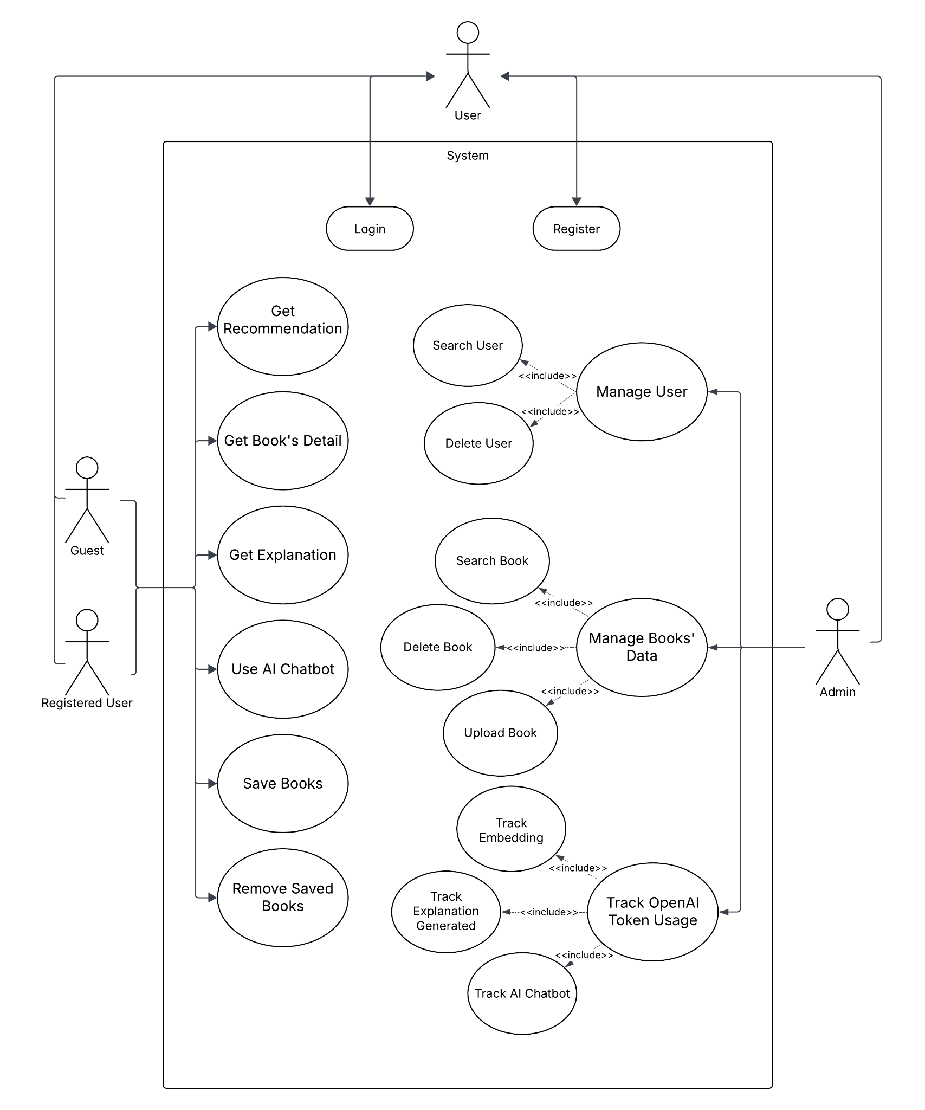

Figure 3.1: Use cases diagram

3.2.2 User Characteristics
Three types of users interact with the system: Registered User, Guest and Admin. Each user type has different uses in the system, so each user has its requirement:
- Admin: A user who can manage users, database and track the OpenAI token has been used.
- Registered User and Guest can access all of the recommendation web’s resources, only Registered User can save books.

3.3 Webapp Book Recommendation’s Use Case and Scenario Description

3.3.1 Use case: Register (Sub-feature 1.1)

Brief description
This use case describes how a user registers an account to the system.

Flow of events

Basic Flow
Actor Action | System Action | Data
 | 1. The system requests the Actor enter required information | - Username  - Email  - Password
2. The Actor enters required information | 3. The system check if the account already exists in the database | - Internal DB
 | 4. If valid, the system creates a new user in the database
 | 5. The system returns a success message and redirects the Actor to the login page

Table 3.1: Register Basic Flow

Alternative Flows
(i) Account exists
If the username or email already exists in the system, the system displays an error message.
(ii) Invalid Format
If the Actor has not entered invalid information to create a new account as required, the system displays an error message. The Actor can either re-enter the invalid fields or cancel the operation.
(iii) Insufficient Information
If the Actor has not specified sufficient Information to create a new account as required, the system displays an error message. The Actor can either enter the missing information or cancel the operation.

Special Requirement
Only Guest can Register into the system.

Pre-conditions
User is not logged in.

Post-conditions
If the Use Case is successful, the user registers successfully. If not, the system state is unchanged.

3.3.2 Use case: Login (Sub-feature 1.2)

Brief description
The Use Case describes how a user logs into the system.

Flow of events

Basic Flow

Actor Action | System Action | Data
 | 1. The system requests the Actor enter their username/email and password in the login form | - Identifier (username/email)  - Password
2. The Actor enters their username/email and password | 3. The system validates the entered username/email and password and logs the Actor into the system

Table 3.2: Login Basic Flow

Alternative Flows
(i) Invalid information
If the Actor enters an invalid username/email or password, the system displays an error message. The Actor can either re-enter their information or cancel the operation.

Special Requirement
None.

Pre-conditions
The user’s account must exist.

Post-conditions
If the Use Case was successful, the Actor is now logged into the system. If not, the system state is unchanged.

3.3.3 Use case: Get Recommendation (Sub-feature 2.1)

Brief description
This use case describes how a user gets a recommendation from the system.

Flow of events

Basic Flow

Actor Action | System Action | Data
1. The Actor types a keyword, sentence in the search bar. | 2. The system captures the query and calls OpenAI Embedding API to convert the text into a vector. | - User input
3. The Actor presses Enter or click search button | 4. The system performs a similarity search in Milvus vector database | - Query vector
 | 5. The system retrieves top 1000 books with the closest vectors to their query
 | 6. The system returns the list of books to the front-end to display | - List of books

Table 3.3: Vector Search Basic Flow

Alternative Flows
(i) Empty Query
If the user submits an empty query, the system will not send a request and return nothing.
(ii) No similar book found
If no similar book’s vector is found in Milvus, the system returns an empty list and a fallback message.
(iii) Embedding error
If the embedding API call fails (due to network or quota issues), the system will return an error.

Special Requirement
The OpenAI Embedding API key must be valid and set in the system environment.

Pre-conditions
The user has typed a non-empty query into the search bar.

Post-conditions
The system returns a list of books semantically similar to the user’s query.

3.3.4 Use case: Get Book’s Detail (Sub-feature 2.2)

Brief description
This use case describes how a user views detailed information of a selected book.

Flow of events

Basic Flow

Actor Action | System Action | Data
1. The user clicks on a book. | 2. The system opens a popup window showing full book details | - Book ID  - Book metadata (title, author, etc.)
 | 3. The system loads data then displays information such as title, author, thumbnail, categories, language, publishing year, publisher, description and number of pages. | - Book detail fields

Table 3.4: Get Book’s Detail Basic Flow

Alternative Flows
(i) Missing Book Information
If some book fields (e.g., author or publisher) are missing, the system will display “Unknown” as a placeholder.

Special Requirement
The selected book must exist in the result list.

Pre-conditions
The Actor is on the homepage and has received a list of recommended books and selected one.

Post-conditions
The system displays a pop-up showing the full details of the selected book.

3.3.5 Use Case: Save Book (Sub-feature 3.1)

Brief description:
This use case describes how a logged-in Actor can save a book into their personal list for later access.

Flow of events

Basic Flow

Actor Action | System Action | Data
1. After get the book’s detail, the Actor click the save button | 2. The front-end sends a POST request to the back-end API with the selected book ID and user’s token | - Book ID  - JWT Token
 | 3. The back-end verifies the user’s token and check whether the book is already in the user’s list | - User ID from token
 | 4. If not already saved, the system adds the book to the user’s favorite list

Table 3.5: Save Book Basic Flow

Alternative Flows
(i) Actor not logged in
If the user tries to save the book without logging into the system, the system will block the action and prompt the Actor to log in.
(ii) Book Already Saved
If the book already exists in the user’s saved list, a removed button will be displayed (sub-feature 3.2).

Special Requirement
None.

Pre-conditions
The Actor must be logged into the system before this Use Case begins.

Post-conditions
If the Use Case was successful, the book is added to the user’s book list. Otherwise, the system state is unchanged.

3.3.6 Use Case: Remove Saved Book (Sub-feature 3.2)

Brief Description
This use case demonstrates how a logged-in user removes a previously saved book from their list.

Basic flow of events

Basic Flow

Actor Action | System Action | Data
1. The user clicks the remove button | 2. The front-end sends a request to the back-end with the book ID and the user’s token | - Book ID  - JWT Token
 | 3. The back-end verifies the token and checks if the book exists in the user’s list. | - User ID from token
 | 4. If found, the system removes the book from the user's book list.

Table 3.6: Remove Save Book Basic Flow

Alternative Flows
(i) Book not in the list
If the book is not in the user’s list yet, a button Save Book will be displayed (Sub-feature 3.1).
(ii) User not Logged in
If the user is not logged in, the system will block the action and prompt the Actor for login.

Special Requirement
None.

Pre-conditions
The Actor must be logged into the system before this Use Case begins.

Post-conditions
If the Use Case was successful, the selected book is removed from the user’s list. Otherwise, the system state is unchanged.

3.3.7 Use Case: Chatbot Assistance (Sub-feature 4.1)

Brief description
This use case describes how an Actor interacts with the integrated AI chatbot to receive book suggestions or ask questions related to the book.

Basic flow of events

Basic Flow
Actor Action | System Action | Data
1. The Actor opens the chatbot window on the front-end
2. The Actor types a message. | 3. The front-end sends the message to the back-end via the chatbot API | - User message
 | 4. The back-end forwards the message to OpenAI Chat API with a predefined prompt.
 | 5. The system receives a response from OpenAI and sends it back to the front-end.

Table 3.7: Chatbot Assistance Basic Flow

Alternative Flows
(i) Empty Message
If the user submits an empty message, the system does not send the request and ignores the input.

Special Requirement
None.

Pre-conditions
The Actor enters a non-empty message related to book's topic.

Post-conditions
The Actor receives a meaningful response based on their query.

3.3.8 Use Case: Explanation Generated (Sub-feature 4.2)

Brief description
This use case describes how an Actor receives an explanation generated from OpenAI Chat API for the reason why a book is recommended.

Basic flow of events

Basic Flow

Actor Action | System Action | Data
1. The Actor clicks the explain button on a book | 2. The front-end sends a request to the back-end with the book’s information | - Book title  - Author  - Description
 | 3. The back-end forwards information to OpenAI Chat API with a predefined prompt.
 | 4. The API returns a short explanation to the front-end

Table 3.8: Explanation Generated Basic Flow

Alternative Flows
(i) Missing or Invalid Book Data
If the title, author or description of the book is missing, the system returns an error and disables operation.

Special Requirement
None.

Pre-conditions
The book must have valid information.

Post-conditions
The Actor receives an explanation message about the selected book why they might be interested in it.

3.4 Admin Panel’s Use Case and Scenario Description

3.4.1 Use case: Login (Sub-feature 1.1)

Brief description
This use case describes how an Admin logs into the system.

Flow of events

Basic Flow

Actor Action | System Action | Data
 | 1. The system requests the Actor enter their username and password | - Username  - Password
2. The Actor enters their username and password | 3. The system validates the entered information and logs the Actor into the system

Table 3.9: Login Basic Flow (Admin-panel)

Alternative Flows
(i) Invalid username/password
If the Actor enters an invalid username or password, the system displays an error message. The Actor can re-enter their information or cancel the operation.

Special Requirements
Admin account is pre-created.
Only users flagged as Admin in the database can access the admin dashboard.

Pre-conditions
The Admin account must exist.

Post-conditions
If the use case is successful, the Actor is granted access to the admin dashboard. If login fails, no state is changed.

3.4.2 Use Case: Search User (Sub-feature 2.1)

Brief description
This use case describes how the admin searches for a specific username or email in order to view their account.

Basic flow of events

Basic Flow

Actor Action | System Action | Data
1. Admin enters username or email into the search bar. | 2. The system sends a request to back-end with the query string | - Username  - Email
 | 3. The system returns a list of users whose username or email matches the query and display on front-end | - List of users

Table 3.10: Search User Basic Flow

Alternative Flow
(i) No matching users
If no users match the search query, the system returns an empty list.

Special Requirement
None.

Pre-conditions
The Admin must be logged into the system before this Use Case begins.

Post-conditions
If the Use Case was successful, the system displays all users matching the search query. Otherwise, nothing will be displayed, the system state is unchanged.

3.4.3 Use Case: Delete User (Sub-feature 2.2)

Brief description
This use case describes how an Admin removes an user account from the system.

Basic flow of events

Basic Flow:

Actor Action | System Action | Data
1. Admin press delete button from Search User interface | 2. The front-end sends a request to back-end | - User ID
 | 3. The back-end deletes the user from the database.

Table 3.11: Delete User

Alternative Flows:
(i) User not found
If a User with the specified id number does not exist in the database, the system displays an error message. The Admin can cancel the operation.

Special Requirement
None.

Pre-conditions
The Admin must be logged into the system before this Use Case begins.

Post-conditions
If the Use Case was successful, the user account is permanently removed from the database. Otherwise, the system state is unchanged.

3.4.4 Use Case: Search Book (Sub-feature 3.1)

Brief description
This Use Case describes how an Admin searches for books stored in the Milvus database.

Basic flow of events

Basic Flow

Actor Action | System Action | Data
1. Admin enters keyword(s) into the search bar | 2. The front-end sends a request to back-end | - Title  - Author
 | 3. The back-end performs a filtered query on Milvus
 | 4. The system returns a list of matched books | - List of books

Table 3.12: Search Book Basic Flow

Alternative Flows
(i) No matching book found
If no books match the query, the system returns an empty list.

Special Requirement
None.

Pre-conditions
The Admin must be logged into the system before the Use Case begins.

Post-conditions
If the Use Case was successful, A list of matching books is displayed. Otherwise, the system state remains unchanged.

3.4.5 Use Case: Delete Book (Sub-feature 3.2)

Brief description
This Use Case describes how the Admin removes a book from the system.

Basic flow of events

Basic Flow

Actor Action | System Action | Data
1. The Admin selects remove button from the Search Book interface | 2. The front-end sends a request to back-end | - Book ID
 | 3. The system removes the book from the database

Table 3.13: Delete Book Basic Flow

Alternative Flows
(i) Book not found
If the book specified id number does not exist on Milvus, the system displays an error message. The Admin can cancel the operation.

Special Requirement
None.

Pre-conditions
The Admin must be logged into the system before the Use Case begins.

Post-conditions
If the Use Case was successful, the selected book will be permanently removed from the system. Otherwise, the system remains unchanged.

3.4.6 Use Case: Upload Book (Sub-feature 3.3)

Brief description
This Use Case describes how the Admin uploads a CSV file containing book data to the system’s Miluvs database.

Basic flow of events

Basic Flow

Actor Action | System Action | Data
1. The Admin navigates to the “Upload Dataset” section | 2. The system requests Admin to upload a .csv file and an existed Milvus collection to stored or create a new collection
3. The Admin selects a file and chooses a target collection or create new | 4. The front-end sends a request to back-end with the file and collection name | - CSV file  - Collection name
 | 5. The back-end embeds the dataset and stores vectors in Milvus | - Embedded dataset
 | 6. The system adds new list of books

Table 3.14: Upload Dataset (Sub-feature 3.3)

Alternative Flows
(i) Missing collection name
If no collection is selected or entered, the system prompts the admin to provide one. The Admin re-selects or enters a new collection, or can cancel the operation.
(ii) Invalid File
If the uploaded file is not in valid .csv format, the system returns an error. The Admin can re-upload a new file, or cancel the operation.

Special Requirement
None.

Pre-conditions
The Admin must be logged into the system before the Use Case begins.

Post-conditions
If the Use Case was successful, a new list of books is uploaded to the system. Otherwise, the system state is unchanged.

3.4.7 Use Case: Track Embedding Token Usage (Sub-feature 4.1)

Brief description
This Use Case allows the Admin to view the number of OpenAI API tokens used for embedding book content.

Basic flow of events

Basic Flow

Actor Action | System Action | Data
 | 1. The back-end retrieves token usage logs
 | 2. The system filters and displays the total tokens used for embedding purpose

Table 3.15: Track Embedding Token Basic Flow

Alternative flows
(i) No token used
If no embedding is used or no logs are recorded, the system displays none.

Special Requirement
None.

Pre-conditions
The Admin must be logged into the system before the Use Case begins.

Post-conditions
If there was an embedding operation, the system displays total token usage. Otherwise, nothing is shown, the system state remains unchanged.

3.4.8 Use Case: Track Explanation Token Usage (Sub-feature 4.2)

Brief description
This Use Case allows the Admin to view the number of OpenAI API tokens used for explanation generated content.

Basic flow of events

Basic Flow

Actor Action | System Action | Data
 | 1. The back-end retrieves token usage logs
 | 2. The system filters and displays the total tokens used for explanation generated purpose

Table 3.16: Track Explanation Generated Token Basic Flow

Alternative flows
(i) No token used
If no explanation generated is used or no logs are recorded, the system displays none.

Special Requirement
None.

Pre-conditions
The Admin must be logged into the system before the Use Case begins.

Post-conditions
If there were any explanation generated operation, the system displays total token usage. Otherwise, nothing is shown, the system state remains unchanged.

3.4.9 Use Case: Track AI Chatbot Token Usage (Sub-feature 4.3)

Brief description
This Use Case allows the Admin to view the number of OpenAI API tokens used for AI Chatbot content.

Basic flow of events

Basic Flow

Actor Action | System Action | Data
 | 1. The back-end retrieves token usage logs
 | 2. The system filters and displays the total tokens used for AI Chatbot purpose

Table 3.17: Track AI Chatbot Token Basic Flow

Alternative flows
(i) No token used
If no AI Chatbot is used or no logs are recorded, the system displays none.

Special Requirement
None.

Pre-conditions
The Admin must be logged into the system before the Use Case begins.

Post-conditions
If there were any AI Chatbot operation, the system displays total token usage. Otherwise, nothing is shown, the system state remains unchanged.

Chapter 4

Methodology

In this chapter, we will list all the tools and techniques used in this project, the reasons why they are chosen with overall system architecture and the detailed use cases implementations.

4.1 System Architecture
We use the C4 model to describe the software architecture of the system because this approach helps clearly represent the relationships between key components.

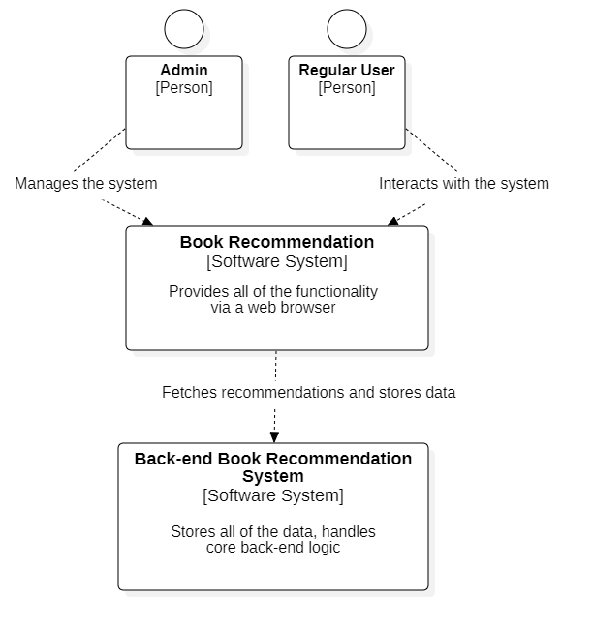

Figure 4.1: Level 1: System Context diagram: Book Recommendation Architecture diagram
This is the System Context diagram for the Web application Book Recommendation. The diagram illustrates how the system interacts with external actors: Admin and Regular User (Registered User and Guest.
The Book Recommendation System provides all the functionality via two web browsers, one is for the Regular User and the other is for the Admin, allowing actors to interact with the system with specific purposes.
The Back-end Book Recommendation System stores all of the data (books data, users data, admins data and OpenAI API tokens usage data) and handles the core back-end logic, providing all system functionality.

4.1.1 Level 2: Container diagram

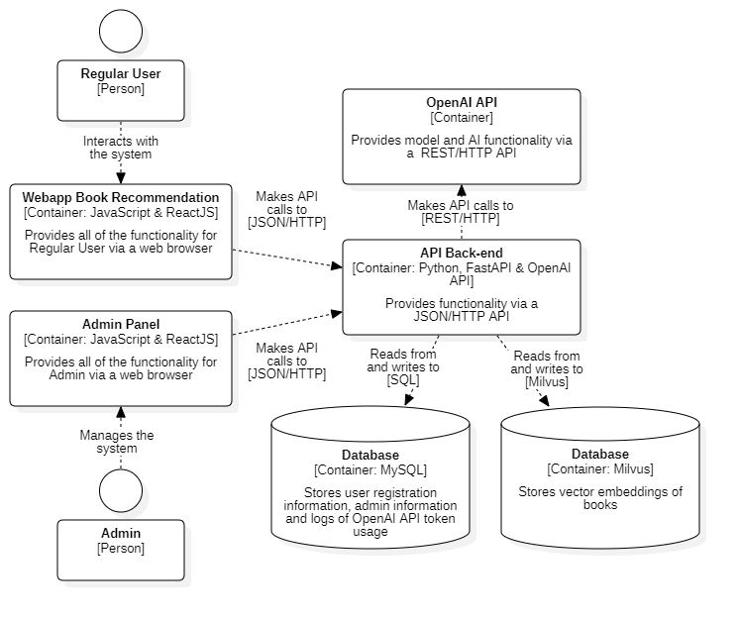

Figure 4.2: Level 2: Container diagram for Book Recommendation system

It shows that the application is made up of 6 containers: a web application Book Recommendation for Regular User, a web application Admin Panel for Admin, a server-side API Application, two databases, and an external OpenAI API service. The web applications are ReactJS applications that run in the user’s web browser, providing all of the Book Recommendation features for each user (Regular User and Admin) via JSON/HTTP API calls. The API Back-end, built with Python and FastAPI, handles requests from both web applications (Book Recommendation and Admin Panel), calls the external OpenAI API for embedding model and AI features, reads from and writes data to the internal databases (MySQL and Milvus).

4.1.2: Level 3: Component Diagram

4.1.2.1: Component diagram for Web application Book Recommendation

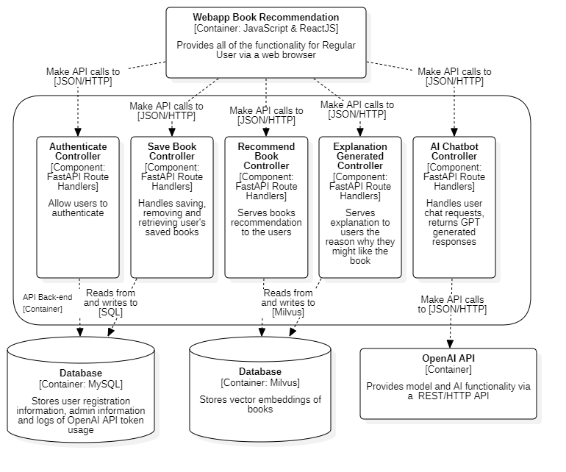

Figure 4.3: Level 3: Component diagram for Web application Book Recommendation

This is the Component Diagram for the Web application Book Recommendation, showing the main parts inside the API Back-end application. Here, there are 5 FastAPI Route Controllers providing access points for the JSON/HTTP API. Each controller handles specific tasks: authentication, saving books, recommending books, and AI features (generated for explaining and chatbot).
Since this project is not too big at the moment, the logic is written directly inside the controllers. This fastens the development process, and makes it easier to change or update features. However, as the project grows bigger in the future, the structure needs to be refactored and separated the logic into components and controllers, this will help maintain the system better.
The controllers work with other parts of the system to perform their functions. They read data from and write data to the MySQL database, for the Web application Book Recommendation, the database stores user registration information and logs of OpenAI API token usage, Milvus database to fetch similar books using vector search, and some controllers send request to OpenAI API to get response.

4.1.2.2: Component diagram for Admin Panel

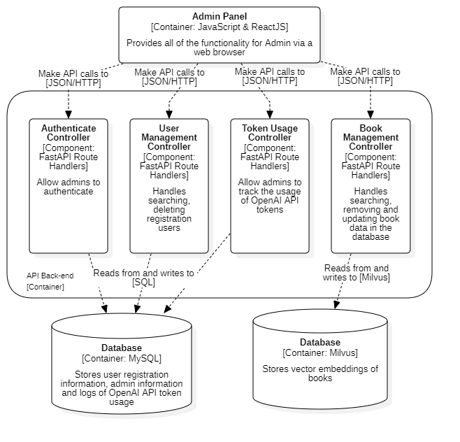

Figure 4.4: Level 3: Component diagram for Admin Panel
This is the Component diagram for the Admin Panel of the Book Recommendation system, showing the main parts inside the Back-end API application. Here, there are 5 FastAPI Route Controllers providing access points for the JSON/HTTP API. Each controller handles specific tasks: authentication, user management, book (data) management, and tracking OpenAI API token usage of the system.
Again, same as the Webapp Book Recommendation, the Admin Panel has the logic written directly inside the controllers.
The controllers work with the other parts of the system to perform their functions. They read data from and write data to the MySQL, for Admin Panel, MySQL database stores user account information, book data and logs of OpenAI API token usage, and Milvus database. There is a controller (Book Management Controller) that interacts with the Milvus database to manage the books data.

4.1.3: Level 4: Code

4.1.3.1: Code for Webapp Book Recommendation

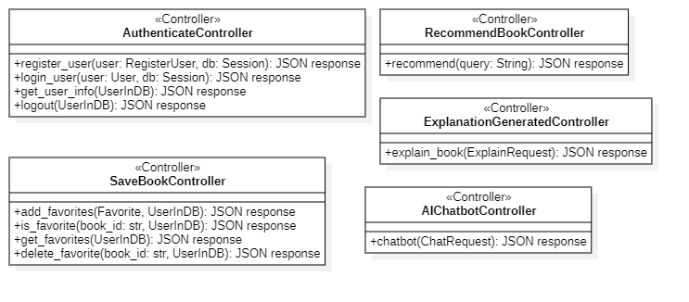

Figure 4.5: Level 4: API Back-end for Webapp Book Recommendation Class diagram

This is the Class diagram for the API Back-end for Webapp Book Recommendation, describing the main controllers. Each controller contains operations (API endpoints) that handle specific user’s requests and return JSON responses. These controllers are not actual Python classes, but groups of related functions defined in modules. In this diagram, these modules are assigned as controllers to make the structure clearer.

4.1.3.2: Code for Admin Panel

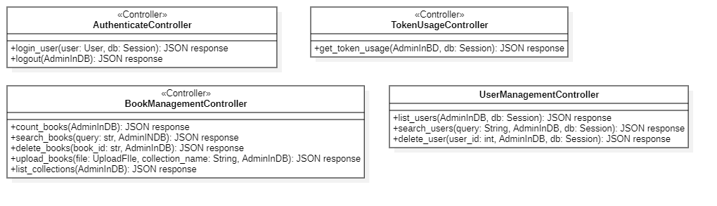

Figure 4.6: Level 4: API Back-end for Admin Panel Class diagram

This is the Class diagram for the API Back-end for Admin Panel, describing the main controllers. Each controller contains operations (API endpoints) that handle admin’s requests and return JSON responses. These controllers are not actual Python classes, but groups of related functions defined in modules. In this diagram, these modules are assigned as controllers to make the structure clearer.

4.2 Database Design

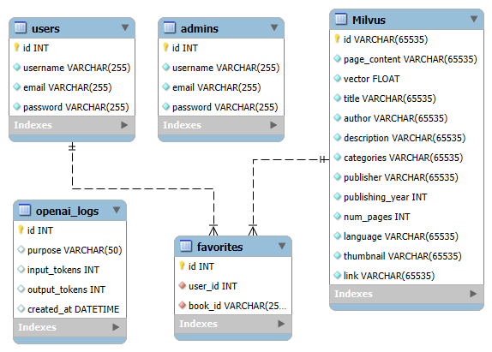

Figure 4.2: Overall Database Design

Table 4.1: Database User Design
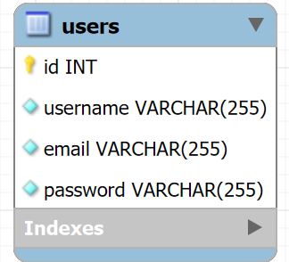

- “users” is the table that contains the information of registered users. This table has sensitive data of users such as “password”.
- The “password” field in this table is encrypted to keep user accounts secure.
- After the user register, the system saves the user information and assigns a unique “id” to the user, and this “id” is the Primary key of the table

Tabel 4.2: Database Admin Design
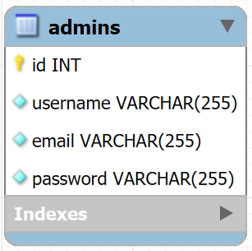
- “Admins” is the table that contains the information of admins. The admin’s account is pre-created.
- The “password” field in this table is encrypted to keep user accounts secure.
- After creating an account for admin, the system saves the admin information and assigns a unique “id” to the admin, and this “id” is the Primary key of the table.

Table 4.3: Database Milvus Design
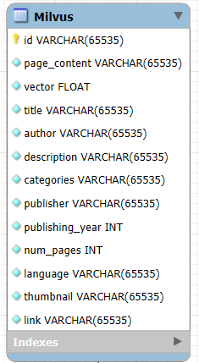

- The “Milvus” is a simulated table that represents how vector-embedded book data is managed. The table is not physically present in the MySQL database and only serves for visualization purposes in the database design.
- The “id” field is a unique identifier for each book, this field is the Primary key of the table, used to reference book entries.
- The “vector” field contains the high-dimensional embedding of the book.

Table 4.4: Database Favorites Design

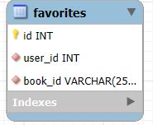

- The “favorites” is the table that stores the books which the users have saved.
- The “user_id” field is a Foreign key that references the “id” field in the “users” table. It identifies which user saved the book.
- The “book_id” field stores the ID of the saved book, which matches the ID of the book stored in the Milvus database.
- The “id” field identifies each favorite record, the field is the Primary key of this table.

Table 4.5: Database OpenAI Logs Design

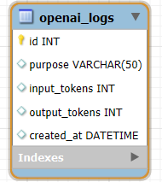

- The “openai_logs” is the table that stores logs of OpenAI API token usage.
- The “purpose” field describes the reason for the API call (e.g., explanation, chatbot).
- The “input_tokens” and “output_tokens” fields record how many tokens were used in the request and response.
- The “created_at” field stores the timestamp when the API is used.
- The “id” field identifies each log entry, the field is the Primary key of this table.

4.3 Use Cases Implementation

4.3.1 Register
This use case describes how a user registers to the system.This user cannot register for Admin since the Admin account is pre-created. When a user wants to register into the system, the system will display a register interface and request the user to enter username, email and password. After the user enters the required information, the system checks if the entered email or username are unique from the table “users” in the database. If unique, the system saves the user information, encrypts the password, assigns a unique id to the user, then redirects to the login interface. Otherwise, the system displays an error message and the user has to re-enter the information.

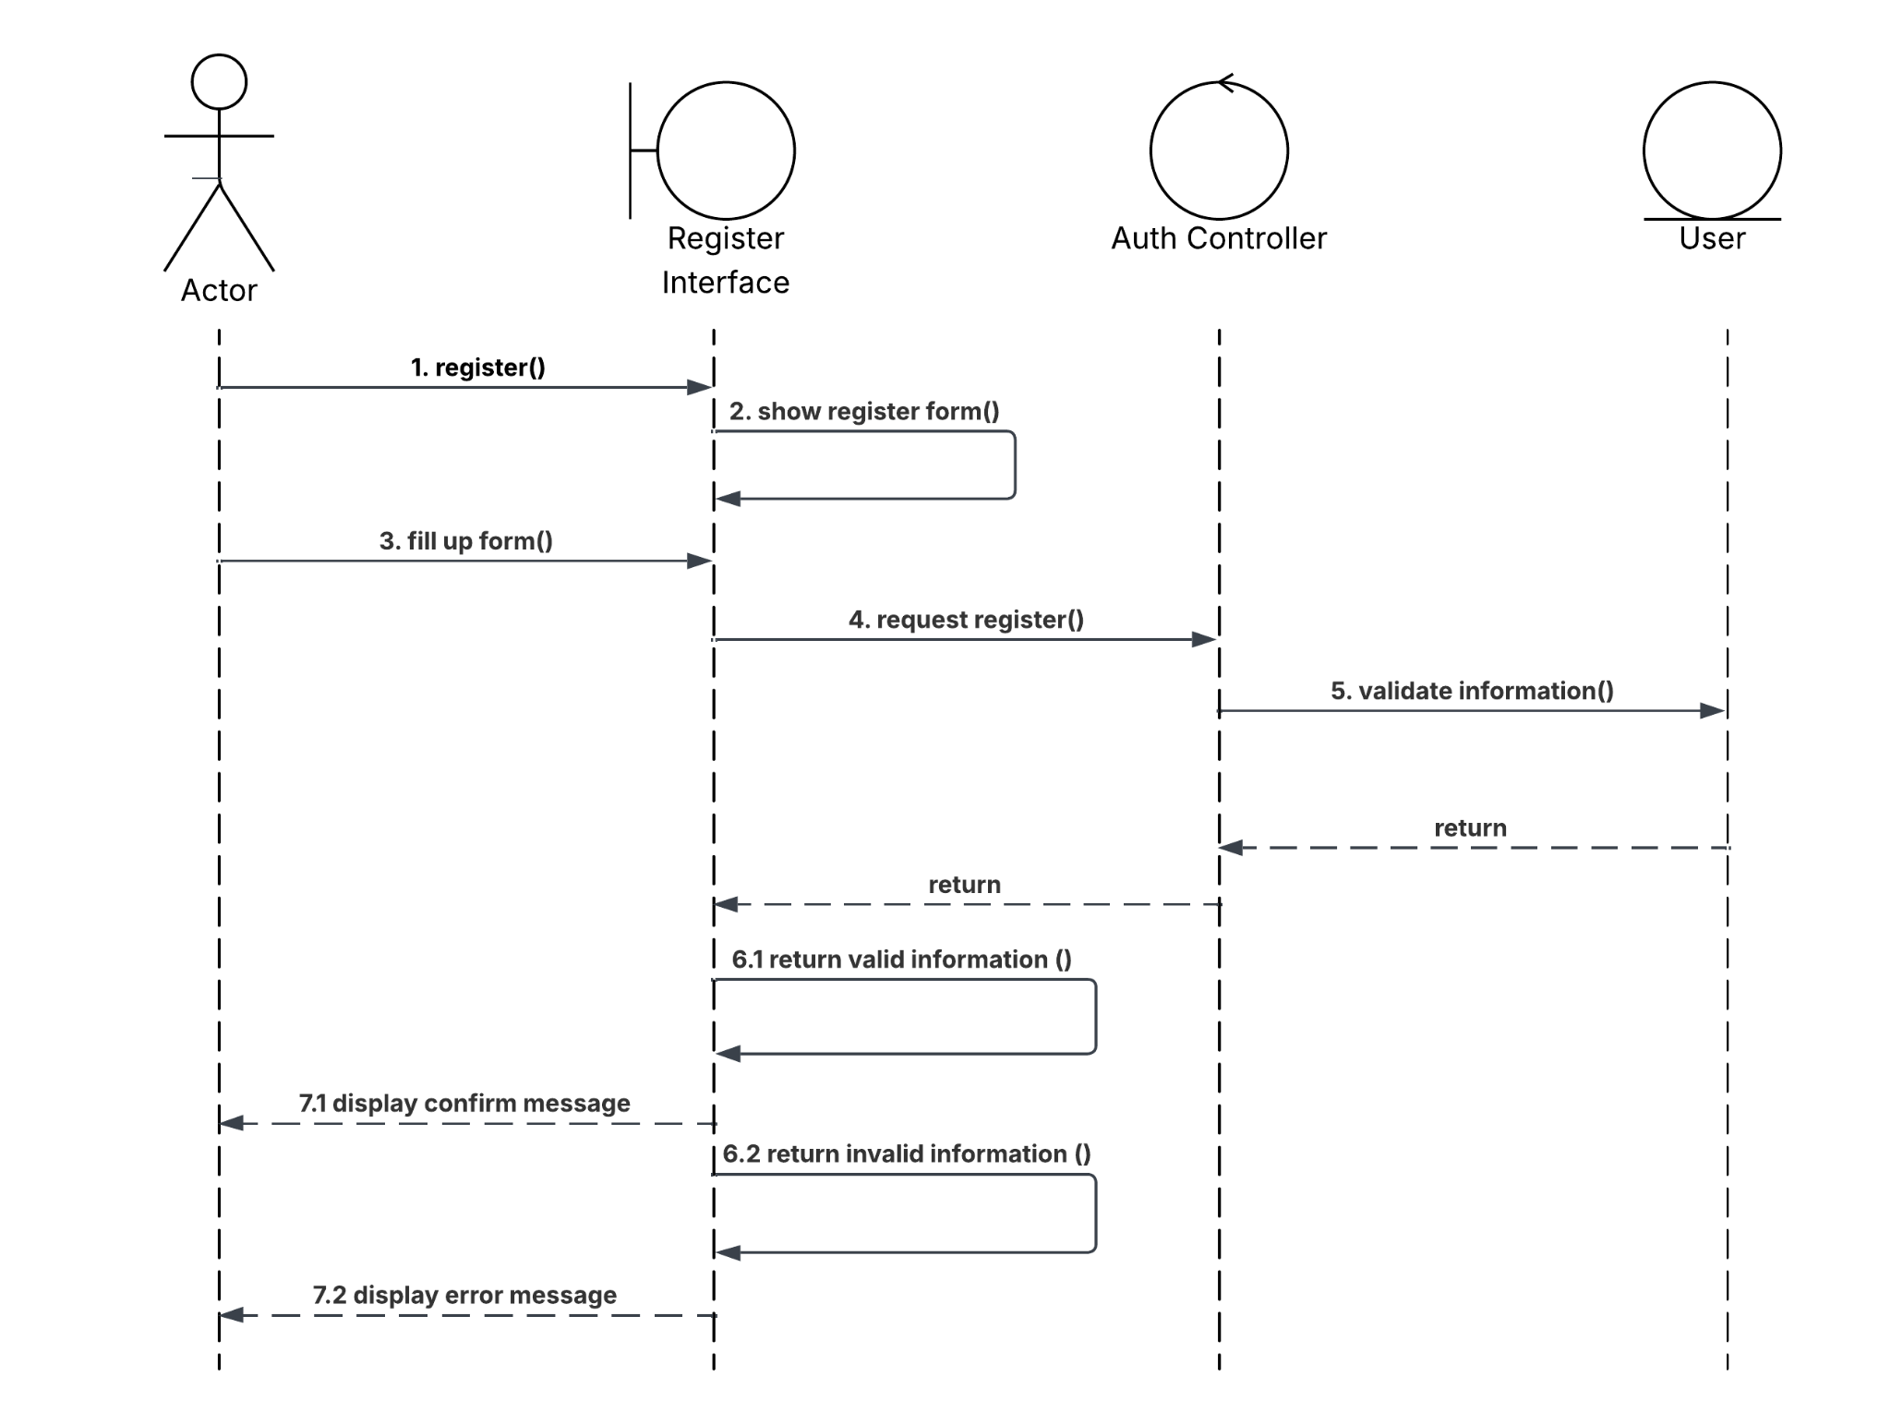

Figure 4.3: Register Sequence Diagram

4.3.2 Login
This use case describes how a user login to the system. This user can be an Admin or a Regular User. When a user wants to login, the system requests the actor to enter username and password. Once the user enters the required information, the system will check if the information is valid. If valid, the Admin will be logged into the Admin Panel, for Regular User, will be logged into the Web application. Otherwise, the system displays an error message and the user has to re-enter the information.

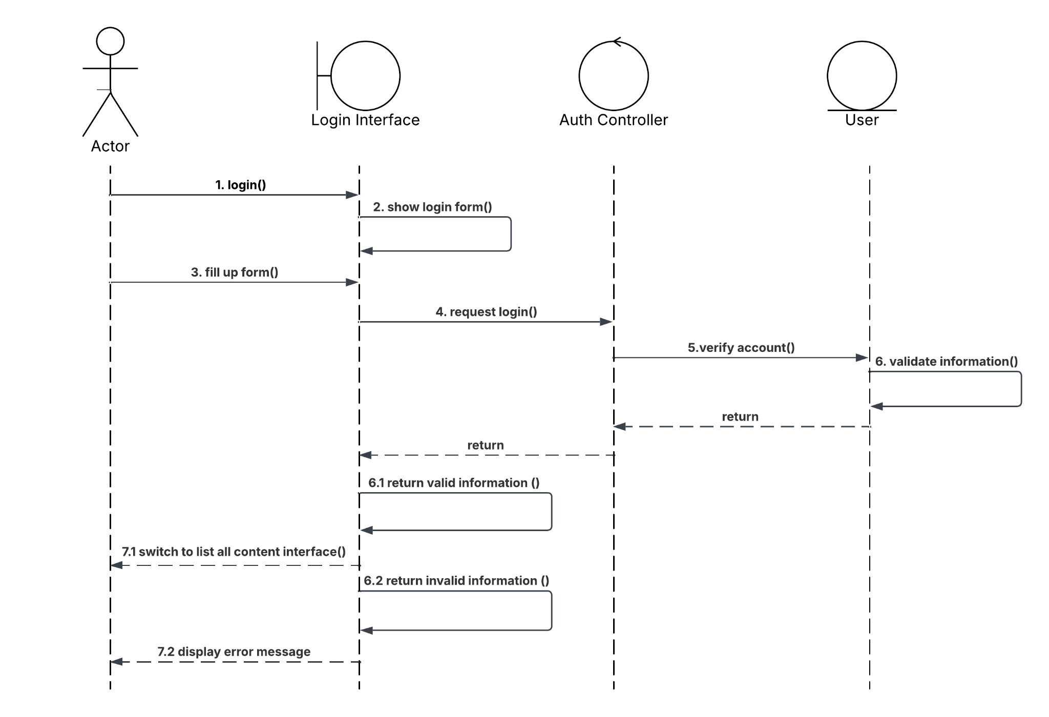

Figure 4.4: Login Sequence Diagram

4.3.3 Recommend Books
This use case describes how an Actor gets book recommendations from the system. When the user enters a query into the search bar on the web application. The system sends the query to the API back-end, which then embeds the query into a vector. Once the embedding is done, the system performs a similarity vector search in the Milvus database, where the vectors of books are stored. If relevant results are found, the system displays a list of books. Otherwise, the system displays none.

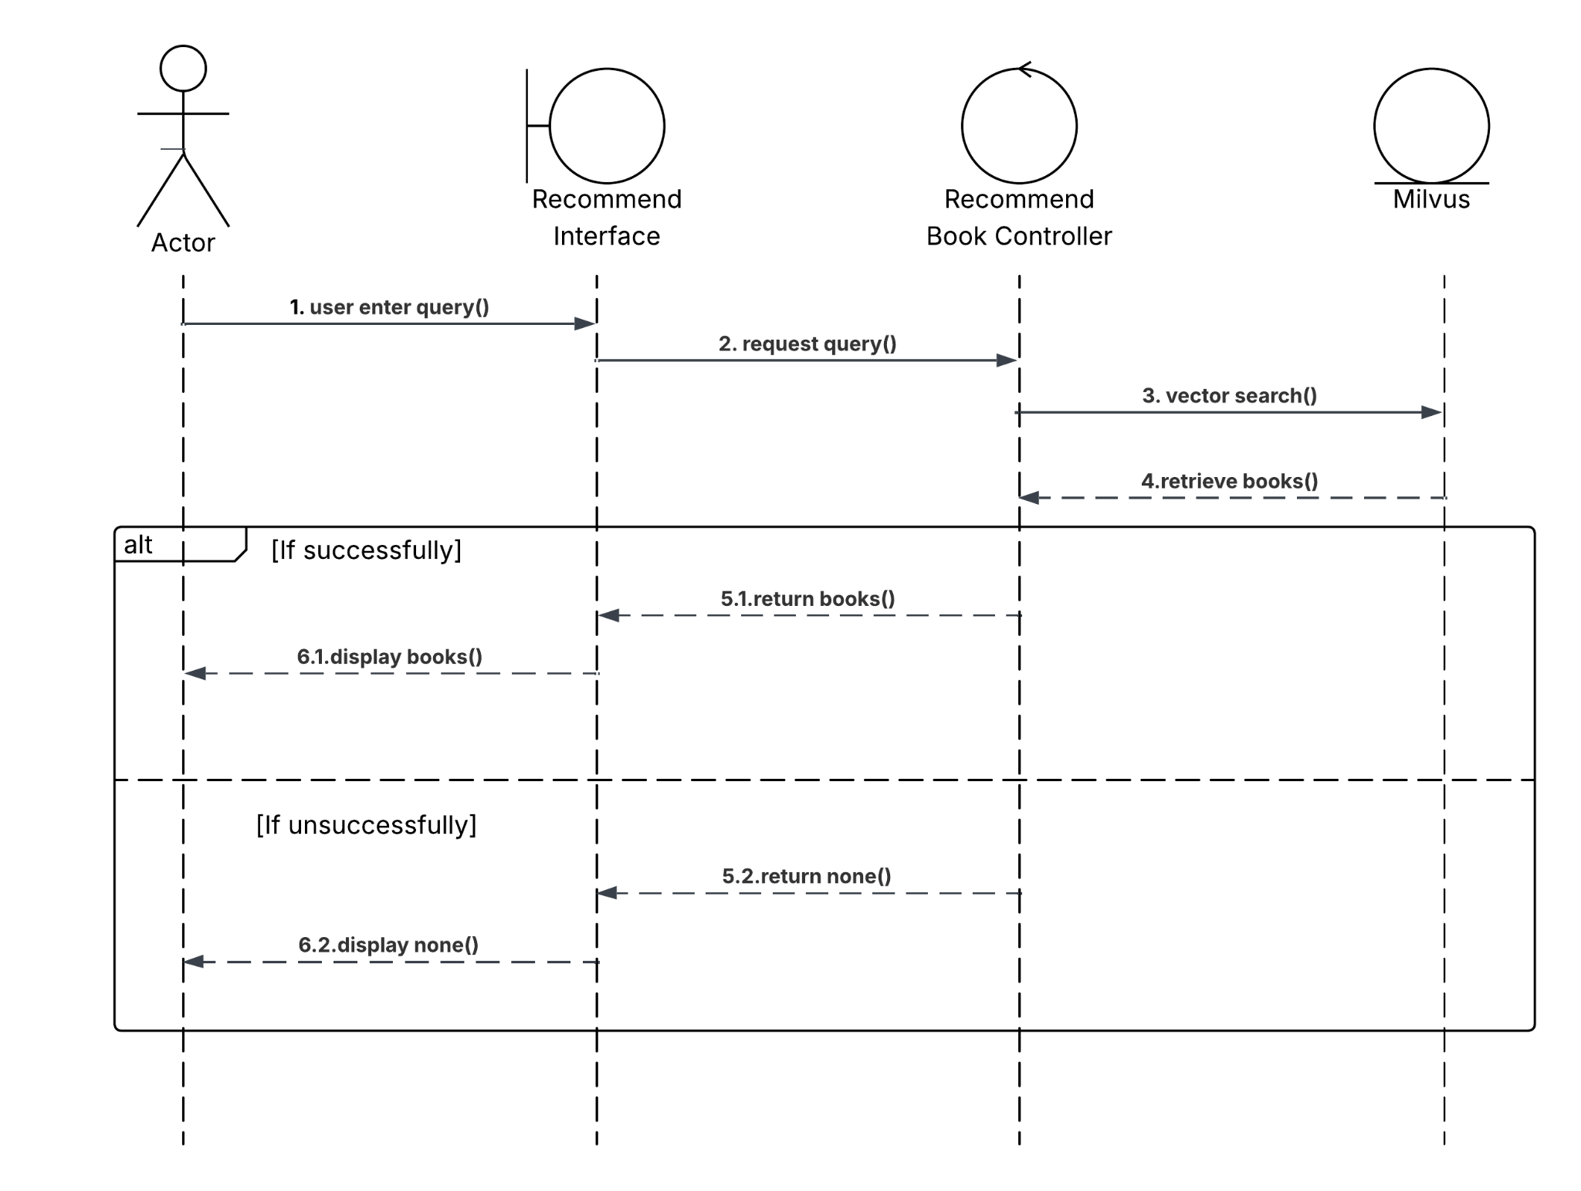

Figure 4.5: Recommend Books Sequence Diagram

4.3.4 Get Explanation
This use case describes how an Actor receives an explanation why the Actor might like the book. When the Actor clicks on the specific button with explanation purpose, the front-end sends the book’s information (title, author, description) to the API back-end. The controller then sends the request to the OpenAI API to generate the explanation. If successfully, the generated explanation will be displayed on the front-end. Otherwise, if the system cannot connect to the OpenAI API or the usage quota has been reached, the system will display an error message.

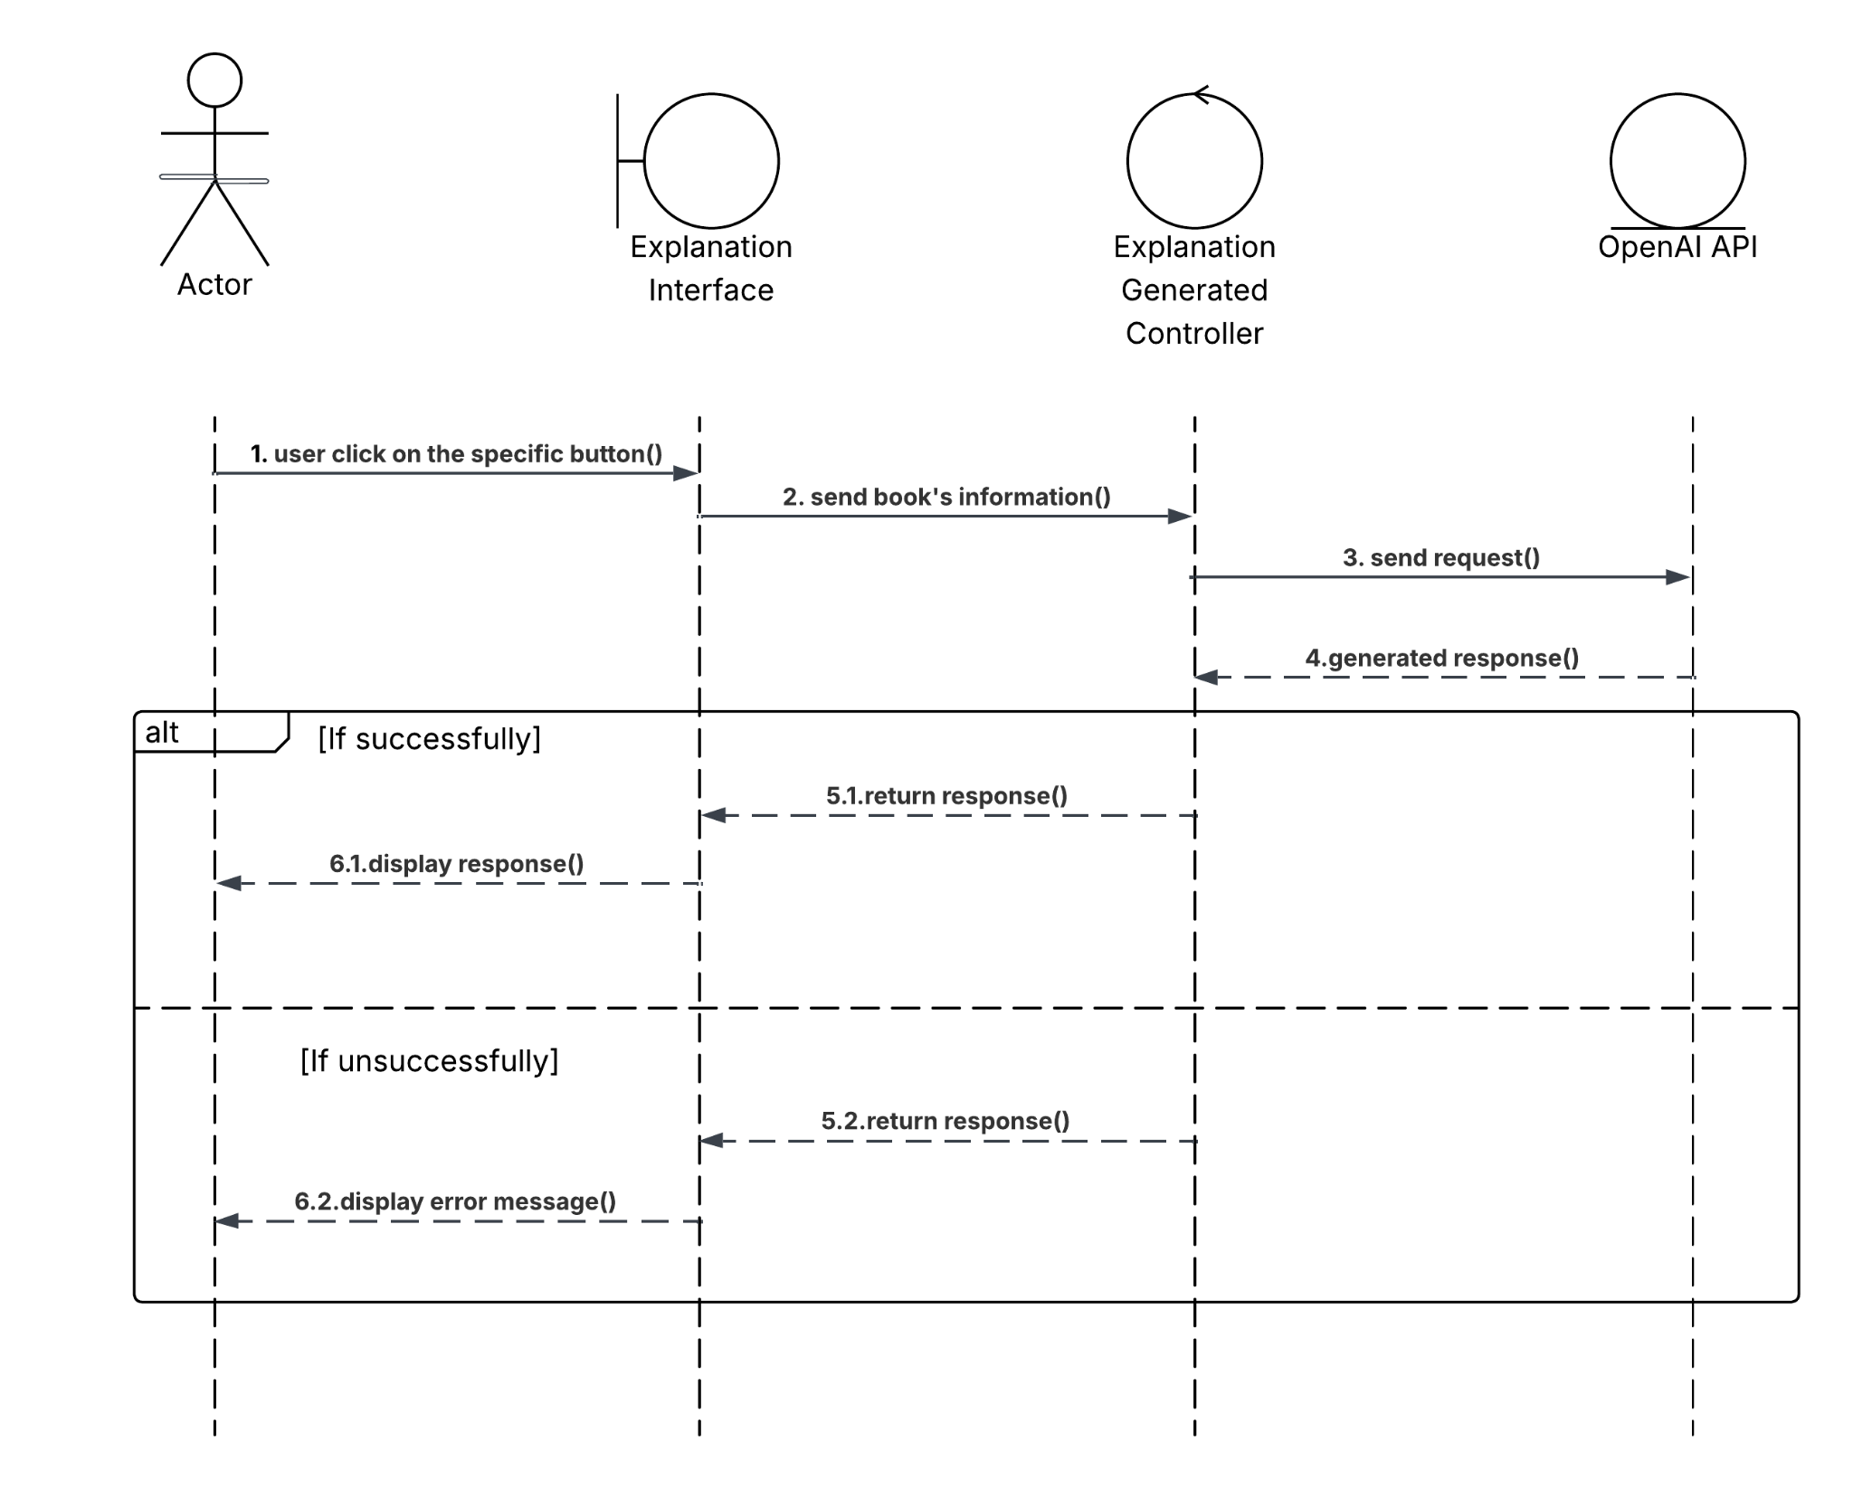

Figure 4.6: Get Explanation Sequence Diagram

4.3.5 AI Chatbot
This use case describes how an Actor interacts with the AI Chatbot to get more specific recommendations. When the Actor enters the query, the front-end sends the query to the API back-end. The controller then sends the request to the OpenAI API to generate the response. If successfully, the generated response will be displayed on the front-end. Otherwise, if the system cannot connect to the OpenAI API or the usage quota has been reached, the system will display an error message.
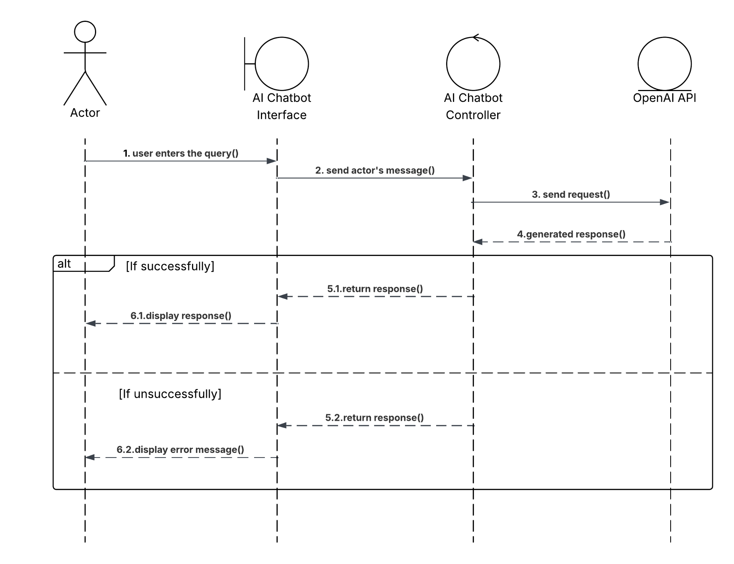

Figure 4.7: AI Chatbot Sequence Diagram

4.3.6 Save Book
This use case describes how a registered user saves a book to their favorites list in the web application. The user must be logged into the system before the use case begins. When the user clicks on the specific button with saving purpose, the system sends a request to the API back-end along with the book’s ID and the user’s authentication token. The system then verifies whether the book is already saved by the current user. If the book is not saved, the system inserts a new entry into the “favorites” table in the MySQL database. Otherwise, instead of displaying the save button, the system displays remove buttons with remove from the favorites list purpose.

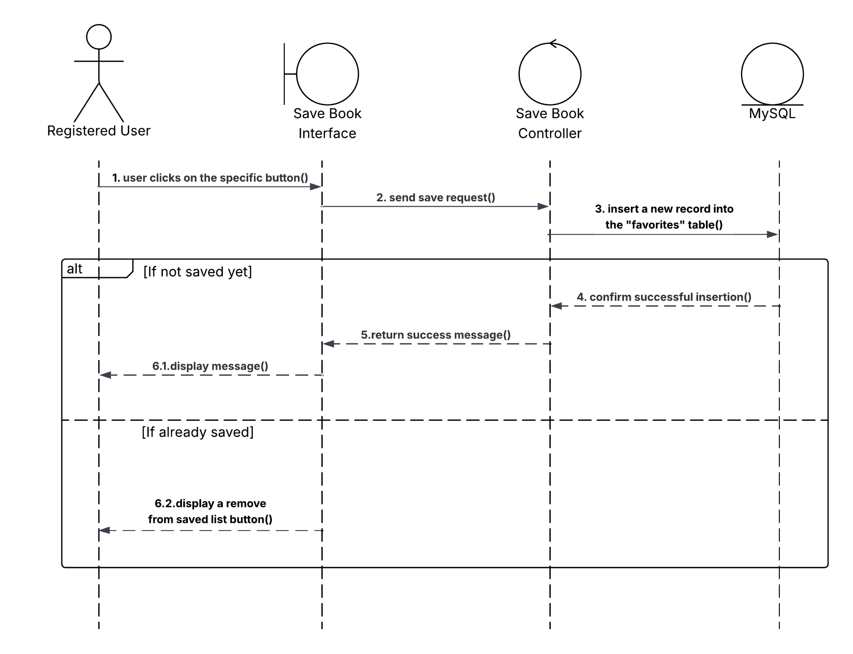

Figure 4.8: Save Book Sequence Diagram

4.3.7 Remove Book
This use case describes how a registered user removes a book from their favorites list in the web application. The user must be logged into the system before the use case begins. When the user clicks on the specific button with removing purpose, the system sends a request to the API back-end along with the book’s ID and the user’s authentication token. The system then verifies whether the book is already removed by the current user. If the book is not removed, the system deletes the record from the “favorites” table in the MySQL database. Otherwise, instead of displaying the remove button, the system displays save buttons.

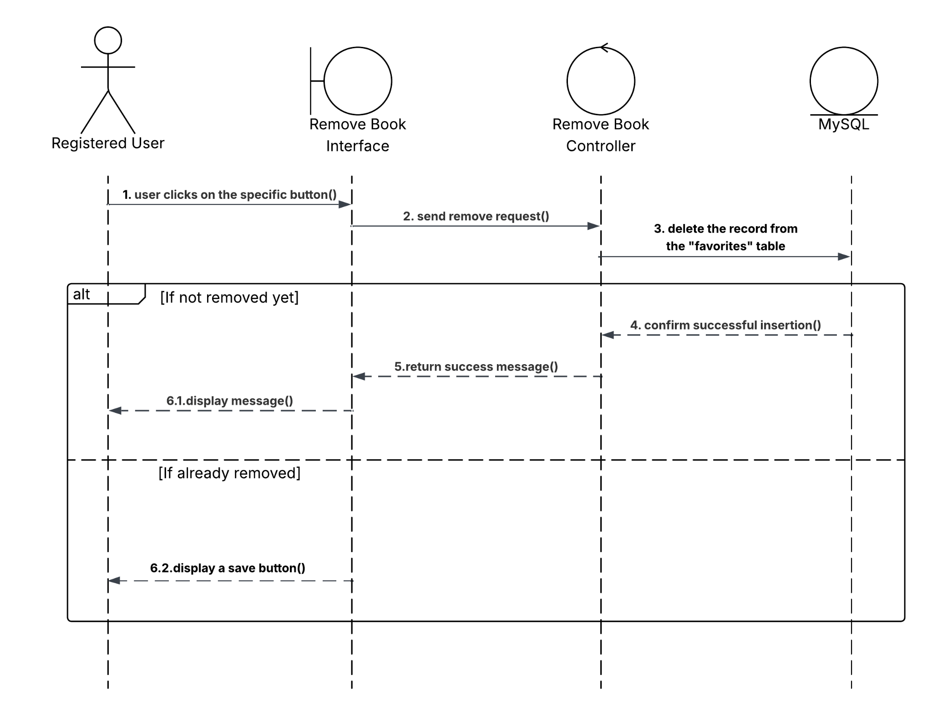

Figure 4.9: Remove Book Sequence Diagram

4.3.8 Book Management
This use case describes how an Admin manages book data from the Admin Panel Web application, including searching, uploading and deleting books. All books data are stored and handled in the Milvus vector database. We will zoom into each feature.

4.3.8.1 Search Books
This use case describes how an Admin searches for books through the Admin Panel. Unlike web application Book Recommendation, the system uses Milvus to search based on metadata of books such as title, author. If successfully, a list of books that match the actual keywords will be displayed. Otherwise, the system displays none.

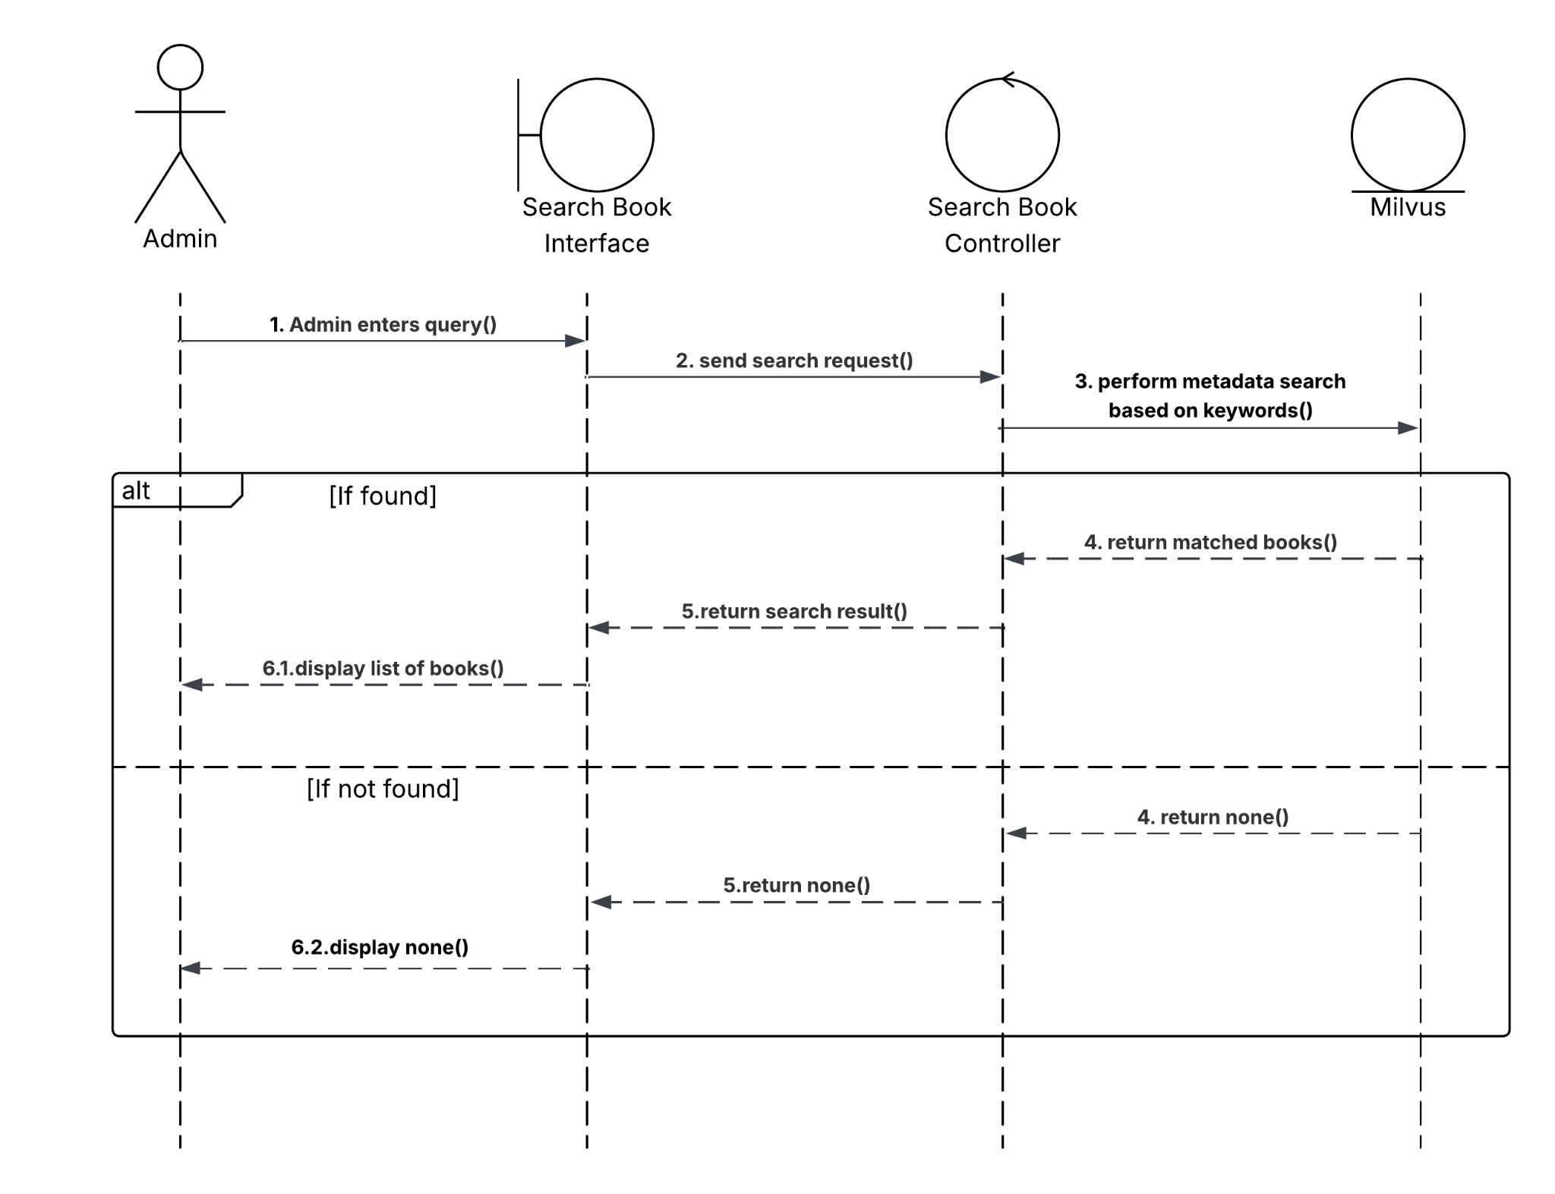

Figure 4.10: Search Book Sequence Diagram

4.3.8.2 Delete Book Data
This use case describes how an Admin deletes a specific book from the system. When the admin clicks on the remove button, the system sends a request to the back-end with that id of the book. If successful, the system shows a confirmation message. Otherwise, the system state remains unchanged.

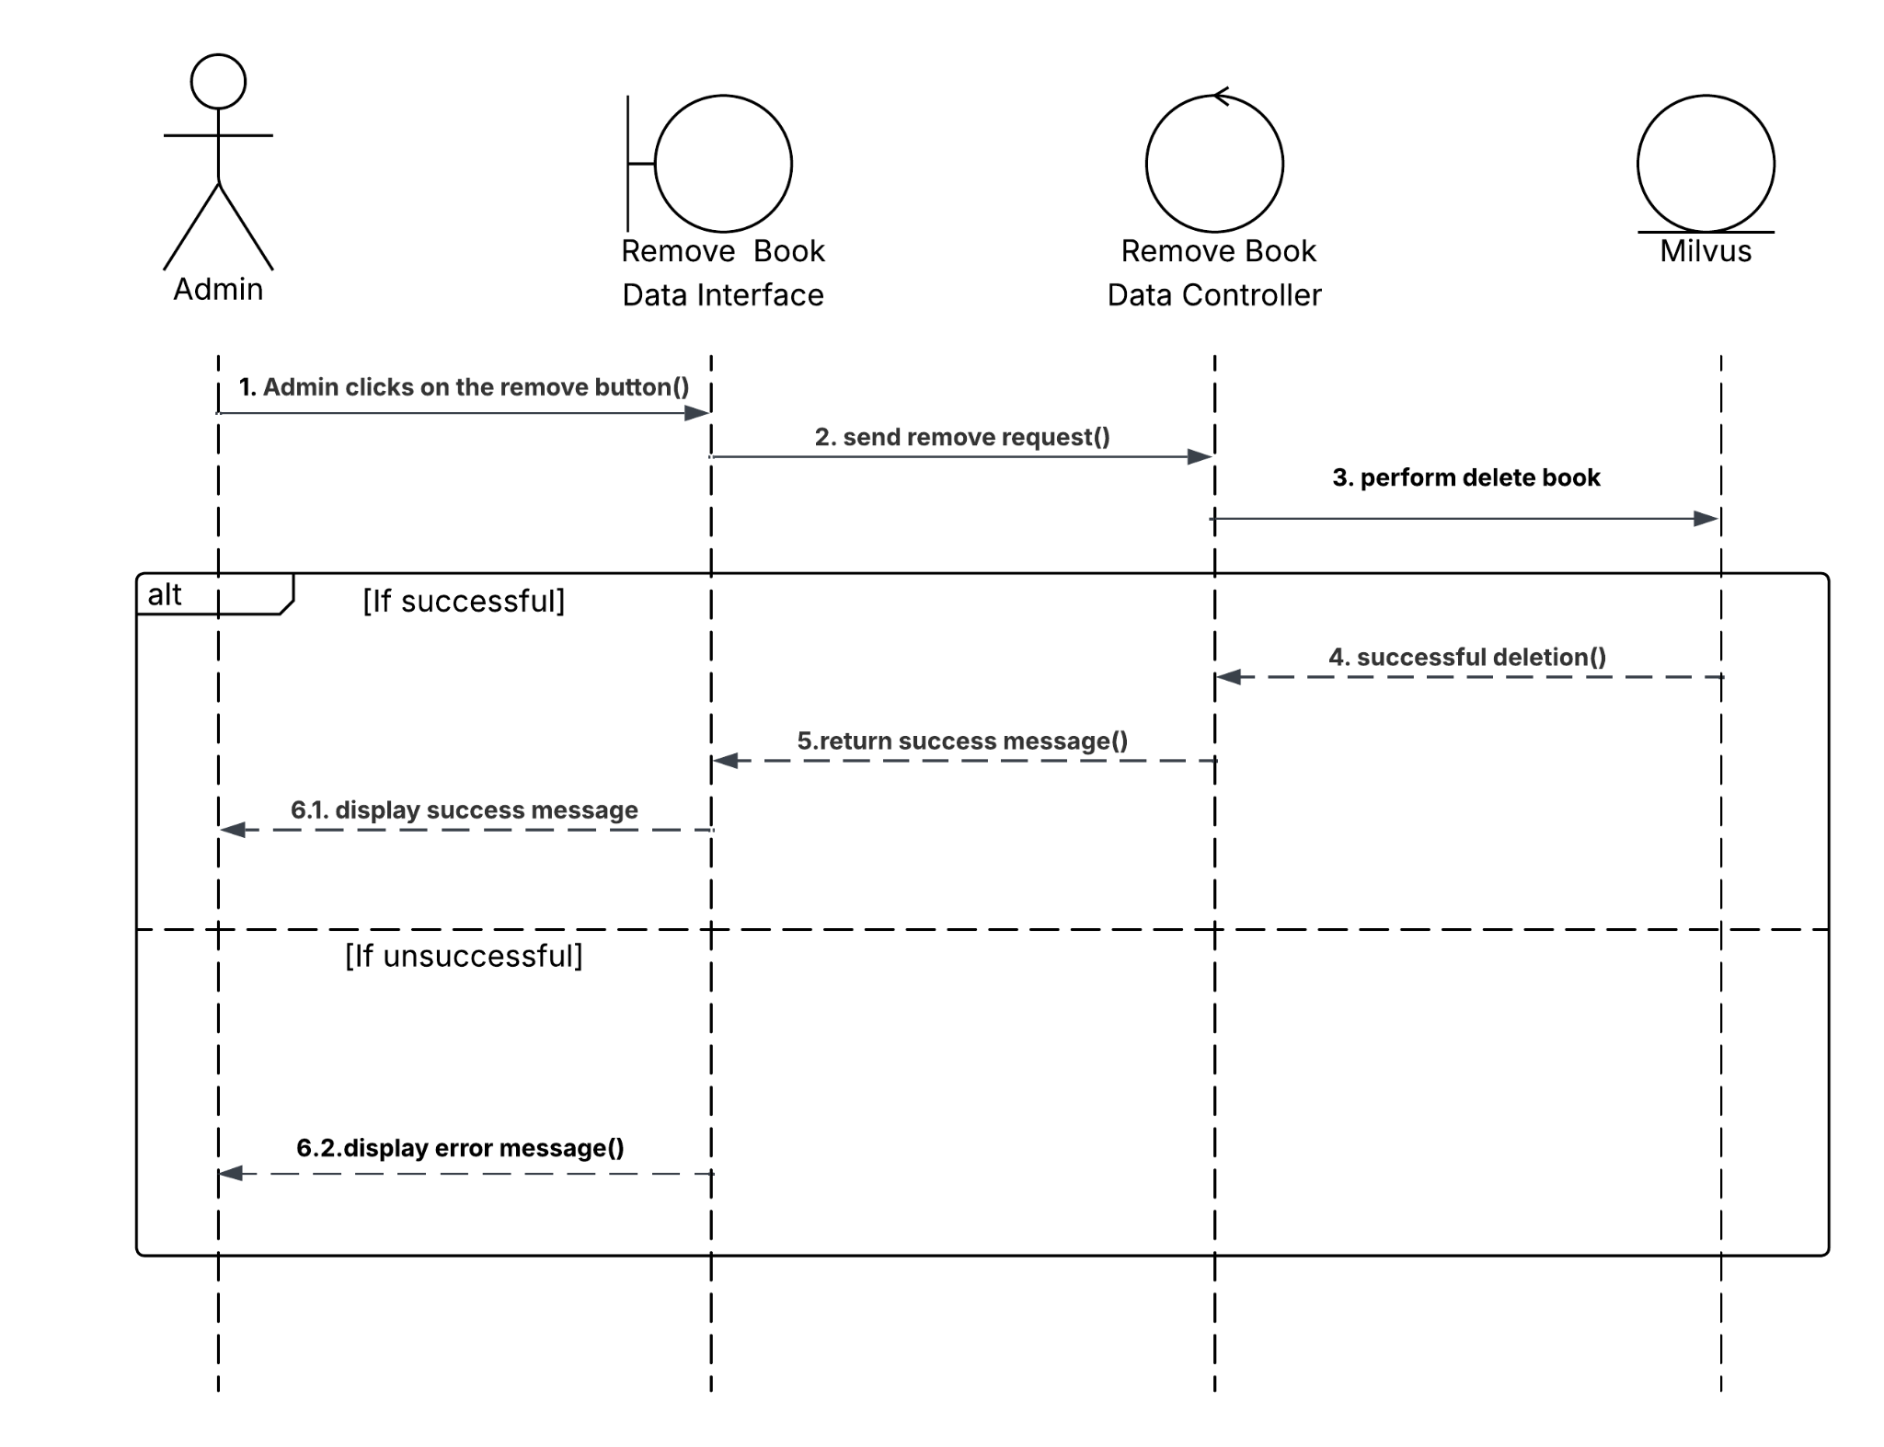

Figure 4.11: Remove Book Data Sequence Diagram

4.3.8.3 Upload Book
This use case describes how an Admin uploads a new book to the system. The admin clicks on the upload button, submits the new dataset in .csv format. The back-end then processes the file, starts embedding the file by using an embedding model called from OpenAI API, and stores the book on the Milvus database, also the Admin can choose the existing collection or create a new one to upload. If successful, a new dataset of books is uploaded to the system. Otherwise, an error occurs, the system state remains unchanged.
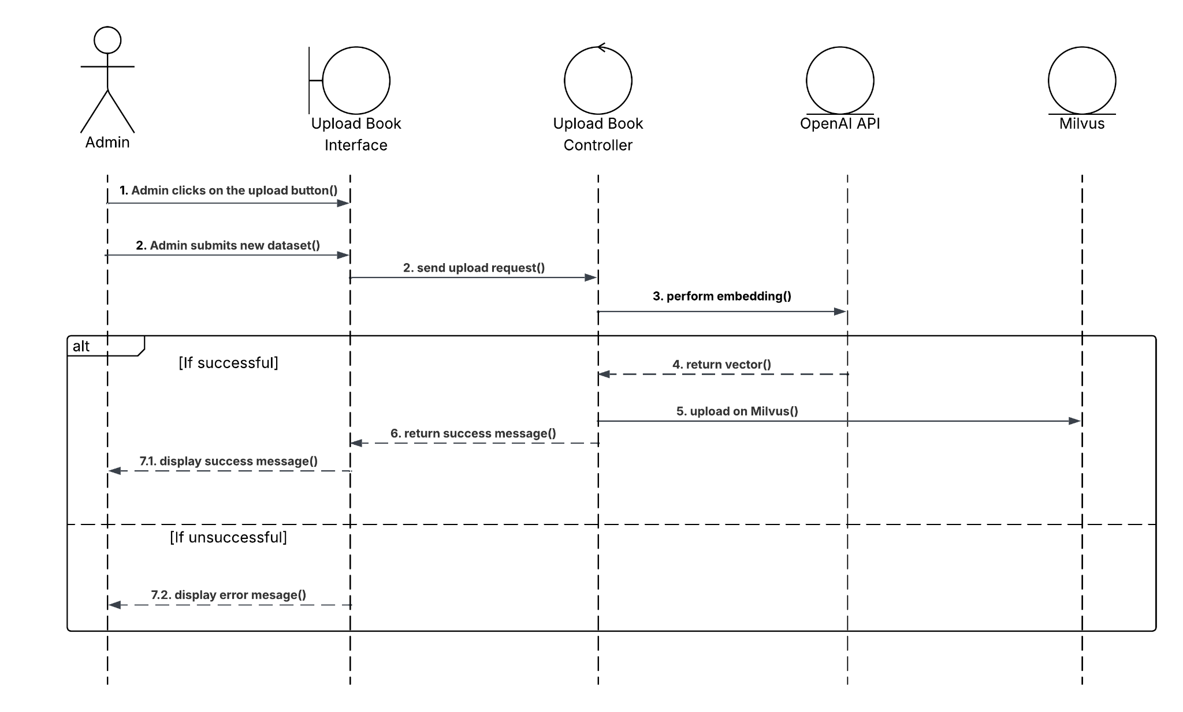

Figure 4.12: Upload Book Sequence Diagram

4.3.8.4 Search Users
This use case describes how an Admin searches for a specific registered user. The admin inputs a search query (e.g, username or email), the system then processes and returns matching users stored in the MySQL database. If successful, a list of users will be displayed. Otherwise, the system displays none, the system state remains unchanged.
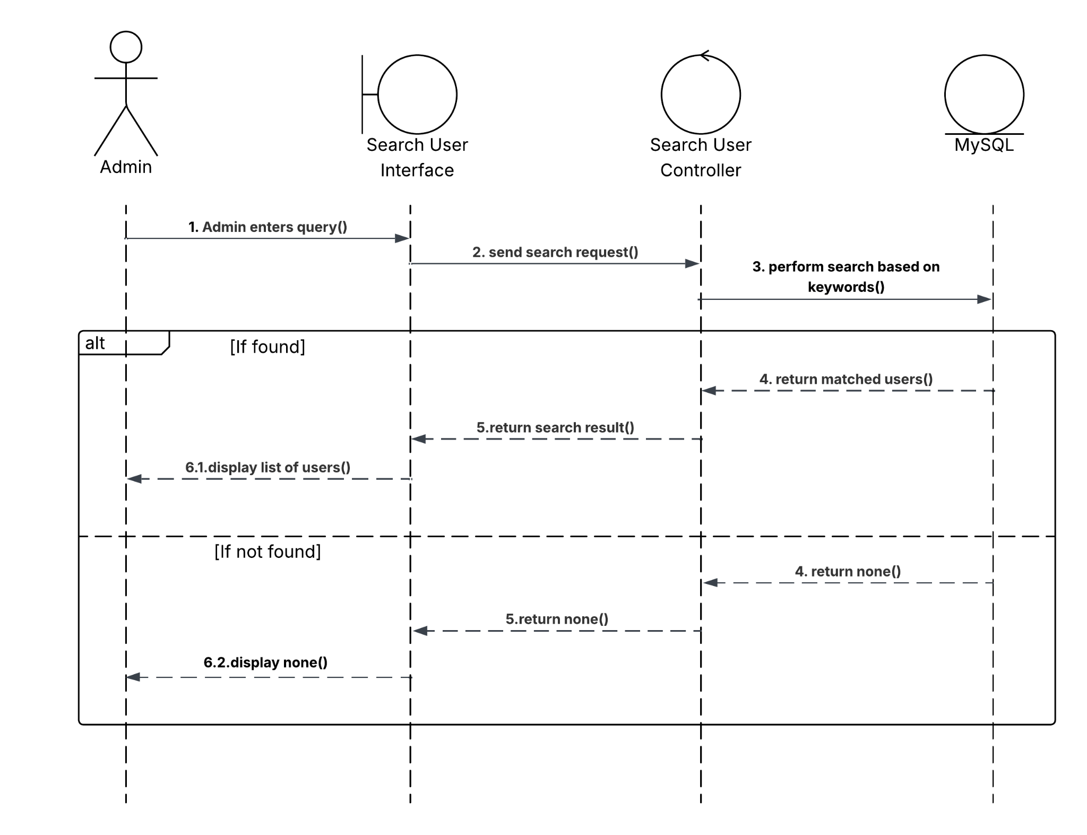

Figure 4.13: Search User Sequence Diagram

4.3.8.5 Delete User
This use case describes how an Admin removes a user account from the system. After querying the users, the Admin clicks the delete button on a specific user account. The system sends a request to the back-end, which deletes the user’s record from the MySQL database. If successful, the selected user account will be removed from the system. Otherwise, the system remains unchanged.
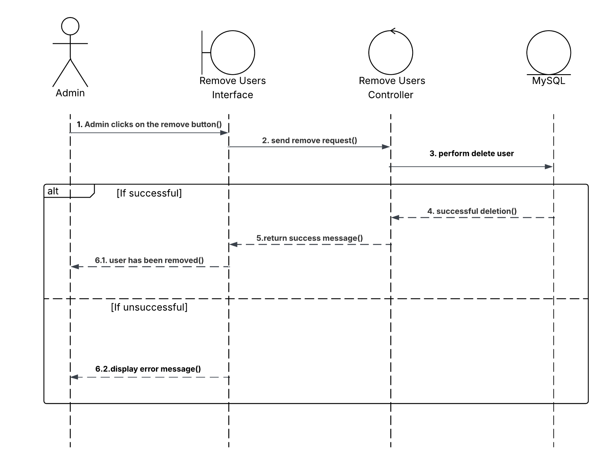

Figure 4.14: Remove User Sequence Diagram

4.3.8.6 Track OpenAI API Token Usage
This use case describes how an Admin tracks OpenAI API token consumption across different system features (explanation generated, AI Chatbot, embedding). The front-end sends a request, the back-end then retrieves token usage records from the MySQL database and returns data for specific purposes (explanation generated, AI Chatbot, embedding). If any feature is used and the log is recorded, the system will display the data. Otherwise, the system remains unchanged.

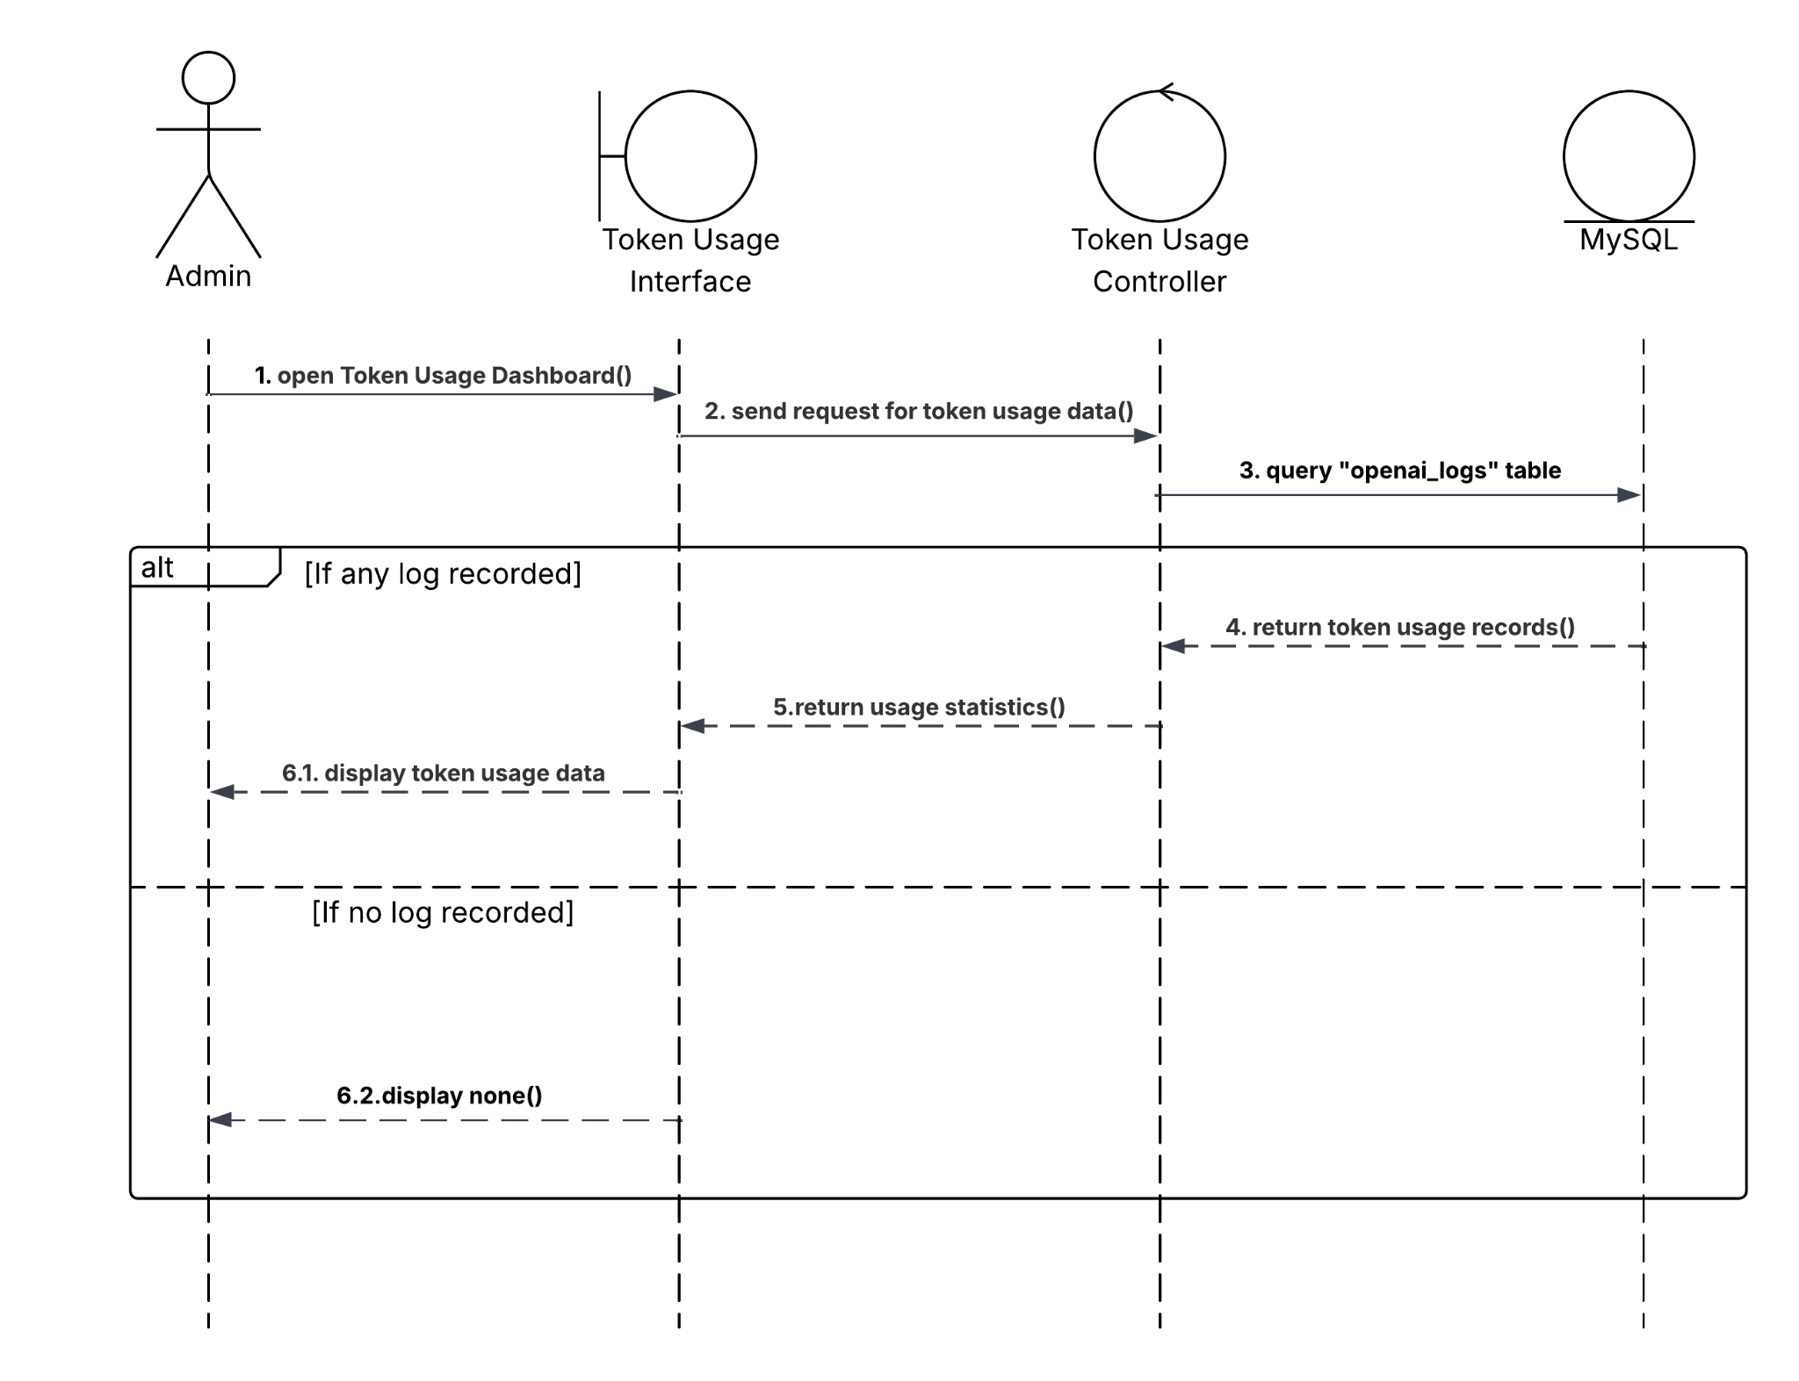

Figure 4.15: Track OpenAI API Token Usage Sequence Diagram

4.4 Tools and Techniques

4.4.1 OpenAI API
The OpenAI API provides access to a range of powerful AI models, which used for this project are “text-embedding-ada-002” model for text embedding and “gpt-4o-mini” for generating responses. [1]
Using the OpenAI embedding model offers significant advantages over open-source models like “BERT” or “sentence-transformer”. The model provides high quality vector representations of text, capturing deep semantic meaning just based on keywords, giving better accuracy results, and works well with different languages.
Since every feature (embedding, chatbot) is provided through API, we do not need to train, host or manage any machine learning infrastructure, this saves time and resources on technical setup but still gives high quality results. However, there is a cost for using these models. Each API call consumes tokens, for example, embedding 1 line (1 book) in a dataset cost around 100 - 300 tokens, depending on much text it contains, while a single chatbot or explanation response uses 50 - 300 tokens depending on the message. At the current OpenAI pricing, 1000 tokens cost $0.0001 for “text-embedding-ada-002” embedding model (the most economical model), in this project, the dataset contains 10631 books, which consumes 2690673 tokens, this result in a total cost of $0.2691, making it an affordable solution even for large datasets. Both chatbot and explanation generated using “gpt-4o-mini”, 1000 tokens cost $0.0005 for input and $0.0015 for output. But overall, this is still a fair price for such features provided by OpenAI.

4.4.2 FastAPI
FastAPI is a modern, high-performance web framework for building APIs with Python. It allows the system to handle multiple requests at the same time, improving performance, especially in applications that rely on external services like OpenAI API or SQL,MIlvus database. [2]
FastAPI is lightweight, easy to set up, and supports many useful features. It helps reduce development time, simplifies common tasks, and increases overall productivity.

4.4.3 ReactJS
React.js is an open source JavaScript package to create single-page apps' user interfaces. For web applications, it is used to manage the view layer. We can also make reusable UI components with React. [3]
React allows developers to create large web applications that can change data without reloading the page,which is important for this project, where users interact frequently with features like searching, viewing detail books or chatting with the AI. The primary purpose of React is to be fast, scalable and straight forward.
Compared to other front-end frameworks like Angular or Vue, React is simpler and works well with basic HTML, CSS and JavaScript knowledge. It also works well with the FastAPI back-end used in this project.
Overall, ReactJS is a great choice for this project, offering speed, flexibility.

4.4.4 SQL
SQL is a great choice since the project needs reliable data structure, clear relationships between data and business logic. While NoSQL has unstable schemas and is not fit for complex queries. [4]

4.4.5 Milvus
Milvus is an open-source vector database to store and search high-dimensional vectors. Milvus allows the system to perform fast and accurate similarity searches based on meaning, not just keywords. [5]
This is especially useful for this project, instead of comparing plain text, Milvus compares vector distances, which leads to more relevant results even when the input is vague or general.
Milvus is also designed for high performance and scalability. It can handle thousands of vectors and return results in real time, which is important when the dataset grows or when many users are using the system at the same time.

4.4.6 Swagger
API Documentation is needed because the application is connected to many other services. It will improve user adaption, save support time and easier maintenance.
Swagger, using the OpenAPI specification, is a great tool for this purpose. It automatically generates interactive API documentation based on the code, allowing developers to test and explore endpoints directly in the browser. [6]

4.4.7 JWT (JSON Web Token)
JWT is widely used for authentication and data exchange. JWT is used in this project to handle user and admin authentication in a secure and stateless way. When an user or an admin logs in, the server creates a token that includes their username and role. This token is sent to the client and later the server will validate the JWT, the response will be returned. [7]
JWT helps the system stay simple and fast since it does not need to store login sessions on the servers. It also makes it easy to protect certain API routes, for example, only admins with a valid token can access admin features.
Overall, JWT is an ideal choice to handle authentication in a system that has different types of users (regular users and admins).

Chapter 5

Results and Discussion

5.1 Result
T After three months of development, the Web application Book Recommendation and an Admin Panel for it has basically been completed, meeting the initial criteria. To be more specific, the system has been designed with the following functions:
- Register and Login: Allow users to create an account and log into the system using the registered account (admin is pre-created)
- Recommending Book: Allow users to get book recommendations from the system by just typing a few words, without needing to enter exact keywords.
- View Book Detail: Allow users to view details of the book which they got suggested.
- Generated Explanation: Allow users to get an explanation why they might like the selected book.
- AI Chatbot: Allow users to chat with the AI, to get more specific suggestions.
- Save Book: Allow users to save the selected book.
- Manage Users: Allow admins to search, delete a specific user account.
- Manage Books: Allow admins to search, delete a specific book, updating book’s database.
- Track OpenAI API Token Usage: Allow admins to monitor the total OpenAI API Token consumption for each specific service (embedding, AI Chatbot, explanation generated) so they can make an ideal billing plan to maintain the API key.

5.1.1 API
These are all the endpoints for the API has been building.

Methods | URLs | Action
POST | /register | Signup new account
POST | /login | Login as user
POST | /admin/login | Login as admin
GET | /loginfo | Get user login info
GET | /admin/overview | Admin overview data
GET | /admin/users/search | Search user
GET | /admin/users | LIst all users
DELETE | /admin/users/{user_id} | Delete a user account
GET | /admin/books/count | Count total books in the system
GET | /admin/books/search | Search book
DELETE | /admin/books/{book_id} | Delete book from the system
GET | /admin/collections | Choose Milvus collection
POST | /admin/upload-books | Embed and upload dataset
GET | /admin/token-usage | Get token usage logs
GET | /bookrcm | Get book recommendations
GET | /suggestions | Get book keyword suggestions
POST | /explain | Generated explanation about selected book
POST | /chatbot-recommend | Chat with AI
GET | /userfavorites | Get saved books of user
POST | /favorites | Save selected book to favorites
DELETE | /favorites/{book_id} | Remove book from favorites

GET | /is_favorite/{book_id} | Check if book is in favorites list
POST | /logout | Logout as user
POST | /admin/logout | Logout as admin

5.2 Discussion
Despite being implemented completely, there are still some existing problems.
Integrating external services such as OpenAI API and MIlvus vector database was a new experience, it took a considerable amount of time to fully understand what it is and how to do.
The current back-end structure mainly focuses on functional completion, with most logic placed directly in controller functions. The project has not been separated into modular components yet. Since this is still a moderate project, the current structure is manageable. But for further development, the codebase is harder to maintain, especially when adding new features or handling more complex logic.
Lastly, the website is only running locally and has not been deployed to any public domains.

Chapter 6

Conclusions

6.1 Conclusion
In conclusion, the purpose and objective of the Web application Book Recommendation using Vector search and OpenAI Embedding are archived. By providing a user-friendly interface on the web, recommending books becomes more accessible and more effective.
The main functions have already been implemented:
- User can get book recommendations, chat with AI, get explanation
- User can save a selected book.
- Admin can manage users and books.

6.2 Future works
To further improve the system in the future, the following tasks need to be done:
- Deploy system on a public domain.
- Modularize Back-end Architecture.
- Password Recovery.
- Recommendation Personalization.
- Create a Guideline for using the system.
- Multilingual Support.

[1] OpenAI API Documentation. [Online]. https://platform.openai.com/docs
[2] FastAPI Documentation. [Online]. https://fastapi.tiangolo.com/
[3] React Official Documentation. [Online].https://reactjs.org/docs/getting-started.html
[4] MySQL 8.0 Reference Manual. [Online]. https://dev.mysql.com/doc/refman/8.0/en/
[5] Milvus Documentation. [Online]. https://milvus.io/docs
[6] Swagger Open Source Tools. [Online]. https://swagger.io/tools/open-source/
[7]JWT Handbook – Introduction to JSON Web Tokens. [Online]. https://auth0.com/learn/json-web-tokens

Appendices
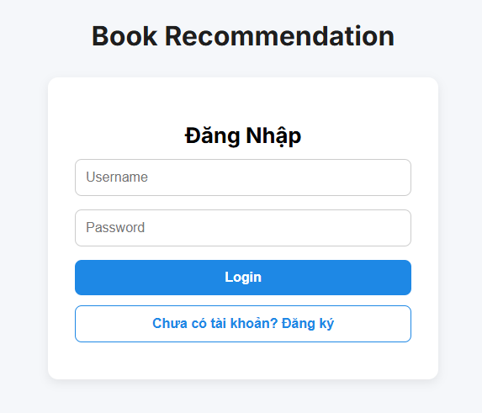

Figure 1: Login User Interface

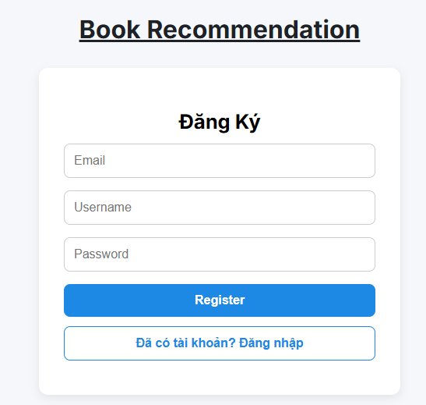

Figure 2: Registered User Interface

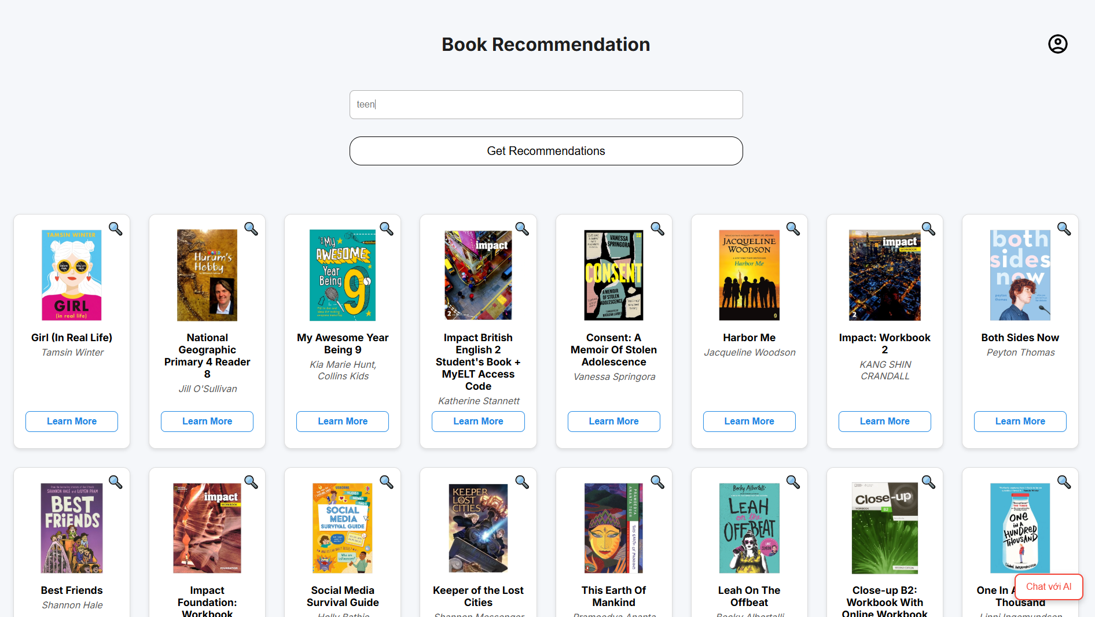

Figure 3: Recommending Book Interface

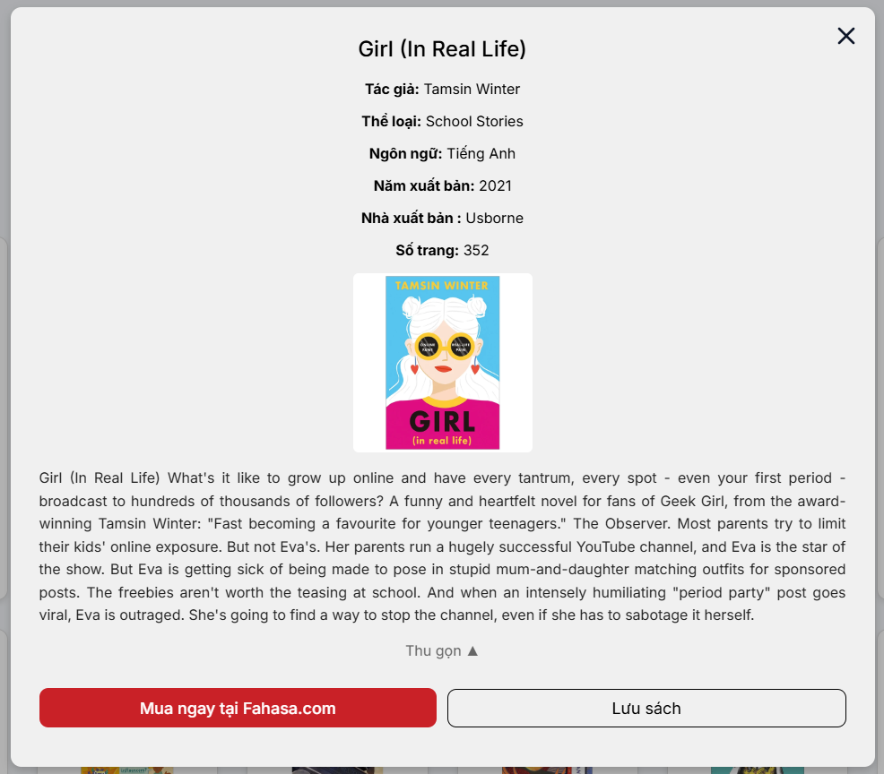

Figure 4: View Book’s Detail Interface

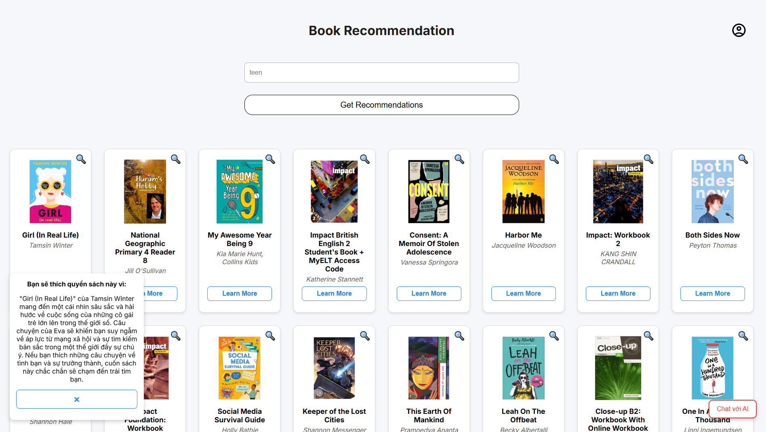

Figure 5: Explanation Generated Interface
(Small box on the bottom left screen)

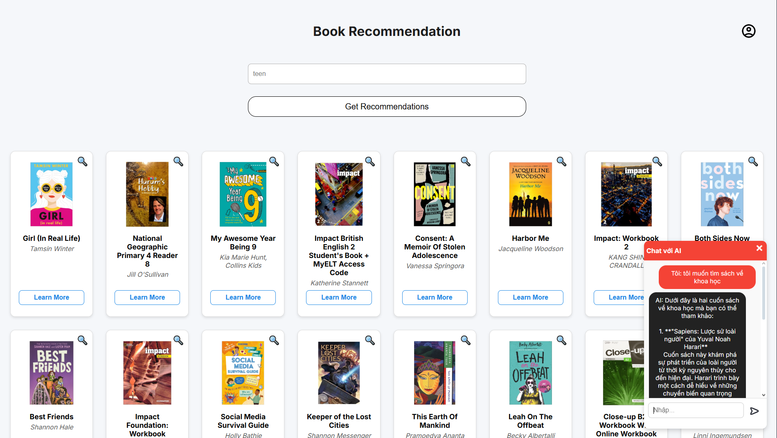

Figure 6: AI Chatbot Interface
(Small box on the bottom right screen)
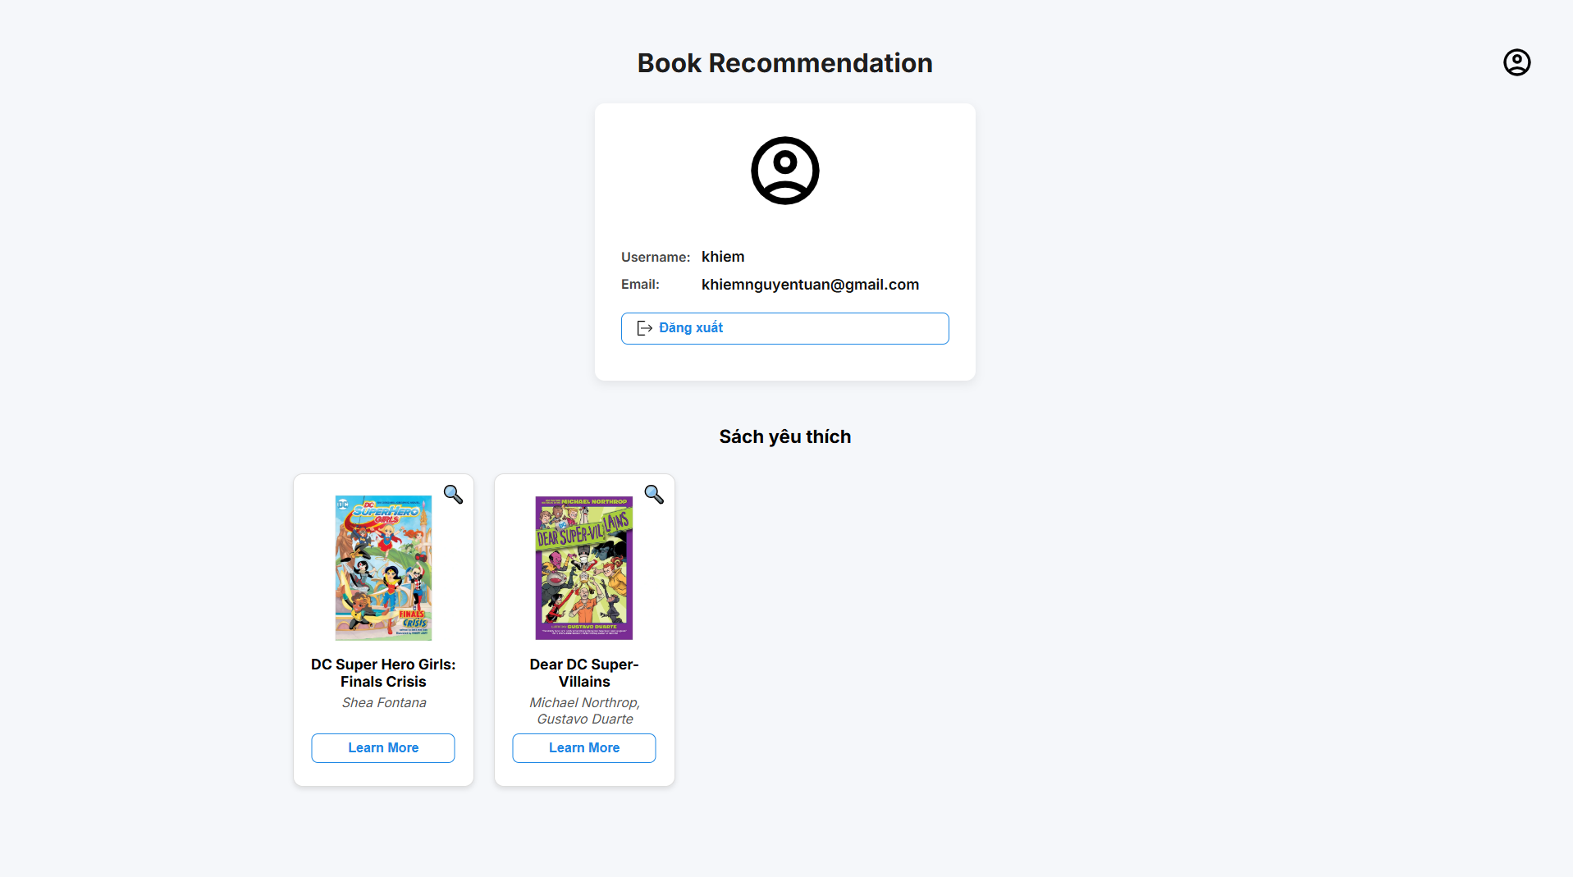

Figure 7: Account information and Favorite List Interface

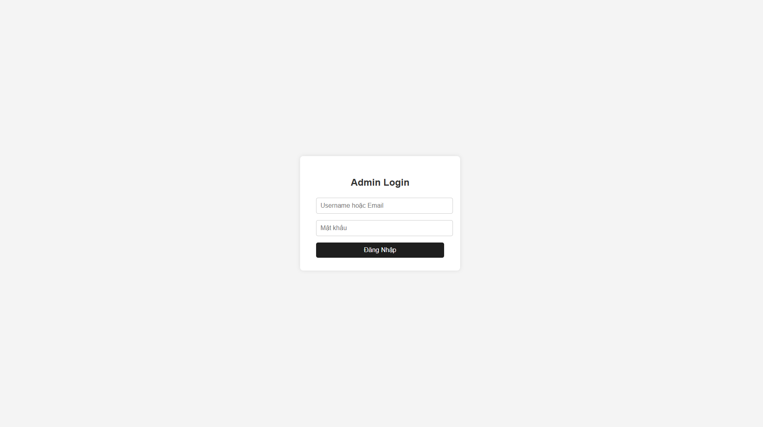

Figure 8: Admin Login Interface
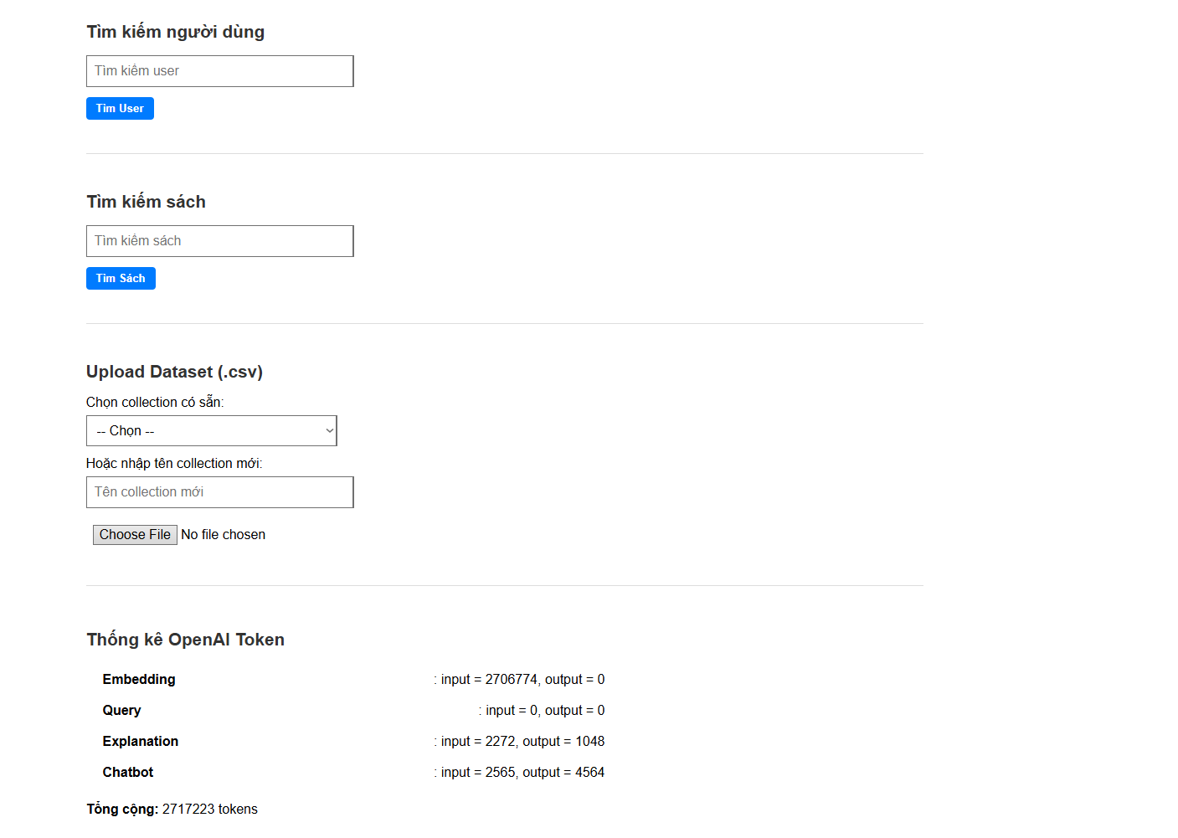

Figure 9: Admin Panel Interface
(Manage Users, Manage Books, Track OpenAI API Token Usage)

