Chapter 7: Advanced deep-learning best practices
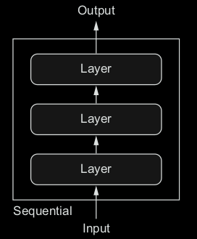
This chapter covers
○ The Keras functional API
○ Using Keras callbacks
○ Working with the TensorBoard visualization tool
○ Important best practices for developing state-of-the-art models

1. Beyond Sequence-to-sequential model
The model can be complicated that rathan than just a stack of layers, they can be several modules and structures merge into eachother.
With independent inputs, or multiple outputs, some have interal branching between layers that make them look like graphs of layers.

But this may be suboptimal, because the information
extracted by the models may be redundant. A better way is to jointly learn a more accurate model of the data by using a model that can see all available input modalities simultaneously: a model with three input branches
These three important use cases—multi-input models, multi-output models, and
graph-like models—aren’t possible when using only the Sequential model class in
Keras
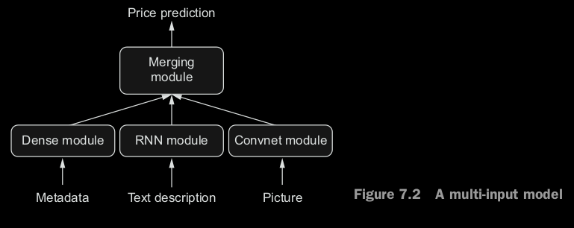
Outputs/heads : due to correlation between outcomes, need to learn jointly to extract result better.

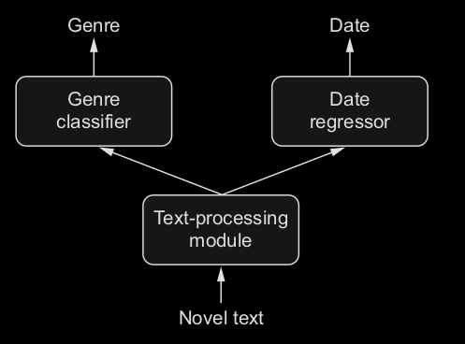

Topology: the study of geometric properties and spatial relations unaffected by the continuous change of shape or size of figures.

2. Inception Modules: input is processed by several perallel convolutional branches whose output are then merged back into a single tensor.
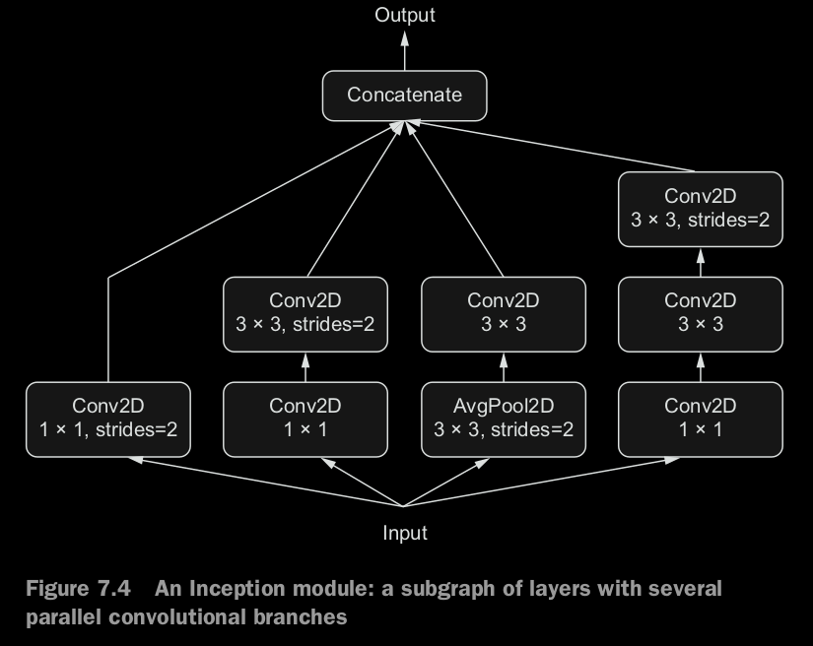

3. Residual connection (ResNet): consist of reinjecting previous representations into the downstream flow of data by adding a past output tensor to a later output tensor => help prevent information loss along the data-processing flow.
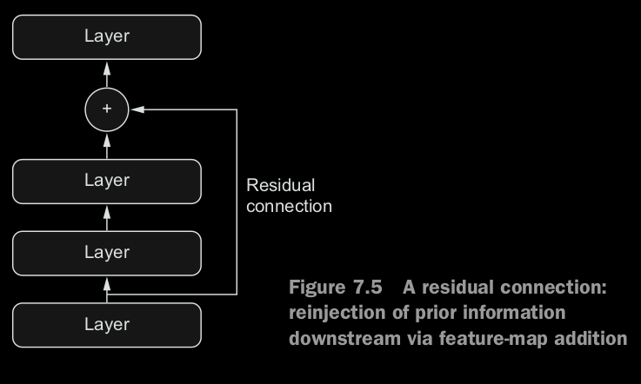

3. Functional API: directly manupulate tensors (use layers as functions) that take input as tensors and return tensors

from keras.models import Sequential, Model
from keras import layers
from keras import Input

seq_model = Sequential()
seq_model.add(layers.Dense(32, activation='relu', input_shape=(64,)))
seq_model.add(layers.Dense(32, activation='relu'))
seq_model.add(layers.Dense(10, activation='softmax'))

EQUIVALENT TO

input_tensor = Input(shape=(64,))
x = layers.Dense(32, activation='relu')(input_tensor)
x = layers.Dense(32, activation='relu')(x)
output_tensor = layers.Dense(10, activation='softmax')(x)
model = Model(input_tensor, output_tensor)

THAN EVERYTHING IS THE SAME

model.compile(optimizer='rmsprop', loss='categorical_crossentropy')
import numpy as np
x_train = np.random.random((1000, 64))
y_train = np.random.random((1000, 10))
model.fit(x_train, y_train, epochs=10, batch_size=128)
score = model.evaluate(x_train, y_train)

4. Multi-input models: use functional API (keras.layers.add/.concatenate)

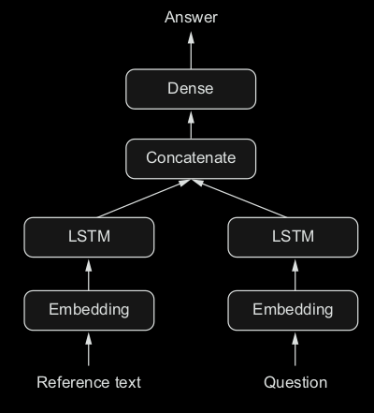
Ex: question answering model

text_input = Input(shape=(None,), dtype='int32', name='text')
embedded_text = layers.Embedding(64, text_vocabulary_size)(text_input)
encoded_text = layers.LSTM(32)(embedded_text)

question_input = Input(shape=(None,),dtype='iembedded_question = layers.Embedding(32, question_vocabulary_size)(question_input)
encoded_question = layers.LSTM(16)(embedded_question)nt32',name='question')

concatenated = layers.concatenate([encoded_text, encoded_question], axis=-1)

answer = layers.Dense(answer_vocabulary_size, activation='softmax') (concatenated)

model = Model([text_input, question_input], answer)
model.compile(optimizer='rmsprop', loss='categorical_crossentropy',
metrics=['acc'])

model.fit([text, question], answers, epochs=10, batch_size=128) #use np list
model.fit({'text': text, 'question': question}, answers,epochs=10, batch_size=128) #use dictionary,name needed

5. Multi-output models (mutiple heads)

vocabulary_size = 50000
num_income_groups = 10

posts_input = Input(shape=(None,), dtype='int32', name='posts')
embedded_posts = layers.Embedding(256, vocabulary_size)(posts_input)

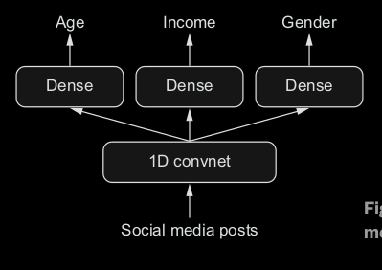
x = layers.Conv1D(128, 5, activation='relu')(embedded_posts)
x = layers.MaxPooling1D(5)(x)
x = layers.Conv1D(256, 5, activation='relu')(x)
x = layers.Conv1D(256, 5, activation='relu')(x)
x = layers.MaxPooling1D(5)(x)
x = layers.Conv1D(256, 5, activation='relu')(x)
x = layers.Conv1D(256, 5, activation='relu')(x)
x = layers.GlobalMaxPooling1D()(x)
x = layers.Dense(128, activation='relu')(x)

age_prediction = layers.Dense(1, name='age')(x)
income_prediction = layers.Dense(num_income_groups, activation='softmax', name='income')(x)
gender_prediction = layers.Dense(1, activation='sigmoid', name='gender')(x)

model = Model(posts_input, [age_prediction, income_prediction, gender_prediction])

All lose values are added together => global loss, which is minimized during training

model.compile(optimizer='rmsprop', loss=['mse', 'categorical_crossentropy', 'binary_crossentropy'])
OR
model.compile(optimizer='rmsprop', loss={'age': 'mse',
'income': 'categorical_crossentropy',
'gender': 'binary_crossentropy'})

6. To remedy the effect when one category have much larger loss, can assign different levels of importance to the loss values in their contribution to the final loss (especially when losses’ values in different scales

model.compile(optimizer='rmsprop', loss=['mse', 'categorical_crossentropy', 'binary_crossentropy'], loss_weights=[0.25, 1., 10.])

model.compile(optimizer='rmsprop', loss={'age': 'mse',
'income': 'categorical_crossentropy',
'gender': 'binary_crossentropy'},
loss_weights={'age': 0.25,
'income': 1.,
'gender': 10.})

7. Directed acyclic graphs of layers: networks with complex internal topology (BUT cannot have cycles). Because it is impossible for tensor x to become the input of the layers that generated x (except recurrent)

- Common NN components are implemented as graphs (Inception modules and residual connections).

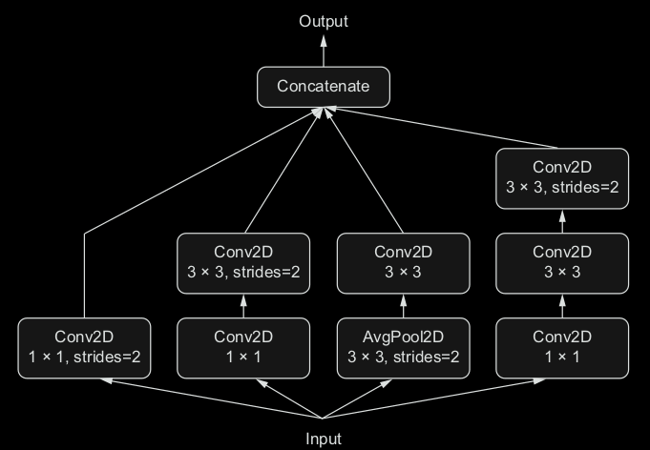
8. Inception modules: popular type of Network architecture for CNN. Consist of a stack of modules that themselves look like small independent networks in parallel branches.
- Most basic form have 1x1 convolution, followed by 3x3, ending w/ concatenation of the resulting features => help to learn spatial features and channel-wise features

9. The purpose of 1 × 1 convolutions
will compute features that mix together information from the channels of the input tensor, but it won’t mix information across space (because it’s looking at one tile at a time). Such 1 × 1 convolutions (also called pointwise convolutions) are featured in Inception modules, where they contribute to factoring out channel-wise feature learning and space-wise feature learning—a reasonable thing to do if you assume that each channel is
highly autocorrelated across space, but different channels may not be highly correlated with each other.

10. keras.applications.inception_v3.InceptionV3 or Xception (extreme inception)

Xception focuses on logical extreme, more on depth-wise convolution => better in everything

11. Residual connections
They tackle two common problems that plague any large-scale deep-learning model: vanishing gradients and representational bottlenecks. In general, adding residual connections to any model that has more than 10 layers is likely to be beneficial.
Rather than being concatenated to the later activation, the earlier output is summed with the later activation, which assumes that both activations are the same size. If they’re different sizes, you can use a linear transformation to reshape the earlier activation into the target shape (for example, a Dense layer without an activation or, for convolutional feature maps, a 1 × 1 convolution without an activation).

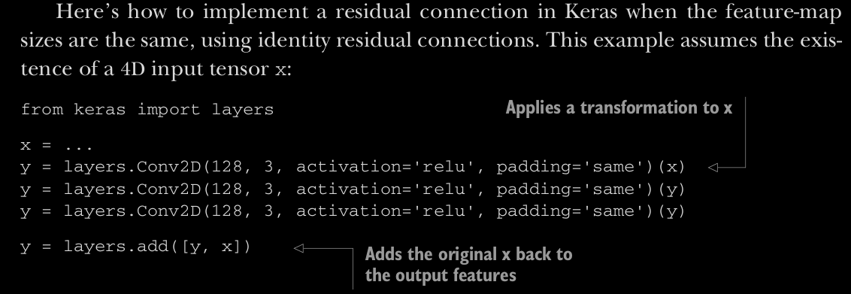

12. Representational bottlenecks in deep learning
If one layer is too small (for example, it has features that are too low-dimensional), then the model will be constrained by how much information can be crammed into the activations of this layer.
=> Residual helps with this problems

13. Vanishing gradients
Backpropagation, the master algorithm used to train deep neural networks, works by propagating a feedback signal from the output loss down to earlier layers. If this feedback signal has to be propagated through a deep stack of layers, the signal may become tenuous or even be lost entirely, rendering the network untrainable. This
issue is known as vanishing gradients.

14. Callback: to act on a model during training
- Model checkpointing / early stopping / dynamically adjusting the value of certain parameters during training (learning rate) / logging training metrics…

callbacks_list = [keras.callbacks.EarlyStopping(monitor='acc',epoch (that is, two epochs)patience=1,),
keras.callbacks.ModelCheckpoint(filepath='my_model.h5',monitor='val_loss',save_best_only=True,))

model.fit(x, y, epochs=10, batch_size=32, callbacks=callbacks_list, validation_data=(x_val, y_val))

=> can write your own callback

15. Tensorboard. Brower-based visualization tool (packaged with TensorFlow)
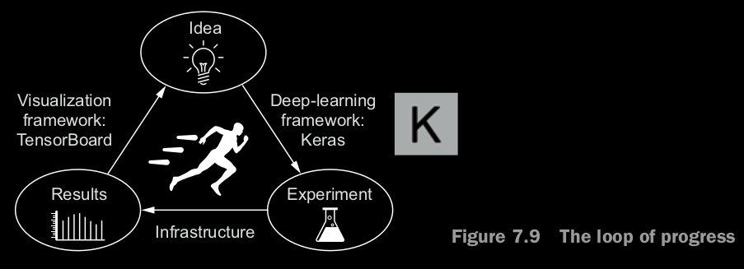
○ Visually monitoring metrics during training
○ Visualizing your model architecture
○ Visualizing histograms of activations and gradients
○ Exploring embeddings in 3D

callbacks = [keras.callbacks.TensorBoard (log_dir=’my_log_dir’,histogram_freg=1,embeddings_freg=1,)]
history = model.fit(x_train, y_train, epochs=20, batch_size=128, validation_split=0.2,callbacks=callbacks)
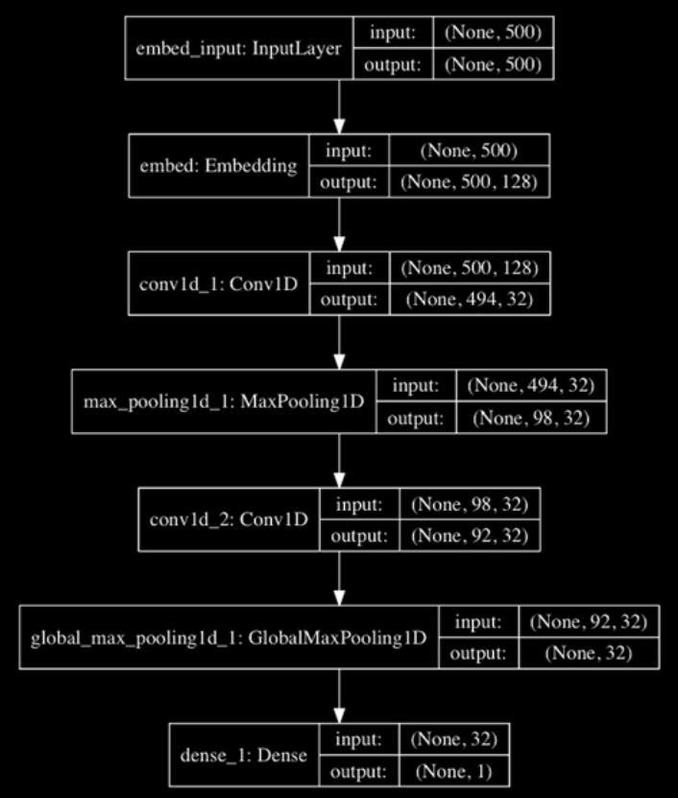
16. keras.utils.plot_model needs pydot-ng and graphviz labrary

from keras.utils import plot_model
plot_model(model, show_shapes=True, to_file='model.png')

17. Batch Normalization: method that make datas seen by ML model more similar to each other => generalize

- Subtract by Mean and divide by Standard Deviation => assume data follows a normal (Gaussian) distribution
and this distribution is cetered and scaled to unit variance

normalized_data = (data - np.mean(data, axis=...)) / np.std(data, axis=…)

Batch normalization is a type of layer ( BatchNormalization in Keras). It can adaptively normalize data even as the mean and variance change over time during training (internally maintaining an exponential moving average of the batch-wise mean and variance of the data seen during training)
=> help gradient propagation/ residual connections / deeper networks

conv_model.add(layers.BatchNormalization()) //can be added after conv or dense layers.add
//Default is -1 (channels_last)
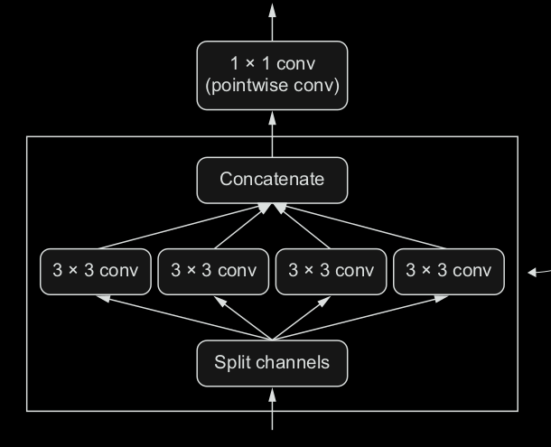
18. Depthwise separable convolution ( SeparableConv2D )
- Lighter (fewer trainable weight parameters)/ Faster (fewer floating-point operations) / little bit better
This layer performs a spatial convolution on each channel of its input, independently, before mixing output channels via a pointwise convolution (a 1 × 1 convolution)

- It requires significantly fewer parameters and involves fewer computations, thus resulting in smaller, speedier models. And because it’s a more representationally efficient way to perform convolution, it tends to learn
better representations using less data, resulting in better-performing models.

from keras.models import Sequential, Model
from keras import layers
height = 64
width = 64
channels = 3
num_classes = 10

model = Sequential()
model.add(layers.SeparableConv2D(32, 3,activation='relu', input_shape=(height, width, channels,)))
model.add(layers.SeparableConv2D(64, 3, activation='relu'))
model.add(layers.MaxPooling2D(2))
model.add(layers.SeparableConv2D(64, 3, activation='relu'))
model.add(layers.SeparableConv2D(128, 3, activation='relu'))
model.add(layers.MaxPooling2D(2))
model.add(layers.SeparableConv2D(64, 3, activation='relu'))
model.add(layers.SeparableConv2D(128, 3, activation='relu'))
model.add(layers.GlobalAveragePooling2D())
model.add(layers.Dense(32, activation='relu'))
model.add(layers.Dense(num_classes, activation='softmax'))
model.compile(optimizer='rmsprop', loss='categorical_crossentropy')

19. Hyperparameter optimization
When building a deep-learning model, you have to make many seemingly arbitrary
decisions: How many layers should you stack? How many units or filters should go in
each layer? Should you use relu as activation, or a different function? Should you use
BatchNormalization after a given layer? How much dropout should you use? And so
on. These architecture-level parameters are called hyperparameters to distinguish them
from the parameters of a model, which are trained via backpropagation.

Thus you need to explore the space of possible decisions automatically, systemati-
cally, in a principled way. You need to search the architecture space and find the best-
performing ones empirically. That’s what the field of automatic hyperparameter opti-
mization is about: it’s an entire field of research, and an important one.

The process of optimizing hyperparameters typically looks like this:
1. Choose a set of hyperparameters (automatically).
2. Build the corresponding model.
3. Fit it to your training data, and measure the final performance on the validation data.
4.Choose the next set of hyperparameters to try (automatically).
5. Repeat.
6. Eventually, measure performance on your test data.
Many different techniques are possible: Bayesian optimization, genetic algorithms, simple random search, and so on.

Traing weight is easy, can use loss function on mini-batch of data and use Backpropagation algorithm to move weight in the right direction.

Updating hyperparameters, on the other hand, is extremely challenging. Consider the following:
1. Very expensive to retrain new model from scratch on the dataset (try a new set)
2. Hyperparameter space is typically made of discrete decisions (not continuous or differentiable)
=> rely on gradient-free optimization techniques

=> Developing automately optimize hyperparameter is important (hyperopt/hyperas)

19. Model ensembling: consist of pooling together the predictions of a set of different models, to produce better predictions.

preds_a=model_a.predict(x_val)
preds_b=model_b.predict(x_val)
preds_c=model_c.predict(x_val)
preds_d=model_d.predict(x_val)
final_preds = 0.25 * (preds_a + preds_b + preds_c + preds_d)

This will work only if the classifiers are more or less equally good. If one of them is significantly worse than the others, the final predictions may not be as good as the best classifier of the group.

Try to blend DL with shallow learning. Consist of jointly training a deep NN with a large linear model.

○ When building high-performing deep convnets, you’ll need to use residual con-
nections, batch normalization, and depthwise separable convolutions. In the
future, it’s likely that depthwise separable convolutions will completely replace
regular convolutions, whether for 1D , 2D , or 3D applications, due to their
higher representational efficiency.
○ Building deep networks requires making many small hyperparameter and
architecture choices, which together define how good your model will be.
Rather than basing these choices on intuition or random chance, it’s better to
systematically search hyperparameter space to find optimal choices. At this time, the process is expensive, and the tools to do it aren’t very good. But the
Hyperopt and Hyperas libraries may be able to help you. When doing hyperpa-
rameter optimization, be mindful of validation-set overfitting!
○ Winning machine-learning competitions or otherwise obtaining the best possi-
ble results on a task can only be done with large ensembles of models. Ensem-
bling via a well-optimized weighted average is usually good enough. Remember:
diversity is strength. It’s largely pointless to ensemble very similar models; the
best ensembles are sets of models that are as dissimilar as possible (while having
as much predictive power as possible, naturally).

Chapter summary
○ In this chapter, you learned the following:
– How to build models as arbitrary graphs of layers, reuse layers (layer
weight sharing), and use models as Python functions (model templating).
– You can use Keras callbacks to monitor your models during training and
take action based on model state.
– TensorBoard allows you to visualize metrics, activation histograms, and
even embedding spaces.
– What batch normalization, depthwise separable convolution, and resid-
ual connections are.
– Why you should use hyperparameter optimization and model ensembling.
○ With these new tools, you’re better equipped to use deep learning in the
real world and start building highly competitive deep-learning models.

