CHAPTER 8: GENERATIVE DL

This chapter covers
○ Text generation with LSTM
○ Implementing DeepDream
○ Performing neural style transfer
○ Variational autoencoders
○ Understanding generative adversarial networks

1. Text generation with LSTM

softmax temperature characterizes the entropy of the probability distribution used for sampling: it characterizes how surprising or predictable the choice of the next character will be.

def reweight_distribution(original_distribution, temperature=0.5):
distribution = np.log(original_distribution) / temperature
distribution = np.exp(distribution)
return distribution / np.sum(distribution)

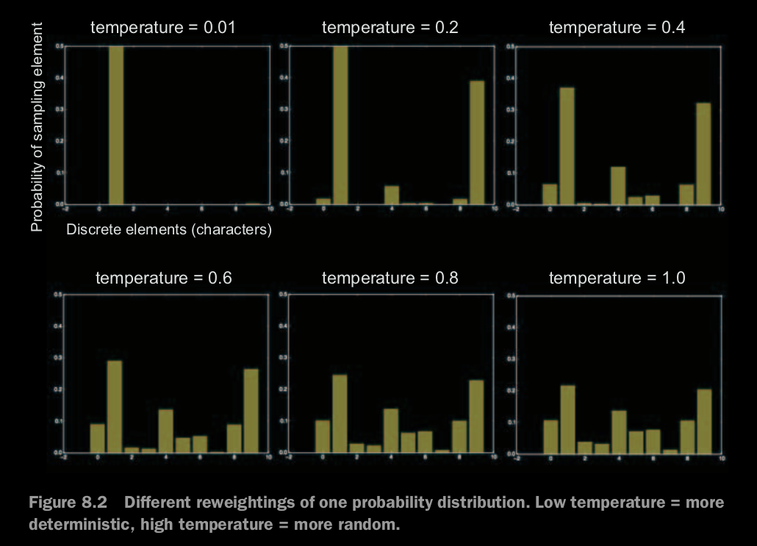

2. Implementing character-level LSTM text generation

Jupiter notebook

TRAINING THE LANGUAGE MODEL AND SAMPLING FROM IT
Given a trained model and a seed text snippet, you can generate new text by doing the following repeatedly:

1. Draw from the model a probability distribution for the next character, given the generated text available so far.
2. Reweight the distribution to a certain temperature.
3. Sample the next character at random according to the reweighted distribution.
4. Add the new character at the end of the available text.

3. Implementing DeepDream in Keras
Lower layers result in geometric patterns, while higher layers result in visuals in which you can recognize some classes from ImageNet (e.g. birds or dogs). We'll start from a somewhat arbitrary configuration involving four layers -- but you will definitely want to explore many different configurations later on:

Wrapping up
○ DeepDream consists of running a convnet in reverse to generate inputs based
on the representations learned by the network.
○ The results produced are fun and somewhat similar to the visual artifacts
induced in humans by the disruption of the visual cortex via psychedelics.
○ Note that the process isn’t specific to image models or even to convnets. It can
be done for speech, music, and more.

4. Neural Style transfer
Neural style transfer consists of applying the style of a reference image to a target
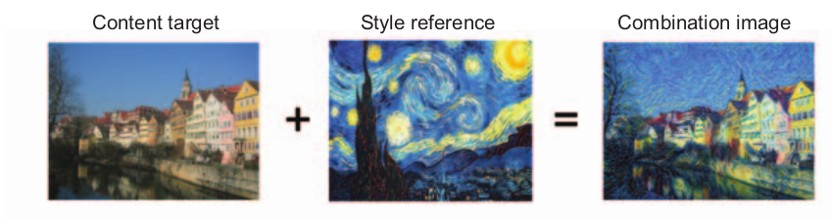
image while conserving the content of the target image.

style essentially means textures, colors, and visual patterns in the image, at various spatial scales; and the content is the higher-level macrostructure of the image.

The key notion behind implementing style transfer is the same idea that’s central
to all deep-learning algorithms: you define a loss function to specify what you want to
achieve, and you minimize this loss. You know what you want to achieve: conserving
the content of the original image while adopting the style of the reference image. If
we were able to mathematically define content and style, then an appropriate loss func-
tion to minimize would be the following:

loss = distance(style(reference_image) - style(generated_image)) +
distance(content(original_image) – content(generated_image))

5. The content loss (in higher/upper layers which contain more global and abstract information)
L2 norm between activations of an upper layer in the pretrained convnet, computed over the target image, and the activations of the same layer computed over the generated image.
So the upper image will see both 2 is the same. => reserve content

6. The style loss
Gram matrix of a layer’s actiavations: the inner product of the feature maps of a given layer.
This inner product can be understood as representing a map of the correlations between the layer’s features. These feature correlations capture the statistics of the patterns of a particular spatial scale, which empirically correspond to the appearance of the textures found at this scale.

In short, you can use a pretrained convnet to define a loss that will do the following:
○ Preserve content by maintaining similar high-level layer activations between the
target content image and the generated image. The convnet should “see” both
the target image and the generated image as containing the same things.
○ Preserve style by maintaining similar correlations within activations for both low-
level layers and high-level layers. Feature correlations capture textures : the gen-
erated image and the style-reference image should share the same textures at
different spatial scales.

7. Neural style transfer in Keras

