**UNIVERSITY OF INFORMATION TECHNOLOGY**

**FACULTY OF INFORMATION SYSTEM**

**GROUP 1**

* **HOÀNG MINH KHIÊM**
* **NGUYỄN HOÀNG LONG**
* **NGUYỄN THỊ NGA**
* **TRẦN ANH TUẤN**

**BOOK CONTROLLING PROJECT**

**INFORMATION TECHNOLOGY PROJECT MANAGEMENT**

**HO CHI MINH City, 2019**

**UNIVERSITY OF INFORMATION TECHNOLOGY**

**FACULTY OF INFORMATION SYSTEM**

**GROUP 1**

* **HOÀNG MINH KHIÊM - 16520588**
* **NGUYỄN HOÀNG LONG - 16520688**
* **NGUYỄN THI NGA - 16520727**
* **TRẦN ANH TUẤN - 16521386**

**BOOK CONTROLLING PROJECT**

**INFORMATION TECHNOLOGY PROJECT MANAGEMENT**

**LECTURER: Cao Thị Nhạn**

**TEACHER ASSISTANT: Nguyễn Thị Kim Phụng**

**HO CHI MINH City, 2019**

# **ACKNOWLEDGEMENTS**

We would like to express our special appreciation and thanks to Mrs. Cao Thi Nhan (Data Process Object Modeling’s Lecturer) and Mrs. Nguyen Thi Kim Phung (Data Process Object Modeling’s Teacher Assistant as well as our Mentor), you two have been tremendous mentors to all of us. We would like to thank you both for encouraging and supporting for our project. Your advices on our project and knowledges given to us during the course of last term have been invaluable. Without those valuable instructions, we will not be able to finish this project well, fully and delivery it on time. However, there still be some mistakes that can be avoid during this project implementation.

We very looking forward to your comments and suggestions to improve our knowledges as well as a valuable premise for the following projects.

Sincerely,

Ho Chi Minh City, 9th June 2019

**Leader of the Team**

# **MENTOR’S COMMENTS**

Ho Chi Minh City, ……. ……………… 2019

**` Mentor Signature**

Contents

**ACKNOWLEDGEMENTS** 3

**MENTOR’S COMMENTS** 4

Contents 5

**A.** **Project’s Content:** 6

**I.** **Introduction:** 6

**1.** **Project’s Scope:** 6

**2.** **Used tools:** 6

**II.** **Project’s Requirement:** 7

**1.** **Functional requirements:** 7

**2.** **Non-functional requirements:** 7

**III.** **System design:** 8

**1.** **Use case model:** 8

**2.** **Activity diagram:** 11

**3.** **Sequence Diagram:** 22

**4.** **Class Diagram:** 35

**5.** **GUI:** 42

**IV.** **Configuration and Demon running:** 59

**1.** **Configration:** 59

**2.** **Demo running:** 59

**3.** **Source Code:** 59

**V.** **Summary:** 60

**1.** **Work assignment:** 60

1. **Project’s Content:**
2. **Introduction:**

* Nowadays, technologies are evolving very quickly. Everyone is talking about 4.0, 4.0 this, 4.0 that… That makes technologies become an indispensable part of our life, technologies do participate in a various range of careers. So, applying technologies in purchase book online is not an exception. With the help of technologies, the process of buying a book will be much easier, and for the customer, finding the right book with a reasonable price will be faster.
  1. **Project’s Scope:**
* Due to time limit the book controlling project will mainly focus on helping customer searching and purchasing their desired books. Beside that our application also can manage book and customer information.
  1. **Used tools:**
* During implemented this project, our group used some software to support for searching and implementing include:
  + Microsoft SQL Server 2017
  + Microsoft Visual Studio 2017
  + Microsoft Office 2017

1. **Project’s Requirement:**
   1. **Functional requirements:**
   * **Customer:**
     + Find book.
     + Add to card.
     + Purchase book.
     + Manage account.
   * **Admin/ Staff:**
     + Manage book.
     + Manage customer.
     + Manage account.
     + Manage staff (admin only).
     + Make report.
   1. **Non-functional requirements:**

* Active 24/7.
* Can support up to multiple users at the same time.
* Ability to secure customer’s information.
* Responding speed minimum is 1s.
* Convenient, user friendly.
* Short time maintaining (from 1 up to 3 hours).

1. **System design:**
   1. **Use case model:**
      1. **Digram:**



* + 1. **List of actors:**

|  |  |  |
| --- | --- | --- |
| **No.** | **Name** | **Description** |
| 1 | Admin | Manage the whole system |
| 2 | Staff | Manage the application |
| 3 | Customer | Book buyer |

* + 1. **List of Use Case:**

|  |  |  |
| --- | --- | --- |
| **No.** | **Use case** | **Description** |
| 1 | Login | Login into the application |
| 2 | Manage Staff (admin only) | Make change to the staff database |
| 3 | Manage book | Make change to the book database |
| 4 | Manage user | Make change to the user database |
| 5 | Make report | Make monthly report |
| 6 | Manage account information | Configure your account |
| 7 | Check and confirm order | Confirm the order |
| 8 | Change password | Change your account password |
| 9 | Search and view book information | Find the right book |
| 10 | Buy book | Buy book |
| 11 | Select quantity | Input the number of copies |
| 12 | Manage cart | Make change to your cart |
| 13 | View purchase history | Confirm all the previous purchases |
| 14 | Change address | Change your account address |
| 15 | Ban user | Ban the unwanted user |
| 16 | Find password | Find your password (if forget) |

* 1. **Activity diagram:**
     1. **Manage Staff:**
* Name: Manage Staff.
* Description: Make change to the staff database

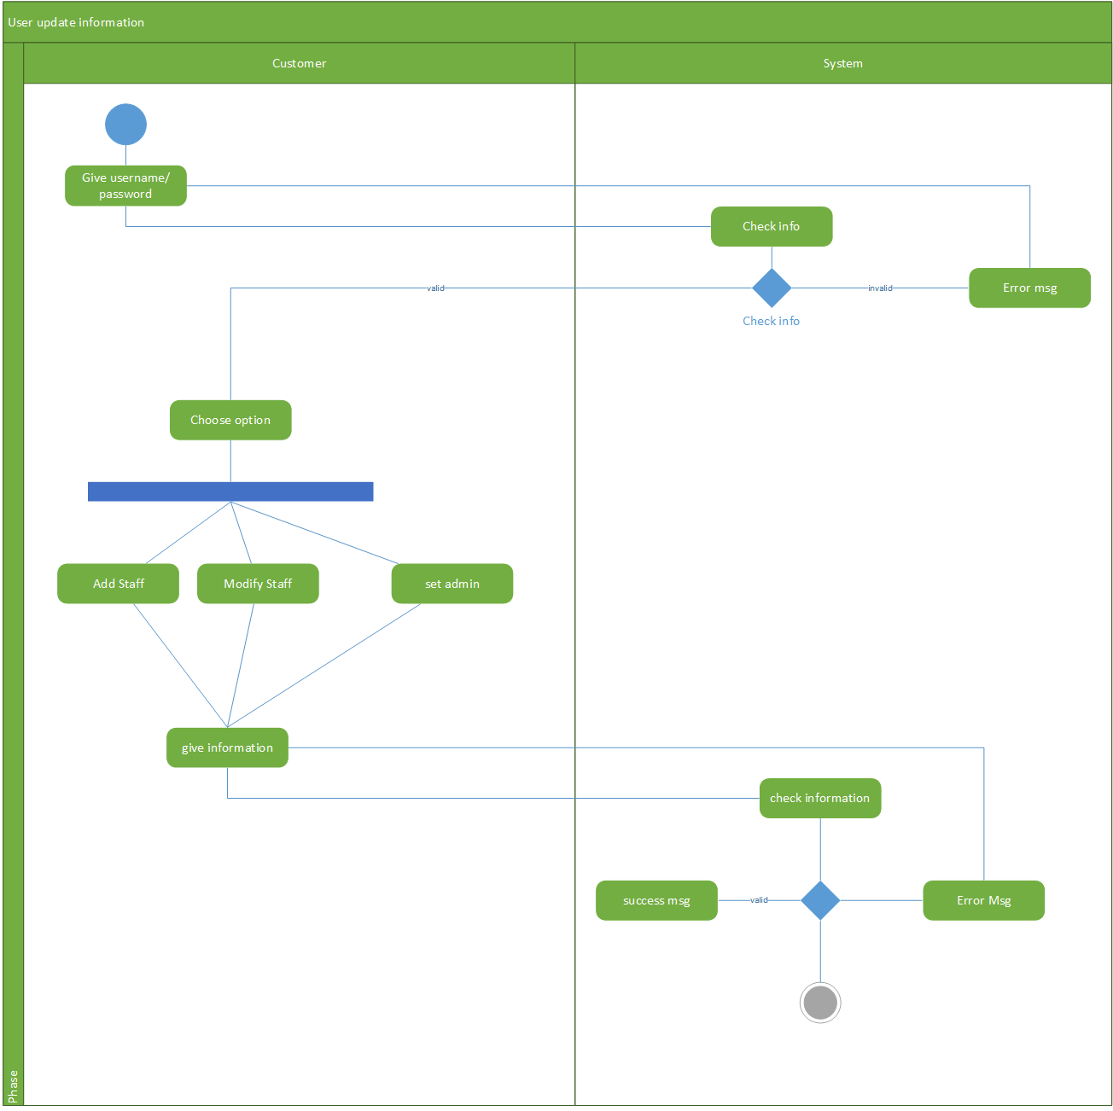

* + 1. **Manage Book:**
* Name: Mange book.
* Description: Make change to the book database

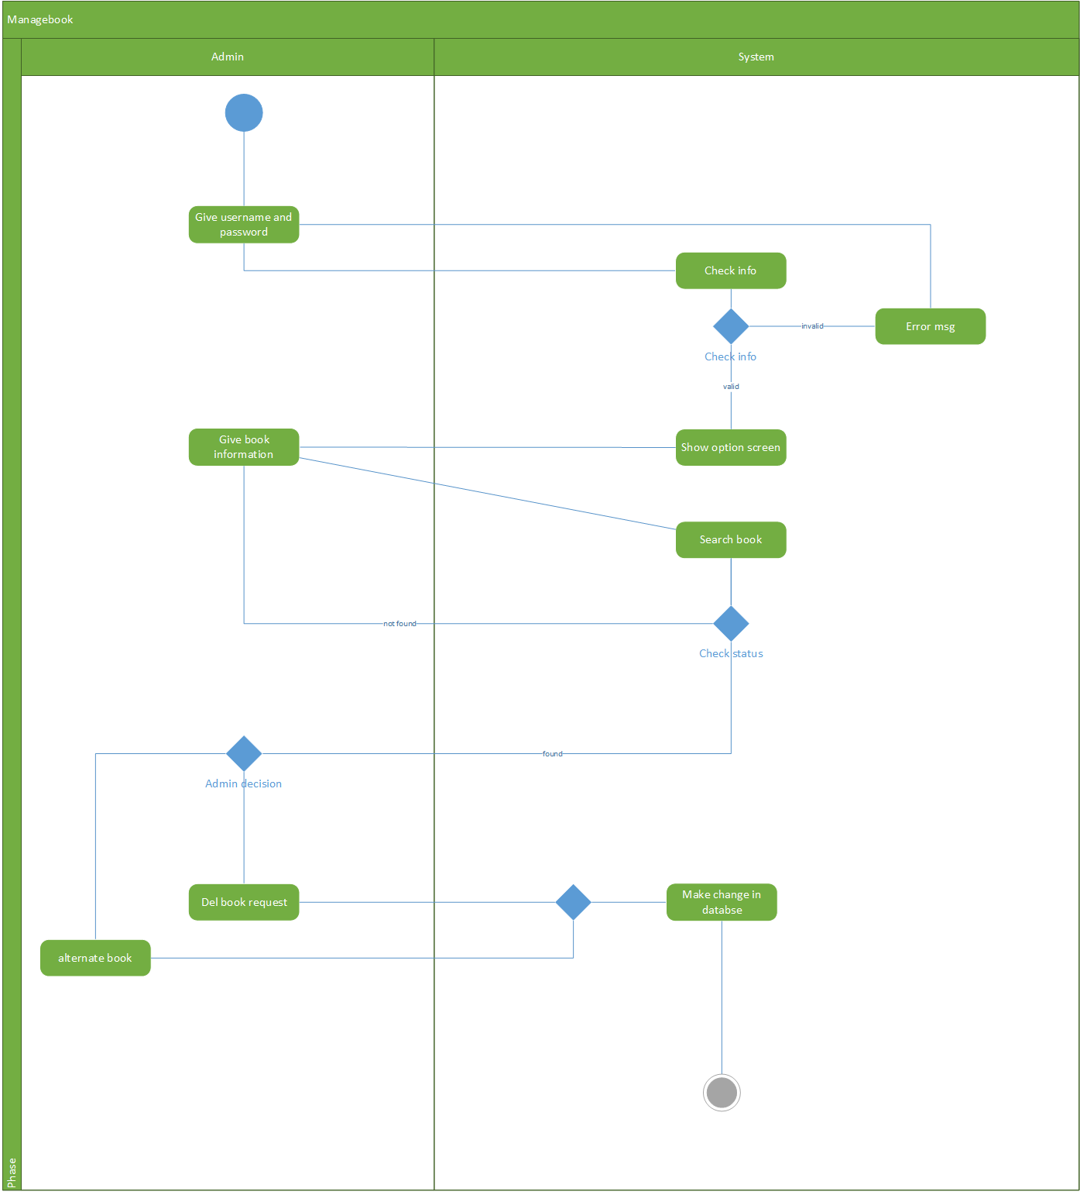

* + 1. **Manage User:**
* Name: Mange user.
* Description: Make change to the user database.

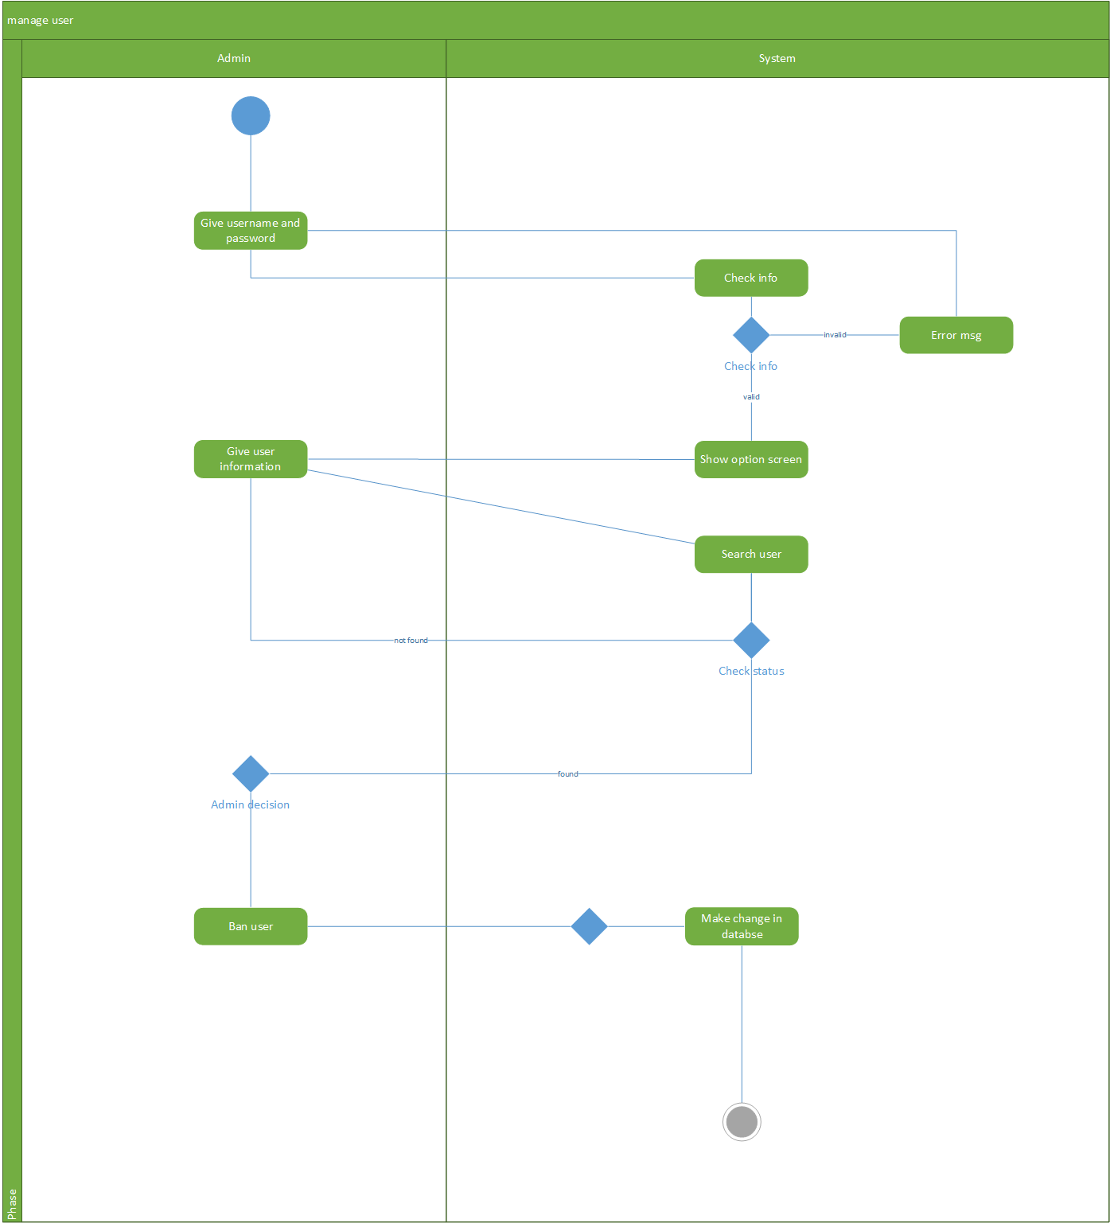

* + 1. **Make Report:**
* Name: Make report.
* Description: Make monthly report.

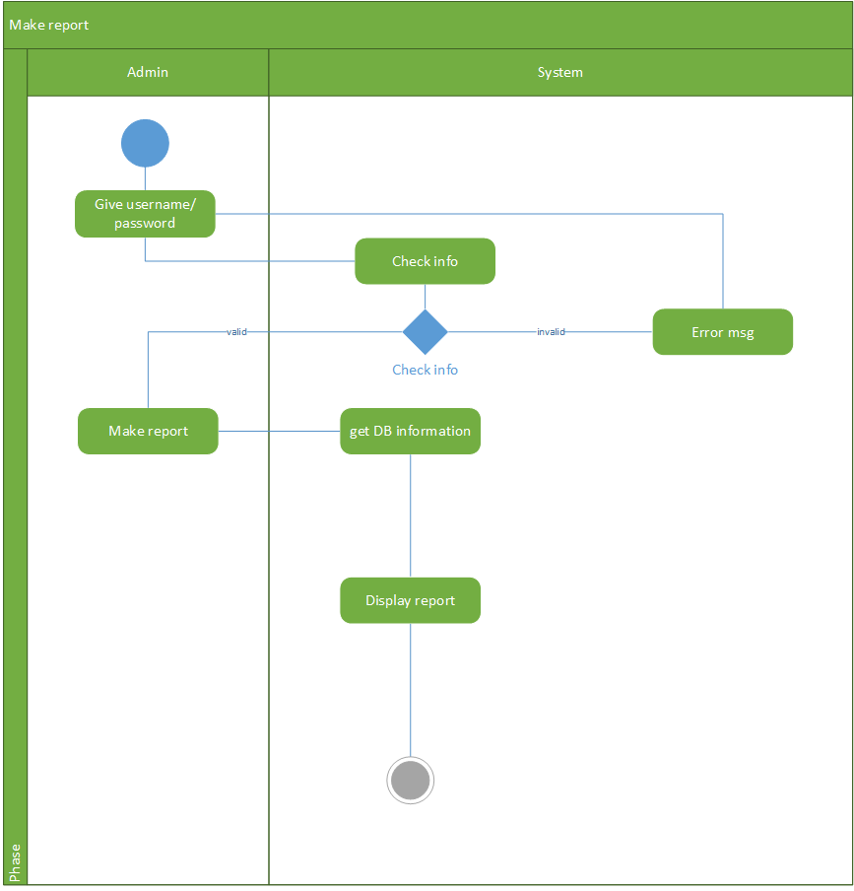

* + 1. **Add User:**
* Name: Add user.
* Description: Add new user to database

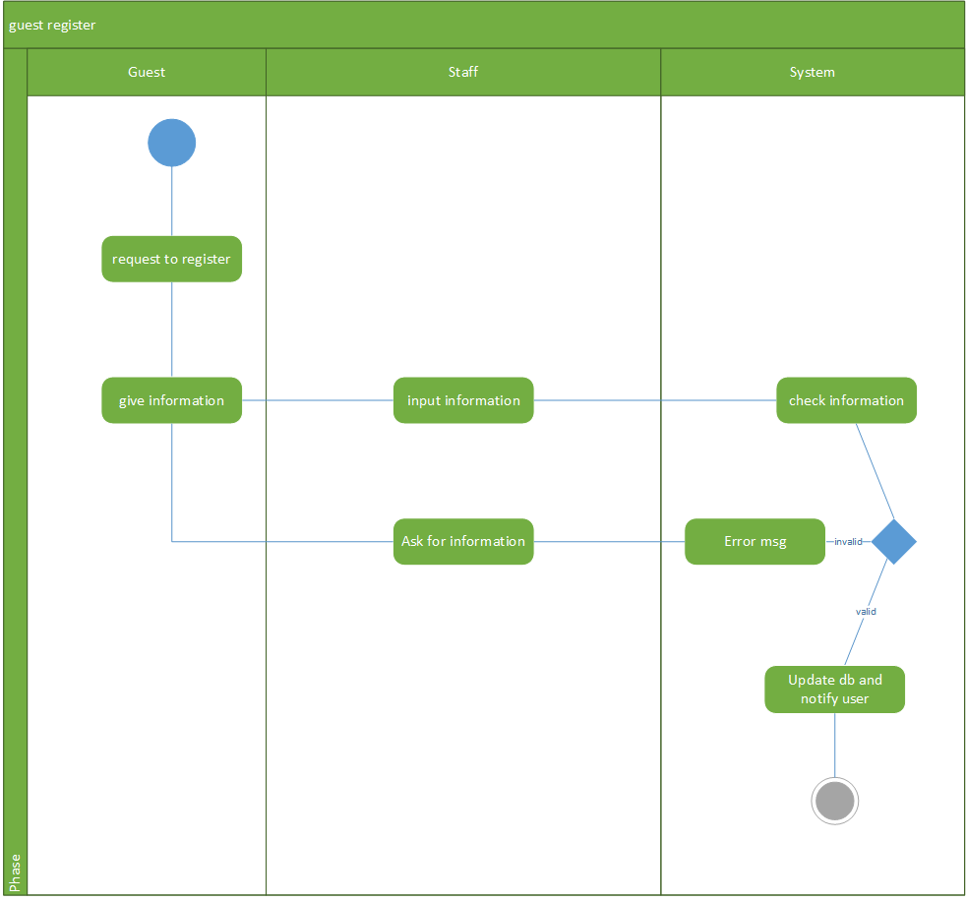

* + 1. **Manage Account Information:**
* Name: Manage account information.
* Description: Configure your account.

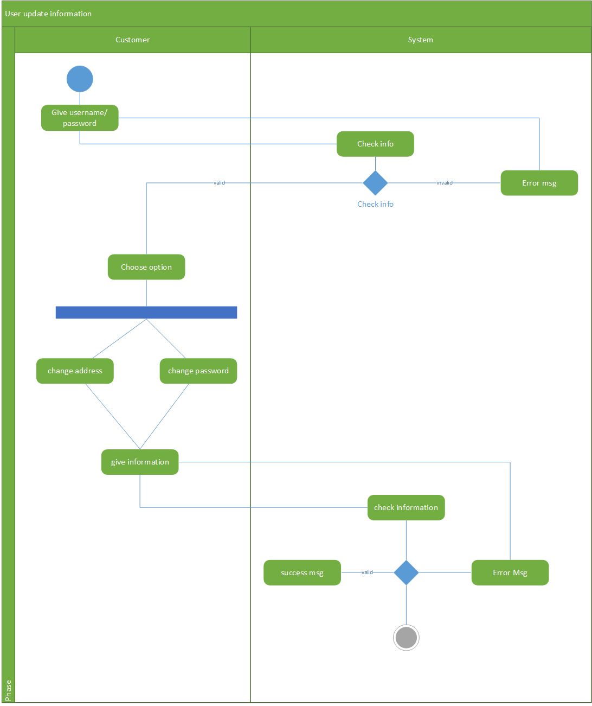

* + 1. **Search Book:**
* Name: Search book.
* Description: User search for the right book.

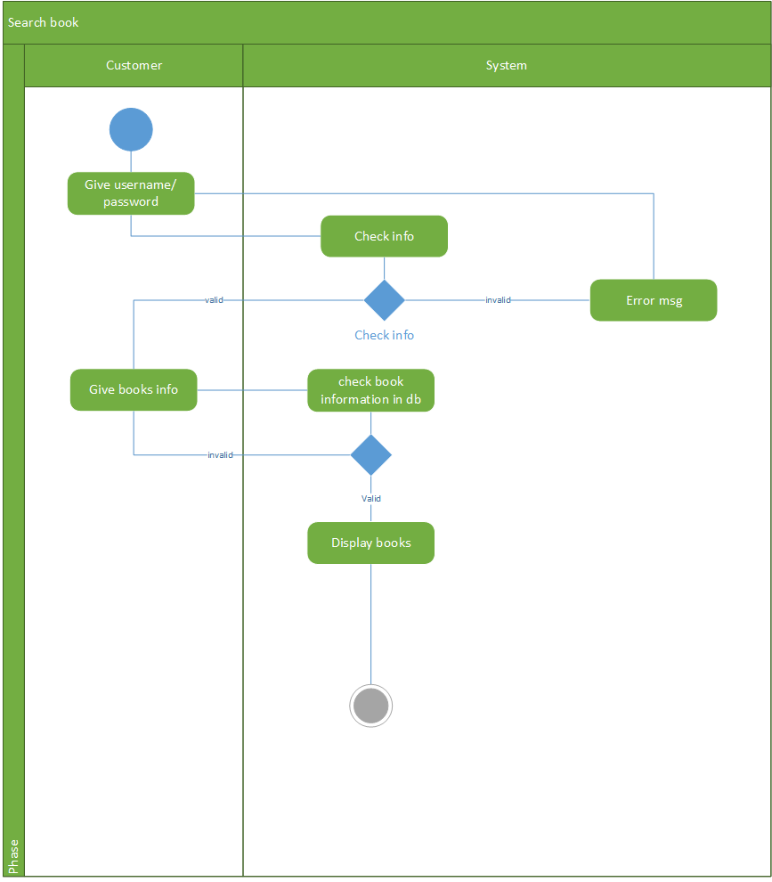

* + 1. **Buy Book:**
* Name: Buy book.
* Description: Customer choose to buy the book.

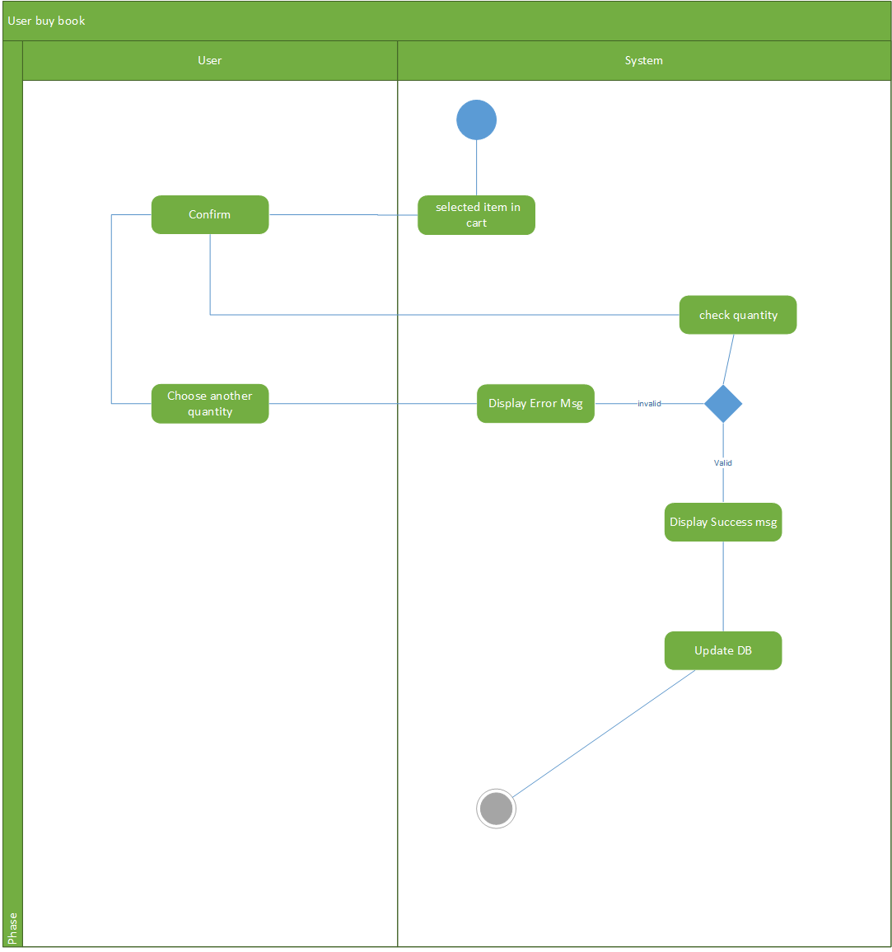

* + 1. **View Purchase History:**
* Name: View purchase history.
* Description: Customer check the purchase history.

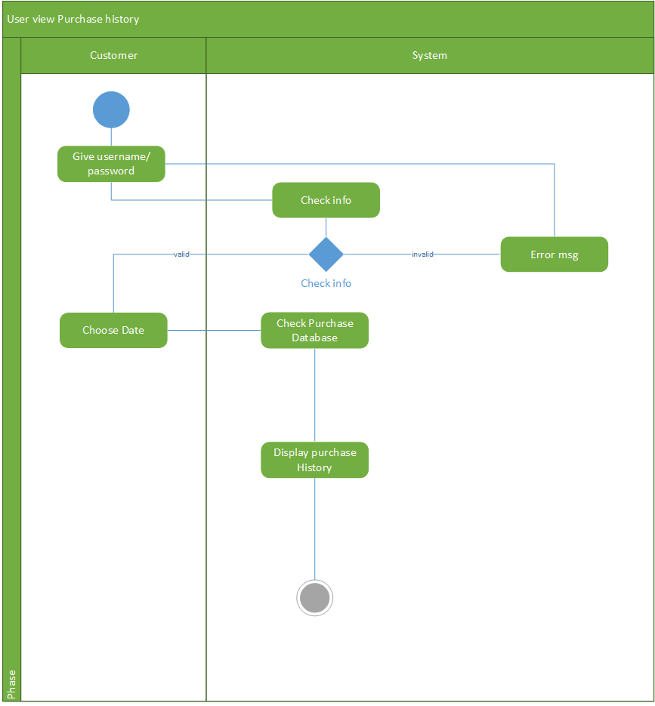

* + 1. **Manage Cart:**
* Name: Manage cart.
* Description: Customer make change to the cart.

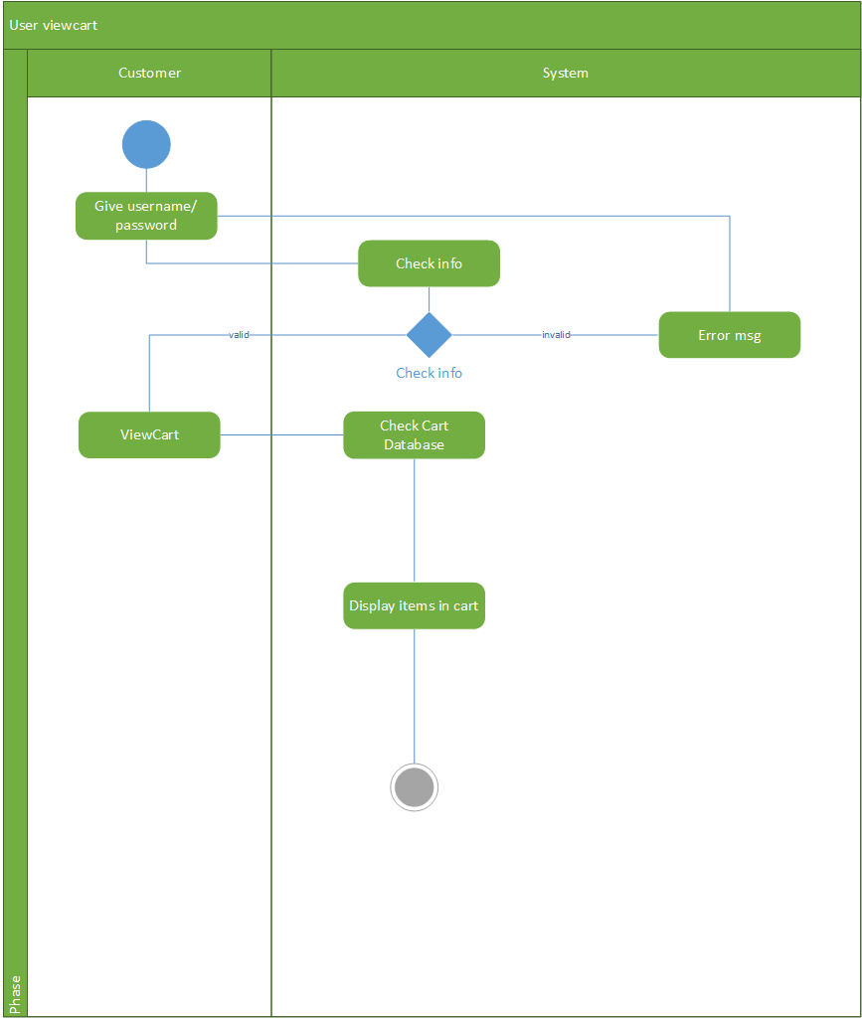

* + 1. **Find Password:**
* Name: Find password.
* Description: User find the password if forget.

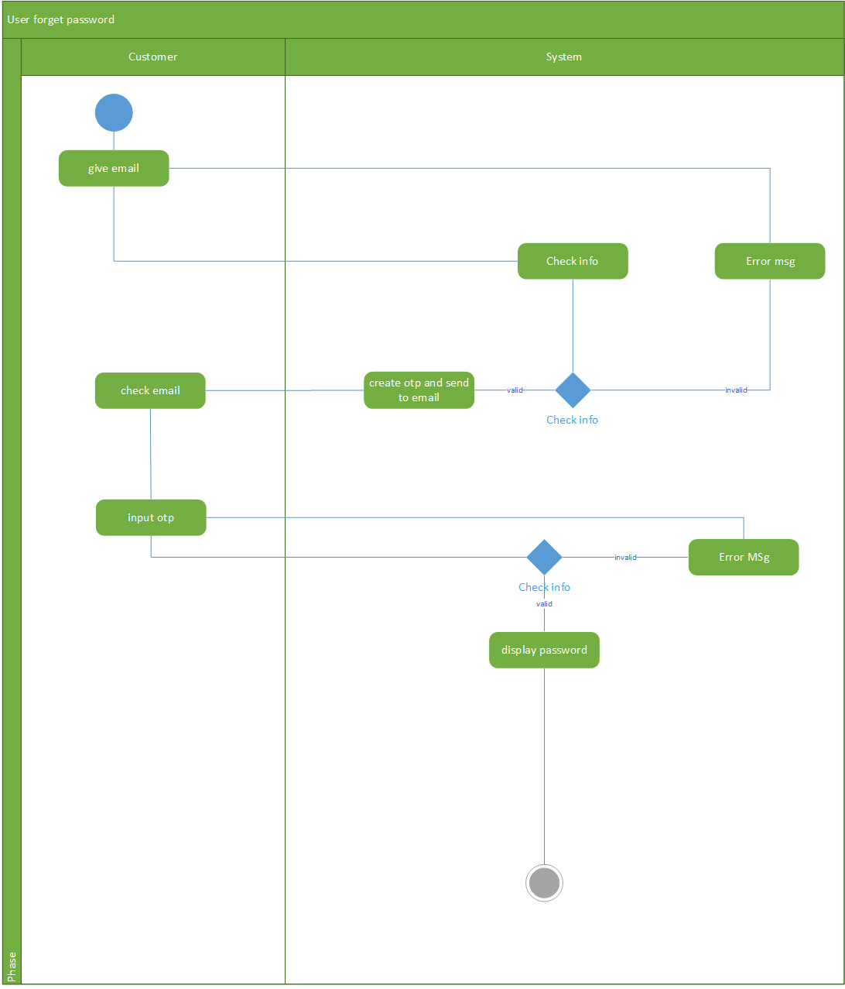

* 1. **Sequence Diagram:**
     1. **List of Sequence Diagram:**

|  |  |  |  |
| --- | --- | --- | --- |
| **No.** | **Name** | **Description** | **Section** |
| 1 | Login | User logins into the application. | 5.2 |
| 2 | Register | User creates Customer account. | 5.3 |
| 3 | Forgot Password | User gets password back. | 5.4 |
| 4 | Add to Cart | Customer adds Book into Cart. | 5.5 |
| 5 | Manage Cart | Customer manages Cart. | 5.6 |
| 6 | Purchase Book | Customer purchases Book in Cart | 5.7 |
| 7 | Customer Manage Account | Customer manage account. | 5.8 |
| 8 | Admin/Staff Mange Book | Admin/Staff add, update, delete Book. | 5.9 |
| 9 | Admin/Staff Manage Customer | Admin/Staff add, update, ban or delete Customer. | 5.10 |
| 10 | Admin Manage Staff | Admin add, update, delete or set admin Staff. | 5.11 |
| 11 | Admin/Staff Manage Account | Admin/Staff update Address or change Password. | 5.12 |
| 12 | Ship Book | Shipping process. | 5.13 |

* + 1. **Login:**



* + 1. **Register:**



* + 1. **Forgot Password:**



* + 1. **Add to Cart:**



* + 1. **Manage Cart:**



* + 1. **Purchase Book(s):**



* + 1. **Customer Manage Account:**



* + 1. **Admin/Staff Manage Book:**



* + 1. **Admin/Staff Manage Customer:**



* + 1. **Admin Manage Staff:**



* + 1. **Admin/Staff Manage Account:**



* + 1. **Ship Book:**



* 1. **Class Diagram:**
     1. **List of Class Diagram:**

|  |  |  |
| --- | --- | --- |
| **No.** | **Name** | **Section** |
| 1 | Class Entity Diagram | 6.2 |
| 2 | Class General UI Diagram | 6.3 |
| 3 | Class Cus_Search_UI Diagram | 6.4 |
| 4 | Class StaffControll_UI Diagram | 6.5 |

* + 1. **Class Entity Diagram:**

1. Diagram:



1. List of Class Entity Diagram:

|  |  |
| --- | --- |
| **Customer** | |
| **Attribute** | cus_id  cus_username  cus_password  cus_address  cus_email  create_by  create_date  update_by  update_date |
| **Operation** | searchBook()  addtoCart()  viewCart()  purchaseBook()  viewHistory() |

|  |  |
| --- | --- |
| **Staff** | |
| **Attribute** | stf_id  stf_username  stf_password  stf_email  admin_flag = 0  create_by  create_date  update_by  update_date |
| **Operation** | addBook()  updateBook()  delBook()  addCustomer()  updateCusAddress()  delCus()  banCus()  updateStock() |

|  |  |
| --- | --- |
| **Admin** | |
| **Attribute** | admin_flag = 1 |
| **Operation** | addStf()  updateStf()  delStf()  setAdmin() |

|  |  |
| --- | --- |
| **Book** | |
| **Attribute** | book_id  book_name  book_title  book_price  created_by  created_date  update_by  update_date |
| **Operation** |  |

|  |  |
| --- | --- |
| **Stock** | |
| **Attribute** | stock_id book_id quantity create_date create_by update_by update_date |
| **Operation** |  |

|  |  |
| --- | --- |
| **Cart** | |
| **Attribute** | cart_id  cus_id  cart_flag  cart_day |
| **Operation** |  |

|  |  |
| --- | --- |
| **Pick_temp (**The information of cart) | |
| **Attribute** | cart_id  book_id  cus_id  quantity  total_price |
| **Operation** |  |

|  |  |
| --- | --- |
| **Purchase** | |
| **Attribute** | purchase_id  cus_id  purchase_date  total_price |
| **Operation** |  |

|  |  |
| --- | --- |
| **History (**Hold information of Purchase) | |
| **Attribute** | purchase_id  cus_id  book_id  quantity price |
| **Operation** |  |

* + 1. **Class General UI Diagram:**

1. Diagram:



* + 1. **Class Cus_Search_UI Diagram:**

1. Diagram:



* + 1. **Class StaffControl_UI Diagram:**

1. Diagram:



* 1. **GUI:**
     1. **List of GUI:**

|  |  |  |
| --- | --- | --- |
| **No.** | **Name** | **Section** |
| 1 | Login_UI | 7.2 |
| 2 | ForgotPass_UI | 7.3 |
| 3 | Register_UI | 7.4 |
| 4 | Cus_Search_UI – Book Searching Tab | 7.5 |
| 5 | Cus_Search_UI – My Cart Tab | 7.6 |
| 6 | Cus_Search_UI – Purchase History Tab | 7.7 |
| 7 | Cus_Search_UI – Account Control Tab | 7.8 |
| 8 | StaffControl_UI – Book Control Tab | 7.9 |
| 9 | StaffControl_UI – Customer Control Tab | 7.10 |
| 10 | StaffControl_UI – Staff Control Tab | 7.11 |
| 11 | StaffControl_UI – Account Tab | 7.12 |
| 12 | StaffControl_UI – Report Tab | 7.13 |
| 13 | Quantity_Report | 7.14 |
| 14 | Sale_Report | 7.15 |
| 15 | Customer_Report | 7.16 |
| 16 | Staff_Reprot | 7.17 |

* + 1. **Login_UI Form:**

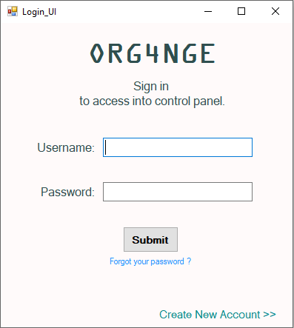

* + 1. **Forgot Password:**

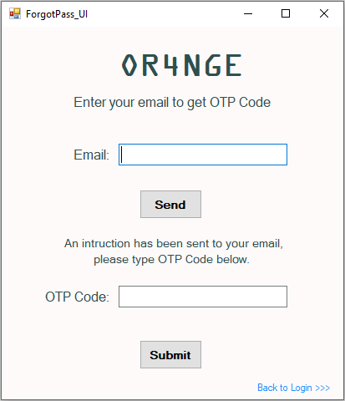

* + 1. **Register_UI Form:**

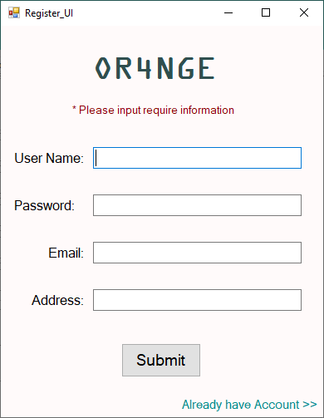

* + 1. **Cus_Search_UI – Book Search Tab:**

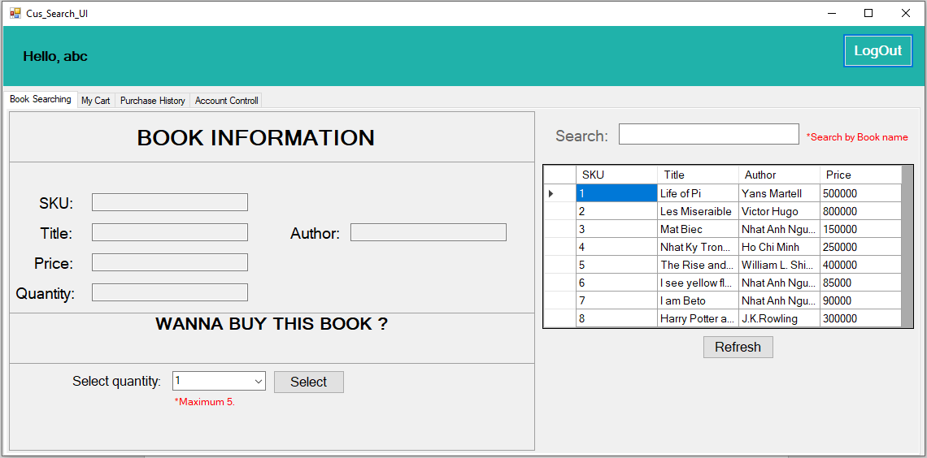

*Better resolution: <http://prntscr.com/o9c23x> .*

* + 1. **Cus_Search_UI – My Cart Tab:**

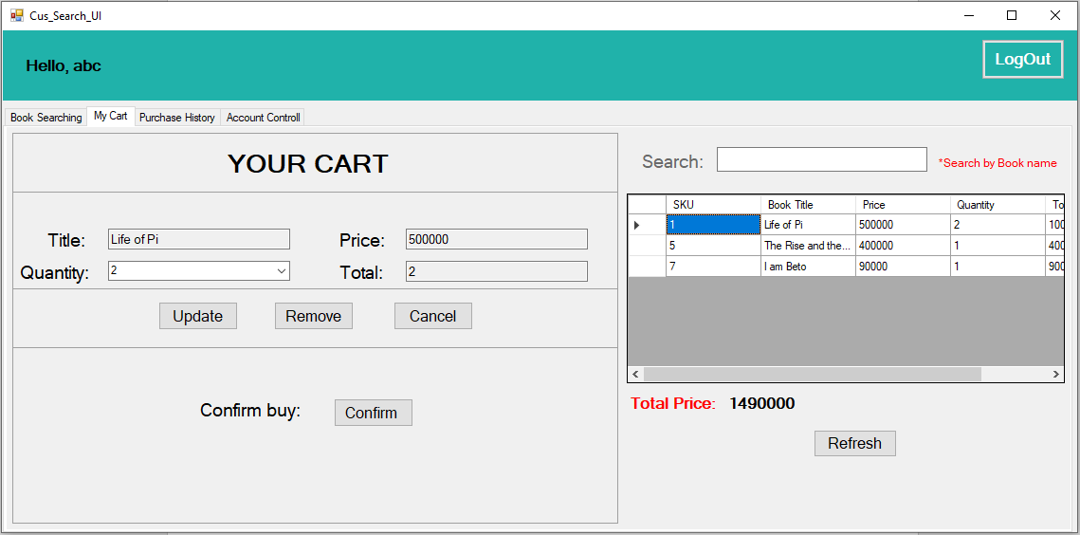

*Better resolution: <http://prntscr.com/o9c2is> .*

* + 1. **Cus_Search_UI – Purchase History Tab:**

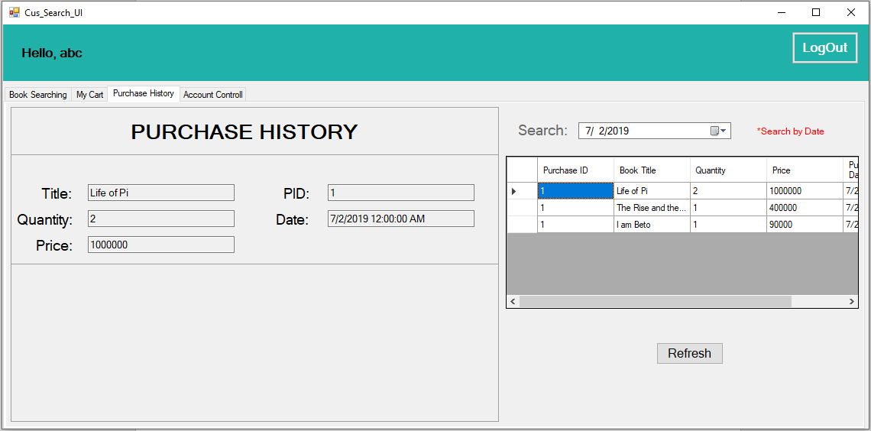

*Better resolution: <http://prntscr.com/o9c3ah> .*

* + 1. **Cus_Search_UI – Account Controll Tab:**

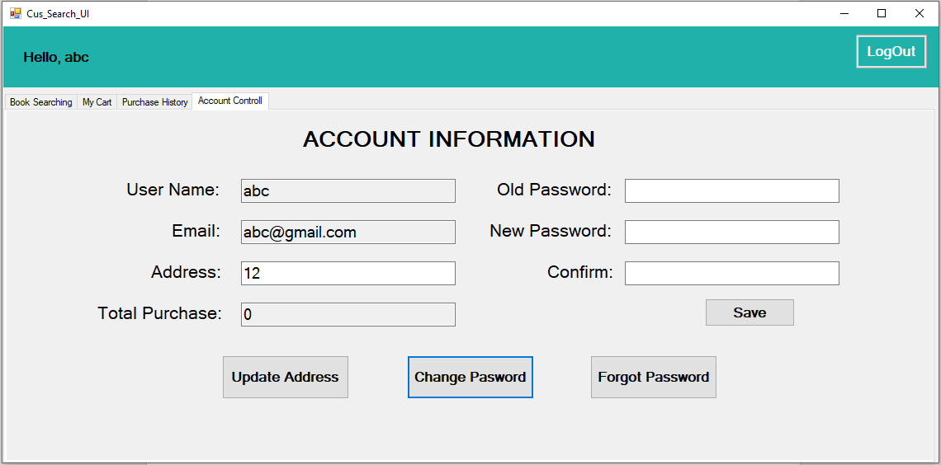

*Better resolution: <http://prntscr.com/o9c3ms> .*

* + 1. **StaffControll_UI – Book Controll Tab:**

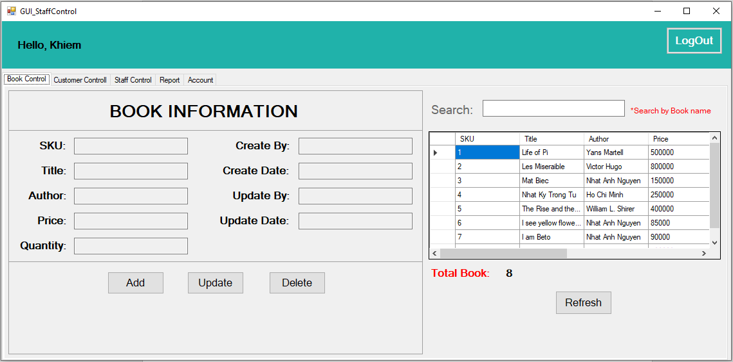

*Better resolution:* [*http://prntscr.com/o9c40h*](http://prntscr.com/o9c40h) *.*

* + 1. **StaffControll_UI – Customer Controll Tab:**

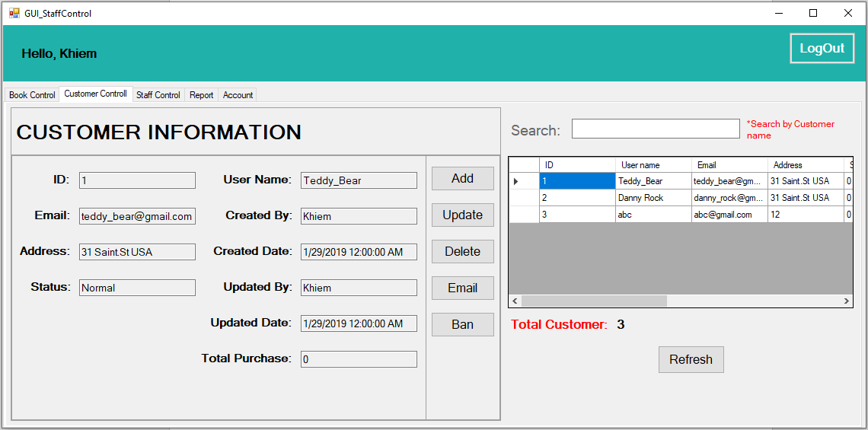

*Better resolution: <http://prntscr.com/o9c4a5> .*

* + 1. **StaffControll_UI – Staff Controll Tab:**

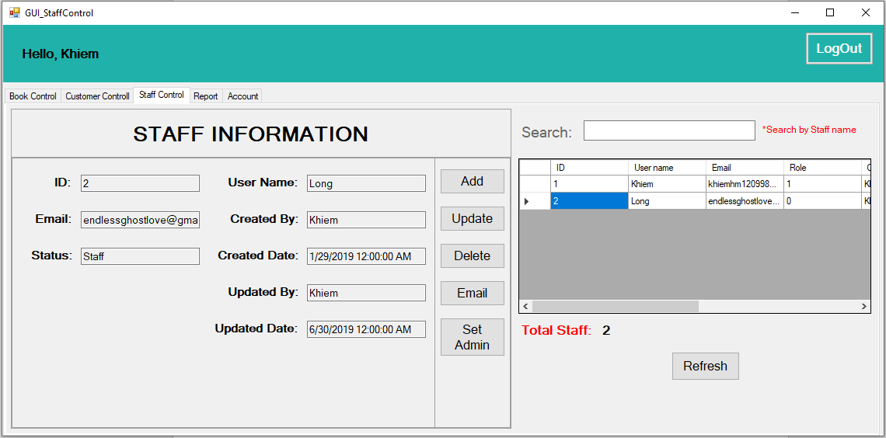

*Better resolution: <http://prntscr.com/o9c4jj> .*

* + 1. **StaffControll_UI – Report Tab:**

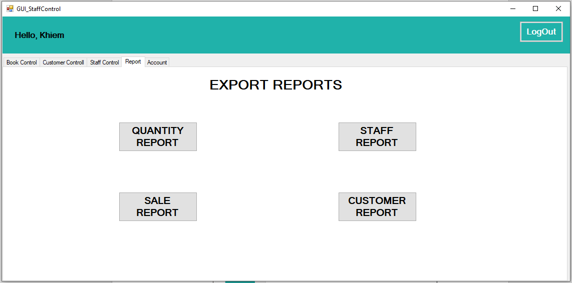

*Better resolution:* [*http://prntscr.com/o9c4y4*](http://prntscr.com/o9c4y4) *.*

* + 1. **StaffControll_UI – Account Tab:**

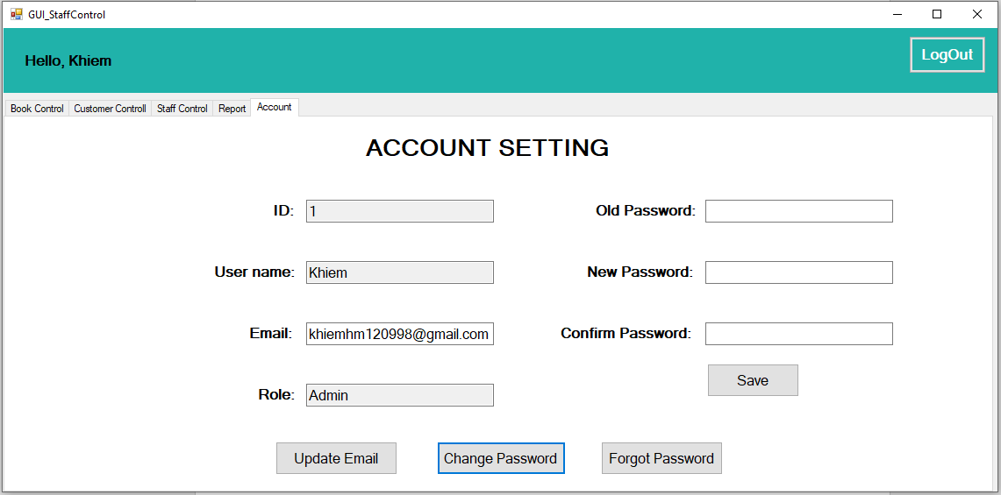

*Better resolution: <http://prntscr.com/o9c5as> .*

* + 1. **Quantity Report:**

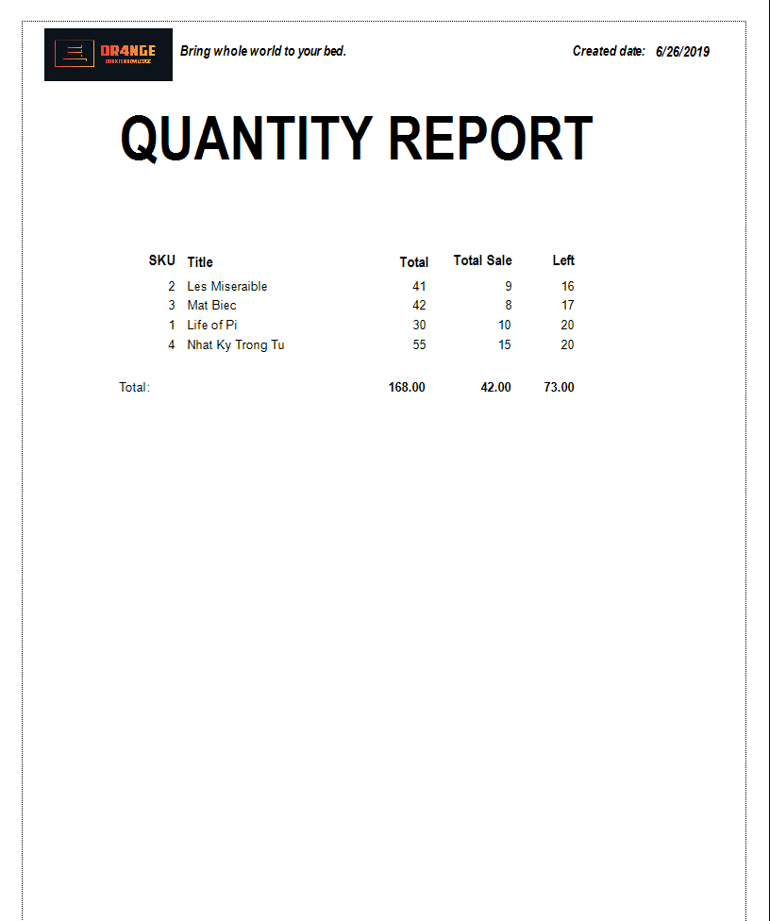

*Better resolution:* [*http://prntscr.com/o9c5ub*](http://prntscr.com/o9c5ub) *.*

* + 1. **Sale Report:**

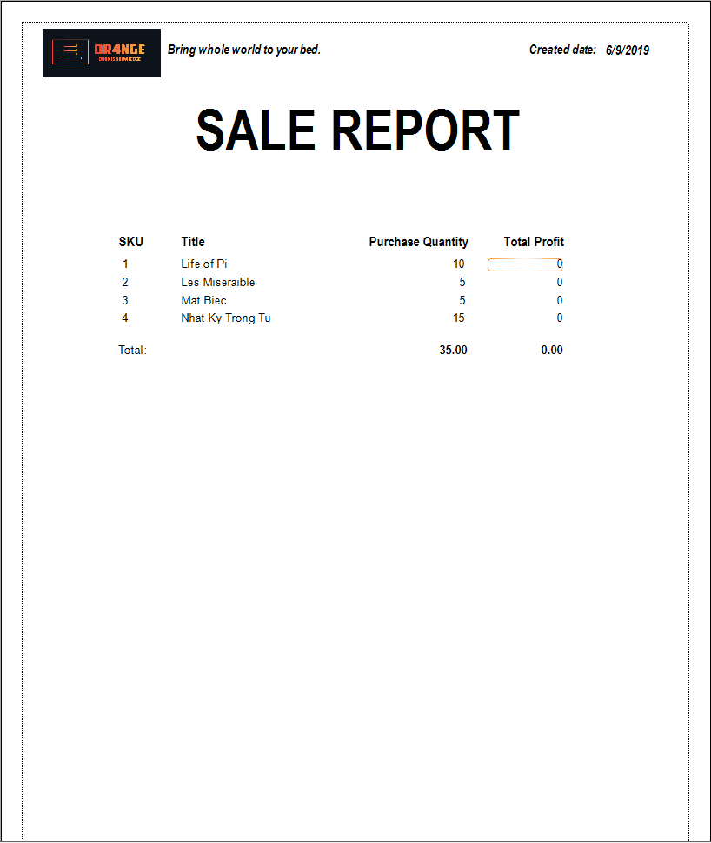

* + 1. **Staff Report:**

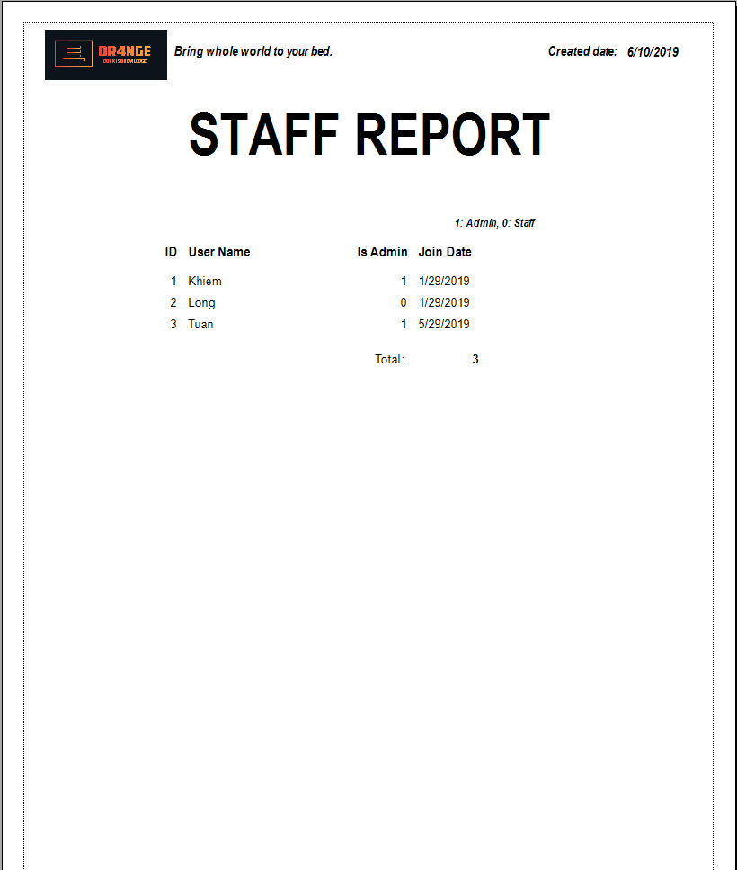

* + 1. **Customer Report:**

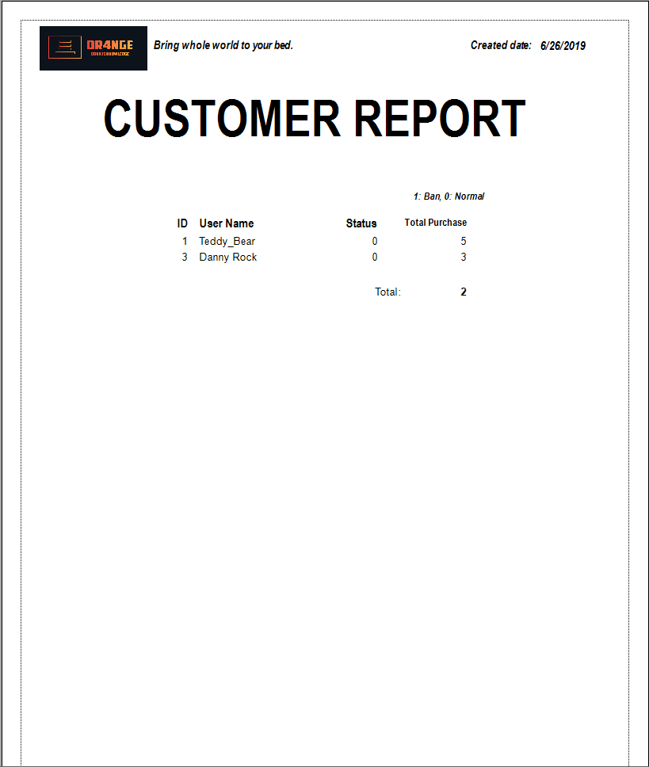

1. **Configuration and Demon running:**
   1. **Configration:**

* Run SQL_Query.sql file by SQL Server Management
* Open Book-controlling.sln
* Edit 3 cs file:
  + DB_Connect.cs
  + Cus_Search_UI.cs
  + StaffControl_UI.cs
* Change the path into:

Data Source=”Your machine name “;Initial Catalog=Book_controlling; Integrated Security=True

* + Please follow the bellow link:  
    <https://youtu.be/GORQXqi-kDc>
  1. **Demo running:**
* Please follow the bellow link:

<https://youtu.be/jKOaD6j6eB8>

* 1. **Source Code:**
* Please follow the bellow link:

<https://youtu.be/jKOaD6j6eB8>

1. **Summary:**
   1. **Work assignment:**

|  |  |
| --- | --- |
| **Member** | **Assign** |
| Hoang Minh Khiem | * Implement Application. * Database design. * Design Class Diagram. * Design Sequence Diagrams. * Make Report Documents. * Videos. |
| Nguyen Hoang Long | * Design Use-Case Model. * Design Sequence Diagrams. * Make Report Documents. |
| Nguyen Thi Nga | * Search Information. |
| Tran Anh Tuan | * Implement Application. * Design Class diagrams. * Design Sequence Diagrams. * Database Design. |