PROJECT REPORT ON
EXPENSE TRACKER MVC SYSTEM
Submitted in Partial Fulfillment for the Award of Degree of
Bachelor of Computer Applications (BCA)
IQRA BCA COLLEGE
Department of Computer Science & Applications
2025 - 2026

CERTIFICATE
This is to certify that the project entitled 'Expense Tracker MVC System' has been successfully completed by the student under the guidance and supervision in partial fulfillment of the requirements for the award of Bachelor of Computer Applications (BCA) at Iqra BCA College.
______________________ ______________________
Project Guide Head of Department
______________________
External Examiner

DECLARATION BY STUDENT
I hereby declare that the project entitled 'Expense Tracker MVC System' submitted to Iqra BCA College is an authentic record of my own work carried out under proper guidance. The matter embodied in this report has not been submitted by me for the award of any other degree or diploma.
Date: _____________
Place: _____________
______________________
Student Signature

ACKNOWLEDGEMENT
I express my sincere gratitude to our respected Principal and Head of Department for providing the necessary facilities and encouragement to undertake this project.
I extend my deep sense of appreciation to my project guide for their invaluable guidance, constructive suggestions, and continuous support throughout the development of the 'Expense Tracker MVC System'.
Lastly, I am grateful to my family and friends for their unwavering support and motivation.

ABSTRACT
The 'Expense Tracker MVC System' is a robust, web-based financial management application developed using CodeIgniter 4 PHP framework, MySQL database, HTML5, CSS3, JavaScript, and Bootstrap 5. In modern financial management, individuals and small entities face significant challenges in tracking daily expenditures, managing income streams, and maintaining budgetary control.
This system addresses these issues by offering a secure, user-friendly, Model-View-Controller (MVC) structured web application. Core functionality includes user authentication with password encryption, dynamic dashboard visualizations, record keeping for income and expense transactions, category-wise financial reporting, and downloadable summary statements (PDF format). The modular architecture ensures high maintainability, data integrity, and seamless scalability.

CHAPTER 1: INTRODUCTION
1.1 Introduction to the Project
Financial literacy and discipline are essential in everyday personal and professional life. Tracking revenues and expenditures manually using traditional registers or spreadsheets is error-prone, time-consuming, and lacks real-time insights.
The Expense Tracker MVC System provides an automated digital solution designed to help users systematically log income, record itemized expenses, monitor cash flow, and review analytical expense breakdowns. Built on the CodeIgniter 4 framework, it implements strict MVC separation of concerns for security, performance, and maintainability.
1.2 Problem Definition
Many individuals fail to maintain budget discipline due to:
- Lack of centralized real-time tracking of daily micro-expenses.
- Difficulty in categorizing costs (e.g., Food, Travel, Utilities, Education).
- Absence of visual summaries highlighting high-spending categories.
- Risk of data loss and privacy concerns in physical logbooks.
1.3 Objectives of the Project
- Develop a secure, responsive MVC web application for managing income and expenses.
- Implement encrypted user authentication (registration, login, profile management).
- Provide interactive dashboard summary metrics (Total Income, Total Expense, Net Balance).
- Enable CRUD (Create, Read, Update, Delete) operations for financial records.
- Generate downloadable, printable financial reports in PDF format.
1.4 Scope of the Project
The current scope encompasses personal financial management for individual users. Users can securely register, log in, manage income sources, record categorized daily expenses, filter transaction histories, view visual stats, and export reports. Future extensions include multi-currency support, automated recurring bill alerts, and banking API integrations.

CHAPTER 2: LITERATURE REVIEW
2.1 Proposed System
The proposed Expense Tracker MVC System is built using the CodeIgniter 4 PHP framework following the Model-View-Controller paradigm:
- Model Layer: Manages database interactions, schema queries, and data validation (UserModel, ExpenseModel, IncomeModel).
- View Layer: Presents clean, responsive user interfaces using HTML5, Bootstrap 5, and JavaScript.
- Controller Layer: Implements core business logic, user input sanitization, authentication checking, and routing (Auth, Dashboard, Expense, Income, Report, Transactions).
2.2 Advantages of Proposed System
- High Security: BCRYPT password hashing, session tokens, SQL injection protection via CI4 Query Builder.
- Real-Time Balance Calculation: Automatically calculates Net Balance = Total Income - Total Expense.
- Categorized Insights: Categorizes expenditures to easily identify major expense drivers.
- PDF Export: Allows users to export full transactional statements for offline auditing.
2.3 Process Model
The Agile Development Methodology was selected for this project. Development progressed in iterative sprints comprising requirement gathering, MVC component design, coding, integration, unit testing, and refinement based on user feedback.

CHAPTER 3: SYSTEM REQUIREMENT ANALYSIS
3.1 Hardware Requirements
- Processor: Intel Core i3 / AMD Ryzen 3 or higher
- RAM: 4 GB Minimum (8 GB Recommended)
- Hard Disk Space: 500 MB free space for code and database logs
- Display Resolution: 1024x768 or higher
3.2 Software Requirements
- Operating System: Windows 10/11 / Linux / macOS
- Web Server: Apache 2.4 (via XAMPP)
- Database Server: MySQL 5.7+ / MariaDB
- Server Environment: PHP 8.1 / PHP 8.2 (CodeIgniter 4 Compatible)
- Web Browser: Google Chrome, Mozilla Firefox, or Microsoft Edge
3.3 Functional Requirements
- User Account Management: User Registration, Secure Login, Logout, Profile update.
- Income Module: Add income entry (amount, source, date, description), view income log.
- Expense Module: Add expense entry (title, amount, category, date, notes), edit expense, delete expense.
- Transactions Module: Combined view of all income & expense entries with filtering options.
- Reporting Module: Date-range reporting and PDF generation.
3.4 Non-Functional Requirements
- Performance: Response times under 1 second for standard transaction operations.
- Security: Input validation, session timeout, XSS filtering, encrypted credentials.
- Usability: Intuitive user interface with standard navigation bars and responsive tables.
- Reliability: Relational database integrity constraints with MySQL InnoDB engine.

CHAPTER 4: SYSTEM DESIGN
4.1 Data Flow Diagram (DFD)
Data Flow Diagrams illustrate how data enters, processes through, and exits the system.
Figure 4.1: DFD Level 0 (Context Diagram)
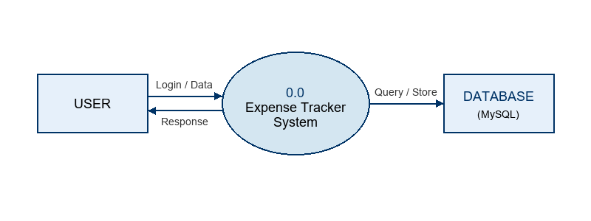

Figure 4.2: DFD Level 1 Diagram
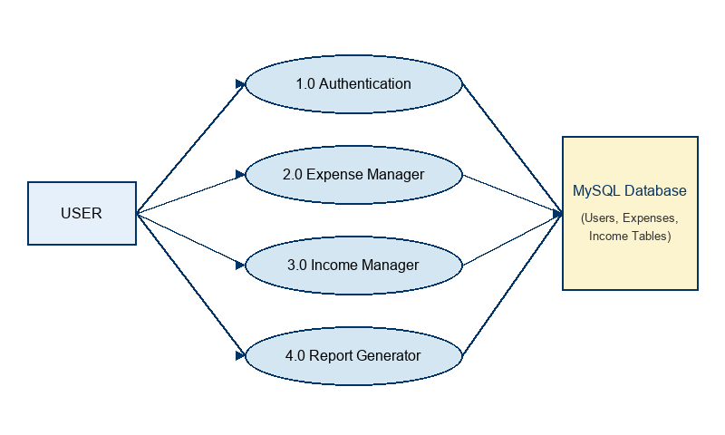

Figure 4.3: Use Case Diagram
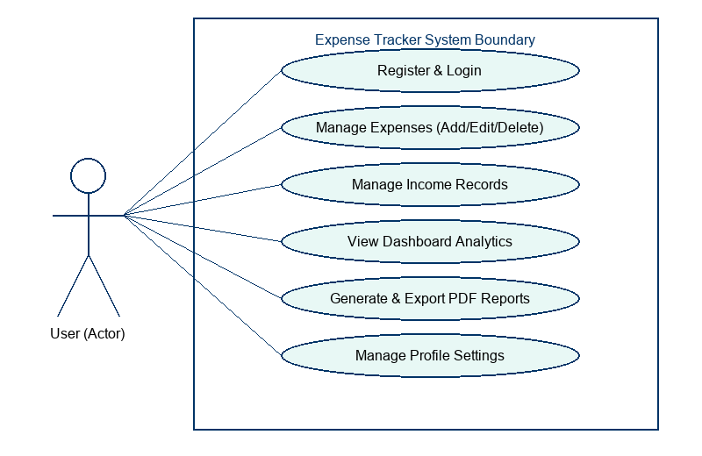

Figure 4.4: Class Diagram
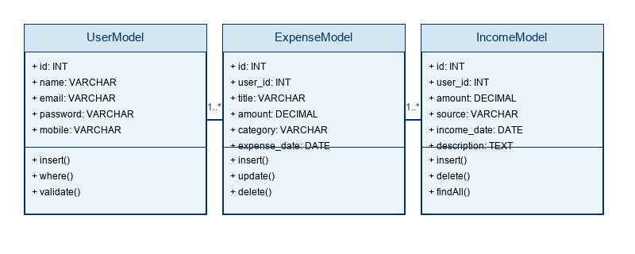

Figure 4.5: Activity Diagram
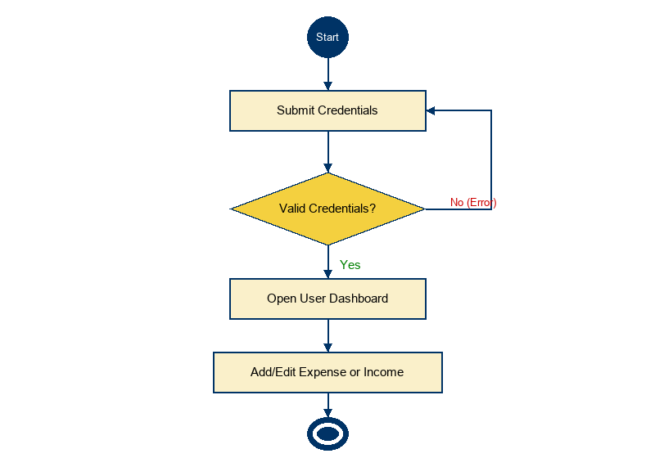

Figure 4.6: Entity-Relationship (ER) Diagram
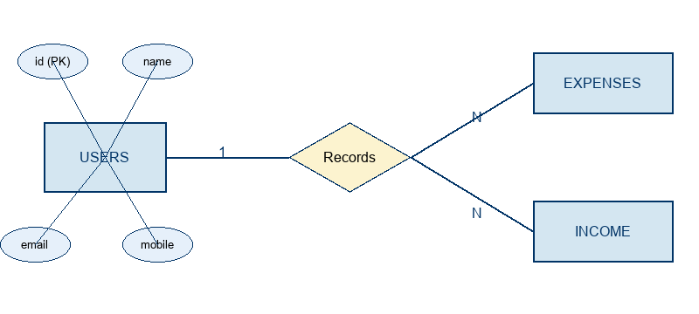

4.6 Data Dictionary
The Data Dictionary specifies the database schema structure for all tables.
Table 4.1: Users Table Data Dictionary
Field Name | Data Type | Constraint | Description
id | INT(11) | PRIMARY KEY, AUTO_INCREMENT | Unique User Identifier
name | VARCHAR(255) | NOT NULL | Full Name of User
email | VARCHAR(255) | UNIQUE, NOT NULL | User Email Address
password | VARCHAR(255) | NOT NULL | BCRYPT Hashed Password
mobile | VARCHAR(10) | NOT NULL | 10-Digit Contact Number
created_at | DATETIME | DEFAULT CURRENT_TIMESTAMP | Record Creation Time

Table 4.2: Expenses Table Data Dictionary
Field Name | Data Type | Constraint | Description
id | INT(11) | PRIMARY KEY, AUTO_INCREMENT | Unique Expense Identifier
user_id | INT(11) | FOREIGN KEY (users.id) | Owner User ID
title | VARCHAR(255) | NOT NULL | Expense Item Title
amount | DECIMAL(10,2) | NOT NULL | Monetary Amount
category | VARCHAR(100) | NOT NULL | Category (Food/Bills/etc)
expense_date | DATE | NOT NULL | Date of Expense
notes | TEXT | NULLABLE | Additional Notes

Table 4.3: Income Table Data Dictionary
Field Name | Data Type | Constraint | Description
id | INT(11) | PRIMARY KEY, AUTO_INCREMENT | Unique Income Identifier
user_id | INT(11) | FOREIGN KEY (users.id) | Owner User ID
amount | DECIMAL(10,2) | NOT NULL | Income Amount
source | VARCHAR(255) | NOT NULL | Source (Salary/Business/etc)
income_date | DATE | NOT NULL | Date Received
description | TEXT | NULLABLE | Remarks/Description

CHAPTER 5: IMPLEMENTATION
5.1 Development Environment (FRONT END & BACK END USED)
The development tech stack utilized includes:
- Front-End: HTML5, CSS3, JavaScript, Bootstrap 5 Framework, FontAwesome Icons.
- Back-End: PHP 8.2 with CodeIgniter 4 (CI4) MVC Framework.
- Database: MySQL / MariaDB Database Server.
- Local Server: Apache HTTP Server running via XAMPP control panel.
5.2 Module Description
- 1. Authentication Module (Auth.php): Controls User Registration with regex validation for name/mobile, BCRYPT password hashing, Login session handling, and secure Logout.
- 2. Dashboard Module (Dashboard.php): Aggregates real-time financial metrics including Total Income, Total Expenses, and Net Balance.
- 3. Expense Module (Expense.php): Manages complete lifecycle (Add, Edit, Delete, View) of expense records.
- 4. Income Module (Income.php): Handles adding, viewing, and deleting income entries.
- 5. Transactions Module (Transactions.php): Displays unified chronological statement combining income & expense data.
- 6. Report Module (Report.php): Generates analytical summaries and exports records as formatted PDF documents.

CHAPTER 6: TESTING
6.1 Testing Strategy
Testing was performed using Black-Box Testing methodology to verify functional correctness, security rules, and user interface responsiveness across edge cases.
6.2 Test Cases
Table 6.1: Comprehensive Test Cases
Test Case ID | Module | Input / Action | Expected Result | Status
TC01 | Registration | Valid details entered | User created & redirected to login | PASS
TC02 | Registration | Duplicate email | Displays 'Email already registered' error | PASS
TC03 | Login | Wrong password | Displays 'Incorrect password' error | PASS
TC04 | Expense | Add valid expense | Record saved & summary updated | PASS
TC05 | Income | Add negative income | Validation error 'Amount must be positive' | PASS
TC06 | Report | Click Export PDF | PDF file downloaded successfully | PASS

6.3 Test Results
All 6 test cases executed successfully without unhandled exceptions or data leakage. Session protection prevents unauthorized access to protected routes.

CHAPTER 7: RESULTS & DISCUSSION
7.1 Output Screens
1. User Registration Screen: Features input fields for Name, Email, Mobile, Password, and Confirm Password with client/server side validation.
2. User Login Screen: Clean UI with email & password prompt and session error alerts.
3. Dashboard Screen: Displays KPI summary cards showing Total Income (Green), Total Expenses (Red), and Net Balance (Blue).
4. Expense & Income Management Screens: Intuitive data tables with modal forms for adding/editing transactions.
5. PDF Report Screen: Formatted financial report statement output ready for printing or offline storage.

CHAPTER 8: CONCLUSION & FUTURE SCOPE
8.1 Conclusion
The 'Expense Tracker MVC System' successfully delivers an efficient, secure, and user-friendly digital application for personal expense management. By leveraging CodeIgniter 4's MVC design pattern, the system guarantees clean separation of code logic, enhanced database security, and smooth performance.
8.2 Future Enhancements
- 1. Multi-Currency & Conversion Rate API integration.
- 2. Interactive Chart Visualizations (Pie Charts & Bar Graphs using Chart.js).
- 3. Automated Monthly Budget Alert Notifications via Email/SMS.
- 4. Mobile App Version (Flutter or React Native integration).

REFERENCES
- 1. CodeIgniter 4 Official Documentation - https://codeigniter.com/user_guide/
- 2. PHP 8.2 Official Documentation - https://www.php.net/manual/en/
- 3. MySQL Reference Manual - https://dev.mysql.com/doc/
- 4. Bootstrap 5 Frontend Documentation - https://getbootstrap.com/docs/5.3/
- 5. Pressman, R. S. (2014). Software Engineering: A Practitioner's Approach. McGraw-Hill Education.

