Determination of Climate Change Impact of Streamflow Simulation in Chindwin River Basin

Thuzar Han #1, Win Win Zin #2, Zin Marlar Tin San #3

#*Civil Engineering Department, Yangon Technological University  
Yangon, Republic of the Union of Myanmar*

[1](mailto:1nguwahmc@gmail.com) thuzarhan84@gmail.com

[2](mailto:2nayaye1@gmail.com) [winwinzin@gmail.com](mailto:ccthinkyi@gmail.com)

3 zinmarlartinsan@gmail.com

*Abstract- This study accessed the impact of climate change on streamflow simulation in the Chindwin river basin. It is evaluated by using a global climate model (GCM) coupled with a hydrologic model, Hydrological Engineering Center-Hydrological Model System (HEC-HMS). Downscaled future data (2020-2100) under Rcp4.5 and Rcp8.5 emission scenarios are compared to the climate data for a baseline period (1981-2005). Future predicted rainfall were assigned as input in HEC-HMS model to estimate the future of the streamflow at three future time horizons: 2030s (2020-2046), 2060s (2047-2073) and 2090s (2074-2100). It is seen that average annual maximum and minimum temperature will increase by 2.6°C and 2.9°C, respectively, towards the end of 21st century. The average annual precipitation will also increase from 32% to 62% under two emission scenarios. The results indicated that the hydrology of the study basin will be influenced by climate change. Overall, at the end of century, streamflow will increase 24% to 28% respectively.*

*Keywords* – *Climate Change Impacts, Global Climate Models, HEC-HMS, Streamflow*

I. INTRODUCTION

The exact magnitude of the changes in the global climate is still uncertain, and subject of worldwide scientific studies. It has been established that human activities are leading to the alteration of the climate through global warming [1]. Following the greenhouse gas emission scenarios for the 21st century, climate change will cause increased temperature and changes in precipitation. The changes of these climatic parameters will significantly affect the hydrological regions of river systems. Changes in seasonality and amount of streamflow from river systems are likely to occur due to climate change [2].

Myanmar is exposed to severe natural weather events, which have increased in intensity and frequency over the last 60 years because of its geographic location and characteristics. In the center of Southeast Asia’s southwest monsoon area and crossed by large river systems ending in a vast delta, many parts of Myanmar experience heavy rain-induced floods. The nation’s coast makes up more than half of the eastern side of the Bay of Bengal and the Andaman Sea, which is prone to cyclones and associated strong winds, heavy rains and storm surges. Droughts are also frequent, particularly in central Myanmar. In every region in Myanmar, temperatures are expected to increase by the middle of the century. Temperatures are projected to rise by 1.3°C to 2.7°C above historical levels, with the highest estimates associated with large increases in global greenhouse gas emissions. In case of precipitation, changes in rainfall patterns are projected to vary by region and season. Projections show that precipitation gains are most likely to occur during the monsoon season, whereas it is unclear whether precipitation will increase or decrease during the cool or hot seasons [3].

One of the most challenging area in hydrology is denoted by the availability of data and accurate prediction of runoff response to precipitation and its discharge to the outlet will be extremely difficult to achieve with constrained or no data (Chu and Steinman,2009; Halwatura and Najim,2013; Todini,1996)[4]. The USACE model, Hydrologic Modeling System, is designed to simulate the precipitation-runoff processes of dendritic catchment systems (HEC, 2008). HEC-HMS is widely used in a broad range of hydrologic problems varying from the analysis of large river basin water supply and flood hydrology to the study of small urban or natural catchment runoff. HEC-HMS has been used for studies of water availability, urban drainage, flow forecasting, future urbanization impact, reservoir spillway design, flood damage reduction, flood plain regulation and systems operation (HEC,2008)[5]. The Hydrologic Engineering Center- Hydrologic Modeling System (HEC-HMS), which is one of many watershed models supporting both lumped and distributed model (Madsen, 2000) used to simulate rainfall-runoff correlation, has become a popular and reliable hydrologic model due to its capability in short-term simulation ,ease to use and the use of common methods (Arekhi,2012), the less required input parameters, economics, the capacity in runoff simulation in ungauged catchment (Choudhari et al.,2014) and low flow prediction (De Silva et al.,2013)[4]. Therefore, the main objective of this study is to apply HEC-HMS model for simulating streamflow of Chindwin river basin due to climate change impacts.

II. STUDY AREA

Chindwin river is the largest tributary of Ayeyarwaddy river. The Chindwin river, which is originated in the northern border mountains and the Kumon ranges in Kachin state, flows down through the Hukawng valley, Hkamti, Tamanthi, Homalin, and Mawlaik to the southwest along the eastern edge of the 2000-3800m high Rakhine Mountains with repeating numerous bends. Location of study area is shown in Figure 1. The Chindwin river has the catchment area of 115,300 km2 with the gap of 130 m between the confluence and the Hukawng Valley. Length of the river is approximately 1046 km [6].

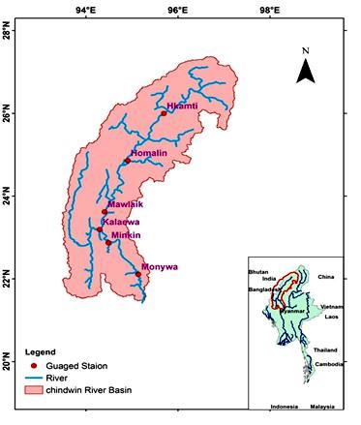

Fig.1 Location Map of Study Area

III. DATA COLLECTION

For the Chindwin river basin, a digital elevation model (DEM) is derived from Shuttle Radar Topography Mission (SRTM) 30m Digital Elevation Model with 30m resolution (http://earthexplorer.usgs.gov/). Daily rainfall data of six rain gauge stations (Hkamti, Homalin, Kalaewa, Mawlaik, Minkin and Monywa) are collected from the Department of Meteorology and Hydrology (DMH) in Myanmar for the period of 1981-2015. Discharge data of daily interval, monthly maximum and minimum temperature data of five stations, not including Minkin station, are collected for the year of 1981-2015 from the DMH. Twelve Global Climate Models (CanESM2, CCSM4, CMCC-CMS, GFDL-CM3,GFDL-ESM2G, GFDL-ESM2M, HadGEM2-AO, INM-CM4, MIROC-ESM, MIROC-ESMCHEM, MPI-ESM-LR and MPI-ESM-MR) are collected from Earth System Grid Federation (ESGF) (http://esg-dn1.nsc.liu.se) which is an online database source according to the latitude and longitude of the rainfall stations.

IV. METHODOLOGY

## Climate Model Downscaling

General circulation models and regional climate models are the important tools to project the expected future scenarios of climatic parameters. But the spatial resolutions of GCMs are too coarse for basin scale hydrologic modeling. Therefore, it is necessary to do downscaling the climatic variables. Linear scaling method (Teutschbein & Seibert, 2012) for temperature and precipitation are utilized for downscaling of the climate variables. For the linear scaling of temperature, firstly, changes in the monthly GCM data and also precipitation changes in the daily GCM data between a base period (1981-2005) and future period were calculated for each month and for each daily time. Precipitation is typically corrected with a multiplier and temperature with an additive term on a monthly basis in Eq. (1) and Eq. (2).

Pcor,*m,d* = Praw,*m,d*.[{μ(Pobs,*m*)}/{μ(Praw,*m*)}] (1)

Tcor,*m,d* = Traw,*m,d* + μ(Tobs,*m*) - μ(Traw,*m*) (2)

Where Pcor,*m,d* and Tcor*,m,d*are corrected precipitation and temperature on the *d*th day of *m*th month and Praw,*m,d* and Traw*,m,d*are the raw precipitation and temperature on the *d*th day of *m*th month. μ (.) represents the expectation operator (for example, μ(Tobs*,m*) represents the mean value of observed temperature at given month *m*)[7].

*B*. *Overview of HEC-HMS and Hydrologic Model Set Up*

Runoff of the basin was simulated using the Hydrologic Engineering Center-Hydrologic Modeling System (HEC-HMS), version 4.2.1, developed by the United States Army Crops of Engineers. It is able to reproduce runoff on a daily basis with high efficiency, and has been used in various sizes of catchments all over the world. The advantages of using HEC-HMS are that it draws on more than 30 years of experience in hydrologic simulation. This model adopts a concept of semi-distributed modeling by using sub-catchments and channel routing components. These sub-catchments are routed as streamflow at channel or river course. Rainfall-runoff simulation using HMS consisted of modeling four basic components of the hydrologic cycle. The basic components of the HEC-HMS are the basin model, meteorological model, control specification, and time-series data [8]. The physical representation of watershed such as sub-basin, stream network, reaches and outlet point are developed in the basin model. These characteristics are created using HEC-GeoHMS 10.2 that works with ArcView GIS 10.2. The user can select a variety of methods in loss, direct runoff, base flow and channel flow routing methods. As this hydrologic model is needed to run for long period, the initial and constant loss method is selected. In this method the loss is as continuous changes in soil moisture content. Snyder unit hydrograph method is selected as transform model and exponential recession method is selected to calculate the base flow of watershed. Muskingum method was used as channel flow routing to transfer flow in the reaches. The meteorological model is developed with average of gauge station rainfall in each junction. Control specification such as start date and time, end date and time, and time interval for each run are also set up in the model.

V. RESULTS AND DISCUSSION

## Climate Trends

In this study, twelve GCMs (CanESM2, CCSM4, CMCC-CMS, GFDL-CM3, GFDL-ESM2G, GFDL-ESM2M, HadGEM2-AO, INM-CM4, MIROC-ESM, MIROC-ESMCHEM, MPI-ESM-LR and MPI-ESM-MR) were analyzed and it was noticed that INM-CM4 GCM is the best among tested GCMs. So, this INM_CM4 model was applied for predicting future rainfall. Precipitation and temperature are the key drivers for the hydrological regime of rivers and climate change has its main impacts through changes in these two variables. Projected changes in the average annual precipitation are presented in TABLE I for all climate projections and three time periods, 2030s (2020-2046), 2060s (2047-2073) and 2090s (2074-2100). It is observed that the climate model projection indicate decreasing trends with the range of 12 to 13% for only one Kalaewa station in Rcp4.5 scenario and all stations are increasing percentage value in precipitation under two emission scenarios Rcp4.5 and Rcp8.5. In case of temperature, the new temperature change projections for Chindwin river basin (see TABLE II and TABLE III) reveal 1.4°C to 1.7°C increase average minimum temperature and about 0.9°C increase of maximum temperature by the end of 2090s under representative concentration pathways Rcp4.5. Under high emission scenario (Rcp8.5), the average minimum and maximum temperature will increase by 2.8°C to 3.0°C and 2.5°C to 2.8°C respectively.

1. AVERAGE ANNUAL RAINFALL PROJECTIONS (%) UNDER RCP4.5 and RCP8.5 SCENARIOS

|  |  |  |  |  |  |  |
| --- | --- | --- | --- | --- | --- | --- |
| **Station** | **Average Annual Rainfall under Rcp4.5 (%)** | | | **Average Annual Rainfall under Rcp8.5 (%)** | | |
| ***2030s*** | ***2060s*** | ***2090s*** | ***2030s*** | ***2060s*** | ***2090s*** |
| Hkamti | 17 | 12 | 12 | 15 | 13 | 12 |
| Homalin | 12 | 7 | 8 | 10 | 8 | 6 |
| Kalaewa | 34 | -12 | -13 | 43 | 55 | 76 |
| Mawlaik | 68 | 81 | 107 | 79 | 93 | 109 |
| Minkin | 37 | 50 | 64 | 47 | 59 | 80 |
| Monywa | 43 | 55 | 72 | 51 | 63 | 87 |

1. AVERAGE ANNUAL MAXIMUM AND MINIMUM TEMPERATURE CHANGE PROJECTIONS (°C) UNDER RCP4.5

|  |  |  |  |  |  |  |
| --- | --- | --- | --- | --- | --- | --- |
| **Station** | **Average Annual Maximum Temperature Increases**  **(°C)** | | | **Average Annual Minimum Temperature Increases**  **(°C)** | | |
| ***2030s*** | ***2060s*** | ***2090s*** | ***2030s*** | ***2060s*** | ***2090s*** |
| Hkamti | 0.4 | 1.0 | 0.9 | 0.3 | 0.6 | 1.4 |
| Homalin | 0.2 | 1.0 | 0.9 | 0.3 | 0.6 | 1.4 |
| Kalaewa | 0.4 | 0.7 | 0.9 | 0.6 | 1.1 | 1.7 |
| Mawlaik | 0.4 | 0.9 | 0.9 | 0.4 | 0.9 | 1.6 |
| Monywa | 0.4 | 0.7 | 0.9 | 0.6 | 1.1 | 1.7 |

1. AVERAGE ANNUAL MAXIMUM AND MINIMUM TEMPERATURE CHANGE PROJECTIONS (°C) UNDER RCP8.5

|  |  |  |  |  |  |  |
| --- | --- | --- | --- | --- | --- | --- |
| **Station** | **Average Annual Maximum Temperature Increases**  **(°C)** | | | **Average Annual Minimum Temperature Increases**  **(°C)** | | |
| ***2030s*** | ***2060s*** | ***2090s*** | ***2030s*** | ***2060s*** | ***2090s*** |
| Hkamti | 0.6 | 1.6 | 2.8 | 0.4 | 1.5 | 2.8 |
| Homalin | 0.6 | 1.6 | 2.8 | 0.4 | 1.5 | 2.8 |
| Kalaewa | 0.6 | 1.4 | 2.5 | 0.8 | 1.9 | 3.0 |
| Mawlaik | 0.6 | 1.6 | 2.7 | 0.6 | 1.7 | 2.9 |
| Monywa | 0.6 | 1.4 | 2.5 | 0.8 | 1.9 | 3.0 |

## HEC-HMS Model Parameters Calibration and Validation

Calibration of the model is an important step in which the parameters are adjusted to get a good agreement between observed discharge and simulated discharge for a particular station. The calibration procedure involves a combination of both manual and automated calibration. The manual calibration proceeds the automotive optimization to ensure a physically meaningful set of initial parameters. Model validation is the process of testing the model ability to simulate observed data, other than those used for the calibration, within acceptable accuracy. During this process, calibrated model parameter values are kept constant. The calibration and validation periods do not overlap and separate with each other [7]. The hydrologic model is calibrated for Monywa (outlet) station. The period of 2006-2011 is used for model calibration whereas the period of 2012-2015 is used for validation. Observed and simulated hydrographs for the years of 2006-2011 and 2012-2015 are shown in Figure 2 and Figure 3. Coefficient of determination (R2) and the Nash-Sutcliffe efficiency (ENS) are used to check the model performance in simulating the hydrologic process. The values of ENS for calibration and validation are found as 0.77 and 0.81. For calibration and validation, the values of R2 are 0.89 and 0.87 which show that the calibration and validation are quite satisfactory.

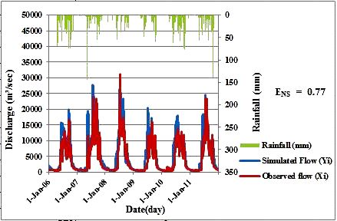

Fig.2 Calibration graph at Monywa (Outlet) station of 2006-2011

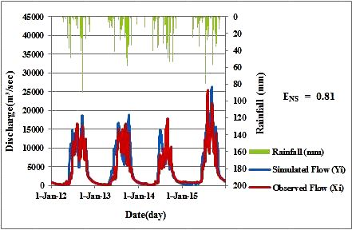

Fig.3 Validation graph at Monywa (Outlet) station of 2012-2015

## Climate Change Impacts on Streamflow

The impact of climate change on streamflow is analyzed. Firstly, calibrated hydrologic model is run for future scenarios and the percentage change in average annual discharge for each scenario run relative to base period (1981-2005) is also projected for two emission scenarios and three time windows, 2030s, 2060s and 2090s. The annual discharge change ranges from a minimum 12% to maximum 39% respectively depending upon time period and climate model. The average annual flow will increase 20% to 24% for RCP4.5 scenario and considering high emission scenario (RCP8.5), the average annual discharge will also increase a minimum 23% to maximum 28% respectively. Therefore, in case of INM_CM4, the long-term average annual discharge is forecasted to increase for all time periods. These results are described in Figure 4 and Figure 5.

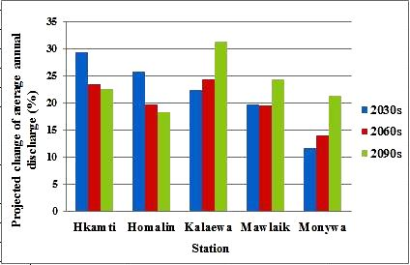

Fig.4 Projected changes of annual discharge in 2030s, 2060s and 2090s relative to the base period (1981-2005) under RCP4.5 scenario

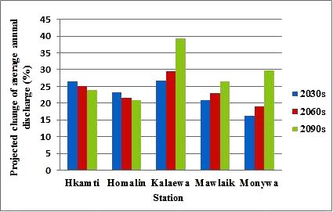

Fig.5 Projected changes of annual discharge in 2030s, 2060s and 2090s relative to the base period (1981-2005) under RCP8.5 scenario

VI. CONCLUSION

This study presents the analyses of impacts on streamflow simulation due to the impact of climate change. Firstly, twelve GCMs (CanESM2, CCSM4, CMCC-CMS, GFDL-CM3,GFDL-ESM2G, GFDL-ESM2M, HadGEM2-AO, INM-CM4, MIROC-ESM, MIROC-ESMCHEM, MPI-ESM-LR and MPI-ESM-MR) were analyzed and bias correction was done. Next, INM-CM4 GCM was chosen based on statistical criteria. Then, future rainfalls were predicted. HEC-HMS model is used for runoff simulation. Model parameters are calibrated, validated and computed climate change scenario for the year of three future periods 2030s, 2060s and 2090s. The model performance obtained by Nash-Sutcliffe Efficiency (ENS) and coefficient of determination (R2) are greater than 0.75 for both model calibration and validation. The results show that the expected increase in average annual discharge will be between 18% to 31% and 21% to 39% respectively by the end of 2100 under two emission scenarios Rcp4.5 and Rcp8.5. The maximum discharge will occur in 2090s in Kalaewa station for both two scenarios. This is clearly that the streamflow projection under INM_CM4 shows dramatically increasing trends in the future period. This case study may be helpful to predict streamflow changes in future period for Chindwin river basin in Myanmar. Since increasing discharges at respective Chindwin river basin stations are expected to increase in coming decades up till 2100, short term and longer term master plan for flood control and agricultural practices to meet the future climate change scenario should be formulated in advance before severe disaster trike in future.

ACKNOWLEDGMENTS

The author would like to express her deepest thanks and gratitude to Dr. Nyan Myint Kyaw, Professor and Head of the Department of Civil Engineering of the Yangon Technological University. The author’s special thanks go to her supervisor Dr. Win Win Zin, Professor of the Department of Civil Engineering of the Yangon Technological University, for her invaluable advice and suggestion throughout the study. The author would like to express her thanks to her co-supervisor Dr. Zin Mar Lar Tin San, for her valuable comments and guidance during this study. Finally, her special thanks, go to all who help her with necessary assistance for this study.

REFERENCES

1. Md. Mostafa Ali, Afiya Narzis and Shammi Haque, “Impacts of Climate Changes on Peak Flow of Upper Meghna River Basin,” Journal of PU, Part:B, vol.3, No:2, 2016, pp. 54-63.
2. Stocker, T.F., Qin D., Plattner, G.K., Tignor, M., Allen, J. Boschung, S.K., Nauels A., Xia Y., Bex V., and Midgley, P.M.2013, “The Physical Science Basis Contribution of Working Group I to the Fifth Assessment Report of the Intergovernmental Panel on Climate Change,” Cambridge University, Cambridge, United Kingdom and New York, 2013.
3. Radley Horton, Manishka De Mel, Danielle Peters, Corey Lesk, Ryan Bartlett, Hanna Helsingen, Daniel Bader, Pasquale Capizzi, Shaun Martin and Cynthia Rosenzweig, “Accessing Climate Risk in Myanmar,” New York, NY, USA: Center for Climate Systems Research at Columbia University, WWF-US and WWF-Myanmar, 2017.
4. Kimhuy Sok and Chantha Oeurng, “ Application of HEC-HMS Model to Access Streamflow and Water Resources Availability in Stung Sangker Catchment of Mekong’Tonle Sap Lake Basin in Cambodia,” Department of Rural Engineering, Institute of Technology of Cambodia, Russian Federation Boulevard, P.O. Box 86 Phnom Penh, Cambodia, 2016.
5. Hec, 2008, HEC-HMS, User’s Manual Version 3.3. Hydrologic Engineering Center California.
6. Kyu Kyu Thin, “Estimation of Runoff Potential in Chindwin River Basin Using Remote Sensing and GIS,” M.E Thesis, Yangon Technological University, 2012.
7. Min Khaing, “Assessing Climate Change Impacts on Hydropower Generation in the Myitnge River Basin, Myanmar.”
8. Shelly Win, “Development of Flood Inundation Map for the Bago River,” M.E Thesis, Yangon Technological University, 2012.