## MS.KHIN KYI KYI KHINE

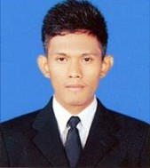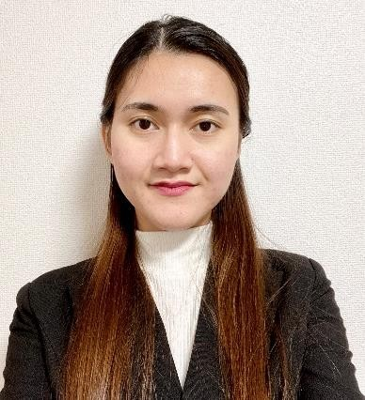

### Address : 700-0816, 1-2-1, Tondacho, Kita-ku, Okayama City, Okayama Prefecture Alpha Tomitacho 602, Japan.

**Contact Number : +819081717896**

**Email Address :** [**khinkyikyikhine3991@gmail.com**](mailto:khinkyikyikhine3991@gmail.com)

**CAREER OBJECTIVE**

To become a complete web developer fully equipped with coding knowledge and skills, and to seek for further career advancement through learning, sharing experiences and knowledge in the new working environment by contributing my best of abilities, talents and strengths

**PERSONAL PROFILE**

## Full Name : Khin Kyi Kyi Khine Father’s Name : U Khin Maung Win Date Of Birth : 31-July-1993 Religion : Buddhist

**Nationality : Myanmar**

**Race : Burmese**

**Gender : Female**

**Blood Group : A Marital Status : Single**

**NRC No. : 12/OuKaMa(Ng) 202480**

**Passport No. : ME180847 Expected Salary : Negotiable**

**EDUCATIONAL BACKGROUND**

* **Bachelor of Science in Computer Science (2013), University of Computer Studies Yangon in Myanmar.**
* **Bachelor of Science in Computer Science (Hons:) (2014), University of Computer Studies Yangon in Myanmar.**

**WORKING EXPERIENCE (1)**

|  |  |
| --- | --- |
| **Company Name** | **Itami Art Co., Ltd (Myanmar Branch)** |
| **Position** | **Office Staff** |
| **Duration** | **February 2016 to October 2019** |
| **Department** | **Data Processing and Design Production (Myanmar Team)** |

**Duties & Responsibilities**

* Attend daily meetings with Japan manager and members.
* Shares data which send from japan on box app within member and start job.
* In data processing, already created original banners and curtains designs check using adobe illustrator, process

and report.

* If data processing occurred errors, return data to the japan office.
* In design production, original banners, and curtains of japan customer’s request must be checked and if data is

OK, its will be designed using adobe illustrator and photoshop.

* Testing, checking & commissioning of data processing system installations and preparing reports.
* Review and check members designs, work done and quality.
* Manage all members to ensure that the work carried out according to specification.
* Taking care of responsibility and quick learning.
* Decision and feedback according design knowledge.
* Solving japanese customer request problems with zoom meeting.

**WORKING EXPERIENCE (2)**

|  |  |
| --- | --- |
| **Company Name** | **Itami Art Co., Ltd (Head Office In Japan)** |
| **Position** | **HTML Coder, Web Design** |
| **Duration** | **October 2019 to Present** |
| **Department** | **Marketing Division SE Group Coding Team** |

## Duties & Responsibilities

* Assist team leader on overall coding daily tasks.
* Advice better than customer service for marketing department of weekly meeting.
* Attend daily meetings with web design and coding team member for daily tasks.
* Discuss client customer for web site creation jobs.
* Coding lecture for team member in branch office myanmar, check and review code web page of team member.
* Shares data which send from our company staging environment within member and start job.
* Manage all members to ensure that the work carried out according to specification.
* Testing, checking & commissioning of main office task to send myanmar team and preparing reports.
* Taking care of responsibility and quick learning.
* Solving coding error deal with coding knowledge.
* Decision and feedback according to coding knowledge.

**Job History Summary**

After graduating from the University of Computer Studies, Yangon, specializing in computer science, I joined Itami Art Co., Ltd. (Myanmar branch office). An advertising company that sells promotional materials such as original banners and curtains from the Internet. For about three years after joining the company, I used Adobe Illustrator and Photoshop to design and process the banners requested by customers. From the 4th year of joining the company, I was transferred to the head office in Okayama and assigned to the WEB design group and coding team of the marketing section. Since I was transferred, the workflow and contents have changed and I tried to create a website. I considered the work of responding to Responsive sites such as creating sales pages and official websites for our websites, coding LP pages, and using WordPress from the customer's perspective, and responded to make the site easy to see and use. It has been evaluated as being able to respond to work with a sense of speed. In addition, I give a coding lecture to the staff in the Myanmar branch office and perform work distribution and coding checks.

**About Myself**

My strength is a sense of responsibility. I can work with a strong sense of responsibility for my role.

I have some knowledge about coding before joining the company, but after joining the company, by doing work that has nothing to do with coding, I can challenge myself and get used to the new environment so that I can know what I do not know.

For about three years after joining the company, I worked at a branch office in Myanmar, using Adobe Illustrator and Photoshop to design and process banner flags. From the 4th year of joining the company, I was transferred to the head office in Okayama and joined the WEB design group coding team of the marketing section.

The workflow and contents were completely different, and the work environment changed, but I was able to overcome any difficulties due to my responsibility to do everything to the end, no matter what my strength was. It was a great opportunity for me, who has coding knowledge and wants to be a web developer. Regarding work, I studied by dealing with detailed correction tasks and tried to create a site. From there, I improved my skills and was challenged to create a Responsive site, WordPress site, JavaScript, PHP modification, and expanded the range I can do.

**PROFESSIONAL QUALIFICATION**

* Japanese Language Proficiency Test (N2)
* English (intermediate level)

**SKILL**

* HTML, CSS
* Responsive Website creation (Media Queries/Materialize)
* WordPress
* JavaScript, jQuery
* PHP
* GitHub, GitLab
* Adobe
* Visual Studio, Dreamweaver
* 4Dbox Plans, Figma
* Microsoft office

**Capabilities**

* Strong confident my qualification and skills
* Work under pressure
* Manage on project
* Leadership skill
* Physically fit
* Time management
* Experience in problem solving skill

**Reason For Leaving**

* To get new challenge and update experiences.
* I am strongly interested in a new challenge and an opportunity to use my technical skills and experience

in a different capacity than I have in the past.

* I here declare that all the above information furnished is true and complete to the best of my knowledge.

Yours Sincerely,

# Khin Kyi Kyi Khine (Ms.)