# **FCT 10011**

# **Fundamental of Web Technology**

# **Luxuria**

# **Group Name:**

# Quinoa

# **Group Members:**

# Chan Kwang Yung (101215067)

# Joey Tan Tzy Wei (101214653)

# Hendro Lee (101214954)

# Shane Hanson (101214420)

# 

# **Client overview**

The team has been recently approached by a company called Luxuria Inc. Luxuria inc. is a famous fashion company that was found in October 16, 2013, located in Sarawak, Malaysia. It specialises in advertising and providing information of products from major fashion brands such as Gucci, Prada and Louis Vuitton. It also showcases clothing from clothing-retailing companies such as H&M, Uniqlo, and ZARA. Any local who are interested in the latest fashion will know the name Luxuria as their trusted fashion company to update themselves on the latest fashion fits. The company is mostly known for its fashion magazines due to the high quality pictures it displays and detailed information on each fashion fit. The company are so devoted into reporting fashion that the CEO would visit major fashion weeks and runway shows to personally interview the designers. Its recently published issue has gotten so much attention that the magazine was even distributed internationally and became the talk of the week.

Though still being a very young company, it has garnered enough resources to further their business potentials. The current end goal of the company is to be able to host an award show to gather all the biggest fashion brands around the world and showcase their works on live television. But before that, the next step that they should take is to expand its markets into international grounds and the best way to do so is by creating a website. Since Luxuria is a fashion company, they came to the team for assistance in developing a website that will fulfill the company’s purpose which is advertising and providing information.

After careful consideration, the team has came to the conclusion to create a website that will fulfill a set of criteria. Firstly, the design and structure of the website should look clean and should include elements such as a consistent visual identity and user-friendliness to enable web-usability. Next, the website should give the users a way to provide feedback so that the company can listen to the voices of the people to be able to further enhance themselves to satisfy the users. Thirdly, the website is to have symmetrical and asymmetrical elements to maintain user interest while maintaining user-friendliness.

# **Web Research**

The team has decided to use three websites from three different companies which are Gucci, Rolex and H&M and as research and referencing materials in order to develop a shopping website for Luxuria Inc. All these three websites are crucial for the team to achieve the desired outcome for the company as the said websites all contains significant elements that will fulfill the requirements of the company as well as attracting the eyes of its buyers.

**Gucci**

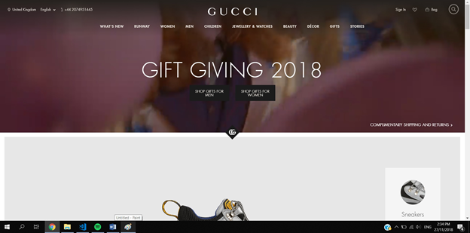

URL: <https://www.gucci.com/uk/en_gb/>

**Content**

Gucci uses mostly multimedia as its content which makes it quite visual oriented. Even with having a large amount of videos and photo elements, the website still maintained a clean look by having large white space in between different elements. The team plans to use the same method by having white space between different products and a close proximity to content related to said products.

**Style**

The style that Gucci is going for is a kind of vintage style look due to the multimedia elements containing some retro essences. The team wishes to follow this theme to develop the website due to how interesting and classic look it looks.

**Design**

The design of the webpages is quite simple and consistent throughout the website. It uses both asymmetrical and symmetrical balance between the elements in which will attract the users attention. Despite its vintage look, the typography is mostly of sans-serif fonts to make it look professional and tidy.

**Layout**

The layout is simple with the header and menu centered on top and the footer positioned at the bottom while the content fills up the rest of the space in the middle. The team wishes to follow this style of layout as the layout is well-structured and simple which will allow the user easy navigation throughout the website.

**Colour**

Gucci generally uses a grayscale colour scheme and have colourful multimedia elements to contrast with it. This inspired the team to use it as well so that the main content is more obvious to the user.

**Features**

One interesting feature that caught the attention of the team is the huge drop down menu. When the user hovers over the menu, the gradient of the menu will transition into a solid colour and a large slightly transparent drop down menu will appear. The team is inspired to have similar feature by having a slightly transparent drop down menu which is slightly transparent.

**Rolex**

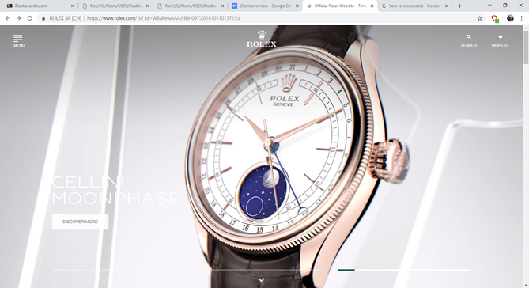

URL:<https://www.rolex.com/?ef_id=W8aRewAAAJHbH097:20181017020512:s>

**Content**

Rolex also uses mostly multimedia elements as it is to aid in advertising their products to the users. Texts are also used in the website but it is mostly just to provide basic information such as providing names and brief information about the product. The multimedia in this webpage is generally larger in size which generally overwhelms and attracts the users more. This inspires the team to use larger dimensions for the multimedia content as well.

**Style**

The style is generally a more professional-looking style. It emphasizes a lot on its products and in contrast, making the style less interesting. This is significant as it would not distract the user from the main content of the website.

**Design**

The design of the elements are arranged very neatly. Despite the tidiness, it uses mostly asymmetrical balance for the elements to keep the interest of the users.The typography of the website is of sans-serif fonts to show that it is more of a modern and professional website.

**Layout**

Rolex also used a simple layout where the header and menu is on the same block level with the logo being in the center and the menu being on the left side. Below the header and menu is the content which fills the whole page and followed by the footer to end the webpage.

**Color**

The colour scheme however is quite out of the ordinary. Rolex uses a monochromatic colour scheme where the colours consist of white as the major colour a tint of green on some elements such as the buttons to contrast the white. The reason they use this colour scheme can also be due to the fact that it is their company’s main colour theme.

**Features**

An intriguing feature that is present in Rolex is the use of the slideshow as the main attention-getter when the user enters the homepage. The slideshow consists of both video and photo media where the video will play automatically. It also provides left or right buttons to give the users the option to skip or replay slides as they wish. The team wishes to have a similar feature in the homepage as well. This can effectively catch the attention of the user once they enter the page.

**H&M**

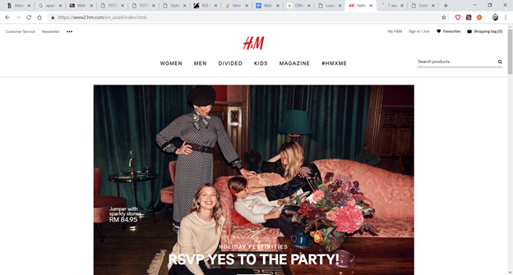

**URL:** <https://www2.hm.com/en_asia4/index.html>

**Content**

Much like the other websites mentioned, H&M also uses pictures to portray their products. The pictures are used as links to navigate through the websites. This makes it easier for customer to navigate and search for specific products. The inspire the team to use more images as navigation to other webpages.

**Style**

H&M seems like it is going for a simplistic style with minimum features and special effects. This can be advantageous to the website as the simple style makes it easier for user to see the content and navigate through the website easily.

**Design**

The design was consistent throughout the website. As it is very simplistic, everything is arranged very neatly with the use of asymmetrical and symmetrical balance between the elements. Many of the images are arranged in an abstract manner with images of different dimensions but forms one shape when it is united together. The typography is of sans-serif font throughout the website as well.

**Layout**

The website uses a slightly different layout compared to other websites. The header, menu and footer is much like Gucci’s layout but the difference is in the content. The content is centered in the middle with large margins filling up left and right of the content.This creates a more tidy look towards the webpages. This layout stands out as it differentiates from the above two websites that has the content filling in all the gap. The team wishes to use this layout on one of the webpages as it as interesting way of arranging the images to make it look neat while attracting the user.

**Color**

The colour scheme of this website is very simple as well. It mostly grayscale colour. H&M uses black mostly on the footer of the website and the rest of the element uses white with black colored fonts. Using this grayscale colour scheme as the background gives the colourful images more contrast and focus on the main content.

# **Website Development and Planning Process**

# **Step 1: Define the purpose**

The website’s primary goal is to advertise and provide information to the users of products from major fashion companies. The secondary goal of the website is to provide convenience to the users to access and learn new information on on the latest clothing trends. Another secondary goal is to introduce the company to newer users and attracting new customers into the website which is crucial for the growth of the company. In order to achieve these goals, the team decided to create develop an elegant and vintage looking website that provides information on fashion clothings and also the company to promote the company and to fulfill the company’s primary goal. The website should be published as it fulfills all the company’s requirements and also promotes the company’s name to the world.

## **Step 2: Identify the Target Audience**

Based on the company’s main purpose, the targeted audience would be on people who are interested in fashion with middle to high-class income disregarding of gender or age. Since the audience would mainly of people who are invested in art and wear, this means that a portion of them may not be experienced web users and may find it difficult to understand and navigate through a complex interface. Hence, web-usability is one of the top priority for the team. The audience should expect to gain information on fashion products from major fashion companies and the information of Luxuria Inc as well.

## **Step 3: Plan the Content**

**Home page**

On the homepage, the users will be initially greeted by a large overwhelming slideshow to pull in the attention of the user. The slideshow acts as a navigation method for the user to enter various web pages in the website. Apart from that, a navigation bar on top of the slideshow also helps to provide ease of navigation as well. Scrolling down from the slideshow, a summary about the background of the company is there to introduce the company. After that, a table telling the user about the available products inside the company also provides the user information of the available content in the website.

**Secondary Pages**

The secondary pages contain a consistent layout, name, logo, banner, typography, colour scheme with the home page. This maintains a sense of unity and visual consistency to avoid confusion from the user. The only difference throughout the web pages is the way the contents are arranged and the information of the contents. Each pages contains value added content which are pictures.

## **Step 4: Plan the structure**

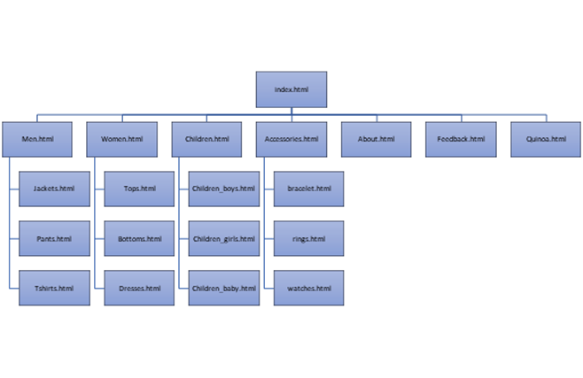

The structure of the website is of hierarchical structure. The web pages are categorized under different categories and followed by subcategories. This is due to the website containing complex information and thus needs to be organized in categories to ease the process of navigation for the users.

## **Step 5: Plan the design**

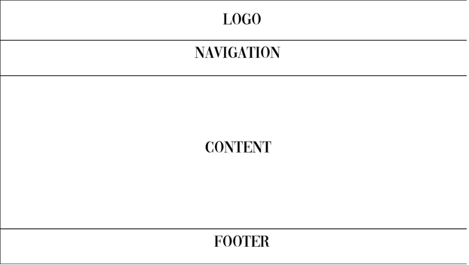

All pages have a consistent layout to and similar visual elements to avoid confusion and to maintain visual identity. The elements that are consistent includes logo, navigation bar and footer where content varies from different web pages. The colour the team uses is rather dull which mostly consist of grayscale colours. The colourful images provides visual contrast to enhance readability and to let the users focus on the main content. The team also uses one css file called style.css to style all the webpages as it eases the process of formatting and styling the webpages.

## **Step 6: Plan the navigation**

The navigation of the website are of user-based and user-controlled navigation. The linking relationship between pages are based on the users where the users can access and navigate through the website through various ways such as through the navigation bars, the home page, site maps in the footer element. The team also used both text rollover and image links to ease navigation to external and internal links. A drop down menu also offers the user the option to navigate through the website. The drop down menu is designed to be concise, clear, selective, context, interactive, consistent.

# **Web Design Element**

**Colour Scheme**

The colour scheme of the website is based on a monochromatic grayscale colour scheme. The team used neutral colours such as black, white, and grey to highlight and differentiate between different elements. The grayscale colours are used instead of any colours because these colours can complement any other colours. The dull colour scheme in turns emphasizes the contents due to contrasting colours. The web pages consist of the same colour scheme to maintain consistency and the simplicity of the website.

**Layout and Navigation**

The team website is of a fluid layout where it can be resized accordingly to the window size. The page layout is very simple and straightforward as shown in the wire frame previously. The team mostly used percentages and em as the unit of measurement to allow the layout to change according to the window size. Navigation is mainly made using list tags which are in the footer element and drop down menu.

**Typography and Graphics**

Since the website is of a vintage or classic style, the team decided to implement a lot of serif fonts such as Times New Roman to complement the overall style. The navigation bar and footer element however is of sans-serif font to show professionalism and tidiness. Graphics such as images are used as well. The images are generally colourful to contrast with the grayscale background. All images used are relevant and crucial to the website which are comprised of jpeg and png files.

**Multimedia and interactivity**

The team uses multiple multimedia elements such as animations and images. The team decided to use some animations and transitions to gain the interest of the user when using the website. One of the animation is when the user hover over the image of the products. The image will then be zoomed and text will appear. A significant multimedia element is the slideshow in the index page. The slideshow is a bunch of slides that eases the process of navigating through the website for the user. The reason behind why the team is did not include left or right buttons in the slideshow is due to the fast speed of the each transition of the slides and the straightforward content in each slide.

**Final design**

**Balance**

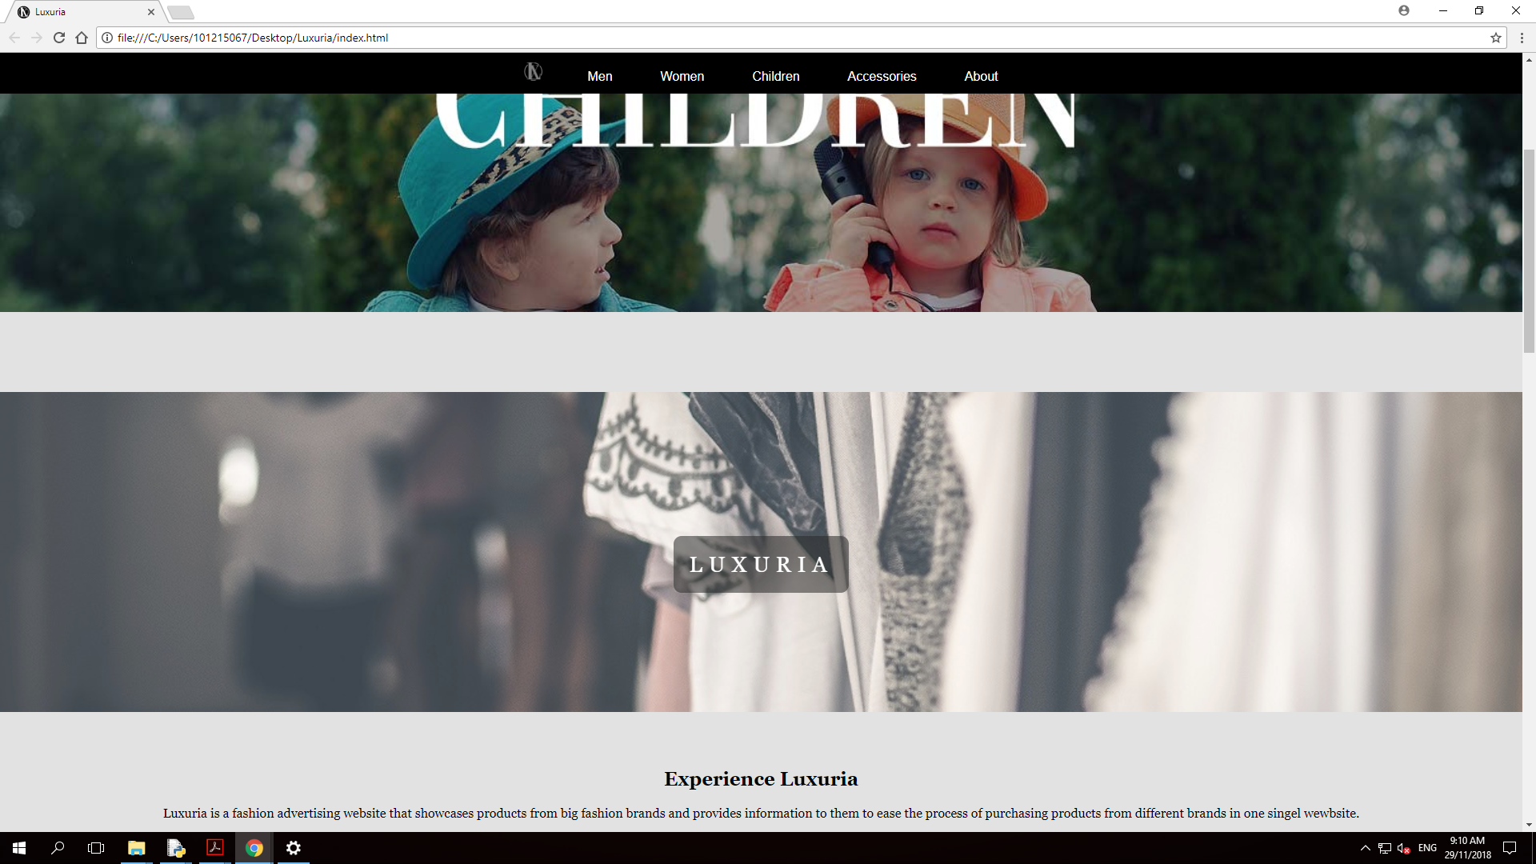

The website uses both symmetrical and asymmetrical balance for its website. The index page is of asymmetrical balance for the purpose of making it look interesting and dynamic to attract more the users once they enter the website. However, the secondary web pages consists of both asymmetrical and symmetrical balance.

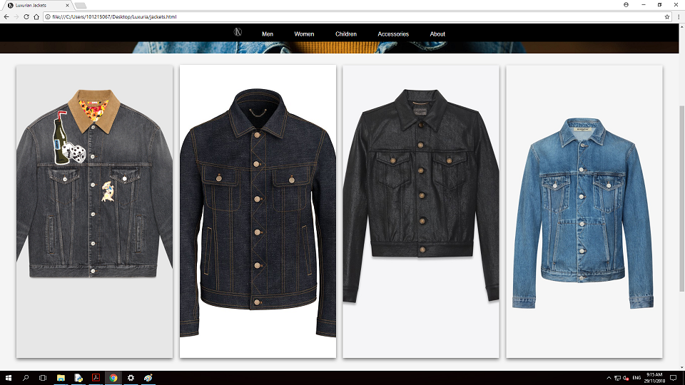

For example, the product catalogue pages are of symmetrical balance where the products are arranged neatly while asymmetrical balance is present in the category pages.

**Proximity**

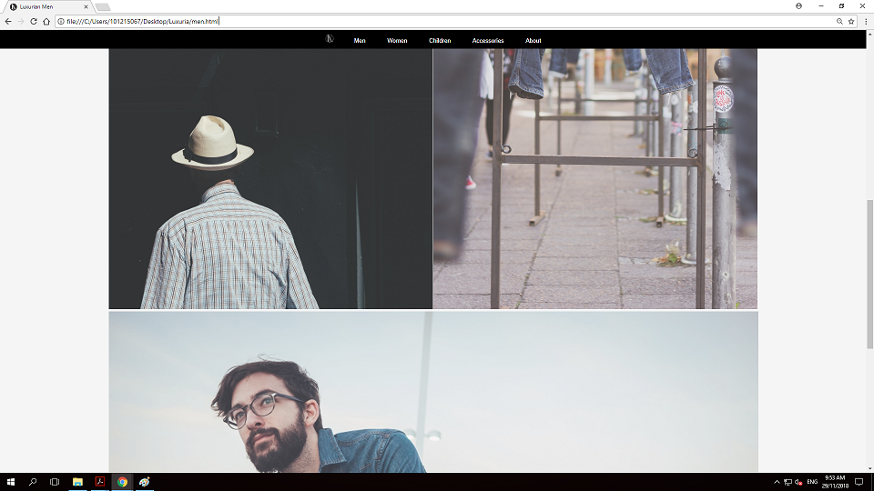

The website uses proximity to make the website more neat and organise. For example, the index pages uses white space to separate the slideshow with the banner. Another great example is the white space between the images in the category pages. All the images in the page are positioned very close to each other to show that they are connected and the white space around the images eliminates the clutter and makes the content more tidy.

**Contrast and focus**

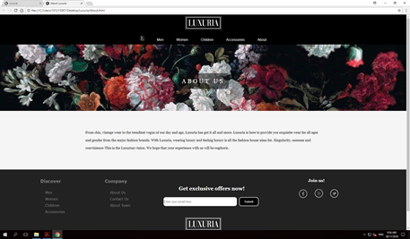

As stated before, the background colour scheme of the website is of grayscale colours. Colourful images are used to contrast the the background colours so that the images are emphasized and create a focal point for the users.

**Unity and visual identity**

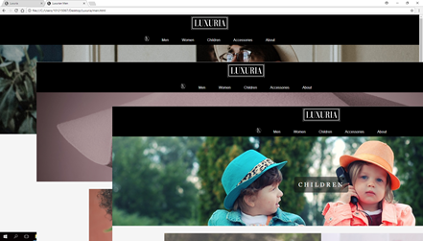

All the webpages have a consistent page layout and where the logo is positioned at the top and centered along with the navigation bar. All the footer elements are also the same where it consists of a site map, a text box for the users to subscribe to the newsletter followed by social media external links. Most of the web pages also consist of a large banners, telling the user what the web page is about. These repeating elements provides a sense of oneness and maintains a consistent visual identity throughout the website.

# Member contributions

**Chan Kwang Yung**

Chan Kwang Yung is the leader and mastermind of the team.

* He designed the foundation HTML and CSS for secondary web pages which are category pages, product catalogue pages.
* He led and and distributed the task in the team
* He is in charge of making the women section of the website and the navigation bar.
* He also made the feedback page, about the company page and participated in the index developing page.
* He did most of the documentations for the report as well
* He created the large logo positioned on the central top of the website

**Hendro Lee**

Hendro is the vice leader and code maintainer of the team.

* He mostly contributed in compiling the files, debugging, arranging the files neatly
* He also made the icon on the web page tab along with Shane Hanson
* He is in charge of the accessories section of the website and footer element
* He hosted the website

**Joey Tan Tzy Wei**

Joey is the support of the team. He helps every team member by contributing a little in each section.

* He made the group members’ introduction page
* He is also in charge of the children section of the website
* He is supportive in every parts of web pages made by the teammates
* He perfected the slideshow in the index page

**Shane Hanson**

Shane is the designer of the team. Many of the images that needs to be edited is done by him/

* He made the mini logo located in the navigation bar, he also edited the slides on the slideshow in the index page
* He is in charge of men section of the website
* He did the parallax scrolling feature