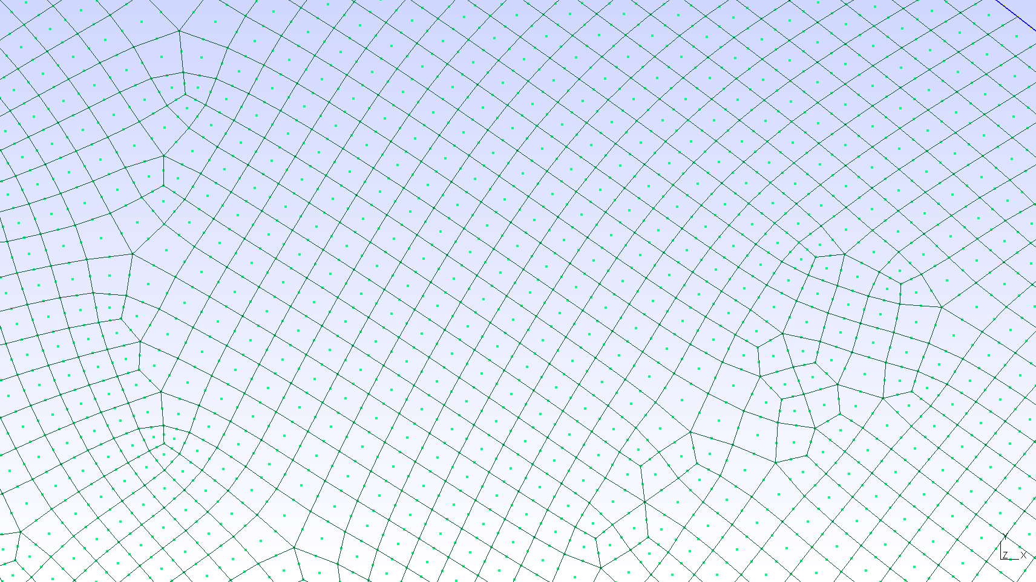
A GENERAL GUIDE ABOUT MESHING IN Gmsh

Khinil Sahu¹, Naresh Kumar Goud Lakku², Manasa Ranjan Behera²˒³
¹ Department of Civil Engineering, Indira Gandhi Institute of Technology, Sarang
² Department of Civil Engineering, Indian Institute of Technology Bombay
³ Department of Civil Engineering & Centre for Climate Studies, Indian Institute of Technology Bombay

What is Meshing?
Meshing is the process of dividing a complex geometry into many small, simple elements so that numerical methods such as the Finite Element Method (FEM), Finite Volume Method (FVM), or Computational Fluid Dynamics (CFD) can be used to solve engineering problems.
Think of it like this:
- Real structure → Continuous body
- FEM solver → Cannot solve the entire body at once
- Solution → Divide the body into thousands or millions of small pieces called elements
These elements together form a mesh.

Why is Meshing Needed?
Meshing converts a continuous mathematical problem into a finite number of equations that a computer can solve.
Without meshing:
- Stress cannot be computed.
- Displacement cannot be computed.
- Fluid flow cannot be computed.
- Tsunami propagation cannot be computed.

Types of Meshing
  - STRUCTURED AND UNSTRUCTURED
A structured mesh features perfectly ordered, repeating cells (like graph paper) with fixed connectivity, whereas an unstructured mesh uses irregular cell shapes (like triangles) arranged flexibly to easily fit complex geometries

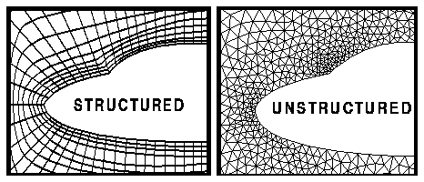
  - BASED ON ELEMENT TYPES 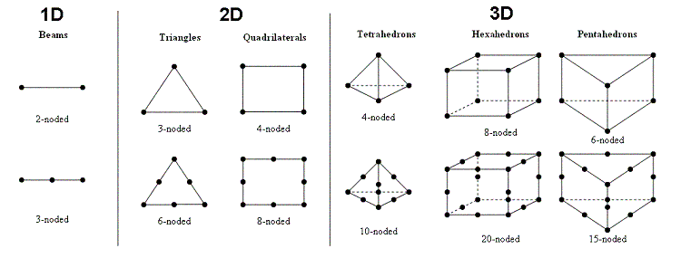

Meshing Algorithms
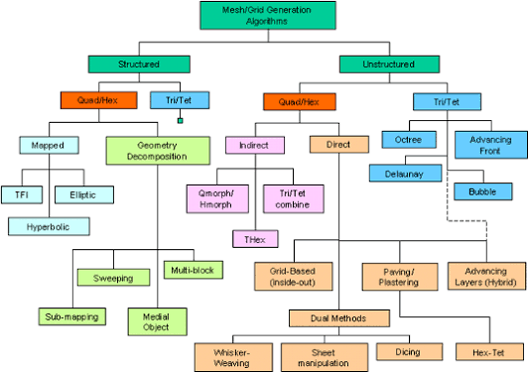
Gmsh provides several meshing algorithms for generating computational meshes.Here we have used an algorithm 8
Algorithm 6 (Frontal-Delaunay): Generates high-quality triangular meshes with smooth element distribution and is widely used for FEM and CFD applications.
Algorithm 8 (Frontal-Delaunay for Quads): Creates a triangular mesh and then recombines triangles into quadrilateral elements, producing quad-dominant meshes suitable for structural and ocean engineering analyses.
These algorithms provide reliable and high-quality meshes for numerical simulations.
Algorithm Number | Algorithm Name | Element Type | Description
1 | MeshAdapt | Triangles | Adaptive mesh refinement based on geometry.
2 | Automatic | Triangles | Gmsh automatically selects an appropriate algorithm.
3 | Initial Mesh Only | Triangles | Generates only the initial mesh.
5 | Delaunay | Triangles | Robust Delaunay triangulation for complex geometries.
6 | Frontal-Delaunay | Triangles | Produces high-quality triangular meshes; most commonly used.
7 | BAMG | Triangles | Anisotropic mesh generation with variable element sizes.
8 | Frontal-Delaunay for Quads | Quadrilateral-dominant | Generates triangles and recombines them into quadrilaterals.
9 | Packing of Parallelograms | Quadrilateral-dominant | Experimental algorithm for quadrilateral mesh generation.

TYPICAL WROKFLOW

How to Generate a Mesh
Users can begin by downloading the sample latitude–longitude boundary file provided in TXT or CSV format. The file can then be uploaded to the web-based conversion tool or processed through the Jupyter Notebook script to automatically generate a Gmsh geometry (.geo) file .After generating the geometry file, open it in Gmsh to visualize the computational domain. A two-dimensional mesh can then be generated by pressing Ctrl + 2 or selecting Mesh → 2D from the menu.
Users may inspect and refine the mesh if necessary before exporting it for numerical simulations. Hyperlinks to the sample input file is provided for reference.
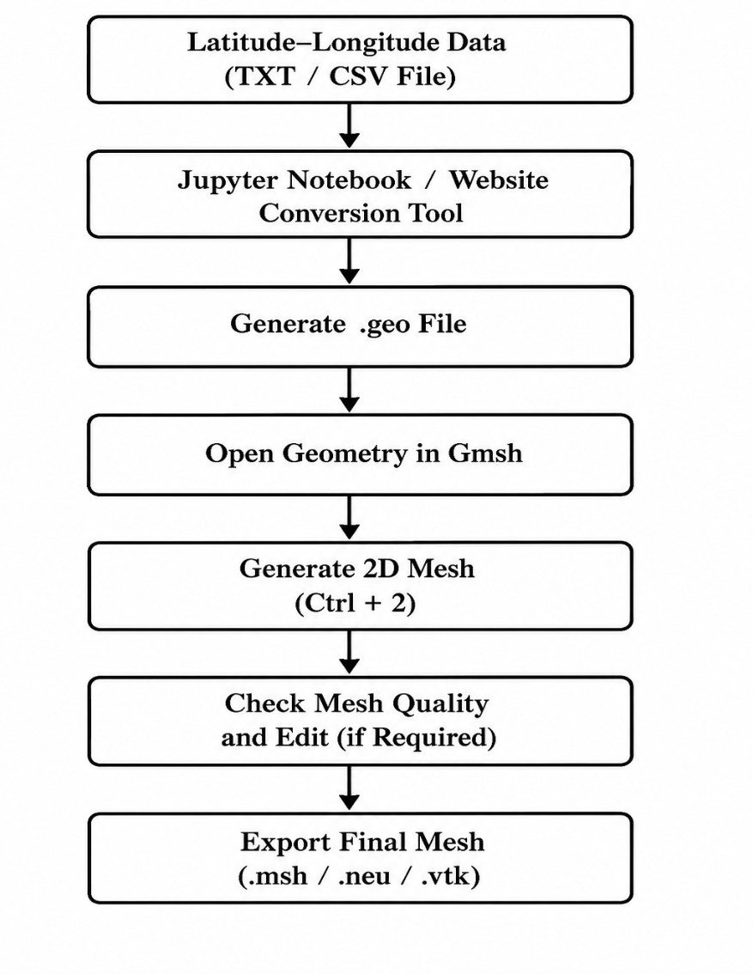
RESOURCES
1. Website for conversion - https://l8g429k4.mule.page/
2. jupyter notebook In Julia code - file.ipynb
3. Gmsh software - https://gmsh.info/
4. Gmsh tutorial book - https://gmsh.info/doc/texinfo/

