Assignment-1
Model-1
1. What is SDLC?
    - SDLC stands for Software Development Lifecycle.
    - It is a process that development teams use to design and build software.
    - The goal of SDLC is to create high-quality software that meets customer expectations.

    - Here are the typical phases in the SDLC

Planning | Identify the project requirements, scope, and objectives.
Analysis | Model and Specify the requirements- “What”.
Design | The process of creating something new, Whether it’s an object, system, or idea.
Implementation (Coding) | Construct a Solution in Software.
Testing | Validate the solution against the requirements.
Maintenance | The act of keeping something in good condition by making repairs and correcting problems.

2. What is software testing?
- Software testing is the process of evaluating a software’s quality, functionality, and performance to ensure it works as intended.
- Types of software testing
1. Unit testing
2. Integration testing
3. Regression testing
4. Smoke testing
5. System testing
6. End-to-End testing
7. Sanity testing
8. Acceptance testing

- Unit testing: Unit tests are typically written by developers as they write the code for a given unit.
- Integration testing: Integration testing is a software testing method in which individual units or components of a software application are combined and tested as a group.
- Regression testing: Regression testing is a software testing method in which previously developed and tested software is retested after it has been modified or changed.
- Smoke testing: Smoke testing is a software testing method that verifies a new build's basic functionality and stability.
- System testing: System testing is a process that evaluates a software product's functionality from the user's perspective.
- End-to-End testing: End-to-end testing is a software testing technique that verifies an application's functionality and performance from start to finish.
- Sanity testing: Sanity testing is a type of software testing that verifies that minor changes to a software application have not introduced new issues.
- Acceptance testing: Acceptance testing is a type of software testing that ensures a product is ready for use by meeting business requirements and user expectations.

3. What is agile methodology?
- Agile methodologies are iterative and incremental, which means it's known for breaking a project into smaller parts and adjusting to changing requirements.
1. They prioritize flexibility, collaboration, and customer satisfaction.

- Major companies like Facebook, Google, and Amazon use Agile because of its adaptability and customer-focused approach.

Life cycle of Agile Methodology

planning
Deployment
Req analysis
testing
designing
Agile Development Methodology
Implementation

- Requirement Gathering
    - The project team identifies and documents the needs and expectations of various stakeholders, including clients, users, and subject matter experts.
    - It involves defining the project’s scope, objectives, and requirements.
    - Establishing a budget and schedule.
    - Creating a project plan and allocating resources.
- Design

    - Developing a high-level system architecture.
    - Creating detailed specifications, which include data structures, algorithms, and interfaces.
    - Planning for the software’s user interface.

- Development (Coding)

Writing the actual code for the software. Conducting unit testing to verify the functionality of individual components.

- Testing

This phase involves several types of testing:

    - Integration Testing: Ensuring that different components work together.
    - System Testing: Testing the entire system as a whole.

- Deployment

    - Deploying the software to a production environment.
    - Make sure it works smoothly in the real world.
    - Providing training and support for end-users.

- Review (Maintenance)

    - Addressing and resolving any issues that may arise after deployment.
    - Releasing updates and patches to enhance the software and address problems.

4. What is SRS?
- A software requirements specification is a comprehensive description of the intended purpose and environment for software under development.
- How do you know when your SRS is ready for development? What makes it exceptional? That’s what we are going to cover in this article.
Software Requirement Specification
Specification
type
Safety
Reliability
Maintainability
Interface
Performance
Quality
Functional

Characteristics of exceptional SRS

There are certain things developers should strive to achieve in their SRS document to make it primed for a smooth development project. These can be broken up into three categories:
- Meaningful qualities
- Characteristics that meet goals
- Identifiable requirement smells

5. What is OOPS?
- Programming is like writing.
- If you can write a demonstration, you can make a program.
- So, programming is also easy.
- But, actually, programming is not so easy, because a real good program is not easily programmed. It needs the programmers’ lots of wisdom, lots of knowledge about programming and lots of experience.
- It is like writing, to be a good writer needs lots of experience and lots of knowledge about the world.
- Learning and practise is necessary.
- The Massachusetts Institute of Technology was the first institution to utilize terminology referring to “objects” in the sense that we use object-oriented programming today, in the late 1950s and early 1960s.
- It is a method for storing data and the operations required to process that data based on the mathematical field known as abstract data types.
- Programming could advance to a more abstract level thanks to OOP.

6. Write basic concepts of oops?
- Object oriented programming is a programming paradigm that use objects and classes to structure software. Here are the basic concepts of OOP;

- Class: The Word “class” has multiple meanings, including a group of people, a category, or a ranking.
    - A group of people who have a similar social or economic status.
- Object: An instance of class. It represents an entity with both attributes and methods.
- An “object” is anything to which a concept applies.
- This is the basic unit of object-oriented programming.

- Encapsulation: Encapsulation too bind a data and code into a single unit its call encapsulation.
- It also involves restricting access to certain components to protect the integrity of the data.

- Inheritance: The object of one class can acquire the property of object of other class it called and inheritance.
- The assets that a person leaves to their loved ones after they die.

- Polymorphism: Polymorphism means “having many forms”.
- It allows different object to respond to the same message in different ways, the response specific to the type of object.
- There are two types of polymorphism
- Compile time (method overloading)
- Run time (method overriding)

- Abstraction: Abstraction is the representation of the essential features of an object. These are ‘encapsulation’ into an abstract data type.
- Data abstraction refers to, providing only essential information to the outside word and hiding their background.

7. what is object?
- Object it is an instance of class.
- This is the basic unit of object-oriented programming.
- We can pass value difficult through the object.
- Objects communicate to other objects by sending messages.
- Messages are received by the methods of an object
- An object is like a black box.
- Object is derived from abstract data type
- Objects of a program interact by sending messages to each other.

The two parts of an object

Object = Data + Methods
Or
To say the same differently

- An object has the responsibility to know and the responsibility to do.

8. What is class?

Class is defined as group of data and method.

A class declaration defines new user defined data type that links code and data.

A class can be considered as the blueprint or definition or a temple for an object and describes the properties of and behaviour of that object, but without any existence.

For example, in the case of car or laptop, there will be a blueprint or design created first and then the actual car or laptop will be built based on that.

We do not actually but these blue prints but the actual objects.

The basic syntax for the class definition:

Class Class Name [extends Super Class Name]

{

[fileds declaration]

[methods declaration]

}

What is encapsulation?

Encapsulation is too binding a data and code into a single unit its call encapsulation.

Encapsulation is placing the data and the functions that work on that data in the same place.

Encapsulations in java is the process of wrapping up od data (properties) and behaviour (methods) of an object into single unit; and the unit here is a class.

Encapsulations in plain English means to enclose or be enclosed in or as if on a capsule. In java, a class is the capsule (or unit).

In java, everything is enclosed within a class or interface, unlike languages such as C and C++, where we can have global variables outside classes.

Encapsulation enables data hiding, hiding irrelevant information from the users of a class and exposing only the relevant details required by the user.

We can expose our operations hiding the details of what is needed to perform that operation.

Now modifications to the project internals are only controlled through these methods.

what is inheritance?

The object of one class can acquire the propriety of object of other class its call an inheritance.

One of the most useful aspects of object-oriented programming is code reusability. As the name suggests Inheritance is the process of forming a new class from an existing class that is from the existing class called as base class, new class is formed called as derived class.

This is a very important concept of object-oriented programming since this feature helps to reduce the code size.

How to Use Inheritance in Java?

The extends keyword is used for inheritance in java. Using the

extends keyword indicates you are derived from an existing class. In

other words, “extends” refers to increased functionality.

Syntax:

Class Derived Class extends Base Class

{

//methods and fields

}

Types of inheritance

Single Inheritance

Multilevel Inheritance

Hierarchical Inheritance

Multiple Inheritance

Hybrid Inheritance

Single Inheritance

In single inheritance, a sub-class is derived from only one super class. It inherits the properties and behaviour of a single-parent class.

Sometimes, it is also known as simple inheritance. In the below figure, ‘A’ is a parent class and ‘B’ is a child class. The class ‘B’ inherits all the properties of the class ‘A’.
A

B

- Multilevel Inheritance

- In Multilevel Inheritance, a derived class will be inheriting a base class, and as well as the derived class also acts as the base class for other classes.
- In the below image, class A serves as a base class for the derived class B, which in turn serves as a base class for the derived class C. In Java, a class cannot directly access the grandparent’s members.
Base class
A

B
Intermediators class

C
Derived class

- Hierarchical Inheritance
- In Hierarchical Inheritance, one class serves as a superclass (base class) for more than one subclass. In the below image, class A serves as a base class for the derived classes B, C, and D.
A
C
D
B
Base class

Derived 1 Derived 2 Derived 3

Multiple Inheritance (Through Interfaces)
- In Multiple inheritances, one can have more than one superclass and inherit features from all parent classes.
- In Java, we can achieve multiple inheritances only through interfaces. In the image below, Class C is derived from interfaces A and B.

B
A
C

Hybrid Inheritance
- Hybrid inheritance is the combination of both single and multiple inheritance.
- For example, class A and class B extends class C & another class D extends class A hybrid inheritance, because it is a combination of single and hierarchical inheritance.
A

B
C
D

11. What is polymorphism?

- Polymorphism means “having many forms”.
- It allows different objects to respond to the same message in different ways, the response specific to the type of the object.
- The ability to use an operator or function in different ways in other words giving different meaning or functions to the operators or functions is called polymorphism.
- That is a single function or an operator functioning in many ways different upon the usage is called polymorphism.
- There are two types of polymorphism in java
- Compile time polymorphism (Method Overloading)
- Runtime polymorphism (Method Overriding)
- Method Overloading
- Method overloading is a feature in object-oriented programming that allows a class to have multiple methods with the same name but different parameters.
- This feature is used to perform similar operations in different ways.
- Method overloading improves code readability and reusability.
For example, method overloading compile polymorphism.

Package combasic;
Public class demo 1{
Static void test ()
{
System.out.printin (“test with no Argument”);
}
Static void test (int a)
{
System.out.printIn(“test with 1 Argument”);
}
Static void test (int a, int b)
{
System.out.printin (“test with 2 Argument”);
}
Public static void main (string [] args){
Test (10);
Test ();
Test (20);
}
}
Output:-
Test with 1 int Argument
Test with no Argument
Test with 2 int Argument

- Method Overriding
- Method overriding is a programming feature that allows a subclass to provide a specific implementation of a method that is already defined in its superclass.
- Method overriding allows for specific behaviour in the subclass while maintaining the same method signature as the superclass.
- It enhances code flexibility and reusability.
- For example, in java, a dog class inherits from an animal class and overrides the move () method to provide a specific behaviour, such as “Dog is running.”
12. Write SDLC phases with basic introduction.
- The system development life cycle is complex project management model that encompasses system or software creation from its initial idea to its finalized deployment and maintenance.
- A Software Development Life Cycle is essentially a series of steps, or phases, that provide a model for the development and lifecycle management of an application or piece of software.
- The methodology within the SDLC process can vary across industries and organizations, but standards such as ISO/IEC 12207 represent processes that establish a lifecycle for software, and provide a mode for the development, acquisition, and configuration of software systems.
- The goal of the SDLC life cycle model is to deliver high-quality, maintainable software that meets the user’s requirements.
SDLC phases:
- Requirement Gathering
- Analysis Phase
- Design Phase
- Implementation Phase
- Testing Phase
- Maintenance Phase

- Requirement gathering
- Requirements gathering is the process of identifying your project's exact requirements from start to finish.
- It helps ensure that a project meets the needs of its customers and stakeholders
- Although requirements may be documented in written form, they may be incomplete, unambiguous, or even incorrect.
- Requirements will Change!
- Inadequately captured or expressed in the first place
- User and business needs change during the project
- It helps ensure that a project is successful in a competitive market

Types of Requirements:
- Functional Requirements:
- Functional Requirements describe system services or functions
- Compute sales tax on a purchase
- Update the database on the server
- Non-Functional Requirements:
- Non-Functional Requirements are constraints on the system or the development process.
- Non-functional requirements may be more critical than functional requirements.
- If these are not met, the system is useless!
- Analysis phases
- The analysis phase in the Software Development Life Cycle (SDLC) is a strategic phase that involves gathering, analysing, and prioritizing requirements
- This phase defines the problem that the customer is trying to solve.
- The deliverable result at the end of this phase is a requirement document.
- This analysis represents the “what” phase.
- The architecture defines the components, their interfaces and behaviours.
- The deliverable design document is the architecture.
- This phase represents the “how” phase.
- The design may include the usage of existing components.
- Design Phase
- when developers define the technical details of a product.
- The design phase provides a detailed plan for building the product.
- The design phase helps ensure that the product meets the requirements and constraints of the problem.
- The Design Phase answers the questions about "how" you will build the best solution.
- The architecture team also converts the typical scenarios into a test plan.
- Implementation Phase
- The implementation phase of the Software Development Life Cycle (SDLC) is when a system is installed to support business functions.
- It is a critical step in the software development process.
- The quality of the implementation affects the software's efficiency, stability, and maintainability.
- The implementation phase deals with issues of quality, performance, baselines, libraries, and debugging.
- Testing phase
- It is much easier to explain to a customer why there is a missing feature than to explain to a customer why the product lacks quality.
- The testing phase ensures that the software works as intended and meets customer requirements.
- The project team creates a test plan that outlines the types of tests, resources, and test scripts.
- The testing phase helps to reduce the number of errors in the software.
- The testing phase helps to evaluate the software's functionality, reliability, and usability.
- Maintenance phase
- The maintenance phase of the Software Development Life Cycle is when software is updated, repaired, and maintained after it has been released.
- Software is upgraded to improve performance, fix bugs, or meet customer needs
- Software is integrated with new systems
- Software is repaired if it breaks.
- Software is modified to address flaws or changing requirements
- Software is enhanced based on user feedback
- Maintenance improves the software's overall performance
- Maintenance fixes bugs and other issues

13. Explain phases of the waterfall model?
- The waterfall model is a software development model used in the context of large, complex projects, typically in the field of information technology.
- It is characterized by a structured, sequential approach to project management and software development.
- The waterfall model is useful in situations where the project requirements are well-defined and the project goals are clear.
- Easy to Understand: The Classical Waterfall Model is very simple and easy to understand.
- Individual Processing: Phases in the Classical Waterfall model are processed one at a time.
- Properly Defined: In the classical waterfall model, each stage in the model is clearly defined.
- Clear Milestones: The classical Waterfall model has very clear and well-understood milestones.
- In the classical waterfall model evolution of software from one phase to another phase is like a waterfall.
- This model recommends that a new phase can start only after the completion of the previous phase.

Waterfall model (classical software cycle)

Requirement
Design
Development
Deployment
Testing
Maintenance

- Requirement: -
- The first phase involves gathering requirements from stakeholders and analysing them to understand the scope and objectives of the project.
- Design: -
- Once the requirements are understood, the design phase begins.
- This involves creating a detailed design document that outlines the software architecture, user interface, and system components.

- Development:-
- The Development phase include implementation involves coding the software based on the design specifications.
- This phase also includes unit testing to ensure that each component of the software is working as expected.
- Testing: -
- In the testing phase, the software is tested as a whole to ensure that it meets the requirements and is free from defects.
- Deployment: -
- Once the software has been tested and approved, it is deployed to the production environment.
- Maintenance: -
- The final phase of the Waterfall Model is maintenance, which involves fixing any issues that arise after the software has been deployed and ensuring that it continues to meet the requirements over time.

14. Write phases of spiral model?

- The Spiral Model in Software Engineering is similar to the incremental model, with more emphasis placed on risk analysis.
- The spiral model has four phases: Planning, risk analysis, product development and next phase planning or Evaluation
- The spiral model is used by software engineers and is favoured for large, expensive and complicated projects.
- The Spiral Model is a software development framework that combines other development models’ iterative and incremental nature with a risk management component.
- The spiral model is called the metamodel” because it encompasses other software development lifecycles.
- This makes it a highly adaptable framework that can be used to guide and adapt any software development process.
- The spiral model analysis all proposed solutions and identifies, analysis and addresses all potential risks.
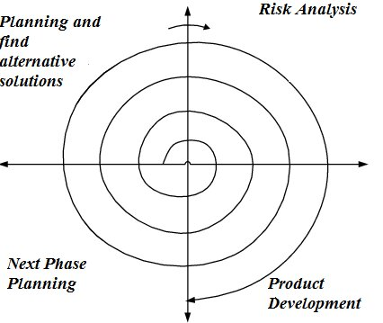

- Planning
- This phase begins by gathering business requirements into a baseline spiral.
- In the subsequent spiral, all system, subsystem and unit requirements are identified at this stage as the product matures.
- This phase also includes understanding system requirements through ongoing customer and system analyst communication.
- The product will be deployed in the identified market at the end of the spiral.
- This includes iteration cost, schedule, and resource estimates.
- Risk analysis
- After the “plan” phase, the team prepares for the “risk” phase.
- The “risk” phase is designed to consider the variability in the rate at which a given product might fail.
- It is designed to account for the uncertainty in the rate at which a given product might fail.
- Once risks are identified, risk mitigation strategies are planned and completed.

Product development
- In the next quadrant, prototypes are built and tested. This step includes architectural design, module design, physical product design and final design.
- This phase also includes the actual implementation of features in a project, which are verified by performing testing.
- Next phases planning
- In this phase, the customer evaluates the software and gives feedback.
- The team prepares for the next phase of the planning process.
- The next phase of the planning process is known as the “spiral” phase.

15. Explain working methodology of agile model and also write pros and cons?
- Mostly used model in today’s digital era.
- Agile means “The ability to respond to changes from requirements, technology& people”.
- It is an incremental and iterative process of software development.
- Highest priority is to satisfy the customers to early & continue delivery of software.
- Being flexible about changing requirements at any point of development.

Advantages of Agile Model

Supports customer involvement and customer satisfaction.

Strong communication of the software team with the customer.

Little planning required.

Efficient design and fulfils the business requirement.

Anytime changes are acceptable.

Provides a very realistic approach to software development.

Updated versions of functioning software are released every week.

It reduces total development time.

Disadvantages of Agile Model
- Due to the lack pf proper documentation, once the project completes and the developers alloyed to another project, maintenance of the finished project can become a difficulty.
- Depends heavily on customer interaction, so if customer is not clear, team van be driven in the wrong direction.

16. Draw Use case on Online bill Payment system.

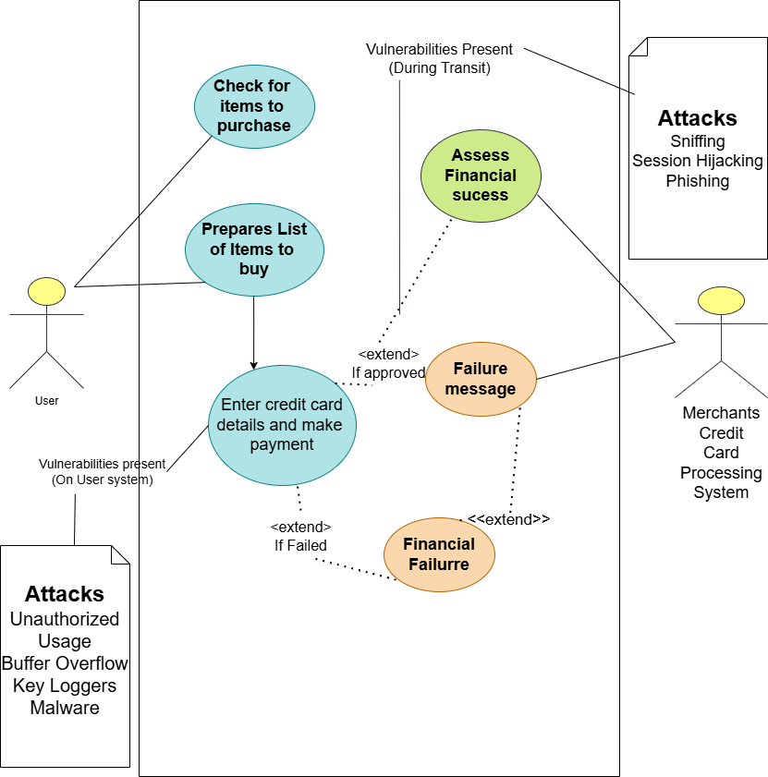

17. Draw use case on broad casting system?
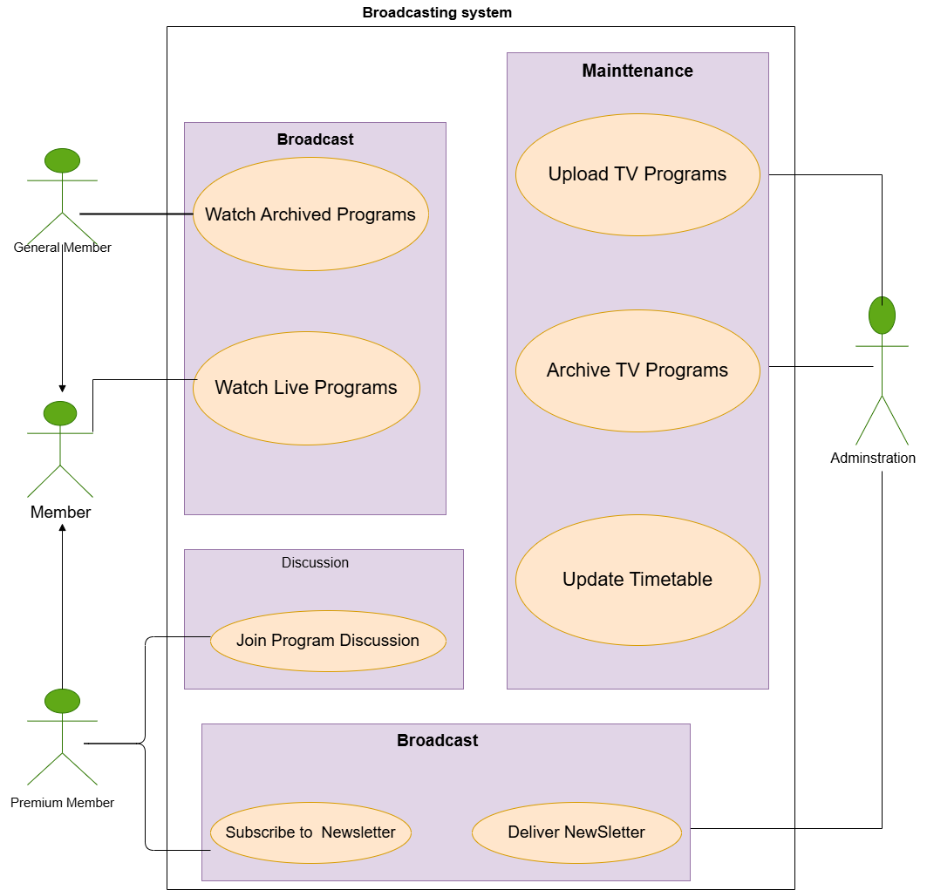

18. Draw use case on OTT platform?
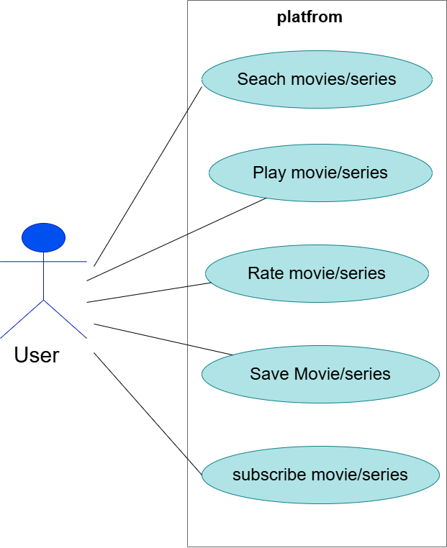
19. Draw use case on E-commerce application.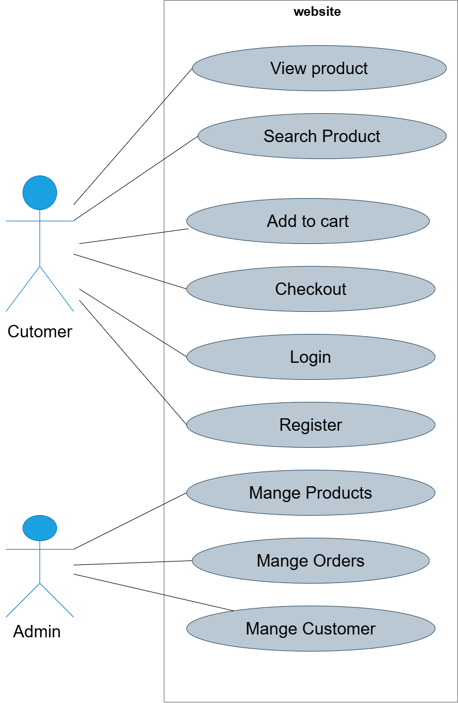

20. Draw Use case on banking system for customers. 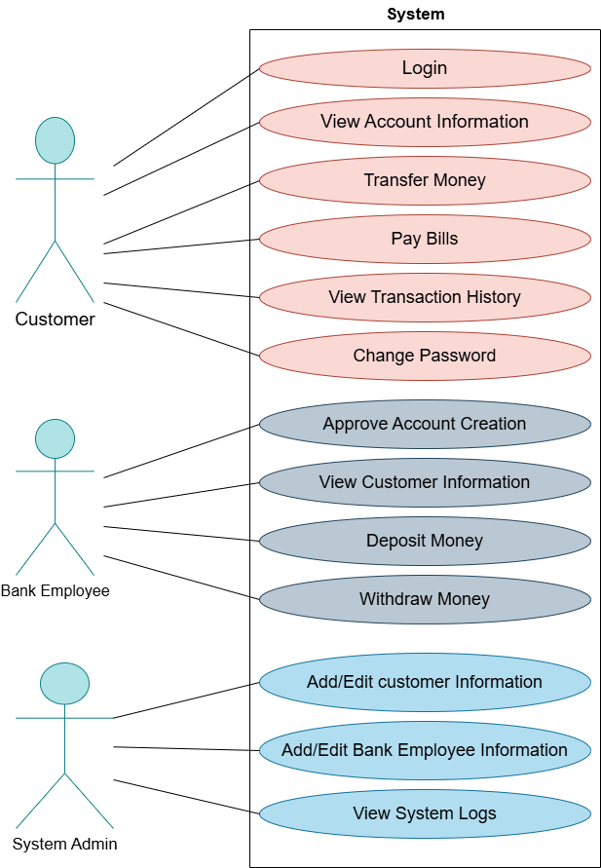
21. Draw use case on Online shopping product using payment gateway.

