Database Management Systems

Food Ordering System

# Project Report

**Khizar Asad – 23988**

**Humayun Raza - 24464**

# Business Scenario:

Our business scenario is a food delivery web application, which allows listings of multiple restaurants and allows customers to create accounts and place orders from any restaurant of their choice from

the listed restaurants.

# Business Rules:

Users:

1. **Registration & Login:**
   * **Users must register with valid personal details.**
   * **Registered users can log in using their credentials.**
2. **Ordering:**
   * **Users can browse the restaurant menu.**
   * **Users can add items to their cart.**
   * **Users can place an order from their cart.**
   * **Users can view the status of their orders.**
3. **Profile & History:**
   * **Users can update their personal details.**
   * **Users can view their order history.**

Restaurants:

1. **Registration & Login (If restaurants have their own dashboard/account):**
   * **Restaurants must be added by the admin.**
   * **Restaurants can log in using credentials provided by the admin.**
2. **Orders:**
   * **Restaurants can view orders placed for their establishment.**
   * **Restaurants can accept or reject an order.**
   * **Restaurants can update the status of an order (e.g., "preparing," "out for delivery," "delivered").**
3. **Menu Management:**
   * **Restaurants can add, update, or remove items from their menu.**
   * **Restaurants can update item prices.**

Admin:

1. **Access:**
   * **Admin has exclusive login credentials.**
   * **Admin has full access to the system and its data.**
2. **User Management:**
   * **Admin can view all user details.**
   * **Admin can delete users.**
3. **Restaurant Management:**
   * **Admin can add new restaurants.**
   * **Admin can update restaurant details.**
   * **Admin can delete restaurants.**
   * **Admin can add Riders.**
4. **Order Oversight:**
   * **Admin can view all orders placed on the platform.**
   * **Admin can intervene in any order if necessary (though this should be limited to ensure restaurant autonomy).**
5. **Reports & Analytics (Optional but good for future scalability):**
   * **Admin can generate and view reports on user activity, top restaurants, order trends, etc.**

# Entities:

**USERS:**

* **Represents the registered users on the food ordering platform. Attributes:**
* **UserID: Unique identifier for each user. Auto-incremented.**
* **Role: Specifies the role of the user (e.g., user, admin). Default is 'user'.**
* **fullName: Full name of the user.**
* **email: Unique email address of the user.**
* **password: Encrypted password for the user.**
* **phone_number: Phone number of the user.**
* **address: Address where the user wishes to get the food delivered.**

**RESTAURANTS:**

* **Represents the restaurants on the platform.**

Attributes:

* **RestaurantID: Unique identifier for each restaurant. Auto-incremented.**
* **email: Unique email address for the restaurant.**
* **password: Encrypted password for the restaurant.**
* **RestaurantName: Name of the restaurant.**
* **address: Address of the restaurant.**
* **phone_number: Phone number of the restaurant.**
* **website: Website link for the restaurant.**

**RESTAURANTITEMS:**

* **Represents the menu items offered by restaurants.**

Attributes:

* **PRODUCTID: Unique identifier for each product/item. Auto-incremented.**
* **RestaurantID: Identifier linking the product to its respective restaurant.**
* **Name: Name of the product/item.**
* **Description: Description of the product/item.**
* **Category: Category of the product/item (e.g., starters, main course, etc.).**
* **Price: Price of the product/item. ORDERS:**
* **Represents the orders placed by users. Attributes:**
* **OrderID: Unique identifier for each order. Auto-incremented.**
* **UserID: Identifier linking the order to the user who placed it.**
* **RestaurantID: Identifier linking the order to the restaurant.**
* **OrderTimeDate: Timestamp when the order was placed.**
* **OrderStatus: Status of the order (e.g., pending, processing, delivered).**
* **GRANDTOTAL: Total amount for the order.**

**ORDER_DETAILS:**

* **Represents the detailed breakdown of an order in terms of the items/products.**

Attributes:

* **OrderID: Identifier linking to the main order.**
* **ProductID: Identifier linking to the product/item in the order.**
* **Quantity: Number of units of the product/item in the order.**
* **Subtotal: Total cost of the product/item considering its quantity.**

**RIDERS:**

* **Represents riders available in the system so orders can be assigned to the Rider.**

Attributes:

* **RiderID: The Riders unique Identifier.**
* **OrderID: Current Order assigned to rider; can be NULL.**
* **Status: Shows current status of rider e.g if the rider is available to take an order.**
* **Name: Rider name.**
* **Phone Number: Rider contact number.**

# Entities:

1. **RESTAURANTITEMS to RESTAURANTS:**
   * **Type: Many-to-One**
   * **Multiplicity: A product/item (RESTAURANTITEMS) belongs to one restaurant (RESTAURANTS), but a restaurant can have many products/items.**
2. **ORDERS to USERS:**
   * **Type: Many-to-One**
   * **Multiplicity: An order (ORDERS) is placed by one user (USERS), but a user can place many orders.**
3. **ORDERS to RESTAURANTS:**
   * **Type: Many-to-One**
   * **Multiplicity: An order (ORDERS) is for one restaurant (RESTAURANTS), but a restaurant can receive many orders.**
4. **ORDER_DETAILS to ORDERS:**
   * **Type: Many-to-One**
   * **Multiplicity: A specific product/item detail (ORDER_DETAILS) belongs to one order (ORDERS), but an order can have details for many products/items.**
5. **ORDER_DETAILS to RESTAURANTITEMS:**
   * **Type: Many-to-One**
   * **Multiplicity: A specific product/item detail (ORDER_DETAILS) corresponds to one product/item (RESTAURANTITEMS), but a product/item can be in the details of many orders.**
6. **RIDERS to ORDERS:**
   * **Type: One-to-One**
   * **Multiplicity: A specific rider can only have one order assigned to him at a time**

# ER Diagram:

# 

# DDL SNIPPETS:

**DDL Script**

**Constraints Applied to Tables:**

1. USERS table:  
 - UserID: Primary Key  
 - Role: Default value 'user'  
 - Email: Unique  
2. RESTAURANTS table:  
 - RestaurantID: Primary Key  
 - Email: Unique  
3. RESTAURANTITEMS table:  
 - PRODUCTID: Primary Key  
 - RestaurantID: Foreign Key referencing RESTAURANTS  
4. ORDERS table:  
 - OrderID: Primary Key  
 - UserID and RestaurantID: Foreign Keys  
5. ORDER_DETAILS table:  
 - Composite Primary Key (OrderID, ProductID)  
 - Foreign Keys referencing ORDERS and RESTAURANTITEMS  
6. RIDERS table:  
 - RiderID: Primary Key  
 - ORDERID: Foreign Key referencing ORDERS

**Triggers, Stored Procedures, and Views:**

# 1. Triggers: - users_bir: Before insert trigger on USERS table for auto-incrementing UserID. - restaurants_bir: Similar trigger for RESTAURANTS table. - restaurant_items_bir: Trigger for RESTAURANTITEMS table. - orders_bir: Trigger for ORDERS table. - riders_bir: Trigger for RIDERS table. 2. Stored Procedures: - UPDATEORDERANDRIDERSTATUS: Procedure to update order and rider statuses.

# Technical Aspects:

# We have used ReactJS as our front-end framework for this project. For the back-end we have used NodeJS with ExpressJS. As our database we have used Oracle SQL.

# Work Contribution:

# Database Schema Planning was done by both group members, and both worked equally to make our database schema which aligned with our plans for the project.

# Khizar worked on the Back-end API’s and architecture of the project.

# Humayun worked on the front-end of the project.

**Wireframes**

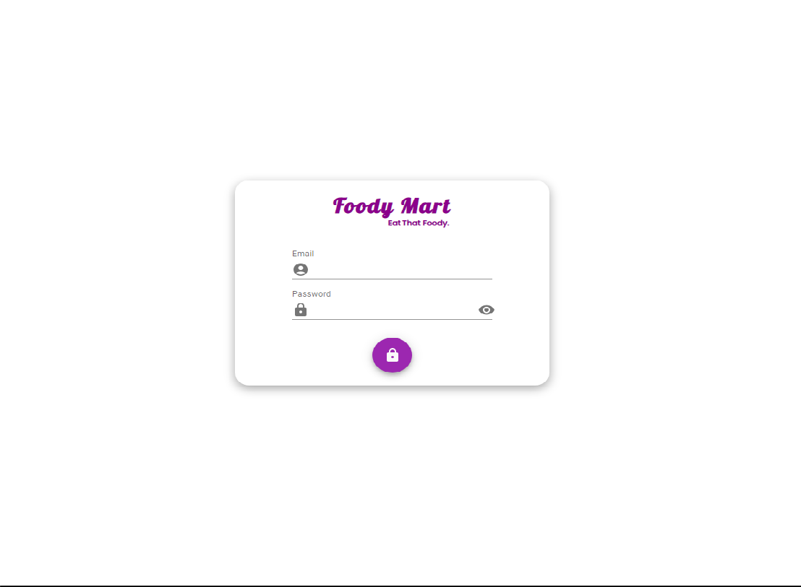

*Figure 1 -Login Page*

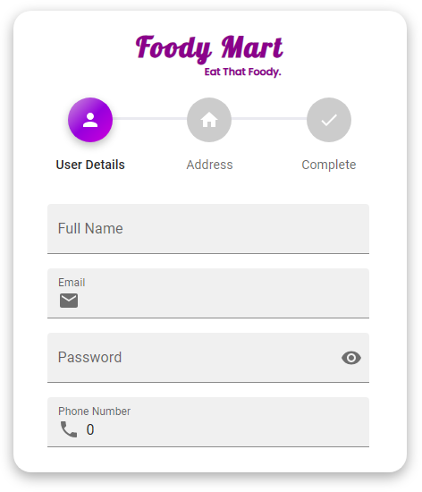

*Figure 2 -Register Page*

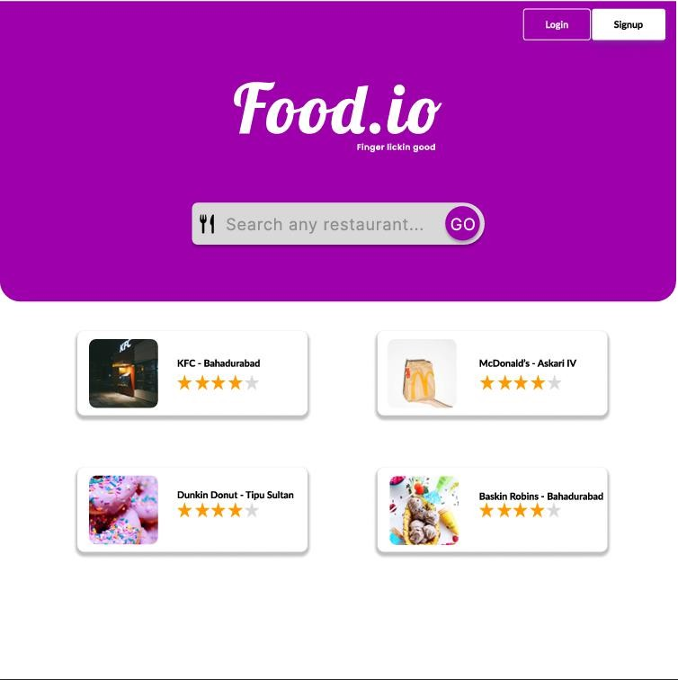

*Figure 3- Home Page*

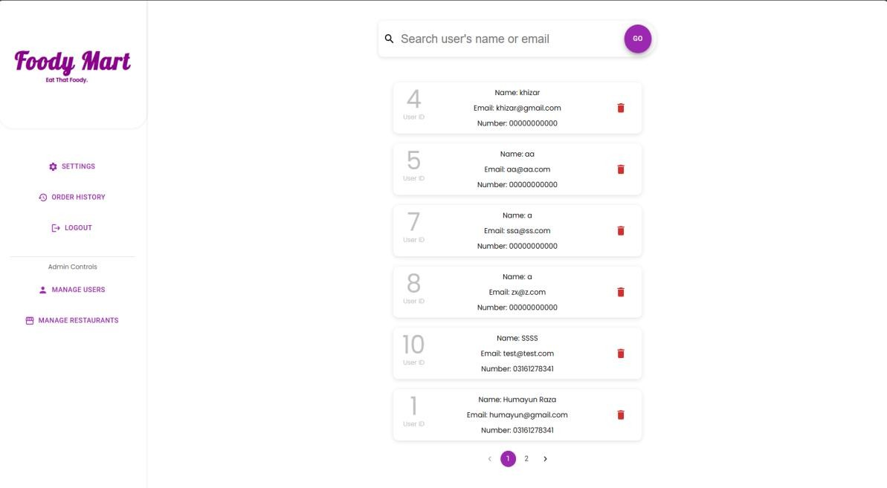

*Figure 4 - User/Admin Dashboard*