Improving the Persona Consistency of Conversational AI

Khizar Shabir  
 School of Computing  
FAST NUCES  
 Islamabad  
 i160294@nu.edu.pk

Abdul Mogees  
School of Computing  
 FAST NUCES  
 Islamabad  
 i160199@nu.edu.pk

Dr Mirza Omer Beg  
 School of Computing  
FAST NUCES  
 Islamabad  
 omer.beg@nu.edu.pk

ABSTRACT

Conversation consistency is very important if a conversational agent wants to build trust and long-term confidence. Personality is a key differentiator in a conversational agent. Further, a conversational model that should be able to answer questions from a vast domain and makes an interesting conversation needs to be trained on a large dataset that covers a vast variety of communication aspects.

Considering these two goals in mind, we trained a dialogue generation model using transfer learning that takes input the personality and history sentences as contexts and outputs the response based on the input context. The dialogue model after getting trained on our custom dataset was able to learn its personality and capture the context of the dialogue.

Dataset used for training this model was based on movie subtitles dataset that is provided by opensubtitles. The dialogue model is based on GPT and transfer learning.

1 Motivation

Since the beginning of the field of computer science, man has always been fascinated by the idea of a machine that is just like humans. This fascination was the main drive behind the emergence of new fields like Artificial Intelligence. Since the mid of 20th century, scientists are working to convert this fascination into reality. This struggle goes from ELIZA, the first AI chatbot, all the way to MITSUKU, four times winner of Loebner Prize. Work in this field has always been more focused on a close domain. Building a conversational agent that can chat on various topics is a very challenging task. The goal of an open-domain dialog agent is to maximize the long-term user engagement. One big challenge with building these kinds of conversational agents is the consistency in their conversation. Conversational consistency is very important if a conversational agent wants to build trust and long-term confidence. In this research paper, we discuss a conversation expert with personality. It will be able to chat on various topics, with its conversation consistent to its persona. An agent that can chat with humans in the way that people talk to each other will be easier and more enjoyable to use in our day-to-day lives — going beyond simple tasks like playing a song or booking an appointment. In the past, the absence of big conversation datasets was one of the main reasons for the scarcity of conversational agents and their poor performance. But now big datasets are available by using which agent’s conversation can be significantly improved. Main challenges in this project include understanding the context of the conversation, building persona of the agent and improving the consistency of the agent with respect to its persona.

2 Related Work

Kory Mathewson built a generative sequence-to-sequence model by training it on the vast dataset of movie subtitles [1]. The variety of this dataset was very large that is why the conversation of the conversational agent built on it was very interesting. We have also used that dataset for training our agent named NEO. In the paper [4], the authors at Stanford University experiment building open-domain response generator with personality and identity. They built chatbots that imitate characters in popular TV shows. The automated evaluation of their chatbots using BLEU and ROGUE metrics produced very low scores. In the paper [3] Sean Welleck with other authors at Facebook research team presents a new approach to increase the consistency of any conversational agent. They say that a model trained on Dialogue NLI dataset can further improve the consistency of the dialogue model. They tested this technique by using automatic metrics on the evaluation sets specially designed to check the consistency of the conversational model. This technique gives promising results we plan to use this technique in future to further increase the conversational consistency of the model.

3 Dataset Preparation

A generative language model that should be able to answer questions from a vast domain needs to be trained on a large dataset that covers a vast variety of communication aspects. For this, one of the best options available was the dataset of movies subtitles. Kory W. Mathewson used this dataset in implementing an improviser robot. [1]

For gathering the dataset of movie subtitles, we did web scraping using R language scripts. Using this technique, we gathered a large dataset of around 10GB that comprises of subtitles of English movies from the 1950s to 2015. Data downloaded this way is in form of XML files. Movie dialogues are bounded by time tags, which gives information about starting and ending time of that particular sentence on the screen. We don't need any other kind of data other than the movie dialogues.

We only needed the dialogue portion from these XML files. So, for that, we used XML ElementTree to parse the XML files and extract only useful data. For this purpose, a python script was used to parse XML files and convert them into text files that contain only movie dialogues. Moreover, after extracting data from XMLs, there was still a need to clean the data. As subtitles don't only contain movie dialogues but also contain sentences that explain the scene or some pre context. These sentences are mostly enclosed in some kind of bracket or some other special character. We used python regex to clean our data from this kind of gibberish data for us.

Since our model is a dialogue generating model, so it should be trained on responses to sentences. We converted each subtitle file as a separate JSON object, which further contains two objects, personality, utterances. Personality contains the personality sentence of the conversational agent. While utterances are further composed up of two objects, candidates and history. The candidates contain randomly chosen sentences and the last sentence, which is the true response of the history sentences. The shape of our dataset is similar to PERSONA-CHAT dataset [2] but contains only one personality instead of multiple personalities, as in PERSONA-CHAT dataset, and our custom dataset. Therefore, the model is trained on three contexts, the personality, history and response.

4 GPT model and Transfer learning

­GPT (generative pre-trained transformer) is a simple model that was trained on a bulk of web text for a simple task "next word prediction". This is a very powerful transformer and can generate a long continuation of text by capturing the context of the text being produced. We are using a language model that can produce predict the output word by taking input a sequence of words and generating a probability distribution over the vocabulary.

Pre-training is a very costly operation of such a model on a huge dataset that is why we have fine-tuned the GPT model on our custom dataset. Since improving, the consistency of the conversational agent is the main objective of our model. Using the persona sentences of the agent also as the input context can help improve the conversational consistency of agent according to its persona.

There are mainly three input contexts, the persona sentences, conversation history and since our model generates tokens word by word, we are using the already generated tokens also as input context. The input sequence is made up of these contexts. We have used word embedding, position embedding and segment embedding for feeding all three contexts into the transformer. Segment embedding are used to differentiate between different input segment like speaker 1 and speaker 2.While position embedding are just the position of the token in the input context in the range of maximum tokens in the input context.

We have used a next step prediction loss and language model loss and added them together. In the initial training of BERT model, the next sentence prediction is used. In this task, model has to correctly classify the true next sentence among distractors. The hidden state of the last token was passed into a linear layer to get a score and then applying cross-entropy loss to correctly identify the ground truth sentence.

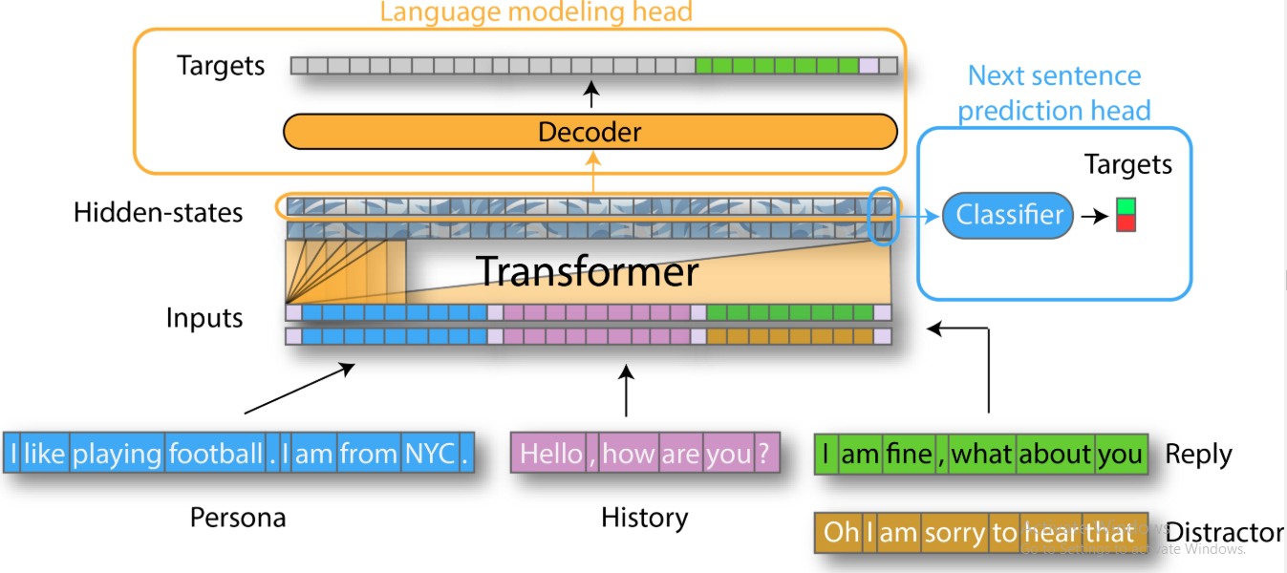

Figure 2: Our model is built on a similar technique that was used by hugging face in ConvAI2, a competition at NeurIPS and got the first position in it.

After fine-tuning the model on our dataset. The model was able to predict the next sentence tokens. For converting these tokens into a complete response sentence, we have used a decoder mechanism. The results of top-k and top-p sampling are better than the old methods like greedy method. Top k sampling keeps the token that falls in a certain range of probability and discards other tokens. It helps the model from going off-topic.

Markov assumption suggest that the future events in the dynamic system depends on its recent history. By considering this assumption we only use recent 2-3 history sentences an input context instead of using all of the dialogue history.

5 Future Work

The main goal of building a conversation model was ensuring its conversational consistency according to its persona. That is why used the personality sentences as input context during training. It was the process of instilling consistency according to its personality. Despite understanding its personality and building dialogue according to that, the conversation of our model can sometimes distract from its personality. For further ensuring to increase the dialogue consistency, we plan to use a consistency model based on the NLI dataset based on the research of Facebook research team [3]. They claim that when this model is combined with the dialogue generating models, it increases their consistency. We will use the evaluation method used by the Facebook research team [3] to evaluate the conversational consistency of agent. We can also use the BLEU metric that compares the model output with the human written output and computes a score.

6 Conclusion

The conversational model discussed in this paper is focused on improving the consistency of communication of chatbot with its persona. We trained a dialogue generation model using transfer learning that takes input the personality and history sentences as contexts and outputs the response based on the input context. The dialogue model after getting trained on our custom dataset was able to learn its personality and capture the context of the dialogue. The evaluation criteria on which this consistency will be measured is one of our future goals that we will be working on in future. We can use automatic metrics like BLEU score or Turing test for evaluating our conversational agent. Other researchers have improved consistency using similar techniques.

REFERENCES

[1] Mathewson, Kory W., and Piotr Mirowski. "Improvised theatre alongside artificial intelligences." *Thirteenth Artificial Intelligence and Interactive Digital Entertainment Conference*. 2017.

[2] Zhang, Saizheng, et al. "Personalizing Dialogue Agents: I have a dog, do you have pets too?." *arXiv preprint arXiv:1801.07243* (2018).

[3] Welleck, Sean, et al. "Dialogue natural language inference." *arXiv preprint arXiv:1811.00671* (2018).

[4] Nguyen, Huyen, David Morales, and Tessera Chin. "A neural chatbot with personality." (2017): 1-7.

Conference Name:ACM Woodstock conference

Conference Short Name:WOODSTOCK’18

Conference Location:El Paso, Texas USA

ISBN:978-1-4503-0000-0/18/06

Year:2018

Date:June

Copyright Year:2018

Copyright Statement:rightsretained

DOI:10.1145/1234567890

RRH: F. Surname et al.

Price:$15.00