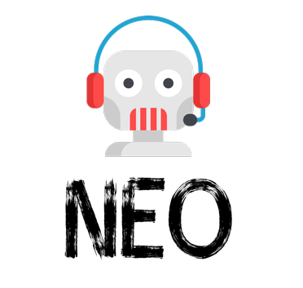

FYP REPORT

Khizar Shabir-16I-0294

Ahmad Abdul Mogees Asharf-16I-0199

Table of Contents

Title…………………………………………………………………………………………………………………… 2

Complete FYP Title……………………………………………………………………………………………. 2

Project Type………………………………………………………………………………………………………. 2

FYP Group Information…………………………………………………………………………………….. 2

Supervisor………………………………………………………………………………………………………... 2

Co-Supervisor……………………………………………………………………………………………………. 2

Project Overview………………………………………………………………………………………………. 2

Motivation………………………………………………………………………………………………………… 2

Objectives. ……………………………………………………………………………………………………..… 3

Use/Impact………………………………………………………………………………………………………. 3

High-Level Features…………………………………………………………………………………………. 3

System Diagram………………………………………………………………………………………………. 4

Technical Challenges……………………………………………………………………………………… 4

Tools/Technologies………………………………………………………………………………………… 5

FYP Timeline………………………………………………………………………………………………….. 6

References………………………………………………………………………………………………………. 7

**Title:** Neo

**Complete FYP Title:** Neo – An Open-Domain AI Conversational Agent

**Project type**: Research and Development

**FYP Group Information:**

|  |  |  |  |
| --- | --- | --- | --- |
| Name | Roll No | CGPA | Email |
| Khizar Shabir | 16I-0294 | 3.20 | i160294@nu.edu.pk |
| Abdul Mogees | 16I-0199 | 2.86 | i160199@nu.edu.pk |

**FYP Supervisor**

Name: Dr. Omer Beg Signature:

**Co-Supervisor**

Name: Mr. Shoaib Mehboob Signature:

**Project Overview:**

We want to make an artificially intelligent conversational agent that will have the ability to communicate with its users on any topic and will be able to improvise communication depending upon the context. Recent work in conversational agents has been focused on goal-directed dialogues based on some closed domain such as making a phone call, sending text, appointment setting, question answering, etc. Natural human conversations are seldom limited to the scope and jump from topic to topic. Our chatbot will be able to explore this dimension of communication.

Diving into a little detail, if we see famous chatbots around us i.e. Google Assistant, Siri etc. their sole purpose of existence is getting things done in the domain they cover, that is the device they are installed on. We are seeing chatbot from another perspective which is making it a fulltime friend that can chat with you all day long. Toyota has worked in this domain recently. They made a robot named KIROBO that can chat with you while you are driving alone. But the limitation was that it used Japanese language. We will be making a similar thing that will be able to chat with you in English language.

In other words, we can say that we are making an AI friend that is always with you no matter where you are.

**Motivation:**

Since the beginning of the field of computer science, man has always fascinated the idea of a machine that is just like humans. This fascination was the main drive behind the immergence of new fields like Artificial Intelligence. Since the mid of 20th century, scientists are working to convert this fascination into reality. This struggle goes from ELIZA, the first AI chatbot, all the way to MITSUKU, four times winner of Loebner Prize. Work in this field has always been more focused on a close domain. All the tech giants like Google, IBM, Amazon, and Facebook are working in this domain, but none has focused much on an open domain chatbot. This gives us the motivation to explore this relatively new field.

**Objectives:**

Our goal is to build an AI-based communication agent that can talk to its users on any general topic. And most importantly it will have the ability to stay in the topic and understand it along with improvising the communication based on the latest inputs.

**Use/Impact:**

If we talk about the importance of our project, the audience of this chatbot is very vast. It ranges from kids to old people, people having any kind of interests. Secondly, there are a lot of introvert people who can't express their views or feelings with fellow human beings. For them, this chatbot can act as a friend that can talk to them whenever they want. Similarly, it can be used like Toyota’s KIROBO. People can talk to it when doing some tasks that they find boring like maybe cooking or driving etc. It can be used as a stage performer along with human performers. Neo will portray a friendly face of AI. It also qualifies as a learning leisure time activity.

**High-level Features**:

* Speech recognition using Google API.
* Dialogue management/generation system built using deep neural network-based language model.
* Text-to-Speech using Google API.
* The whole integrated system will be hosted on an online website.

**System Diagram:**

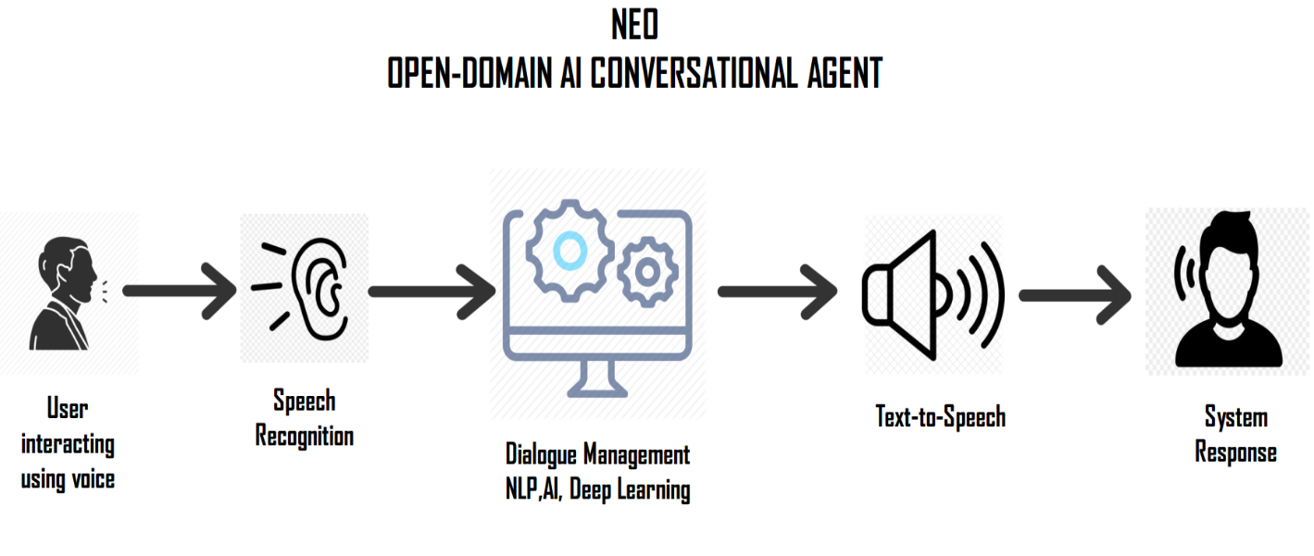

**Technical Challenges:**

* Building a generative dialogue system using deep neural network-based language model.
* Capturing the general theme of the dialogue.
* Removal of offensive words in speech.
* Use of Reinforcement learning for training the conversational agent.
* Integration of speech to text system with dialogue systems and then connecting with text to speech system.
* Keeping record of context of communication.

**Tools and technologies:**

Python, TensorFlow, PyTorch, Node.js, React

|  |  |  |
| --- | --- | --- |
| Technology | Skill Level of Khizar | Skill Level of Mogees |
| Python | 8 | 8 |
| TensorFlow | 2 | 2 |
| PyTorch | 2 | 2 |
| Node.js | 1 | 1 |
| React | 1 | 1 |

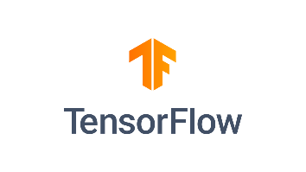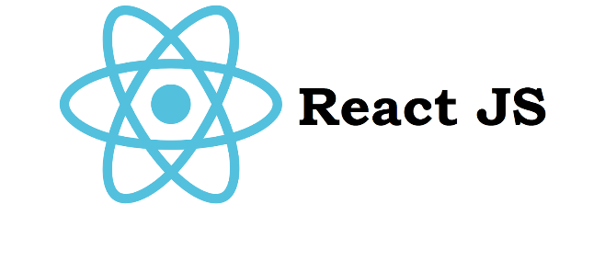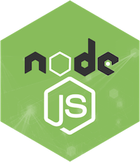

**Final Year Project Timeline:**

**References:**

|  |  |
| --- | --- |
| [1] | P. M. Kory W Mathewson, "Improvised Theatre Alongside Artificial Intelligences," in *AAAI Conference on Artificial Intelligence and Interactive Digital Entertainment*, 2017. |
| [2] | P. M. Kory Wallace Mathewson, "Improvised Comedy as a Turing Test," in *NIPS Workshop on Machine Learning for Creativity and Design*, 2017/11/23. |
| [3] | P. M. P. Kory W Mathewson, "Actor-critic reinforcement learning with simultaneous human control and feedback," *arXiv preprint arXiv:1703.01274,* no. Under review for the 34th International Conference on Machine Learning, Sydney, Australia, 2017, pp. 10 pages, 2 pages of references, 2017/3/3. |
| [4] | J. W. A. S. K. C. Sean Welleck, "Dialogue natural language inference," *ACL 2019,* 2018/11/1. |