DATABASE SYSTEMS

Project Report

“Online Computer Store”

Group members

1. Syed Wyle Mustafa 19K-0368
2. Khizir Farrukh 19K-0359
3. Shazim Abbas 19K-1351

Introduction and a brief description of the project:

The motivation behind this project is to get into the huge local market of online computer stores to get our slice of the bread. Our aim is to deliver a trusted platform to the customers where they can purchase or get after sales services worry-free.

The Customer can login/register an account. The Customers can search for any required item. The Customer can add/remove one or more items to/from the shopping cart. The Customer provides necessary details and proceeds to select a payment method. After payment validation, the order details will be sent to the customer by email. The Customer can view order history with status. The Customer can review item(s) after successful delivery.

The Admin can manage vendor and the stock. The Admin can see customer information.

ERD:

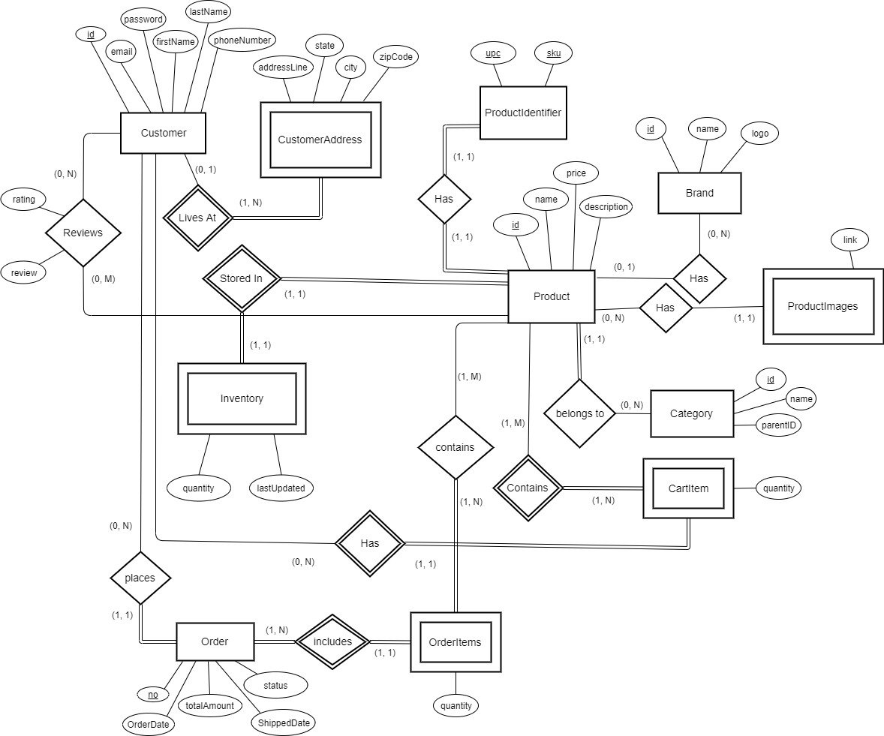

Normalized Tables:

|  |  |  |  |  |  |  |  |
| --- | --- | --- | --- | --- | --- | --- | --- |
| **Product Brands** | | | | | | | |
| ***Name*** | | *brands* | | | | | |
| ***Alias*** | | *N/A* | | | | | |
| ***Where-used/how- used*** | | *Provides the brand name and logo for the product.* | | | | | |
| ***Content description*** | | *Stores the brand name and logo for a brand.* | | | | | |
|  | | | | | | | |
| ***Column Name*** | ***Description*** | | ***Type*** | ***Length*** | ***Nullable*** | ***Default Value*** | ***Key Type*** |
| *id* | *ID used to identify the brand* | | *int* | *11* | *no* | *<auto increment>* | *Primary key* |
| *name* | *Brand’s name* | | *varchar* | *64* | *no* | *none* | *None* |
| *logo* | *Brand’s logo path on computer* | | *varchar* | *256* | *yes* | *NULL* | *None* |

|  |  |  |  |  |  |  |  |
| --- | --- | --- | --- | --- | --- | --- | --- |
| **Product Categories** | | | | | | | |
| ***Name*** | | *categories* | | | | | |
| ***Alias*** | | *N/A* | | | | | |
| ***Where-used/how- used*** | | *Provides the category name for the product.* | | | | | |
| ***Content description*** | | *Stores the category name and its parent.* | | | | | |
|  | | | | | | | |
| ***Column Name*** | ***Description*** | | ***Type*** | ***Length*** | ***Nullable*** | ***Default Value*** | ***Key Type*** |
| *id* | *ID used to identify the category* | | *int* | *11* | *no* | *<auto increment>* | *Primary key* |
| *name* | *Category name* | | *varchar* | *64* | *no* | *none* | *None* |
| *parentID* | *ID of category on which this category belongs to.* | | *int* | *11* | *yes* | *NULL* | *Foreign key* |

|  |  |  |  |  |  |  |  |
| --- | --- | --- | --- | --- | --- | --- | --- |
| **Customer’s Address** | | | | | | | |
| ***Name*** | | *customeraddress* | | | | | |
| ***Alias*** | | *N/A* | | | | | |
| ***Where-used/how- used*** | | *Provides the address of the customer upon the time of placing order.* | | | | | |
| ***Content description*** | | *Stores the address details of the customer.* | | | | | |
|  | | | | | | | |
| ***Column Name*** | ***Description*** | | ***Type*** | ***Length*** | ***Nullable*** | ***Default Value*** | ***Key Type*** |
| *id* | *ID of the customer of which the address is stored* | | *int* | *11* | *no* | *None* | *Foreign key + Primary key* |
| *addressLine* | *Address on which the customer lives (or his delivery address)* | | *varchar* | *256* | *No* | *None* | *None* |
| *state* | *State of the city in which the customer lives* | | *varchar* | *50* | *No* | *None* | *None* |
| *City* | *Residence city of customer* | | *varchar* | *50* | *No* | *None* | *None* |
| *zipCode* | *Identifies the area of customers residence* | | *varchar* | *8* | *No* | *None* | *None* |

|  |  |  |  |  |  |  |  |  |  |  |  |  |
| --- | --- | --- | --- | --- | --- | --- | --- | --- | --- | --- | --- | --- |
| **Customer Details** | | | | | | | | | | | | |
| ***Name*** | | *customers* | | | | | | | | | | |
| ***Alias*** | | *N/A* | | | | | | | | | | |
| ***Where-used/how- used*** | | *Provides the customer details when required (e.g. password on login).* | | | | | | | | | | |
| ***Content description*** | | *Stores the details of the customer except address.* | | | | | | | | | | |
|  | | | | | | | | | | | | |
| ***Column Name*** | ***Description*** | | ***Type*** | | ***Length*** | | ***Nullable*** | | ***Default Value*** | | | ***Key Type*** |
| *id* | *ID of the customer.* | | *int* | | *11* | | *No* | | *<auto increment>* | | | *Primary key* |
| *email* | *Email address of the customer used for user identification (login purposes).* | | *varchar* | | *320* | | *No* | | *None* | | | *Unique* |
| *password* | *Security key used by customer to login.* | | *binary* | | *60* | | *No* | | *None* | | | *None* |
| *firstName* | *First name of the customer.* | | *varchar* | | *50* | | *No* | | *None* | | | *None* |
| *lastName* | *Last name of the customer.* | | *varchar* | | *50* | | *No* | | *None* | | | *None* |
| *phoneNumber* | *Phone number used to contact the customer.* | | *varchar* | | *11* | | *No* | | *None* | | | *None* |
| **Product IDs** | | | | | | | | | | | | |
| ***Name*** | | *productidentifier* | | | | | | | | | | |
| ***Alias*** | | *N/A* | | | | | | | | | | |
| ***Where-used/how- used*** | | *Used for product searching upon product management.* | | | | | | | | | | |
| ***Content description*** | | *Actual identifiers of the product.* | | | | | | | | | | |
|  | | | | | | | | | | | | |
| ***Column Name*** | ***Description*** | | | ***Type*** | | ***Length*** | | ***Nullable*** | | ***Default Value*** | ***Key Type*** | |
| *upc* | *Universal product code, identifies the product.* | | | *varchar* | | *12* | | *No* | | *None* | *Primary key* | |
| *sku* | *Stock keeping unit, identifies the product variation* | | | *varchar* | | *64* | | *No* | | *None* | *Primary key* | |
| *id* | *Used to identify the product details* | | | *int* | | *11* | | *No* | | *None* | *Foreign key* | |

|  |  |  |  |  |  |  |  |
| --- | --- | --- | --- | --- | --- | --- | --- |
| **Product Details** | | | | | | | |
| ***Name*** | | *products* | | | | | |
| ***Alias*** | | *N/A* | | | | | |
| ***Where-used/how- used*** | | *Provides the entire product details when customer visits product lists/product details page.* | | | | | |
| ***Content description*** | | *Stores the entire product details.* | | | | | |
|  | | | | | | | |
| ***Column Name*** | ***Description*** | | ***Type*** | ***Length*** | ***Nullable*** | ***Default Value*** | ***Key Type*** |
| *id* | *Used to identify the product details.* | | *int* | *11* | *No* | *None* | *Primary key* |
| *name* | *What the product is called, contains description summary.* | | *varchar* | *250* | *No* | *None* | *Unique* |
| *price* | *How much the product is being sold for.* | | *Decimal* | *(10,2)* | *No* | *0.00* | *None* |
| *description* | *Contains brief description of the product.* | | *text* | *-* | *Yes* | *NULL* | *None* |
| *brandID* | *Brand on which the product belongs to.* | | *int* | *11* | *Yes* | *NULL* | *Foreign key* |
| *categoryID* | *Category on which the product belongs to.* | | *int* | *11* | *No* | *None* | *Foreign key* |

|  |  |  |  |  |  |  |  |
| --- | --- | --- | --- | --- | --- | --- | --- |
| **Product Reviews** | | | | | | | |
| ***Name*** | | *reviews* | | | | | |
| ***Alias*** | | *N/A* | | | | | |
| ***Where-used/how- used*** | | *Used when user visits product details page or adds review.* | | | | | |
| ***Content description*** | |  | | | | | |
|  | | | | | | | |
| ***Column Name*** | ***Description*** | | ***Type*** | ***Length*** | ***Nullable*** | ***Default Value*** | ***Key Type*** |
| *customerID* | *Customer who reviewed the product.* | | *int* | *11* | *No* | *None* | *Primary key + Foreign key* |
| *productID* | *Product which is reviewed.* | | *int* | *11* | *No* | *None* | *Primary key + Foreign key* |
| *rating* | *Rating (out of 5) provided to the product* | | *int* | *1)* | *No* | *None* | *None* |
| *review* | *Customers opinion about the product (Actual review)* | | *text* | *-* | *Yes* | *NULL* | *None* |

|  |  |  |  |  |  |  |  |
| --- | --- | --- | --- | --- | --- | --- | --- |
| **Product Inventory** | | | | | | | |
| ***Name*** | | *inventory* | | | | | |
| ***Alias*** | | *N/A* | | | | | |
| ***Where-used/how- used*** | | *Used for stock information of product (In Stock/Out of Stock).* | | | | | |
| ***Content description*** | | *Stores the stock details of product.* | | | | | |
|  | | | | | | | |
| ***Column Name*** | ***Description*** | | ***Type*** | ***Length*** | ***Nullable*** | ***Default Value*** | ***Key Type*** |
| *productID* | *Identifies the product.* | | *int* | *11* | *No* | *None* | *Primary key + Foreign key* |
| *quantity* | *Quantity of product currently in stock.* | | *int* | *11* | *No* | *0* | *None* |
| *lastUpdated* | *Date on which the product’s inventory was updated.* | | *date* | *-* | *No* | *Current_timestamp()* | *None* |

|  |  |  |  |  |  |  |  |
| --- | --- | --- | --- | --- | --- | --- | --- |
| **Product Images** | | | | | | | |
| ***Name*** | | *productimages* | | | | | |
| ***Alias*** | | *N/A* | | | | | |
| ***Where-used/how- used*** | | *Used when product is displayed to customer (provides image).* | | | | | |
| ***Content description*** | | *Stores the image link for the product.* | | | | | |
|  | | | | | | | |
| ***Column Name*** | ***Description*** | | ***Type*** | ***Length*** | ***Nullable*** | ***Default Value*** | ***Key Type*** |
| *productID* | *Identifies the product.* | | *int* | *11* | *No* | *None* | *Foreign key* |
| *link* | *Address of the image stored on the computer.* | | *varchar* | *256* | *No* | *None* | *None* |

|  |  |  |  |  |  |  |  |
| --- | --- | --- | --- | --- | --- | --- | --- |
| **Product Cart Items** | | | | | | | |
| ***Name*** | | *cartitem* | | | | | |
| ***Alias*** | | *N/A* | | | | | |
| ***Where-used/how- used*** | | *Used when customer adds a product to cart, allows him to manage product quantity and he can order multiple items at the same time.* | | | | | |
| ***Content description*** | | *Stores the cart information (Which product is added to cart by which customer and the quantity of the item).* | | | | | |
|  | | | | | | | |
| ***Column Name*** | ***Description*** | | ***Type*** | ***Length*** | ***Nullable*** | ***Default Value*** | ***Key Type*** |
| *customerID* | *Identifies the customer who has product in cart.* | | *int* | *11* | *No* | *None* | *Primary key + Foreign key* |
| *productID* | *Identifies the product in cart.* | | *int* | *11* | *No* | *None* | *Primary key + Foreign key* |
| *quantity* | *Quantity of product in cart.* | | *int* | *11* | *No* | *None* | *None* |

|  |  |  |  |  |  |  |  |
| --- | --- | --- | --- | --- | --- | --- | --- |
| **Order Items** | | | | | | | |
| ***Name*** | | *orderitems* | | | | | |
| ***Alias*** | | *N/A* | | | | | |
| ***Where-used/how- used*** | | *Used to store and display the products ordered in an order placed by customer.* | | | | | |
| ***Content description*** | | *Stores the product with quantity and amount ordered.* | | | | | |
|  | | | | | | | |
| ***Column Name*** | ***Description*** | | ***Type*** | ***Length*** | ***Nullable*** | ***Default Value*** | ***Key Type*** |
| *orderNo* | *Identifies the order containing the order items.* | | *int* | *11* | *No* | *None* | *Primary key + Foreign key* |
| *productID* | *Identifies the product ordered.* | | *int* | *11* | *No* | *None* | *Primary key + Foreign key* |
| *quantity* | *Quantity of product ordered.* | | *int* | *11* | *No* | *None* | *None* |
| *amount* | *Total order amount for that specific product.* | | *Decimal* | *(10,2)* | *No* | *None* | *None* |

|  |  |  |  |  |  |  |  |
| --- | --- | --- | --- | --- | --- | --- | --- |
| **Orders** | | | | | | | |
| ***Name*** | | *order* | | | | | |
| ***Alias*** | | *N/A* | | | | | |
| ***Where-used/how- used*** | | *Used to store and display the basic order details of the order placed by customer* | | | | | |
| ***Content description*** | | *Stores which customer placed order, the order amount, when its ordered and what is its current status.* | | | | | |
|  | | | | | | | |
| ***Column Name*** | ***Description*** | | ***Type*** | ***Length*** | ***Nullable*** | ***Default Value*** | ***Key Type*** |
| *no* | *Identifies the order placed.* | | *int* | *11* | *No* | *None* | *Primary key* |
| *customerID* | *Identifies the customer who palced the order.* | | *int* | *11* | *No* | *None* | *Foreign key* |
| *OrderDate* | *Date on which the order was placed.* | | *date* | *-* | *No* | *None* | *None* |
| *totalAmount* | *Total billing amount for that order.* | | *Decimal* | *(10,2)* | *No* | *None* | *None* |
| *ShippedDate* | *Date on which product was shipped to the customer.* | | *date* | *-* | *Yes* | *NULL* | *None* |
| *status* | *Stores the current status of the order (Pending, Shipped, Delivered, Returned, Cancelled, Failed).* | | *varchar* | *10* | *No* | *None* | *None* |

Tools and Technologies used in the project:

1. Backend Languages: NodeJS, PHP.
2. Frontend Languages: HTML, CSS, JS.
3. Database: MYSQL
4. Servers: Apache Server for PHP (Xampp), MySQL Workbench, NPM for NodeJS.