**Software Requirement and Design Analysis**

**Sports Eye: A Sports Equipment Store**

**Version [1.0.0]**

|  |  |
| --- | --- |
| **Course Code** | **CS3004** |
| **Instructor** | **Syeda Rubab Jaffar** |
| **Project Team** | **Syed Wyle Mustafa (19K-0368)**  **Khizir Farrukh (19K-0359)**  **Shazim Abbas (19K-1351)** |
| **Submission Date** | **18/12/2021** |

Table of Contents

1. INTRODUCTION 5
   1. Purpose of Document 5
   2. Intended Audience 5
2. OVERALL SYSTEM DESCRIPTION 6
   1. Project Background 6
   2. Project Scope 6
   3. Not In Scope 6
   4. Project Objectives 6
   5. Stakeholders 6
   6. Operating Environment 6
   7. System Constraints 6
   8. Assumptions & Dependencies 6
3. EXTERNAL INTERFACE REQUIREMENTS 7
   1. Hardware Interfaces 7
   2. Software Interfaces 7
   3. Communications Interfaces 7
4. FUNCTIONAL REQUIREMENTS 8
   1. FUNCTIONAL HIERARCHY 8
   2. Use Cases 8
      1. [Title of use case] 8
5. NON-FUNCTIONAL REQUIREMENTS 9
   1. Performance Requirements 9
   2. Safety Requirements 9
   3. Security Requirements 9
   4. User Documentation 9

SDS 10

1. SYSTEM ARCHITECTURE 11
   1. SYSTEM LEVEL ARCHITECTURE 11
   2. SOFTWARE ARCHITECTURE 11
2. DESIGN STRATEGY 12
3. DETAILED SYSTEM DESIGN 13
   1. DATABASE DESIGN 13
4. APPLICATION DESIGN 15
5. REFERENCES 15
6. APPENDICES 17

## Introduction

##### Purpose of Document

To provide a detailed overview of our software product, its parameters and goals. This document describes the project's target audience and its user interface, hardware and software requirements. It defines how our client, team and audience see the product and its functionality. Nonetheless, it helps any designer and developer to assist in software delivery life cycle (SDLC) processes.

##### Intended Audience

The document is intended for requirements engineer, developer and project manager.

* 1. **Definition of Terms, Acronyms and Abbreviations**

|  |  |
| --- | --- |
| **Term** | **Description** |
| PHP | Hypertext Preprocessor |
| DBMS | Database Management System |
| SQL | Structured Query Language |
| HTML | Hypertext Markup Language |
| NPM | Node Package Manager |
| CSS | Cascading Style Sheets |
| EJS | Embedded JavaScript Templating |
| SRS | System Requirement Specification |
| SDS | System Design Specification |
| E-Store | The virtual store of a retailer that sells goods or services over the Internet |

##### Document Convention

|  |  |  |  |
| --- | --- | --- | --- |
| **Document General** | **Main Headings** | **Sub Headings** | **Descriptions** |
| Font: Calibri (Body) | Size: 16pt | Size: 12pt | Size: 10pt |

## Overall System Description

##### Project Background

The Computer Store is an e-store that sells computer components and other tech related products, eliminating the need to physically visit the store. Tech Market is growing rapidly and so is online shopping. This project will push the business to be the part of this growing market.

##### Project Scope

This solution offers two sides, one is the admin side with which the store owner/admin can manage website data (Brands, Categories, Products, Orders, and Inventory) and view customer information, second is the user side with which a customer can view, purchase, and review products. A user can also see order history and account information.

##### Not In Scope

Distributor Information, Serial Number wise product record, Return request, Delivery Tracking, Review Edit, Discount system.

##### Project Objectives

To allow the business to be the part of growing online tech market. To allow the business to efficiently manage website data. To allow the customer to purchase desired products comfortably without physical traveling.

##### Stakeholders

Customer, Administrator, Requirements Engineer, Developer and Project manager.

##### Operating Environment

##### The server-side component of the software must operate within any operating system that can run Apache Server, Node JS, and MySQL Service such as Windows and Linux.

The client-side component of the software must operate within a common-web browser environment.

##### System Constraints

1. Only English Language is supported, for any other language it is required that the client -side web browser provides automatic translation to the client’s system language.

ii) A great user experience is required for both Admin and Customer, so a clean and easy to use UI is required.

##### Assumptions & Dependencies

1. The client-side common-web browser environment provides automatic translation to the client’s system language if not English.

## External Interface Requirements

The system we have designed is flexible and adaptive to every type of interfaces with some preliminary requirements.

##### Hardware Interfaces

Any Device with Browser Compatibility

##### Software Interfaces

##### No Such software requirements only up to date web browser required with Internet connectivity.

##### Communications Interfaces

Not Applicable

## Functional Requirements

##### Functional Hierarchy

##### Untitled Diagram (3) (1) (3) (5)

##### Use Cases

**4.2.1. The Computer Store**

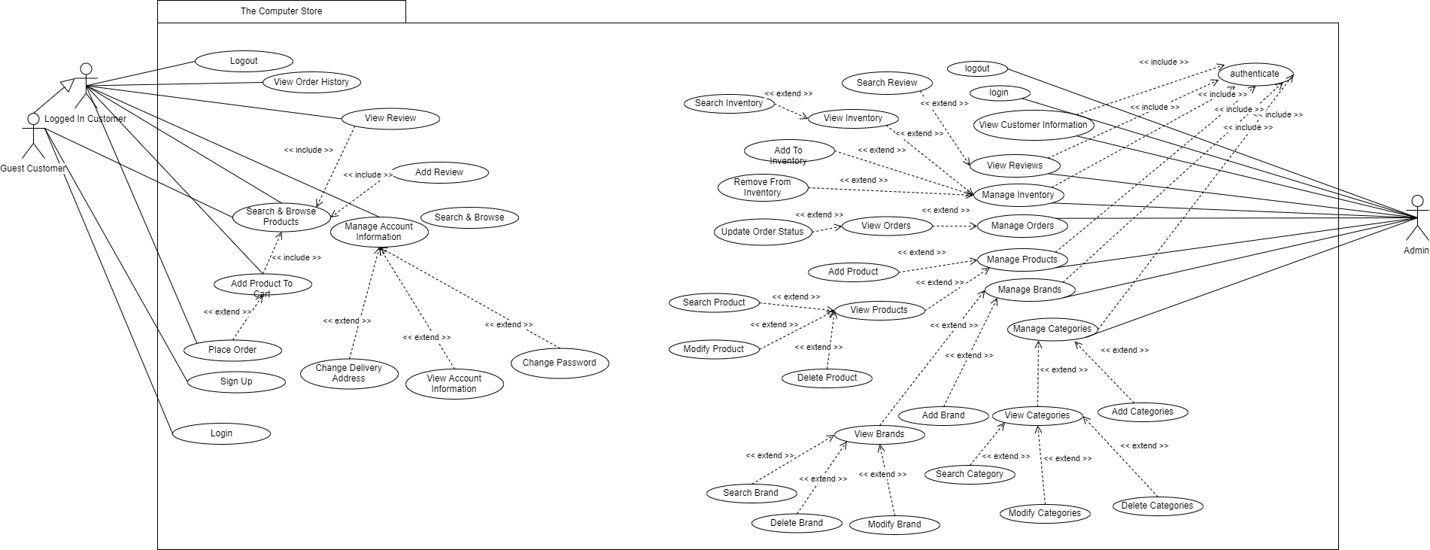

Use cases mentioned of two main actors of the system which are Admin, and User.

|  |  |
| --- | --- |
| **Use Case Description** Use cases mentioned of two main actors of the system which are Admin, and Customer.  Admin is responsible for managing website’s data while customer interacts with the added data. | |
| **Use Case name:** | The Computer Store |
|  | |
| **Primary actor:** Admin, Customer | **Other actors:** N/A |
| **Stakeholders:** | Customer, Administrator, Requirements Engineer, Developer and Project manager |
| **Relationships**   * **Includes:** Authenticate, Search & Browse Products * **Extends:** Search Review, View Inventory, Search Inventory, Add To Inventory, Remove From Inventory, View Orders, Update Order Status, Add Product, View Products, Search Product, Modify Product, Delete Product, View Brands, Search Brand, Delete Brand, Modify Brand, Add Brand, View Categories, Add Categories, Search Categories, Modify Categories, Delete Categories, Change Delivery Address, View Account Information, Change Password, Place Order. | |
| **Pre-conditions:**   * For placing order Customer must login. * Every Admin action must be authenticated. * Admin must log in with the credentials provided. | |
| **Flow of Events:**   1. Customer visits the page. 2. Customer searches & browses products. 3. Customer adds products to cart. 4. Customer places order. 5. Customer gets redirected to products page. 6. Customer reviews purchased products. 7. Admin logins in. 8. Admin can select any of the available option. | |
| **Alternative and exceptional flows:**  **4.1** If product is sold out while in cart then user is informed about it.  **7.1, 8.1** If any of the service on the page is unavailable an error page shows up. | |
| **Post-conditions:**   * User Logs out. | |

## Non-functional Requirements

##### Performance Requirements

The Web app should be hosted and deployed on a server that is able to handle every speed and scalability of the system with no problem.

##### Safety Requirements

##### Users must not perform any suspicious activity as a safety precaution. If they are found involved, they can be IP blocked.

##### Security Requirements

All activity requests requiring authentication must be authenticated, if required, before its processing.

##### User Documentation

Not applicable.

# SDS

## System Architecture

System designed is mainly categorized into two categories. Customer Side and Administrator Side. Customer Side is responsible for handling user related queries such as sign up, login, product searching and browsing. Cart system for user to ease their purchases through our platform. On the admin side, all the CRUD related queries for all website’s data are handled and every detail is accessible by admin except the user password that is encrypted and belongs solely to the customer.

### System Level Architecture

The deployment and component diagram below may help towards better understanding of the architecture.

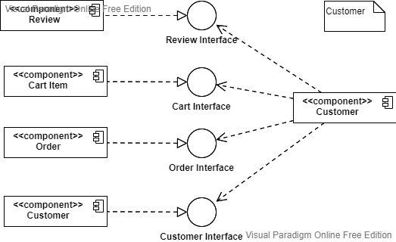

Above component diagram shows how customer interact with other components inside the system.

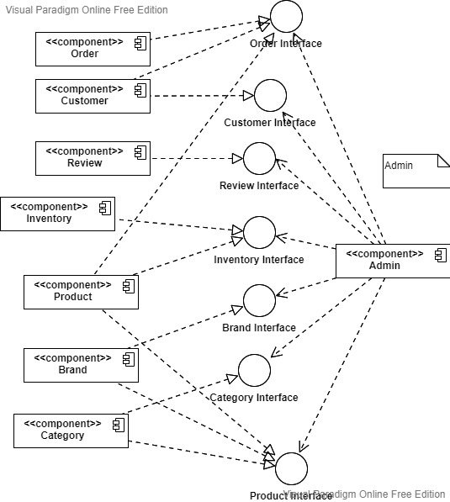

Above Component Diagram shows how admin manages different operations.

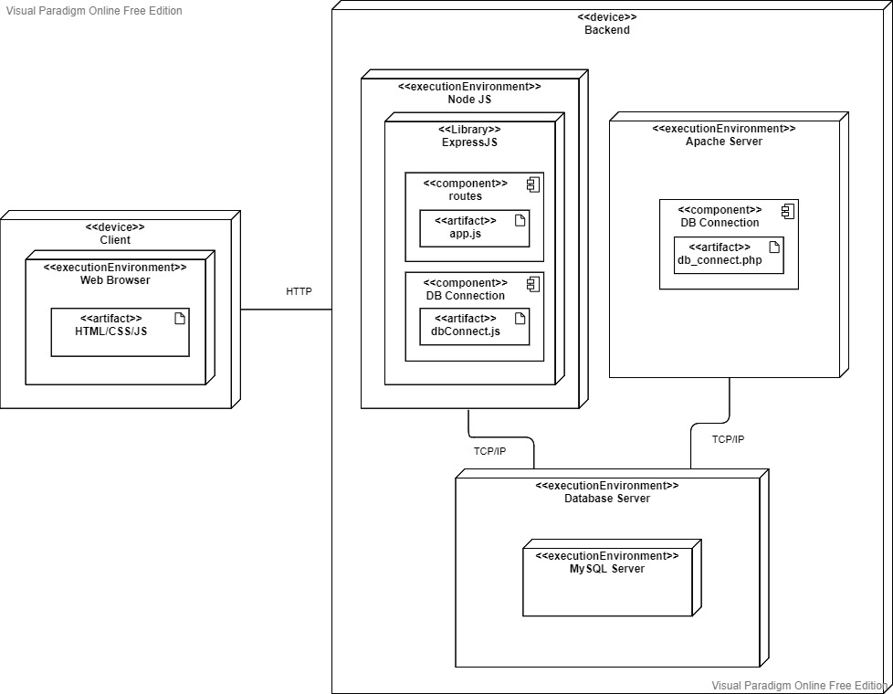

Above Deployment Diagram shows how the whole architecture is structured of the system

### Software Architecture

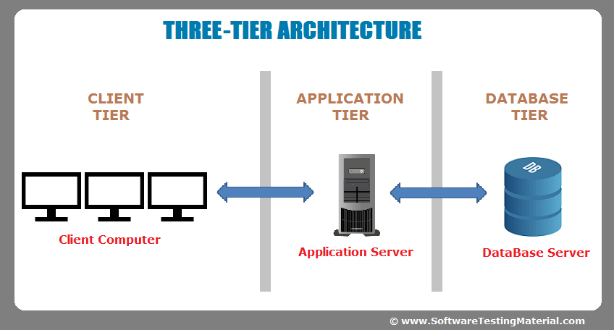

3 Tier Schema will be followed.

## Design Strategy

The system can be extended by adding multiple features in future like online payment, delivery tracking. Statistical features can also be implemented to provide the administrator with proper information about different business insights.  
User interface can also be enhanced by making it more interactive like navigation, more visual feedback, and more information etc.

## Detailed System Design

### Database Design

#### ER Diagram

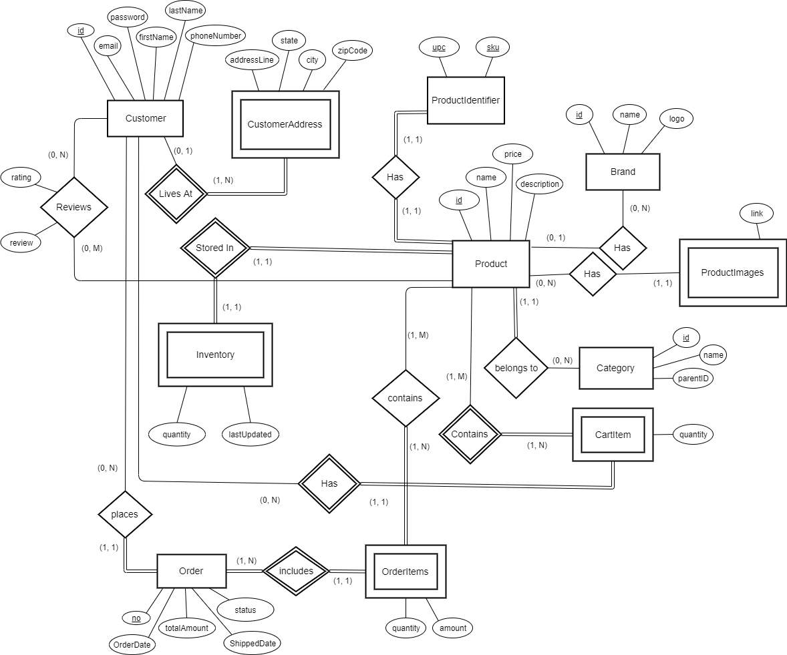

#### Data Dictionary

* + - 1. Data 1

|  |  |  |  |  |  |  |  |
| --- | --- | --- | --- | --- | --- | --- | --- |
| **Product Brands** | | | | | | | |
| ***Name*** | | *brands* | | | | | |
| ***Alias*** | | *N/A* | | | | | |
| ***Where-used/how- used*** | | *Provides the brand name and logo for the product.* | | | | | |
| ***Content description*** | | *Stores the brand name and logo for a brand.* | | | | | |
|  | | | | | | | |
| ***Column Name*** | ***Description*** | | ***Type*** | ***Length*** | ***Nullable*** | ***Default Value*** | ***Key Type*** |
| *id* | *ID used to identify the brand* | | *int* | *11* | *no* | *<auto increment>* | *Primary key* |
| *name* | *Brand’s name* | | *varchar* | *64* | *no* | *none* | *None* |
| *logo* | *Brand’s logo path on computer* | | *varchar* | *256* | *yes* | *NULL* | *None* |

* + - 1. Data 2

|  |  |  |  |  |  |  |  |
| --- | --- | --- | --- | --- | --- | --- | --- |
| **Product Categories** | | | | | | | |
| ***Name*** | | *categories* | | | | | |
| ***Alias*** | | *N/A* | | | | | |
| ***Where-used/how- used*** | | *Provides the category name for the product.* | | | | | |
| ***Content description*** | | *Stores the category name and its parent.* | | | | | |
|  | | | | | | | |
| ***Column Name*** | ***Description*** | | ***Type*** | ***Length*** | ***Nullable*** | ***Default Value*** | ***Key Type*** |
| *id* | *ID used to identify the category* | | *int* | *11* | *no* | *<auto increment>* | *Primary key* |
| *name* | *Category name* | | *varchar* | *64* | *no* | *none* | *None* |
| *parentID* | *ID of category on which this category belongs to.* | | *int* | *11* | *yes* | *NULL* | *Foreign key* |

* + - 1. Data 3

|  |  |  |  |  |  |  |  |
| --- | --- | --- | --- | --- | --- | --- | --- |
| **Customer’s Address** | | | | | | | |
| ***Name*** | | *customeraddress* | | | | | |
| ***Alias*** | | *N/A* | | | | | |
| ***Where-used/how- used*** | | *Provides the address of the customer upon the time of placing order.* | | | | | |
| ***Content description*** | | *Stores the address details of the customer.* | | | | | |
|  | | | | | | | |
| ***Column Name*** | ***Description*** | | ***Type*** | ***Length*** | ***Nullable*** | ***Default Value*** | ***Key Type*** |
| *id* | *ID of the customer of which the address is stored* | | *int* | *11* | *no* | *None* | *Foreign key + Primary key* |
| *addressLine* | *Address on which the customer lives (or his delivery address)* | | *varchar* | *256* | *No* | *None* | *None* |
| *state* | *State of the city in which the customer lives* | | *varchar* | *50* | *No* | *None* | *None* |
| *City* | *Residence city of customer* | | *varchar* | *50* | *No* | *None* | *None* |
| *zipCode* | *Identifies the area of customers residence* | | *varchar* | *8* | *No* | *None* | *None* |

* + - 1. Data 4

|  |  |  |  |  |  |  |  |
| --- | --- | --- | --- | --- | --- | --- | --- |
| **Customer Details** | | | | | | | |
| ***Name*** | | *customers* | | | | | |
| ***Alias*** | | *N/A* | | | | | |
| ***Where-used/how- used*** | | *Provides the customer details when required (e.g. password on login).* | | | | | |
| ***Content description*** | | *Stores the details of the customer except address.* | | | | | |
|  | | | | | | | |
| ***Column Name*** | ***Description*** | | ***Type*** | ***Length*** | ***Nullable*** | ***Default Value*** | ***Key Type*** |
| *id* | *ID of the customer.* | | *int* | *11* | *No* | *<auto increment>* | *Primary key* |
| *email* | *Email address of the customer used for user identification (login purposes).* | | *varchar* | *320* | *No* | *None* | *Unique* |
| *password* | *Security key used by customer to login.* | | *binary* | *60* | *No* | *None* | *None* |
| *firstName* | *First name of the customer.* | | *varchar* | *50* | *No* | *None* | *None* |
| *lastName* | *Last name of the customer.* | | *varchar* | *50* | *No* | *None* | *None* |
| *phoneNumber* | *Phone number used to contact the customer.* | | *varchar* | *11* | *No* | *None* | *None* |

* + - 1. Data 5

|  |  |  |  |  |  |  |  |
| --- | --- | --- | --- | --- | --- | --- | --- |
| **Product IDs** | | | | | | | |
| ***Name*** | | *productidentifier* | | | | | |
| ***Alias*** | | *N/A* | | | | | |
| ***Where-used/how- used*** | | *Used for product searching upon product management.* | | | | | |
| ***Content description*** | | *Actual identifiers of the product.* | | | | | |
|  | | | | | | | |
| ***Column Name*** | ***Description*** | | ***Type*** | ***Length*** | ***Nullable*** | ***Default Value*** | ***Key Type*** |
| *upc* | *Universal product code, identifies the product.* | | *varchar* | *12* | *No* | *None* | *Primary key* |
| *sku* | *Stock keeping unit, identifies the product variation* | | *varchar* | *64* | *No* | *None* | *Primary key* |
| *id* | *Used to identify the product details* | | *int* | *11* | *No* | *None* | *Foreign key* |

* + - 1. Data 6

|  |  |  |  |  |  |  |  |
| --- | --- | --- | --- | --- | --- | --- | --- |
| **Product Details** | | | | | | | |
| ***Name*** | | *products* | | | | | |
| ***Alias*** | | *N/A* | | | | | |
| ***Where-used/how- used*** | | *Provides the entire product details when customer visits product lists/product details page.* | | | | | |
| ***Content description*** | | *Stores the entire product details.* | | | | | |
|  | | | | | | | |
| ***Column Name*** | ***Description*** | | ***Type*** | ***Length*** | ***Nullable*** | ***Default Value*** | ***Key Type*** |
| *id* | *Used to identify the product details.* | | *int* | *11* | *No* | *<auto increment>* | *Primary key* |
| *name* | *What the product is called, contains description summary.* | | *varchar* | *250* | *No* | *None* | *Unique* |
| *price* | *How much the product is being sold for.* | | *Decimal* | *(10,2)* | *No* | *0.00* | *None* |
| *description* | *Contains brief description of the product.* | | *text* | *-* | *Yes* | *NULL* | *None* |
| *brandID* | *Brand on which the product belongs to.* | | *int* | *11* | *Yes* | *NULL* | *Foreign key* |
| *categoryID* | *Category on which the product belongs to.* | | *int* | *11* | *No* | *None* | *Foreign key* |

* + - 1. Data 7

|  |  |  |  |  |  |  |  |
| --- | --- | --- | --- | --- | --- | --- | --- |
| **Product Reviews** | | | | | | | |
| ***Name*** | | *reviews* | | | | | |
| ***Alias*** | | *N/A* | | | | | |
| ***Where-used/how- used*** | | *Used when user visits product details page or adds review.* | | | | | |
| ***Content description*** | |  | | | | | |
|  | | | | | | | |
| ***Column Name*** | ***Description*** | | ***Type*** | ***Length*** | ***Nullable*** | ***Default Value*** | ***Key Type*** |
| *customerID* | *Customer who reviewed the product.* | | *int* | *11* | *No* | *None* | *Primary key + Foreign key* |
| *productID* | *Product which is reviewed.* | | *int* | *11* | *No* | *None* | *Primary key + Foreign key* |
| *rating* | *Rating (out of 5) provided to the product* | | *int* | *1)* | *No* | *None* | *None* |
| *review* | *Customers opinion about the product (Actual review)* | | *text* | *-* | *Yes* | *NULL* | *None* |

* + - 1. Data 8

|  |  |  |  |  |  |  |  |
| --- | --- | --- | --- | --- | --- | --- | --- |
| **Product Inventory** | | | | | | | |
| ***Name*** | | *inventory* | | | | | |
| ***Alias*** | | *N/A* | | | | | |
| ***Where-used/how- used*** | | *Used for stock information of product (In Stock/Out of Stock).* | | | | | |
| ***Content description*** | | *Stores the stock details of product.* | | | | | |
|  | | | | | | | |
| ***Column Name*** | ***Description*** | | ***Type*** | ***Length*** | ***Nullable*** | ***Default Value*** | ***Key Type*** |
| *productID* | *Identifies the product.* | | *int* | *11* | *No* | *None* | *Primary key + Foreign key* |
| *quantity* | *Quantity of product currently in stock.* | | *int* | *11* | *No* | *0* | *None* |
| *lastUpdated* | *Date on which the product’s inventory was updated.* | | *date* | *-* | *No* | *Current_timestamp()* | *None* |

* + - 1. Data 9

|  |  |  |  |  |  |  |  |
| --- | --- | --- | --- | --- | --- | --- | --- |
| **Product Images** | | | | | | | |
| ***Name*** | | *productimages* | | | | | |
| ***Alias*** | | *N/A* | | | | | |
| ***Where-used/how- used*** | | *Used when product is displayed to customer (provides image).* | | | | | |
| ***Content description*** | | *Stores the image link for the product.* | | | | | |
|  | | | | | | | |
| ***Column Name*** | ***Description*** | | ***Type*** | ***Length*** | ***Nullable*** | ***Default Value*** | ***Key Type*** |
| *productID* | *Identifies the product.* | | *int* | *11* | *No* | *None* | *Foreign key* |
| *link* | *Address of the image stored on the computer.* | | *varchar* | *256* | *No* | *None* | *None* |

* + - 1. Data 10

|  |  |  |  |  |  |  |  |
| --- | --- | --- | --- | --- | --- | --- | --- |
| **Product Cart Items** | | | | | | | |
| ***Name*** | | *cartitem* | | | | | |
| ***Alias*** | | *N/A* | | | | | |
| ***Where-used/how- used*** | | *Used when customer adds a product to cart, allows him to manage product quantity and he can order multiple items at the same time.* | | | | | |
| ***Content description*** | | *Stores the cart information (Which product is added to cart by which customer and the quantity of the item).* | | | | | |
|  | | | | | | | |
| ***Column Name*** | ***Description*** | | ***Type*** | ***Length*** | ***Nullable*** | ***Default Value*** | ***Key Type*** |
| *customerID* | *Identifies the customer who has product in cart.* | | *int* | *11* | *No* | *None* | *Primary key + Foreign key* |
| *productID* | *Identifies the product in cart.* | | *int* | *11* | *No* | *None* | *Primary key + Foreign key* |
| *quantity* | *Quantity of product in cart.* | | *int* | *11* | *No* | *None* | *None* |

* + - 1. Data 11

|  |  |  |  |  |  |  |  |
| --- | --- | --- | --- | --- | --- | --- | --- |
| **Order Items** | | | | | | | |
| ***Name*** | | *orderitems* | | | | | |
| ***Alias*** | | *N/A* | | | | | |
| ***Where-used/how- used*** | | *Used to store and display the products ordered in an order placed by customer.* | | | | | |
| ***Content description*** | | *Stores the product with quantity and amount ordered.* | | | | | |
|  | | | | | | | |
| ***Column Name*** | ***Description*** | | ***Type*** | ***Length*** | ***Nullable*** | ***Default Value*** | ***Key Type*** |
| *orderNo* | *Identifies the order containing the order items.* | | *int* | *11* | *No* | *<auto increment>* | *Primary key + Foreign key* |
| *productID* | *Identifies the product ordered.* | | *int* | *11* | *No* | *None* | *Primary key + Foreign key* |
| *quantity* | *Quantity of product ordered.* | | *int* | *11* | *No* | *None* | *None* |
| *amount* | *Total order amount for that specific product.* | | *Decimal* | *(10,2)* | *No* | *None* | *None* |

* + - 1. Data 12

|  |  |  |  |  |  |  |  |
| --- | --- | --- | --- | --- | --- | --- | --- |
| **Orders** | | | | | | | |
| ***Name*** | | *order* | | | | | |
| ***Alias*** | | *N/A* | | | | | |
| ***Where-used/how- used*** | | *Used to store and display the basic order details of the order placed by customer* | | | | | |
| ***Content description*** | | *Stores which customer placed order, the order amount, when its ordered and what is its current status.* | | | | | |
|  | | | | | | | |
| ***Column Name*** | ***Description*** | | ***Type*** | ***Length*** | ***Nullable*** | ***Default Value*** | ***Key Type*** |
| *no* | *Identifies the order placed.* | | *int* | *11* | *No* | *None* | *Primary key* |
| *customerID* | *Identifies the customer who palced the order.* | | *int* | *11* | *No* | *None* | *Foreign key* |
| *OrderDate* | *Date on which the order was placed.* | | *date* | *-* | *No* | *Current_timestamp()* | *None* |
| *totalAmount* | *Total billing amount for that order.* | | *Decimal* | *(10,2)* | *No* | *0* | *None* |
| *ShippedDate* | *Date on which product was shipped to the customer.* | | *date* | *-* | *Yes* | *NULL* | *None* |
| *status* | *Stores the current status of the order (Pending, Shipped, Delivered, Returned, Canceled, Failed).* | | *varchar* | *10* | *No* | *Pending* | *None* |

### Application Design

#### Sequence Diagram

* + - 1. <Sequence Diagram 1>

This sequence diagram shows admin use case of viewing, adding, removing and modifying products.

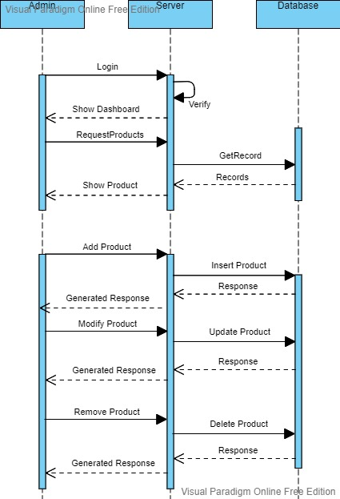

#### State Diagram

* + - 1. <State Diagram 1>

State Diagram shows the status of order after it is placed by the customer.

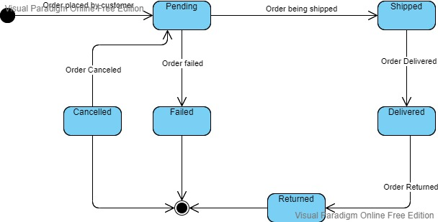

#### Activity Diagram

* + - 1. <Activity Diagram 1>

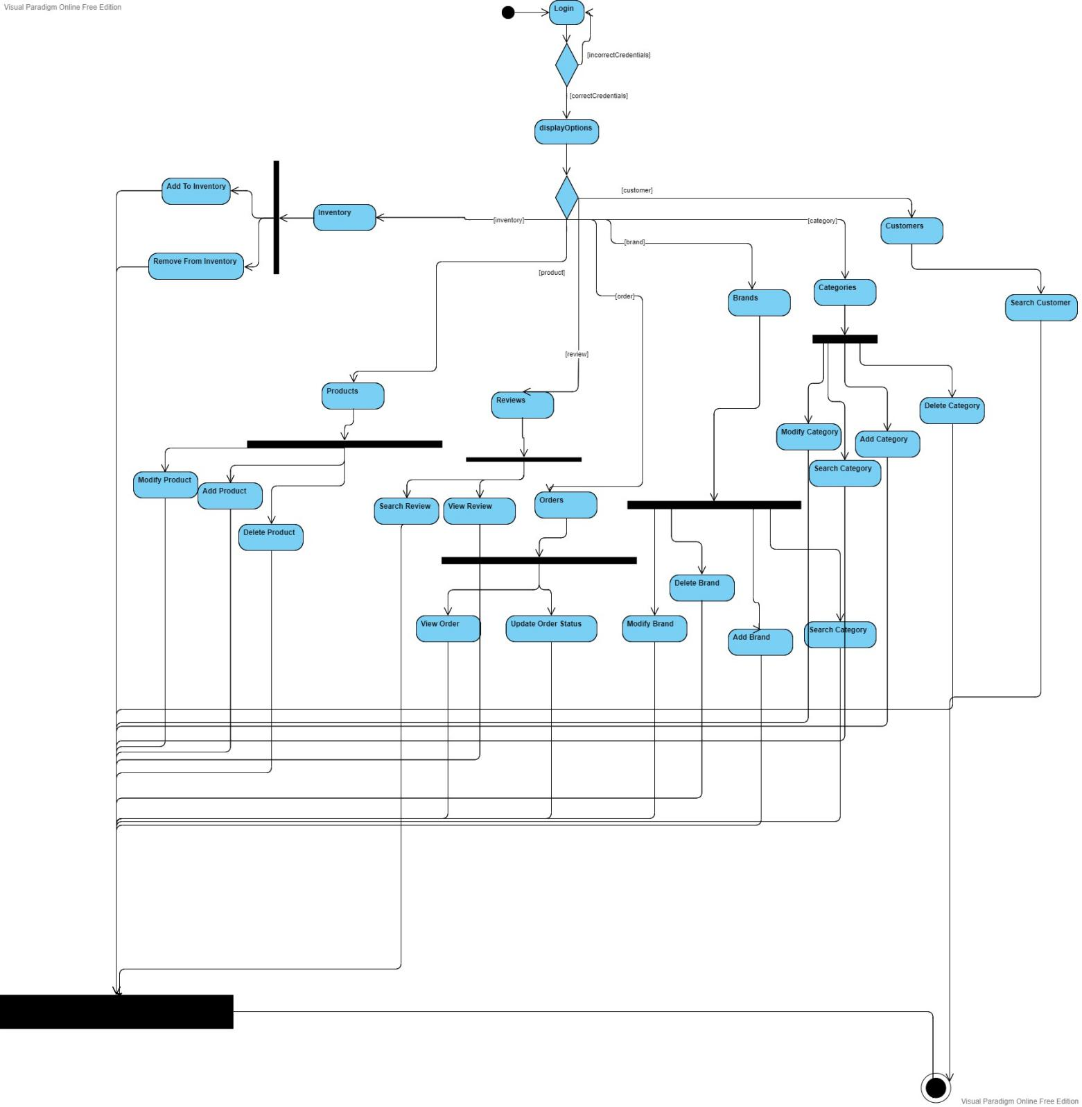

Diagram demonstrating admin activity.

* + - 1. <Activity Diagram 2>

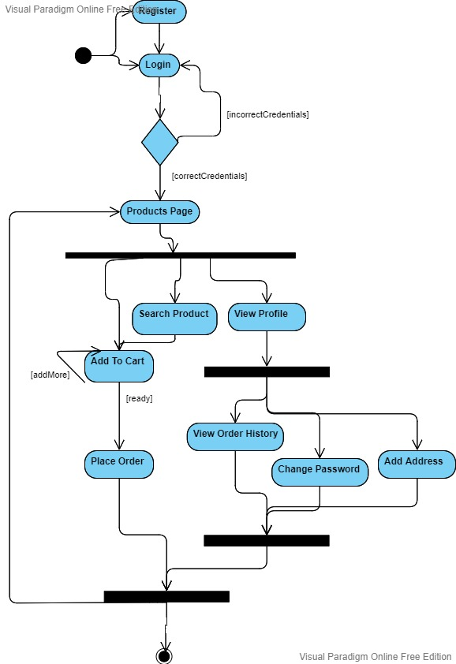

Diagram demonstrating user activity.

## References

## Not Applicable.

## Appendices

Not Applicable.