# Day_5_Testing_Error_Handling_and_Backend_Integration_Refinement.pdf

Step:01: Functional Testing

"Everything is working fine according to my expectations. The product cart is adding items correctly, updating quantities, removing products, and calculating the total price as expected. The checkout button also redirects properly with the correct details and my website is fully responsive."

Step:02: Error Handling

My API is working properly but my products images are loading slowly

Step:03: Thunder Client API

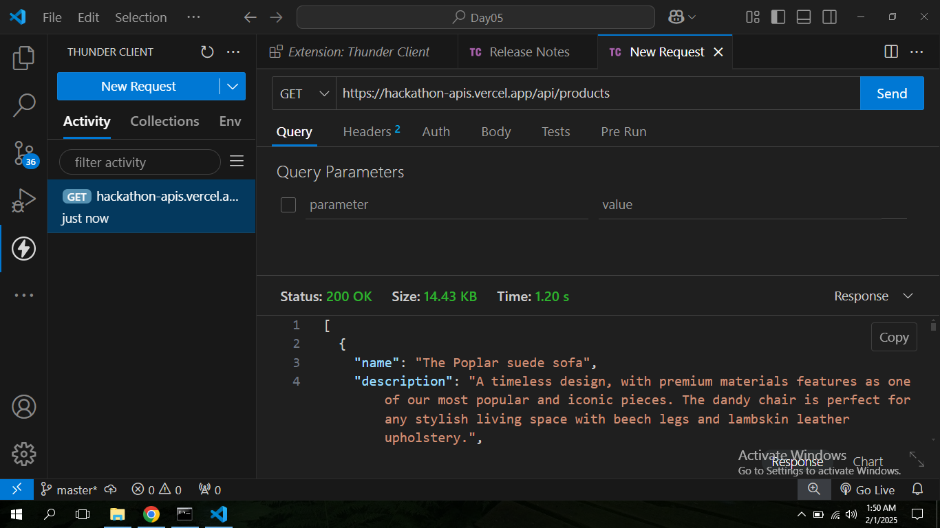

|  |  |  |  |  |  |  |  |  |  |
| --- | --- | --- | --- | --- | --- | --- | --- | --- | --- |
| **Test Case ID** | **Test Case Description** | **Test Steps** | **Expected Result** | **Actual Result** | **Status** | **Severity Level** | **Assigned To** | **Remarks** |  |
| 2 | TC001 | Validate product listing page | Open product page > Verify products | Products displayed correctly | Products displayed correctly | Passed | High | - | No issues found |
| 3 | TC002 | Test API error handling | Disconnect API > Refresh page | Show fallback UI with error message | Error message shown | Passed | Medium | - | Handled gracefully |
| 4 | TC003 | Check cart functionality | Add product to cart > Verify cart contents | Cart updates with added product | Cart updates as expected | Passed | High | - | Works as expected |
| 5 | TC004 | Ensure responsiveness on mobile | Resize browser window > Check layout | Layout adjusts properly to screen size | Responsive layout working as intended | Passed | Medium | - | Test successful |

Step:04: Performance Optimization

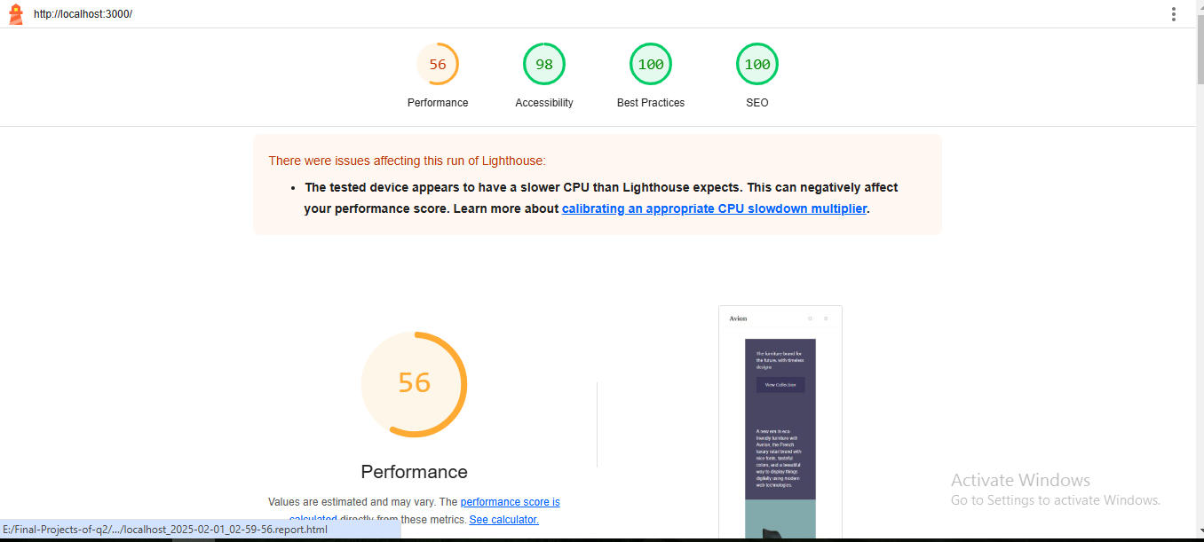

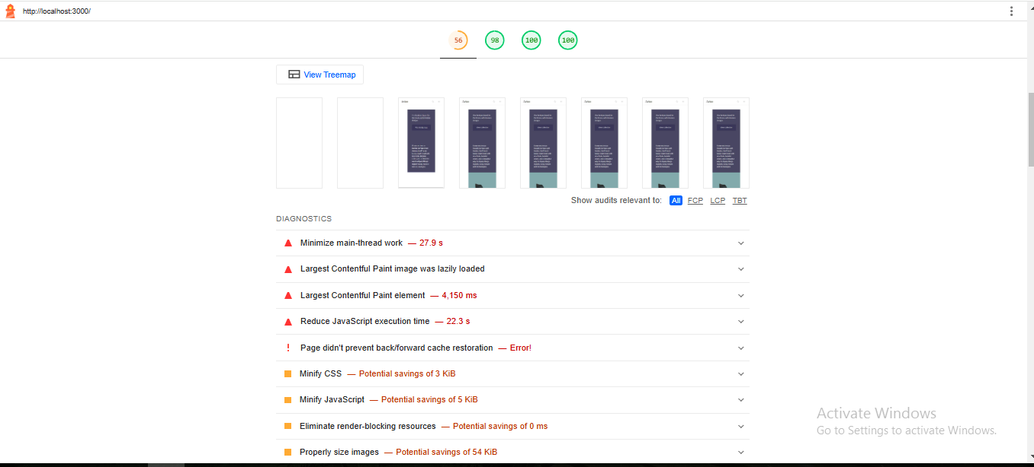

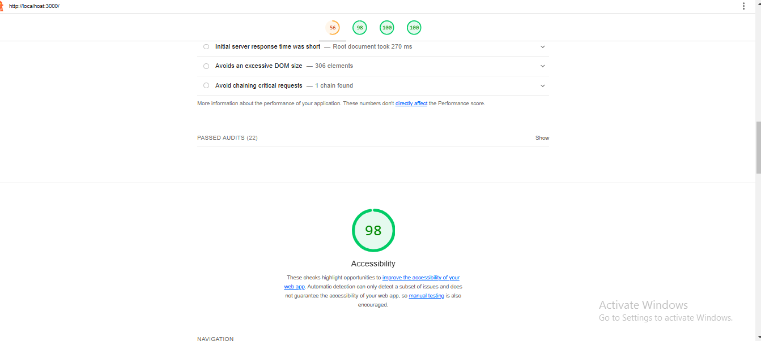

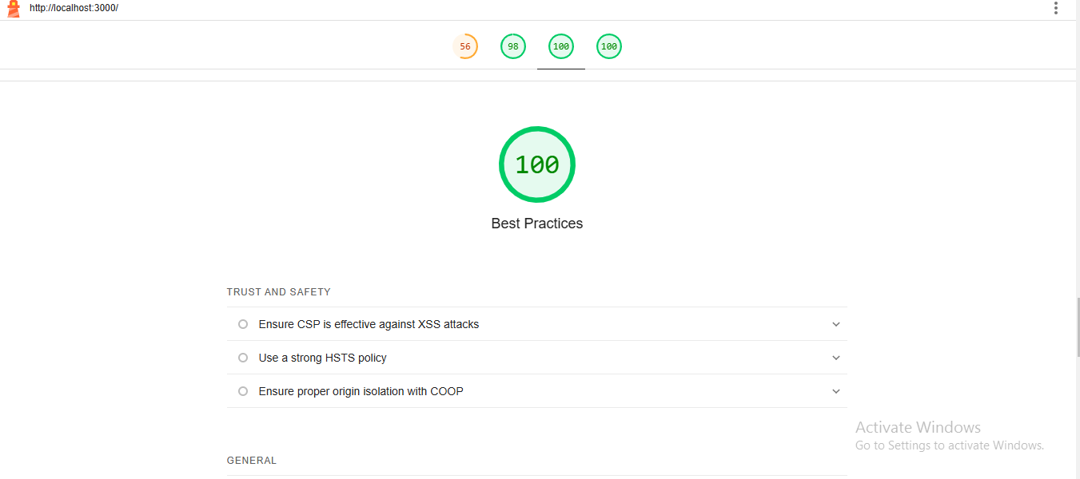

Developer Resources

