USE OLAP_HW

CREATE TABLE [Dbo].[FaktOrders](

[OrderID] [int] NOT NULL,

[CustomerID] [int] NOT NULL,

[SalespersonPersonID] [int] NOT NULL,

[OrderDate] [date] NOT NULL,

[DeliveryMethodName] [nvarchar](50) NOT NULL

CONSTRAINT [PK_FaktOrders] PRIMARY KEY CLUSTERED

(

[OrderID] ASC

))

INSERT [Dbo].[FaktOrders]

SELECT so.OrderID,so.CustomerID,so.SalespersonPersonID,so.OrderDate,adm.DeliveryMethodName FROM [WideWorldImporters].Sales.Orders so

JOIN [WideWorldImporters].Sales.Invoices si ON so.OrderID = si.OrderID

JOIN [WideWorldImporters].Application.DeliveryMethods adm ON adm.DeliveryMethodID = si.DeliveryMethodID

CREATE TABLE [Dbo].[DimCustomers](

[CustomerID] [int] NOT NULL,

[CustomerName] [nvarchar](100) NOT NULL,

[CreditLimit] [decimal](18, 2) NULL,

[AccountOpenedDate] [date] NOT NULL,

CONSTRAINT [PK_DimCustomers] PRIMARY KEY CLUSTERED

(

[CustomerID] ASC

)

)

GO

INSERT [Dbo].[DimCustomers]

SELECT [CustomerID],[CustomerName],[CreditLimit],[AccountOpenedDate] FROM [WideWorldImporters].Sales.Customers

GO

CREATE TABLE [Dbo].[DimPeople](

[PersonID] [int] NOT NULL,

[FullName] [nvarchar](50) NOT NULL,

[EmailAddress] [nvarchar](256) NULL

CONSTRAINT [PK_DimPeople] PRIMARY KEY CLUSTERED

(

[PersonID] ASC

)

)

GO

INSERT [Dbo].[DimPeople]

SELECT [PersonID],[FullName],[EmailAddress] FROM [WideWorldImporters].Application.People

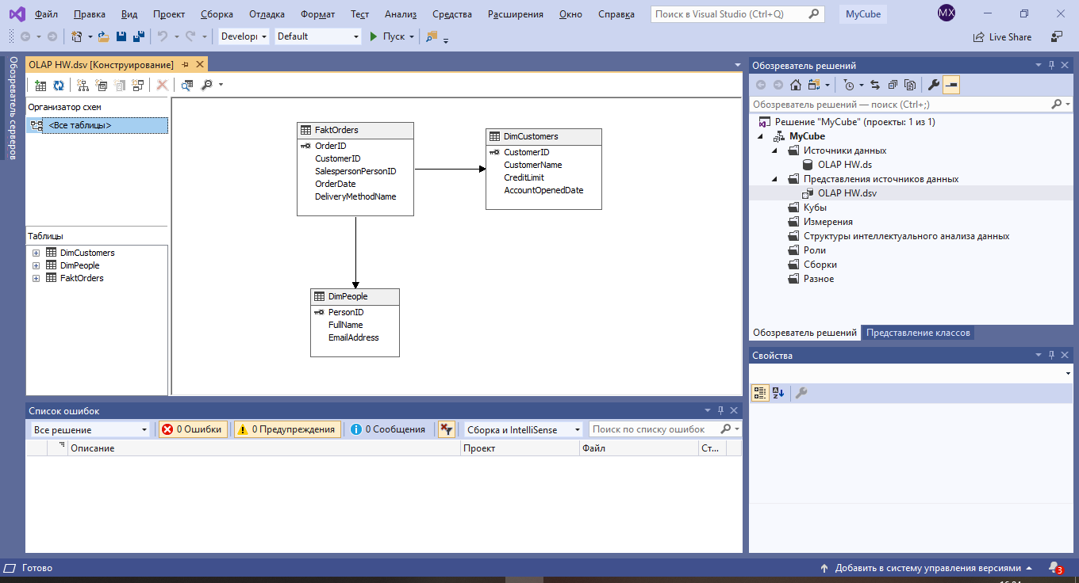

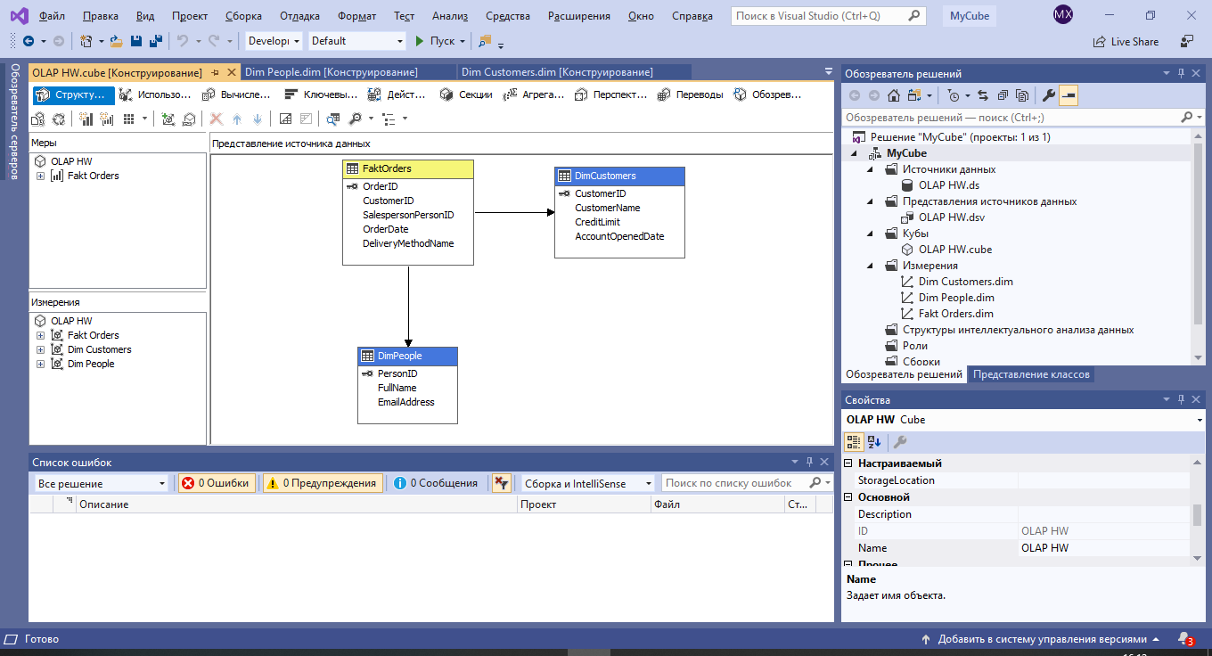

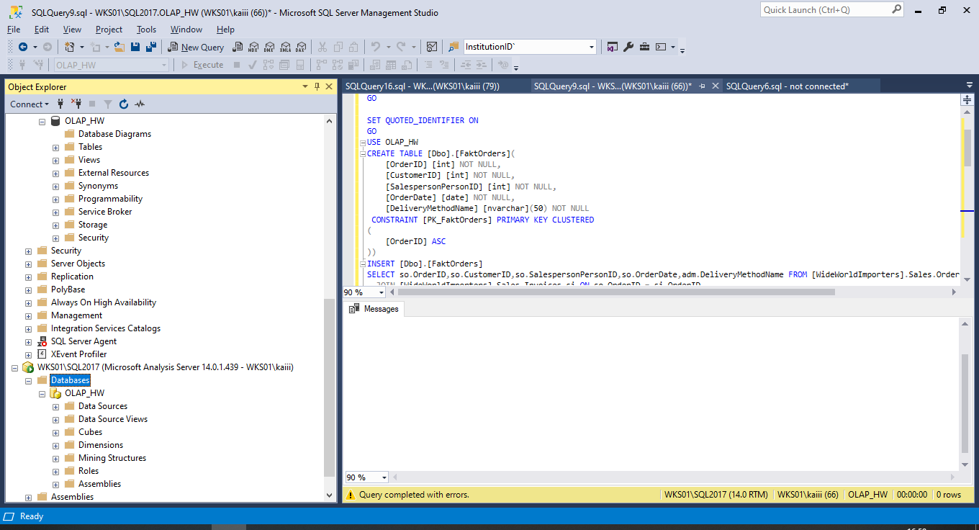

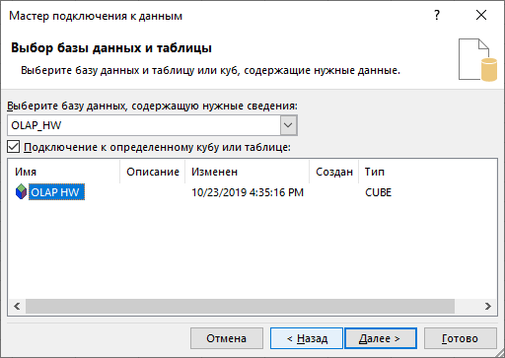

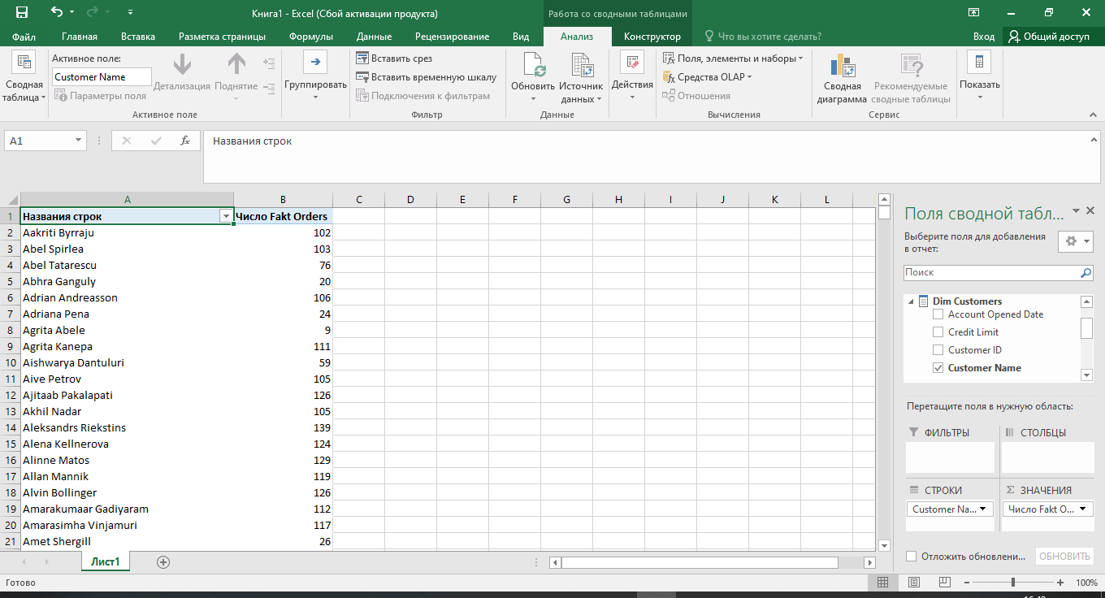

Количество продаж по клиентам

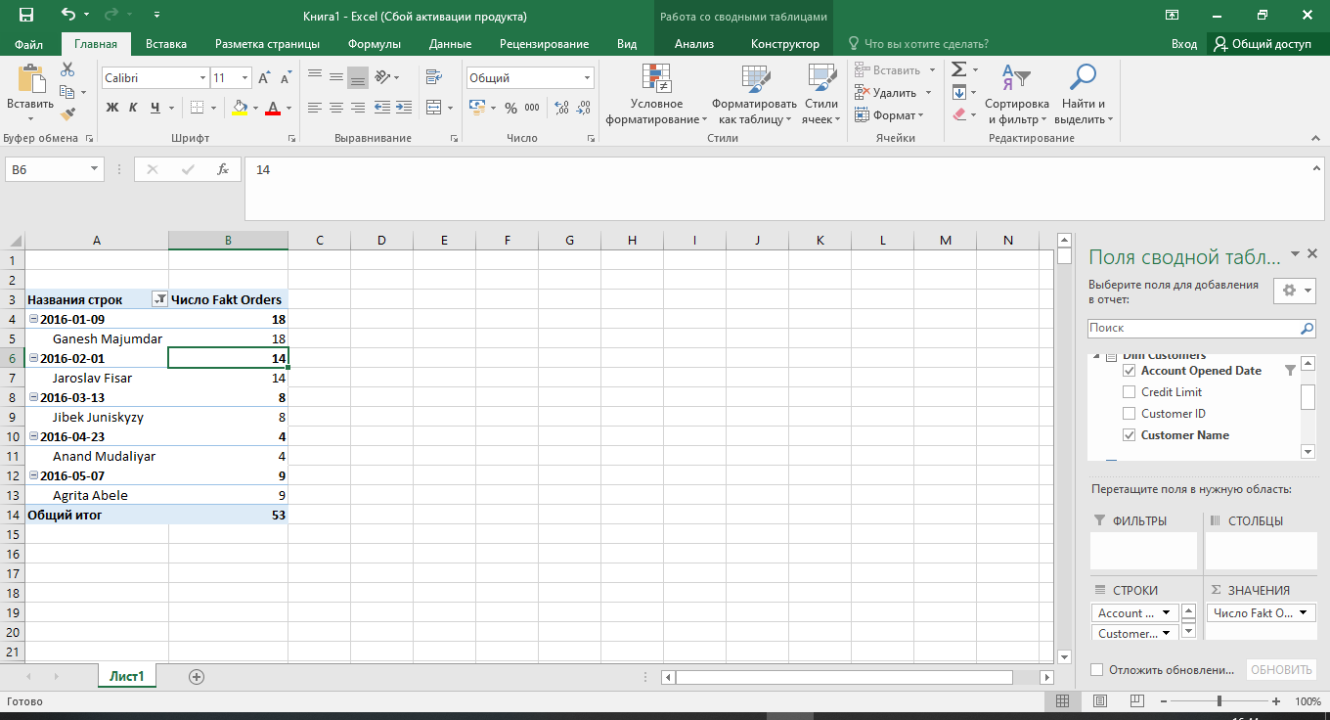

Количество продаж по счетам клиентов открытым в 2016 году

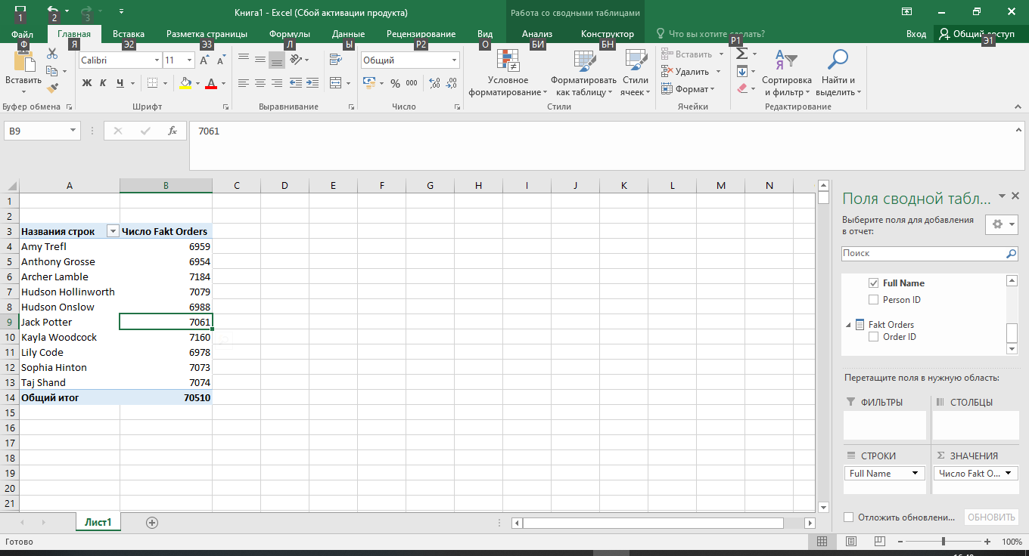

Количество продаж в разрезе сотрудников