Title: A satellite-data-driven distributed conceptual hydrological model with mass-conserving-perceptron for the Upper Meghna Basin.
Problem Statement: The Upper Meghna Basin (UMB) is an important transboundary river between Bangladesh and India with limited gauge stations. Data sharing between countries is often difficult due to many reasons. The 65,000 sq. km. UMB is a complex transboundary river basin shared between Bangladesh and India, including wet mountainous regions and deltaic low flood plains, with around 166 large and 6,300 smaller water bodies called “Haors” and “Beels”, respectively (Rahaman et al., 2021). The Meghalaya, Barak, and Tripura regions of India (67% of UMB) are the major hilly sub-basins where heavy seasonal rainfalls occur, which rapidly flash enormous water volumes through the low-lying Sylhet sub-basin of Bangladesh (33% of UMB) (Masood & Takeuchi, 2016).
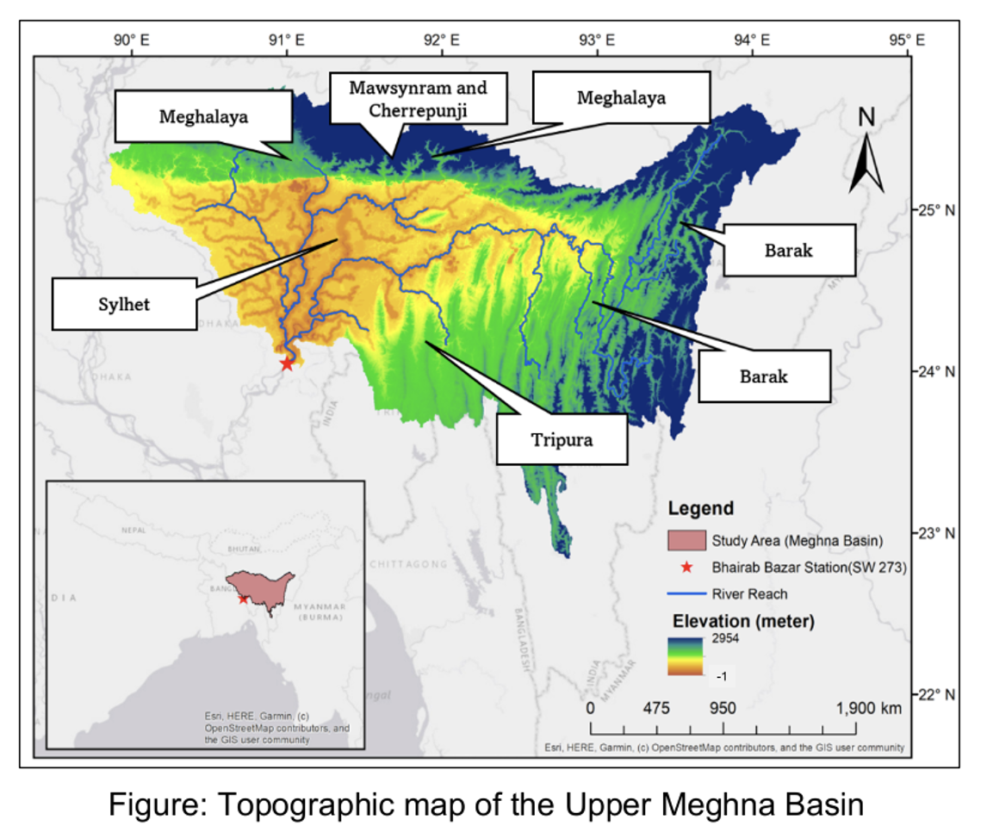
The basin’s heavy rainfall and geological features give it a flashy hydrological nature, and almost every year the low-lying regions in Bangladesh experience pre-monsoon flash floods and monsoon flooding, causing severe damage to human lives, agriculture, fisheries, and infrastructure (Masood & Takeuchi, 2016). The basin also includes the world’s two wettest regions, Mawsynram and Cherrapunji, which receive an annual rainfall of approximately 11,430 mm, with record daily rainfall reaching up to 1,003 mm and 1,560 mm, respectively (Rahman et al., 2020). Rapid changes in climate are expected to severely alter hydrological behaviors and the flow regimes of the basin (Islam et al., 2018), which may further worsen flood risks in the future. The compound effects of the UMB and two other major basins: the Ganges and Brahmaputra, could lead to devastating impacts in Bangladesh (Gadeke et al., 2022).
Therefore, it is very important to assess climate change impacts on the UMB, particularly for future conditions, to support sustainable policymaking at both national and international levels. One of the key strategies to assess climate change impacts on river basins is to model streamflow, for which hydrological models are commonly used (Islam et al., 2018).
However, recent studies have shown that machine learning and deep learning (ML & DL) models are more efficient and frequently outperform traditional hydrological models in streamflow prediction and forecasting (Lange & Sippel, 2020). Additionally, recent studies indicate that among various DL models, the Long Short-Term Memory (LSTM) model consistently demonstrates superior performance in predicting basin streamflow (Arsenault et al., 2023; Fan et al., 2023; Le et al., 2023; Sabzipour et al., 2023).
Proposed Project: Considering the importance of a highly accurate and fast hydrological model for the UMB, the current project proposes to build a satellite-data-driven MCP based fast distributed hydrological model for that region or least give the fundamental framework upon which future work can be done to refine the model. This will allow engineers, policymakers, water resources managers and others to quickly simulate results, predict near future, analyze climate impact and take appropriate decisions confidently. The main objectives of the current project are:
- To create mass conserving perceptron or physics based improved perceptron.
- Use this perceptron and 87 grided precipitation and temperature data to build a conceptual distributed hydrological model for the UMB.
- Verify the model and publish it for further future work or improvement.

Dataset:
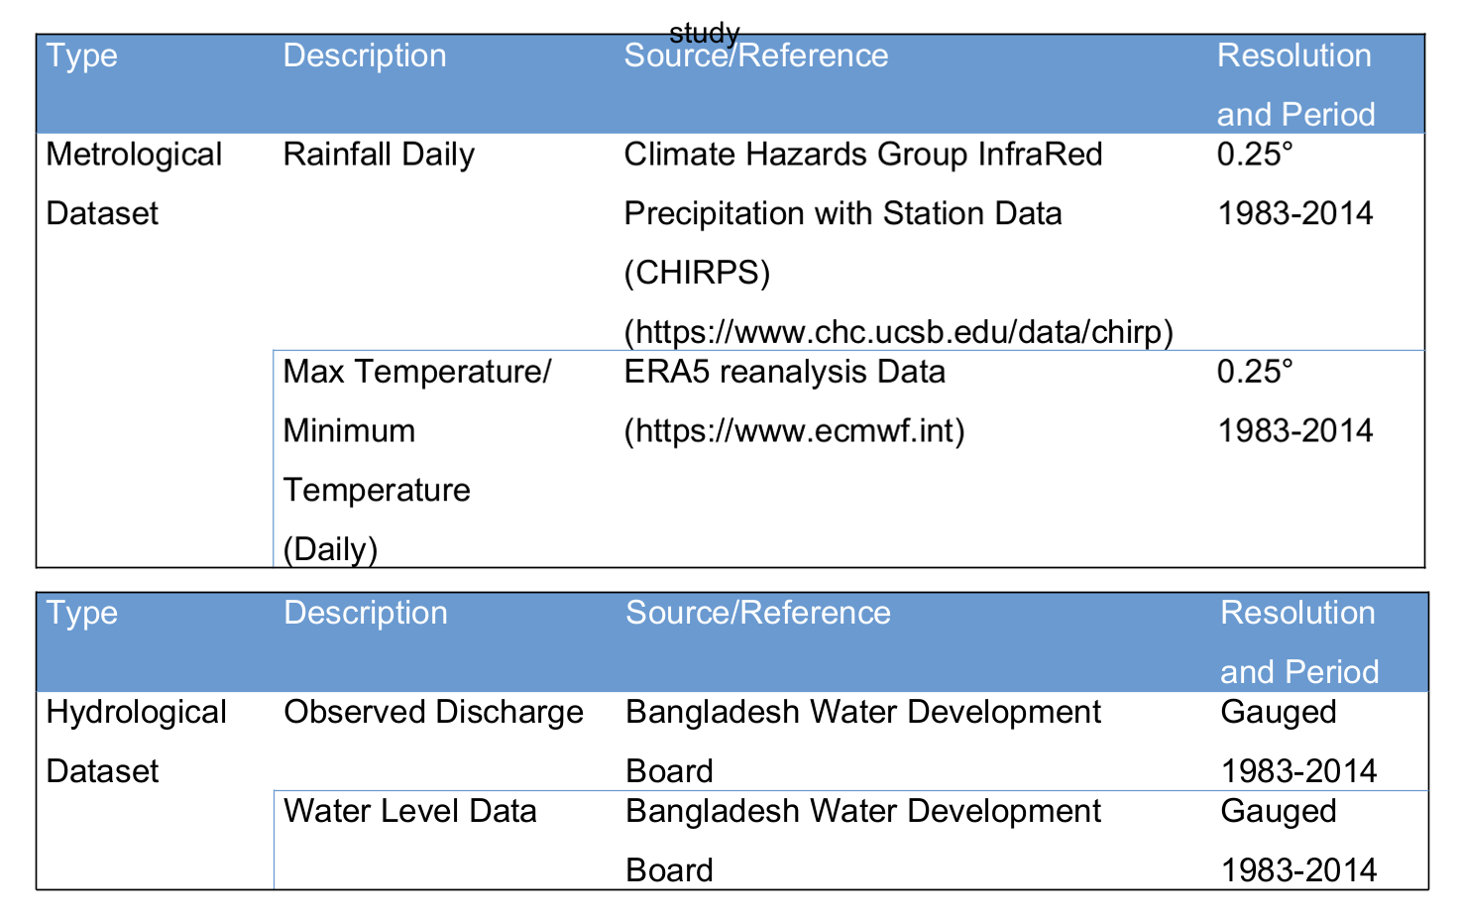
Methodology:
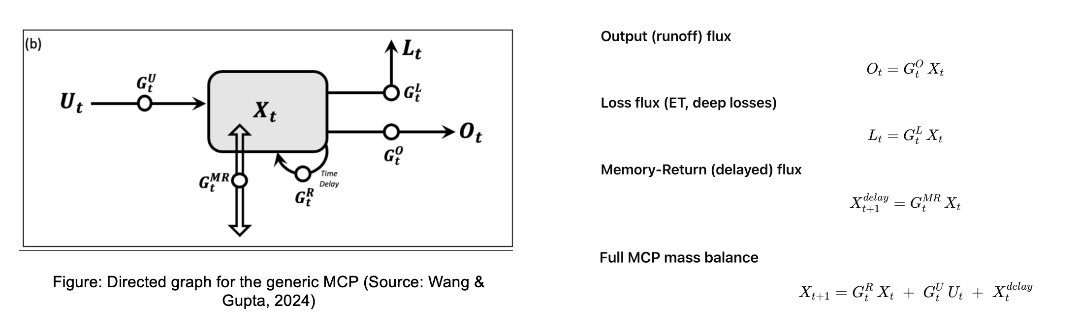
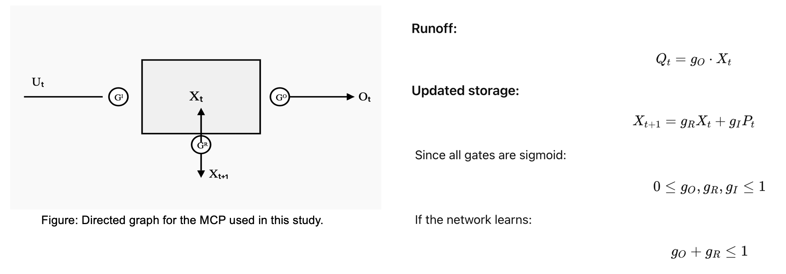
The MCP will be created using gated functions with LSTM perceptron as directed by Wang & Gupta, 2024. Then with that perceptron, first, a lumped model will be created which then will be further refined to a distributed model for each grided/ sub-basin points. Necessary physical concepts will be introduced along the way to better represent the physics in the model.
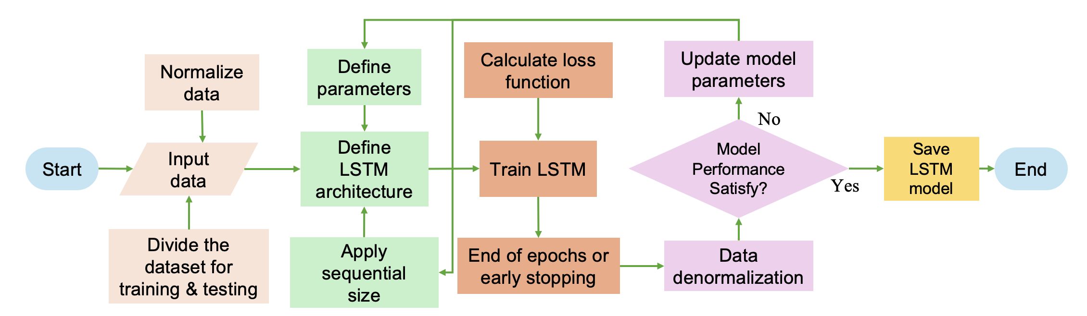
Expected outcome: An improved representative data-driven fast hydrological model for the UMB that can be used for better decision making and hydrological analysis, rapid simulation and others. This model can be also improved further as future work and can be handed over to the governmental agencies such Bangladesh Water Development Board and the conceptual framework can be published to the scientific community for knowledge sharing.

References:
Arsenault, R., Martel, J.-L., Brunet, F., Brissette, F., & Mai, J. (2023). Continuous streamflow prediction in ungauged basins: Long short-term memory neural networks clearly outperform traditional hydrological models. Hydrology and Earth System Sciences, 27(1), 139–157. https://doi.org/10.5194/hess-27-139-2023

Fan, H., Jiang, M., Xu, L., Zhu, H., Cheng, J., & Jiang, J. (2020). Comparison of long short-term memory networks and the hydrological model in runoff simulation. Water, 12(1), Article 1. https://doi.org/10.3390/w12010175

Islam, A. S., Paul, S., Mohammed, K., Billah, M., Fahad, M. G. R., Hasan, M. A., Islam, G. T., & Bala, S. K. (2018). Hydrological response to climate change of the Brahmaputra basin using CMIP5 general circulation model ensemble. Journal of Water and Climate Change, 9(3), 434–448.

Kratzert, F., Klotz, D., Brenner, C., Schulz, K., & Herrnegger, M. (2018). Rainfall–runoff modelling using long short-term memory (LSTM) networks. Hydrology and Earth System Sciences, 22(11), 6005–6022.

Le, X.-H., Nguyen, D. H., Jung, S., & Lee, G. (2023). Deep neural network-based discharge prediction for upstream hydrological stations: A comparative study. Earth Science Informatics, 16(4), 3113–3124. https://doi.org/10.1007/s12145-023-01082-9

Natel de Moura, C., Seibert, J., & Detzel, D. H. M. (2022). Evaluating the long short-term memory (LSTM) network for discharge prediction under changing climate conditions. Hydrology Research, 53(5), 657–667.

Rahaman, A. Z., Sarker, G. C., Tamim Al Hossain, B. Md., Bhuiyan, S. R., & Julker Naem, A. S. M. (2021). Assessment of community-based climate change risk focusing agriculture and fisheries sector in haor areas of Bangladesh. Atmospheric and Climate Sciences, 11(2), 342–362. https://doi.org/10.4236/acs.2021.112020

Rahman, M. M., Thompson, J. R., & Flower, R. J. (2020). Hydrological impacts of climate change on rice-cultivated riparian wetlands in the Upper Meghna River Basin (Bangladesh and India). Hydrological Sciences Journal, 65(1), 33–56. https://doi.org/10.1080/02626667.2019.1676427

Sabzipour, B., Arsenault, R., Troin, M., Martel, J.-L., Brissette, F., Brunet, F., & Mai, J. (2023). Comparing a long short-term memory (LSTM) neural network with a physically based hydrological model for streamflow forecasting over a Canadian catchment. Journal of Hydrology, 627, 130380.

Tsiaras, K. (2020). Stock market predictions using LSTM neural networks (Bachelor’s thesis). National and Kapodistrian University of Athens School of Science. https://pergamos.lib.uoa.gr/uoa/dl/object/2898087/file.pdf

Whitehead, P. G., Jin, L., Macadam, I., Janes, T., Sarkar, S., Rodda, H. J. E., Sinha, R., & Nicholls, R. J. (2018). Modelling impacts of climate change and socio-economic change on the Ganga, Brahmaputra, Meghna, Hooghly and Mahanadi river systems in India and Bangladesh. Science of the Total Environment, 636, 1362–1372. https://doi.org/10.1016/j.scitotenv.2018.04.362

Wang, Y. H., & Gupta, H. V. (2024). Towards interpretable physical-conceptual catchment-scale hydrological modeling using the mass-conserving-perceptron. Water Resources Research, 60(10), e2024WR037224.

Wang, Y. H., & Gupta, H. V. (2024). Using machine learning to discover parsimonious and physically interpretable representations of catchment-scale rainfall-runoff dynamics. arXiv preprint, arXiv:2412.04845.

