**2.5. SEQUENCE DIAGRAM:**

**2.5.1. (Guest) Register Sequence Diagram:**

**2.5.2. (Guest) View air quality data Sequence Diagram:**

**2.5.3. (Guest) Search information by location Sequence Diagram:**

**2.5.4. (User) Log in Sequence Diagram:**

**2.5.5. (User) View detailed air quality data Sequence Diagram:**

**2.5.6. (User) View air quality forecast Sequence Diagram:**

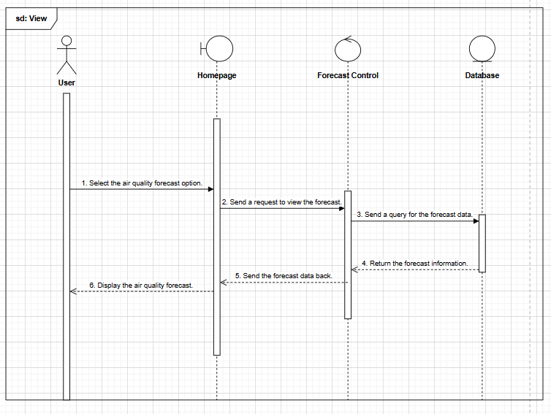

**2.5.7. (User) Configure and receive alert Sequence Diagram:**

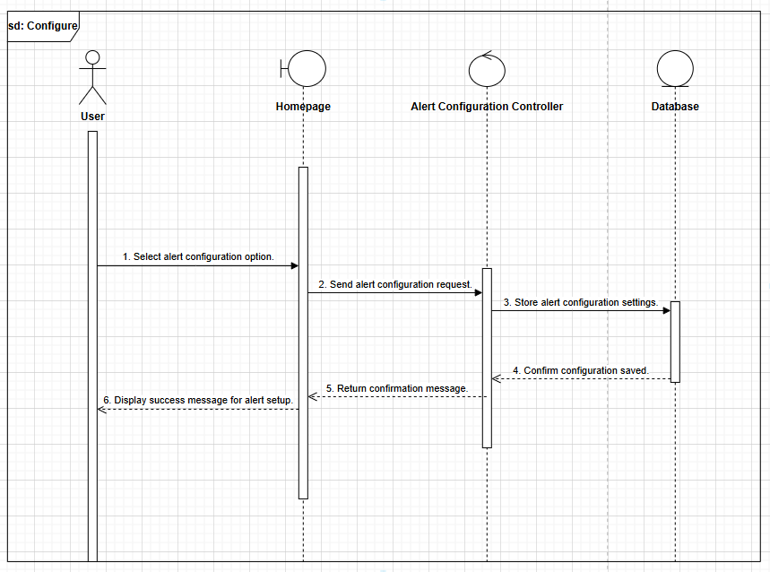

**2.5.8. (User) Track data history Sequence Diagram:**

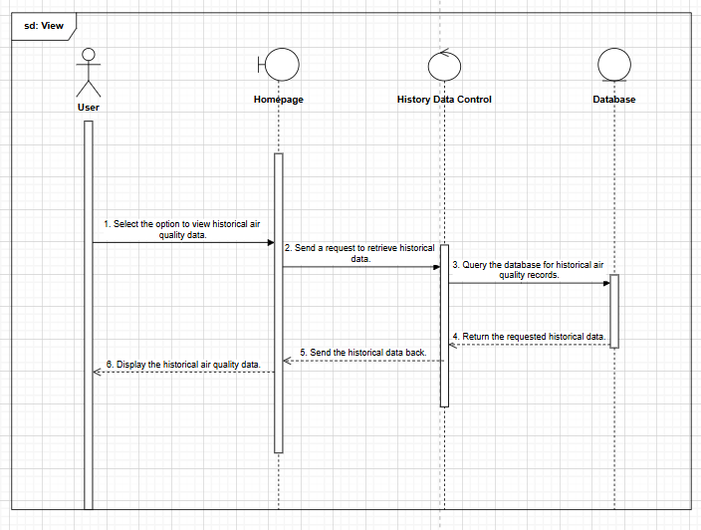

**2.5.9. (User) Contact support Sequence Diagram:**

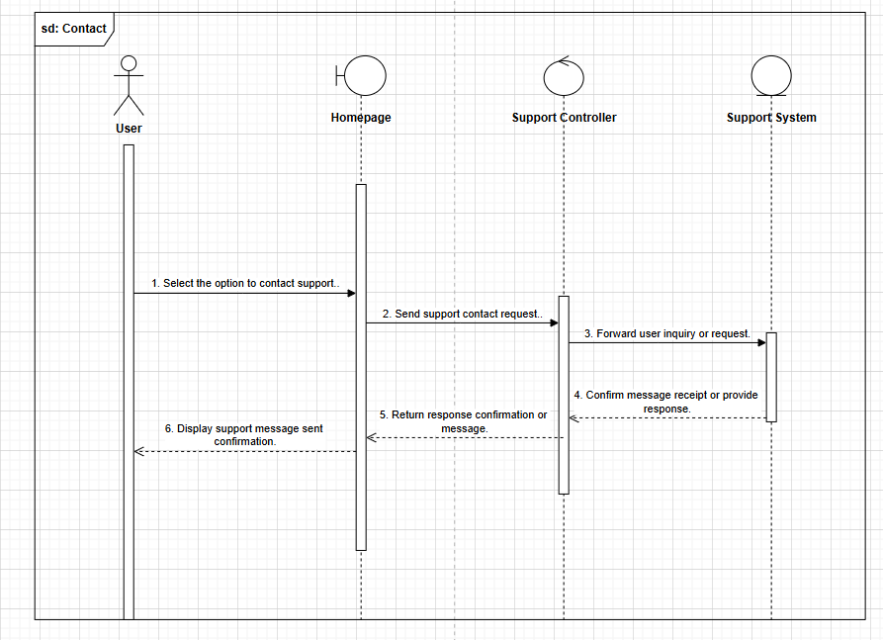

**2.5.10. (User/Admin) Forgot password Sequence Diagram:**

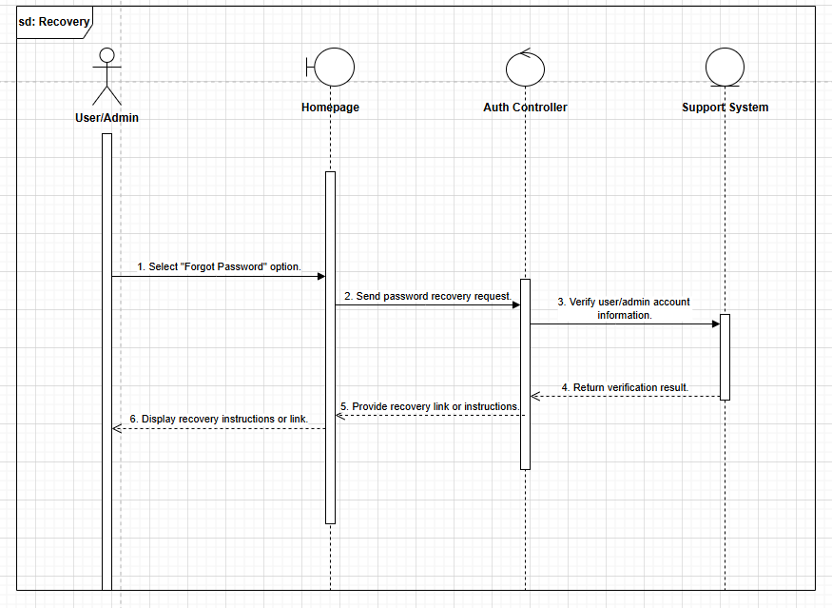

**2.5.11. (Admin) Log in Sequence Diagram:**

**2.5.12. (Admin) Manage sensor data Sequence Diagram:**

**2.5.13. (Admin) Update Sensor Data Sequence Diagram:**

**2.5.14. (Admin) Delete Sensor Data Sequence Diagram:**

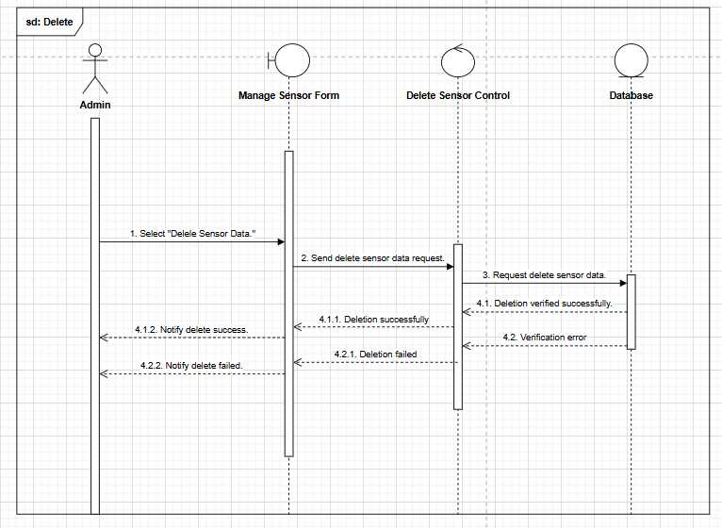

**2.5.15. (Admin) Set alert thresholds Sequence Diagram:**

**2.5.16. (Admin) Add New Alert Threshold Sequence Diagram:**

**2.5.17. (Admin) Delete Alert Threshold Sequence Diagram:**

**2.5.18. (Admin) Manage user accounts Sequence Diagram:**

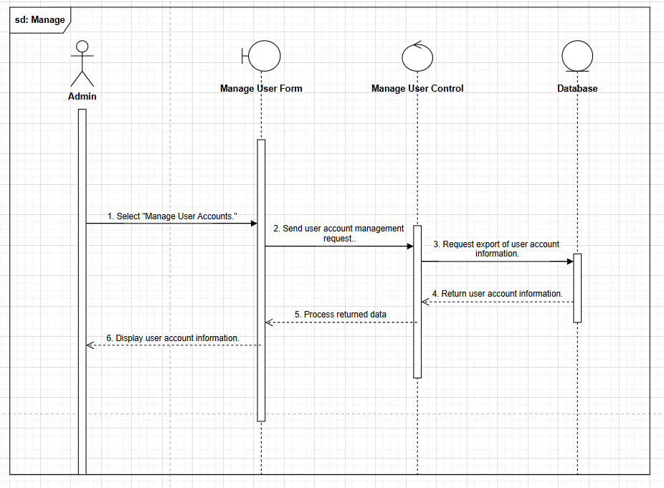

**2.5.19. (Admin) Add New Account Sequence Diagram:**

**2.5.20. (Admin) Edit Account Information Sequence Diagram:**

**2.5.21. (Admin) Delete Account Sequence Diagram:**

**2.5.22. (Admin) View air quality report Sequence Diagram:**

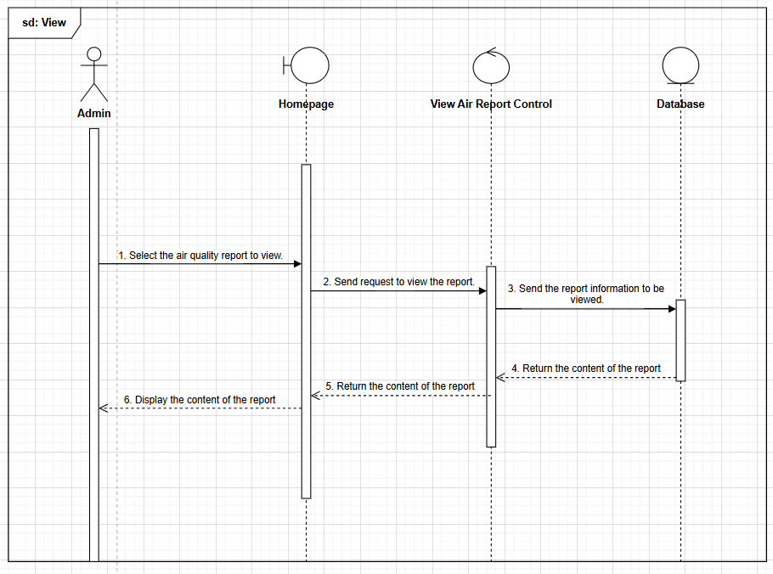

**2.5.23. (Admin) Statistic air quality report Sequence Diagram:**

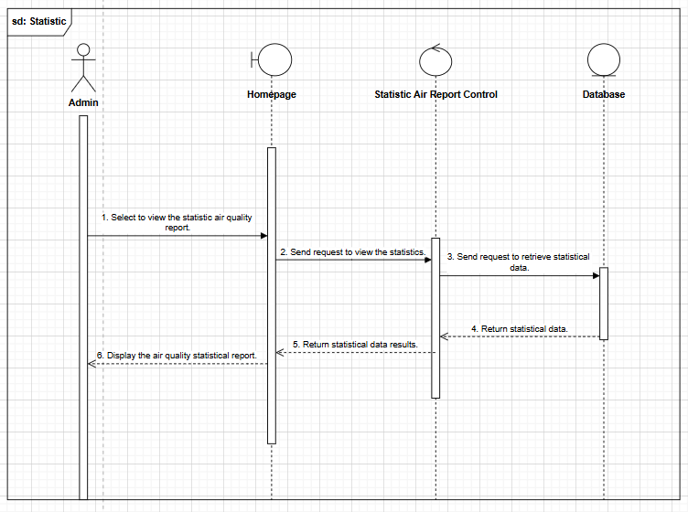

**2.5.24. (Sensor) Submit air quality data Sequence Diagram:**

**2.6. ACTIVITY DIAGRAM:**

**2.6.1. (Guest) Register Activity Diagram:**

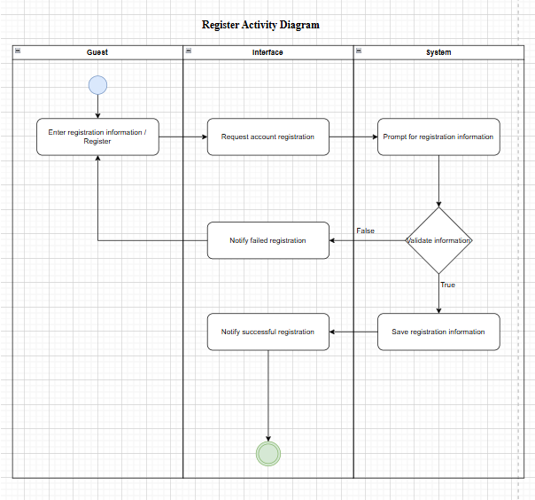

**2.6.2. (Guest) View air quality data Activity Diagram:**

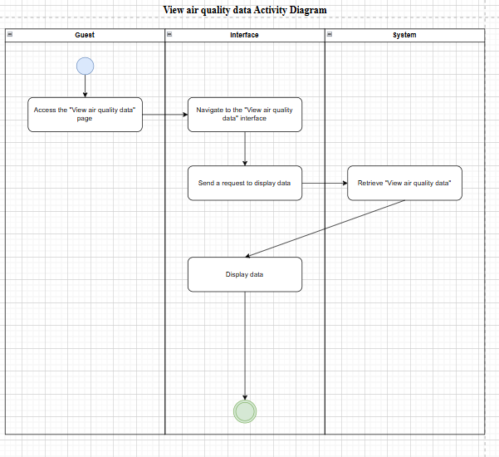

**2.6.3. (Guest) Search information by location Activity Diagram:**

**2.6.4. (User) Log in Activity Diagram:**

**2.6.5. (User) View detailed air quality data Activity Diagram:**

**2.6.6. (User) View air quality forecast Activity Diagram:**

**2.6.7. (User/Admin) Forgot password Activity Diagram:**

**2.6.8. (Admin) Log in Activity Diagram:**

**2.6.9. (Admin) Update Sensor Data Activity Diagram:**

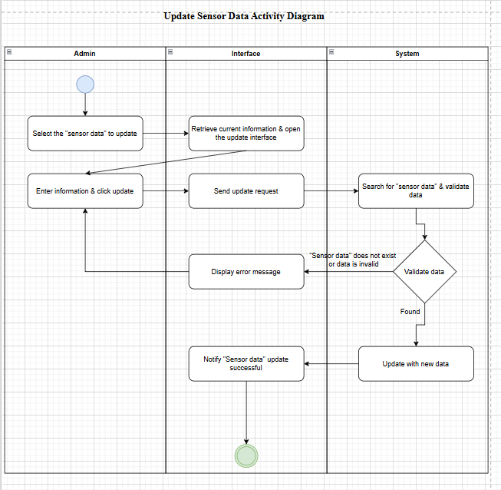

**2.6.10. (Admin) Delete Sensor Data Activity Diagram:**

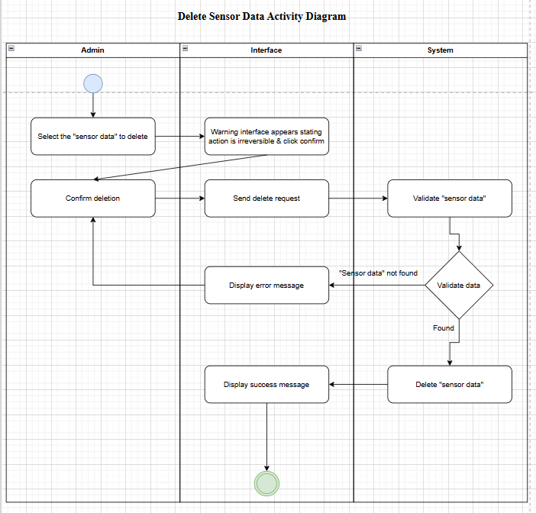

**2.6.11. (Admin) Add New Alert threshold Activity Diagram:**

**2.6.12. (Admin) Delete Alert Threshold Activity Diagram:**

**2.6.13. (Admin) Add New Account Activity Diagram:**

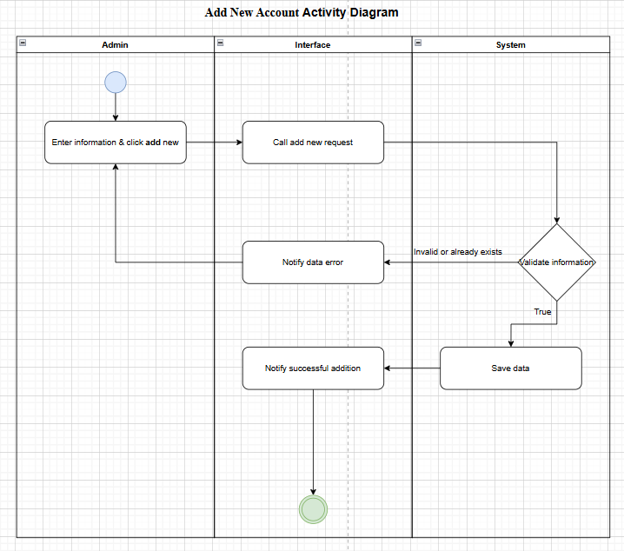

**2.6.14. (Admin) Edit Account Information Activity Diagram:**

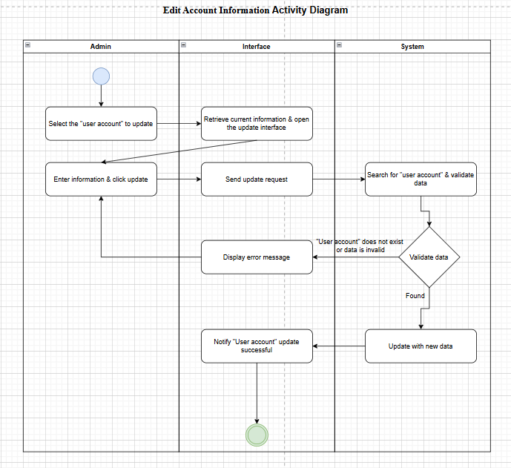

**2.6.15. (Admin) Delete Account Activity Diagram:**

**2.6.16. (Admin) View air quality report Activity Diagram:**

**2.6.17. (Admin) Statistic air quality report Activity Diagram:**

