* Main usecase:

* Guest’s main usecase:

* User’s main usecase:

* Admin’s main usecase:

* Sensor’s main usecase:

* (Guest) Register usecase:

* (Guest) View air quality data usecase:

* (Guest) Search information by location usecase**:A diagram of a search information

  AI-generated content may be incorrect.**
* (User) Log in usecase**:A white oval with black text

  AI-generated content may be incorrect.**
* (User) View detailed air quality data usecase**:**

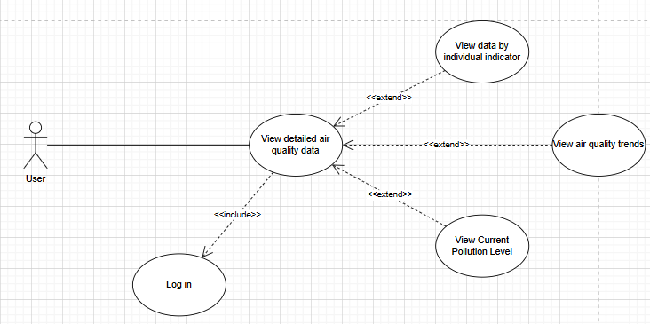

* (User) View air quality forecast usecase**:**

* (User) Configure and receive alerts usecase**:**

* (User) Track data history usecase**:**

* (User) Contact support usecase**:**

* (User/Admin) Forgot password usecase**:A diagram of a person's network

  AI-generated content may be incorrect.**
* (Admin) Log in usecase**:A white oval with black text

  AI-generated content may be incorrect.**
* (Admin) Manage sensor data usecase:**A diagram of a network

  AI-generated content may be incorrect.**
* (Admin) Set alert thresholds usecase**:A diagram of a system

  AI-generated content may be incorrect.**
* (Admin) Manage user accounts usecase**:A diagram of a company

  AI-generated content may be incorrect.**
* (Admin) View air quality reports usecase**:A diagram of a company

  AI-generated content may be incorrect.**
* (Admin) Statistic air quality report usecase**:A diagram of a company

  AI-generated content may be incorrect.**
* (Sensor) Submit air quality data usecase:

