

**Mitsubishi 4 Ton PS Series 5JJ**

**Rs. 224,999/-**

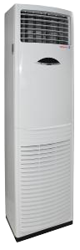

**Product Features**

* Three Minutes Protection
* Rust Resistant Cabinet
* Reserved Air Outlet
* State of the Art
* Air Vane Technology

**Specification**

**Type** Floor Standing AC

**Cooling (Btu/h)** 35000

**Voltage (V)** 220-240

**Power Input (W)** 3400

**EER (Btu/W-h-W/W)** 6.2-3.10