

**UNIVERSITY OF GREENWICH**  
Module code – Module name

Assessment name

|  |  |
| --- | --- |
| Student name | Vo Phuong Thuc |
| ID number (00xxxxxxx) | 001391527 |
| Lecturer/Tutor name | Doan Dinh Ho |
| Student submission date |  |

Table of Contents

1. INTRODUCTION 3

2. EVALUATION 5

2.1. THE PRODUCT 5

2.1.1. BENEFITS OF THE SYSTEM 5

2.1.2. NIEL HEURISTICS FOR USER INTERFACE 10

2.1.3. ADDITIONAL FEATURES THAT COULD BE IMPLEMENTED 11

2.2. THE PROCESS 12

2.3. THE TEAM 12

2.3.1. TEAM EVALUATION 12

2.3.2. TEAM JUSTIFICATION 13

2.4. SELF-EVALUATION 15

3. CONCLUSION 16

4. REFERENCES 17

5. APPENDIX 18

# INTRODUCTION

The main objective of this coursework is to develop a Role-based University Magazine Submission System using the Scrum methodology. This system is intended for universities, aiming to collect contributions from students of each faculty on a yearly basis. Another goal of the system is to assign specific actions to different roles corresponding to their permissions within the system.

Regarding the Scrum methodology, a team of 5 individuals was established with different roles to fulfill the project requirements according to the core principles of Scrum. These roles include Scrum Master, Product Owner, Database Engineer, Web Designer, Developer, and Tester. In practice, with a 5-person team, everyone must act as a developer, while the remaining roles can be combined and fulfilled by one individual.

With the Scrum methodology, the project is divided into sprints, with each sprint having its own product backlog. The team must complete the required tasks to accomplish the project within each sprint, with regular meetings (minutes) held to track progress.

Figure 1. Homepage

This report will also provide a brief description of the developed system along with corresponding screenshots for each user requirement, including detailed explanations of each system function. Upon completion, the product will be thoroughly evaluated for both frontend and backend aspects to determine if it meets the user requirements.

Furthermore, the author will assess how effectively the Scrum methodology was implemented during the website development process. Evaluating each member of the development team will be conducted using an Excel spreadsheet based on various criteria.

Finally, an evaluation of the author's contribution to the team's effort, presentation, and product will be conducted.

Figure 2. Login page

# EVALUATION

## THE PRODUCT

The product website has been developed to meet all user requirements, allowing interaction on the website with each role and their corresponding actions, with the primary purpose of collecting contributions from students. The product is built on the ASP.NET Core MVC framework of C# because it provides a flexible and powerful approach for building web applications, is well-compatible with modern .NET Core platforms, and has strong support from a large developer community.

The core functionalities of the product, such as collecting student contributions and selecting contributions for publication, were prioritized in development as they were the main features emphasized by the client. To meet these requirements, the development team closely followed the Scrum framework. By completing items in the product backlog planned for each sprint, the team successfully fulfilled all items in each sprint. Additionally, two offline meetings were held every week for discussion, exchange of ideas, and support in completing the items.

### **BENEFITS OF THE SYSTEM**

**USABILITY:**

The website is designed to align with the theme of a university-level education system website. The primary color scheme of the website is blue and white, providing a minimalist and user-friendly feel for both students and university staff. The choice of colors aims to evoke a sense of vibrancy and freshness, reflecting the dynamic nature of academic life. The clean design ensures ease of navigation and enhances the overall user experience.

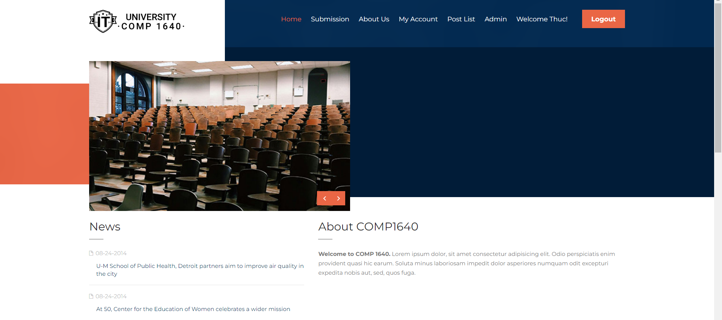

Figure 3. The main theme color is blue and white with some orange.

The website is designed with various buttons for user interaction, facilitating seamless execution of essential tasks. For instance, it features navigation bars enabling users to easily navigate back to previous pages or specific interfaces.



Figure 4. Navigation at the home page

In the page for roles belonging to school staff, there is also a navigation column on the right side of the interface, with the function of switching between interfaces of a role.

Figure 5. Dashboard navigation

When it comes to the core functions, it involves the feature of students submitting contributions under the university's supervision. Once a contribution is added, it is observed and verified by the corresponding coordinator based on the student's faculty.

Figure 6. Contribution Submission page

------------------------------------------

Figure 7. The students must agree to the Terms a Conditions

------------------------------------------

Figure 8. The students can upload multiple files (only document or image file types)

The student can also change the file that the body added when submitting the contribution, for example, if the student uploads 4 files when submitting a new contribution, then when he wants to edit, he can edit the files one by one.

Figure 9. Edit contribution file(s) page

Another requirement in the user requirements document, is that the coordinator of the student's faculty has submitted contributions, has the ability to view, download and leave comments for that contribution. They will also receive an email notification every time a student uploads a new contribution. These are intended to help coordinators recognize and control which contributions have just been added to the system and comment.

Figure 10. Table of Student contribution

------------------------------------------

Figure 11. The coordinator will receive an email.

**SECURITY AND PRIVACY:**

In terms of security, the system ensures that the most important data is protected, both in terms of interface and backend. For example, the user account password is protected using the PBKDF2 password hashing method in ASP.NET Core Identity, ensuring that the password is never even stored in plaintext. clearly in the database. This helps prevent the risk of password information being leaked even if the database is compromised.

Figure 12. ASP.NET Core MVC uses PBKDF2 algorithm to hash password.

### **NIEL HEURISTICS FOR USER INTERFACE**

* **Visibility of system Status – Rating 4**

The website's interface is designed to ensure users can easily discern the system's requests during actions like logging in or uploading files. It consistently provides clear details about input fields, promptly prompting users if any fields are left unfilled. This adherence to Nielsen's rule - stating that systems should always provide users with appropriate feedback within a reasonable timeframe - is demonstrated in Appendix (section 5 page 18).

* **User control and freedom – Rating 5**

Users have the liberty to navigate the website according to their roles, benefiting from features customized to their needs, albeit within the boundaries set by user requirements. Students enjoy extensive control over the submission process, encompassing tasks such as file uploads and personal information editing prior to submission. This adherence to Nielsen's guideline, “Users often perform actions by mistake. They need a clearly marked "emergency exit" to leave the unwanted action without having to go through an extended process.” (Nielsen, 1993). The screenshot could be noticed in Appendix (section 5 page 18 - 19).

* **Error Prevention – Rating 5**

Frequently used functions, such as registration and login, are configured to prevent users from entering incomplete data. Similarly, features like contribution submission are designed to prohibit users from excluding essential files from the system's requirements. These measures enhance the user experience and decrease the likelihood of errors within the system.

And this also complies with Nielsen's Error Prevention rule, which states that "Good error messages are important, but the best designs carefully prevent problems from occurring in the first place. Either eliminate error-prone conditions, or check for them and present users with a confirmation option before they commit to the action." (Nielsen, 1993). The illustration is shown in Appendix (section 5 page 19).

* **Aesthetic and minimalist design – Rating 5**

The design of the website can be considered to closely adhere to this criterion. With its simple design and a color scheme predominantly featuring white and shades of blue and orange for certain buttons, the website is aptly crafted for an educational system. Furthermore, due to the development team's adherence to user requirements, there are very few instances of redundant information displayed on the user interface in practice, and that closely follows the statement of one of Nielsen's 10 criteria that "Interfaces should not contain information that is irrelevant or rarely needed. Every extra unit of information in an interface competes with the relevant units of information and diminishes their relative visibility ." (Nielsen, 1993). The illustration is shown in Appendix (section 5 page 20).

* **Help Users Recognize, Diagnose, and Recover from Errors – Rating 5**

Based on the description of the criterion, the website has closely adhered to its core by configuring necessary notifications for users when they perform an inappropriate action within a certain function. For example, if a user with the Student role clicks on the Admin button in the navigation on the homepage, an interface indicating that they do not have access rights and requesting them to return to the homepage will appear, aligning with the criterion's description that "Error messages should be expressed in plain language (no error codes), precisely indicate the problem, and constructively suggest a solution.". (Nielsen, 1993). The illustration is shown in Appendix (section 5 page 21)

Rating Scale: 1 = Poor, 2 = Fair, 3 = Good, 4 = Very Good, 5 = Excellent

### **ADDITIONAL FEATURES THAT COULD BE IMPLEMENTED**

Due to time constraints, the team has successfully completed the requirements outlined in the specification along with certain additional features, albeit not thoroughly polished. As a result, some lingering bugs remain in the system that need to be addressed to enhance the user experience.

Furthermore, the feature of ...

## THE PROCESS

This project was initiated with the goal of creating a website to collect contribution submissions from students by faculty and academic years under the management of coordinators, managers, and administrators. The Scrum methodology was consistently employed throughout the project, facilitating continuous interaction with clients through weekly meetings and ensuring development aligns closely with client requirements. Additionally, it enhances communication and collaboration within the team, aiding individuals in understanding the project's progress.

For the sake of project completion, team roles were assigned according to each member's strengths, ensuring smoother progress as individuals excel in their designated roles. Leveraging the convenience of modern online meeting applications (such as Google Meet, Zoom, Microsoft Teams), the majority of team meetings were conducted online for exchanging ideas, confirming completed features, testing functionalities, assigning upcoming tasks, and documenting progress in the Scrum template.

However, the team encountered some serious issues leading to the immediate organization of emergency meetings to collectively address and resolve them, recognizing the crucial role of face-to-face meetings in the Scrum framework. In hindsight, the team successfully delivered the product, benefiting from the advantages offered by the Scrum methodology. Clear analysis and adherence to user requirements enabled the team to develop a product that fulfilled all user requirements and additional functionalities.

## THE TEAM

### **TEAM EVALUATION**

|  |  |  |  |  |  |  |  |
| --- | --- | --- | --- | --- | --- | --- | --- |
| FACTOR | WEIGHT | THUC |  | KDA | KHOA | DAT | TRAN |
| Attendance | 10 | 8 |  | 8 | 9 | 9 | 7 |
| Timekeeping | 10 | 8 |  | 8 | 9 | 9 | 7 |
| Initiative | 10 | 7 |  | 8 | 10 | 8 | 10 |
| Communication | 10 | 8 |  | 8 | 6 | 10 | 8 |
| Collaboration | 10 | 9 |  | 7 | 10 | 7 | 7 |
| Focus | 10 | 9 |  | 9 | 8 | 8 | 10 |
| Commitment | 10 | 10 |  | 10 | 9 | 10 | 9 |
| TOTAL | 70 | 8.4 |  | 8.3 | 8.7 | 8.7 | 8.3 |

|  |  |
| --- | --- |
| PERSON | TOTAL |
| THUC | 8.4 |
| KDA | 8.3 |
| KHOA | 8.7 |
| DAT | 8.7 |
| TRAN | 8.3 |

### **TEAM JUSTIFICATION**

|  |  |  |  |
| --- | --- | --- | --- |
| **Name** | **Factor** | **Average Rating** | **Comments** |
| **THUC(Author)** | Attendance: **8** Timekeeping: **8** Initiative: **7** Communication:**8** Collaboration: **9** Focus: **9** Commitment:**10** | **8.4** | As a leader, Thuc is responsible for assigning what members must do in the project following the Scrum method. Although there were problems at the beginning of the project, with his suggestions, the dev team continued the project with new, more familiar technology. In addition, he also designed the database for the project quite well when he and Khoa designed a quite complete database, contributing to faster progress of the project. In addition, Thuc's aspects such as communication and coordination are also strengths, as he can coordinate with any member to complete the product's features. |
| **KDA** | Attendance: **8** Timekeeping: **8** Initiative: **8** Communication:**8** Collaboration: **7** Focus: **9** Commitment:**10** | **8.3** | Kda, as a tester, attended most meetings with the team quite on time, and worked with the team to come up with solutions to problems that arose. He can also handle most of the tasks assigned by the technical leader. In terms of communication, Kda has very open and cooperative communication with members of the dev team. |
| **KHOA** | Attendance: **9** Timekeeping: **9** Initiative: **10** Communication:**6** Collaboration: **10** Focus: **8** Commitment:**9** | **8.7** | Khoa is an excellent developer, he has a very logical problem-solving mindset, and is assigned most of the difficult algorithmic and structural tasks. However, his communication is not really that good, sometimes people have trouble understanding what he says, and he has to explain what he just said. Except for that, Khoa's creativity, cooperation, and punctuality are all very good. |
| **DAT** | Attendance: **9** Timekeeping: **9** Initiative: **8** Communication:**10** Collaboration: **7** Focus: **8** Commitment:**10** | **8.7** | A developer who is not too good at the backend, he is more inclined towards the frontend, but every time he is assigned to work with the backend, Dat still completes it very well. In terms of communication, Dat is the team's excellent communicator. In most meetings, Dat is the one who provides very detailed analysis of case studies/user requirements. He was also the main person who completed the group report. |
| **TRAN** | Attendance: **7** Timekeeping: **7** Initiative: **10** Communication:**8** Collaboration: **7** Focus: **10** Commitment:**9** | **8.3** | Tran is an excellent developer in the statistical parts of the project, so she is often assigned to handle dashboard-related features in the product and completes the assigned work very well. In terms of communication, she doesn't really communicate too much with the team. Being a private person, Tran only communicates when her part conflicts, or she has questions. Otherwise, all other aspects of Tran are very good, including testing the product features, which she completed very well. |

## SELF-EVALUATION

Throughout the project development, I assumed the position of both database engineer and leader, a position I was chosen for based on my experience and proficiency in designing databases gained through courses at university, along with the team's confidence in my ability to present confidently and research documents in English. My confidence and ability to work with various types of databases alongside my developer role earned the trust of my teammates to lead this project effectively.

In the initial stages of the project, I proposed adopting the new technology, Next.js, a bold decision driven by our team's eagerness for new challenges. However, issues arose as Next.js, a React framework, lacked substantial global community support and faced inconsistencies in its official documentation, leading to reconsideration of the project's timeline. Consequently, I suggested transitioning to Asp.net Core MVC, a framework familiar to the entire team from recent coursework, facilitating smoother development.

As I delved into database design, I swiftly outlined which tables would be included in the project, forming an initial database draft. With team input, we unanimously decided on Microsoft SQL Server as our database technology, leveraging the team's familiarity with MSSQL, which complemented well with Asp.net Core MVC.

Applying the Scrum framework to project management, I actively participated in developing user stories and product backlogs, alongside attending weekly scrum meetings. Proactiveness and responsibility ensured timely completion of project tasks and goals.

Furthermore, I played a crucial role in presenting and introducing the project to the class each week. Through these presentations, I directly received and synthesized feedback from the instructor to collaborate with the team in improving the product's quality. Patience and adaptability to feedback demonstrated my leadership not only in technical development but also in driving project progress.

In summary, my contribution extended beyond technical design and development to guiding the team through challenges, eliciting and implementing feedback, thereby ensuring the project's success.

# CONCLUSION

In summary, this report has shown the core functions of the project stated in the user requirements by evaluating the product through aspects such as usability, interface, and potential development. In addition, the development process has been thoroughly evaluated, including in terms of the people involved in the project. Finally, the author himself must also reflect on the product development process and evaluate his own performance in detail.

# REFERENCES

Nielsen, J. (1993). *Usability Engineering.* Academic Press.

# APPENDIX

Figure 13. System will show error messages if students do not enter enough fields.

Figure 14. Student can view the submission detail and change the file.

Figure 15. Students can select files to replace (edit)

Figure 16. Users cannot enter any pages exceed their role authority.

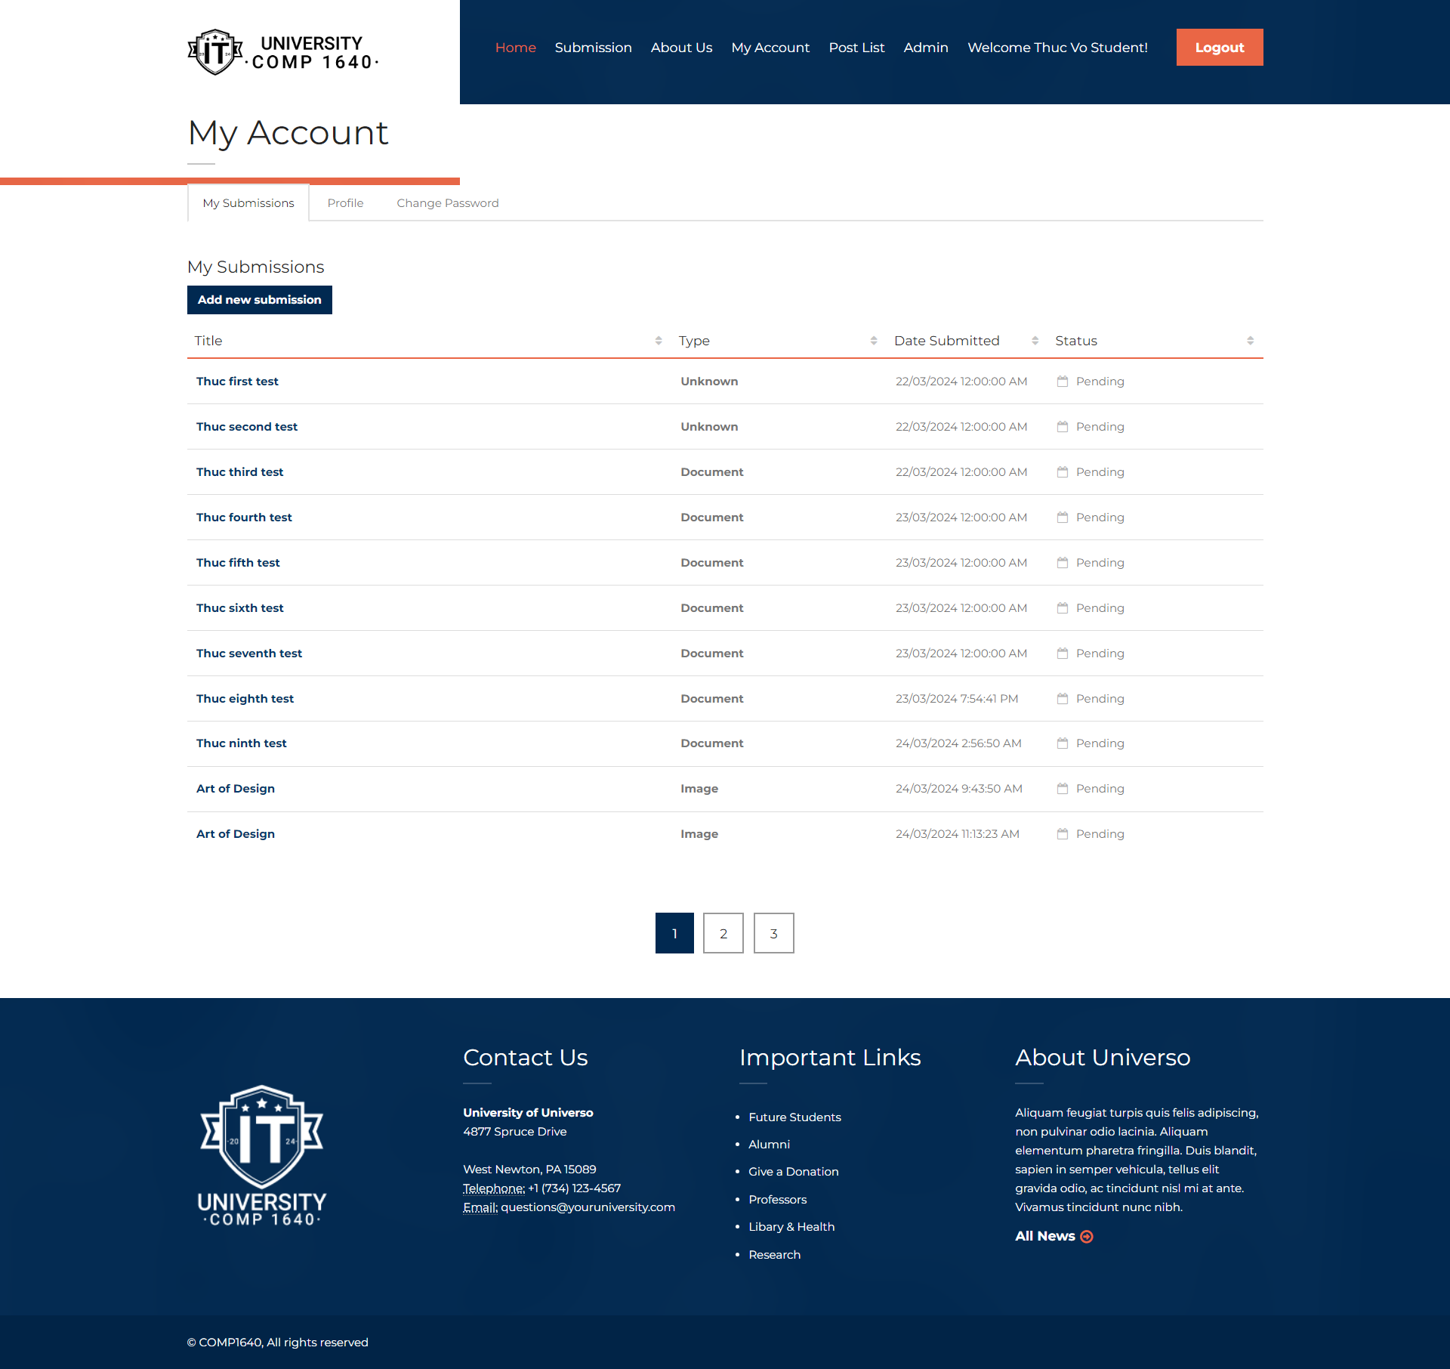

Figure 17. Main theme color of the UI is blue and white.

Figure 18. Users can receive information about what is going on with their information.