**COMP 1682 Project Proposal**

**Developing a Web-based Booking and Management System for Dental Clinics**

**xxxx**

**Business Computing BSc Hons**

**1 Overview**

In recent years, online booking systems have become more prevalent replacing traditional methods of booking appointments via phone with communication of appointment reminders being restricted to letters. Such traditional methods pose a problem with non-attendance in clinics wasting resources and decreasing the efficiency of clinics which can possibly lead to extended waiting lists for appointments. Furthermore, statistical analysis into attendances tested on different types of booking systems depicted that online booking systems had a better rate of attendance than traditional systems, (Parmar et al, 2009). Given the improvement in attendances provided an online system, the intended outcome of this project is to create a functional web-based booking system which allows patients to register with their dental practice and book appointments online.

Further investigation into online access to health-related resources illustrate patients’ increased convenience and satisfaction. This is further proved as stated by de Lusignan et al in 2014 “Patients’ access to online services offered greater convenience particularly in time-saving when compared with other methods of interaction with their health provider”. Patients will also be able to see their dental records and be reminded of their appointments via email which will further, greatly increase the efficiency of the dental clinic and improve means of communication. The system will also allow patients to view their bookings and be able to cancel them as well as staff to access scheduled appointments and add available dentist times onto the system. This will improve the convenience of booking dental appointments as patients will be able to book on the day appointments as well as weeks in advance from anywhere using the web-based system.

**Keywords:** Booking System, Appointment, Email, Attendances, Non-attendance

**2 Aim**

The aim of this project is to implement an online appointment booking system which enables patients to book appointments online as well as view their records and will allow dentistry staff to enter data directly into the database to improve the efficiency of dental clinics which in return should decrease non-attendances.

**3 Objectives**

3.1 Analysis and Requirements Gathering:

3.1.1 Research into pre-existing online booking systems and their functionality by using academic resources that lead to a coherent idea of what is required of online booking systems. [4.0]

3.1.2 Write a literature review on existing work on the importance of online booking systems by explaining and analysing data with all assumptions and limitations stated. [14.0]

3.1.3 Detail functional and non-functional requirements for online booking systems by understanding what is required of an online booking system based on research from the literature review. [2.0]

3.1.4 Verify requirements by creating a questionnaire about what consumers look for in an online appointment booking system for dental clinics and identifying the key requirements. [4.0]

3.2 Design:

3.2.1 Create a rich picture diagram identifying all participants and external factors in the system to illustrate the complexity of the situation. [2.0]

3.2.2 Create a Use-Case diagrams to address functionalities of the systems with all possible actors of the systems by using the online software Lucidchart. [3.0]

3.2.3 Create a conceptual ERD to understand the entities involved in the system and their relationships by using Lucidchart. [2.0]

3.2.4 Create a physical ERD diagram to identify the columns and keys for the system by utilising Lucidchart. [4.0]

3.2.5 Create possible user interfaces using Axure RP 9 to address possible HCI components for web-based systems. [2.0]

3.2.6 Create a database schema on paper to comprehend the details stored in the database. [4.0]

3.3: Development and Implementation:

3.3.1 Implement the database schema by creating tables and populating data in MYSQL. [1.0]

3.3.2 Create the user-friendly interface for the system which can be easily navigated by utilising Visual Studio with C# coding. [5.0]

3.3.3 Add all relevant information into the first, visible to everyone tier of the web application. [2.0]

3.3.4 Allow new patients to register as well as sign in after registration using C# in Visual Studio. [6.0]

3.3.5 Allow patients to book appointments as well as view their records by selecting dates available for the dentist they wish to book with and confirming their booking via email. [8.0]

3.3.6 Allow staff to log in and view patient records as well as add available times into the appointment booking system. [4.0]

3.4: Testing:

3.4.1 Usability testing to understand the issues with user interface by seeing how users will interact with the system and how easily they can navigate the system. [5.0]

3.4.2 Black box testing to identify all issues with functionality by getting users who do not know the code to try to register and book an appointment. [2.0]

3.4.3 White box testing to identify issues in the system that restrict the functionality by trying to register as a patient and book appointment with particular dentists. [5.0]

3.5: Evaluation:

3.5.1 Evaluate the functionality achieved with the initial system requirements in mind. [5.0]

3.5.2 Evaluate the product efficacy in areas such as reliability, security and scalability by understanding possible risk factors. [3.0]

3.5.3 Discuss possible setbacks and what can be done to improve the system further by understanding limitations of the system. [2.0]

**4 Legal, Social, Ethical and Professional**

Legal:

A consideration to take into account would be the legal aspect of storing patient data. As stated in the Data Protection Act 2018, information held on patients must be stored in a way that ensures security which entails protection against unlawful and unauthorised access to the data. For this project, the data will consist of mock patients therefore no real patient data will be handled in an unsecure manner. However, for extra security measures, any passwords entered into the system will be encrypted and the patient data will only be available to view from the administrative staff login. The system will also not allow any payments to occur online to ensure no credit or debit card fraud.

Social:

A social consideration would be the accessibility of the web-based system. The system will accommodate people with colour-blindness by ensuring the application looks understandable in grey scale as well as in colour so patients do not have trouble deciphering it. The system will also provide the option to pick between NHS covered dental care and private dental care allowing patients who cannot afford private dental care to also be able to book urgently if in need. The application will also contain information written in reasonable font size to ensure patients with weak eye sight can also view the information without trouble.

Ethical:

Under the Data Protection Act 2018, users of the system should be informed about how their data is being used and who has access to their personal information. For this reason, the data kept on the mock patients on the system will only be accessible to the patient themselves and the administrative staff. The patient can access their own data to update their information and also see what information is being stored on them. The data will also not be used for marketing and forwarded onto third parties as such.

**5 Planning (see appendix A)**

The project will be developed using the agile methodology, Rapid Application Development (RAD). RAD methodology prioritises the development of the product taking into account user feedback. RAD is also appropriate for set timed projects that can last 30 to 90 days therefore it is appropriate for this project as it will last approximately 90 days as evident in the Gantt chart. The system will be developed by using an evolutionary prototype which involves a series of iterations/refinements that will eventually become the final solution. This will save time as there would be no extra prototypes created for testing purposes. The requirements will be gathered before beginning the RAD cycles however requirements can possibly change alongside which will be accommodated by the evolutionary prototyping. There will be at the very least three iterations for the product which will consist of the development and testing phase. The final testing will consist of black box and white box testing and is dependent on the third iteration to be completed.

Tools and Technologies:

For this project, the Integrated Development Environment (IDE), Visual Studio will be used with coding in C# to create the product user interface and all its functionality. Given my previous experience of working with Visual Studio and C#, I will be able to create most functionality however there are some aspects that I am unfamiliar with that are not in my skillset which I will learn from coding websites and helpful online videos. The database will be on MYSQL and connected through Visual Studio. The design diagrams will be created using Lucidchart which accommodates the proper creation of objects and their relationships. For the user interface designs, I will be using Axure RP 9 as that provides a proper platform to create intricate interface designs.

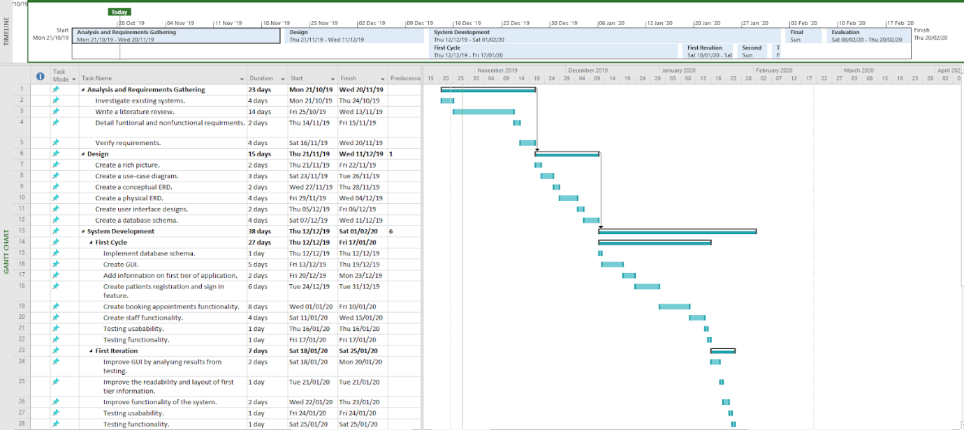

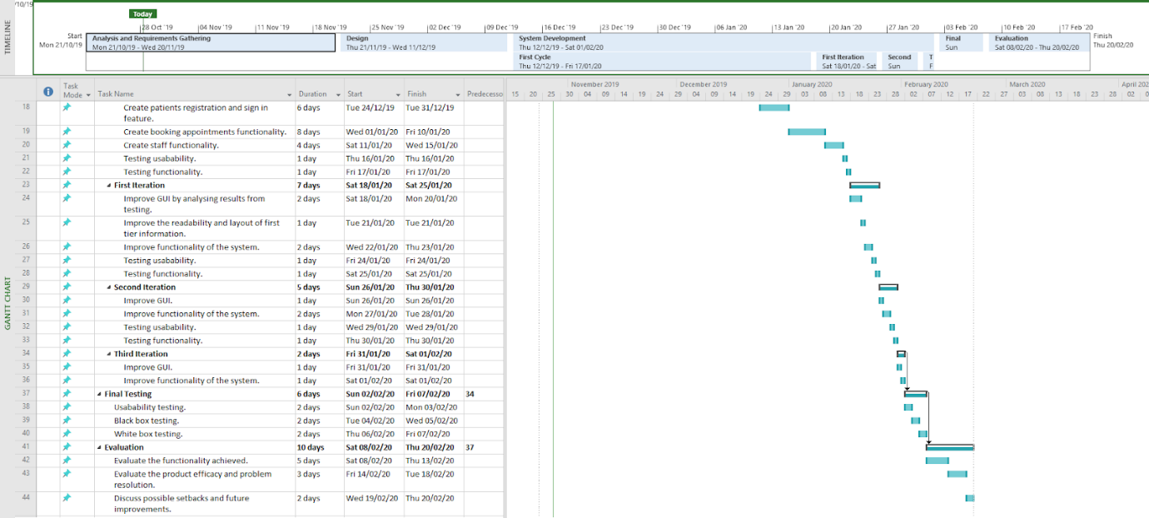

**6 Initial References**

de Lusignan, S., Mold, F., Sheikh, A., Majeed, A., Wyatt, J.C., Quinn, T., Cavill, M., Gronlund, T.A., Franco, C., Chauhan, U. and Blakey, H., 2014. Patients’ online access to their electronic health records and linked online services: a systematic interpretative review. *BMJ open*, *4*(9), p.e006021.

GOV.UK. (2018). *Data protection*. [online] Available at: https://www.gov.uk/data-protection [Accessed 15 Dec. 2018].

Parmar, V., Large, A., Madden, C. and Das, V., 2009. The online outpatient booking system ‘Choose and Book’ improves attendance rates at an audiology clinic: a comparative audit. *Journal of Innovation in Health Informatics*, *17*(3), pp.183-186.