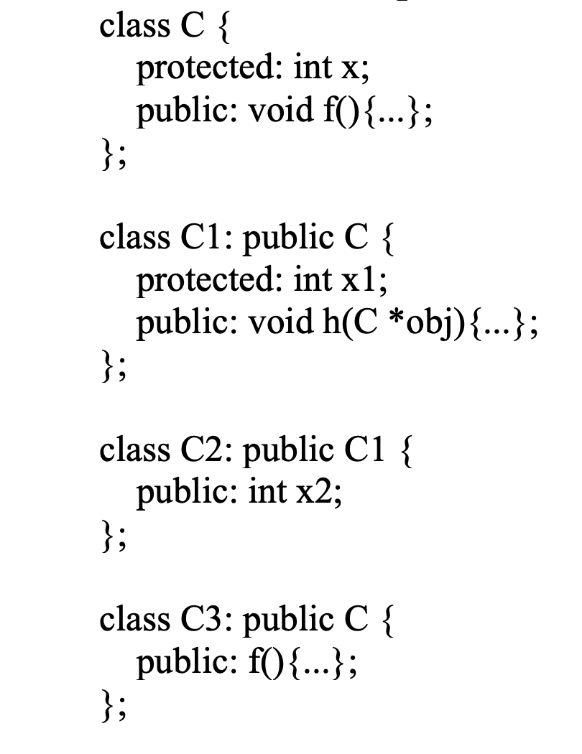  
a.



Class C



Class C1. Class C3



Class C2



b.

C1 obj1;

obj1.x is not allowed since x is protected so it cannot be access from outside

obj1.f() is allowed since the function is public in both the classes

obj1.x1 is not allowed since x1 is protected so it cannot be access from outside

obj1.x2 is not allowed since x2 is not defined in the C1 object

c.

Assume that the body of C1::h contains the following declarations

C2 \*obj2;

C3 \*obj3;

obj->x is allowed since obj is a C object pointer that point to a value that’s protected by C for C1

obj2->x is allowed since obj2 is a C2 object pointer so it can point to a C2 object which can access x from inheritance from C and C1.

obj->x is allowed since obj3 is a C3 object pointer so it can point to a C3 object which can access x from inheritance from C.