**DANANG SOFTWARE CORPORATION**

**SOFTECH-APTECH**

Library Management System

Guiding faculty: Nguyễn Quốc Nguyên

Members:

* Nguyễn Công Sơn.
* Phạm Đình Trung.
* Nguyễn Công Dương.

Group: 02

Batch: 118

I. Problem Definition 3

II. Customer Requirement Specification 4

1. Admin use-case: 5

2. Customer Use-case 6

III. Project Plan 7

IV. E-R Diagrams 8

V. Table design 9

V. ALGORITHMS 10

1. Administrator Module 10

1.1. LOGIN & LOGOUT SYSTEM 10

1.2. UPDATE 11

1.3. SEARCH 15

1.4. REPORTS 16

VI. GUI DESIGN 17

2. ADMINISTRATOR MODULE 17

2.1. LOGIN 17

2.2. FUNCTION 18

2.3. UPDATE 19

2.4. SEARCH 20

2.5. STATISTICS AND REPORTS 22

3. user MODULE 23

3.1. LOGIN UESER 23

3.2. SEARCH BOOK 23

3.3. ADD RENT 24

VII. TASK SHEET 25

VIII. Testing Checklist 27

# I. Problem Definition

Softech Ltd. has a library which is managed by Ms. Thuy manually. All records are on paper and Thuy finds it very difficult to manage when somebody issues or returns the books. She has to maintain list of books along with details such as Author name, book title etc. When a book is to be issued, she has to manually search for that book and again for issuing book she has to maintain a register which will have details of book issued such as Name of the book, Author, Employee details (name, department etc) , Date of issue, Date of return, etc. This process is tedious and time consuming. She has brought it to the notice of her seniors and they have proposed the solution of developing a system which will help Thuy managing the things more effectively and also save her time. She will be the only user of the system.

# II. Customer Requirement Specification

Work Breakdown Structure (WBS)

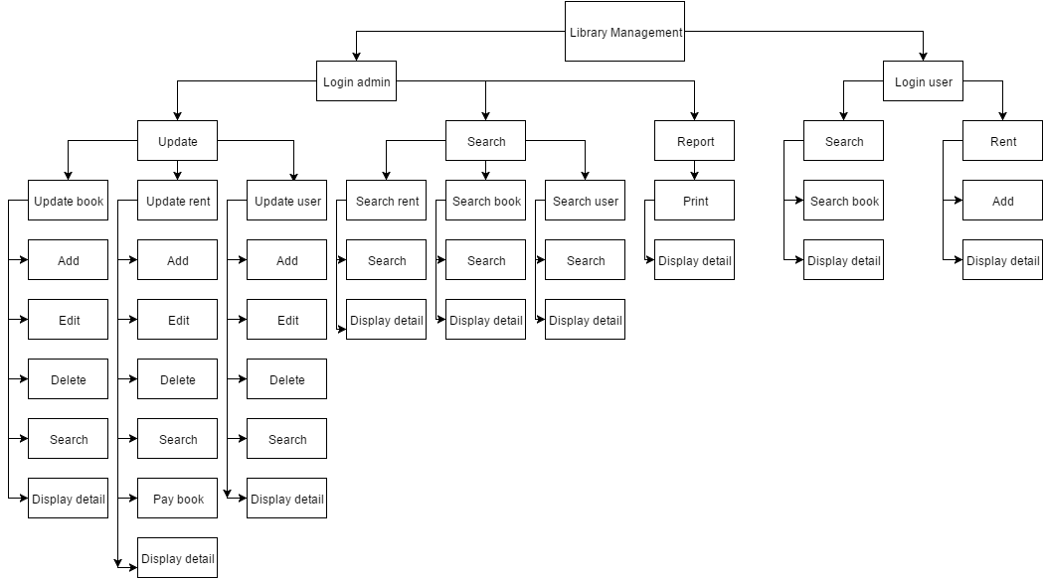

## Admin use-case:

Admin users are library staff who has the duty and right to serve customers action. Admin has the highest right over the system and their action are described with rules following:

* Update
  + Update user : student code, password, name, birthday, address, phone number.
  + Update book : book code, book name, author, publishing house, cost, quantity.
  + Update rent : rent code, student code ,book code, day rent , day pay.
* Search
  + Search user : student code, password, name, birthday, address, phone number.
  + Search book : book code, book name, author, publishing house, cost, quantity.
  + Search rent : rent code, student code, book code, day rent , day pay.
* Statistics and reports
  + Print.

System

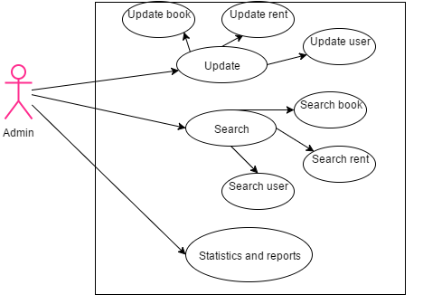

## Customer Use-case

Customers are the main users of the system who use the library system. They have the following:

* Search book : book code, book name, author, publishing house, cost, quantity.
* Add rent : rent code, student code ,book code, day rent , day pay.

System

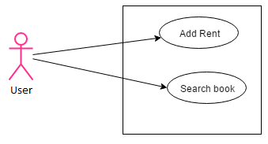

# III. Project Plan

|  |  |  |
| --- | --- | --- |
| Date Time | Tasks | Members |
| 10/12 – 17/12 | Project Planning.  Analyze and Database design  Customer and Admin usecase specification  Write first document | The whole team  Document write : Nguyen Cong Son. |
| 18/12 – 27/12 | Develop Admin Module   * Design admin interface * Develop function   Develop Customer Module   * Design customer interface * Develop function | The whole team  Document write : Nguyen Cong Son |
| 28/12 – 17/1 | Complete eProject   * Module admin * Module customer * Input data * Test | The whole team  Document write : Nguyen Cong Son |

# IV. E-R Diagrams

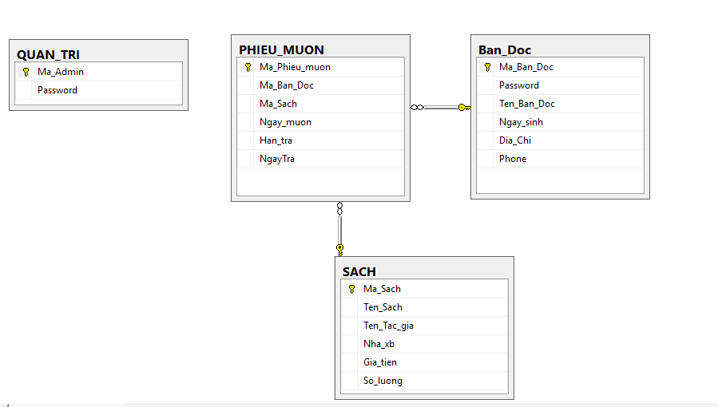

# V. Table design

* Table Quan_Tri

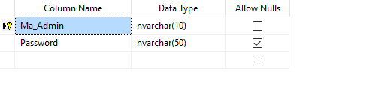

* Table Sach

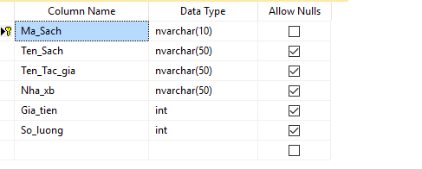

* Table Phieu_Muon

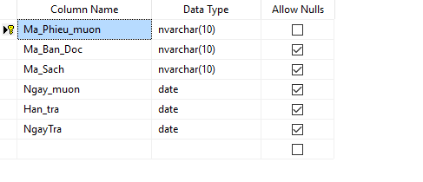

* Table Ban_Doc

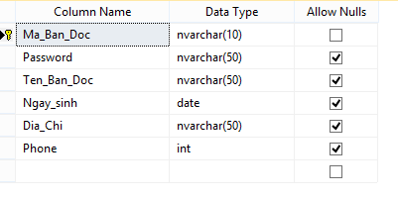

# V. ALGORITHMS

## 1. Administrator Module

### LOGIN & LOGOUT SYSTEM

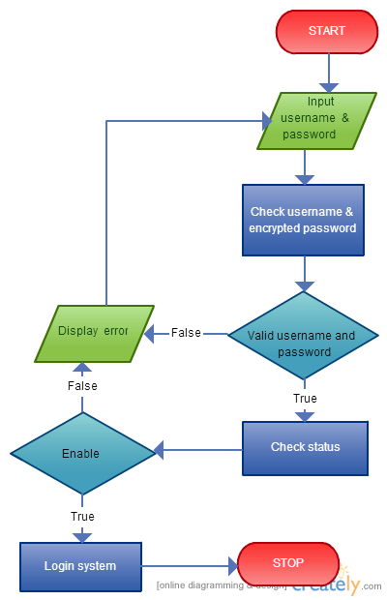

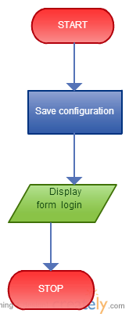

### UPDATE

* + 1. Add

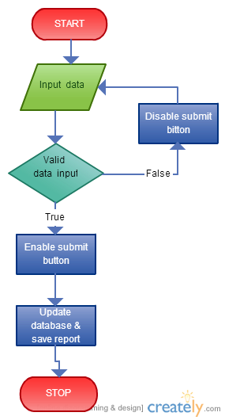

* + 1. Edit



* + 1. Delete



* + 1. Pay Book.



### SEARCH

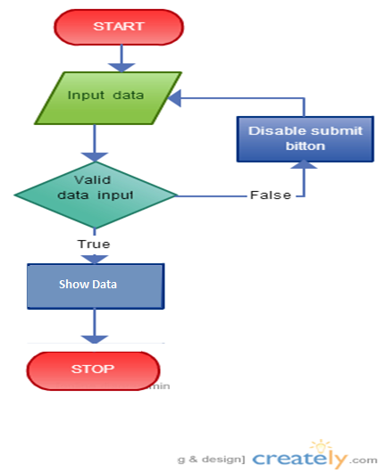

### REPORTS

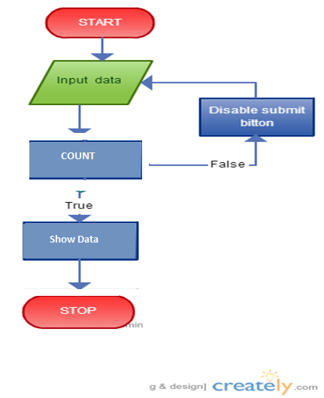

# VI. GUI DESIGN

## ADMINISTRATOR MODULE

### LOGIN

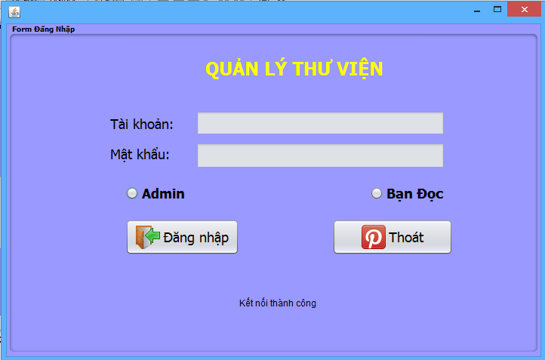

### FUNCTION

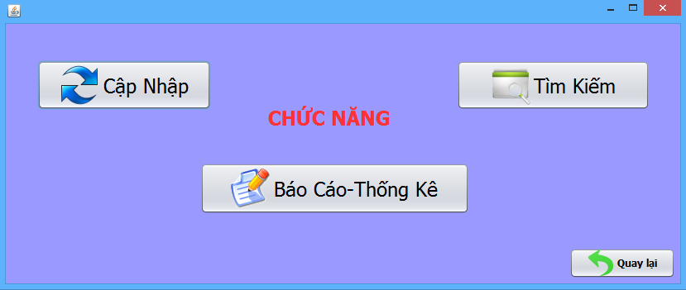

### UPDATE

* + 1. Update book.

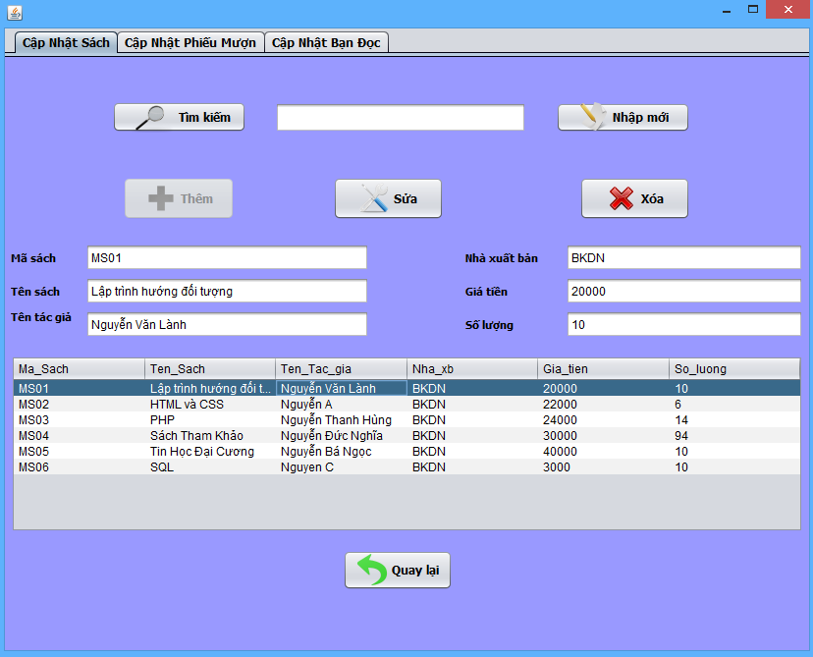

* + 1. Update rent.

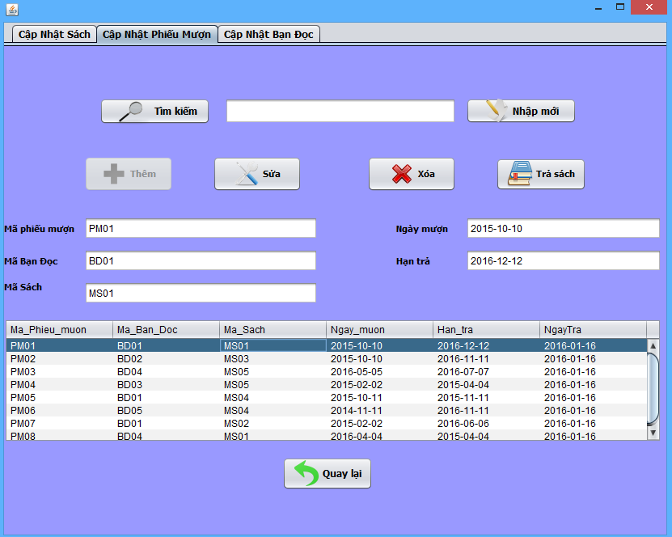

* + 1. Update user.

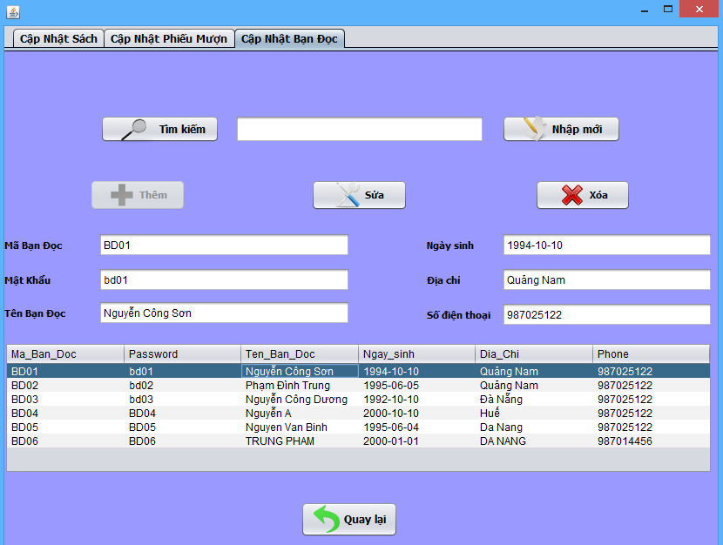

### SEARCH

* + 1. Search book.

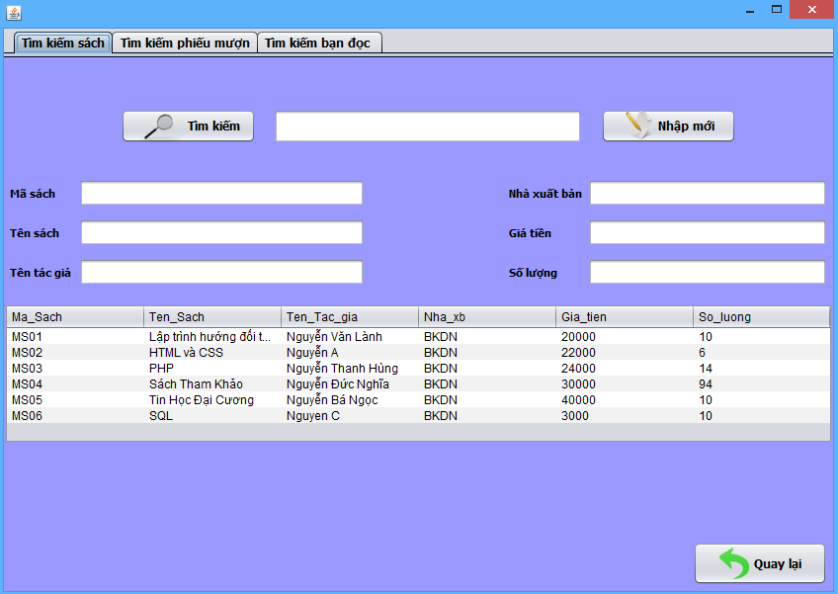

* + 1. Search rent.

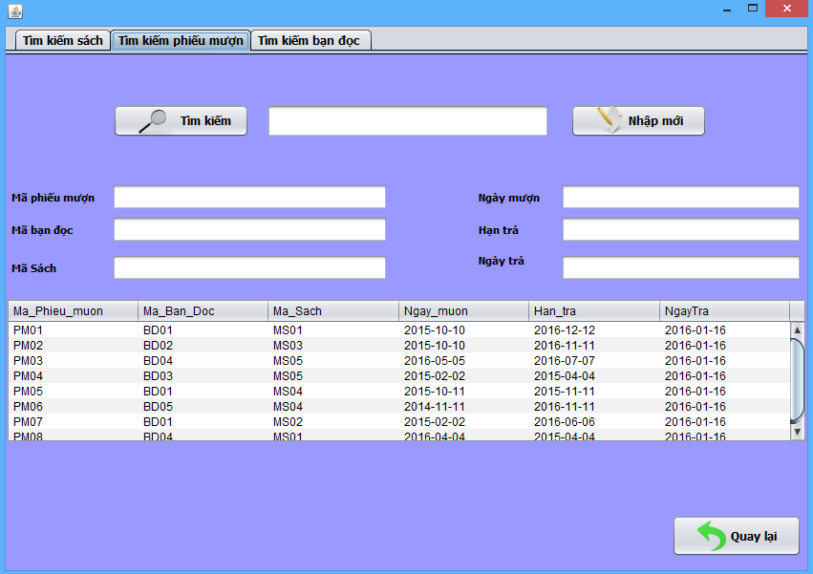

* + 1. Search user.

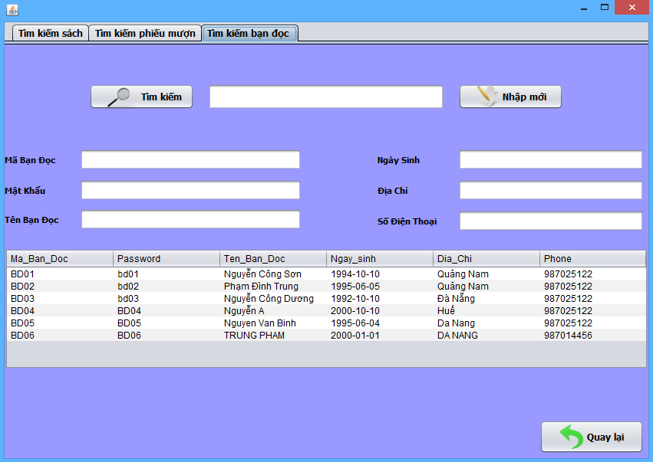

### STATISTICS AND REPORTS

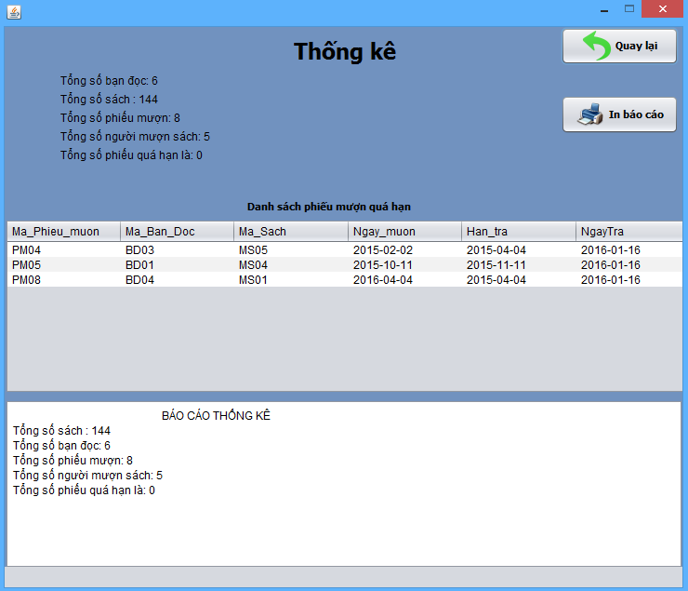

## user MODULE

### LOGIN UESER

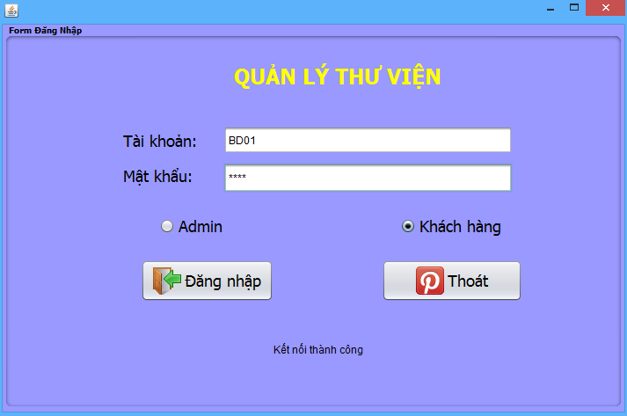

### SEARCH BOOK

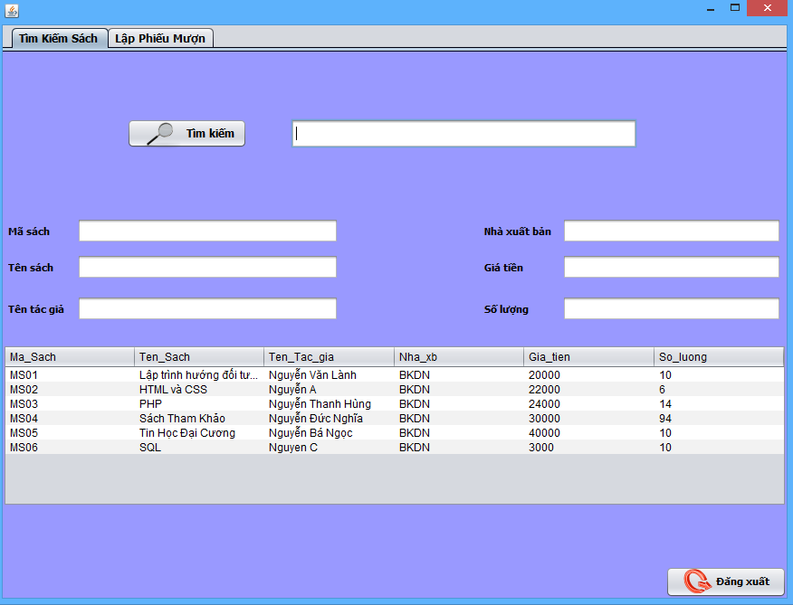

### ADD RENT

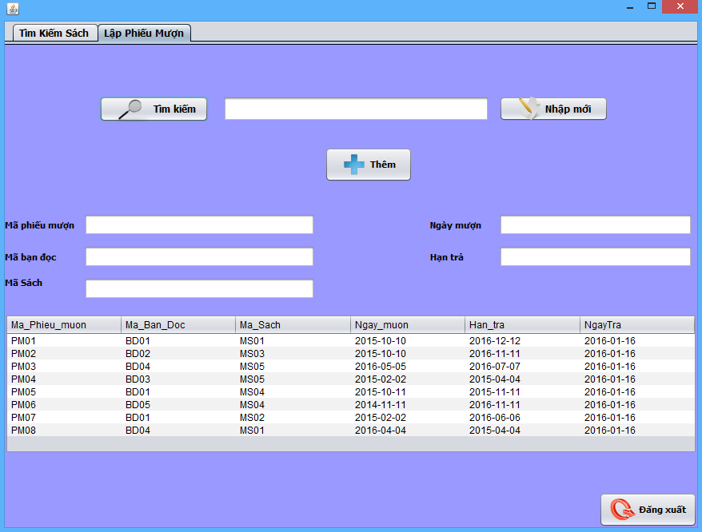

# VII. TASK SHEET

Each members of the team required to take part in any phase and any module of the projects. So the whole team together can complete and understand all tasks of this banking system.

|  |  |  |  |  |
| --- | --- | --- | --- | --- |
| **No** | **Tasks** | **Member** | **Decription** | **Status** |
| **1** | Design database | Pham Dinh Trung | Design database for library management system | Complete |
| **2** | Study and create basic application structure | All member | Prepare and Write Eproject documentation.  Creating diagram, chart and UML modeling. | Complete |
| **3** | Slide | Nguyen Cong Son | Slide show | Complete |
| **MODULE ADMINISTRATOR** | | | | |
| **4** | Design Admin GUI | Nguyen Cong Son | Design interface for admin system | Complete |
| **5** | Pham Dinh Trung |
| **6** | Code moduel | Nguyen Cong Son | Create Model, controller, View package and classes | Complete |
| **7** | Adminstrator Update | Nguyen Cong Duong | Login, logout | Complete |
| **8** | You Read Update | Nguyen Cong Son | Create new user, edit user, delete user | Complete |
| **9** | Book Update | Nguyen Cong Duong | Create new book, edit book, delete book | Complete |
| **10** | Rent Update | Pham Dinh Trung | Create new add rent book, edit rent book, delete book, give book back | Complete |
| **11** | Search Management | Nguyen Cong Son | Search book , rent book, user | Complete |
| **12** | Statistics and reports | Pham Đình Trung | Create reports | Complete |
| **13** | Test module admin | All member | Test application | Complete |
| **MODULE YOU READ** | | | | |
| **14** | Design You Read GUI | Nguyen Cong Son | Design interface for user system | Complete |
| **15** | Pham Dinh Trung |
| **16** | Code model Classes | Nguyen Cong Son | Create Model, controller, View package and classes | Complete |
| **17** | Login, Logout | Nguyen Cong Duong | Login, Logout. | Complete |
| **18** | Search Book | Nguyen Cong Duong | Search book | Complete |
| **19** | Add Rent | Pham Dinh Trung | Create new add rent book, edit rent book, delete book, pay book | Complete |
| **20** | Test module you read | All member | Test application | Complete |

# VIII. Testing Checklist

|  |  |
| --- | --- |
| **Checklist Item** | **Result** |
| Correct database design that support the requirements | PASSED |
| Coding style, naming convention, code documentation | PASSED |
| Data Validity on Object level | PASSED |
| Data validity on Form level | PASSED |
| Data length validity | PASSED |
| Required fields data validity | PASSED |

THE END.