Test Plans

Test Case # | Input |  | Expected Output | Actual Output | Did the test pass?
1  One time and follow all rules | 50  30  15  9  5  7  8  n |  | - Either my input is too low or high.  - If my input high, then upper bound is the input  - If my input low, then. lower bound is the input. | - Please enter guess between (1-50)  - Please enter guess between (1-30)  - Please enter guess between (1-15)  - Please enter guess between (1-9)  - Please enter guess between (5-9)  - Please enter guess between (7-9)  - Win, play again?  - exit | - yes
2  Two times and follow all rules | 50  30  y |  | - Either my input is too low or high.  - If my input high, then upper bound is the input  - If my input low, then. lower bound is the input.  - Run again if I type y | - Please enter guess between (1-50)  - Win  - Run again | - yes
3  One time and guess higher or lower than bound | 123  -1  50  75  65  59  63  64  n |  | - Either my input is too low or high.  - If my input high, then upper bound is the input  - If my input low, then. lower bound is the input.  - If input higher or lower than min and max allowed, then print error | - Error printed  - Error printed  - Please enter between (50 - 100).  - Please enter between (50 - 75).  - Please enter between (50 - 65).  - Please enter between (59 -65).  - Please enter between (63 -65).  - Win  - Exit | - yes

Screen Shots

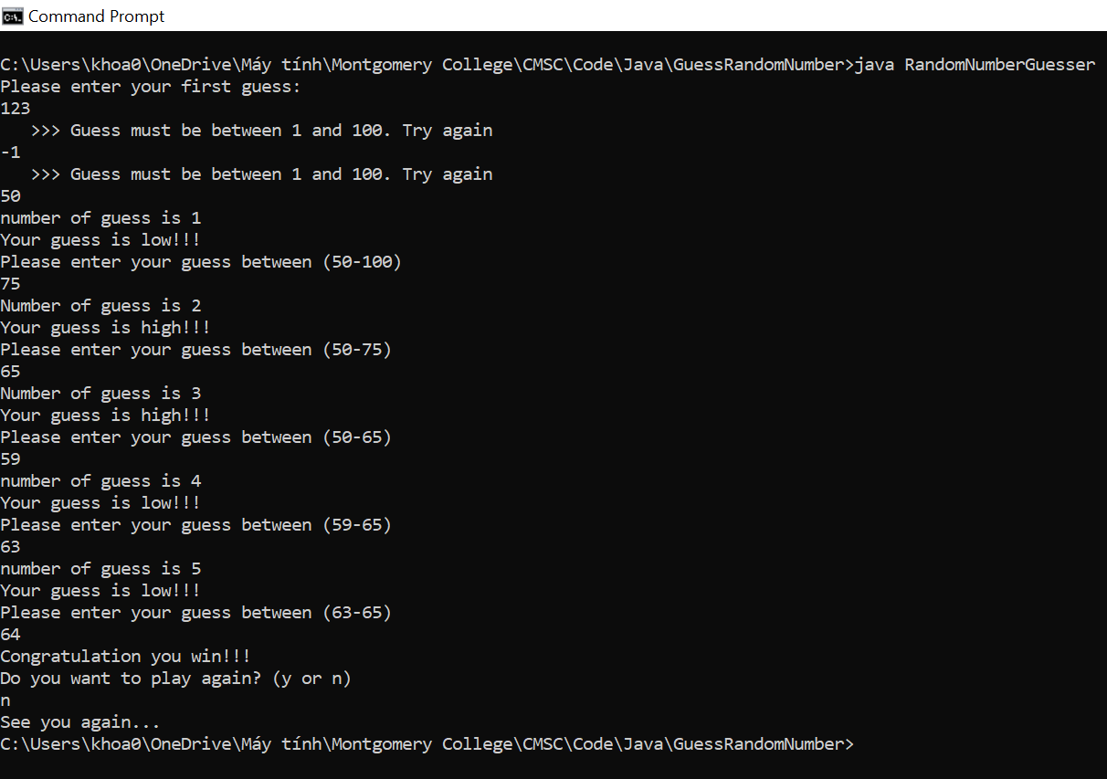

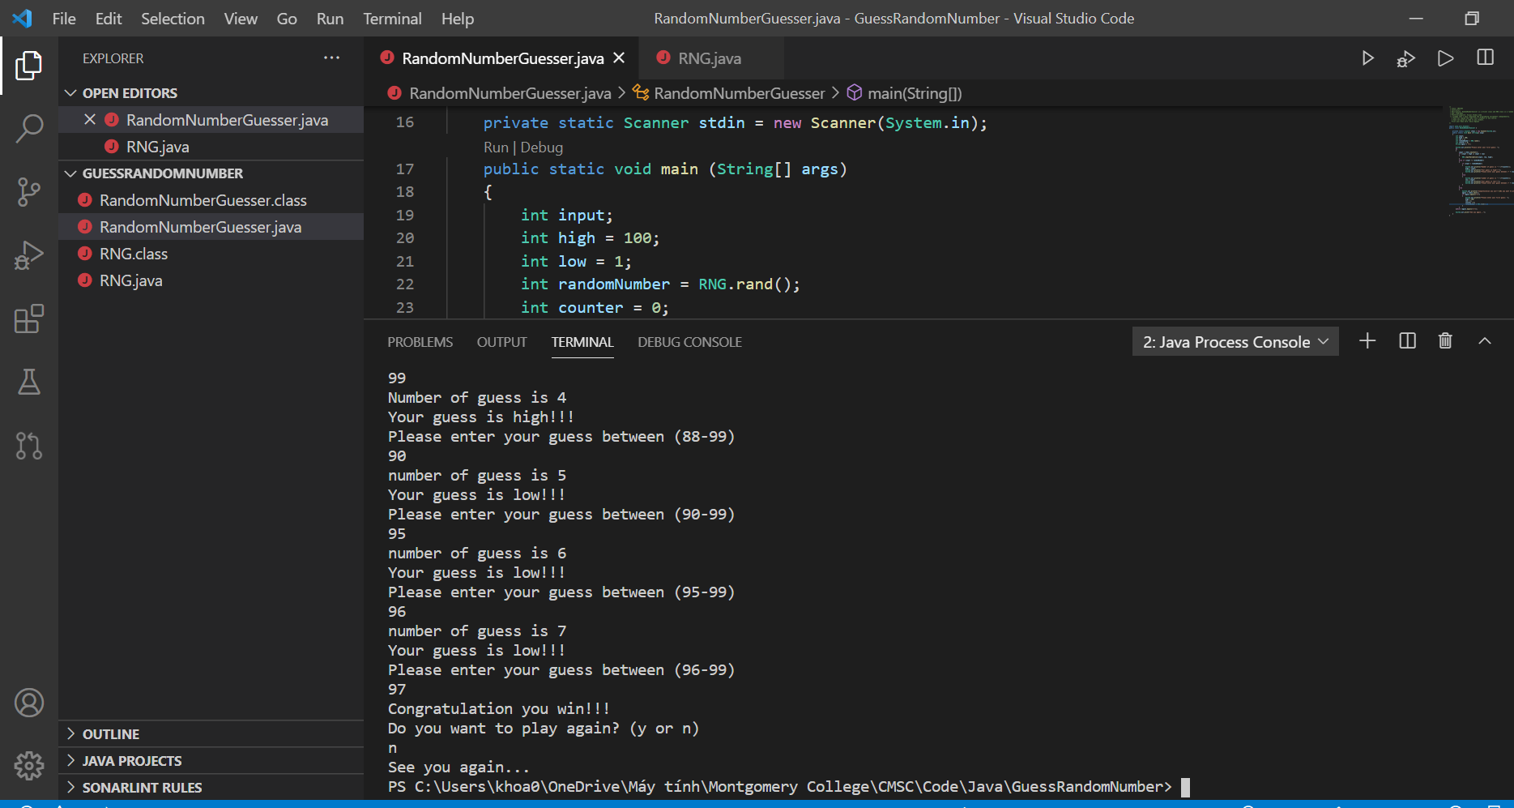
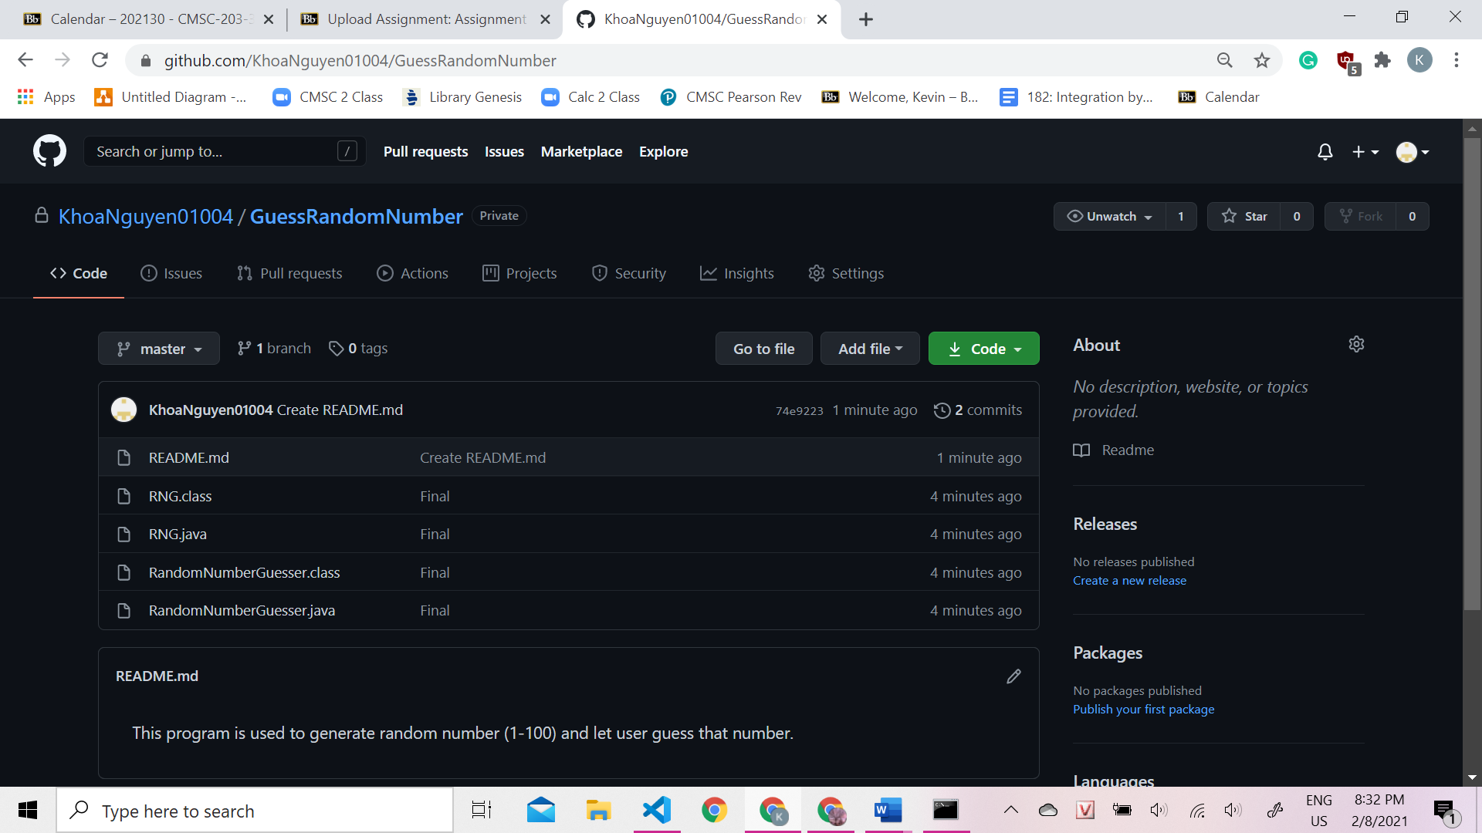
Lesson Learned

- I have learned how to work with different classes
- I take user input when necessary.
- Call functions and pass variables into parameters
- The thing that I am most struggle on when work is accidently take user input too many times
- To do better in the next project, I will read the given classes carefully before write my driver class
- The thing that I most successful with in this project is be able to work with different class

