**1. Ask question to make a clear for above requirements:**

|  |  |
| --- | --- |
| **Question** | **Answers** |
| Which public transport will be integrated with the automatic ticketing system? | Can be a Bus or a MRT, etc.. depending on Users need most. |
| What payment methods are available to users? | Credit Card, QR Code payment linked with banking system, or digital wallet as modes of payment. |
| In case of payment by credit card, what will the ticket machine do? | The ticket vendor machine will issue a paper ticket with a bar code itself and their credit card account be charged. |
| What happens when a passenger selects their destination and the credit has been validated? | Once a destination has been selected, the system will request the user to input their credit card information or show a QR Code for mobile payment. When the credit transaction has been validated, the ticket is issued. |
| What steps do users have to do to buy tickets? | Choose destination, input their credit card, number of tickets or payment method, and then wait for issuing ticket. |
| What if passengers using an digital wallet? | The same for digital wallet means that the ticket vendor machine will show a QR Code after the passenger selecting a route for their mobile phone payment. |

**2. Write a set of functional, non-functional and domain requirements for a Ticket Vendor Machine. You can conduct this exercise to Excel or Word. Remember to concentrate on expectations of reliability and response time.**

Functional Requirements:

1. Let users to select their desired mode of payment, such as credit card or digital wallet.
2. Issue a paper ticket with a bar code for users who pay with credit card.
3. Process credit card transactions and charge to the user's account.
4. Display a menu of potential destinations when the user select the start button to choose after selecting their payment method.
5. Show a QR code for users when chosen digital wallet.
6. Must validate credit transactions before the paper ticket is issued.
7. Print the receipt according to user request.
8. Make a stop button to shut down the system in emergency cases.

Non-functional Requirements:

1. Process payments and issue tickets within 10 seconds of the user selecting their destination.
2. Have a reliability of at least 99.9% to ensure minimal downtime.
3. Built-in system to prevent fraud and ensure secure payment processing.
4. The Ticket Vendor Machine must be user-friendly and easy to understand, with clear instructions and messages displayed on the screen.
5. Comply with all relevant safety and security standards.

Domain Requirements:

1. Support multiple languages to cater to a diverse user base.
2. Compatible with different types of credit cards and digital wallets.
3. Must be able to process transactions for all types of public transportation (bus, MRT, etc.) within the smart ticketing system.
4. Must be able to handle peak hours and high traffic, especially during rush hour or special events.
5. Generate reports and analytics on usage, revenue and user behavior to assist in decision making and system improvement.

**3. Make a Use Case diagram for Ticket Vendor Machine, you are also encouraged to make Use Case**

**Description for all use cases on your use case diagram.**

Model describes Use case Diagram of Vendor Machine:

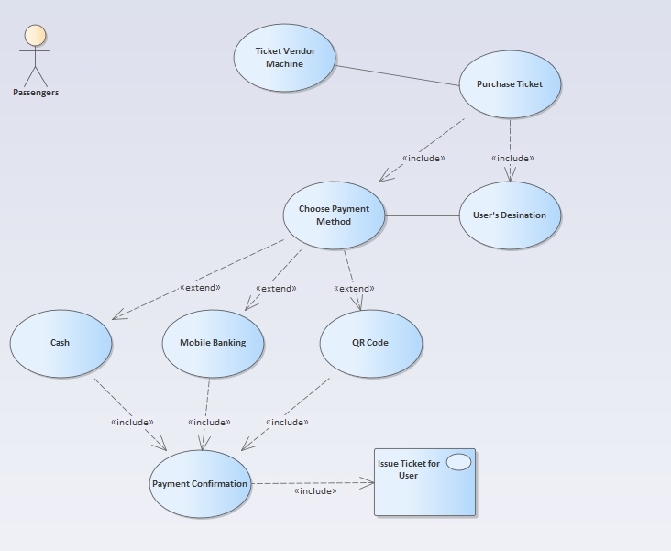

**4. Make an Activity diagram to present the process of passenger’s buying a ticket from ticket vendor**

**machine (Look like ATM)**

- The activity diagram for communication among systems if your system is integrated with other system like Momo, VNPay, ZaloPay,...etc

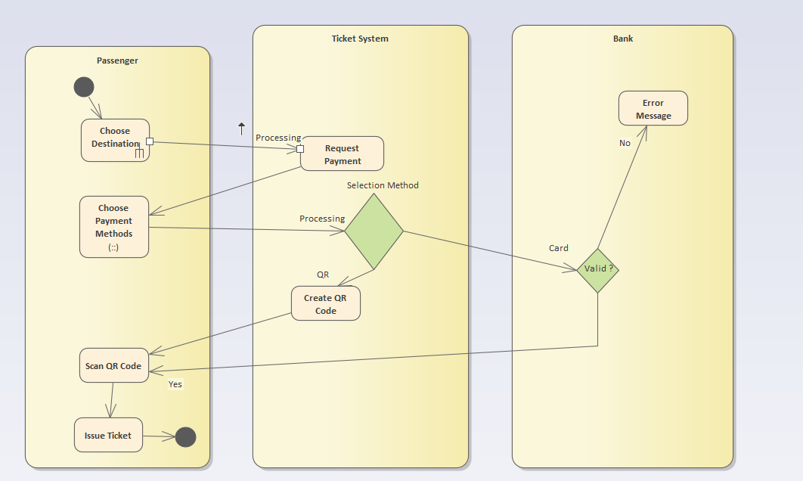

**5. Let’s say that the Ticketing Vendor Machine have main use case: Buy a ticket then you are**

**required to complete the sequence diagram, Communication Diagram, State chart diagram, and**

**Class diagram.**

Sequence diagram:

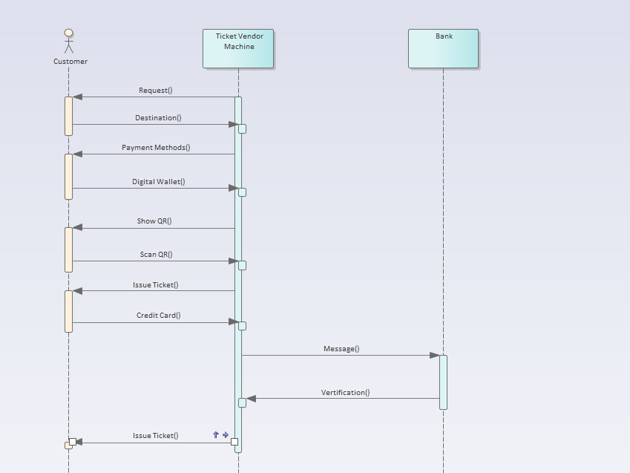

State chart diagram:

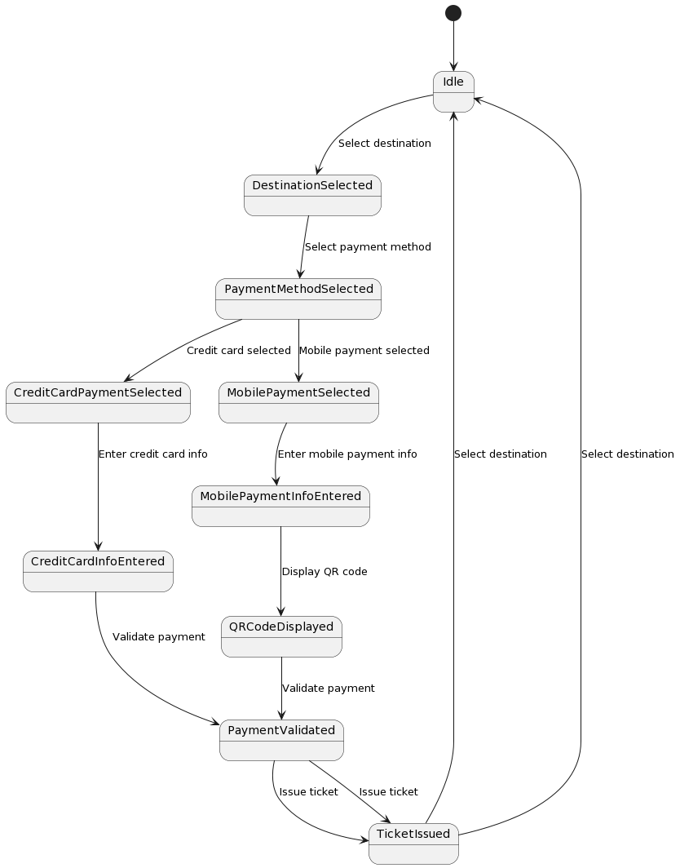

Class Diagram:

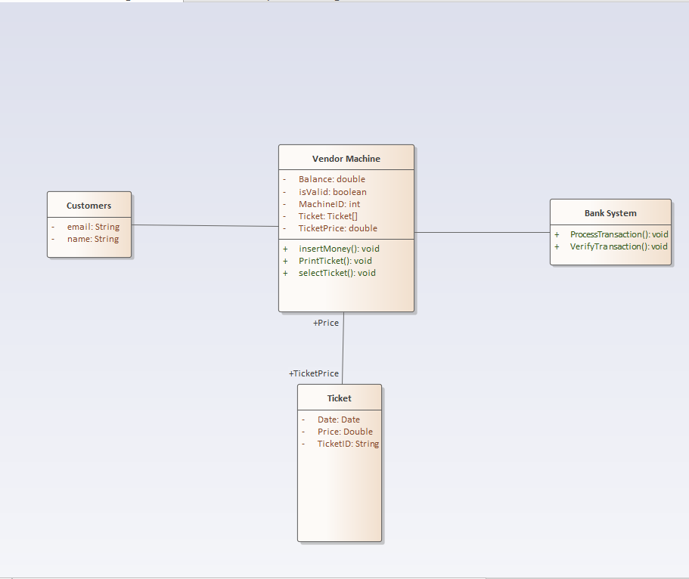

**6. Design an either wireframe/mockup with balsamiq or prototype with figma for your use cases.**

Balsamiq describes activities of Ticket Vendor machine:

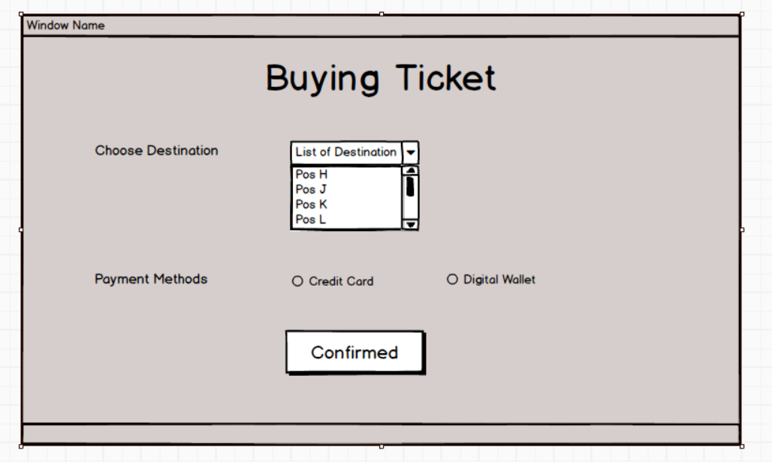

When Customer chose Credit Card Payment:

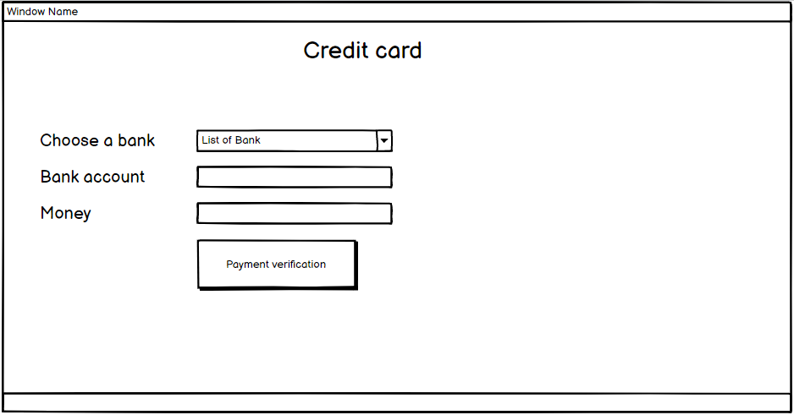

Same with Digital Wallet:

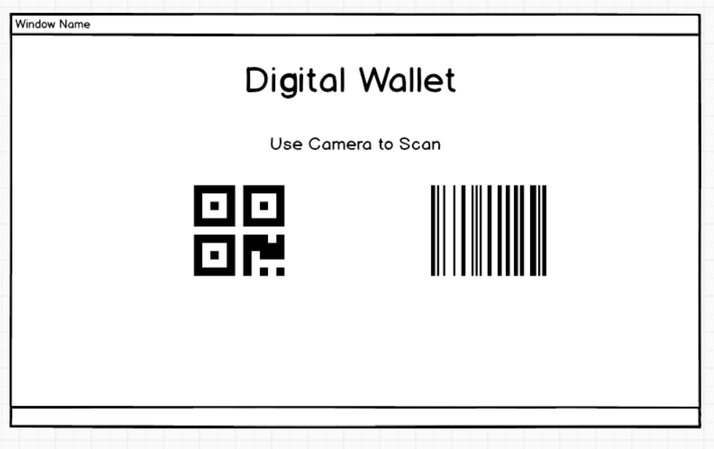

After Completed the Payment:

